INDOOR AIR QUALITY ASSESSMENT

Freetown-Lakeville Middle School
96 Howland Road
Lakeville MA

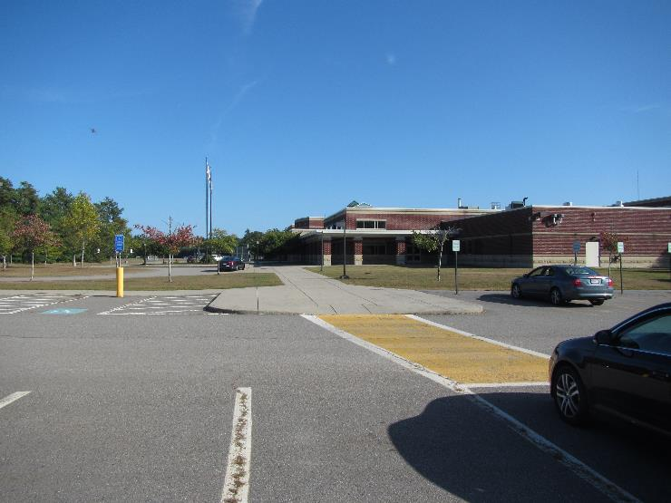

Prepared by:
Massachusetts Department of Public Health
Bureau of Environmental Health
Indoor Air Quality Program
October 2019

Background
Building: | Freetown Lakeville Middle School (FLMS)
Address: | 96 Howland Road  Lakeville MA 02347
Assessment Requested by: | Greg Goodwin, Facilities Director, Freetown-Lakeville Regional School District
Reason for Request: | General indoor air quality (IAQ) concerns
Date of Assessment: | September 20, 2019
Massachusetts Department of Public Health/Bureau of Environmental Health (MDPH/BEH) Staff Conducting Assessment: | Mike Feeney, Director; IAQ Program
Date of Building Construction: | 2002
Building Description: | Middle School, two-story brick construction with flat roofs
Building Population: | 750 students in grades 6 through 8 with a staff of approximately 70
Windows: | Mostly openable

METHODS
Please refer to the IAQ Manual for methods, sampling procedures, and interpretation of results (MDPH, 2015).

IAQ Testing Results
The following is a summary of indoor air testing results (Table 1).
- Carbon dioxide levels were above the MDPH guideline of 800 parts per million (ppm) in 37 of 60 areas surveyed, indicating a lack of air exchange in more than half the areas tested.
- Temperature was within or close to the recommended range of 70°F to 78°F in areas tested.
- Relative humidity was within the recommended range of 40 to 60% in areas tested.
- Carbon monoxide levels were non-detectable (ND) in all indoor areas tested.
- Fine particulate matter (PM2.5) concentrations measured were below the National Ambient Air Quality Standard (NAAQS) level of 35 μg/m³ in all areas tested.
- Volatile Organic Compounds (VOCs) were ND in all areas tested.
This sampling indicates that the ventilation system in the building could provide more fresh air. However, please note that the system was deactivated in a number of areas throughout the school via room thermostats, as indicated by elevated carbon dioxide levels. To maximize air exchange, the BEH recommends that mechanical ventilation systems operate continuously during periods of school occupancy. Without the system operating as designed, normally occurring pollutants cannot be diluted or removed, allowing them to build up and lead to IAQ/comfort complaints.

Ventilation
A heating, ventilating and air conditioning (HVAC) system has several functions. First it provides heating and, if equipped, cooling. Second, it is a source of fresh air. Finally, an HVAC system will dilute and remove normally occurring indoor environmental pollutants by not only introducing fresh air, but by filtering the airstream and ejecting stale air to the outdoors via exhaust ventilation. Even if an HVAC system is operating as designed, point sources of respiratory irritation may exist and cause symptoms in sensitive individuals.
Fresh air is provided by a combination of unit ventilators (univents) located in individual classrooms along the outside wall (Picture 1) and air handling units (AHUs) which serve central areas (Picture 2). Unit ventilators draw fresh air through a vent on the exterior wall (Picture 3). Air is mixed with return air from the room, filtered, heated/cooled (if needed) and delivered back to the room (Figure 1). Air from the AHUs is filtered, heated/cooled and delivered to rooms via ducted supply vents.
Classrooms have exhaust vents that are ducted to exhaust fans on the roof (Picture 4). Additional exhaust vents are located in rest rooms and other areas. As noted previously, some of the univents, supply vents, and exhaust vents were found to be weakly functioning or off at the time of the assessment which can limit air exchange. The art room has a switch-operated dedicated exhaust vent in the kiln room, to remove heat and pollutants from operation. This vent should be used every time the kiln is in use and for a period of time after it cools down.
Univents are equipped with filters to remove particles from the air. Even if installed properly, filters of the type found during this assessment provide minimal filtration (Picture 5). The dust spot efficiency is the ability of a filter to remove particulate matter of a certain diameter from air passing through the filter. The MDPH recommends pleated filters with a Minimum Efficiency Reporting Value (MERV) of 8, which are adequate in filtering out pollen and mold spores (ASHRAE, 2012). Filters should also be changed two to four times a year, or per the manufacturer’s recommendations. Consideration should be given to installing pleated filters. Note that increasing filtration may require evaluation and adjustments to the units to manage increased flow resistance created from using higher MERV filters.
The univents have holes in interior walls (Picture 6) that are above the filters. These openings can allow air from wall cavities to bypass the filters. Air drawn into univents should be directed through filters to prevent the aerosolization of particles, odors and other debris.

Microbial/Moisture Concerns
Of note is the weather condition experienced in New England during the summer of 2018:
The New England area experienced an unprecedented period of extended hot, humid weather. According to the Washington Post, “[d]ata…show[s]…cities in the Northeast have witnessed such humidity levels for record-challenging duration...[i]ncluding Albany, Boston, Burlington Portland and Providence” during the summer of 2018 (WP, 2018). “Boston and nearby locations… [saw]…historic numbers of those warm nights with low temperatures at or above 70 degrees…Providence and Blue Hill Observatory have already broken their annual records” (WP, 2018).
If a building does not have adequate exhaust ventilation and air chilling capacity to remove/reduce relative humidity from outside air, then hot, moist air can be introduced into a building and linger to increase occupant discomfort as well as possibly moisten materials that may lead to mold growth.
At the FLMS, the HVAC system provides chilled air during warm weather. Each unit ventilator has a drip pan connected to pipes that drain water (e.g., condensate) that drips from the cooling coils. Accumulation of debris was observed in drip pans (Picture 7), which can serve as mold growth media when wet from condensation. Insulation on pipes connected to univent coils was found heavily water-damaged and likely mold-contaminated (Picture 8). The end of the insulation is open. In order to prevent wetting of insulation, it is recommended that the butt end of insulation be sealed with vapor retarder mastic (NAIMA, 2015):
Vapor Retarder Coating (Picture 9) (author note: This type of coating is typically referred to in the marketplace as a vapor barrier.) This coating resists the ingress of water vapor toward a cold operating system. Vapor retarders are applied on the outside of the insulation to assist in keeping the insulation dry. The importance of using a proper vapor retarder over a cold system, even if it is just air conditioning ductwork, has become more obvious in recent years with the prevalence of mold and mildew problems occurring where moisture has been allowed to intrude (Pugh, R. 2002).
Without vapor-retarding mastic or other sealant, water vapor can readily condense on the chilled water pipe to wet insulation, which can in turn moisten the insulation paper to result in mold growth as seen in Picture 8. As noted, regarding the weather experienced during the summer of 2018, water damage from condensation likely occurred to insulation.
Stained ceiling tiles were observed in a number of areas (Table 1). Some of the observed stained tiles were from condensation accumulating on fresh air diffusers (Picture 10) and sprinkler heads (Picture 11) that likely occurred during hot, humid weather in summer months. During the summer, the AC system/chiller creates cold water that is fed to univents and AHUs for cooling. When the HVAC system was designed, a thermal load (heat produced by occupants and activities) corresponding to the full capacity of the school, approximately 800 people, was used in design calculations. This thermal load determines the temperature at which the coolant is chilled to provide comfortable air. As is the case with most schools, the population is significantly lower during summer vacation. This discrepancy is likely leading to overcooling when the chiller is in use, which may lead to condensation on surfaces that are chilled below the dew point.
A window in the library appears to leak during rainy weather, demonstrated by the presence of a cloth towel on the sill. Porous materials (e.g., cloth towels) used to absorb water leaks may become mold-colonized. Repairing the window is recommended.
Plants were observed in a few areas (Picture 12). Plants can be a source of pollen and mold, which can be respiratory irritants to some individuals. Plants should be properly maintained and equipped with drip pans and should be located away from air diffusers to prevent the aerosolization of dirt, pollen and mold.
There were several refrigerators in the building, and one was found to have an odor and evidence of mold (Pictures 13 and 14). Refrigerators should be cleaned regularly to prevent microbial growth and odors.
The band room contains an upright piano. A significant musty odor was detected when the keys are pressed, which like indicates that the felt hammers inside the piano have become mold colonized. It is advised not to use this piano unless it has been remediated.
The outside of the building was examined for conditions that may impact IAQ. Plants along the edges of the foundation can prevent walls from drying and lead to drainage problems/deterioration of the building envelope. When near air intakes, they can also be a source of odors, pollen and debris to the inside of the building.
The exterior of the FLMS consists of a traditional red brick exterior wall and cement panels. In order to allow water to drain from the exterior brick walls, a series of weep holes (Picture 15) is customarily installed at or near the foundation slab/exterior wall system junction (Figure 2). The purpose of a weep hole is to allow for accumulated water to drain from a wall system (Dalzell, J.R., 1955). Failure to install weep holes in brickwork will allow water to accumulate in the base of walls, resulting in seepage and possible moistening of building components (Figure 3).
An extensive examination of the exterior brick walls of FLMS was conducted to identify the location and condition of weep holes. Of note is that some weep holes are partially blocked with debris. It is advised that “[i]n no case should the holes be located below grade”, since dirt can fill weep holes to prevent drainage (Dalzell, J.R., 1955). No weep holes were identified along the front of the building in any of the exterior brick wall systems. Either weep holes were not installed or are buried below grade in this area.

Other IAQ Evaluations
Exposure to low levels of total volatile organic compounds (TVOCs) may produce eye, nose, throat, and/or respiratory irritation in some sensitive individuals. Levels of TVOCs measured in the building were not detected (below the detection level of the instrument) at the time of the assessment. BEH/IAQ staff also examined rooms for products containing VOCs. BEH/IAQ staff noted plug-in air fresheners (Picture 16), hand sanitizers, cleaners and dry erase materials in use within the building (Table 1). These products have the potential to be irritants to the eyes, nose, throat, and respiratory system of sensitive individuals.
A fragrance/odor was noted in the hallway outside Room 096. This odor was traced to the medical office where a fragrance diffuser was in use. The use of fragrance oil diffusers and plug-in air fresheners is not recommended since these products can cause irritation to individuals with compromised respiratory health (e.g., asthma) as well as eye, nose and respiratory system irritation as detailed in the guideline “Clean Air is Odor-free: Removing fragrances to improve indoor air quality in schools and offices”, which is included as Appendix A.
Some areas were carpeted or had area carpets (Table 1). Carpets should be cleaned annually (or semi-annually in soiled/high traffic areas) in accordance with Institute of Inspection, Cleaning and Restoration Certification (IICRC) recommendations, (IICRC, 2012). Regular cleaning with a high efficiency particulate air (HEPA) filtered vacuum in combination with an annual cleaning will help to reduce accumulation and potential aerosolization of materials from carpeting. Area carpets too worn to be effectively cleaned should be replaced.
Upholstered furniture was observed in several areas (Table 1). These items are covered with fabrics that may be exposed to human skin. This type of contact can leave oils, perspiration, hair and skin cells. Dust mites feed upon human skin cells and excrete waste products that contain allergens. In addition, if relative humidity levels increase above 60 percent, dust mites tend to proliferate (US EPA, 1992). In order to remove dust mites and other pollutants, frequent vacuuming of upholstered furniture and plush toys is recommended (Berry, 1994). It is also recommended that upholstered furniture be professionally cleaned on an annual basis. Where an excessively dusty environment exists due to outdoor conditions or indoor activities (e.g., renovations), cleaning frequency should be increased (every six months) (IICRC, 2000).
In a number of areas, items were observed on the floor, windowsills, tabletops, counters, bookcases and desks. The large number of items stored provides a source for dusts to accumulate. These items (e.g., papers, folders, boxes) make it difficult for custodial staff to clean. Items should be relocated and/or be cleaned periodically to avoid excessive dust build up.
Note that EPA conducted a National School Radon Survey in which it discovered nearly one in five schools had “…at least one frequently occupied ground contact room with short-term radon levels above 4 [picocuries per liter] pCi/L” (US EPA, 1993). The BEH/IAQ Program therefore recommends that every school be tested for radon, and that this testing be conducted during the heating season while school is in session in a manner consistent with USEPA radon testing guidelines. Radon measurement specialists and other information can be found at www.nrsb.org and http://aarst-nrpp.com/wp, with additional information at: http://www.mass.gov/eohhs/gov/departments/dph/programs/environmental-health/exposure-topics/iaq/radon.

Conclusions/Recommendations
The conditions within the FLMS require both short-term and long-term strategies. Short-term recommendations can be implemented as soon as practicable to improve IAQ. Long-term strategies may require planning and capital to prevent the reoccurrence of conditions conducive to HVAC leaks/condensation and mold growth. In view of the findings at the time of the visit, the following recommendations are made:

Short-Term Recommendations
- Operate supply and exhaust ventilation in all areas during occupied periods. During temperate weather, use windows to supplement fresh air. Work with building occupants to resolve comfort/noise concerns without reducing fresh air supply (e.g., repairing noisy univents, relocating desks away from vents).
- Begin a program of removing mold-colonized insulation from univent coil supply pipes. Ensure installation includes a vapor retardant coating to seal the open ends of insulation to prevent mold colonization.
- Determine the R Value of the univent pipe insulation. Do not operate the chiller for the HVAC system at a temperature that exceeds the R value for the insulation.
- Clean debris from the univent drip pans. Ensure that drip pans drain condensation in a manner to prevent pooling water.
- Remove blockages from the top and front of univents and from exhaust vents.
- Ensure the kiln exhaust vent is used whenever the kiln is on and until the cycle has finished/kiln cooled down. Consider running the kiln only when the adjacent classroom is not occupied. If kiln is no longer in use, seal the kiln exhaust vent for prevent air backflow into the building and disconnect the kiln from its power-source.
- Repair roof/plumbing leaks and replace stained ceiling tiles. Ensure that the roof gets examined regularly for deterioration and leaks, and that debris is removed regularly.
- If metal supply diffusers cannot be adequately cleaned (see Picture 10), replace or refinish.
- Ensure that procedures are in place for occupants to report leaks, wet tiles, and other maintenance conditions so that they can be logged and repaired promptly.
- Consider removing plants from library and other locations as needed.
- Ensure refrigerators are cleaned out regularly and that spills are cleaned promptly to prevent odors. If science room refrigerators are not used, consider removing them.
- Ensure that all floor drains in the science classroom and elsewhere are wetted at least twice a week to maintain water seal in the drain traps.
- Discontinue the use of all fragrance producing materials (e.g., plug-in air fresheners and fragrance diffusers).
- Reduce the use of cleaning products, sanitizers and other products containing VOCs. Use only school-issued products, ensure they are properly labeled, and keep material safety sheets on file for each product at the school.
- Ensure that all weep holes are open and unburied.
- Do not mow grass during school hours.
- Ensure air purifiers/filters used are maintained in accordance with manufacturer’s instructions. Avoid the use of air purifiers that may produce ozone.
- Use dehumidifiers during hot, humid weather to prevent floor condensation as needed.
- Move the upright piano into storage until remediated.
- Clean trays of whiteboard marker debris regularly.
- Repair window leak in library. Discontinue use of towels to soak up rain water.
- Change filters regularly in univents (2 to 4 times a year), and vacuum the cabinets of debris each time the filters are changed.
- Clean supply and exhaust vents and personal fans regularly to prevent aerosolization of debris.
- Clean carpeting, area rugs and plush/upholstered items regularly and discard those that are worn out or too soiled to be cleaned.
- Consider reducing the amount of items stored in classrooms to make cleaning easier. Periodically move items to clean flat surfaces.
- For buildings in New England, periods of low relative humidity during the winter are often unavoidable. Therefore, scrupulous cleaning practices should be adopted to minimize common indoor air contaminants whose irritant effects can be enhanced when the relative humidity is low. To control for dusts, a high efficiency particulate arrestance (HEPA) filter equipped vacuum cleaner in conjunction with wet wiping of all surfaces is recommended. Drinking water during the day can help ease some symptoms associated with a dry environment (e.g., throat and sinus irritations).
- Reduce the amount of items stored on flat surfaces to allow regular cleaning.
- Consider adopting the US EPA (2000) document, “Tools for Schools”, as an instrument for maintaining a good IAQ environment in the building. This document is available at: http://www.epa.gov/iaq/schools/index.html.
- Refer to resource manual and other related IAQ documents located on the MDPH’s website for further building-wide evaluations and advice on maintaining public buildings. These documents are available at: http://mass.gov/dph/iaq.

Long Term Recommendations
- Consider removing tree from interior courtyard to enhance drying of exterior walls. Remove plants to at least five feet away from the building foundation, including in the courtyard.
- Consider replacing thermostats throughout the building to prevent univent deactivation.
- Consult with a ventilation engineer to evaluate with univent can have filters increased to a MERV 8 (or higher) rating.

References
ASHRAE. 2012. American Society of Heating, Refrigeration and Air Conditioning Engineers (ASHRAE) Standard 52.2-2012 -- Method of Testing General Ventilation Air-Cleaning Devices for Removal Efficiency by Particle Size (ANSI Approved).
Berry, M.A. 1994. Protecting the Built Environment: Cleaning for Health. Michael A. Berry, Chapel Hill, NC.
Dalzell, J.R. 1955. Simplified Masonry Planning and Building. McGraw-Hill Book Company, Inc. New York, NY.
IICRC. 2000. IICRC S001. Reference Guideline for Professional On-Location Cleaning of Textile Floor Covering Materials. Institute of Inspection, Cleaning and Restoration Certification. Institute of Inspection Cleaning and Restoration, Vancouver, WA.
IICRC. 2012. Institute of Inspection, Cleaning and Restoration Certification. Carpet Cleaning: FAQ.
MDPH. 2015. Massachusetts Department of Public Health. Indoor Air Quality Manual: Chapters I-III. Available at: http://www.mass.gov/eohhs/gov/departments/dph/programs/environmental-health/exposure-topics/iaq/iaq-manual/.
NAIMA. 2015. Guide to Insulating Chilled Water Piping Systems with Mineral Fiber Pipe Insulation. North American Insulation Manufacturer’s Association, Alexandria, VA. https://insulationinstitute.org/wp-content/uploads/2015/11/CI228.pdf
Pugh, R., 2002. Mastics 101. National Insulation Association. Herndon, VA. https://insulation.org/io/articles/mastics-101/
US EPA. 1992. Indoor Biological Pollutants. US Environmental Protection Agency, Environmental Criteria and Assessment Office, Office of Health and Environmental Assessment, research Triangle Park, NC. EPA 600/8-91/202. January 1992.
US EPA. 1993. Radon Measurement in Schools, Revised Edition. Office of Air and Radiation, Office of Radiation and Indoor Air, Indoor Environments Division (6609J). EPA 402-R-92-014.
US EPA. 2000. Tools for Schools. Office of Air and Radiation, Office of Radiation and Indoor Air, Indoor Environments Division (6609J). EPA 402-K-95-001, Second Edition. http://www.epa.gov/iaq/schools/tools4s2.html.
WP. 2018. ‘It’s been relentless’: Smothering summer humidity in the Northeast has crushed records. Washington Post, Washington, DC. https://www.washingtonpost.com/news/capital-weather-gang/wp/2018/08/30/its-been-relentless-smothering-summer-humidity-in-the-northeast-has-crushed-records/
Picture 1
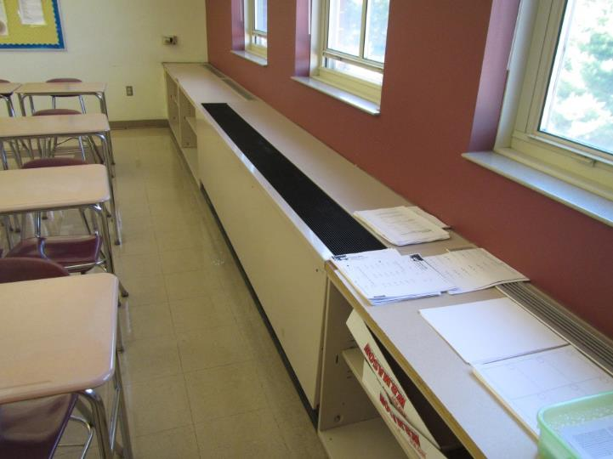
Univent
Picture 2
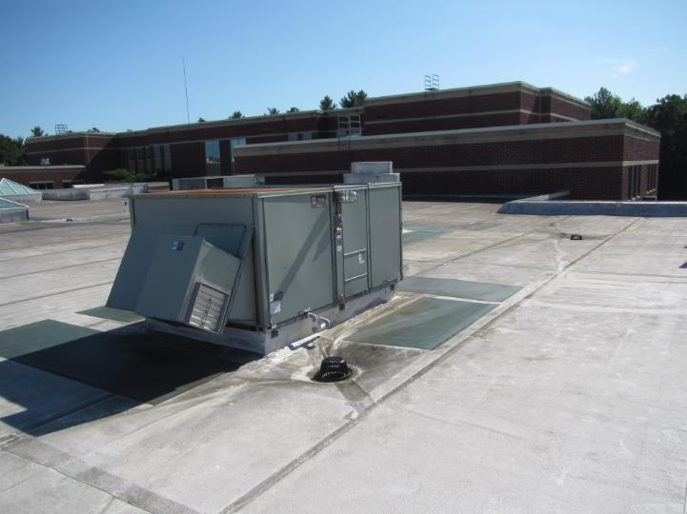
Rooftop AHU
Picture 3
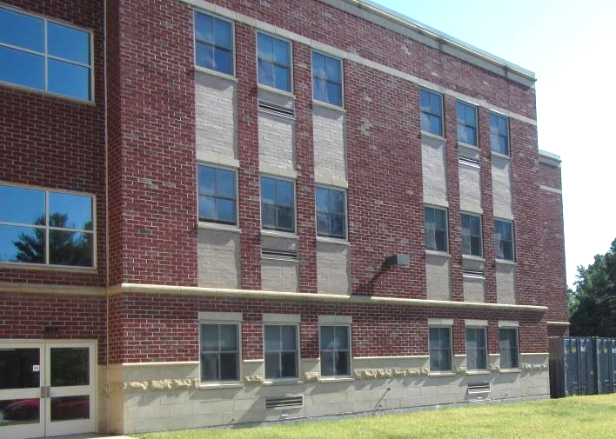
Univent fresh air intake (arrows)
Picture 4
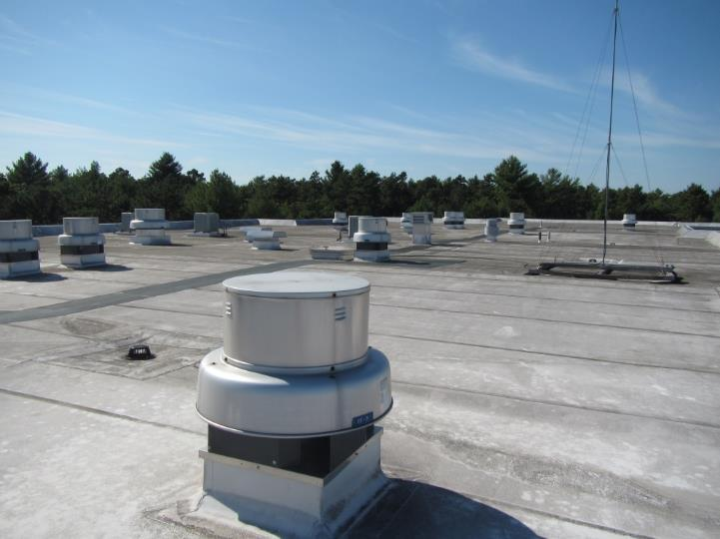
Rooftop exhaust fan
Picture 5
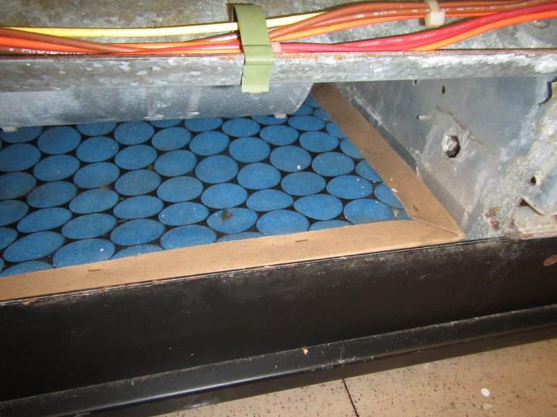
Univent filters that provide minimal filtration
Picture 6
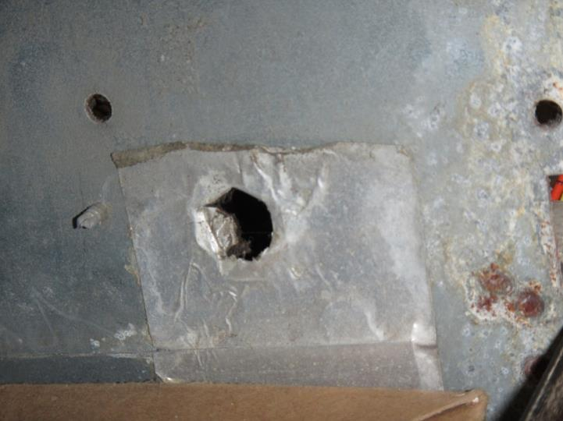
Holes in univent interior walls
Picture 7
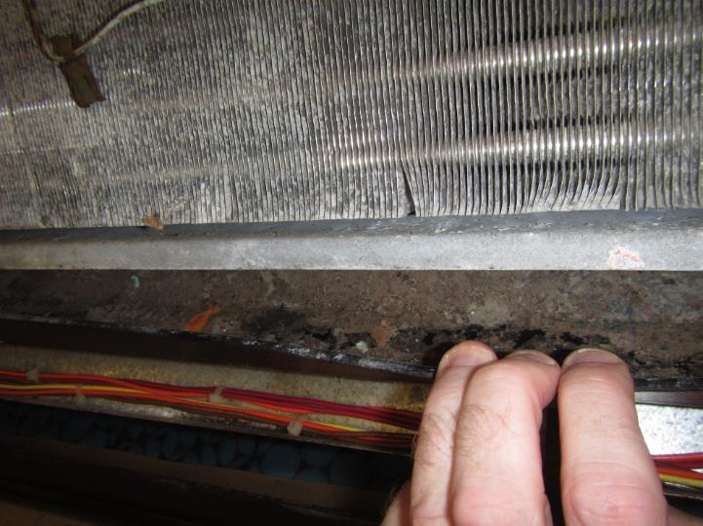
Debris in a drip pan
Picture 8
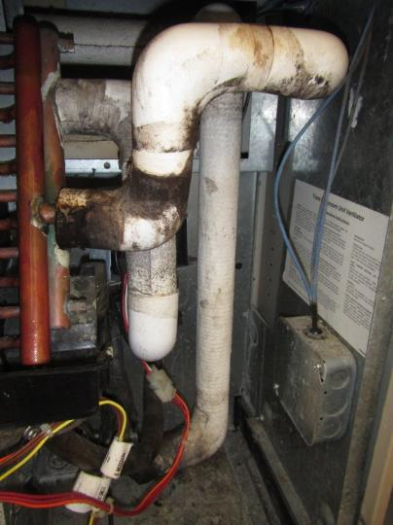
Pipe insulation connected to univent coils found heavily water-damaged with likely mold
Picture 9
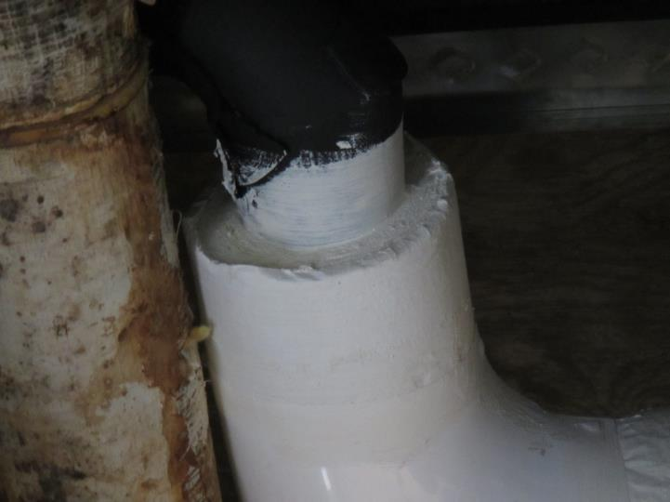
Example of a vapor retarder coating from another building
Picture 10
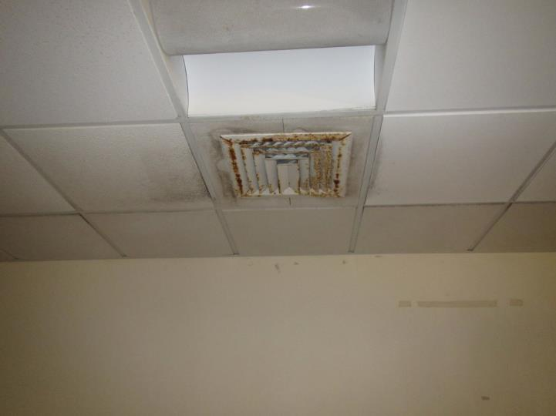
Stained tiles and vanes from condensation accumulating on fresh air diffusers
Picture 11
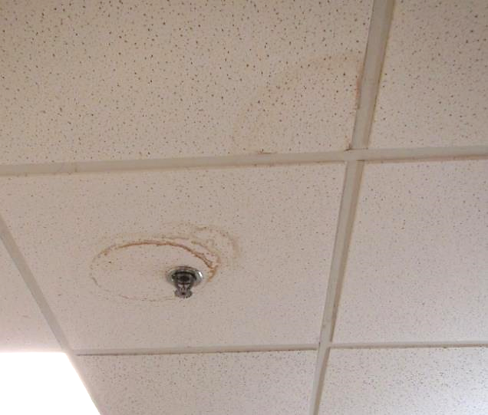
Stained tiles from condensation accumulating on sprinkler head
Picture 12
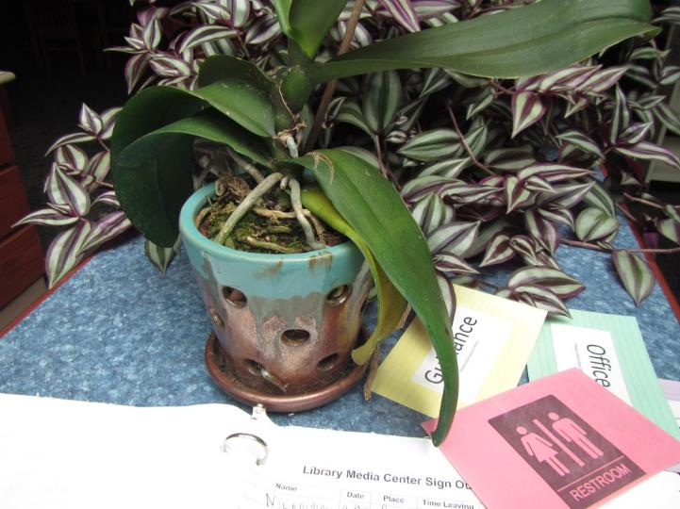
Plants in library, note debris in water collection plate and porous surface underneath
Picture 13
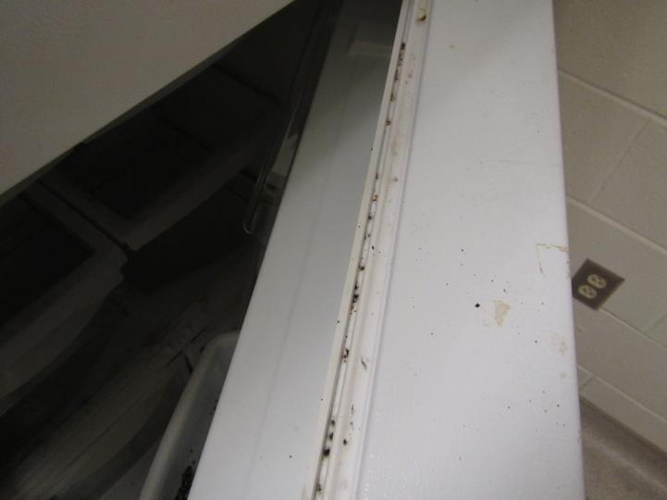
Mold on refrigerator gasket
Picture 14
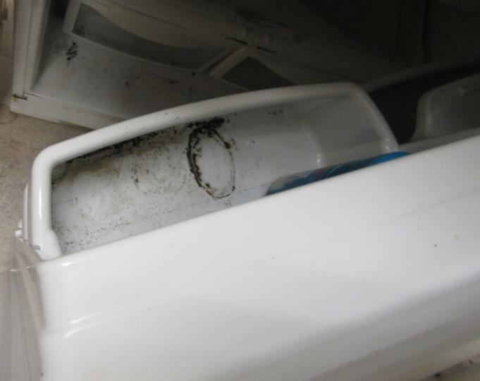
Mold inside refrigerator
Picture 15
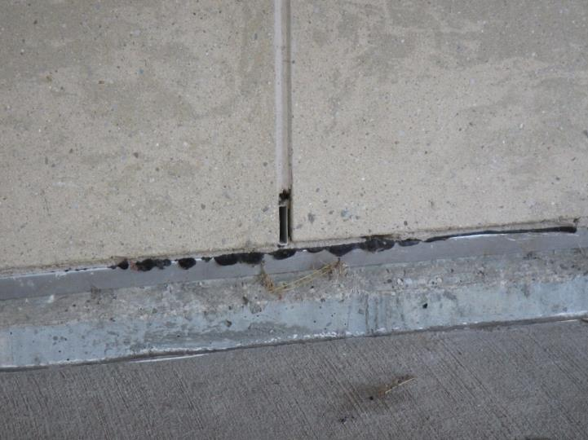
Weep hole, note debris at base of weep hole
Picture 16

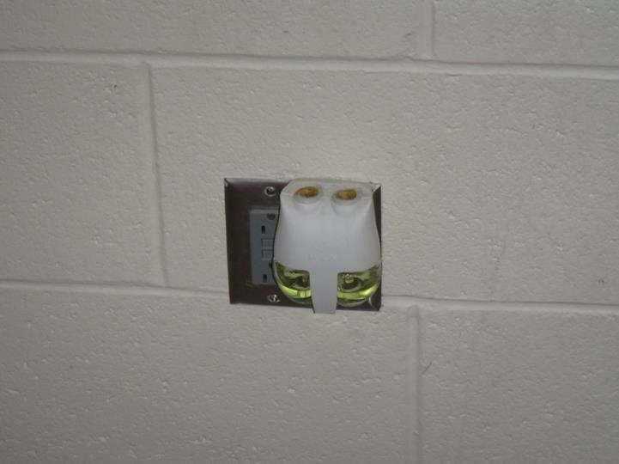

Plug-in air freshener

Location | Carbon  Dioxide  (ppm) | Carbon Monoxide  (ppm) | Temp  (°F) | Relative  Humidity  (%) | PM2.5  (µg/m³) | TVOCs  (ppm) | Occupants  in Room | Windows  Openable | Ventilation |  | Remarks
 |  |  |  |  |  |  |  |  | Supply | Exhaust
Background | 422 | ND | 83 | 32 | 8 | ND
310 | 964 | ND | 73 | 46 | 10 | ND | 2 | Y | Y on | Y | Fragrance, 4 WD CT
309 | 460 | ND | 70 | 44 | 5 | ND | 0 | N | Y | Y | 2 WD CT
211 | 1339 | ND | 70 | 55 | 6 | ND | 29 | N | Y | Y
213 | 729 | ND | 73 | 49 | 7 | ND | 27 | N | Y on | Y
Art 2 | 977 | ND | 72 | 47 | 5 | ND | 1 | N | Y on | Y
Art 1 | 1287 | ND | 73 | 48 | 6 | ND | 1 | N | Y on | Y
215 | 1389 | ND | 73 | 49 | 6 | ND | 1 | Y open | Y on | Y
216 | 432 | ND | 72 | 45 | 8 | ND | 0 | Y open | Y on | Y
214 | 2677 | ND | 73 | 53 | 14 | ND | 26 | Y | Y on | Y
212 | 2321 | ND | 75 | 54 | 8 | ND | 29 | Y | Y on | Y | Fan on
210 | 693 | ND | 74 | 42 | 6 | ND | 2 | Y | Y | Y | WD CTs (10+)
208 | 810 | ND | 73 | 45 | 7 | ND | 11 | Y | Y | Y | Fragrance
206 | 2212 | ND | 73 | 47 | 6 | ND | 2 | Y | Y | Y
205 | 1843 | ND | 74 | 54 | 7 | ND | 1 | Y | Y | Y | Plants
204 | 1341 | ND | 74 | 54 | 8 | ND | 2 | Y | Y | Y
202 | 1610 | ND | 73 | 47 | 6 | ND | 23 | Y | Y | Y
207 | 581 | ND | 73 | 45 | 8 | ND | 2 | Y open | Y | Y
Elevator | 725 | ND | 74 | 43 | 12 | ND | 0 |  |  |  | Hydraulic fluid
107 | 939 | ND | 73 | 45 | 7 | ND | 20 | Y | Y | Y
103 | 1513 | ND | 73 | 50 | 6 | ND | 26 | Y | Y | Y | Fragrances
100 | 979 | ND | 72 | 47 | 6 | ND | 6 | Y | Y | Y
101 | 967 | ND | 71 | 48 | 6 | ND | 7 | Y | Y | Y
Principal | 523 | ND | 69 | 48 | 3 | ND | 1 | Y | Y | Y
Reception | 507 | ND | 70 | 45 | 12 | ND | 1 | Y | Y | Y
Cafeteria | 735 | ND | 71 | 49 | 2 | ND | 250 | N | Y | Y
119 | 542 | ND | 71 | 46 | 5 | ND | 6 | Y | Y on | Y | 1 MT, HS
117 | 408 | ND | 69 | 44 | 12 | ND | 0 | Y | Y | Y
116 | 811 | ND | 69 | 46 | 3 | ND | 5 | Y | Y | Y | 2 MT
115 | 763 | ND | 68 | 47 | 4 | ND | 1 | Y | Y | Y
Elevator | 706 | ND | 70 | 47 | 5 | ND | 0 | N | N | N
Teacher’s planning | 780 | ND | 70 | 48 | 4 | ND | 0 | N | Y | Y | 1 WD CT, photocopier
307 | 1200 | ND | 72 | 47 | 6 | ND | 23 | N | Y | Y | Plug-in, plants
306 | 2064 | ND | 74 | 49 | 4 | ND | 27 | Y | Y | Y
305 | 1474 | ND | 74 | 47 | 5 | ND | 23 | Y | Y | Y | Plug-in, 2 WD CT
303 | 1348 | ND | 74 | 46 | 7 | ND | 21 | Y | Y on | Y
304 | 1023 | ND | 74 | 49 | 9 | ND | 33 | Y | Y | Y | Plants
311 | 1162 | ND | 74 | 44 | 6 | ND | 29 | Y | Y | Y | Plug-in
313 | 1799 | ND | 74 | 49 | 7 | ND | 26 | Y | Y on | Y
316 | 633 | ND | 73 | 41 | 4 | ND | 1 | Y | Y on | Y
315 | 787 | ND | 73 | 45 | 7 | ND | 0 | Y | Y | Y
314 | 943 | ND | 73 | 46 | 0 | ND | 1 | Y open | Y | Y
312 | 1036 | ND | 73 | 47 | 1 | ND | 1 | Y | Y | Y
102 | 873 | ND | 71 | 40 | 7 | ND | 0 | Y | Y on | Y
104 | 1377 | ND | 72 | 53 | 7 | ND | 17 | Y | Y | Y
105 | 947 | ND | 72 | 47 | 6 | ND | 24 | Y | Y on | Y
106 | 1216 | ND | 72 | 50 | 8 | ND | 24 | Y | Y on | Y
108 | 904 | ND | 73 | 45 | 6 | ND | 0 | Y | Y | Y
109 | 677 | ND | 75 | 39 | 5 | ND | 0 | N | Y | Y
110 | 866 | ND | 74 | 41 | 10 | ND | 5 | Y | Y on | Y on | Fragrance
111 | 825 | ND | 74 | 44 | 7 | ND | 25 | N | Y on | Y | Plants
113 | 856 | ND | 74 | 43 | 6 | ND | 17 | Y | Y on | Y
112 | 1832 | ND | 74 | 47 | 7 | ND | 25 | Y | Y on | Y
114 | 1166 | ND | 74 | 46 | 5 | ND | 18 | Y | Y on | Y
Library | 607 | ND | 73 | 44 | 5 | ND | 1 | Y | Y | Y | Plants, upholstered furniture, carpeted
Band
Music room | 564 | ND | 70 | 45 | 4 |  | 0 | Y | Y | Y
Choral room | 1001 | ND | 71 | 51 | 5 | ND | 27 | N | Y | Y | Piano – mold growth
Nurse | 546 | ND | 71 | 50 | 7 | ND | 1 | N | Y | Y | Scent diffuser
Nurse Storage | 551 | ND | 71 | 51 | 7 | ND | 0 | N | Y | Y | Refrigerator
Auditorium | 590 | ND | 70 | 48 | 5 | ND | 0 | N | Y | Y
Gym | 600 | ND | 74 | 51 | 4 | ND | 16 | N | Y | Y

