INCIDENT HIGHLIGHTS

**DATE:**

December 16, 2022

**TIME:**

6:32 a.m.

**VICTIM:**

31-year-old Freight mover

**INDUSTRY/NAICS CODE:**

General freight trucking, local/484110

**EMPLOYER**:

Trucking company

**SAFETY & TRAINING:**

Some involved companies provided training

**SCENE:**

Freight transfer facility

**LOCATION:**

Massachusetts

**EVENT TYPE:**

Struck by backing vehicle

















**REPORT#:** 22MA058 **REPORT DATE:** May 29, 2025

Freight Mover Struck by Backing Dumpster Truck at Freight Transfer Facility—Massachusetts

SUMMARY

At 6:32 a.m. on December 16, 2022, a 31-year-old Hispanic Black laborer for a transportation company was struck and killed by a backing waste haul dumpster truck at a freight transfer facility. READ THE FULL REPORT> (p.3)

CONTRIBUTING FACTORS

**Key contributing factors identified in this investigation include:**

* Inadequate outdoor lighting
* Inadequate designated walkway for pedestrians
* Lack of personal protective clothing, such as reflective vests
* Deficient truck side lighting and rear lighting
* Inadequate training on working around moving vehicles  
  LEARN MORE> (p.11)

RECOMMENDATIONS

**Massachusetts FACE investigators concluded that, to help prevent similar occurrences, employers should:**

* Ensure adequate outdoor lighting for areas with moving vehicles and walking pedestrians
* Ensure there is a designated walkway for pedestrians between the parking lot and buildings
* Ensure that employees wear reflective vests when working near moving vehicles LEARN MORE> (p.12)

[Massachusetts FACE Program](http://www.mass.gov/dph/face)

[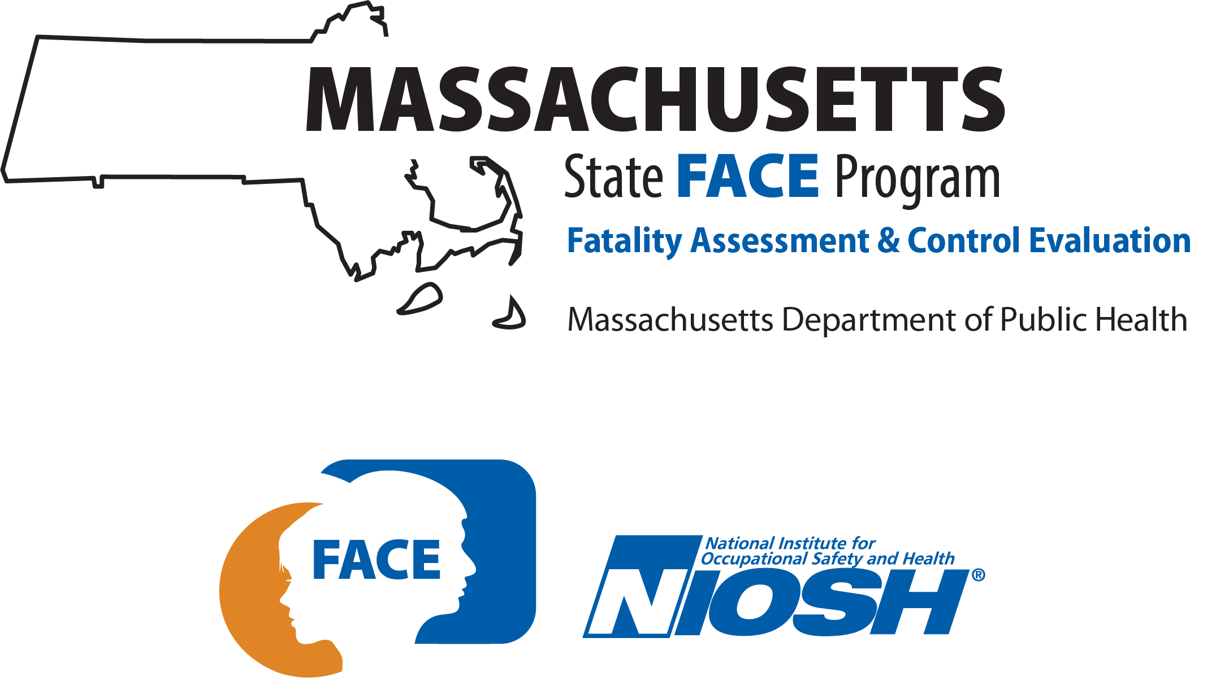](http://www.mass.gov/dph/face)

**Fatality Assessment and Control Evaluation (FACE) Program**

The Massachusetts Department of Public Health, in cooperation with the National Institute for Occupational Safety and Health (NIOSH), conducts investigations on the causes of work-related fatalities. The goal of this program, known as Massachusetts Fatality Assessment and Control Evaluation (Massachusetts FACE) is to prevent future fatal workplace injuries. Massachusetts FACE aims to achieve this goal by identifying and studying the risk factors that contribute to workplace fatalities, by recommending intervention strategies, and by disseminating prevention information to employers and employees.

NIOSH funded state-based FACE Programs currently include: California, Kentucky, Louisiana, Massachusetts, Michigan, New York, Oregon, and Washington.

[Email](mailto:ma.face@mass.gov) | [Website](http://www.mass.gov/fatal-work-related-injuries)



INTRODUCTION

At 6:32 a.m. on December 16, 2022, a 31-year-old Hispanic Black laborer for a truck transportation company was struck and killed by a waste haul dumpster truck at a freight transfer facility. On December 16th, 2022, the Massachusetts FACE Program first learned of this incident through a social media post from the municipal police department. On December 17, 2022, the Massachusetts Office of the Chief Medical Examiner sent a formal notification to the MA FACE Program of the incident and the MA FACE Program initiated steps to collect relevant documentation to investigate the event. The Massachusetts FACE Program reviewed several records in the course of the investigation, including data from the electronic death registration system (death certificate), the public obituary and news coverage, records from the Occupational Safety and Health Administration, and records provided by law enforcement agencies including video footage of the incident as recorded by the dashcam of the truck. The MA FACE staff spoke with representatives from the freight transfer facility and from the waste hauling company. MA FACE staff visited the site to view the parking lot layout, lighting conditions, and vehicle and pedestrian movements.

EMPLOYERS

* The employer of the victim was a small local freight transportation company based in the state. The company was authorized as a motor carrier by the Federal Motor Carrier Safety Administration (FMCSA) and had a US DOT license number. The company conducted authorized for hire interstate general freight operations and had been in business since 2020. The company had one power unit and one driver listed in its FMCSA profile. Between 2020 and 2022, the company had four DOT inspections which included four driver inspections combined with three vehicle inspections. Over the two-year period, the company had taken three vehicles and one driver out of service. During this time, there were no crashes reported to the FMCSA by the company. The freight trucking company was one of several firms present at the site.
* The location of the incident was a warehouse and trucking depot that was operated and leased by a multi-state trucking and logistics management firm. The trucking and logistics management company was based in another state. The trucking and logistics management company was authorized as a freight forwarder by the FMCSA. It provided logistical and warehousing services to national retail customers and also conducted truck transportation and served as a broker for securing other trucking firms, such as the victim’s firm, in forwarding freight. The trucking and logistics management company had an estimated 75 individuals employed at the site and 251 individuals employed in total by the company. It managed material handling at the site.
* A private dumpster rental and waste haul company supplied a roll-on/roll-off dumpster service for the site. The waste haul company was permitted for interstate operations hauling garbage/refuse and had a US DOT license number. The waste management company operated out of Massachusetts and had been in business since 2006, serving Massachusetts and Rhode Island. The waste haul company provided a variety of services, including commercial waste services, recycling services, temporary roll of containers and construction services, transfer station hauling and operations, municipal waste collection, and on-site compacting unit leasing. The waste haul company had one worker at the site at the time of the incident and had 39 employees in total. It had 42 power units and 47 drivers listed in its FMCSA profile. Between 2022 to 2024, according to the FMCSA profile, the waste haul company removed five vehicles and three drivers from service, and had a total of 3 crashes reported, of which two were injury-type crashes and one was a tow.

WRITTEN SAFETY PROGRAMS and TRAINING

The firm that employed the victim did not have a safety program and training information could not be obtained because the company closed after the incident and could not be located. The waste haul management company had trainings for its employees on various safety topics. The trainings were provided several times a year to different personnel. The last safety training the driver of the waste haul truck had attended was 16 months before the event and was on personal protective equipment (PPE) and back to school safety. Some topics in other previous trainings included accident/injury review and trends; lock out/tag out (LO/TO); basic safety rules; incident reporting; container inspection and safety; and hazard communication and right to know. New hires at the waste haul company also had a roll-off driver checklist, which was needed to be completed in a satisfactory manner. The checklist included pre- and post-trip inspection of lights, tires, and fluids, and awareness of surroundings including wires, fixed objects, and overhangs. The driver had completed the activities on the checklist in a satisfactory manner in the month prior to the event, with final sign-off from the supervisor the month of the event. The drivers of the company also attended a professional truck driving school where they received their Commercial Driver’s Licenses (CDL) training. At the driving school, this driver acknowledged reviewing the Federal Motor Carrier Safety Administration’s Drug and Alcohol Clearinghouse registration instructions and factsheet on two months before the event. This driver completed and passed the CDL training at the driving school the month before the event and had previously obtained a class B permit from the Massachusetts Registry of Motor Vehicles.

WORKER INFORMATION

The victim was a 31-year old Hispanic Black male warehouse laborer who worked for the trucking transportation company in Massachusetts. He lived in an adjacent state and was born in the Dominican Republic. At the time of the incident, the laborer was not wearing personal protective equipment.

The waste haul dumpster truck driver had worked for the waste management company for approximately five years. His employer reported the driver had a pristine employment record with the company. The driver held the appropriate license to operate the waste haul truck.

EQUIPMENT

The waste haul truck was a 10-wheeler Mack dumpster truck with a 12.8 liter diesel engine and 248-inch wheelbase. It had a 6x4 drivetrain with eight wheels on two drive axles in the rear. It belonged to the waste haul management company. It was a 2019 model year and received its first state inspection on 6/12/2018. The truck was inspected by authorities after the event. This description contains relevant findings from that inspection, from routine state emissions and commercial vehicle safety tests, and specifications from the manufacturer. The truck had a reverse back-up alarm that was operating as designed and audible in the vicinity of the truck. The truck had headlights that were on at the time of the incident. The truck had two lamps on the rear passenger side that were not functioning. The vehicle’s state inspection report from ten months prior to the event showed that the lighting devices received a pass. The truck had working windshield wipers that were on at the time of the incident. The truck had a circular convex rearview mirror mounted at each front corner fender and mirrors mounted near the driver and passenger door frames. The truck was equipped with a dashcam that was mounted approximately centrally in the cab and was facing forward. The truck had a gross vehicle weight rating of 72,000 pounds.

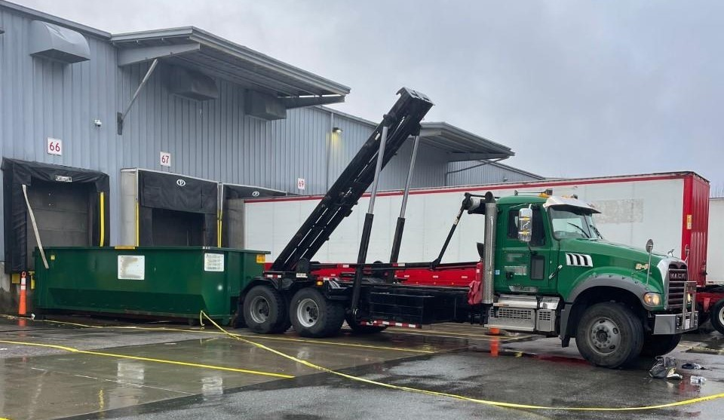

**Image 1. Truck and dumpster involved in the incident. (Photo courtesy of local responders.)**

The dumpster was a 30 cubic yard steel dumpster. A similar model dumpster owned by the waste haul company was measured at 89 inches wide and 75 inches tall. It had a nominal length of 22 feet.

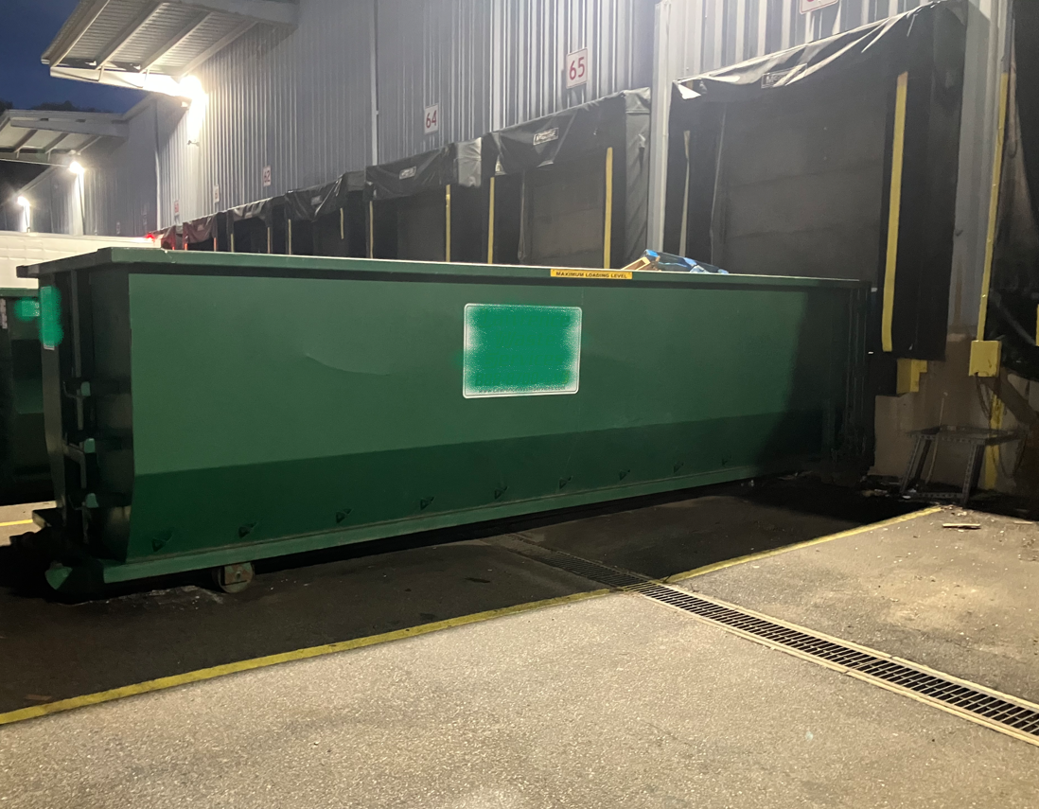

**Image 2. Similar dumpster in position at loading dock. (Photo taken by MA FACE.)**

INCIDENT SCENE

The incident occurred at a freight transfer facility and warehouse that was situated on a 15-acre property that was located two miles off a major metropolitan beltway. The warehouse was constructed in 1986 and was 171,000 square feet. The facility was in an industrial area that was previously serviced by a rail line. An inactive spur rail line ran halfway along the southern side of the building. The warehouse had loading docks on the north, west, and south sides of the building.

of 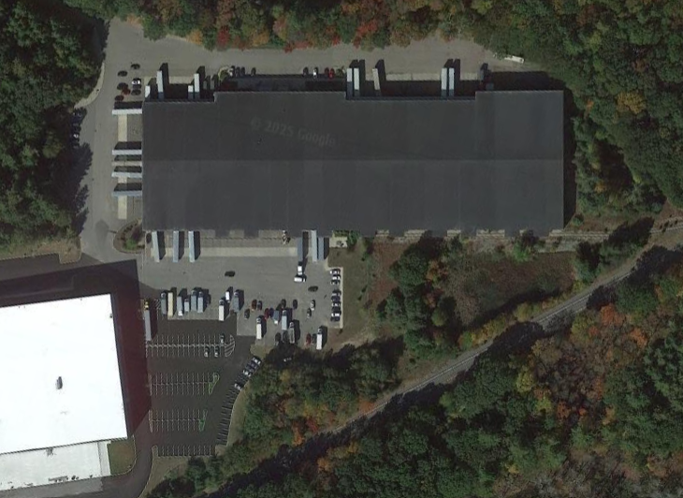

**Image 3. Aerial view of the freight transfer facility. (Photo courtesy of Google Earth.)**

The main parking lot was located on the south side of the building. Personal vehicles and inactive trucks were parked in the lot. The overall layout had an area for vehicles and trucks to pass between the parking spaces and the building, with enough room for trucks to back up to the loading docks. There was a raised sidewalk on the east perimeter of the parking lot that led to exterior steps and an entrance to the building. On the west side of the lot, there were two faded white lines painted on the pavement that led from the first row of parking spots to an entrance on the southwest corner of the building. The two white lines were from a prior parking lot configuration, when the lot was larger and had more parking spaces and hashed no-parking zones that extended west of the lines. No other pedestrian walkways or painted zones were around the parking lot or near the docks. A dumpster was consistently located at a specific dock door on the south side of the building.

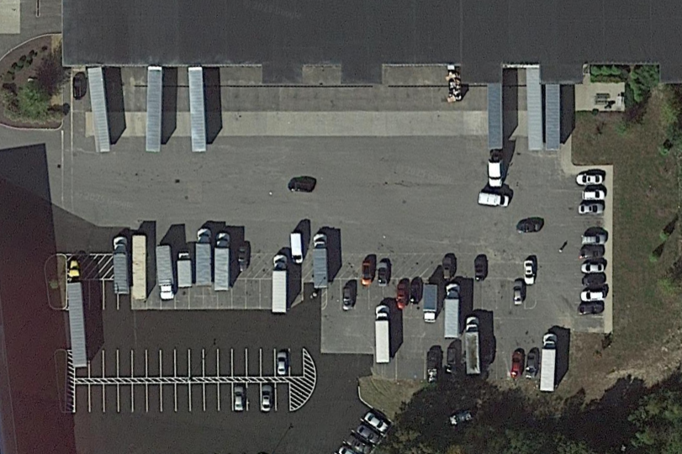

**Image 4. Aerial view of the parking lot. The red X marks the approximate location of the incident. Blue arrows mark traffic patterns. (Photo courtesy of Google Earth.)**

The area of the incident was near the loading dock where the dumpster was to be positioned. This area consisted of paved asphalt and a concrete pad that was located away from the loading dock. The concrete landing pad was a strip that ran the length of the loading dock area. Concrete is used because it has the strength to support the focused weight of a loaded trailer’s landing gear or feet once a trailer is parked and disconnected from a tractor truck.

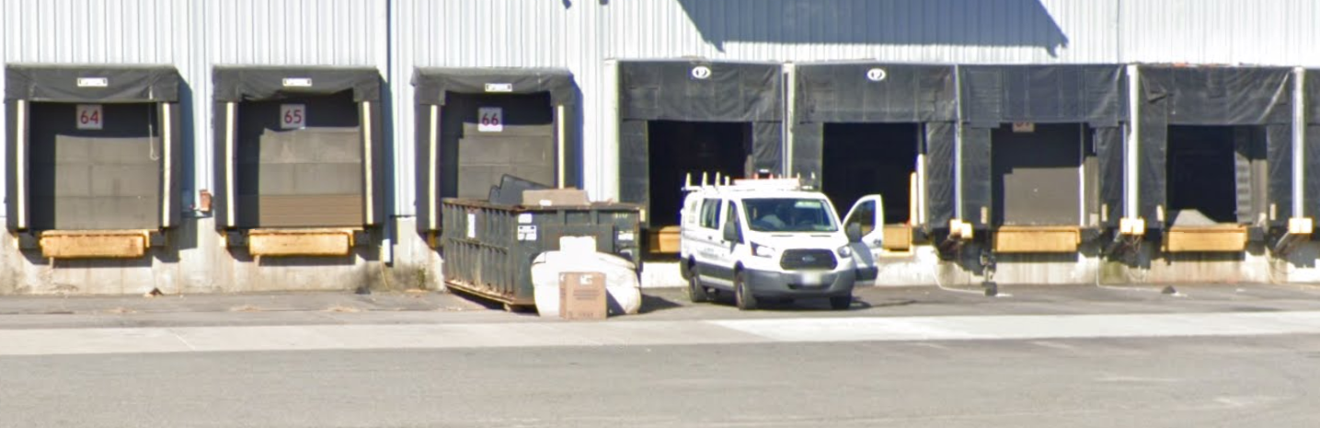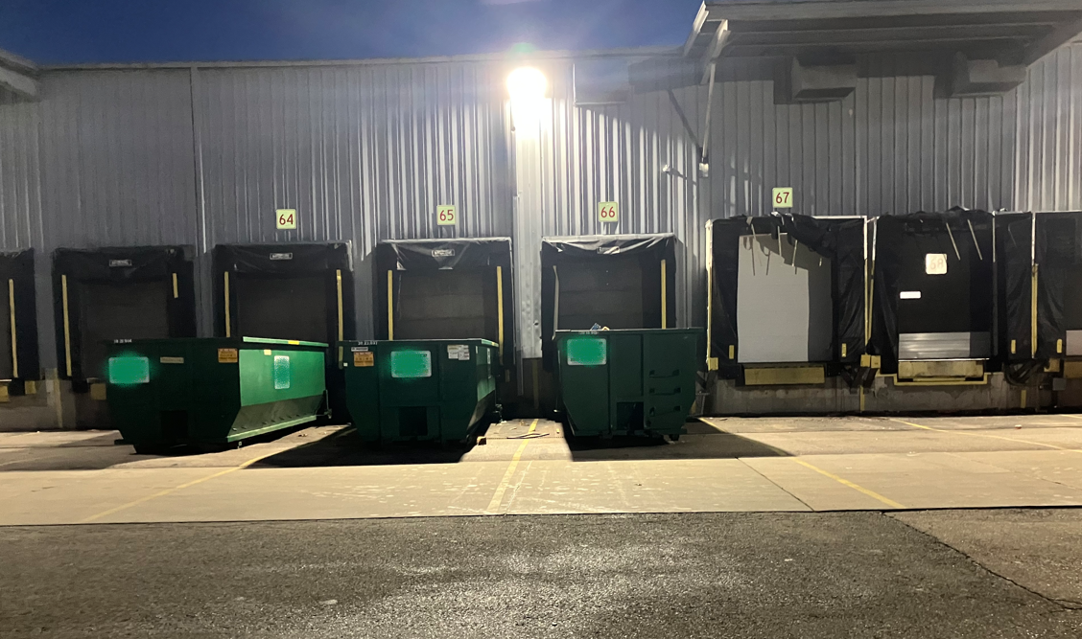

**Image 5 & 6. Loading docks and dumpster. (Photo taken by MA FACE and courtesy of Google, respectively.)**

WEATHER

The weather at the time of the incident was approximately 41 degrees Fahrenheit, 93% humidity, 15 miles per hour East-Northeast wind, and light rain [[Weather Underground](https://www.wunderground.com/history/daily/KPVD/date/2022-12-16)]. The dash cam video of the incident and observations of responding officers suggest it was raining heavily at the time of the incident. The weather is believed to have been a factor in this incident because it may have contributed to poor visibility and may have caused distractions. The droplets and puddles created by the rain created glare from headlights and overhead lights that were in front of and to the side of the truck, and from lights that were behind the truck. These conditions could have caused the images reflected by the rearview side and corner mirrors to be less clear. Also, the sound of the rain on the truck cab and dumpster and in the lot could have contributed to how audible the truck’s engine, movement, and back-up alarm were.

INVESTIGATION

On December 16, 2022, sunrise was at 7:08 a.m. Therefore, at the time of the incident at approximately 6:30 a.m., it was still relatively dark outside. The only sources of light at the time were from outdoor flood lights attached to the building above the warehouse docks, the headlights of certain vehicles in the parking lot, and the light poles in the area of the parking lot where employees park their cars. With the rainy weather and lighting conditions, the visibility in the vicinity of the truck at the time of the incident was poor.

The waste haul truck was dropping off an empty 30 cubic yard dumpster container at the time. Before the waste haul truck driver reversed, the driver had parked the truck, performed a walk-around of the vehicle, and checked the area for hazards. The truck’s back-up alarm was working at the time of the incident. The driver had made one backing attempt and had pulled forward to adjust the alignment of the dumpster and was backing again. The dumpster and sliding bed were in a raised position such that the dumpster was nearing the pavement for deployment.

The victim arrived at the transfer facility and was heading inside to start his shift. There was no supervisor on site. The victim was wearing over-the-ear headphones and dark clothing with black pants and a black jacket that morning. He was crossing the lot and walking towards the transfer facility building and tried to pass behind a waste haul truck. At approximately 6:30 a.m., the waste haul truck was backing up to the dock and struck the victim as he passed behind the truck. He was struck by the left side of the rear of the dumpster and fell to the ground. The truck backed over the victim and stopped once the victim was visible on the ground in front of the truck.

The local police and fire department were dispatched to the location at 6:32 a.m. Medical treatment began at the site and consisted of CPR performed by other workers at the site and then police and fire personnel continued resuscitation efforts. Treatment continued en route to a local hospital. The victim was pronounced deceased at the hospital.

The approximate walking route of the victim and the approximate positioning of the dumpster truck before and after the collision are shown in Image 7.

A review of the police reports, vehicle inspection reports, and dash cam videos revealed several details to the FACE investigators that identified factors that may have contributed to this event. Two lighting elements on the passenger side rear of the vehicle were not operating. The dash cam video included the two fender mirrors in the view. The victim can be seen in the right side fender mirror as he approached the right side rear of the truck and he eclipsed the lights that are visible in the mirror. It is possible that if the lighting on the right rear of the truck were operating, the victim would have been more visible or the victim would have perceived the truck was moving.

When the truck was backing, the dumpster and the bed were in a raised position. This changed aspects of the lighting on the back of the truck that directly affected the illumination of the area and how visible the lights would be to someone walking near the vehicle. Tilting the bed and dumpster and lowering the dumpster to near the ground changes the surfaces that are illuminated. The dumpster effectively blocks the lights from projecting behind the truck and affects how visible the lights would be from the side or rear of the vehicle.

When the dumpster is raised, a different repeating alarm is activated in the cabin. While the load is raised, that periodic alarm is persistent, regardless of whether the vehicle is in gear or in motion. This is separate from the reverse motion alarm. In one video that investigators reviewed that depicts a similar model truck going through the motions of deploying a dumpster container, the two alarms can be heard outside of the truck and activating independently at different times and also concurrently when the load is raised and the truck is backing. The beeps are different cadences or speeds and at times may line up so as to appear as one alarm.

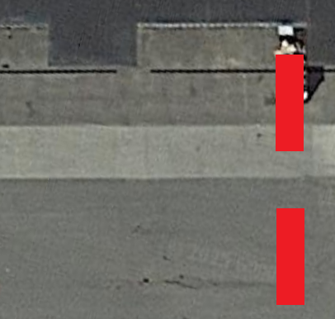

**Image 7. Approximate movement of the backing truck and walking route of the victim. (Photo courtesy of Google.)**

CAUSE OF DEATH

According to the medical examiner, the cause of death was multiple blunt force injuries.

CONTRIBUTING FACTORS

Occupational injuries and fatalities are often the result of one or more contributing factors or key events in a larger sequence of events that ultimately result in the injury or fatality. Massachusetts FACE investigators identified the following unrecognized hazards as key contributing factors in this incident:

* *Inadequate outdoor lighting near moving vehicles and pedestrians*
* *Inadequate designated walkway for pedestrians to walk around moving vehicles*
* *Lack of reflective vests for workers near moving vehicles*
* *Deficient side lighting and rear lighting [and reverse drive motion lighting] that may be obstructed by the tilted dumpster*
* *Inadequate training for site workers on working near moving vehicles*
* *Audible signals that may be obscured by the tilted dumpster or confusing in their meaning*

RECOMMENDATIONS/DISCUSSION

Recommendation #1: Employers should ensure adequate outdoor lighting for areas with moving vehicles and pedestrians walking.

Discussion: First responders at the scene noted that lighting in the area of incident was lacking. The rainy weather and the darkness before sunrise highlighted the issue of inadequate lighting in the loading dock area and the parking lot area. With those external factors, employees, both drivers of vehicles and pedestrians, are affected by poor visibility which increases their risk of struck-by incidents, similar to this case.

The recommendation for outdoor areas with moving vehicles and pedestrians is that employers should ensure the area has adequate illumination. Previously, OSHA has cited the general duty clause after inspection has revealed inadequate lighting of a work space, and recommended following the relevant American National Standards Institute (ANSI) standards for abatement and remediation. There are two such standards that address lighting in the workplace. Both standards were created by the Illuminating Engineering Society of North America (IESNA) and approved by ANSI. One of the standards is the [ANSI/IESNA RP-7-01: Recommended Practice for Lighting Industrial Facilities](https://webstore.ansi.org/preview-pages/IESNA/preview_ANSI+IESNA+RP-7-01.pdf). This standard goes into detail about the types of lighting for specific areas and tasks to satisfy their lighting requirements and luminaire levels. Section 17 outdoor area lighting in this standard describes the difference between projected lighting systems and distributed lighting systems, the advantages of each style, and which lighting system an employer should install in their respective outdoor area. The other lighting standard is the [IES RP-20-14 standard on Lighting for Parking Facilities](https://webstore.ansi.org/preview-pages/IESNA/preview_IES+RP-20-14+(Revised+2016).pdf). This standard goes into detail on the types of parking facilities, the types of light sources and lighting equipment, the light quality and illuminance, as well as maintenance of the lighting. In Part II Parking Lots and Top (Open) Parking Decks of Garages, the standard mentions the importance of considering horizontal illuminance and vertical illuminance and making sure the lighting has good uniformity throughout the parking area. When choosing the equipment for the parking lot, not only should lamp and luminaire type be taken into consideration, but also the size and shape of the area, illuminance requirements, the control of glare, mounting height of luminaire, location requirement of the poles, and effects of spill light. All these factors should be considered when determining where and what type of lighting is used. Employers should use these two standards as guidance in creating safe work environments for employees, especially in areas where workers on foot may interact with moving vehicles. Lighting should also be properly maintained and employers should ensure the lighting equipment is working as intended in order to provide adequate illumination.

Recommendation #2: Employers should ensure there is a clear designated walkway for pedestrians to get between the parking lot and buildings. Conspicuous signs for moving vehicles and pedestrians should be placed near walkways.

Discussion: The victim was struck as he walked near the landing pad area that ran along the warehouse. The configuration of the parking lot and entry doors suggests that any freight truck drivers who back up to a loading dock would gain access to the building by walking in this area. This exposes workers to the hazard of vehicles backing up to park and also vehicles pulling forward to realign with a dock or to depart. The designated walkways for pedestrian workers were inadequate and unclear.

Employers should evaluate traffic patterns in their parking lots and work spaces and designate walkways and crosswalks with painted lines to create spaces that allow employees to safely transit in designated zones. It will be safest if the moving vehicles and pedestrians are separated, either by creating a walkway protected by physical barriers or by creating a route on the perimeter of the driving area. Employers are recommended to discourage employees from walking into high-traffic areas unless at a designated crosswalk. The walkway should be clear and visible for both pedestrians and drivers of moving vehicles. Signs warning pedestrians of moving vehicles and signs emphasizing the drivers of moving vehicles to be aware of pedestrians should be placed near walkways. In times of darkness and low visibility weather, the walkways should still be clear for both pedestrians and drivers. An example of a method to ensure the pedestrian walkway is visible even in undesirable weather and light conditions is to implement an illuminated pathway for the pedestrian. An illuminated pathway can be installed for improved visibility (examples are shown below). Another option is to install more parking lot lights near pedestrian pathways to illuminate the areas.

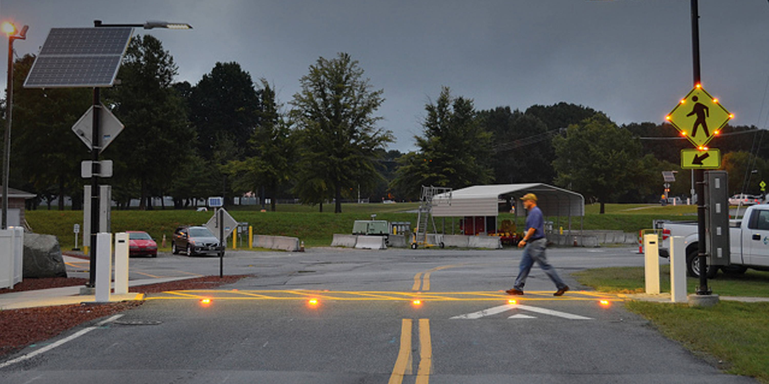

**Image 8 & 9. Examples of illuminated pathways. (Photo courtesy of The Traffic Group and Stockport Council.)**

Recommendation #3: Employers should ensure that employees wear high-visibility personal protective clothing, such as retroreflective vests, when working near moving vehicles.

Discussion: In this case, the worker was not wearing high-visibility personal protective clothing, such as a retroreflective vest. He was on his way to the building to start his work day. Employers should make sure employees wear retroreflective gear, such as vests, when working near moving vehicles in order to increase the visibility of the worker. The [ANSI standard 107-2020: High-Visibility Safety Apparel](https://webstore.ansi.org/standards/isea/ansiisea1072020?source=blog&_gl=1*g66uw0*_gcl_au*MTIxNDkzMTAzNi4xNzQxODc5MzYx) dives into the requirements of high-visibility apparel. The ANSI standard focuses on the design of the apparel, the requirements and performance of the retroreflective materials, and the photometric and physical performance requirements of the retroreflective materials. It also describes the garment types and classes or qualities that should be used based on the work environment and job duties of the worker. Each garment type has its own specific retroreflective material dimension and design, which results in certain visibility characteristics. It is imperative that the employer choose the proper garment type for the expected work environment and risks.

[OSHA standard 1910.132](https://www.osha.gov/laws-regs/regulations/standardnumber/1910/1910.132) states that protective equipment shall be provided, used, and maintained in a sanitary and reliable condition wherever it is necessary by reason of hazards of processes or environment. Employers shall also assess the workplace to determine if the hazards are present and the use of personal protective equipment. For workers whose job duties are around moving vehicles, they are susceptible to the hazards of a struck-by incident. Therefore, the employer is responsible for providing appropriate personal protective equipment to their workers. It is recommended to train the workers on the use of any personal protective equipment, such as retroreflective vests, to ensure proper use and maintenance.

Recommendation #4: Employers should ensure equipment and vehicles are properly maintained.

Discussion: According to the police Driver/Vehicle Examination Report from an inspection on December 16, 2022, the truck had four violations: inoperative turn signal in front, inoperative/ defective hazard warning lamp in front, defective side marker lamp in the rear, and defective clearance lamp in the rear. If these truck lights were operating properly, the lights might have signaled to the victim that the truck was in motion and backing up and thus should not walk behind it.

[Federal Motor Carrier Safety Regulations (FMCSR) standard 49 CFR 393](https://www.ecfr.gov/current/title-49/subtitle-B/chapter-III/subchapter-B/part-393/subpart-B/section-393.9) states that no employer shall operate a commercial motor vehicle unless it is equipped with the parts and accessories necessary for safe operation in accordance to the requirements and specifications in the standard. It includes lamps operable and prohibition of obstructions of lamps and reflectors, reflective devices, and hazard warning signals. Also, [FMCSR standard 49 CFR 396](https://www.ecfr.gov/current/title-49/subtitle-B/chapter-III/subchapter-B/part-396) states that every motor carrier and intermodal equipment provider must systematically inspect, repair, and maintain all motor vehicles subject to its control. The standard mentions that parts and accessories shall be in safe and proper operating condition at all times, including parts and accessories which may affect safety of operation. It is imperative for employers to ensure the safety of their motor vehicles and make sure all parts of them are operating and maintained properly.

Recommendation #5: Employers should train workers on the hazards of working near moving vehicles.

Discussion: [OSHA’s general duty clause](https://www.osha.gov/laws-regs/oshact/section5-duties) states that employers are required to provide training to their employees on hazards present at their jobs and workplaces. It is imperative for employers with workers at transfer facilities and warehouses to train their workers on the hazards of working near moving vehicles and how to prevent struck-by incidents. Training should include the use of personal protective clothing to maintain visibility, the communication methods used between pedestrians and drivers of moving vehicles to coordinate safe movements, the use of designated pedestrian walkways, the awareness of any truck safety features or aspects that relate to pedestrian safety, such as back-up alarms, and vehicle’s blind spot awareness for pedestrians and drivers. All the training should be mindful that there may be moments of low visibility in the work environment during low lighting and inclement weather.

Blind spot awareness training is crucial for both the drivers of the vehicle and the pedestrians who must cross an active truck yard, parking lot, or loading dock. For the pedestrian workers, knowing where the driver of heavy equipment has limited visibility gives the pedestrian knowledge of where they should stand or walk around the vehicle. CDC-NIOSH has a “[Construction Equipment Visibility](https://www.cdc.gov/niosh/motor-vehicle/constructionequipmentvisibilitydiagram/index.html)” resource where they have conducted research on the blind spots of different common heavy equipment vehicles and drafted blind area diagrams. For each vehicle, NIOSH has a diagram representing the operator’s ability to see objects at different elevations: at ground level, at 3 feet, and at 4 ft 11 inches. The 4 ft 11 inches represents the height of a person. NIOSH has conducted diagrams on 2- and 3-axle rear dump trucks, loaders, dozers, and many other types of construction equipment. If an employer does not find their vehicle listed on the website, NIOSH also has a manual on the methods for employers to create their own blind area diagram.

Routine training should be provided to all employees on the program’s topics and procedures, and the training should also include hazard recognition and the avoidance of unsafe conditions. All training provided to employees should be documented. Training ensures that workers know how to safely perform required job tasks. Trainings should be performed by a competent person, which is defined by OSHA as “one who is capable of identifying existing and predictable hazards in the surroundings or working conditions which are unsanitary, hazardous, or dangerous to employees, and who has authorization to take prompt corrective measures to eliminate them.” Any training needs to be provided in the employee’s preferred language. This means the training must be provided in the language(s) and at the literacy level(s) of the employees.

Recommendation #6: Employers working at a shared site should coordinate with each other in conducting a hazard assessment for the site and should collaborate in developing, implementing, and enforcing safety and health programs at a shared site.

Discussion: This incident highlighted a workplace where employees from several different employers intersected. Multi-employer worksites exist in a wide variety of industry sectors. Keeping all employers and employees at a site informed on health and safety protocols is crucial in maintaining worker safety.

Ensuring the health and safety of employees on multi-employer worksites requires diligent oversight on all supervisory levels. The employers should collectively develop, implement, and enforce safety programs. A collaborative, proactive approach to site safety will help ensure the health and safety of all employees.

It is each employer’s responsibility to implement safety precautions to protect all parties present on a site. This includes the discovery of hazardous conditions, the periodic inspection of the worksite, and the installation or maintenance of safety equipment. At multi-employer worksites, OSHA may cite more than one employer for a hazardous condition that violates an OSHA standard. Employers should communicate with each other so that they are aligned on the health and safety trainings for their respective employees. They should also coordinate emergency response procedures. When multiple employers share a worksite, employees of different employers need to work alongside each other and proactive inter-employer collaboration on health and safety is necessary to keep all workers at the site safe by collectively develop, implement, and enforce safety programs.

When developing a safety and health program, employers should start by performing a general hazard analysis of tasks routinely performed by employees. Those findings should be incorporated into the comprehensive program. Employers should also use their employees’ expertise throughout the program development process, and eventually during the updating process, by seeking employee input. Once the program is developed, employers should ensure that they have fully and effectively implemented their safety and health program by routinely performing assessments of tasks and immediately addressing any observed unsafe conditions. The program should also be updated when safety concerns arise and when new equipment or processes are introduced into the workplace.

The Massachusetts Department of Labor Standards (DLS) offers free consultation services to help small employers improve their safety and health programs, identify hazards, and train employees in MA. DLS can be contacted at 508-616-0461. More information about DLS can be found on their website at [mass.gov/dos/consult](https://mass.gov/dos/consult).

The Massachusetts Department of Industrial Accidents (DIA) has grants available for providing workplace health and safety training to employers and employees in MA. Any company covered by the Massachusetts Workers’ Compensation Insurance Law is eligible to apply for these [grants](http://www.mass.gov/dia/safety).

Recommendation #7: Employers and manufacturers should assess safety features of motor vehicles and equipment when they are in use and ensure that the core function of each safety feature is maintained.

Discussion: Motor vehicles and equipment have safety features such as lighting and audible signals that maintain visibility and alert bystanders to vehicle motions, equipment functions, and potential hazards. Some of these features are required for roadway operation and motor vehicle movement, such as the required lighting on the exterior of the truck and the reverse motion audible alarm. Other features are related to the specialized function of the equipment, such as an audible alarm to indicate a dumpster elevator is in motion. Any safety features should be assessed while the vehicle or equipment is in use in its final configuration to ensure each feature is properly working. In this situation, it is important to make sure the reverse motion lights and alarm are still effective when the truck is backing with the dumpster in a raised position for deployment. A review of the configuration of this truck found that the dumpster blocks the lights on the back of the truck. Similarly, the back up alarm may be less audible because of the sound of the vehicle’s engine while raising or lowering the dumpster. These safety controls would not be as effective in preventing back over incidents if they are blocked by the dumpster. Employers and manufacturers should work together to understand how these features could be reconfigured or repositioned to maintain their effectiveness.

Virgina’s OSHA-approved state plan that covers private workplaces has a standard, [16VAC25-97-10](https://www.doli.virginia.gov/wp-content/uploads/2018/05/3-Regulation-Text-SS-1.pdf), that specifically focuses on reverse signal operation safety requirements for motor vehicles and equipment in both the general industry and the construction industry. The standard specifies that no employer shall operate any covered vehicles, which include all general industry and construction industry vehicles, machinery, or equipment capable of operating in reverse and with an obstructed view to the rear, in reverse unless the covered vehicle has a reverse signal alarm audible above the surrounding noise level and the covered vehicle is operated in reverse only when a designated observer or ground guide signals that it is safe to do so. If the reverse signal alarm is not above the surrounding noise level and there isn’t a designated observer or ground guide to signal it’s safe to reverse, then the driver has to visually determine that no employee is in the path of the covered vehicle before operating it in reverse.

ADDITIONAL RESOURCES

ANSI/IESNA [2001]. [ANSI/IESNA RP-7-01 Recommended Practice for Lighting Industrial Facilities](https://webstore.ansi.org/preview-pages/IESNA/preview_ANSI+IESNA+RP-7-01.pdf). Illuminating Engineering Society of North America.

IES [2016]. [IES RP-20-14 Lighting for Parking Facilities](https://webstore.ansi.org/preview-pages/IESNA/preview_IES+RP-20-14+(Revised+2016).pdf). Illuminating Engineering Society of North America.

CDC-NIOSH [2024]. [Construction Equipment Visibility](https://www.cdc.gov/niosh/motor-vehicle/constructionequipmentvisibilitydiagram/index.html). National Institute For Occupational Safey and Health, Motor Vehicle Safey at Work.

DLS [2025]. [On-Site Consultation Program](https://www.mass.gov/on-site-consultation-program). Commonwealth of Massachusetts, Executive Office of Labor and Workforce Development, Department of Labor Standards.

DIA [2025]. [Workplace Safety Grant Program](https://www.mass.gov/workplace-safety-grant-program). Commonwealth of Massachusetts, Department of Industrial Accidents.

DISCLAIMER

Mention of any company or product does not constitute endorsement by Massachusetts FACE and the National Institute for Occupational Safety and Health (NIOSH). In addition, citations to websites external to Massachusetts FACE and NIOSH do not constitute Massachusetts FACE and NIOSH endorsement of the sponsoring organizations or their programs or products. Furthermore, Massachusetts FACE and NIOSH are not responsible for the content of these websites. All web addresses referenced in this document were accessible as of the publication date.

REFERENCES

Weather Underground [2025]. [Warwick, RI Weather History](https://www.wunderground.com/history/daily/us/ri/warwick/KPVD/date/2022-12-16). TWC Product and Technology LLC.

ANSI/IESNA [2001]. [ANSI/IESNA RP-7-01 Recommended Practice for Lighting Industrial Facilities](https://webstore.ansi.org/preview-pages/IESNA/preview_ANSI+IESNA+RP-7-01.pdf). Illuminating Engineering Society of North America.

IES [2016]. [IES RP-20-14 Lighting for Parking Facilities](https://webstore.ansi.org/preview-pages/IESNA/preview_IES+RP-20-14+(Revised+2016).pdf). Illuminating Engineering Society of North America.

ANSI [2020]. [ANSI/ISEA 107-2020: High-Visibility Safety Apparel](https://blog.ansi.org/2020/10/ansi-isea-107-2020-high-visibility-apparel/). American National Standards Institute.

3M [2020]. [ANSI/ISEA 107-2020 Made Easier: A Quick Reference to the High-Visibility Safety Apparel Standard Technical Bulletin](https://multimedia.3m.com/mws/media/638577O/ansi-107-2020-made-easier-high-visibility-apparel.pdf). 3M Personal Safety Division.

OSHA [2025]. [OSHA 1910.132- General Requirements](https://www.osha.gov/laws-regs/regulations/standardnumber/1910/1910.132). U.S. Department of Labor, Occupational Safety and Health Administration.

FMCSA [2025]. [FMCSA Regulations and Interpretations – 49 CFR Parts 300-399](https://www.fmcsa.dot.gov/regulations/search). United States Department of Transportation, Federal Motor Carrier Safety Administration.

eCFR [2025]. [Title 49 CFR Subtitle B Chapter III Subchapter B Part 393- Parts and Accessories Necessary for Safe Operation.](https://www.ecfr.gov/current/title-49/subtitle-B/chapter-III/subchapter-B/part-393/subpart-B/section-393.9) National Archives Code of Federal Regulations.

eCFR [2025]. [Title 49 CFR Subtitle B Chapter III Subchapter B Part 393 Subpart B §393.9 Lamps operable, prohibition of obstructions of lamps and reflectors](https://www.ecfr.gov/current/title-49/subtitle-B/chapter-III/subchapter-B/part-393/subpart-B/section-393.9). National Archives, Code of Federal Regulations.

eCFR [2025]. [Title 49 CFR Subtitle B Chapter III Subchapter B Part 396- Inspection, Repair, and Maintenance](https://www.ecfr.gov/current/title-49/subtitle-B/chapter-III/subchapter-B/part-396). National Archives, Code of Federal Regulations.

OSHA [2025]. [OSH Act of 1970 General Duty Clause SEC. 5. Duties](https://www.osha.gov/laws-regs/oshact/section5-duties). U.S. Department of Labor, Occupational Safety and Health Administration.

CDC-NIOSH [2024]. [Construction Equipment Visibility](https://www.cdc.gov/niosh/motor-vehicle/constructionequipmentvisibilitydiagram/index.html). National Institute For Occupational Safey and Health, Motor Vehicle Safey at Work.

OSHA [1999]. [Multi-Employer Citation Policy](https://www.osha.gov/enforcement/directives/cpl-02-00-124). U.S. Department of Labor, Occupational Safety and Health Administration.

Virginia DOL [2009]. [Reverse Signal Operation Safety Requirements for Motor Vehicles, Machinery and Equipment in General Industry & the Construction Industry](https://www.doli.virginia.gov/wp-content/uploads/2018/05/3-Regulation-Text-SS-1.pdf). Virginia Department of Labor and Industry.