Massachusetts Department of Public Health

Artificial Turf Fields

Environmental Health Fact Sheet *(Updated 12/19/2024)*

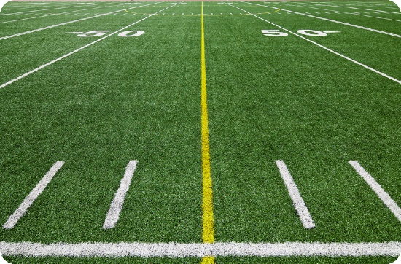An artificial turf field (ATF) is a popular alternative to natural grass. While ATFs are most commonly used outdoors, they have also been installed in many indoor facilities. In recent years, people have raised health concerns about the safety of ATFs, especially regarding potential exposure to chemicals found in the components. This fact sheet informs people about the components of artificial turf fields and ways to use them more safely.

# What are ATFs made of?

Artificial turf fields typically include three layers – padding and backing material at the bottom, infill in the center, and artificial grass blades on top. The grass blades are plastic. The infill layer typically contains crumb rubber from recycled car and truck tires. Infill is often composed exclusively of crumb rubber or a mixture of crumb rubber and sand. Less frequently, infill materials can be entirely plant-based. The sand helps to stabilize the field, while the crumb rubber cushions the surface and keeps the grass blades upright.

# What chemicals are in ATFs?

Tire manufacturing utilizes many natural and artificial substances, some of which are present in crumb rubber infill. These include volatile organic compounds (VOCs), semi-VOCs (SVOCs) such as polycyclic aromatic hydrocarbons (PAHs), and metals such as lead. Per- and polyfluoroalkyl substances (PFAS) have been found in some ATF components.

# Can I be exposed to chemicals while using ATFs?

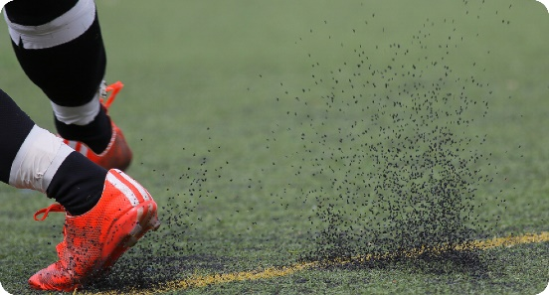There are several ways to be exposed to the chemicals in crumb rubber:

* Breathing in volatile chemicals or dust particles generated from the crumb rubber.
* Swallowing small amounts of crumb rubber while playing on the fields or after playing from unwashed hands.
* Skin contacts with crumb rubber.

A 2019 study by the U.S. Environmental Protection Agency (EPA), the Centers for Disease Control and Prevention (CDC), and the Consumer Product Safety Commission estimates that exposure to chemicals in crumb rubber is likely to be low. For metals like lead, the study found that only a tiny fraction of the metals in crumb rubber would be absorbed if accidentally swallowed. Exposure to VOCs and SVOCs is limited because only small amounts are released into the air, which field users might breathe in. However, concentrations may be higher in air at indoor ATFs than outdoor ATFs. To date, no studies have evaluated PFAS exposure among ATF users.[1]

Follow the tips provided in this factsheet for safer use of ATFs, and to minimize potential exposure to chemicals that may be present in ATFs.

# Can exposure to chemicals in ATFs affect my health?

To date, scientific research mostly concludes that adverse health effects from exposure to chemicals while using ATFs are unlikely. It is important to note that no studies have specifically evaluated whether there is a relationship between disease outcomes and exposure to crumb rubber in ATFs.

A 2024 biomonitoring study by the U.S. EPA, CDC, and Consumer Product Safety Commission measured levels of chemicals in blood and urine samples from study participants using ATFs and natural grass fields. Blood levels of metals after using ATFs were similar to those in the general population, and urine levels of PAH metabolites did not differ among participants using natural grass fields or ATFs.[2]

At sufficiently high exposures, such as in manufacturing settings, the chemicals found in crumb rubber can cause irritation of the eyes, nose, throat, and skin, as well as headaches, nausea, and even organ damage. Some PAHs may also increase the risk of developing cancer if individuals are exposed to very high concentrations over long periods of time.

Many factors determine whether exposure to chemicals through ATF usage can affect health. Factors include exposure amount, frequency, duration, chemical absorption, and individual sensitivity; for example, children are generally more sensitive than adults.

# Can using ATFs on hot days increase my risk for heat-related injury and illness?

Outdoor ATFs can reach higher surface temperatures than natural grass fields on hot days, regardless of the type of ATF infill used. Higher surface temperatures can lead to heat-related injuries, such as burns, blisters, and heat stress.[3] [4] [5]

ATF users should limit use on particularly hot days and take water breaks every 20 minutes. People should monitor ATF surface temperatures using an infrared thermometer and use natural grass field alternatives if ATF surface temperatures exceed 120°F.

# Can I be exposed to lead when playing on ATFs?

Lead has been detected in the crumb rubber of some ATFs. In the 2019 federal study, researchers tested crumb rubber from nine tire recycling facilities and 40 ATFs nationwide. While lead was consistently detected, the researchers determined that if a person accidentally swallowed crumb rubber, only a small amount of lead would be available in the swallowed material for the body to absorb.1

Because the study only evaluated tire crumb rubber, lead may be present in and released from other components (e.g., grass blades) of ATFs. The construction of some ATFs includes certified components with low or no lead content. Using ATFs with this certification can help minimize exposure to lead.

While everyone is exposed to small amounts of lead in their daily life, young children, infants, and pregnant people are most vulnerable to the effects of lead exposure.

Follow the tips provided in this factsheet for safer use of ATFs, and to minimize potential exposure to chemicals that may be present in ATFs.

# Can using ATFs increase my risk for bacterial infections?

Some studies have measured the levels of bacteria on surfaces of different types of athletic fields. Very limited research has found fewer bacteria in ATFs than in soil. The 2019 federal study reported that indoor ATFs have fewer bacteria than outdoor ATFs. However, many factors (e.g., presence of bacteria, moisture, and temperature) influence the risk of bacterial infections following the use of any athletic surface. The frequency and severity of skin abrasions can also affect the risk of infection.1 5 [6] California’s Environmental Protection Agency reported that athletes experience more frequent turf burns (i.e., skin abrasions) on ATFs than on natural fields.[7] Overall, practicing good hygiene is the best way to prevent getting and spreading infections. Washing skin abrasions with soap and water can decrease the risk of bacterial infections.

# Does DPH support the use of ATFs?

DPH does not endorse any consumer product, including ATFs. The purpose of this fact sheet is to summarize currently available information and offer suggestions for ways to minimize possible exposure to potentially harmful chemicals during the use of ATFs.

# Are there tips for safer use of ATFs?

Here are some steps to minimize potential exposure to potentially harmful chemicals in ATFs:

*While playing on ATF:*

* Always wear shoes.
* Do not swallow any crumb rubber that accidentally enters the mouth. Monitor young children to prevent swallowing.
* If playing indoors, take steps to increase ventilation if possible (e.g., open windows/doors, turn on fans).
* Be aware that crumb rubber absorbs heat, which can increase the surface temperature of ATF and lead to heat-related illness.
* Minimize passive recreation (e.g., laying, sitting).

*After playing on ATF:*

* Wash hands after use and before eating (especially young children).
* Clean all clothing and equipment used on ATF.
* Take off shoes before entering the house to prevent tracking in any crumb rubber.
* Clean all turf burns with soap and water.

# Who can I contact to learn more?

Specialists at the Massachusetts Department of Public Health, Bureau of Climate and Environmental Health, are available to answer your questions.

Contact us at 617-624-5757 (TTY: 617-624-5286) or visit us at:   
[Bureau of Climate and Environmental Health | Mass.gov](https://www.mass.gov/orgs/bureau-of-climate-and-environmental-health)

# Resources

1. U.S. EPA & CDC/ATSDR. (July 2019). “Synthetic Turf Field Recycled Tire Crumb Rubber Research Under the Federal Research Action Plan Final Report: Part 1 - Tire Crumb Characterization (Volume 1)”. (EPA/600/R-19/051). U.S. Environmental Protection Agency, Centers for Disease Control and Prevention/Agency for Toxic Substances and Disease Registry. Available at: <https://www.epa.gov/chemical-research/federal-research-recycled-tire-crumb-used-playing-fields-and-playgrounds> (Accessed: June 2020)
2. U.S. EPA & CDC/ATSDR. (April 2024). Synthetic Turf Field Recycled Tire Crumb Rubber Research Under the Federal Research Action Plan Final Report: Part 2 - Exposure Characterization (Volume 2). (EPA/600/R-24/020). U.S. Environmental Protection Agency, Centers for Disease Control and Prevention/Agency for Toxic Substances and Disease Registry. Available at: <https://www.epa.gov/chemical-research/federal-research-recycled-tire-crumb-used-playing-fields-and-playgrounds> (Accessed: June 2024)
3. Myrick, Sonia. “Synthetic Sports Fields and the Heat Island Effect.” The National Recreation and Parks Association. (May 8, 2019). Available at: <https://www.nrpa.org/parks-recreation-magazine/2019/may/synthetic-sports-fields-and-the-heat-island-effect/> (Accessed: November 2024)
4. Toxics Use Reduction Institute (TURI). “Athletic Playing Fields and Artificial Turf: Considerations for Municipalities and Institutions.” (August 2020) Available at: [turi.org/publications/artificial-turf/](https://www.turi.org/publications/artificial-turf/) (Accessed: November 2024)
5. TURI. “Sports Turf Alternatives Assessment: Preliminary Results.” (November 2016). Available at: <https://www.turi.org/publications/physical-and-biological-hazards-artificial-turf/> (Accessed: November 2024)
6. Department of Energy and Environment (DOEE) and Department of Health (DOH). A Study on the Safety of Synthetic Materials Currently Used in Construction at District Public Recreational Spaces (per the DC ‘Safe Fields and Playgrounds Act of 2018’). (October 2022). Available at: <https://fieldturf.com/workspace/uploads/files/rc24-0234-introduction-002.pdf> (Accessed: November 2024)
7. California Office of Environmental Health Hazard Assessment. 2010. Safety Study of Artificial Turf Containing Crumb Rubber Infill Made from Recycled Tires: Measurements of Chemicals and Particulates in the Air, Bacteria in the Turf, and Skin Abrasions Caused by Contact with the Surface. OEHHA, Pesticide and Environmental Toxicology Branch, Funded by the Department of Resources Recycling and Recovery. October 2010. Available at: <https://www2.calrecycle.ca.gov/Publications/Details/1360>.