**FAQ**

**Transportation to COVID-19 Vaccine Appointments for MassHealth Members and Health Safety Net Patients**

**February 2021**

**Who can get help with transportation to COVID-19 vaccine appointments through MassHealth?**

If you have a scheduled COVID-19 vaccine appointment and are a MassHealth member or Health Safety Net patient, you may receive authorization (PT-1) for “Curb to Curb” transportation services to/from your vaccine appointment.

**I have MassHealth Limited, MassHealth Family Assistance, the Children’s Medical Security Plan, or the Health Safety Net. Can I still get help with transportation to my vaccine appointment?**

Yes. Even though people with MassHealth Limited, MassHealth Family Assistance, the Children’s Medical Security Plan, or the Health Safety Net usually aren’t able to get transportation to medical appointments through MassHealth, they CAN get transportation to COVID-19 vaccine appointments through MassHealth.

Members with MassHealth Standard, CommonHealth and CarePlus can also get transportation to vaccine appointments, as well as to other medical appointments, through MassHealth.

**How do you request help with transportation to your COVID vaccine appointment?**

If you are enrolled in a Senior Care Options or One Care plan or in a Program of All-Inclusive Care for the Elderly (PACE), you should contact your health plan or PACE provider to request help with transportation.

All other MassHealth members and Health Safety Net patients need to get approval from MassHealth, and then you will book your ride with a local transportation broker, who will send a driver to pick you up for your appointment and return you home.

If you normally get help with transportation to doctor’s appointments, the most common and fastest way to get approval is to contact your health care provider and have them submit a transportation request for you.

Otherwise, you can **call the MassHealth Customer Service Center at (800) 841-2900; TTY: (800) 497-4648).** When you call, follow the prompts for “transportation to a vaccine appointment” until you are connected with a representative who will help you request transportation.

**What information will you need to provide when requesting transportation to your vaccine appointment?**

You will need to know:

* Your MassHealth ID number;
* The location of your vaccine appointment;
* The date and time of your appointment;
* Where you want to be picked up by the driver; and
* A phone number and/or email address where the driver can reach you.

**What is your “PT-1 number” and who will give you the number?**

Your “PT-1 number” is an assigned reference number that is needed to book your ride with the transportation broker. When you call Customer Service to get approval for transportation to your vaccine appointment, your request is assigned a PT-1 reference number. Customer Service will give you this number once your request is completed, and you should keep it on hand when you schedule your transportation to your appointment.

**Once your request for transportation is approved, how do you book your trip?**

Once you or your provider has requested transportation for your vaccine appointment, wait one business day to be sure your local transportation broker has received the request. Then you should contact your local transportation broker to schedule your trip. If possible, please call the broker to schedule your ride at least three days before your vaccine appointment.

There are six brokers who provide transportation services to different regions across Massachusetts. When you call, please have your PT-1 number ready to speed up the scheduling process.

Please see below for a map of the transportation broker regions and phone numbers for the broker in your area:

* [MART](http://www.mrta.us/masshealth/transportation-provider) – Greater Boston, Central Mass, Pioneer Valley (800) 854-9928
* [GATRA](https://www.gatra.org/human-services-transportation/) – Southeastern Mass (800) 431-1713
* [CCRTA](http://capecodrta.org/about-us.htm) – Cape and Islands (800) 352-7155; option 3
* [BRTA](http://berkshirerta.com/humantran.php) – Berkshire County (800) 292-2782; option 2
* [FRTA](http://frta.org/) – Franklin County (888) 301-2262; option 0
* [CATA](http://www.canntran.com/contact.cfm) – Cape Ann and Merrimack Valley (800) 830-5191

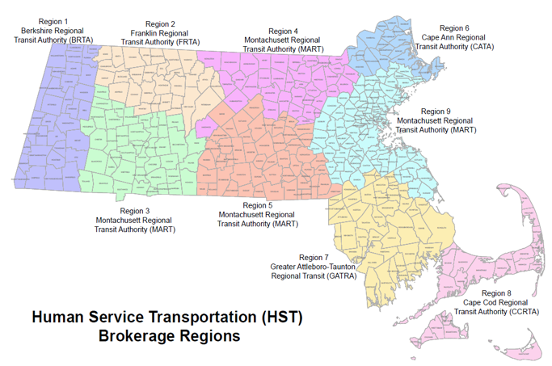

**What if your vaccine appointment is scheduled for tomorrow and you haven’t requested transportation through MassHealth yet?**

You should promptly call CSC, (800) 841-2900 (available Monday through Friday), to initiate the PT-1 as soon as possible. Once you have an active PT-1, you can call the broker to see if they can accommodate an urgent request for the next day. If you cannot get your own transportation, outside of PT-1, for the next day need, you should communicate with your vaccination site as soon as you can to see if they can reschedule your vaccine appointment. Your PT-1 will remain active for future vaccine appointments.

**How will you know when the driver is there?**

You should be ready for your trip, and by the curb for pickup approximately 10 to 15 minutes before your scheduled pickup time. The driver assigned to your trip will be in direct contact with you to coordinate the pick-up. If you do not see your driver within 20 minutes, contact the transportation broker immediately to confirm that they are on the way.

**What happens if your ride does not show up?**

If your assigned ride does not show up, contact the transportation broker you scheduled your ride with as soon as possible to notify them of the situation, and they can try to get another driver to pick you up.

If the broker is not able to get another driver to pick you up, contact your vaccine site as soon as possible to reschedule. You will not have to request a new transportation approval from MassHealth for your rescheduled appointment.

**Will your ride wait for you while you get the vaccine? Or will you have to call for a different driver?**

When you call to schedule your ride, you will also schedule your return trip. Typically, vaccine appointments take 30-60 minutes, so we suggest you book your return trip for one hour after your appointment time. Your driver will wait up to 15 minutes after your scheduled pickup in case your appointment takes longer than expected. However, if your appointment takes longer than expected and your driver has left, you will need to call the transportation broker to make a “will call” request. The transportation broker will send a driver to you within the next hour.

**How do you schedule a trip to get your second dose of the vaccine?**

As soon as you have the date and time of your second dose appointment, you should call your transportation broker to schedule your transportation as soon as possible. Most vaccine sites are scheduling second doses during the first dose appointment.

You do **not** need to request a second approval from MassHealth for transportation for your second dose; your approval will work for both round trips.

**What if your appointment is canceled?**

If your appointment is canceled or needs to be rescheduled, you should contact your transportation broker as soon as possible. If you know of the rescheduled time and date, you can reschedule your ride at the same time.

**Can you get transportation if your appointment is on a weekend?**

Yes. You need to request your approval for transportation on a weekday (Monday-Friday), but transportation is available for weekend vaccine appointments.

**Are there any rules about how close or far away you have to live from the vaccine site to get transportation?**

MassHealth has waived all distance limits for transportation to vaccine appointments. You can get transportation to any vaccine site, even if it is close or far away from your home.

**Can someone ride with you to help you with your vaccine appointment?**

Yes. Someone can go with you to your appointment if you need help getting from the car into the vaccine site, or if you need help during your appointment (for example, because of a disability, hearing or vision impairment). If the person who is helping you is unable to provide transportation for you, then they can ride with you on a trip arranged through MassHealth.

Please note that the person helping you may be able to get their vaccine at the same time **if** you are over age 75, you are getting your vaccine at a mass vaccination site, AND the person helping you makes an appointment in advance.