Daily Procedure for Monitoring Temperatures Using Fridge-Tag®2L |  |  |  | 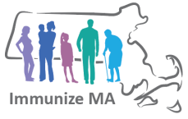
Massachusetts Department of Public Health, Immunization Division
Please follow the procedures below for daily temperature monitoring using the Fridge-Tag®2L:  - In the morning, look at data logger display to view the current temperature and check for “ALARMS” (“X” or “ ! “).  - Press the “READ” button on the display to view the maximum (warmest) temperature since midnight.  - Press the “READ” button on the display a second time to view the minimum (coldest) temperature since midnight.  - Finally, press the “READ” button on the display two more times. The first time you press “READ” will display the warmest temperature from the previous day. The second time will display the coldest temperature from the previous day.*  *By performing this step you would see if the temperature went out of range after you closed the previous day and before midnight. |  | Upload temperature log into the MIIS and call the Vaccine Management Unit immediately at 617-983-6828 under the following conditions:  Refrigerator
If the current or minimum temperature is colder than 2°C (or 35°F) for 15 minutes or more.
If the current or maximum temperature is warmer than 8°C (or 46°F) for 30 minutes or more.
 |  | Freezer
 |  |  | If the current or maximum temperature is warmer than -15°C (or 5°F) for 60 minutes or more.
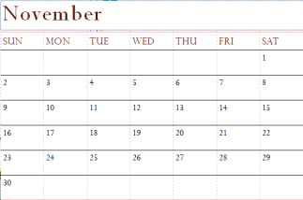
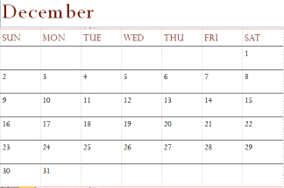
Procedure for Submitting Fridge-Tag®2L Data Logger Reports
Temperature logs must be uploaded into the MIIS monthly even if you are not placing a vaccine order.
Uploading the temperature logs monthly into the MIIS fulfills the CDC requirement to maintain temperature logs for 3 years
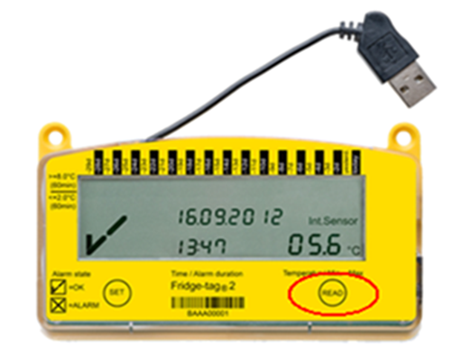
Repeat steps 1-3 above in the afternoon or at closing. By pressing the “READ” button in the morning and afternoon, “AM” and “PM” will print under the Event column on the data logger report. This will fulfill the CDC requirement to monitor the temperature twice daily.
 | NOTE: Failure to perform these steps could result in missed temperature excursions, potentially leading to the need for revaccination of children in practice and potentially delaying your vaccine order.
Vaccine Management Unit | Phone: 617-983-6828|Fax: 617-983-6924| email: dph-vaccine-management@massmail.state.ma.us

