September 8, 2021

Lara Szent-Gyorgyi, MPA
Director, Determination of Need Program Department of Public Health
250 Washington Street
Boston, MA 02108

Re: Determination of Need Application (BCH-21071411-HE) Registration of Ten Taxpayer Group (“TTG”)

Dear Director Szent-Gyorgyi:

We, the undersigned, write pursuant to the provisions of 105 CMR 100.100 to formerly register as a Ten Taxpayer Group relative to The Children’s Medical Center Corporation determination of need application for a substantial capital expenditure, ambulatory surgery, and DoN Required Equipment.

Our group (formally named the “Friends of Boston Children’s Hospital”) are all residents of the Commonwealth of Massachusetts and pay taxes within the Commonwealth. We hereby request recognition as a Ten Taxpayer Group along with the rights associated with such a designation including notice concerning, and participation in, the review of the above-captioned Determination of Need ("DoN") Application filed with the Department of Public Health on July 15, 2021.

We have discussed the DoN with the Applicant. We are not acting as an agent for the Applicant or another party.

The taxpayer designated to receive all written correspondence relative to the above-captioned DoN Application on behalf of the Ten Taxpayer Group is Aimee Williamson (contact information listed below).

Respectfully submitted by:

- Name: Aimee L. Williamson, Ph.D. Address:

Email: aimeewilliamson@comcast.net Signature:
- Name: Kira Astrida Dies Address:

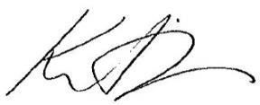
Signature:
- Name: William Lorenzen Address:

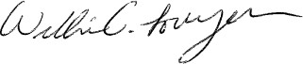
Signature:
- Name: Stephenie Schauberger Address:

Signature: 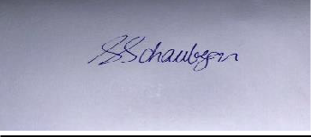

- Name: Daniel J. Holleran Address:

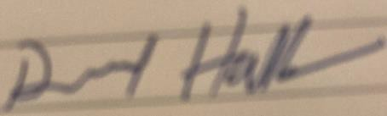
Signature:

- Name: Lisa Burgess Address:

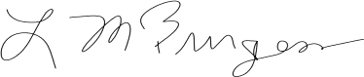
Signature:
- Name: Kathryn E Sullivan Address:
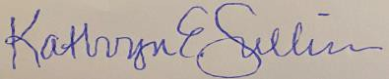

Signature:

- Name: Susanne Smart Address:

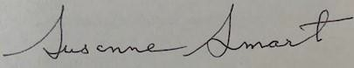
Signature:
- Name: Sylvia Lewinstein, MPA Address:

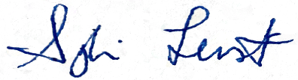
Signature:
- Name: Amy Zimbone Address:

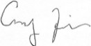
Signature:
- Name: Laura Lynch Address:

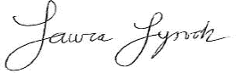
Signature:

