When submitting documentation (Section 10) as part of your FY27 FSIG online application, ensure that all required documents are fully attached. A green circle with a white checkmark will appear to confirm a successful upload. Please note that it may take several minutes for documents to attach correctly. See examples below.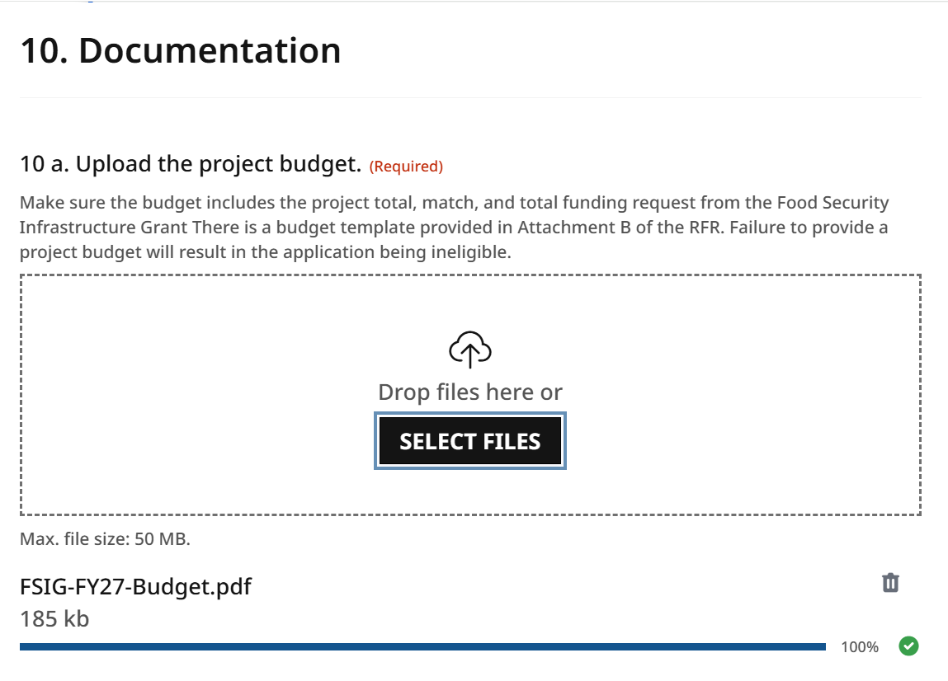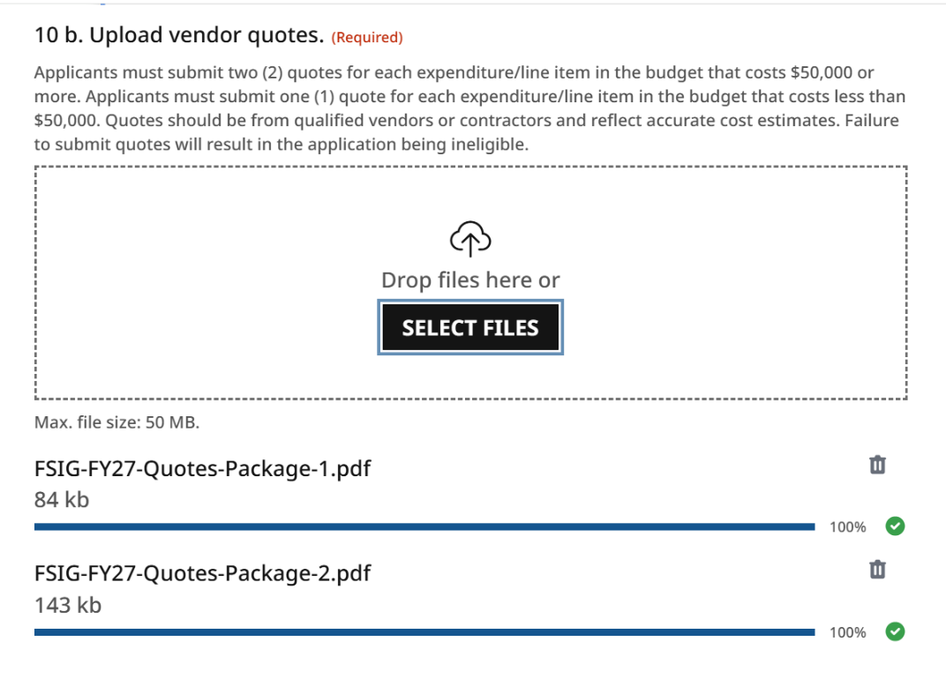
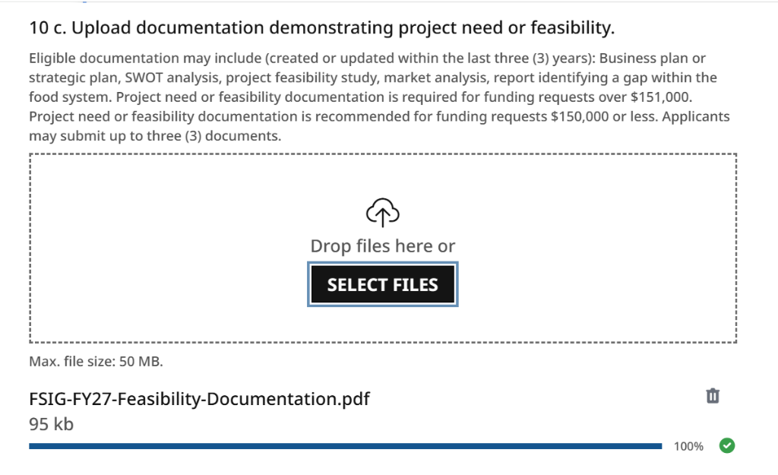
After successfully submitting your FY27 FSIG application, a copy will be sent to the email address provided in the application. In this email, under “10. Documentation,” you will find a list of the document titles that were successfully submitted (see example below). Please note that file links are not accessible—file names are included for confirmation purposes only.
