T H E F U L L F R A M E I N I T I A T I V E

CHANGE THE FOCUS. CHANGE LIVES. CHANGE OUR NATION.

What if there was a way to permanently disrupt cycles of poverty, violence, trauma, and oppression in the United States? Could showing that meaningful change is possible for those who face the steepest odds spark a chain reaction and ultimately upend inequities that hold back individuals and society as a whole? The Full Frame Initiative’s (FFI) answer is a resounding yes.
Catalyzing these transformations is FFI’s reason for being. For nearly a decade, we have partnered with pioneering organizations, systems, and communities across the country to fundamentally shift their focus from fixing piecemeal problems to fostering people’s wellbeing—the needs and experiences essential for health and hope.

With each new partnership, FFI is showing what can happen for families, communities, and this country when the starting place is wellbeing. Through our work, we’re building toward the tipping point when change at every level becomes self-seeding, and lights the way to greater equity and justice.

Here’s what FFI confronts.

Tradeoffs and Stopgap Fixes
Pick up a newspaper anywhere in America today: the headlines may vary, but the story behind the stories is the same. People struggling with poverty, homelessness, crime, domestic violence, and more. Discrimination based on race, national origin, gender identity, sexual orientation, ability, or other identities.

Keep reading, and you’ll see the proposed solutions are remarkably similar, too. People need more services.
Systems need more money. Yet those who face the most challenges are often forced to make tradeoffs that offer a short-term fix to one problem at the expense of the strengths that can help them thrive in the long-term. One step forward results in many steps back.

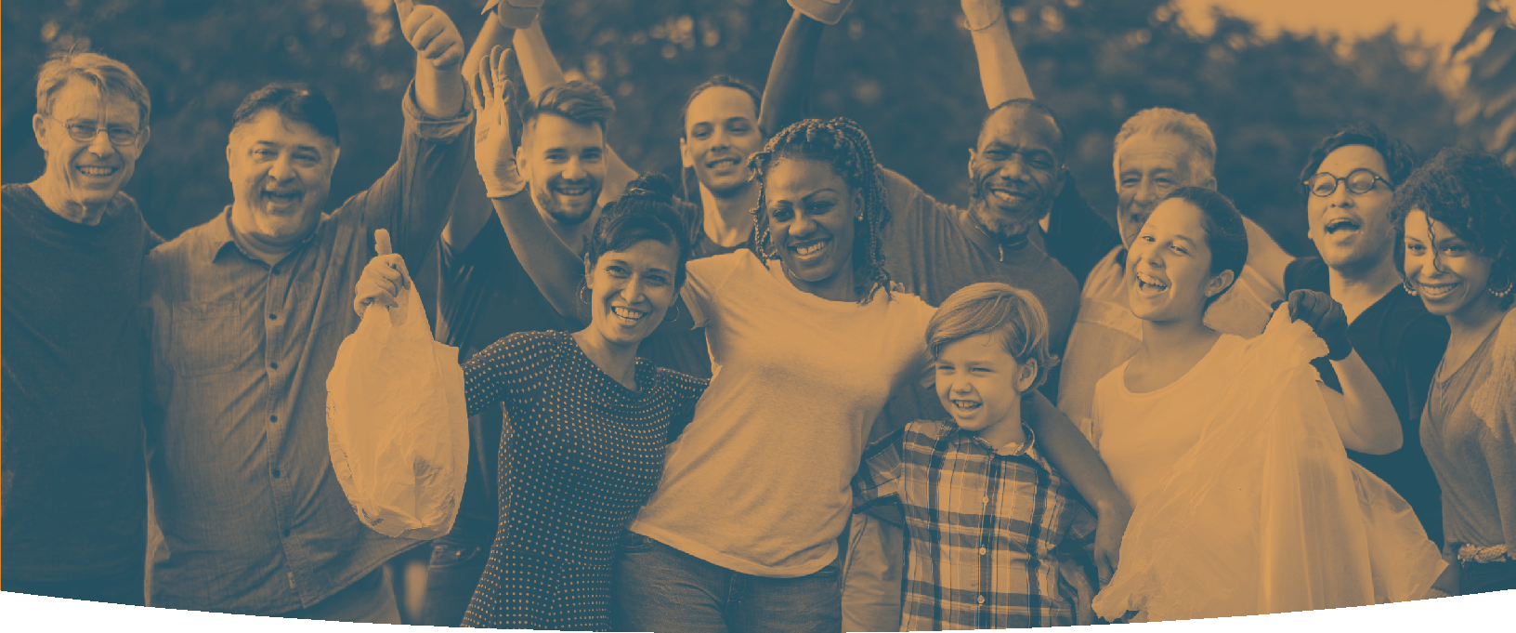
Next page >

“Wellbeing is the set of universal needs and experiences that are essential to weather challenges and have health and hope.”

For example, a homeless family that is moved into an apartment across town may no longer need a place to live. But that move now means they’re two bus rides away from the church where they have a supportive community, and from the school where their kids are thriving. Suddenly, “fixing” the family’s housing problem means taking away many of the assets that boost their resilience. This can take a toll on that family’s housing and economic stability, as well as on their children’s educational success, among other things. This outcome happens even when everyone is doing what the systems and services are set up to do and doing their best—it just doesn’t add up.
fullframeinitiative.org
/FullFrameInitiative
@FullFrameInitv
The Full Frame Initiative is a social change organization that partners with pioneering organizations, systems and
communities across the country to fundamentally shift their focus from fixing problems to fostering wellbeing – the needs and experiences essential for health and hope. Together, we are creating possibilities for lasting change
in people’s lives and sparking a broader movement that replaces poverty, violence, trauma and oppression with wellbeing and justice.

©2015-2019 The Full Frame Initiative

Millions of families are currently in problem-focused intervention programs like the one mentioned above, and our nation spends hundreds of billions of public and private dollars every year to help them. It’s time to stop tinkering around the edges of society’s biggest challenges and shift the approach so that people and our communities can make meaningful, lasting change.

How FFI Works
FFI uses a focus on wellbeing to develop new responses to social problems, and we use a variety of tools to achieve big change. Our capacity builders help communities, programs, and public systems undertake deep changes in practice, in policy, and in culture to better meet people’s needs. Our knowledge team asks hard questions about what works and builds a case for it, challenging the field and communities to do more. And our community team works with allies on the ground to advocate for wellbeing and justice for all.

Take the homeless family. What if they’d entered a system that had a focus on wellbeing built in? There might be a policy to prevent huge tradeoffs: if the “solution” of a new housing placement would result in more challenges to the
family’s overall resilience, the system’s default would be to explore an alternative with fewer tradeoffs and more staying power.

Our efforts are paying off. From improved law-abiding rates in juvenile justice systems, to innovative approaches to supporting survivors of domestic violence, to Massachusetts and Missouri redirecting over $500 million to support better outcomes with fewer tradeoffs, the shift is underway.

Moreover, this growing cadre of pioneering systems and nonprofits across the country are working smarter with what they’ve got instead of starting costly new programs. They’re shifting to a wellbeing orientation because they see it’s better for families and their workforce and that it improves outcomes. And they’re inspiring others to join them.

So far, our work has affected the lives of over 160,000 kids and families in the United States. But we’re just getting started.

The Movement Starts Here
FFI is working strategically with partners to replace poverty, violence, trauma and oppression with wellbeing and justice—creating virtuous circles where vicious cycles previously existed.

With each new partnership, there’s a shift from tunnel vision of discrete problems to the wide angle view of wellbeing, and so the universe of the possible expands. It takes resources, creative thinking, deep collaboration, and visionary leaders to build meaningful movements.

The Full Frame Initiative is up for the challenge—are you?

