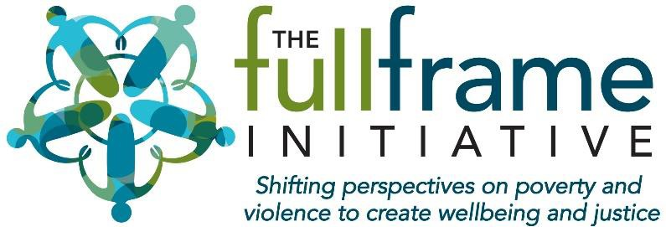
The Wellbeing Learning Collaborative

DPH Providers Meeting Marlborough, MA November 18, 2019
/FullFrameInitiative

@FullFrameInitv

© 2009-2019 The Full Frame Initiative www.fullframeinitiative.org We hope our materials are useful to you. If you would like to reproduce them or use them for your
own work, please contact us first. Using these materials without our consent is not permitted.

Who We Are

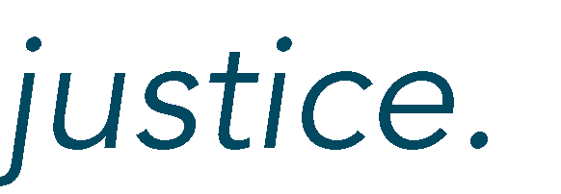

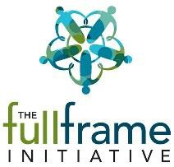
© 2009-2019 The Full Frame Initiative www.fullframeinitiative.org


Assumptions Matter

















By recognizing, legitimizing and building on our universal drive for wellbeing
© 2009-2019 The Full Frame Initiative www.fullframeinitiative.org

Defining Wellbeing

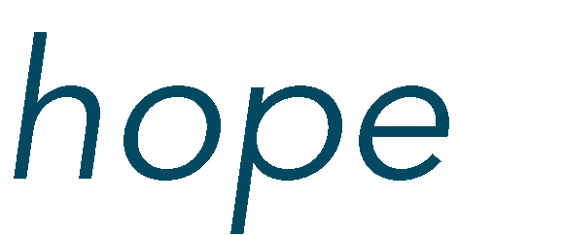
/ˈˌwel ˈˌbēiNG/

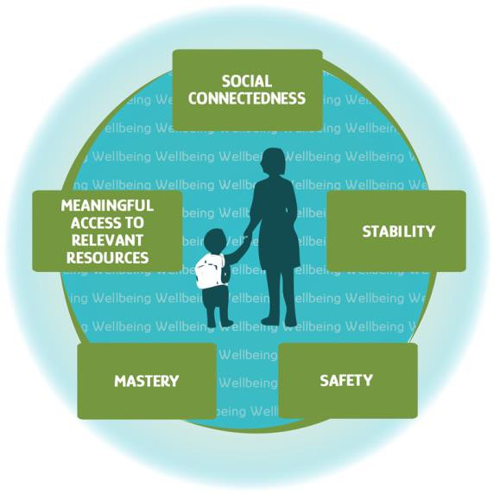
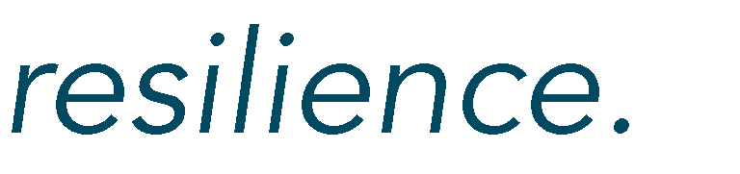

© 2009-2018 The Full Frame Initiative www.fullframeinitiative.org

The Wellbeing Collaborative: Overview

A partnership between the Full Frame Initiative (FFI), the MA Department of Public Health (DPH), and a small group of sexual and domestic violence (SDV) providers interested in focusing their work to support the wellbeing of program participants.

© 2009-2018 The Full Frame Initiative www.fullframeinitiative.org

Overview continued
- 18 month commitment: June 2018-December 2019
- 12 participating organizations, 2 staff per organization
- Quarterly full day in-person meetings and quarterly 2-hour virtual meetings
  - Tool creation and practice, exercises, activities, discussions
- Commitment of 4-6 hours a month outside of meetings:
  - One-on-one coaching with FFI and/or site visits
  - Development of tools
  - Working on practice, policy, or cultural change within their program
or organization (varies by org)
  - Completion of quarterly questionnaires for data purposes
- Use of an intranet site for information sharing and communication between members

© 2009-2018 The Full Frame Initiative www.fullframeinitiative.org

Purpose and Goals
- Develop providers’ ability to shift their focus from problems and
increasing safety to participants’ strengths and increasing their access to
wellbeing.
- Increase understanding and recognition of the motivators of participants’ behaviors and decisions.
- Equip providers to recognize, anticipate and minimize tradeoffs in their
own programs and in other systems.
- Create a vibrant learning collaborative of a group of innovative and creative SDV providers and key allies to build relationships and share practices and lessons learned.
- Increase the SDV field’s understanding of how to increase access to wellbeing across diverse settings, geography, populations and service models.

© 2009-2018 The Full Frame Initiative www.fullframeinitiative.org

Organizations Involved

  - Independence House

  - Jeanne Geiger Crisis Center

  - LUK, Inc.

  - New Hope, Inc.

  - On The Rise

  - REACH

© 2009-2018 The Full Frame Initiative www.fullframeinitiative.org
- Respond, Inc.

- The Salasin Project

- The Second Step

- The Women‘s Center

- Voices Against Violence

- YWCA – Central MA

What We’ve Learned
  - Staff are eager and motivated for change!
  - Leadership commitment and buy-in is essential
  - Staff turnover is both an obstacle and a place for opportunity
  - Members are sharing what they learn in the WC with
colleagues and others in the field
  - Space for organizations to collaborate, co-create, and to support each other is valued and appreciated
  - An overwhelming consensus that this work is important
and needs to continue
  - This requires capacity building and shifting how we view people, more than just training

© 2009-2018 The Full Frame Initiative www.fullframeinitiative.org

Practice Change
Indicators of Impact

- Offering a variety of food and beverages for everyone
- Asking people who call the hotline about tradeoffs, resulting in
more people safely staying in their homes

Tool Creation
- A supervision form that promotes staff wellbeing
- A case presentation tool that centers wellbeing

Policy Change
- Replaced day plans with a house calendar at a shelter, giving
participants more control
- Removed the geographical restrictions on entering shelter

© 2009-2018 The Full Frame Initiative www.fullframeinitiative.org

Quotes from Members

“It [has] provided the ability to step back and look at doing the work in a more holistic way which increases wellbeing for all impacted by domestic violence.”

“The value of getting folks from the field together to share ideas and
experiences is priceless!”

“We recently had a very challenging case where the survivor was weighing a lot of challenges in different parts of her life. This framework provided a helpful way to talk about what was going on.”

© 2009-2018 The Full Frame Initiative www.fullframeinitiative.org

Questions? Answers? Comments?

© 2009-2019 The Full Frame Initiative www.fullframeinitiative.org

Thank You!

Caitlin LeMay
Capacity Building Manager caitlin@fullframeinitiative.org

Madge Haynes
Director of Strategic Partnership Projects madge@fullframeinitiative.org

© 2009-2019 The Full Frame Initiative www.fullframeinitiative.org We hope our materials are useful to you. If you would like to reproduce them or use them for your
own work, please contact us first. Using these materials without our consent is not permitted.

