INDOOR AIR QUALITY ASSESSMENT

Furnace Brook Middle School
500 Furnace Street
Marshfield, Massachusetts

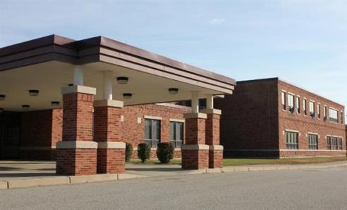

Prepared by:
Massachusetts Department of Public Health
Bureau of Environmental Health
Indoor Air Quality Program
November 2018

Background
Building: | Furnace Brook Middle School (FBMS)
Address: | 500 Furnace Street, Marshfield, Massachusetts
Assessment Coordinated Through: | John Mills, Assistant Principal and Peter Falabella, Marshfield Board of Health
Reason for Request: | Complaint filed with the U.S. Department of Labor Occupational Safety and Health Administration (OSHA) regarding symptoms believed to be related to odor concerns in classroom 1A. Odors were also reported in the Faculty Men’s room and Auditorium.
Date of Assessment: | November 19, 2018
Massachusetts Department of Public Health/Bureau of Environmental Health (MDPH/BEH) Staff Conducting Assessment: | Cory Holmes, Environmental Analyst/Inspector, IAQ Program
Building Description: | Room 1A is a small room located on the ground floor of the FBMS. The room contains office furniture, tile floor, painted gypsum wallboard walls and suspended ceiling tiles. It shares a common wall with general classrooms on each side and the main hallway.
Windows: | Windows are openable in the space.

Methods
Please refer to the IAQ Manual and appendices for methods, sampling procedures, and interpretation of results (MDPH, 2015).

Results and Discussion
The following is a summary of indoor air testing results (Table 1).
- Carbon dioxide measurements were above the MDPH recommended level of 800 parts per million (ppm) in two of four areas surveyed, including room 1A, indicating a lack of air exchange.
- Temperature was within or slightly below the MDPH recommended range of 70°F to 78°F in areas tested at the time of assessment.
- Relative humidity was within or close to the MDPH recommended range of 40 to 60% in all areas tested.
- Carbon monoxide levels were non-detectable (ND) in all areas tested.
- Particulate matter (PM2.5) concentrations measured were below the National Ambient Air Quality (NAAQS) level of 35 μg/m³ in all areas tested.
- Total Volatile Organic Compounds (TVOCs) measurable levels of TVOCs were detected in the faculty men’s restroom and above the ceiling in classroom 1A. This is described further in the Odors/TVOCs section of the report.

Ventilation
A heating, ventilating and air-conditioning (HVAC) system has several functions. First it provides heating and, if equipped, cooling. Second, it is a source of fresh air. Finally, an HVAC system will dilute and remove normally-occurring indoor environmental pollutants by not only introducing fresh air, but also filtering the airstream and ejecting stale air to the outdoors via exhaust ventilation. Even if an HVAC system is operating as designed, point sources of respiratory irritants may be present and produce symptoms in sensitive individuals. The following analysis examines and identifies components of the HVAC system and likely sources of respiratory irritants found in the indoor environment.
Classroom 1A has no means of mechanical supply ventilation but relies on openable windows for introduction of outside air. Classroom 1A does contain a mechanical exhaust vent; in addition, a passive door grill was recently installed to draw air from the hallway to facilitate air exchange (Picture 1).
Mechanical ventilation for classrooms 1 and 3 is provided by unit ventilators “univents” located near classroom windows (Picture 2). Univents draw air from the outdoors through a fresh air intake located on the exterior wall of the building and return air through an air intake located at the base of the unit. Fresh and return air are mixed, filtered, heated or cooled and provided to rooms through an air diffuser located in the top of the unit (Figure 1). The univent in classroom 3 was deactivated; therefore no mechanical source of fresh air was being introduced at the time of assessment.
Exhaust vents are located in the suspended ceiling of classrooms ducted to fans on the roof. No exhaust vent could be located for classroom 1. To maximize air exchange, the BEH/IAQ Program recommends that mechanical ventilation systems operate continuously during periods of school occupancy. Without the system operating as designed, normally occurring pollutants cannot be diluted or removed, allowing them to build up and lead to IAQ/comfort complaints.

Odors/TVOCs
Exposure to low levels of total volatile organic compounds (TVOCs) may produce eye, nose, throat, and/or respiratory irritation in some sensitive individuals. To determine if VOCs were present, BEH/IAQ staff took measurements with a photo-ionization detector (PID) and examined rooms for products containing VOCs. As mentioned, the assessment was prompted by odor complaints, described by occupants as a “chemical, industrial-type odor” No specific source for the odors was identified in the room. BEH/IAQ staff observed an open utility hole in the concrete ceiling above the ceiling tile system (Picture 3). Measurable levels of TVOCs (16 ppm) were detected when the PID probe was inserted into this hole. The source of odors is likely roofing compounds/materials. In addition, several other open holes were observed in the concrete ceiling (Picture 4).
Odors were also reported in the faculty men’s room and measureable levels of TVOCs were traced to an air deodorizer (Picture 5). The ceiling in this room should also be examined for similar utility holes as found in Classroom 1A. Open utility holes with noticeable drafts were observed in the Auditorium (Picture 6).
Finally, BEH/IAQ staff noted hand sanitizers, cleaners/spray bottles, and dry erase materials in use. All of these products have the potential to be irritants to the eyes, nose, throat, and respiratory system of sensitive individuals.

Conclusions and Recommendations
In view of the findings, the following recommendations (regarding classroom 1A) were made at the time of the visit and are reiterated below:
- Seal all open utility holes in Classroom 1A, men’s faculty restroom and Auditorium.
- Ensure local exhaust vents are operable in restrooms and make repairs as necessary.
- Discontinue use of air deodorizers in restrooms.
- Consider installing a mechanical source of fresh air for Classroom 1A.
- Use openable windows to supplement fresh air during temperate weather. Ensure all windows are tightly closed at the end of the day.
- Operate HVAC equipment (univents/exhausts) continuously during occupied periods. Remove all obstructions from the front and top of the univents.
- Reduce the use of cleaning products, sanitizers and other products containing VOCs. Use only school-issued products, ensure they are properly labeled, and keep material safety sheets on file for each product at the school.
- Refer to resource manual and other related IAQ documents located on the MDPH’s website for further building-wide evaluations and advice on maintaining public buildings. These documents are available at http://mass.gov/dph/iaq.

References
MDPH. 2015. Massachusetts Department of Public Health. Massachusetts Department of Public Health Indoor Air Quality Manual: Chapters I-III. Available at: http://www.mass.gov/eohhs/gov/departments/dph/programs/environmental-health/exposure-topics/iaq/iaq-manual/.
Picture 1
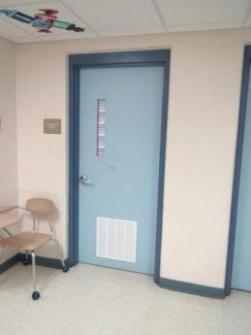
Passive grill in door of Classroom 1A
Picture 2
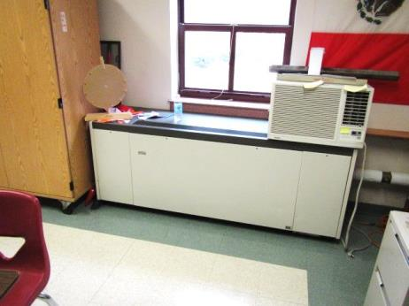
Typical classroom univent
Picture 3
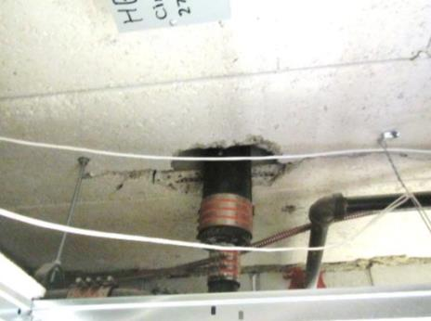
Open utility hole in concrete ceiling in Classroom 1A
Picture 4
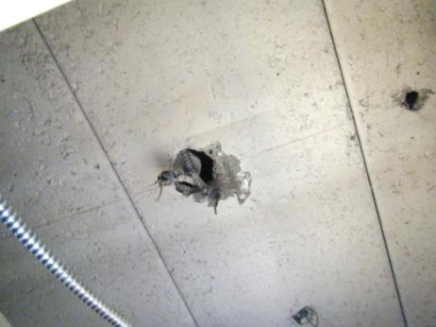
Open utility holes in concrete ceiling in Classroom 1A
Picture 5
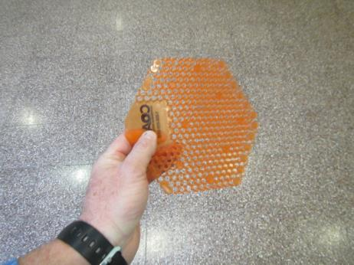
Air deodorizer in faculty men’s restroom
Picture 6
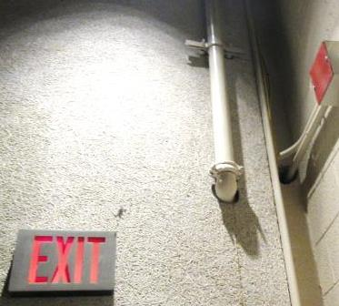
Open utility holes in Auditorium
Location | Carbon  Dioxide  (ppm) | Carbon Monoxide  (ppm) | Temp  (°F) | Relative  Humidity  (%) | PM2.5  (µg/m³) | TVOCs  (ppm) | Occupants  in Room | Windows  Openable | Ventilation |  | Remarks
 |  |  |  |  |  |  |  |  | Supply | Exhaust
Background | 399 | ND | 57 | 55 | 4 | ND |  |  |  |  | Cloudy/overcast
A1 | 960 | ND | 70 | 43 | 6 | ND/16* | 6 | Y | Y  Passive | Y | *16 ppm TVOCs measured in open utility hole above ceiling
Men’s Faculty Restroom |  |  |  |  |  | 1.3-4.5 |  | N | N | Y | Air deodorizer
1 | 565 | ND | 72 | 37 | 8 | ND | 1 | Y | Y | N | 19 occupants gone ~10 mins
3 | 922 | ND | 71 | 40 | 7 | ND | 14 | Y | Y | Y | Univent deactivated
Auditorium | 625 | ND | 69 | 38 | 4 | ND | 0 | N | Y | Y | Open utility holes-drafts

