INDOOR AIR QUALITY ASSESSMENT

Furnace Brook Middle School
500 Furnace Street
Marshfield, Massachusetts

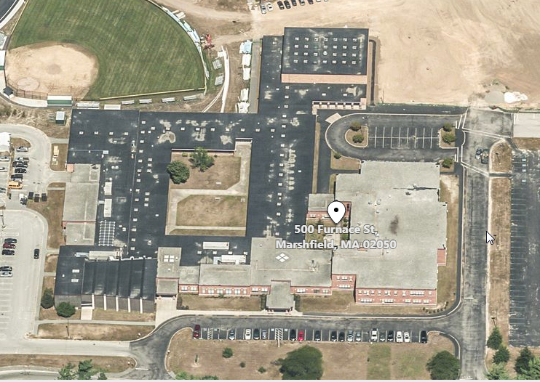

Prepared by:
Massachusetts Department of Public Health
Bureau of Environmental Health
Indoor Air Quality Program
June 2019

Background
Building: | Furnace Brook Middle School (FBMS)
Address: | 500 Furnace Street, Marshfield, Massachusetts
Assessment Coordinated Through: | Fred Russell, Director of Facilities, Town of Marshfield
Reason for Request: | Odor complaints and symptoms (e.g., headaches, general malaise) believed to be related to odor concerns in classroom 16.
Date of Assessment: | June 7, 2019
Massachusetts Department of Public Health/Bureau of Environmental Health (MDPH/BEH) Staff Conducting Assessment: | Cory Holmes, Environmental Analyst/Inspector, IAQ Program
Building Description: | Room 16 is a general classroom located on the ground floor of the FBMS. The room contains office furniture, tile floor, painted gypsum wallboard walls and suspended ceiling tiles. It shares a common wall with general classrooms on each side and the main hallway.
Windows: | Windows are openable in the space.

Methods
Please refer to the IAQ Manual and appendices for methods, sampling procedures, and interpretation of results (MDPH, 2015).

Results and Discussion
The following is a summary of indoor air testing results (Table 1).
- Carbon dioxide measurements were above the MDPH recommended level of 800 parts per million (ppm) in room 16, indicating a lack of air exchange. The unit ventilator was in its “off cycle” and the room contains no exhaust ventilation. This is discussed further in the Ventilation section of this report.
- Temperature was within the MDPH recommended range of 70°F to 78°F at the time of assessment.
- Relative humidity was within the MDPH recommended range of 40 to 60% in all areas tested.
- Carbon monoxide levels were non-detectable (ND).
- Particulate matter (PM2.5) concentrations measured were below the National Ambient Air Quality (NAAQS) level of 35 μg/m³.
- Total Volatile Organic Compounds (TVOCs) Slight readings ranging from ND to 1.4 ppm was measured in the breathing zone (2-4 feet) of the classroom. A peak level of 77 ppm TVOCs was detected at a skylight above the ceiling in 16 (Picture 1). This is described further in the Odors/TVOCs section of the report. No odors/measureable levels of TVOCs were detected directly outside the room (main hallway) or in either adjacent classroom (14 and 16-A respectively) at the time of assessment.

Ventilation
A heating, ventilating and air-conditioning (HVAC) system has several functions. First it provides heating and, if equipped, cooling. Second, it is a source of fresh air. Finally, an HVAC system will dilute and remove normally-occurring indoor environmental pollutants by not only introducing fresh air, but also filtering the airstream and ejecting stale air to the outdoors via exhaust ventilation. Even if an HVAC system is operating as designed, point sources of respiratory irritants may be present and produce symptoms in sensitive individuals. The following analysis examines and identifies components of the HVAC system and likely sources of respiratory irritants found in the indoor environment.
Mechanical ventilation for classrooms 16, and most general classrooms, is provided by unit ventilators (univents) located near classroom windows (Picture 2). Univents draw air from the outdoors through a fresh air intake located on the exterior wall of the building (Picture 3) and return air through an air intake located at the base of the unit. Fresh and return air are mixed, filtered, heated or cooled and provided to rooms through an air diffuser located in the top of the unit (Figure 1). As stated previously, the univent in classroom 16 was deactivated (in the off cycle), therefore no mechanical source of fresh air was being introduced at the time of assessment. It was reported that univents are controlled by an integrated computer system and their operation is tied to a carbon dioxide sensor. Once the carbon dioxide sensor reaches its set point the univent activates. It was believed that the system was set to activate at 800 ppm. This should be verified. In addition, gas sensors, including carbon dioxide, should be maintained/calibrated per the manufacturer’s instructions.
Most classrooms with mechanical ventilation typically have exhaust or return vents installed to remove naturally occurring airborne pollutants and provide air exchange. Room 16 does not have any exhaust/return vents.
To maximize air exchange, the BEH/IAQ Program recommends that mechanical ventilation systems operate continuously during periods of school occupancy. Without the system operating, normally occurring pollutants cannot be diluted or removed, allowing them to build up and lead to IAQ/comfort complaints. However, since the room has no exhaust ventilation, BEH/IAQ Program staff recommended that the univent be deactivated and windows remain shut to prevent pressurization, which can force odors into adjacent areas.

Odors/TVOCs
Exposure to low levels of total volatile organic compounds (TVOCs) may produce eye, nose, throat, and/or respiratory irritation in some sensitive individuals. To determine if VOCs were present, BEH/IAQ staff took measurements with a photo-ionization detector (PID) and examined rooms for products containing VOCs. As mentioned, the assessment was prompted by odor complaints, described by occupants as a “chemical, glue-type odor” School/maintenance staff believed that the odor may be related to roof work. BEH/IAQ staff removed ceiling tiles and observed an abandoned skylight above the ceiling tile system (Picture 1). Measurable levels of TVOCs (up to 77 ppm) were detected above the ceiling when the PID probe was held near spaces around the skylight where drafts could be detected. The source of odors is likely roofing compounds/materials (TREMCO, 2017).
Once detected, the occupants of the classroom were temporarily relocated and the skylight was recommended to be sealed as airtight as possible using caulking and/or plastic/duct tape, until it could be permanently sealed properly.

Conclusions and Recommendations
Following the visit it was reported by school administration that Classroom 16 has been relocated for the remainder of the year. The following recommendations (regarding Classroom 16) were made at the time of the visit and are reiterated below:
- Ensure skylight is sealed as airtight as possible using caulking/duct tape/plastic.
- Keep univent off and windows shut until odors are eliminated to prevent pressurization of Classroom 16, which can force odors into adjacent areas.
- Seal any utility holes, particularly along pipes/exterior wall (Picture 4) into Room 16 A.
- Over the summer examine more permanent solutions to seal the skylight and eliminate source of odors.
- Refer to resource manual and other related IAQ documents located on the MDPH’s website for further building-wide evaluations and advice on maintaining public buildings. These documents are available at http://mass.gov/dph/iaq.

References
MDPH. 2015. Massachusetts Department of Public Health. Massachusetts Department of Public Health Indoor Air Quality Manual: Chapters I-III. Available at: http://www.mass.gov/eohhs/gov/departments/dph/programs/environmental-health/exposure-topics/iaq/iaq-manual/.
TREMCO. 2017. TREMCO, POWERply® Standard Cold Adhesive. U.S. Data Sheet. Revised September, 2017. https://www.tremcoroofing.com/fileshare/specs/POWERply%20Standard%20Cold%20Adhesive.pdf

Picture 1
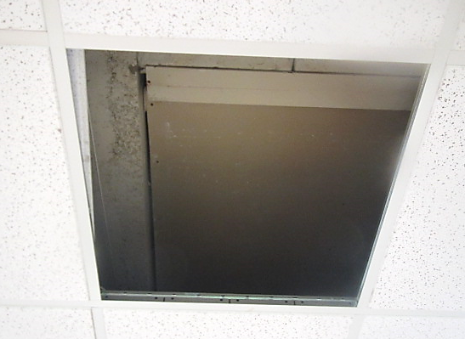
Sealed skylight above ceiling in Classroom 16, note spaces around edges where drafts/odors were detected
Picture 2
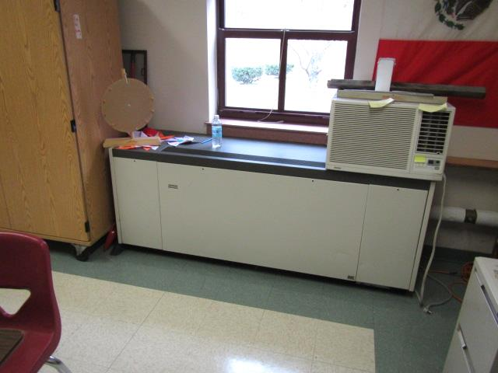
Typical classroom univent
Picture 3
Univent fresh air intakes (arrows)
Picture 4
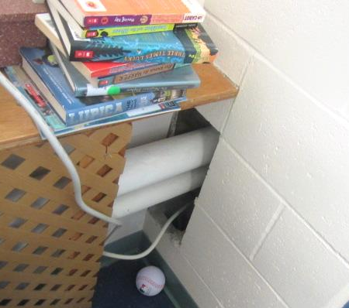
Open pipe chase through interior wall of Classroom 16 into 16A
Location | Carbon  Dioxide  (ppm) | Carbon Monoxide  (ppm) | Temp  (°F) | Relative  Humidity  (%) | PM2.5  (µg/m³) | TVOCs  (ppm) | Occupants  in Room | Windows  Openable | Ventilation |  | Remarks
 |  |  |  |  |  |  |  |  | Supply | Exhaust
Background | 370 | ND | 75 | 47 | 11 | ND |  |  |  |  | Sunny, clear, windy
Room 16 | 841 | ND | 76 | 57 | 7 | ND-1.4 | 1 | Y | Y | N | Slight odors present, stronger when ceiling tiles removed, open pipe chase/hole in interior wall into 16A
Room 16 (Above CT) |  |  |  |  |  | 77 |  |  |  |  | Most elevated TVOC from spaces around sealed skylight-drafts/odors
Hallway Outside Room 16 |  |  |  |  |  | ND |  |  |  |  | No VOC odors
Room 14 |  |  |  |  |  | ND |  |  |  |  | No VOC odors
Room 16A |  |  |  |  |  | ND |  |  |  |  | No VOC odors

