FY18 ECSE Grant Fund Code 262

Instructions for Submitting Final Financial Reports

Introduction:

All Grantees must submit a Final Financial Report at the close of the grant period for each individual grant they have received for the current fiscal year. One report is to be submitted for each individual grant to EEC within sixty days (60) of the close of the grant.

FFR DUE by August 30, 2018 (when all funds are allocated through June 30, 2018 in the Budget)

FFR DUE by October 31, 2018 (when funds are also allocated through August 31, 2018)

How to Complete the Final Financial Report Form:

Please log in to your online grant application to find the Final Financial Report button at the bottom of the home page.
To complete FY18 Final Financial Report, scroll down to bottom of page.

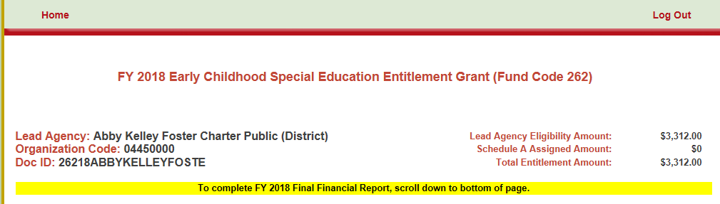

Click on "Final Finanical Report located at the bottom of Home Page:

Final Financial Report:
- 1. Complete the contact information section.
Fill in the Name; Title; Phone; and Email address of person completing this report

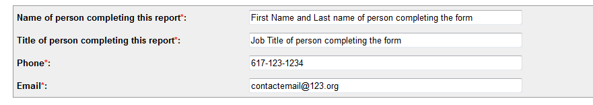
BUDGET INSTRUCTIONS:
Column A: Expenditure Category
Column B: Approved Budget - This column will be pre-populated with the most recently submitted approved budget.
Column C: Funds Expended - Please complete this column based on grant funds received and expended.
Funds Expended must not exceed the dollar amount of funds paid plus MTRS.
Column D: Balance of Unexpended Funds - The balance unexpended (if applicable) will populate based on the expended amount in Column C. The unexpended balance must not be a negative number (less than $0)

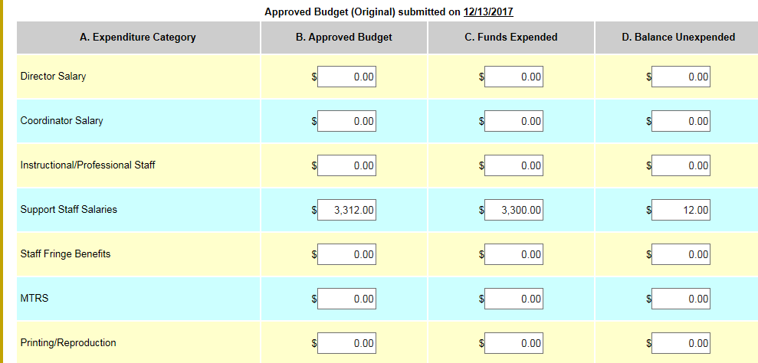

2. Report the Funds Expended in Column C.
- Fill in the grant funds expended based on the approved budget line item expenditures. Funds Expended must not exceed the dollar amount of funds paid plus MTRS.
Please save your information frequently using the save information button located at the bottom of the page.
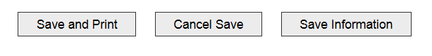
3. Report the amount of FY 2018 262 funds that were Not Requested/ Not Paid by EEC (if any).
- If you were not paid 100% of your FY18 ECSE grant funds, the dollar amount of these unrequested funds should be entered Funds Not Requested/ Not Paid box.

- Return Check Amount: The Return Check Amount will automatically calculate based upon the information entered.
The unexpended balance must not be a negative number (less than $0).

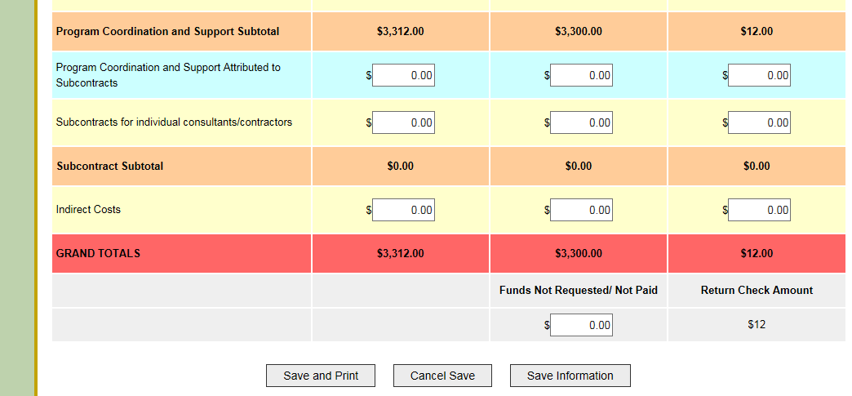

4. Click the Save and Print button, when the form is completed and you are ready to submit the FFR via MAIL.
After clicking the Save and Print button, A PDF of the Final Financial Report is created.
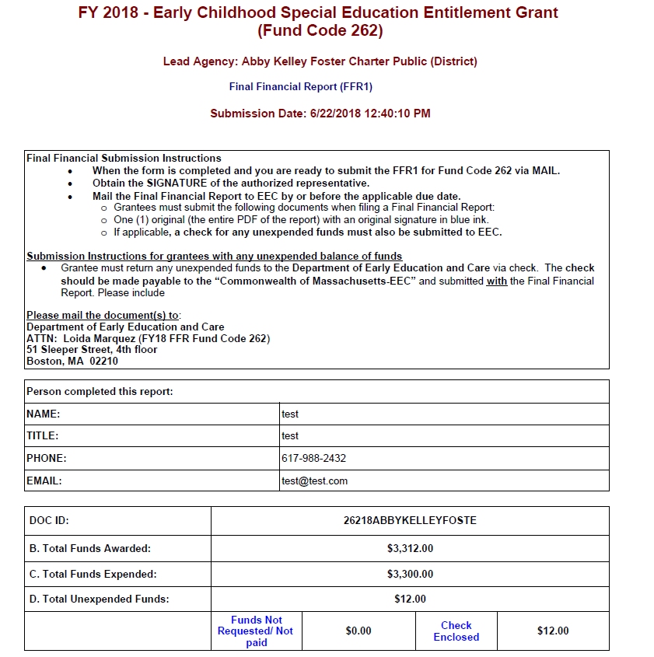
5. Obtain the SIGNATURE of the authorized representative.
- The printed the Final Financial report must be signed by an Authorized Signatory
- Include an original signature (in blue ink) of the authorized representative.
Important: An unsigned Final Financial Report will NOT be approved and will have to be resubmitted to EEC.
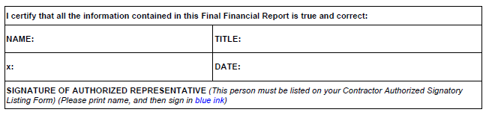

6. Mail the Final Financial Report to EEC.
Grantees must submit the following documents when filing a Final Financial Report:
- One (1) original (the entire PDF of the report) with an original signature in blue ink.
- If applicable, a check for any unexpended funds.
Submission Instructions for grantees with any unexpended balance of funds
- Grantee must return any unexpended funds to the Department of Early Education and Care via check. The check should be made payable to the “Commonwealth of Massachusetts-EEC” and submitted with the Final Financial Report.

Please mail the document(s) to:
Department of Early Education and Care
ATTN: Loida Marquez (FY18 FFR 262)
51 Sleeper Street, 4th floor
Boston, MA 02210

NOTE: Eligibility for FY18/FY19 Tydings:

ECSE Grantees that did not receive 100% of their FY18 ECSE funds or have returned unspent funds via check to EEC will be eligible to request and spend these funds through FY18/FY19 Tydings (Carry Over).
- After the successful submission and reconciliation of the FY18 Final Financial Report, EEC will notify a grantee via email of their eligibility for FY18/FY19 Tydings.
Failure to submit the Final Financial Report and check for unspent funds by the due date will delay access to the Tydings funding.

