Commonwealth of Massachusetts
Executive Office of Health and Human Services

Virtual Gateway



Salary Reserve FY 2012 Reference Guide
December 15, 2011

Table of Contents

Chapter 1: Accessing Provider Data Management to View Salary Reserve Data 2
Introduction 2
Accessing PDM through the Virtual Gateway 2
Viewing the Provider Business Functions Page 2
Accessing the Salary Reserve Data Summary Page 2
Chapter 2: Managing Salary Reserve Data 2
Introduction 2
Accessing the Salary Reserve Contact Page 2
Updating Salary Reserve Contact information 2
Updating Salary Reserve Contact Information 2
Accessing the Salary Reserve Contract Data Page 2
Managing FY12 Salary Reserve Contracts 2
Managing FY12 Salary Reserve Contracts 2
Updating Salary Reserve Contract Data 2
Manage Salary Reserve Wage Data 2
Updating Salary Wage Data 2
Chapter 3: Confirming FY 2012 Salary Reserve Data 2
Introduction 2
Submitting Salary Reserve 2
Confirming Salary Reserve Data 2
Viewing Purchase of Service (POS) Salary Reserve Page 2
Chapter 4: Glossary 2
Introduction 2

Accessing Provider Data Management to View Salary Reserve Data
Introduction | This section of the Provider Data Management (PDM) Service is for the implementation of a data collection web-based application which will collect payroll data from providers and will facilitate the distribution of approximately $10M to Purchase of Service contractors who provide human and social services to Commonwealth clients.  The Salary Reserve web application provides Purchase of Service (POS) providers and EOHHS agency staff with access to real-time data over the internet. The Salary Reserve web application will be the system of record for all of the Salary Reserve data content. This application will be made available whenever Salary Reserve is part of the Budget.  You can access PDM to  - view  - update  - manage  Salary Reserve FY 2012 data.
Accessing PDM through the Virtual Gateway | To access PDM:  1. Open a web browser.  2. Type Web address www.mass.gov/vg in browser.  Health and Human Services Virtual Gateway portal page appears.  3. Click the Virtual Gateway Business Services link listed under ONLINE SERVICES on the left.  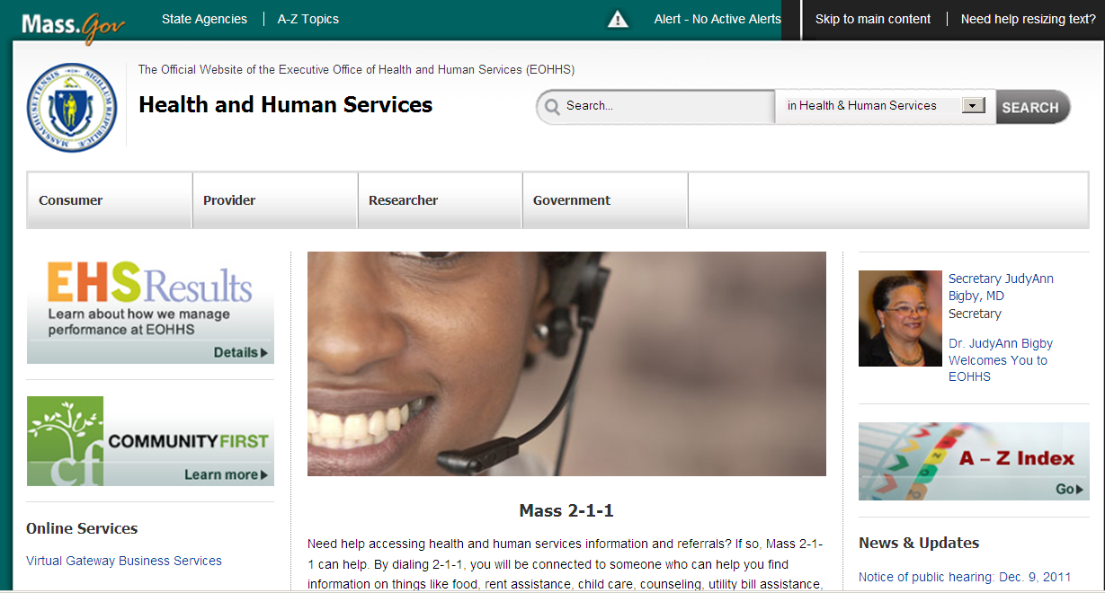
The Virtual Gateway Login page appears.
Note: Security requires that each person have a username and
password.
For more information on logging into the Virtual Gateway, refer to Virtual Gateway Login Job Aid at www.mass.gov/vg/loginassistance .

4. Enter your Username and Password in the Login box, and then click the Login button.
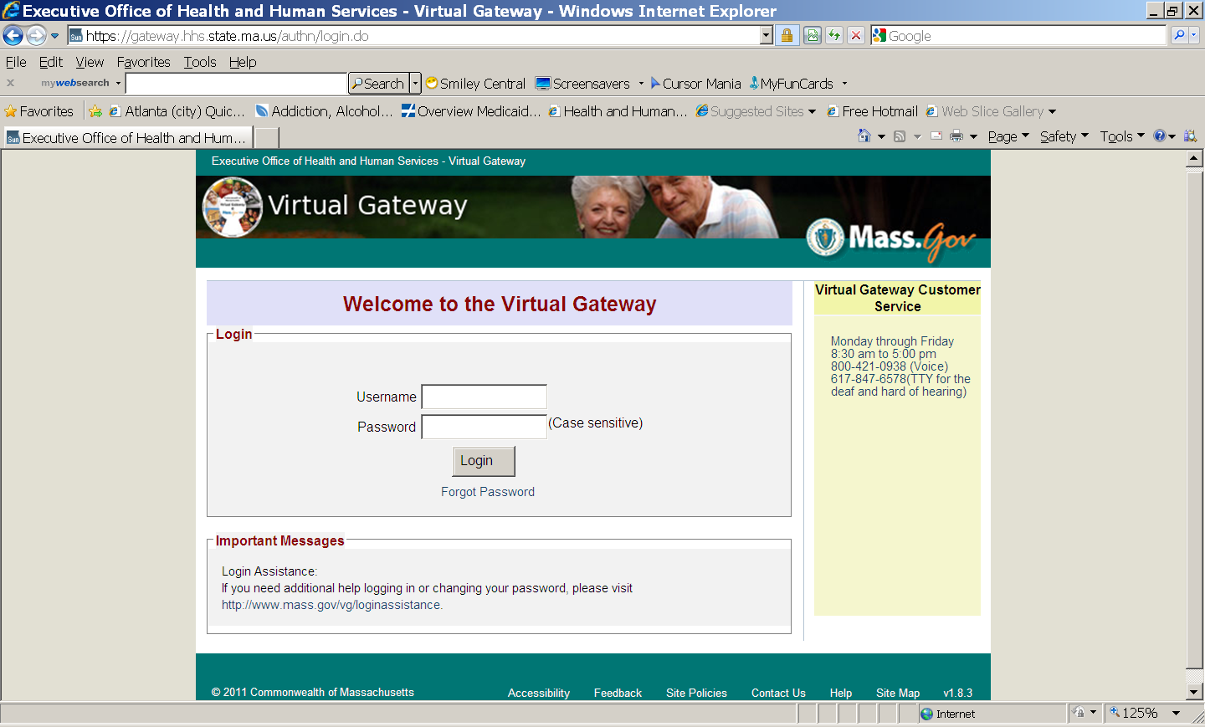
The Virtual Gateway Business Services page appears. (view may be different)
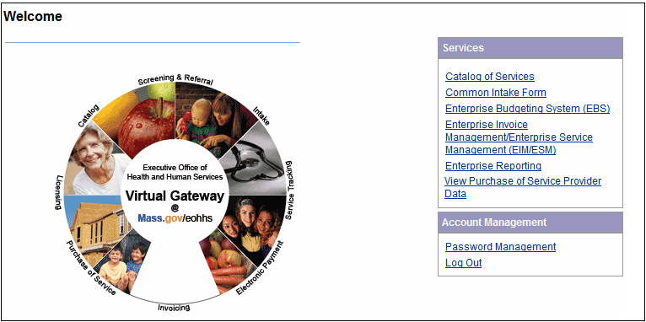
Once logged in, you have access to the Virtual Gateway services.
To access PDM, click the View Purchase of Service Provider Data link.
Then select Access POS
Purchase Of Service(POS) Provider Qualifications:
- Access POS
This link serves as the central repository of EOHHS POS providers information including the following:
- General Information Details
- Provider Contract Summary
- Provider Qualification
- Financial Measures
- Corrective Measures Based on CPA, OSA, or EHS Reviews

Viewing the Provider Business Functions Page | The Provider Business Functions page appears.  Access the Salary Reserve Data Summary page by clicking the Salary Reserve link from the Business Functions page  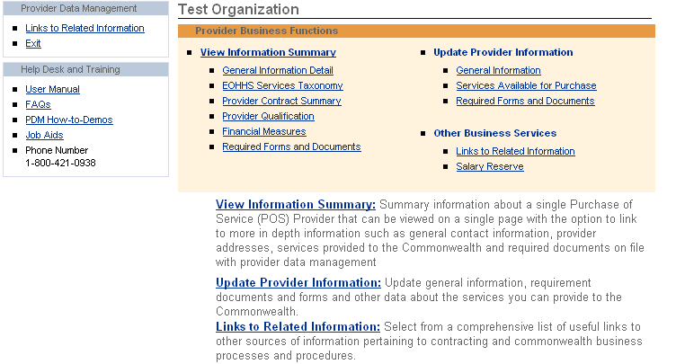  The Salary Reserve Data Summary page appears.  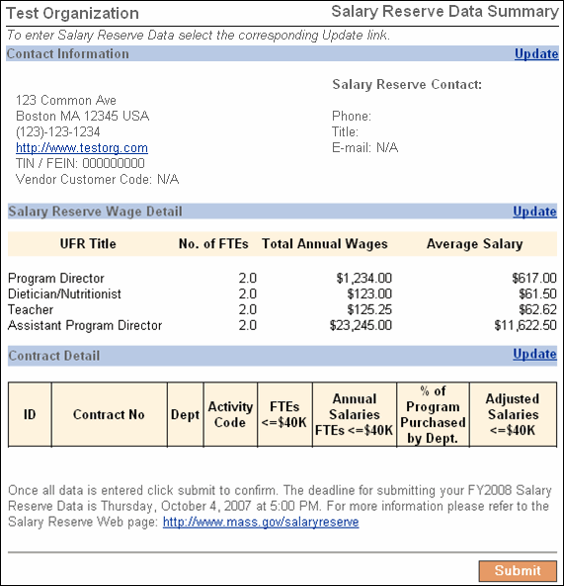
Accessing the Salary Reserve Data Summary Page  Important Note: Deadline for FY2012 SR Data is Friday, March 9, 2012 | You will only be able to view, manage and update data that pertains to your organization.  The following information is viewable from this page:  - Contact Information  - Salary Reserve Wage Detail  - Contract Detail

Managing Salary Reserve Data
Introduction | You can manage or update the following:  - Salary Reserve Contact Information  - Salary Reserve Contract Data  - Wage Data
Accessing the Salary Reserve Contact Page | To access the Update Salary Reserve Contact page, click the Update link from the Salary Reserve Data Summary page.  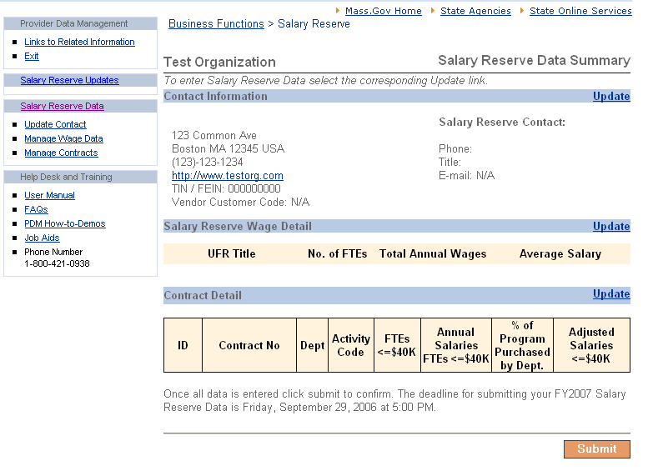

Updating Salary Reserve Contact information | 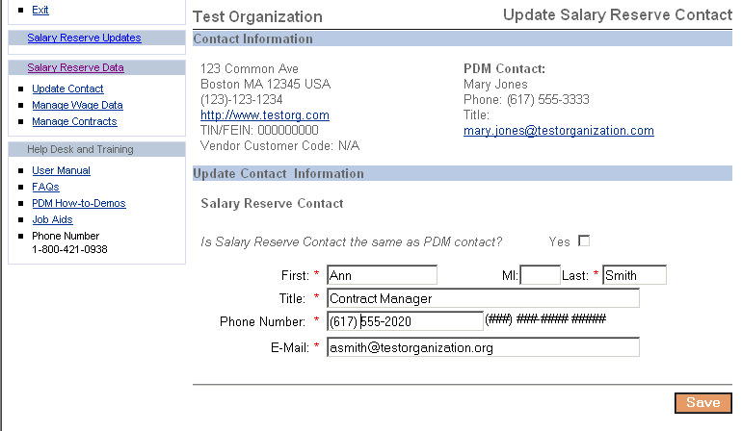  The Update Salary Reserve Contact page appears.  Tip: If you answer Yes to “Is Salary Reserve Contact the same as PDM contact?” the required fields below are disabled. Then, click .  You are returned to the Salary Reserve Contract Data Summary page with the updated contact information displayed.  Tip: Asterisk denotes required fields.  To update Salary Reserve Contact information:  - Enter first and last name.  - Enter title.  - Enter phone number.  (Tip: space for extension up to 5 digits).  - Enter e-mail address.  - Click.
Updating Salary Reserve Contact Information  (continued) | You are returned to the Salary Reserve Contract Data Summary page with the newly entered contact information displayed.  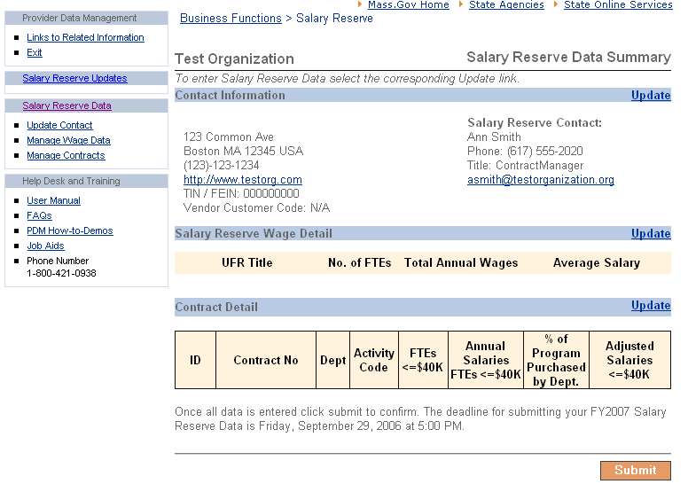
Accessing the Salary Reserve Contract Data Page | To access the Manage FY12 Salary Reserve Contracts page, click the Update link from the Salary Reserve Data Summary page.

Managing FY12 Salary Reserve Contracts | The Manage FY12 Salary Reserve Contracts page appears.  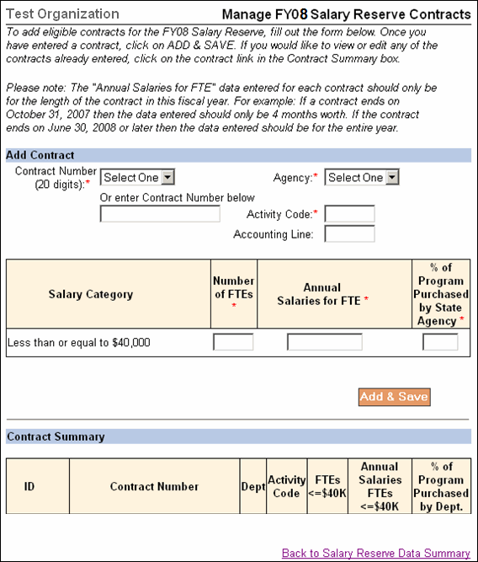  Tip: Asterisk denotes required fields. Do not use the dollar sign or commas.  To add a contract to manage FY12 Salary Reserve Contract data:  - Select a contract from the drop down box or enter (up to 20 digits) contract number in appropriate field.  - Enter required field information.  - Click.  Tip: To add another contract enter data and then click [Add & Save].
Managing FY12 Salary Reserve Contracts  (continued) | The page reappears with the newly entered contract displayed.  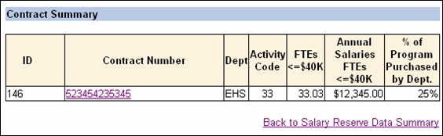  The unique ID number for each line item corresponds to the contract number, appropriation, and activity code.  To return to the Salary Reserve Data Summary page, click the Back to Salary Reserve Data Summary link.
Updating Salary Reserve Contract Data | To update contract data:  - Click the contract number link on the Manage FY12 Salary Reserve Contracts page.  The Update Salary Reserve Contract page appears.  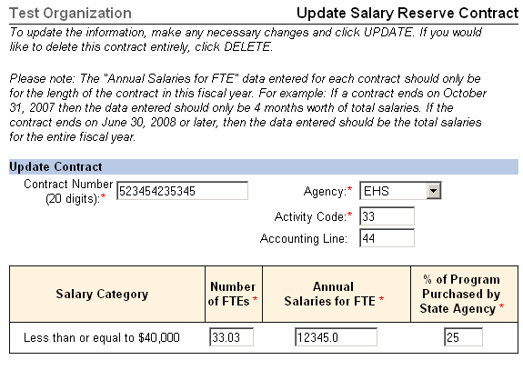  - Enter changes and then click .  Caution: If you click the contract record will be deleted.  You are returned to the Manage FY12 Salary Reserve Contracts page with the updated data displayed.
Manage Salary Reserve Wage Data | To access the Manage Salary Reserve Wage Data page, click the Update link from the Salary Reserve Data Summary page.  The Manage Salary Reserve Wage Data page appears.  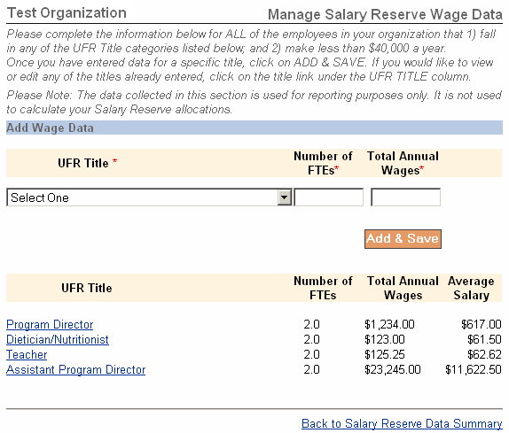  Tip: Asterisk denotes required fields.  To enter wage data:  - Select UFR title from drop down box.  - Enter number of FTEs.  - Enter total annual wages.  - Click.  The page reappears with the newly entered data displayed.  Tip: To add another wage, click.  To return to the Salary Reserve Data Summary page, click the Back to Salary Reserve Data Summary link.
Updating  Salary Wage Data | To update a salary wage data you have previously entered, click the UFR Title link.  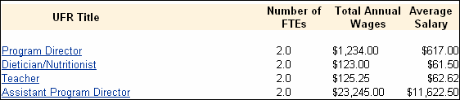  The Update Wage Data page appears.  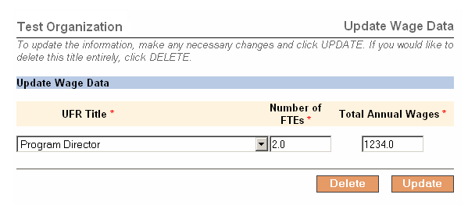  Update Wage data, and then click .  Caution: If you click the contract record will be deleted.  You are returned to the Update Salary Reserve Wage Data page with newly entered data displayed.
Notes:

Confirming FY 2012 Salary Reserve Data
Introduction | After the Salary Reserve data for FY 2012 has been entered for your organization, you will need to complete the submittal and confirmation process.
Submitting Salary Reserve  Important Note: Deadline for FY2012 SR Data is Friday, March 9, 2012  Data | Once all FY 2012 Salary Reserve Data has been entered and reviewed, click .  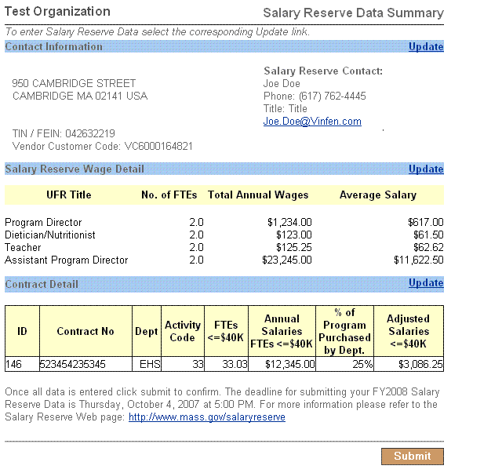

Confirming Salary Reserve Data | The Final Confirmation page appears. (view will read 2012)  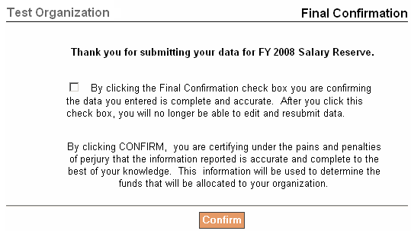  To confirm Final Confirmation click the check box to confirm data entered is complete and accurate and then click.  Once data has been confirmed, an email notification will be sent to the Salary Reserve Administrator.  The Salary Reserve Final Confirmation page appears.  - Click to print a copy of the Salary Reserve Final Confirmation printer friendly version for your records.  The printer friendly version of the Salary Reserve Final Confirmation  page appears.  - View printer friendly version.
Viewing Purchase of Service (POS) Salary Reserve Page | Click the Salary Reserve Updates link from the navigation bar, to view the latest information about Salary Reserve.  The Purchase of Service (POS) Salary Reserve page appears.

Glossary
Introduction | The following table lists the data elements and their definitions for the Salary Reserve Data Collection Application.  Tip: Asterisk denotes required field.

Data Element | Definition
Contractor name | Agency name as used in articles of incorporation or organization.
*Contact person | The name of the person who can answer Salary Reserve questions about the survey, should any arise.
*Telephone | The contractor’s telephone number, including area code and extension, if any.
FEIN | 9 digit federal employer identification number (FEIN).
*FY 2012 contract number | 20 digit MMARS contract identification number.
*Dept. | 3 letter identifier of the department with whom contractor has a contract.
*Full-time equivalents earning less than $40,000 in program | The number of eligible employees (full and part time) in terms of full time equivalents (FTEs) earning less than $40,000 that work in the program.
*Annual salaries of employees earning less than $40,000 in program | The annual salaries of eligible employees earning less than $40,000 for the portion of their time attributable to a program.
*Percentage of program purchased by department | This is the percentage of the program that is purchased by the department.
Annual salaries less than $40,000 attributable to this contract and program | No entry (see note below).  This column is calculated by a built-in formula that multiplies percentage of program purchased by eligible salaries of <$40,000.
*MMARS activity code | Enter the MMARS activity code associated with the listed program.
Accounting Line Number (optional) | Enter the accounting line number associated with the listed program.

Notes:

