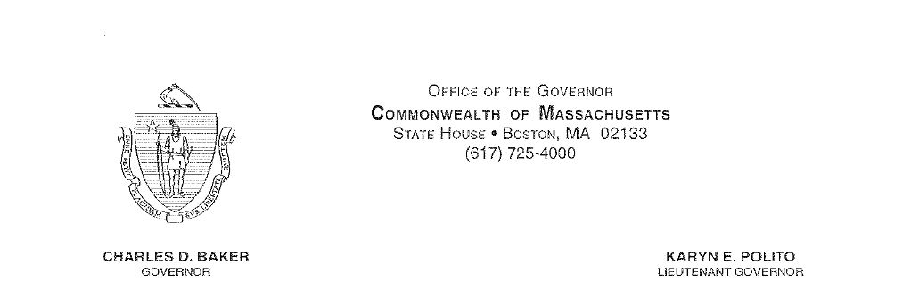

February 17, 2017

To the Honorable Senate and House of Representatives:

I am filing for your consideration a bill entitled “An Act Making Appropriations for Fiscal Year 2017 to Provide for Supplementing Certain Existing Appropriations and for Certain Other Activities and Projects.”
This bill consists of $259 million in supplemental appropriations, at a net state cost of $249 million, primarily for unavoidable deficiencies in the FY17 budget, plus funding for reforms at Bridgewater State Hospital. These spending items include:
- $62 million for representation of indigent defendants;
- $49 million for a reserve for sheriffs deficiencies;
- $29 million for the department of correction, related in part to reforms at Bridgewater State Hospital;
- $21 million for emergency assistance (shelter) deficiencies;
- $20 million for snow and ice costs at the Department of Transportation;
- $15 million for payments to direct care workers mandated by chapter 257;
- $13 million for collective bargaining costs, including funding for the Coalition of Public Safety (COPS) contract
- $11 million for the Turning 22 program at the Department of Developmental Services;
- $8 million for legal settlements and judgments;
- $7 million to raise the ceiling on the Department of Public Health’s authority to spend retained revenue in two accounts, inmate pharmacy purchases, and distribution of WIC formula rebates
- $5 million for caseload exposures at the Department of Children and Families;
- $4 million for Elder Affairs home care services;
- $4 million for National Guard tuition and fee waiver costs owed to campuses;
- $3 million for the Department of Mental Health’s Emergency Service Program in the Southeast region; and
- $9 million for a range of smaller needs (each $2 million or under).
In addition, this bill proposes several sections intended to conform or otherwise facilitate compliance with recent changes to federal law. Among these are:
- Proposed changes to the tax return filing dates for certain business organizations, effective for January 1, 2018;
- Authorization for the Department of Agricultural Resources to undertake inspections in compliance with the Food Safety Modernization Act; and
- Three changes to programs managed by the Department of Children and Families to comply with the federal Preventing Sex Trafficking and Strengthening Families Act of 2014.
The bill also proposes technical changes to recently-enacted legislation, such as the municipal speed enforcement and overlay account provisions in the Municipal Modernization Act. The bill proposes other spending related technical changes that will enable the Commonwealth to end Fiscal Year 2017 in balance.
Sufficient revenues are estimated to be available to finance these appropriations. Because at least one item requires supplemental funding in early March, I urge you to enact this legislation promptly.

Respectfully submitted,

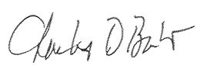

Charles D. Baker
Governor

