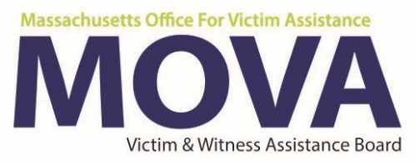

30 / 60 / 90 Staffing Update
Due Dates
30 Day Update – August 1, 2018
60 Day Update – September 1, 2018
90 Day Update – October 2, 2018
** Each period report is due within 5 business days (before or after) of the due date**

Agency Information
Agency Name | Agency Name
Program Name | Program Name
Is the program is 100% operational? (i.e. has no vacant positions to fill.) If no, you must fill in the 30 day program update below. |  |  | Yes as of: Date | No

30 day program performance update
- List all vacant positions.
Comment | Type here
- If applicable, describe steps taken to fill vacant positions. Include programmatic change form and resume if hiring has occurred
Comments | Type here
- Have there been any unexpected barriers to providing services? If so, how is this being addressed?

Comments | Type here
- Are there any topics you would like covered at the Policies & Procedures training?
Comments | Type here
MOVA USE ONLY:

30 Day Action Plan (if applicable)

Is the program is 100% operational? (i.e. has no vacant positions to fill.) If no, you must fill in the 60 day program update below. | Yes as of: Date | No

60 day program performance update
- List all vacant positions.
Comment | Type here
- If applicable, describe steps taken to fill vacant positions. Include programmatic change form and resume if hiring has occurred
Comments | Type here
- Have there been any unexpected barriers to providing services? If so, how is this being addressed?

Comments | Type here
- Any additional comments you would like to make regarding your program?
Comments | Type here
MOVA USE ONLY:

60 Day Action Plan

Is the program is 100% operational? (i.e. has no vacant positions to fill.) If no, you must fill in the 90 day program update below. | Yes as of: Date | No

90 day program performance update
- List all vacant positions.
Comment | Type here
- If applicable, describe steps taken to fill vacant positions. Include programmatic change form and resume if hiring has occurred
Comments | Type here
- Have there been any unexpected barriers to providing services? If so, how is this being addressed?

Comments | Type here
- Provide one example of the impact of services provided under the VOCA program.

Comments | Type here
- If vacant positions have not been hired for, is a budget amendment required to re-allocate funds? MOVA reserves the right to adjust your approved FY19 budget.

Comments | Type here
MOVA USE ONLY:

90 Day Action Plan

