COMMONWEALTH OF MASSACHUSETTS
EXECUTIVE OFFICE FOR ADMINISTRATION AND FINANCE

Massachusetts Office of Information Technology
Chargeback Guide
FY17 Edition

Date: August 1, 2016



Table of Contents
1. Document Purpose 3
2. Introduction 3
2.1 MASSIT Mission 3
2.2 Infrastructure Services Board Role 3
2.3 Infrastructure Services Board Chargeback Principles 3
3. MASSIT as a Business Entity 4
3.1 Customers 4
3.2 Products and Services Provided 4
3.3 MASSIT Snapshot 6
3.4 Provisioning Products/Services from MASSIT 7
3.5 Business Planning Cycle 9
4. Cost Accounting 10
4.1 How is MASSIT Funded 10
4.2 Chargeback Cost Models 10
4.3 Accounting Rules 10
4.4 Cost Pools 11
4.5 Procurement 13
4.6 Identifying Product/Service Costs 13
4.7 Product/Service Cost Reporting: 14
5. Rate Setting 16
5.1 Determining Billable units 16
5.2 Calculation of Rates 16
6. Usage Accounting and Billing 16
6.1 Annual IE Development 16
6.2 Monthly Billing and Reporting System 16
6.3 Chargeback Memo Billing 17
7. Further Information & Additional Support 18

Document Purpose
This document is intended to provide an overview of how MassIT manages the Chargeback billing system to generate revenue to cover the cost of providing infrastructure services.

Introduction

MassIT Mission
MassIT’s mission is to drive the digital business of state government to meet the continually evolving needs of constituents, schools, businesses, and local government.

To that end MassIT is focused to:

- Achieve required service levels for availability, reliability, functionality and performance
- Consistently reduce service/ product delivery costs
- Increase financial transparency
- Promote collaboration and adoption of shared services

Infrastructure Services Board Role
The Infrastructure Services Board (ISB) is a governing body that came into being with Executive Orders (510/532/549) which mandated the consolidation of Information Technology Infrastructure at MassIT. It’s often characterized as an ‘uber’ user group’, that represents the business aspects of customer organizations. It is comprised of representatives from each Executive Department Secretariat in addition to voluntary attendees from outside the Executive Department.

With the advent of EO510/EO532/EO549 the ISB oversees the optimization of IT resources to ensure that they are used most efficiently for the overall benefit of the Commonwealth. To the extent that what’s good for the individual agency differs from what is best for the Commonwealth overall, the ISB is responsible to bring them into alignment.

The ISB also oversees the ongoing review of MassIT Service Levels and acts as an escalation point for critical issues.

Infrastructure Services Board Chargeback Principles

Rates should reflect the actual cost of delivering the Product/Service
Subsidies among customers or products/services should be avoided. To ensure federal compliance, all customers should pay the same rates, for the same products/services. Allocation formulas should be reviewed with the ISB.

Rates should be predictable
MassIT will work with ISB, Technology Governance Board (TGB) and customers to plan for technology obsolescence to avoid stranded investments in technologies getting phased out and allowing for managed transition in an equitable cost fashion. Technology replacements should be built into the rates and disincentives communicated to ISB.

Overhead costs should be transparent and reviewed annually by the ISB

“Start-up” products/ services should have budgets and be reviewed by the ISB
In preparation for the next fiscal year, new products/services should be reviewed with the ISB.

Exceptions to these principles should be communicated to the ISB with appropriate justification.

MassIT will standardize on a limited number of supplier choices for a given technology while offering enough choices to provide for healthy competition for our business

MassIT will communicate the value proposition(s) associated with these standardization choices. TGB’s Architectural Standards guide the supplier choices. There will be a process for managing exceptions- these will be justified and managed through both the ISB & TGB, specifically the TGB project review sub-committee process (i.e. off-the-shelf packages with non-standard technology components).
Standardization is a key enabler for MassIT to reduce infrastructure unit costs.

MassIT as a Business Entity

Customers
MassIT serves Executive Branch agencies, Legislative Branch Entities, Courts, Independent Agencies, Constitutional Offices, and Authorities.
The Executive Branch is MassIT’s largest customer
    - Health and Human Services
    - MassDOT
    - Administration and Finance
    - Public Safety
    - Education
    - Environmental Affairs
    - Housing and Economic Development
    - Labor and Workforce Development

Products and Services Provided
MassIT is organized around 7 lines of business. Each Line of Business manages a number of business services (Application, Print and Mail, and Integration) or Technology products ( Hosting, Data, Security, and Unified Communications) for customers.
Although Technology products can be used independently (e.g. WAN) they are commonly bundled together (network, hosting, and storage) to provide the underlying infrastructure for a customer’s business application known as an “IT Service”.
Each product/service is owned and managed from a business perspective by a MassIT Product Manager, who reports to the Line of Business Director for that product /service area.
Each customer is assigned a MassIT Service Account Manager (SAM) who manages the overall business relationship with the customer.
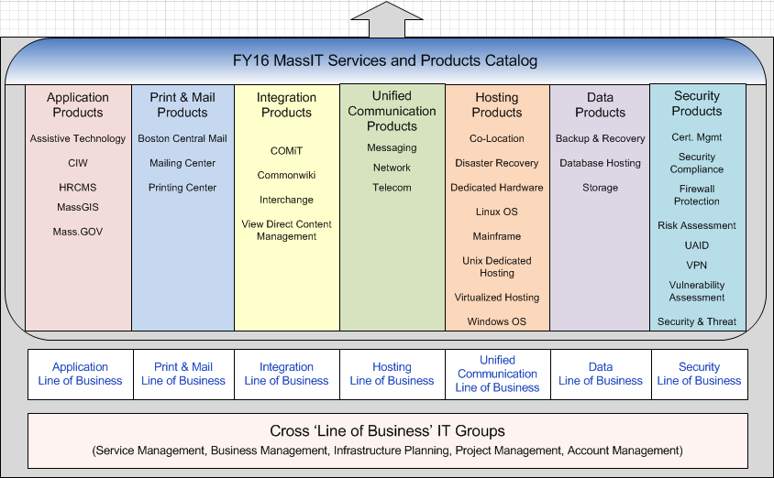

Figure 1 - Overview of MassIT Products/Services

A detailed description of each product/service is available on the MassIT Product and Service Catalog, which is published online at http://www.mass.gov/anf/research-and-tech/it-serv-and-support/MassITs-services-catalog/

The Product Catalog provides the following information:
- Description of products/services & support functions
- Service Targets / Hours of Availability
- Reporting
- Service Request / Lead times
- Customer vs. MassIT Responsibilities
- Chargeback Rate Information

MassIT Snapshot

- 70,000 estimated network users from 330 sites / day
- 25.1 Million messages received on average/ monthly
- 8.35 Million SPAM messages blocked on average/monthly
- 7.4 Million+ online transactions processed by RMV's system/ day
- Host the state's accounting system, and the state's payroll system
- 330,000 web pages hosted on Mass.gov
- 27.6 Million pieces of outgoing paper mail processed
- 600+ TB Storage at 2 Primary Data Centers
- Currently have 859 Virtual Machines Guests and 139 Physical Hosts
- 222 Physical Hosts on Linux and 226 on Windows
- MassIT employs 360 full time equivalent staff

Provisioning Products/Services from MassIT
When a customer intends to utilize additional products/services from MassIT, The MassIT Service Account Manager provides a Business Approval Request (BAR) form with a budget (cost breakdown) that becomes the financial agreement between MassIT and customer. (Figures 2 & 2.1)
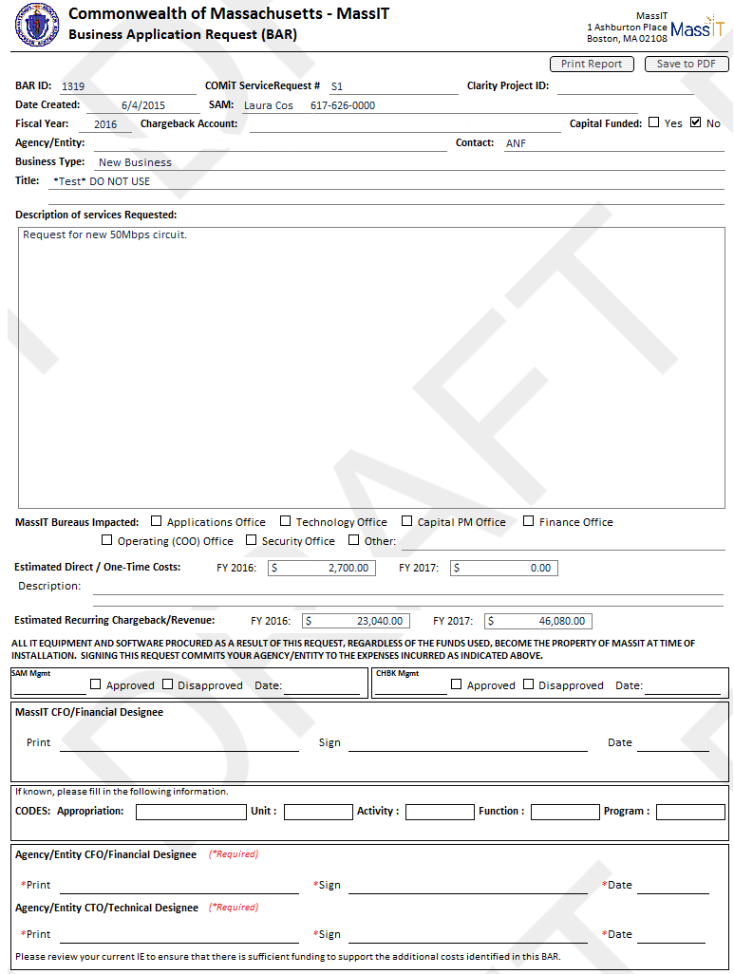
Figure 2 – Example: Business Approval Request (BAR) Form

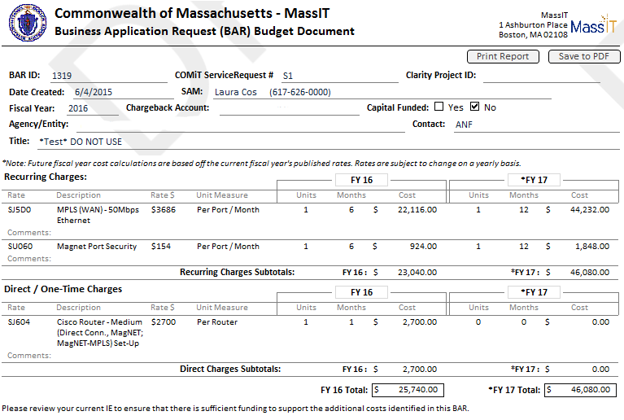
Figure 2.1 – Example: BAR Budget

When a customer is procuring multiple products (e.g. storage, hosting, firewalls) to service a specific business need, the BAR documents will be provided. When requesting fully managed services, the SAMs work with customers to complete an IT Service Level Objective (ITSLO) document which defines the expectations of MassIT and the customer for that fully managed IT Service.

Business Planning Cycle
MassIT is managed like a (zero profit) business. Each product/service area within each line of business develops an annual business plan that accounts for known requirements and defines what activities will take place in the following fiscal year and how costs and revenues need to be adjusted so that a rate can be developed for each product/service.

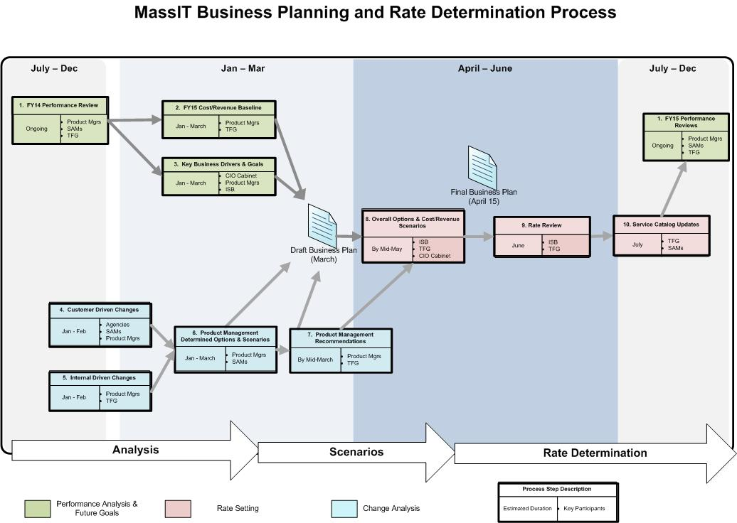

Figure 2 - Overview of MassIT Business Planning Lifecycle

Draft Business Plans are typically reviewed in the April through June timeframe. Rates are reviewed with the ISB members at the August ISB meeting.

Cost Accounting

How is MassIT Funded
MassIT is primarily funded through two chargeback revenue accounts:
- 1790-0200 via legislative authorization (BCS)
- 1790-0400 via legislative authorization (PAD)
MassIT may also receive capital appropriation for specific projects. Capital costs are not included in the statewide chargeback model except for depreciation of costs in order to approximate replacement value once end-of-life occurs.
MassIT also receives a small appropriation 1790-0100 which funds non-chargeback payroll and a retained revenue account 1790-0300 that is used to collect non-state agencies chargebacks.

Chargeback Cost Models

State Model
MassIT provides an invoice every month to customers for their usage of MassIT’s products/services. Rates are based on forecast costs and forecast units of usage.
On a regular basis throughout the year MassIT monitors revenues for over or under recovery and works with the Product Managers within the MassIT lines of business to make corrections as needed.
MassIT’s chargeback costs are subject to both state and federal audits.

Federal Model
MassIT is required to generate a Year-End reconciliation “memo” invoice for specific customers. This is used to provide federal reimbursement for certain federally funded programs and requires MassIT to use federally approved billing rates and methodologies.
MassIT follows generally accepted accounting principles and is audited by KPMG (formerly Deloitte & Touche).

Accounting Rules
MassIT follows the following accounting rules and guidelines.

Code of Federal Regulations (45 CFR95)
The code of regulations specific to administration of grant programs for public assistance and medical assistance mandates specific accounting rules that have to be followed.
Specifically 45CFR95.707(2) makes the federal government a partial owner of MassIT assets – “If the cost of the equipment was claimed in the period acquired and the equipment is later transferred to an activity which is not involved in the performance of programs currently or previously funded by the Federal Government, an amount equal to the fair market value of the equipment on the date of the transfer shall be credited to current expenditures in approximate proportion to the distribution of the equipment's costs”.

OMB Circular A-87
Cost Principles for State, Local and Indian Tribal Governments.

ASMB-C10
Cost Principles and Procedures for Establishing Cost Allocation Plans and Indirect Cost Rates for Agreements with the Federal Government.

General Guidelines
MassIT uses the following guidelines:

- FIPS 96 Federal Information Processing Standards, "Guidelines for Developing and Implementing a Charging System for Data Processing Services", US Dept. of Commerce, National Bureau of Standards.
- ITIL Cost Management for IT products/services
- Straight line depreciation. The Federal government does not allow accelerated method
- The federal government requires accounting based on computer resource usage for shared services where feasible.

When not feasible, MassIT uses an accepted industry standard such as “tiered subscription” or an accepted industry algorithm validated by the Gartner Group, an industry expert. For example for Network rates MassIT uses accepted industry algorithm instead of counting data packets.

Cost Pools
Every cost is assigned to a cost pool called a unit code.

Some unit codes are specific to a single service, for example the HRCMS Application unit code (unit 1102) is specific to the HRCMS service. Some unit codes are shared across multiple products/services, for example the CommonHelp service desk (unit 3212) is shared across all products/services that have customers that utilize the service desk.

The method to allocate shared costs across multiple products/services is determined by accounting rules. MassIT focuses on ensuring that the right costs are associated with the correct products/services and the right tiers of products/services (for example some costs may only be associated with a higher level of service). Figure 4 is an example of how the allocations are tracked.

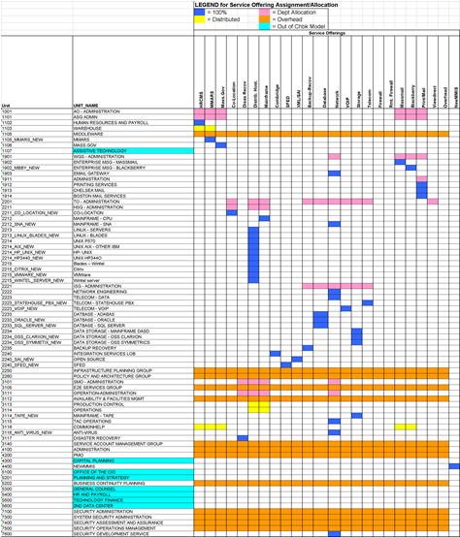

Figure 4 – Example Cost Pool Allocation across products/services

Procurement
All important cost information associated with any procurement is identified and documented on a MassIT Supply Request form. The cost information is then added to the MassIT Asset Management system for tracking purposes prior to a purchase order being issued.

The Supply Request form template is posted online at: Supply Request Template.
The instructions for completing the form are posted online at: Supply Request Instructions.

Identifying Product/Service Costs
The total cost for every product or service, MassIT provides has the following 5 key components:

Customer Specific Costs:
Costs incurred specifically in providing a unique requirement to one customer that is in addition to any standard service costs. For example, any specific overtime costs that are due to supporting a customer’s own application.

Direct Costs:
These are costs that are unique to a single product/service. For example the FTE costs for staff that manage the email exchange servers are assigned directly to the Messaging service.

Indirect Costs:
These are costs that are shared across some, but not all services. This includes data center products e.g. storage and hosting that are utilized by MassIT’s enterprise business services, e.g. Mass.Gov, HRCMS. This might also include maintenance contracts that are shared across a few products – for example a Microsoft support contract will be allocated across the MassMail and Windows OS Hosting based on usage.

Overhead Costs:
These are costs that are shared across all products/services. This is typically done either because the cost is generally attributable to MassIT Service delivery e.g. DCCIO salary or because distributing the cost as an indirect cost would be unnecessarily bureaucratic e.g. facilities leasing costs.

Management Adjustment:
For every product/service the overall cost of the product/service may be adjusted by MassIT. This is used, for example, when introducing new products/services in order to avoid penalizing the early adopters of such products/services.

Product/Service Cost Reporting:
The costs for providing each product/service are published in the MassIT Product Catalog as part of rate setting. MassIT can provide the following reports for each product/service:

Product Manager Report:
This report is used by MassIT Product Managers within MassIT to manage the costs for their product/service.

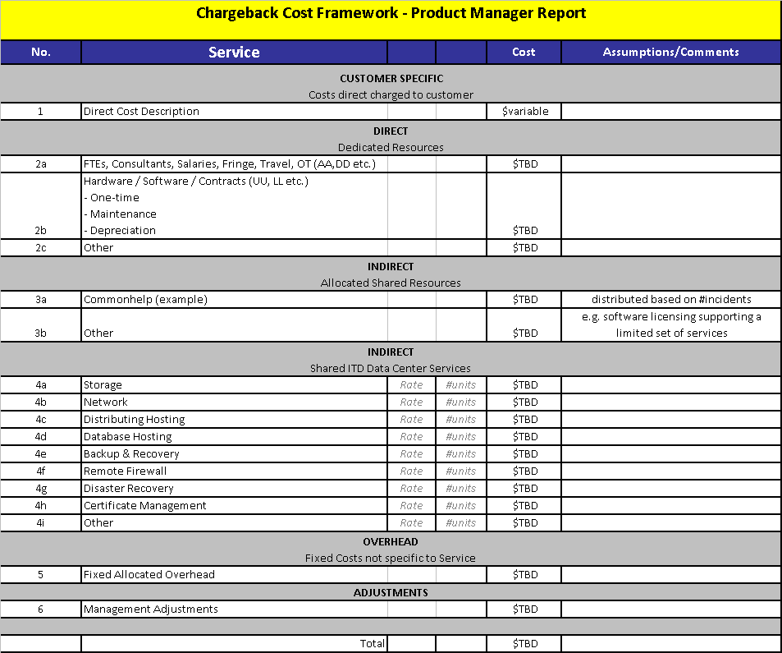
Figure 5 - Product Manager Product/Service Cost Report

Rate Setting

Determining Billable units
Every product/service has one or more billable units and corresponding rate codes associated with it.
Typically rate codes for technical products/services are defined in technical terms – for example storage is charged by Gigabytes (GB) per day. Rate codes for business products/services are typically defined in business terms. For example HRCMS rates are defined in terms of number of pay checks processed.

A complete list of rate codes (and rates) is published online at:
http://www.mass.gov/anf/research-and-tech/it-finance-and-procurement/chargeback-serv/

Calculation of Rates

Simple Rate Calculation:
Rates are determined by forecasting the total product/service costs (based on direct, indirect, overhead and management adjustment) and dividing by the forecast number of billable units.
For example, for the Massmail rate:
- Annual Direct Costs: $1,727,625
- Annual Indirect Allocated Costs $46,307
- Annual Indirect Shared Costs: $1,014,145
- Fixed Allocated Overhead $352,310
- Management Adjustment: ($774,000)
- Total Service Cost = $2,366,387
Billable Unit Code SW040 defined as “Mailboxes per month”.
Total forecast for number of mailboxes, adjusted for whole year = 36,473.
Therefore Rate = $2,366,387 / (12* 36,473) mailboxes = $5.41 per mailbox per month (500Mb).

The high level calculation for each rate is published on the MassIT Product and Service Catalog for each product/service at http://www.mass.gov/anf/research-and-tech/it-serv-and-support/MassITs-services-catalog/

Weighted Rate Calculation:
For some products/services it is necessary to distribute the cost for the product/service across multiple rates.
Example:
The Mainframe costs are distributed across multiple rate codes:
- Prime and Non-Prime CPU charges (weighted algorithm)
- Prime and Non-Prime I/O charges (weighted algorithm)
- DASD space charges
- Tape (3 types) charges (weighted algorithm)
- Print (2 types) charges (weighted algorithm)

In these instances MassIT reviews the weighted algorithm with the Federal government to ensure it complies with the accounting requirements.

Usage Accounting and Billing

Annual IE Development
At the beginning of each fiscal year, prior to the first billing cycle, MassIT will provide customers an estimated forecast of usage based on historical data and any known information provided by customers as part of MassIT business planning.
This usage estimate becomes the basis (based on the new fiscal year rates) for the forecast Internal Encumbrance (IE) for the whole fiscal year.
Historically for the executive department the IE has been provided to each customer agency. The IE information will be provided to the Secretariats, who will then distribute the information accordingly to underlying agencies.

Gathering of Usage Statistics
Each month MassIT will determine how many units of each product/service a customer has used. The tools and processes used to gather this data depend on the product/service area. All usage accounting is tracked (see figure 8) and any difficulties in gathering reliable usage data are resolved between MassIT Product Managers and the MassIT Finance office.
After data has been provided from Product Managers it is validated by the MassIT Chargeback Director to check for inconsistencies versus prior months. Chargeback Statistics are reviewed at an internal MassIT Portfolio Management Subcommittee meeting of the ISB.

Monthly Billing and Reporting System
Information on usage and invoices is provided to customers through the MassIT billing system - IBM Tivoli Usage and Accounting Manager (TUAM). MMARS transactions are congruent with the MassIT billing system.

Chargeback Billing System Accounts
Customer Accounts will be set up in the billing system based on customer’s preference. For technical services typically an account is defined to service a specific customer’s business need. For example, EOHHS has defined an account for Virtual Gateway Development Infrastructure and an account for Virtual Gateway Production Infrastructure. For Enterprise products/services, for example Massmail, MassIT will define the Account codes.

Chargeback Billing System Functionality
The chargeback billing system provides functionality to drill down into detail usage accounting data within a specific account. It also provides functionality to report at a Secretariat level or at an underlying agency level for products/services as appropriate.

Further information on the MassIT Chargeback billing system is available:

MASSIT Chargeback Billing System

Chargeback Memo Billing
When MassIT introduces a new product/service in mid-fiscal year, a “memo bill” is utilized. This memo bill is included within the standard MassIT monthly invoice, is for informational purposes only. It is called a “memo bill” because no actual dollar amounts which must be paid. The “memo bill” is presented in a separate section of the monthly invoice and has the same information as the regular invoice section. The chargeback rate utilized for the product/service offering is calculated to only recover the operational cost MassIT expects to incur for the product/service. This policy enables the customer to calculate what the fiscal impact would be for the product/service offering in the next year.

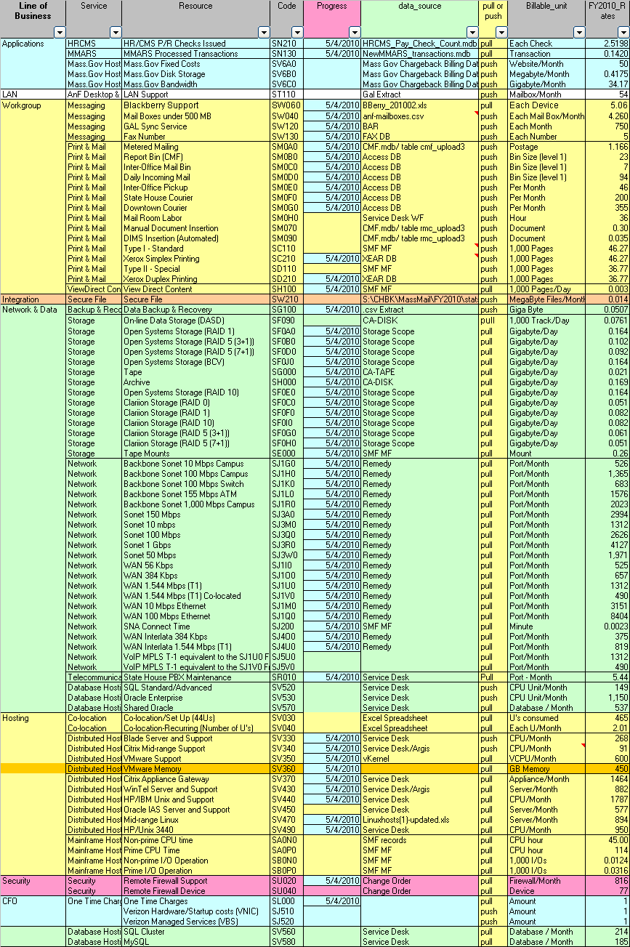
Figure 8 – Example Service Usage Tracking

Further Information & Additional Support
For any questions on the MassIT Chargeback processes please contact your Service Account Manager (SAM).
SAMs are the primary interface to customers on all aspects of MassIT product/service provision. SAMs manage the overall business relationships, manage new business, and meet with customers on a regular basis to review quality of MassIT product/service delivery and resolve billing enquiries. SAMs will be able to answer most MassIT Chargeback questions but if necessary will involve the MassIT Chargeback Director in discussions.

Information on Service Account Managers, including a list by customer with contact details, is published on the MassIT Public Website at:
http://www.mass.gov/anf/research-and-tech/it-serv-and-support/customer-support/serv-acct-mgmt/agency-sam.html

MassIT Chargeback Guide:

