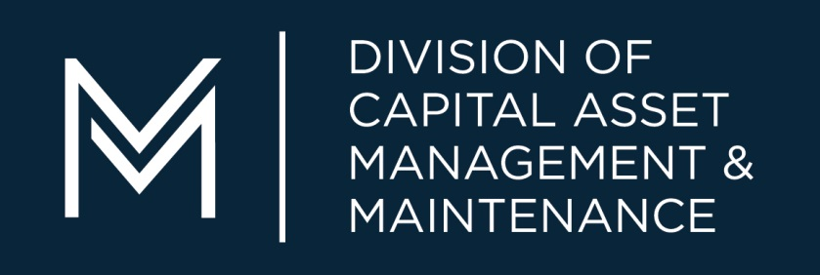

CAMIS

FY22 Deferred Maintenance

User Guide

(Non Higher Ed)

Table of Contents

Accessing and Logging into CAMIS 1
Password Change 1
Navigation 2
Home Screen 3
Finding Projects and Phases 4
Creating a Project 5
Creating a Phase 8
Requesting a Phase 10
Canceling a Phase 11
How to Attach Document 12
Cashflow Projection (Quarterly Update) 13
Exporting Data 18
Bookmarking Reports and Projects 19
Attribute Definitions 21
CAMIS Contacts 23

ACCESSING AND LOGGING INTO CAMIS
To access CAMIS you will use your username and password. Your username is usually your first initial plus last name (John Smith would be jsmith). Your password is defaulted to “password” which you can change.
CAMIS URL HTTPS://CAMIS.DCP.STATE.MA.US
CHANGING PASSWORD
The Password requirements are:
- Must contain at least 1 lower case letter
- Must contain at least 1 upper case letter
- Must contain at least 1 number
- Must contain a special character
- Must be minimum of 6 characters long
Must not exceed 15 characters long
Step | Action | Result
 | From the Home page, click the link to your name located in the upper right | The My Profile page will display  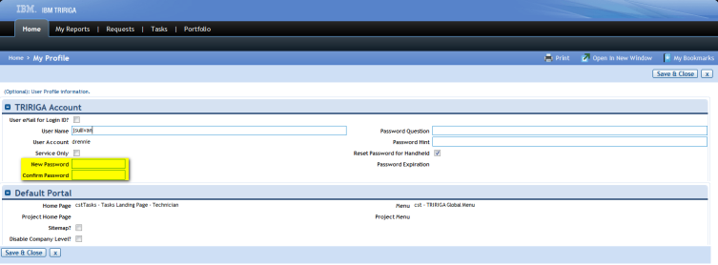
2 | Populate the field with your new password. | New password MUST contain a Cap
3 | Populate the field with your new password
4 | Click the button located at the bottom left of the screen | If successful, you will get a message telling you and you will have to Sign Out and sign back in using the new password.  If you are not successful and you do not get a message telling you that, the New Password screen will present itself again with blank fields. (it is most likely that the special character was not recognized so you should try a different special character in your password).
NAVIGATING CAMIS
This section will explain what the different symbols mean in CAMIS.
Icon | Function
 | Opens the linked object in a new window
 | Page forward when multiple pages are available
 | Page back after page forward has been used
 | Refresh the current page
 | Displays a complete list that is not displayed (used with Tabs)
 | Collapse the portlet
or | Expand or Maximizes the portlet
Produces the list of available values with which to populate the field
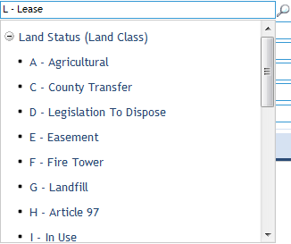
 | Removes the value with which a field is currently populated
Produces the list of available values with which to populate the field
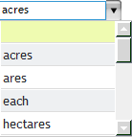
 | Displays a calendar from which a date can be selected to populate the field

HOME SCREEN
Depending on your security role in CAMIS you will access the Deferred Maintenance screens in two ways. If your agency does not use CAMIS for work order management, then your home screen will be the Deferred Maintenance page.

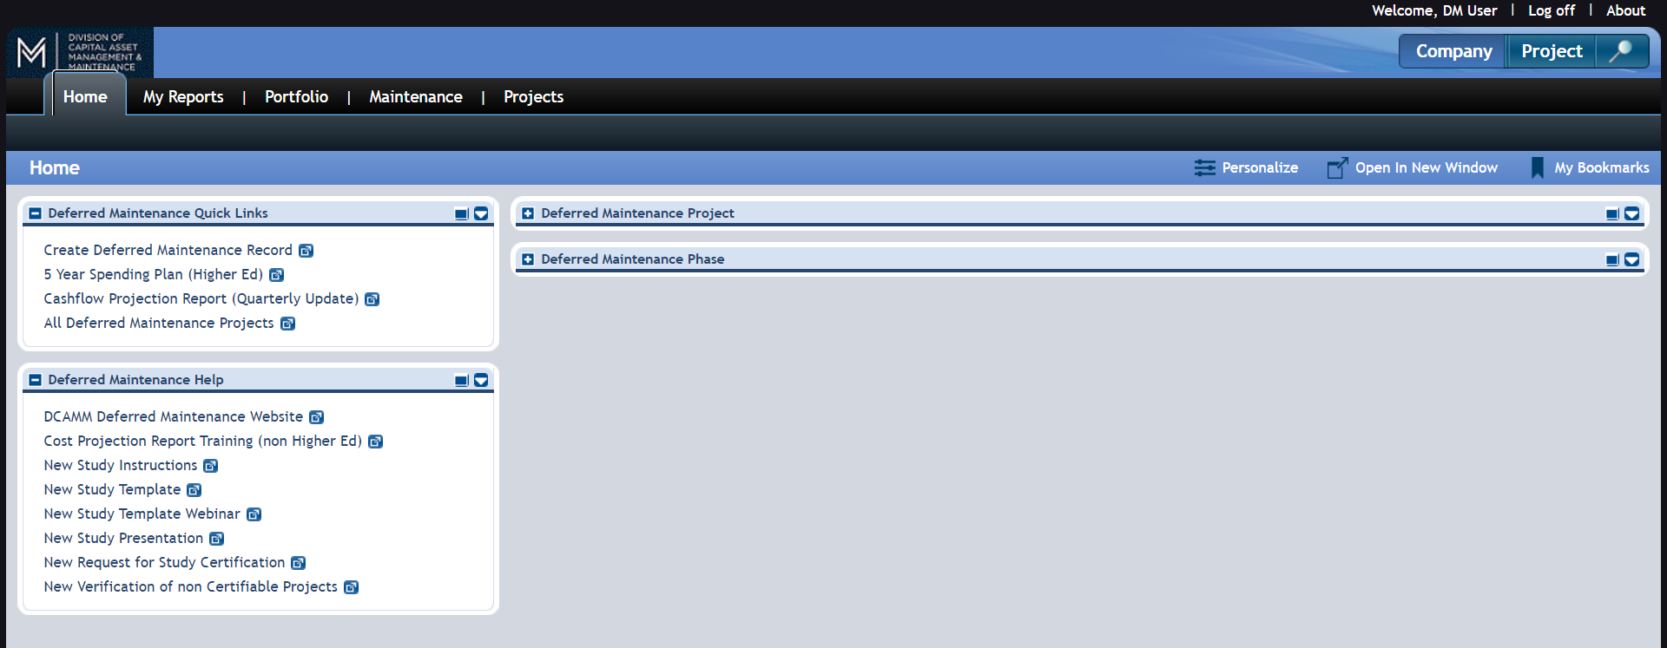

If your facility uses CAMIS for work task management, you will need to navigate to the MAINTENANCE tab and then DEFERRED MAINTENANCE.

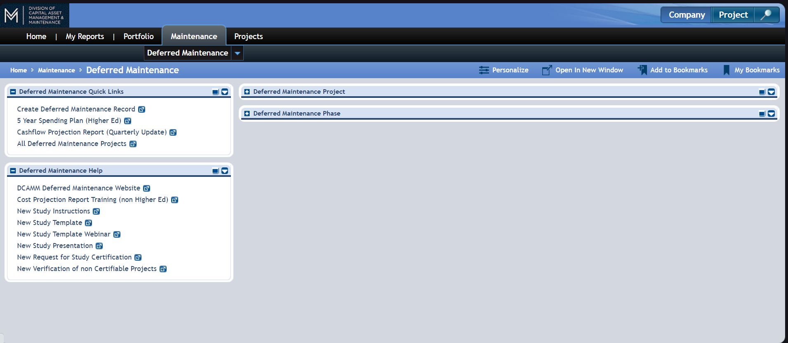

FINDING PROJECTS AND PHASES
In the Deferred Maintenance window, you will see two portlet queries. One is for the Projects and the other is for the phases within the projects. You can search either query to find, sort and even export your data. Use any of the white “contains” boxes to search any of the fields.

Search by J #.
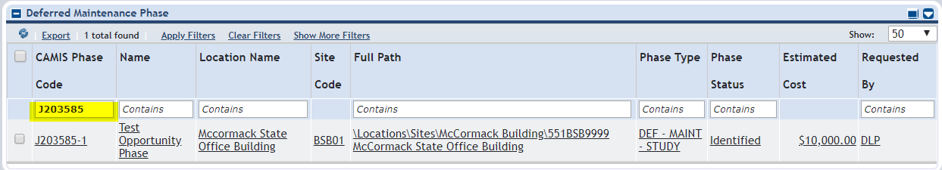

Search by Title.
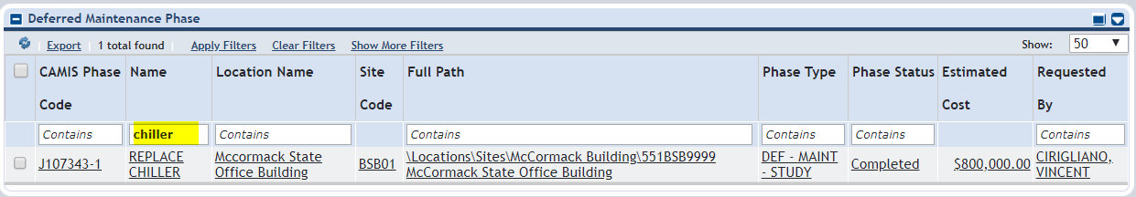
Search by Status
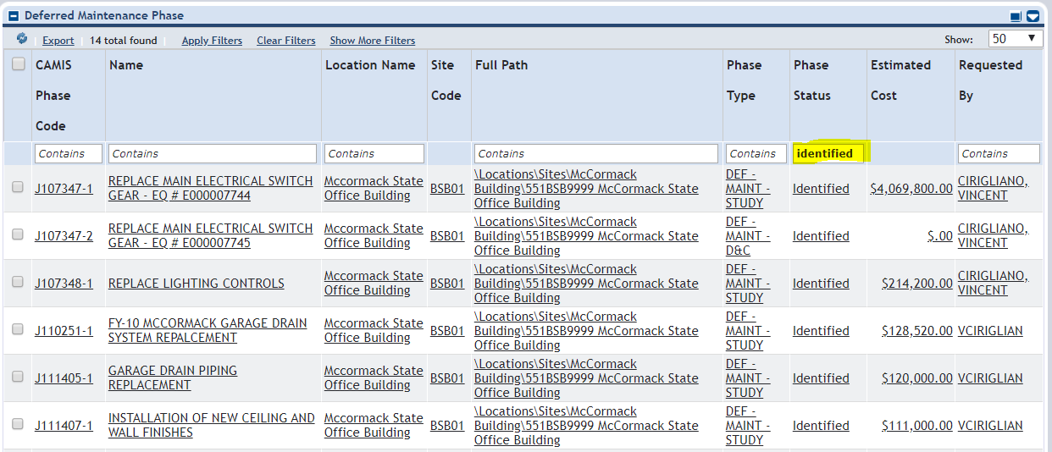
CREATING A PROJECT
To create a Deferred Maintenance record, you must create a project. The project acts as a folder for the phases that will be added later. In the project folder you will enter the basic details such as the project description, location, priority, assets, etc.
After Projects are identified you can then move them into IN PROGRESS and COMPLETE as needed. You will REQUEST a project at the phase level in later steps.
Step |  | Action |  | Result
 | Using the Quick Links you can create a new project.  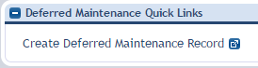  Another way from the list of Deferred Maintenance Project portlet, click the Add link  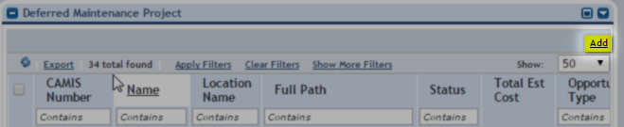 |  | The Project page for the specific phase will display:  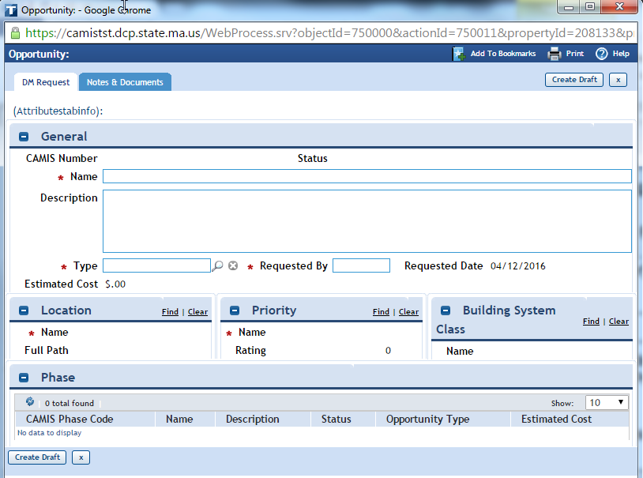
 | Populate the Name and Description Field. The name should have the FY being requested, what the project is and where it is located. The description gives you space to explain why the project is needed.  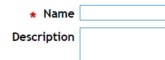 |  | 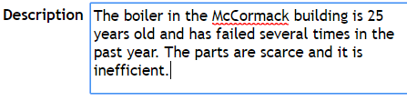
Step |  | Action |  | Result
 | Enter the TYPE of project. This will always be “DEF-MAINT” at the project level.
 | Enter the REQUESTED BY field. This is the person who should be contacted if DCAMM has questions.
 | Enter the LOCATION information by selecting the FIND button. |  | Your location list will appear.  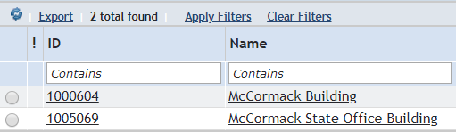
 | Click in the radial button to the left of the applicable Location
 | Click the OK link  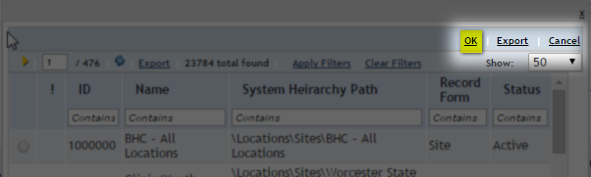 |  | The Location field will be populated with your selection  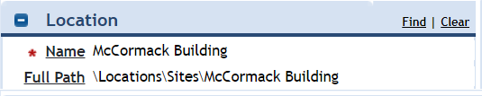
 | In the Priority portlet, click the Find link |  | A list of Priority options will display:  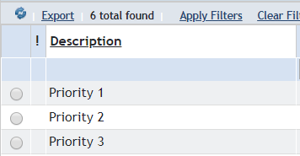
 | Click in the radial button to the left of the applicable Priority and then select OK. |  | 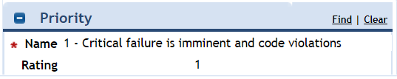
Step |  | Action |  | Result
 | Enter the Building System portlet. This helps DCAMM categorize the project. Select FIND. |  | A list of Building System options will display:  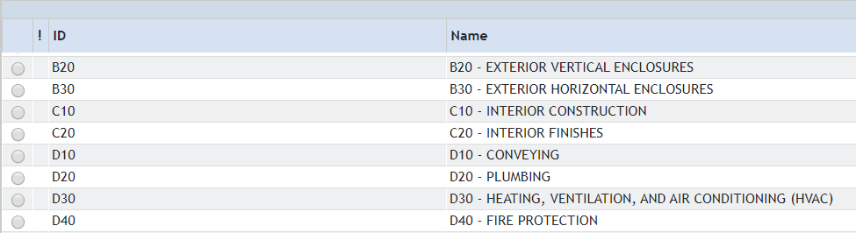
 | Click in the radial button to the left of the applicable Building System and select OK. |  | The Building System field will be populated.  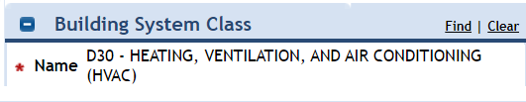
 | Enter any assets (If applicable). Select the FIND button to show a list of assets for the location you selected. |  | A list of assets will appear  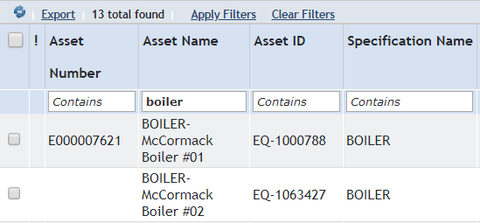
 | Click in the radial button to the left of the applicable Asset(s) and select OK.  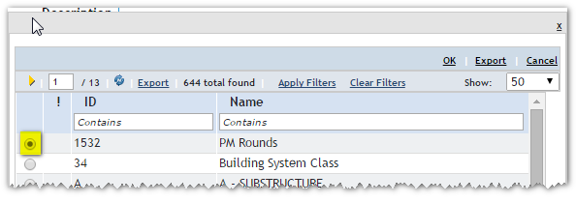 |  | The Assets field will populated  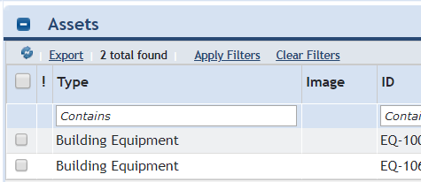
 | To create and save the project, Click the button. |  | Project will be created and J# will appear.  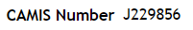
 | If a phase is being entered at this point, stay on the project form. If not, you can select “SAVE AND CLOSE” to leave the form.
CREATING A PHASE
After creating a project, you will need to create a phase on the same form. You should create either one or two phases.
- If the project does not need a study, then phase 1 will be for design and construction (D&C) of the project.

- If a study is needed, then phase 1 will be the study and phase 2 will be the design and construction (D&C) of the project.

Step | Action | Result
 | In the project form, click the ADD button under the phase portlet.  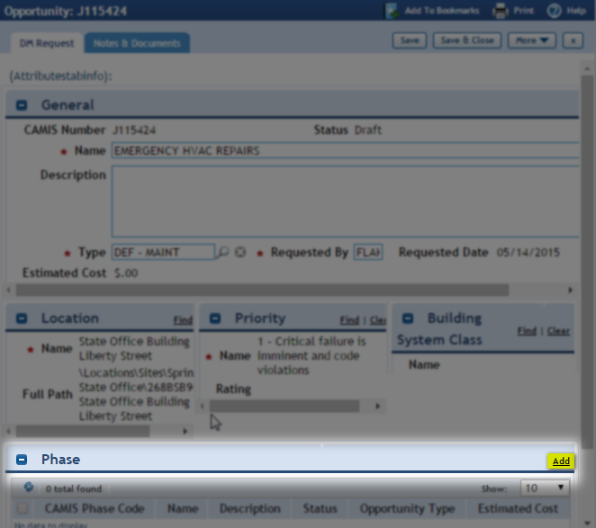 | A Blank Phase page will display:  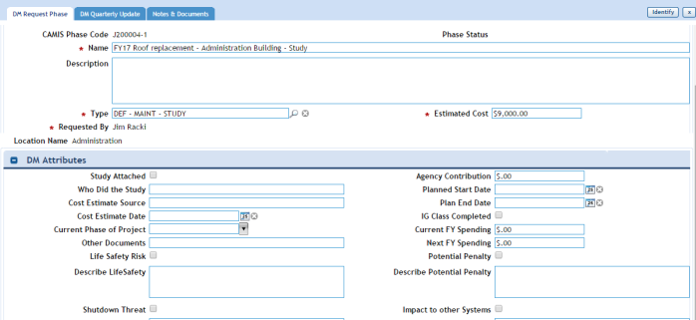
 | Enter the NAME. The recommended way is to copy the project name and add either “ -study” or “-D&C” to the end depending on what this particular phase refers to.
Step | Action | Result
 | Enter the DESCRIPTION. This should be the details of the phase you are entering. | 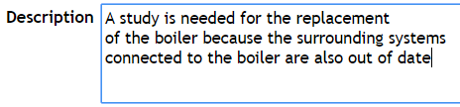
Enter the TYPE. This will be either “DEF-MAINT – D&C” or “DEF-MAINT – STUDY”.
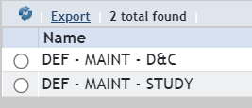
 | Enter the COST. IF you do not know the cost you can enter $0 until you get an actual quote.
 | Enter the DM Attributes. This is a list of questions that you will answer that DCAMM will use to help determine how to distribute funding.  See PAGE 17 for definitions  (If creating an emergency funding phase outside of the DM process this will not be needed) | 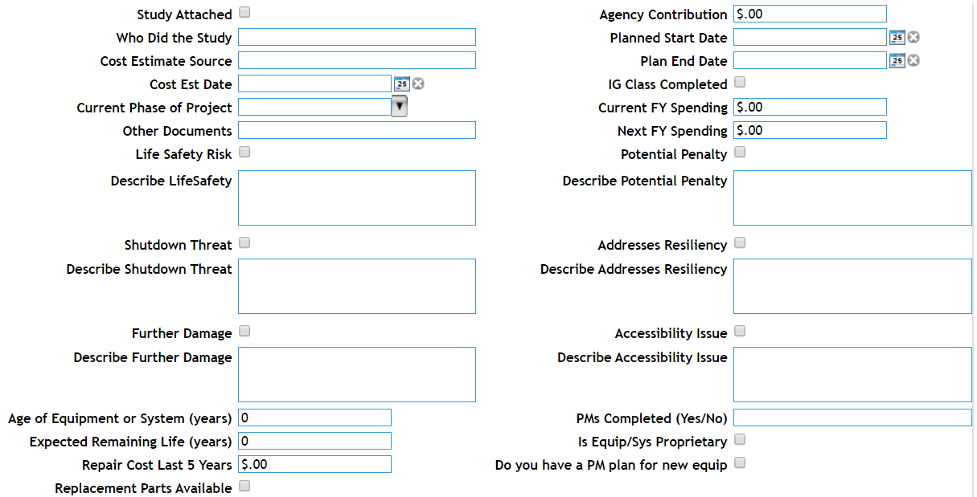
To complete the phase, select the IDENTIFY button on the top right to create and save the phase.
This puts the phase into an IDENTIFIED project ready to be REQUESTED.

REQUESTING A PHASE
When it comes time to request a funding from DCAMM you will want to move any identified phases you have into the requested status so DCAMM can evaluate them.

Step | Action | Result
 | From the list of Phases in the Deferred Maintenance Phase portlet find the phase you want to request.  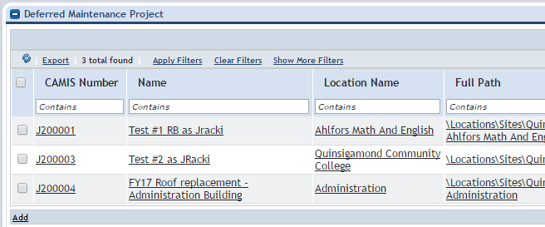 | The Phase page for the specific project will display:  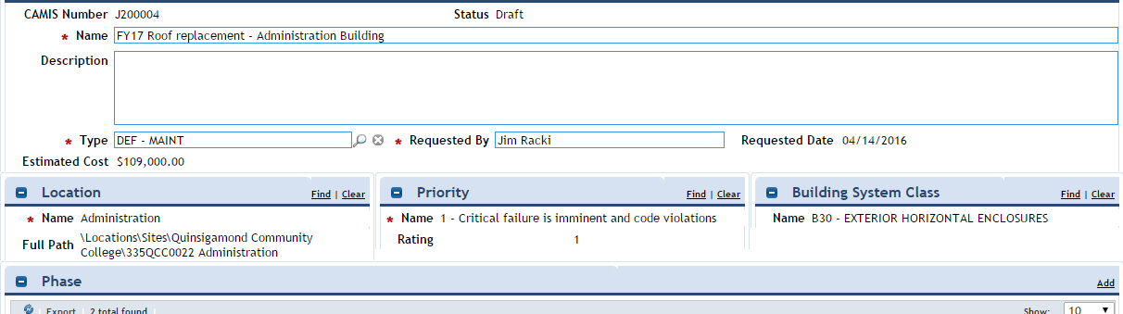
 | In the top right corner of the phase portlet, select REQUESTED to request the phase. | A warning will appear for you to confirm that you want to Request this Phase.  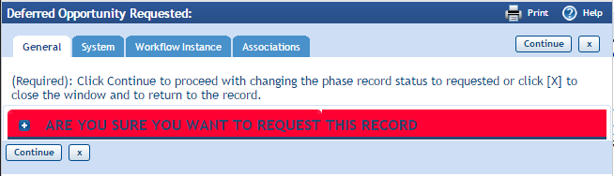
 | Click the button to confirm.  Click the if you do not want to request the Phase. | The Phase will be moved to a Requested status.  The Phase will stay as Identified.
 | The Phase form will close and the phase will be in REQUESTED status.

CANCELING A PHASE
If a phase is no longer needed in the CAMIS system, you can CANCEL the phase. It will not remove the phase, but it will take it off your active lists.
If a phase was cancelled by accident contact a CAMIS COORDINATOR and we can reverse it.
Step | Action | Result
 | From the list of Phases in the Deferred Maintenance Phase portlet select the phase to CANCEL. | The Phase page for the specific project will display:
 | In the top right corner of the phase portlet, select CANCEL to cancel the phase. | A warning will appear for you to confirm that you want to cancel this Phase.  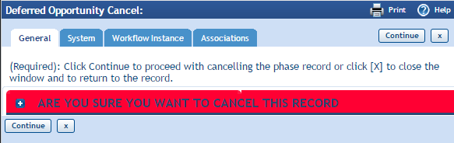
 | Click the button to confirm.  Click the if you do not want to cacnel the Phase. | The Phase will be moved to a Canceled status.  The Phase will not be Canceled.
 | The Phase form will close and the phase will be in cancelled status.

ATTACHING A DOCUMENT TO A RECORD
You can attach documents to almost any record in CAMIS. In the Deferred Maintenance process, please attach any files to the PHASE record. You should attach any records that would support your request for funding such as studies, photos or quotes. The file can be in almost any format (PDF, JPEG, .DOC, etc.)
Step | Action | Result
 | Click on the Notes & Documents tab  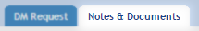 | The page will open:  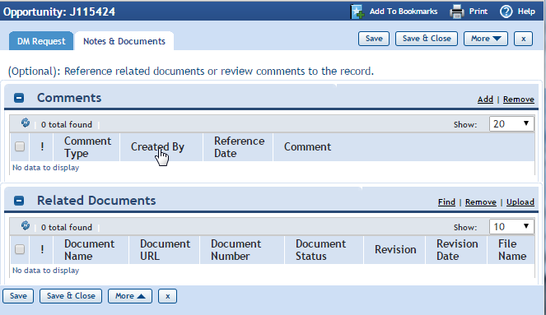
 | In the Related Documents portlet, click the UPLOAD link | The Object attachment Upload page will display:  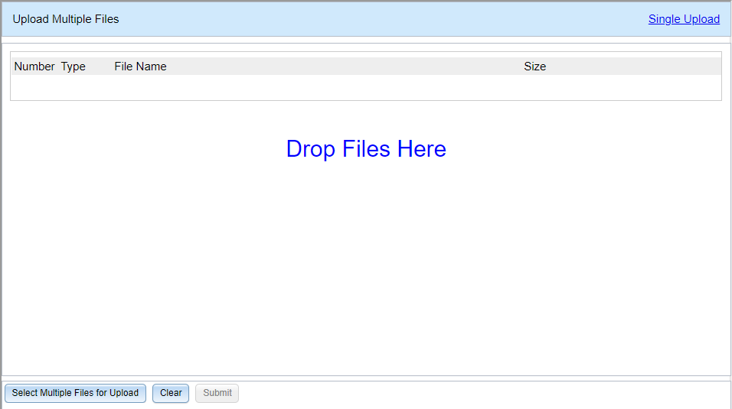
 | You can drag and drop your files right into the “DROP FILES HERE” Section.  Or To browse your computer files, click “SELECT MULTIPLE FILES FOR UPLOAD”. Select the files you want then click | 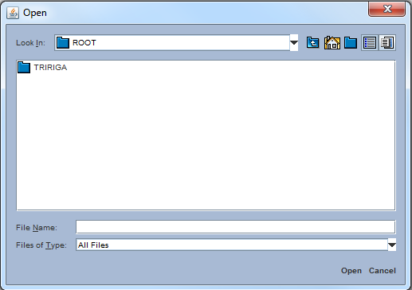
4 | Click the button at the bottom of the screen | The document will be attached and displayed in the Related Documents portlet:
CREATING A CASHFLOW PROJECTION (Quarterly Update)
The new Cashflow projection tab will be replacing the old Project Status Report tab on the project form. We hope that this new design will help both DCAMM and user agencies track the progress of their Deferred Maintenance projects. The new design is based on a Gantt chart which is used frequently in project management. This document will help you navigate the new process.
NOTE: Please create your DM project in the usual way, with a project and phase(s). The only change is the Cashflow Projection tab is on at the Project level form, not the phase level.
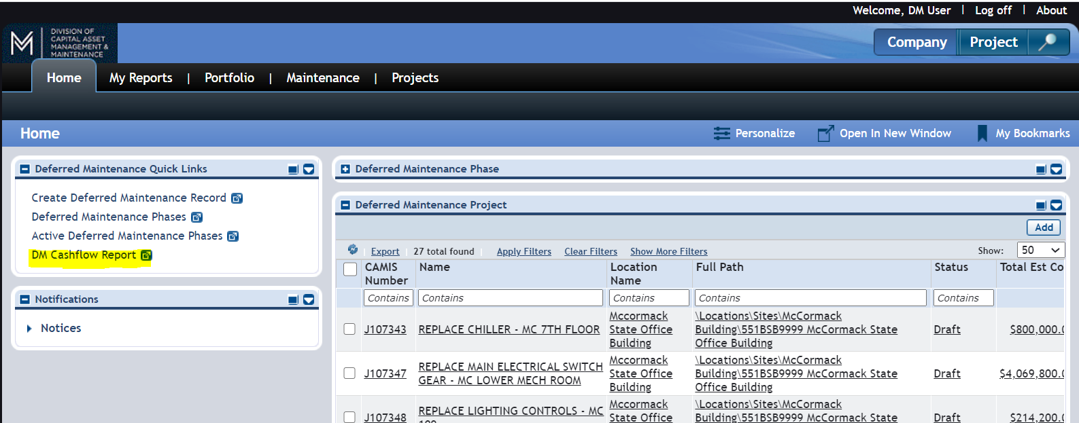
Once you fill out a Cashflow Projection for a project, you will be able to quickly find it in this report. When the next quarterly update comes around you can just use this report to see all your projects.
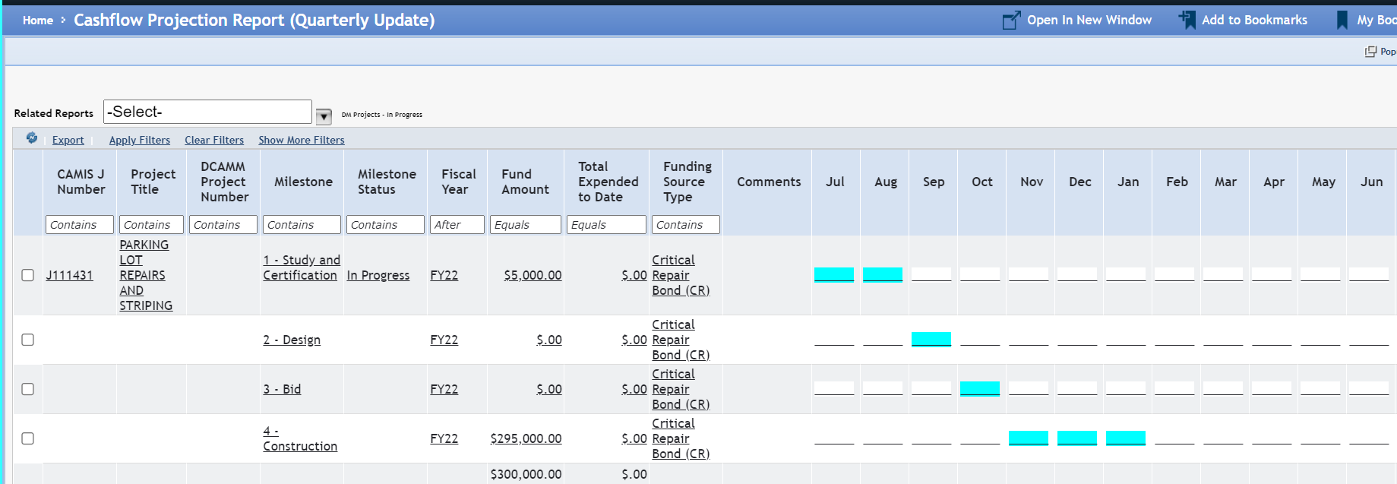

To create a Cashflow Projection, navigate to a project the same way you would edit a current entry. (changed because not everyone has dealt with entering project status reports) Find the project in the DEFERRED MAINTENANCE PROJECT portlet or from your 5 YEAR SPENDING PLAN REPORT and select it to open.
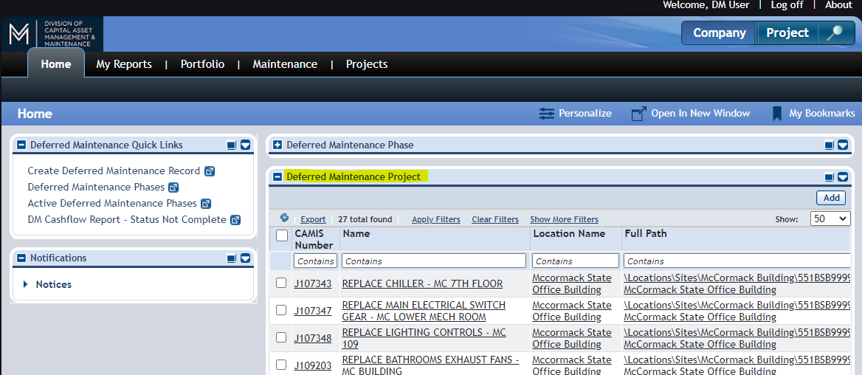

Once open you will see the Cashflow Projection tab where the Project Status Update tab used to be. Select the tab to open it.
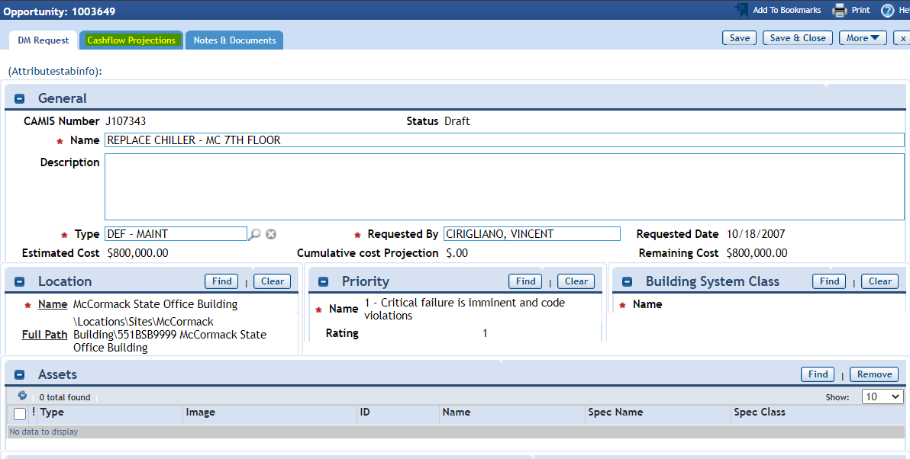

When first opening the tab, it will be blank. We ask that you add 4 lines to this report. To add a line, you will select the ADD button on the right hand side of the screen.
- Study and Certification
- Design
- Bid
- Construction
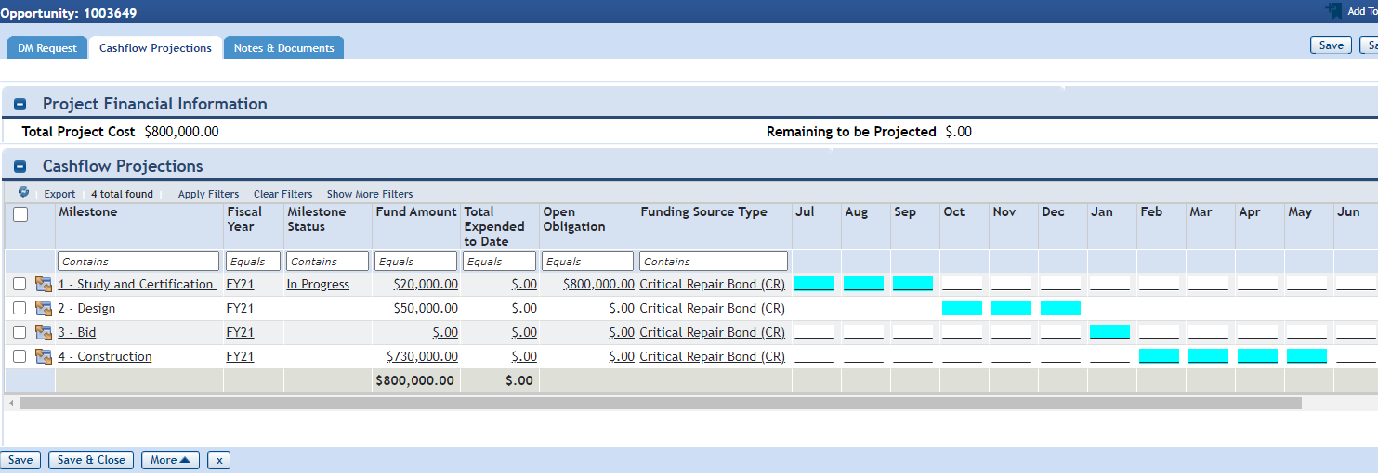
This is what a completed Cashflow projection should look like when complete.

To Create a Cashflow Projection select “ADD” on the right hand side of the screen.
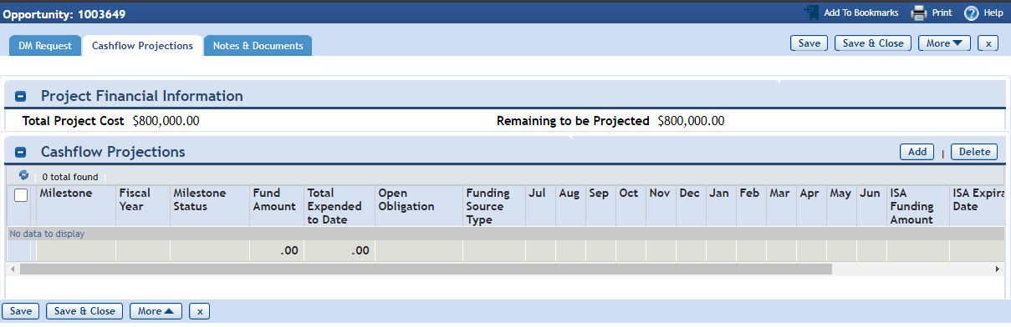

After selecting ADD, the Financial Information and Milestones Timelines form will appear.
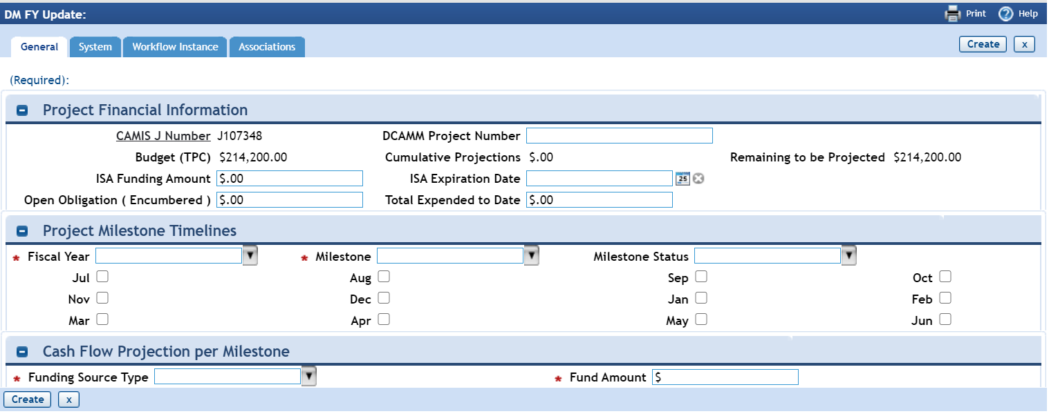

The first section is the Project Financial Information. We ask that you fill out the following.
- ISA Funding Amount: Amount of money transferred in the ISA.
- Open Obligation (Encumbered): Amount of money that has been encumbered.
- DCAMM Project Number: The Project number that was assigned in the ISA (Ex: UML2101)
- ISA Expiration Date: Date that the ISA Expires (Usually 2 years unless extended)
- Total Expended to Date: Amount paid to vendor in this step of process.

The next sections are the Project Milestone Timelines and Projection. This is where you will tell us how long this process should take and if this step is in in progress, completed or Not Applicable.
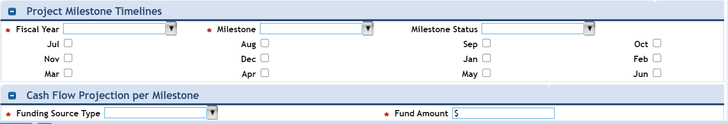

- Fiscal Year: The fiscal year that this step of the process will take place.
- Milestone: The Milestone step that this data refers to.
- Milestone Status: The status of the selected Milestone.
- Months list: The months in which this step will take place.
- Funding Source Type: What type of money is being spent (Bond, Match, SRP, etc)
- Fund Amount: How much you expect to spend on this step.

After completing the four steps in your project you should end up with the report below.
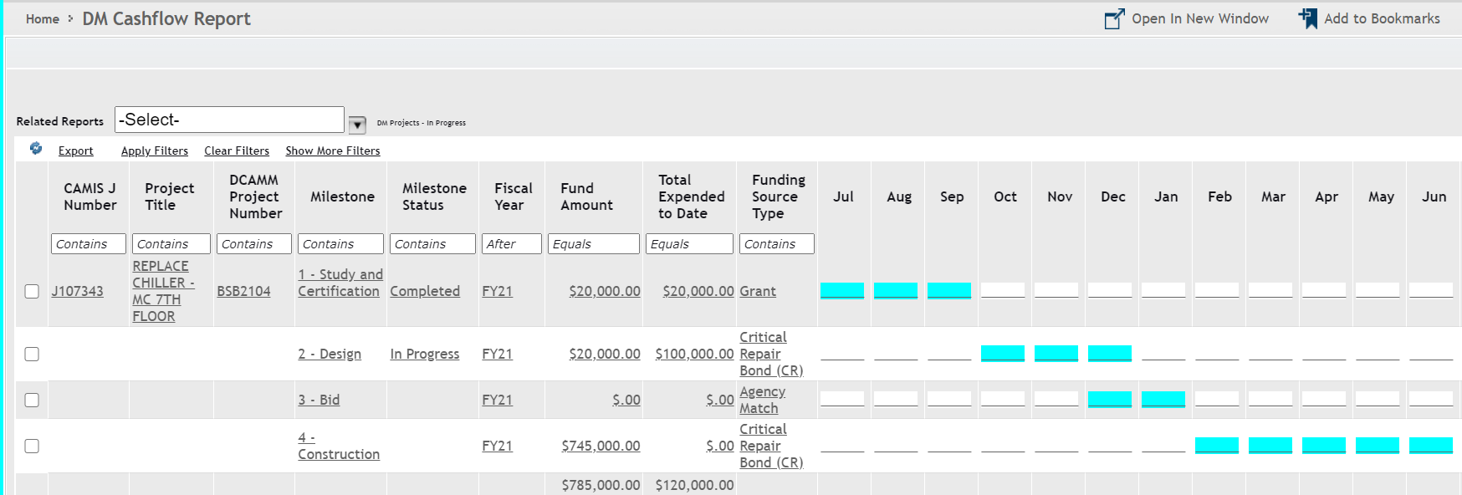

When the time comes for the next update, you can use the Cashflow Report to see all your projects you have created Cashflow projections for. You can also follow this guide and add any other project that does not have a projection yet.

EXPORTING DATA TO EXCEL
There are many ways to export data from CAMIS query portlets or reports. Simply select the EXPORT button which is located above the headers of the query. If you use filters on the query first, the system will only export the filtered data.
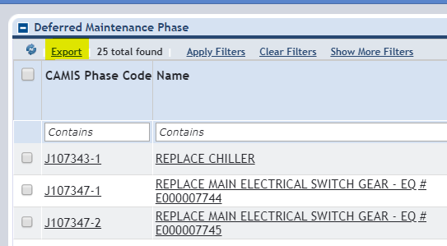
In Chrome browser it will show the downloaded file in the bottom left of your screen. In Explorer browser it will ask if you want to save or open the spreadsheet.
Below is how the data will appear in excel. Most formatting is lost so you will have to reformat text, column widths and heights.

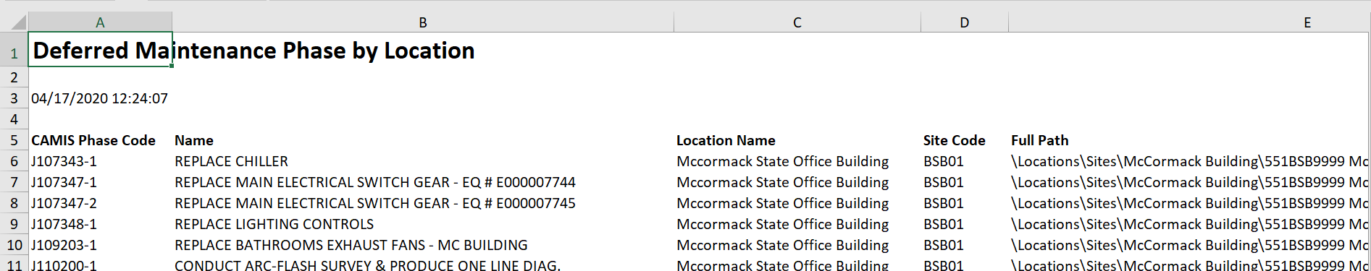

BOOKMARKING REPORTS AND PROJECTS
Using the bookmarking system in CAMIS can be very useful to have quick access to projects and reports you might need often.
Step | Action | Result
 | Open a Report, Project, Phase or many other records in CAMIS. | 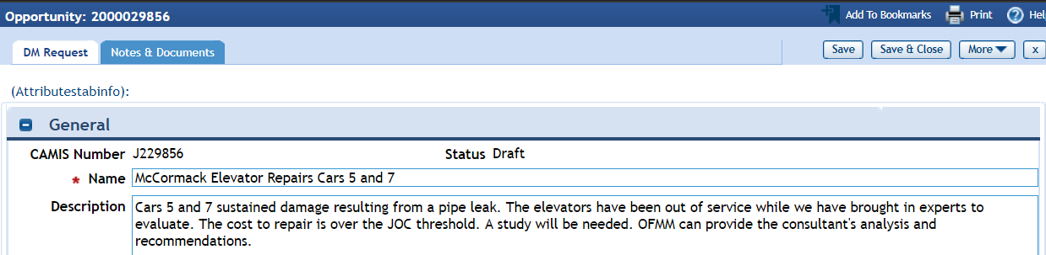
 | Click on the ADD TO BOOKMARKS in the top right hand corner of the record. | The Bookmark window will open.  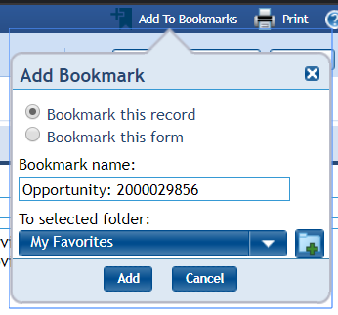
 | Edit the Bookmark Name to something relevant. This would be the project or phase name.  Select ADD to save the bookmark | The bookmark will save.
Step | Action | Result
- L, | The record is now saved in your bookmarks. To retrieve, go to the MY BOOKMARKS on the right hand side of your screen. | This will open your bookmarks and you will see everything you have bookmarked.  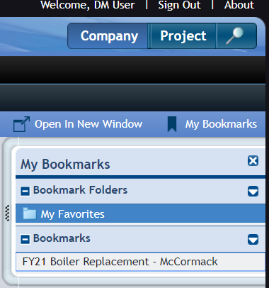
 | Click on any of your saved bookmarks. | Your record will open.  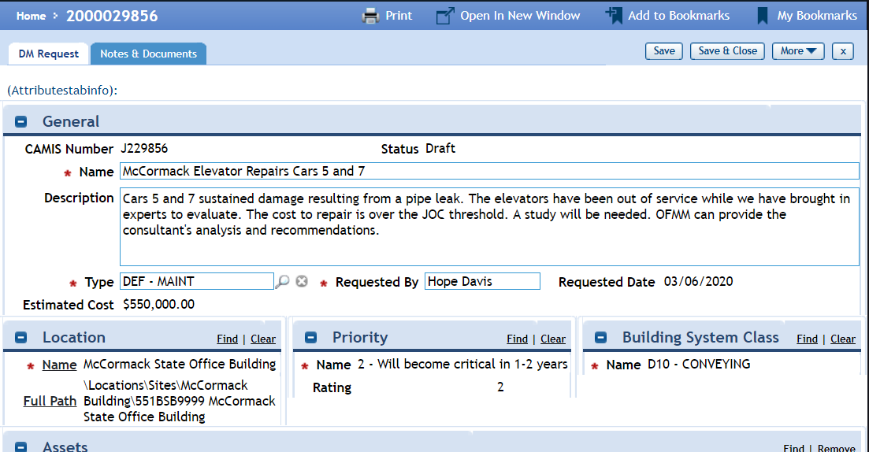

DEFERRED MAINTENANCE ATTRIBUTES
When requesting Deferred Maintenance money, DCAMM needs a way to rank each project that is submitted. These attributes are what DCAMM bases their funding determinations on. The more information you can provide, the better chance the project has of being funded.

Who Did the Study | Name of the house doctor or qualified agency employee that executed the study.
Cost Estimate Source | Vendor Name that provided the service quote to your agency.
Cost Estimate Date | Date the vendor/contractor/house doctor provided your agency a quote for services.
Current Phase of Project | What phase is the project in (Study/ D & C) Use the drop down to select an option.
Other Documents (Notes & Documents) | Checking to note that you have additional document to support this request in funding/
Life Safety Risk | Does the project involve a life safety risk? This would be a possible injury or death if this project is not completed.
Shutdown Threat | Does the project involve a shutdown threat? Is there a possibility if action is not taken on this request that the facility would be closed, if this project is not funded.
Describe Further Damage | Does this project involve anything further damage? If this system problem is not addressed now that over time that it will close further damage to other systems within the building.
Potential Penalty | Does this project involve a potential penalty? If this problem or potential failure will cause the agency to get fined by another government agency (i.e. DPH, DPS, DLS)
Addresses Resiliency | Does this project address resiliency? This would be if the identified problem was going to be increased by the rising climate or if the completion of the project would help reduce climate change.
Accessibility Issue | Does this project involve accessibility issues? Is there a need to address accessibility (i.e. walkways, entryways, elevators, drinking foundations) because of this request or because of certain triggers where must be addressed due this request.
Planned Start Date | When do you estimate that this project will start based upon the project schedule
Plan End Date | Per your planned project schedule when will this project be completed.
IG Class Completed | Name of the facility staff employee involved with this project that has completed the Inspector General’s MCPPO class on procurement
Current FY Spending | If/when this project was funded, what is the total dollar amount you project will be expended in the current fiscal year.
Next FY Spending | The amount you project will be expended in the following fiscal year.
Only Applicable if dealing with equipment
Age of Equipment or System (years) | Current age is based upon when the system was installed in your facility
Expected Remaining Life (years) | Based upon average life span of system and when it was installed how many years does this system have for its useful life.
Repair Cost Last 5 Years | How much has your agency spent on repairs and preventative maintenance for this system.
Replacement Parts Available | Can you still get parts to address the system’s needed repairs?
PMs Completed (Yes/No) | Please provide detailed information what was your preventative maintenance plan
Is Equip/Sys Proprietary | Is the equipment Proprietary (can only be serviced by the original installation vendor)
Do you have a PM plan for new equip | Please provide a detail preventative maintenance (PM) plan for the new equipment

CAMIS TEAM HELPDESK and CONTACTS
The CAMIS helpdesk is monitored by the CAMIS team and is the best way to reach out to solve any problem with CAMIS. CamisHelpdesk.DCAM@MassMail.State.MA.US
CAMIS TEAM
Dennis Fox, Program Manager 857-204-1527 Denis.M.Fox@Mass.gov

Robbie Brown, Program Coordinator 857-204-1319 Robbie.W.Brown@mass.gov

Nancy Nisil, Program Coordinator 857-204-1456 Nancy.Nisil@mass.gov

Noel Jordan, Program Coordinator 857-204-1817 Noel.Jordan@mass.gov
DEFERRED MAINTENANCE TEAM
Director of Facility Resources
Tom Tagan 857-204-1272 Francis.Tagan@mass.gov

Study Certification, DM Liaison Higher Ed
Scott Calisti 857-204-1267 Scott.Calisti@mass.gov

Study Certification, DM Liaison EOPSS
Michele Davis 857-204-1330 michele.davis@mass.gov

DM Liaison EOHHS, EOEEA
Tan Nguyen 857-204-1343 Tan.Nguyen@mass.gov

DM Liaison Trial Courts
Azinga Ming 857-204-1269 Azinga.Ming@mass.gov

