MASSACHUSETTS DEPARTMENT OF PUBLIC HEALTH

Office of Local and Regional Health

ANNUAL REPORT

FISCAL YEAR 2023

Table of Contents

Message from The Director 3

About the Office of Local and Regional Health 4

Fiscal Year 2023 Projects, Achievements, and Milestones 5

Our Equity Work 7

Looking Ahead - Goals for Fiscal Year 2024 8

Connect with OLRH 9

# Message from The Director

Dear Partners,

The fiscal year 2023 marked an important period of growth for the Office of Local and Regional Health. After successfully executing a strategic restructuring, we led the implementation of the vision outlined in the Blueprint for Public Health Excellence, set by the Special Commission on Local and Regional Public Health. Amid ongoing public health challenges, we continued to provide crucial technical assistance and resources to support local public health in Massachusetts.

Our commitment to intentional change, as outlined in the Blueprint's six interlocking recommendations, fueled significant progress. The Office of Local and Regional Health achieved crucial milestones, such as conducting the inaugural Capacity Assessment, expansion of shared services among local public health entities, and oversight of the credentialing process for Registered Sanitarians and Certified Health Officers. Additionally, we have enhanced collaboration with our internal and external partners in a more strategic manner. Notably, we engaged with various partners to begin the development of the Performance Standards. All these initiatives were made possible with our supportive Administration, our local public health partners, and our legislative champions.

We are delighted to share the accomplishments of this past fiscal year in our 2023 Annual Report and highlight our dedicated efforts to center racial equity in our daily operations. These achievements are a testament to the unwavering support and impactful work of our partners each day. We express our deepest gratitude for the commitment to our communities and steadfast collaboration on a statewide scale.

We remain excited about the opportunities ahead and look forward to continuing our collaborative journey. Our partners are indispensable, and we anticipate making a positive impact on public health together in FY24.

Sincerely,

Samuel S. Wong, PhD

Director, Office of Local and Regional Health

Massachusetts Department of Public Health 

# About the Office of Local and Regional Health

The Office of Local and Regional Health (OLRH), within the Massachusetts Department of Public Health (DPH), partners with local public health departments, boards of health, and the Tribes in improving health for all. Like the work of local public health, OLRH’s role is expansive in subject matter and operations. Guided by the [Blueprint for Public Health Excellence](https://www.mass.gov/doc/blueprint-for-public-health-excellence-recommendations-for-improved-effectiveness-and/download), OLRH collaborates closely with local public health partners to expand opportunities for support and technical assistance.

OLRH is dedicated to advancing the recommendations of the [Special Commission on Local and Regional Public Health](https://www.mass.gov/orgs/special-commission-on-local-and-regional-public-health) 2019 Blueprint report. A significant endeavor concluded with the restructuring of OLRH, marked by the establishment of the final unit, Engagement and Policy, joining the other pivotal units – Performance Standards and Data Systems, Workforce Development, and Shared Services. These four units have diligently collaborated internally and with local public health to lead the implementation of the six interlocking recommendations to strengthen Massachusetts’ unique local public health system.

**Additional FY23 Noteworthy Achievements:**

* Established an internal working group to formulate a strategic plan for the upcoming five years
* Enhanced OLRH systems to improve internal collaboration and external communication mechanisms
* Collaborated with the Executive Office of Health and Human Services Inter-Agency Working Group to provide support for emergency assistance shelter sites
* Increased shared services arrangements from 41 in FY22 to 50 in FY23, representing 88% of all municipalities

Working closely with local public health partners, OLRH made substantial progress this fiscal year toward the implementation of the Blueprint's recommendations. In fiscal year (FY) 2023, OLRH continued its commitment to enhancing public health initiatives across the Commonwealth through strategic partnerships and collaborations. These collaborative efforts exemplify the diverse range of contributors who actively participated in bolstering public health infrastructure and services.

# Fiscal Year 2023 Projects, Achievements, and Milestones

OLRH began the fiscal year with a focus on moving the six interlocking recommendations from the Blueprint for Public Health Excellence Report into action. The following section outlines the advancements of the recommendations made by OLRH in FY23.

1. **Elevate the standards for and improve the performance of local public health departments**

* Initiated the development of the inaugural Performance Standards for local public health through internal and external collaboration to set baseline benchmarks
* Conducted a Baseline Capacity Assessment (BCA) with 300 of 305 municipalities participating in the Public Health Excellence (PHE) Grant program. This resulted in 50 unique Capacity Assessment Results Toolkit (CART) meetings to support the grantees in using and understanding their results

1. **Increase cross-jurisdictional sharing of public health services to strengthen the service delivery capabilities of local public health**

* Expanded the number of municipalities sharing public health services from 267 to 311 cities and towns, representing 88% of all municipalities. This increased shared services arrangements (SSAs) from 41 in FY22 to 50 in FY23
* Provided subject matter experts support to local public health and created a summary report of the BCA results

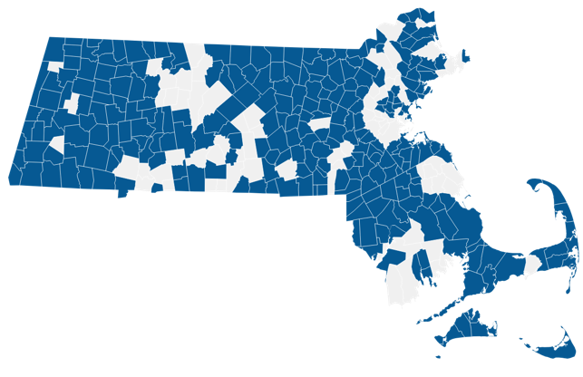 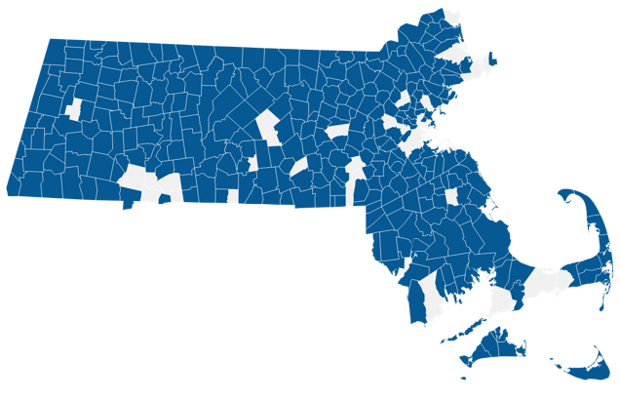

Municipalities in SSAs in 2022 Municipalities in SSAs in 2023

1. **Explore improvements to the current platforms to report, analyze, and interpret data**

* Facilitated internal DPH meetings about data sharing and integration discussions
* Released a Request for Information (RFI), to identify appropriate vendor information for the development of a unified data system for local public health

**4. Set education and training standards for local public health officials and staff and expand access to professional development**

* Implemented a racial and health equity training for more than 450 local public health professionals
* Developed the infrastructure of 10 geographically diverse regional Training Hubs to support local public health workforce towards meeting Workforce Standards, centered on training and professional development
* Hired three state-level central trainers and 13 regional trainers for the 10 newly established Training Hubs

**5. Commit appropriate resources for local and regional public health system change\***

* Developed a comprehensive vision and strategy for OLRH
* Maximized federal resources to support local public health capacity and implementation of Blueprint recommendations

*\*This recommendation is partially dependent on appropriations, which is outside of OLRH.*

**6. Ensure continuity of stakeholder engagement in the implementation of the Special Commission’s recommendations**

* Met biweekly with the Coalition for Local Public Health (CLPH) to discuss topics related to local public health, leveraging an external partnership with the Massachusetts Public Health Association to enhance member group engagement
* Conducted 22 monthly webinars delivering information and resources about local public health topics, averaging 300 participants per webinar
* Strengthened the organization of the Massachusetts Large Cities Health Coalition (local health departments of Commonwealth’s 14 largest cities) and facilitated their monthly meetings
* Created a monthly Shared Services Coordinator Collaborative Space
* Collaborated with internal and external partners when developing the strategic plan for FY24, by coordinating focus groups and interviews

*"We were able to hire two nurses to provide much needed services in our partner communities. The nurses follow up on all infectious disease cases, provide educational programs, and organize vaccine clinics. They have also brought their passion into their work, one nurse started a "simple walking" program, another nurse teaches a Be-Safe program to curb gun deaths. We are fortunate to be able to provide these services to communities that have had limited public health services in the past."*

*- Valley Health Regional Collaborative*

# Our Equity Work

OLRH is committed to addressing inequities that disproportionately impact the ability for communities of color and marginalized populations to reach their full potential of health. OLRH will continue to prioritize engaging partners and deepening our personal and shared knowledge of historical and current impacts of racism and inequity on health outcomes.

As we continue to enhance our understanding of health and racial equity in our work, we highlight some areas of intentional focus addressing equity issues during the past year. We look forward to building on this work in the years to come.

**FY23 Equity Highlights**

* Collaborated with the DPH Office of Health Equity and the Office of Rural Health to align with DPH standards in language, workforce demographic information, and data reporting in the Capacity Assessment
* Prioritized the integration of racial equity values in grantee and external partner interactions
* Implemented a racial equity training program for local public health
* Engaged with external stakeholders to infuse equity principles into all initiatives
* Incorporated racial equity principles into procurement development, internal procurement reviews, and recruitment and hiring processes

*"To reach more members of the community, vaccination efforts were amplified and with positive outcomes; 2023 saw a 35% increase in the vaccination provided to residents across our communities. This included a 60% increase in the number of home-bound residents, one of our most vulnerable populations.”*

*- Eastern Hampden Shared Public Health Services*

# Looking Ahead - Goals for Fiscal Year 2024

OLRH aims to enhance successes of prior years, prioritizing the Special Commission’s recommendations, applying racial equity principles, and fostering close collaboration with local public health and additional partners. The forthcoming initiatives for FY24 detail OLRH’s collaborative efforts to meet these recommendations and strengthen the local public health system.

**Performance Standards and Data Systems**

* Procure the development of the Local Public Health Data Solution with a strong emphasis on change management efforts
* Release the inaugural Performance Standards to establish a baseline to promote a more equitable system for local public health
* Establish a process for local public health to be informed and participate in initiatives to advance Foundational Public Health Services (FPHS)

**Workforce Development**

* Launch TRAIN Massachusetts to local public health
* Build and develop the Careers in Local Public Health website
* Refine internal support and the management of Registered Sanitarian and Certified Health Officer credentials
* Launch the Local Public Health Intensive Training program
* Develop Local Public Health Training Academy Strategic Plan
* Create pathways to support the local public health nursing workforce with nurse leaders and nursing training curricula

**Shared Services Unit:**

* Increase PHE grant funding by approximately $10M
* Refine PHE annual workplan and grant deliverables
* Improve programmatic processes and communication flows for PHE grantees
* Prioritize enhancing Shared Service Arrangement effectiveness and governance for PHE grantees

**Engagement and Policy:**

* Assess effectiveness of existing communication tools and establish diverse modes of communication with external partners
* Develop a communications plan template prioritizing Cultural and Linguistically Appropriate Services (CLAS) standards
* Implement operational infrastructure grounded in equity, through an inclusive hiring process and strategic planning in order to deepen our engagement with partners

The Office of Local and Regional Health remains steadfast in its commitment to building sustainable infrastructure and fostering the development of a more robust local public health system. We extend our sincere gratitude to our partners for their invaluable contributions in FY23.

# **Connect with OLRH**

Phone Number:

(617) 753-8018

Website:

[mass.gov/olrh](https://www.mass.gov/olrh)

Email Address:

[localregionalpublichealth@mass.gov](mailto:localregionalpublichealth@mass.gov)

# Glossary

**Acronyms**

|  |  |
| --- | --- |
| BCA | Baseline Capacity Assessment |
| CART | Capacity Assessment Results Toolkit |
| CLAS | Cultural and Linguistically Appropriate Services |
| CLPH | Coalition for Local Public Health |
| DPH | Department of Public Health |
| FPHS | Foundational Public Health Services |
| FY | Fiscal Year |
| OLRH | Office of Local and Regional Health |
| PHE | Public Health Excellence |
| RFI | Request for Information |
| SSA(s) | Shared Services Arrangements |

**Resources**

[Blueprint for Public Health Excellence](https://www.mass.gov/doc/blueprint-for-public-health-excellence-recommendations-for-improved-effectiveness-and/download)

[Public Health Excellence Grant Program](https://www.mass.gov/info-details/shared-services)

[Special Commission on Local and Regional Public Health](https://www.mass.gov/orgs/special-commission-on-local-and-regional-public-health)