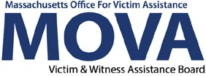
617-586-1340 | mass.gov/mova

eGrants Budget Amendment Step-by-Step Guide
All aspects of MOVA grants management will occur over the electronic grants management (eGrants) system beginning July 1, 2022 (FY23). This guide will walk through each step necessary to request a budget amendment via eGrants. Additional training, videos, and guides for eGrants can be found on MOVA’s eGrants webpage. This guide will apply to budget amendments for both SAFEPLAN and VSS with or without match.

Access to eGrants

The Website
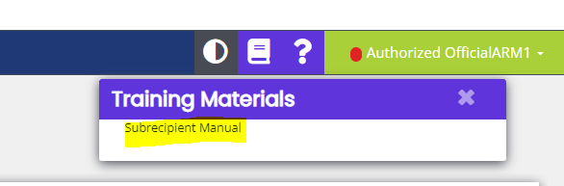
Use this link to access the MOVA eGrants system. Additional technical information about logging onto the eGrants system can be found in the eGrants Subrecipient Manual on eGrants by clicking the book icon in the top right corner of your Dashboard or on MOVA’s eGrants webpage.

Registered Users
Current subrecipient users were required to register in the eGrants system by July 1, 2021. If a user has not yet been registered, visit the Registration Tutorial on MOVA’s eGrants webpage or the eGrants Subrecipient Manual for instructions on registration.

Different user roles have different permissions in the system. Only the following users have the permissions to initiate, fill out, and submit budget amendment requests to MOVA:

- Agency Administrator
- Authorized Representative
- Fiscal Contact

Please ensure that the individual(s) working on the budget amendment is assigned to one or more of these roles for the specific application before moving on.

Budget Amendments Requests

Intro to Budget Amendment Requests in eGrants
Budget amendments refer to when the budget is edited to update line items or reallocate dollars. When a budget amendment proposal has been submitted on eGrants, please note that you are only requesting a budget amendment; MOVA will be responsible for reviewing any changes before they are approved and officially made to the contract. More information about budget amendments can be found in MOVA’s Policies and Procedures.

Once a budget amendment has been initiated, you cannot initiate any new expenditure reports until the contract is back in the status of Contract Executed. You can continue to work on expenditure reports already in process or requiring modifications, but new ones cannot be created.

Initiating a Budget Amendment Request
To initiate a budget amendment request, log into eGrants, navigate to your application, scroll down the lefthand panel to Status Options, click Amendment in Process, and confirm the green OK button in the pop up. The page will be refreshed, and you will be taken to the Document Landing Page. The Document Status will denote Amendment in Process.
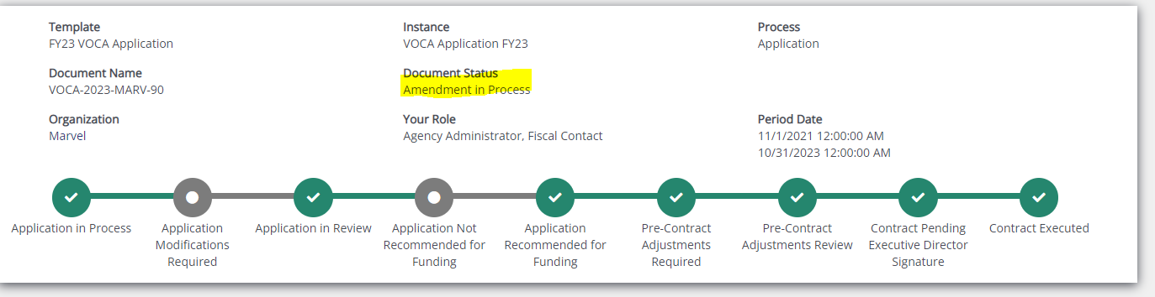

Completing a Budget Amendment Request
To complete a budget amendment request, start by scrolling down the lefthand panel and clicking the Amendment Request tab.
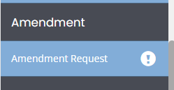

This form must be filled out before submitting the amendment request to MOVA. The information at the top will be auto-filled.
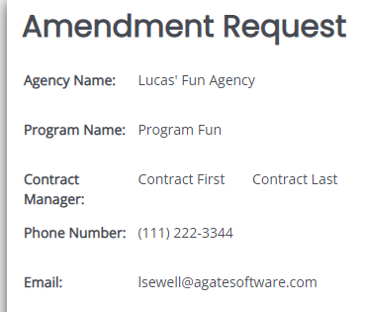

The form starts by asking if you are proposing any staff changes or sub contracts with the amendment request. If so, select Yes, and the form will remind you to initiate, complete, and submit the applicable request; for SAFEPLAN, if you select Yes for staffing changes, you will be prompted to fill out the Court Coverage form in addition to the PCF. If no, select No, and no further actions will be required.
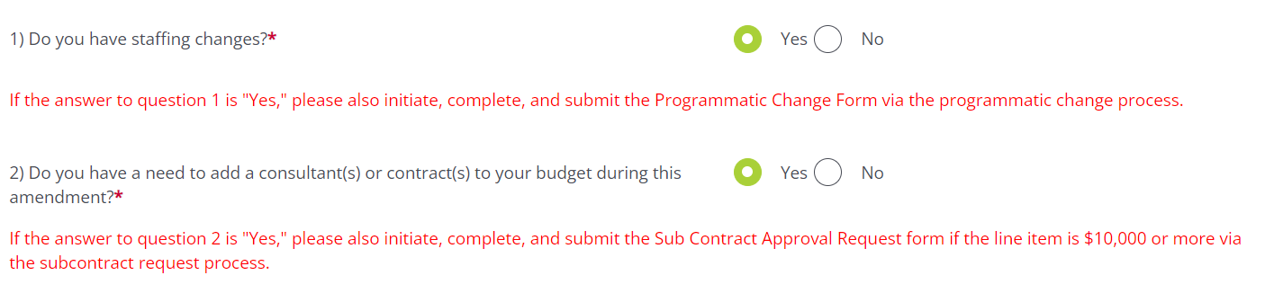

Court Coverage Form

If you are a SAFEPLAN program and propose any changes to staffing, you will be required to update the Court Coverage Agreement form (labeled as Court Coverage on eGrants) to accurately represent the staffing changes. To do this, scroll up to the SAFEPLAN Application Forms in the lefthand panel and select Court Coverage. Make the necessary changes and save them using the Save button in the top righthand corner. This is only required for SAFEPLAN contracts.
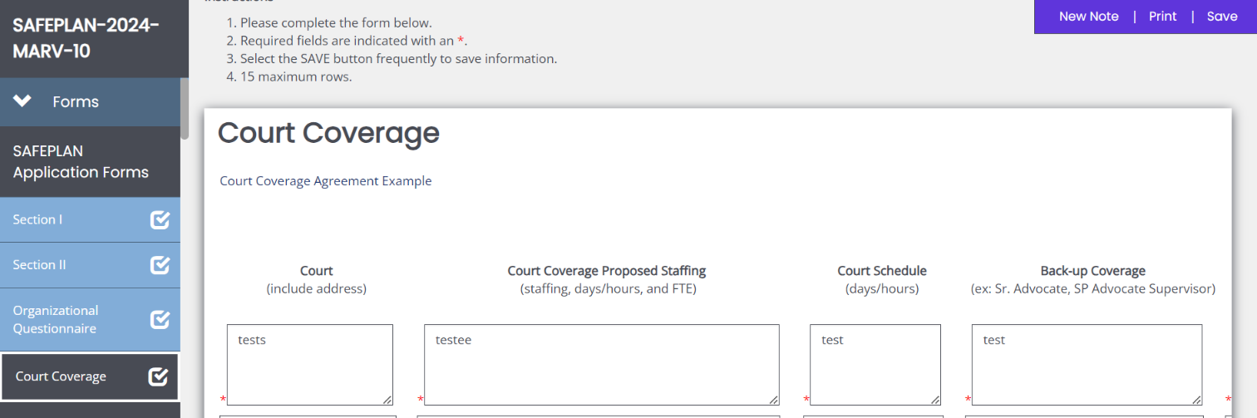

Then, you will have an amendment request narrative section. Use this box to detail the proposed updates to the budget, including but not limited to any line items added or deleted, where dollars are being reallocated to and from, and why the changes are being made. There is an optional upload box in case other files are necessary to support the changes (i.e. a rental agreement, new indirect letter, etc.).

Once all the information has been entered, make sure to save the form using the Save button in the top right corner.

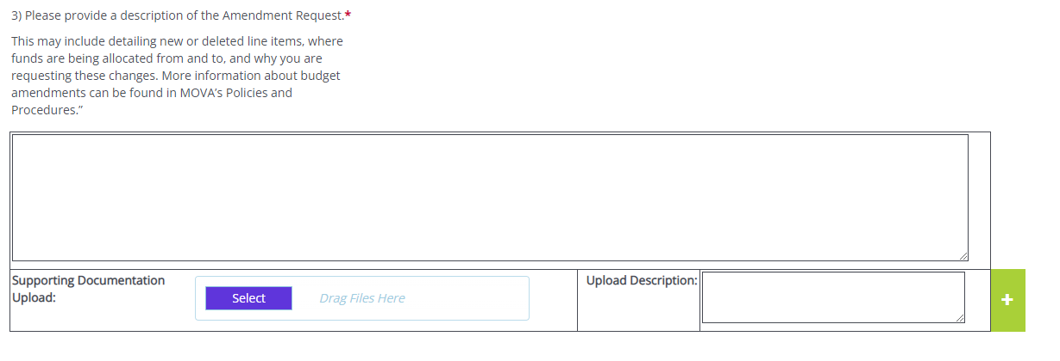
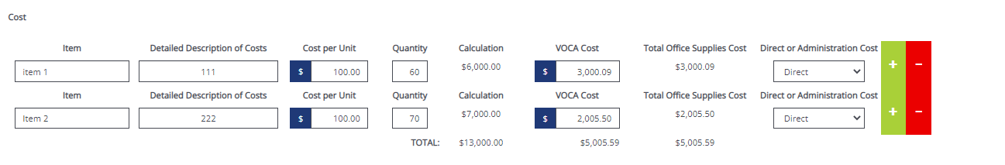
The next step for completing a budget amendment request is updating the budget. This can be done by clicking into each of the budget category tabs and making changes. The lines can be edited, or they can be added and deleted using the green + and red – buttons at the end of the rows respectively.

eGrants Tip: This part of the budget amendment process is the same as the application process. Refer to the FY24 VSS + SAFEPLAN Application Guide found on MOVA’s eGrants webpage for more thorough information regarding editing the budget. Remember that the line items should be filled out and saved before working on the Budget Narrative section and to save your updates frequently.

When all the changes have been made to the budget, click into the Summary tab to confirm that your changes are represented accurately.

If the budget amendment request is accompanied by any programmatic changes (staff changes or sub contract requests), make sure to initiate, fill out, and complete the applicable process(es) using the steps found in the FY24 Programmatic Change and Subcontract Request Guide found on MOVA’s eGrants webpage.

Submitting a Budget Amendment Request

When you have completed and saved all the relevant forms, scroll down the lefthand panel and select Amendment Submitted from Status Options. If there are any errors, the system will tell you in the pop up below and prevent you from submitting:
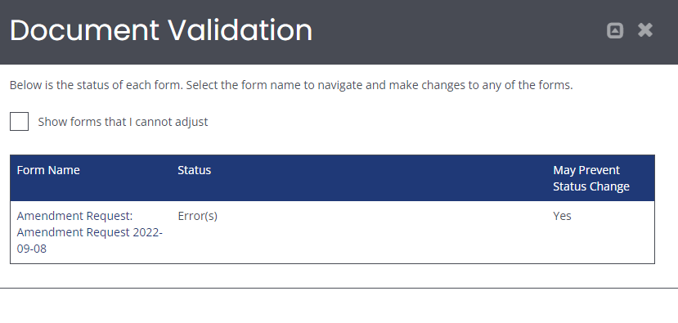

Otherwise, you will see the following pop up if your amendment request is ready for submission:
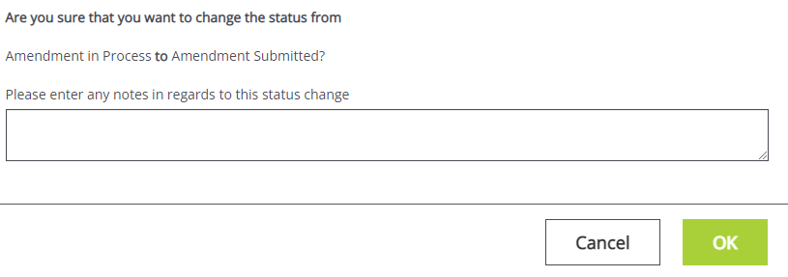

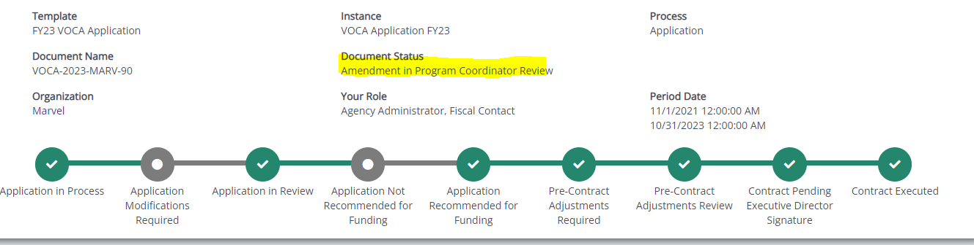
Click the green OK to submit. The system will take you back to the Document Landing Page. Here, you can find the status changed from Amendment in Process to Amendment in Program Coordinator Review.

A few minutes after, you will also receive an email notification confirming that the programmatic change request has been submitted.

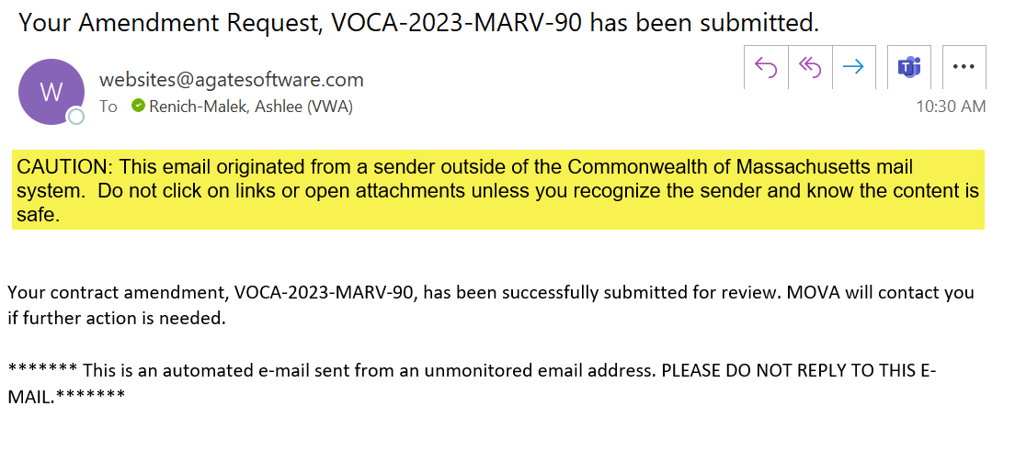

No further actions will be required of you at this time. Below, find the steps on how to find MOVA’s questions and feedback and how to submit additional information to support the budget amendment request.

Budget Amendment Request Canceled

You can cancel a budget amendment request if erroneously initiated or otherwise no longer needed. Scroll down the lefthand panel to Status Options, select Contract Amendment Canceled, and click the green OK on the pop up. This will delete any information put into the Amendment Request form and revert the budget back to its most recently approved state. The contract will revert back into the status of Contract Executed.

Budget Amendment Request Denied

You will receive an email if MOVA denies your budget amendment request, and your application will revert back to the status of Contract Executed, deleting any proposed changes to the budget and information in the Amendment Request form. MOVA will leave a comment in the Notes section to document the denial and then follow up over email if this occurs.
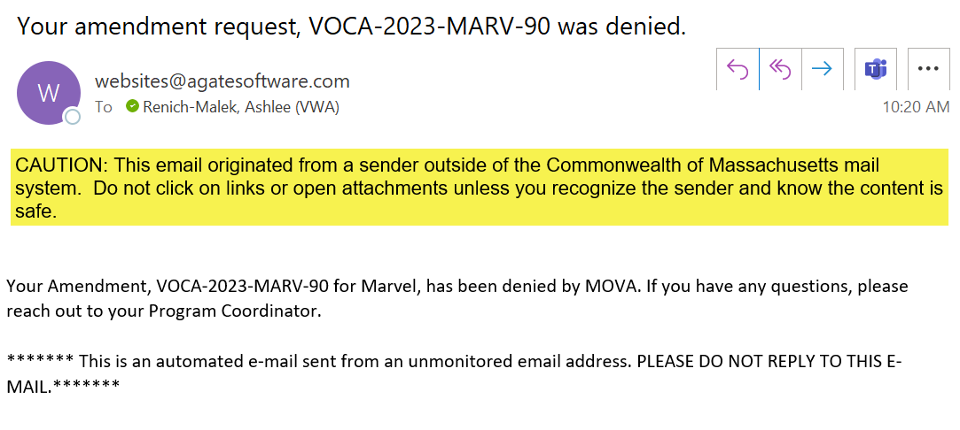

MOVA Requires Follow Up: Amendment in Process

If MOVA requires more information from you, the request will be pushed back to the status of Amendment in Process. You will receive a My Task on your Dashboard on eGrants, and you will receive an email notification.
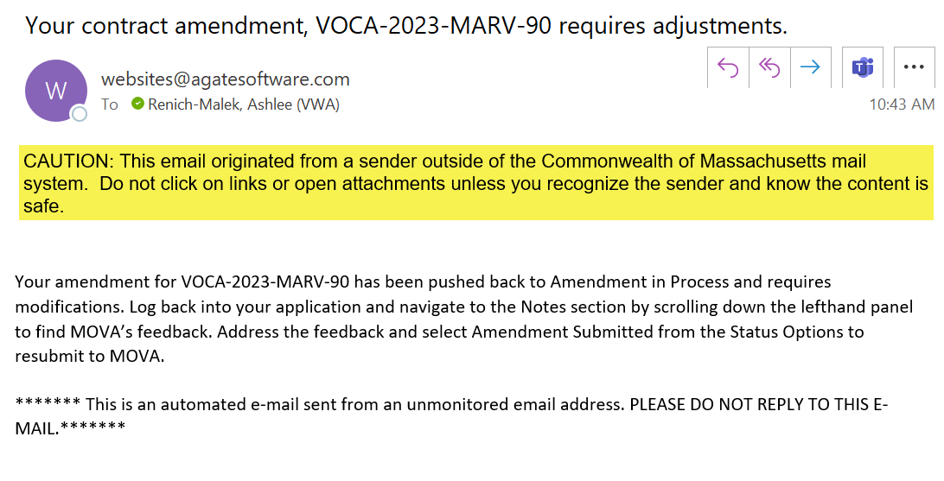

Similar to other eGrants processes, you will be responsible for logging into eGrants, navigating to the application, scrolling down the lefthand panel, and clicking into the Notes section to see MOVA’s follow up and questions. For the budget amendment request process, you will be required to review and resave the Amendment Request form, even if you do not make any other changes.

Otherwise, address MOVA’s follow up and resubmit the amendment request by scrolling down the lefthand panel to Status Options, clicking Amendment Submitted, and confirming OK in the pop again. Once again, the page will be refreshed to the Document Landing Page, and your application will be in the status of Amendment in Program Coordinator Review.

For more information about how to work the Notes section, refer to previous step-by-step eGrants guides for contracting and expenditure reporting.

Budget Amendment Request Approved

Once your budget amendment request has been approved, you will receive an email notification from the system.
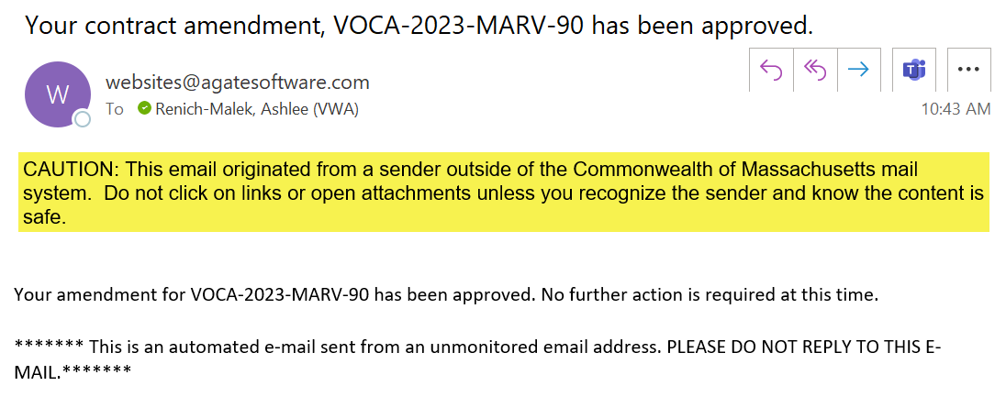

In the application, you will be able to click into the form(s) that you submitted for future reference, but you will not be able to change them.

If you initiate another budget amendment request, you will see both the approved forms and new open forms. Only the new forms will be available for editing.
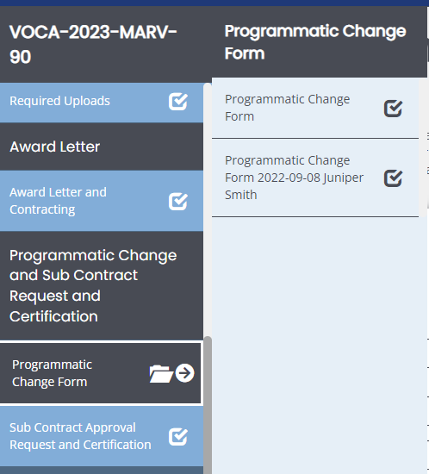

Conclusion
By following all of the above steps, subrecipients can successfully use the MOVA eGrants system to request programmatic change and budget amendment requests.

Resources
This document serves as a step-by-step guide and provides best practices for successfully proposing budget amendments for VSS and SAFEPLAN contracts. More information about this process can be found on MOVA’s eGrants webpage and the Subrecipient Manual.

Please direct your questions to your assigned MOVA Program Coordinator or the Grants Administration Specialist, Ashlee Renich-Malek.

