New FY24-FY28 5 Year Spending Plan

- Either create a new project and phases or open an existing one. Navigate to the 5 Year Spending Plan Tab.

- Select the ADD button the right-hand side of the Funding Plan portlet. This will add the new FY24-FY28 years. We are doing this so we can have a rolling plan every 5 years.
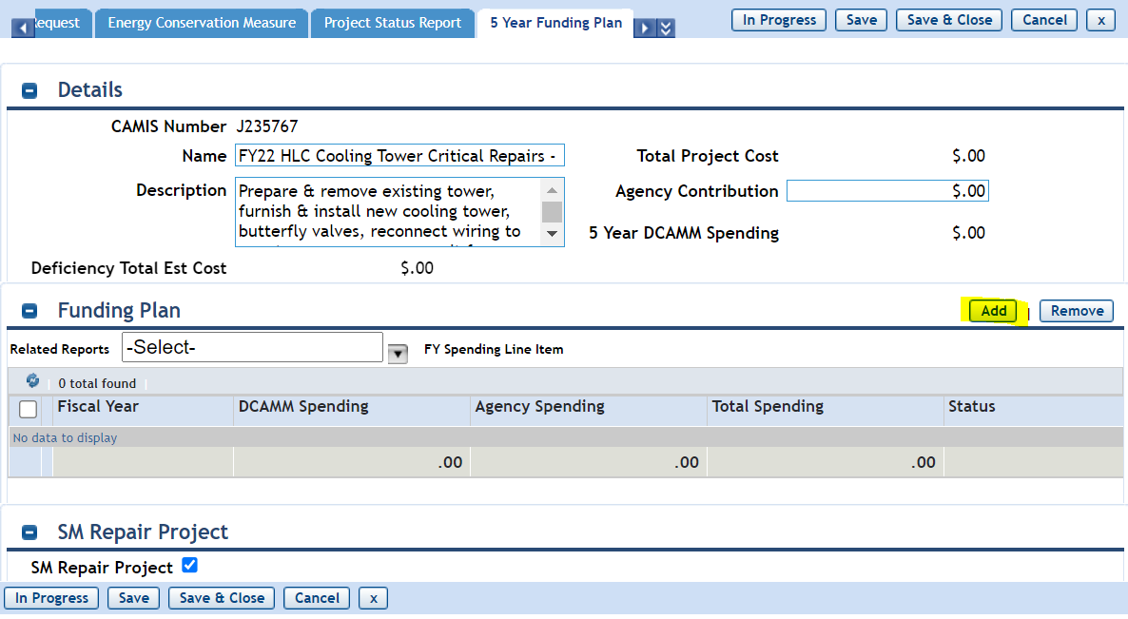
- The system will create a line for each of the 5 years.
  - If you happen to add too many lines you can remove them by highlighting the line and selecting REMOVE on the right-hand side.
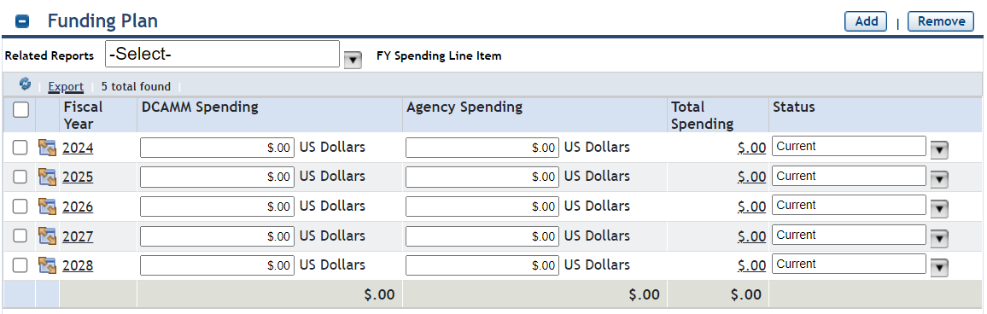

- Enter the amount of estimated spending in the fiscal year it will be spent.
  - Enter the amount of money that will requested from DCAMM.
  - Enter the amount of money that will be spent from your AGENCY.
  - To SAVE these updates, you need to select the 5 boxes next to the years and then select SAVE at the top of the page.

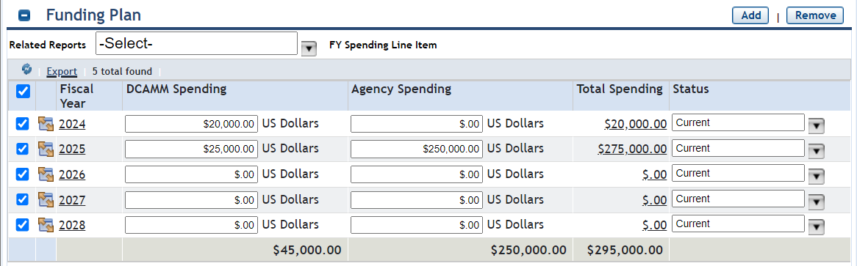
- You can run the FY24-FY28 5 Year spending report to see your spending plan. If you need to update anything, select the project from inside the report and update the estimated spending.

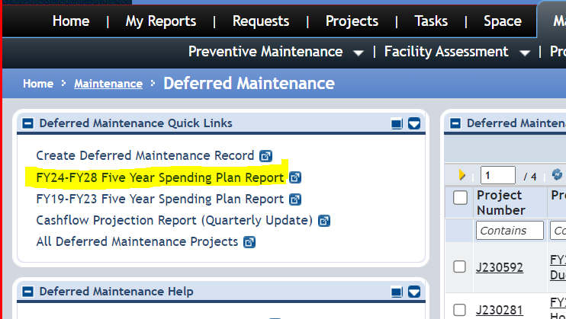

How to view Previous FY19-FY23 Spending Plan
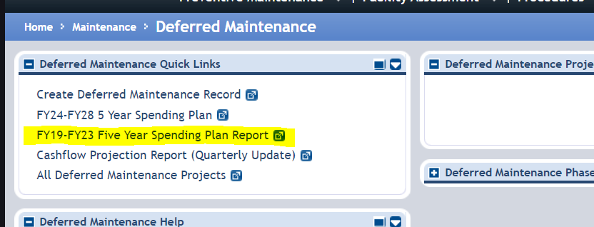
- To view the FY19-FY23 Spending Plan, use the report on the left-hand side of your Deferred Maintenance home page.

- To EDIT your data for FY19-FY23 open the project and navigate to the 5 Year spending Plan Tab. Under the RELATED REPORTS, use the down arrow to select “FY SPENDING LINE ITEM – PRIOR”.
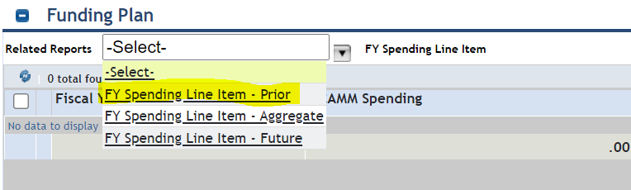

- Update your data in the spending plan fields. To save your data, make sure to check the boxes next to the fields you changed and select SAVE at the top of the page.

