Testimony of David D’Arcangelo
Commissioner for the Massachusetts Commission for the Blind
Joint Committee on Ways and Means
Fiscal Year 2024 Budget
March 21, 2023

Good morning, Chair Cronin, Chair LaNatra, and members of the Joint Committee on Ways & Means. Great to be back with you once again. As you may know, I am John Oliveira, Deputy Commissioner of Massachusetts Commission for the Blind (MCB).

Thank you for the opportunity to provide testimony for Governor Healey’s Fiscal Year 2024 (FY24) budget. The Governor’s budget represents the important and highly specialized programs and services provided by our team at MCB.

MCB serves more than 30,000 individuals in Massachusetts who are legally blind and DeafBlind. Our mission is to provide our consumers with access to employment opportunities and social rehabilitation with the goal of increasing their independence and self-determination.

Governor Healey’s FY24 House1 (H.1) Budget for MCB is funded at $27.1M, which is a $2M (or 7%) decrease from the FY23 GAA. MCB is pleased to report that all Chapter 257 rate services are fully funded. The DeafBlind Extended Supports (DBES), otherwise known as Turning 22, which is the largest appropriation, received a small increase of $15K for projected chargeback costs. The Administration and Program Operations appropriation (4110-0001) increased slightly ($21K) due to rent increases at our Boston and Springfield offices

The $2M decrease is the Governor’s FY24 H.1 budget is largely attributed to the removal of earmarks. The Community Services line item (4110-1000) contained $1M in earmarked funds while the Massachusetts Audio Information Network line item (4110-1010) contained $1.1M of earmarked funds. I appreciate the opportunity to speak in favor of the programs and services each of these appropriations provide to our consumers.

MCB has three principal programs that support our mission:
- Social Rehabilitation – Promote and support independent living in a community-based setting.
- Vocational Rehabilitation – Preparing consumers to engage in competitive integrated employment or supported employment and achieve economic self-sufficiency.
- Turning 22 - Providing residential care, case management, and specialized services for deaf/blind and multi-disabled consumers

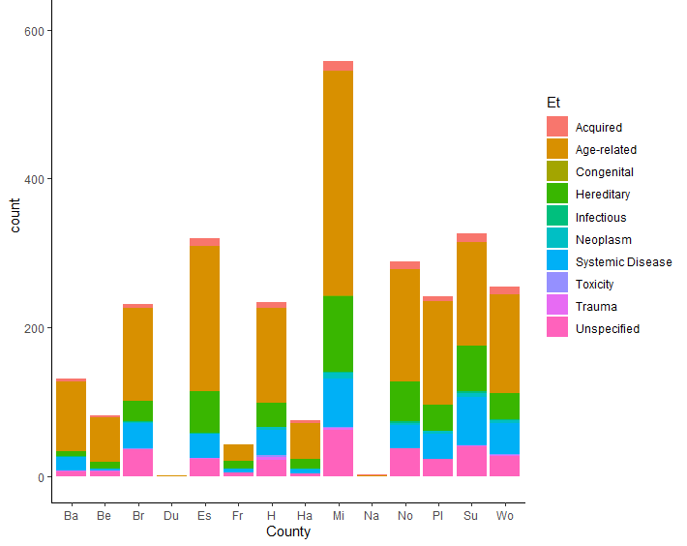
Instances of vision loss by county and the causes of vision loss

The chart above provides a representation of the occurrence of vision loss by county and the causes of vision loss. These data stem from a project funded by federal re-allotment dollars that explored the delta between legal blindness (20/200) and visual impairment.

Age related vision impairment exceeds any other etiology in every county in Massachusetts. As an excerpt from that report indicates,

“Most irreversible low vision conditions in the United States are caused by age-related eye diseases. These include age-related macular degeneration, diabetic retinopathy, and glaucoma as the most common (1). Eighty percent of Americans with low vision are over age 65 (2). Although the annual death rate in the elderly low vision population slows the rate of growth in prevalence, the aging of the U.S. population is accelerating as the generation known as the “baby boomers” move into their older years. Thus, the number of people with low vision is expected to double over the next two decades.”

Top Areas for Continued Progress in FY24:
- Continuing to find and serve new and existing consumers – Currently, more than 30,000 individuals in the Commonwealth are registered with MCB. MCB hosts two events annually to educate eyecare providers about MCB’s statute, MGL c. 6, §136, in addition to the services the agency provides. MCB has instituted a Short Form Questionnaire to gain a better understanding of the needs of its newly registered consumers.

- Improve labor participation among working age blind – With nearly two-thirds of all working age people with disabilities not in the labor force our community faces longstanding challenges.
- Increase employment among working age blind – Planning is underway for MCB’s 2023 Internship Program. Last year, MCB placed 63 consumers with internships. MCB also hosts a Reverse Job Fair for individuals with consumers, bringing together more than 30 Massachusetts employers with job-ready candidates.

- Improve the independence and self-determination for seniors – Approximately 500 MCB consumers aged 65 and older attend one of 53 support groups organized by Massachusetts Association for the Blind (MAB) Community Services (MAB), Sight Loss Services or MCB. MCB is looking the grow the number of groups statewide to support more consumers across the Commonwealth.

- Seeking opportunity to revive MCB’s Public Use Law relative to small business opportunities for Vocational Rehabilitation (VR) consumers – MCB would provide people who are blind and visually impaired in the Commonwealth with employment opportunities in a variety of areas, including web and document accessibility.

- Utilizing AT Survey – MCB is utilizing the results of an Assistive Technology survey conducted last summer to better align its services with the support needs of its consumers.

Conclusion

MCB will continue providing important social, residential, and vocational programs, while seeking opportunities for continued innovation. The proposed funding in the FY24 House 1 budget will allow us to continue important initiatives and sustain our three core programs for the community we serve in Massachusetts.

On behalf of Governor Healey, Lt. Governor Driscoll and Secretary Walsh, I thank you for the opportunity to testify here today, I look forward to your ongoing support, and I am pleased to take any questions.

