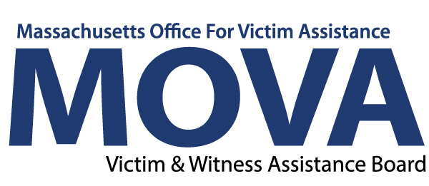

Staffing Update Form
*30 day update due August 1, 2023
*60 day update due September 1, 2023
*90 day update due October 2, 2023

Agency Information
Agency Name | Agency Name
Program Name | Program Name
Is the program is 100% operational? (i.e. has no vacant positions to fill.) If no, you must fill in the 30 day update below. |  |  | Yes as of: Date | No

30 day update
- List all vacant position(s).
Comment | Type here
- If applicable, describe steps taken to fill vacant position(s).
Comments | Type here
- Have there been any unexpected barriers to providing services during the vacancy? If so, how is this being addressed?
Comments | Type here
MOVA USE ONLY:

30 Day Action Plan (if applicable)

Is the program is 100% operational? (i.e. has no vacant positions to fill.) If no, you must fill in the 60 day update below. | Yes as of: Date | No

60 day update
- List all vacant position(s).
Comment | Type here
- If applicable, describe steps taken to fill vacant position(s).
Comments | Type here
- Have there been any unexpected barriers to providing services during the vacancy? If so, how is this being addressed?
Comments | Type here
- Any additional comments you would like to make regarding your program?
Comments | Type here
MOVA USE ONLY:

60 Day Action Plan

Is the program is 100% operational? (i.e. has no vacant positions to fill.) If no, you must fill in the 90 day update below. | Yes as of: Date | No

90 day update
- List all vacant position(s).
Comment | Type here
- If applicable, describe steps taken to fill vacant position(s).
Comments | Type here
- Have there been any unexpected barriers to providing services during the vacancy? If so, how is this being addressed?
Comments | Type here
- If vacant position(s) have not been hired for, is a budget amendment required to re-allocate funds?
Comments | Type here
MOVA USE ONLY:

90 Day Action Plan

