February 2025

Executive Order 515

Toxics Reduction Task Force

Annual Report FY2024

Commonwealth of Massachusetts

# Introduction

To facilitate implementation of EO 515, the [**Toxics Reduction Task Force**](https://www.mass.gov/service-details/toxic-reduction-task-force) (TRTF) was established in 2009 with oversight and leadership by the Operational Services Division (OSD) and the Executive Office of Environmental Affair’s Office of Technical Assistance and Technology (OTA). The TRTF includes staff from OSD and OTA, the Department of Public Health (DPH), the Department of Labor Standards (DLS), the Toxics Use Reduction Institute (TURI), and the Department of Environmental Protection (DEP). The TRTF remains a technical advisory group to help the [Environmentally Preferable Products Procurement Program](https://www.mass.gov/environmentally-preferable-products-epp-procurement-program) identify additional toxics in products on Statewide Contracts (SWC) and explore safer and healthier options. The goals and objectives of the TRTF are to select priority focus areas for reduction in toxic substances in products or services.

During FY24, the TRTF continued to facilitate discussions and provide feedback on safer disinfection practices and products. The TRTF also continued its focus on per- and polyfluoroalkyl substances (PFAS) and participated in the Interstate Chemical Clearinghouse (IC2).

# Safer Products

TURI developed the Pollution Prevention Options Analysis System ([P2OASYS](https://p2oasys.turi.org/)) tool to assist companies and other stakeholders in organizing information to compare the environmental, health, and safety attributes of chemicals, formulated products, and production process changes. TURI continues to update the system with new data to ensure its relevance and usefulness.

The Operational Services Division (OSD) collaborates with TURI to use P2OASYS as a resource for evaluating the environmental, health, and safety attributes of safer products. For instance, in FY22, the tool was used to assess active ingredients in sanitizers and disinfectants for the FAC118 contract bid. The environmental, health, and safety profiles of these active ingredients were shared with the FAC118 Strategic Sourcing Team, aiding their decision-making process regarding which ingredients to permit in products listed on the FAC118 contract.

OSD continues to work with TURI when new chemical-based products are submitted for potential inclusion in contracts. This collaboration provides an additional layer of information on the environmental, health, and safety attributes of products, supporting informed decision-making.

# Cleaning and Disinfecting: Quaternary Ammonium Compounds

Members of the TRTF continued to work in FY24 to promote the reduction of quaternary ammonium compounds (QACs). TURI provides a definition of QACs as “a broad class of several hundred chemicals…. used mainly as active ingredients in antimicrobials, disinfectants, sanitizers, and surfactants. QACs also have many uses beyond disinfection, including wood preservatives, herbicides, eye drops, mouthwashes, nasal sprays, detergents and shampoos, dryer sheets and fabric softeners.”

**Procurement**: The TRTF played a large role in research that helped develop the criteria for surface disinfectants and sanitizers for [FAC118](https://www.mass.gov/doc/fac118/download), the OSD statewide contract for Environmentally Preferable Cleaning Products, Programs, Equipment and Supplies that have a lesser impact on public health and the environment, while ensuring efficacy and high performance. This includes surface and laundry disinfectants, food contact sanitizers, and non-food contact surface sanitizers, but excludes hand sanitizers, antimicrobial hand soaps, and products designed to kill pathogens on medical instruments or equipment. This contract continues to be marketed to public buyers for its ease in procuring safer products and those without quaternary ammonium chloride compounds (QACs). Notably, the contract Sourcing Team chose to prohibit products with QAC active ingredients as they are known to cause asthma, cancer, and/or skin sensitization[1].

Although QACs are prohibited on FAC118, they continue to be sold in other OSD statewide contracts, notably the [Maintenance Repair and Operations](https://www.mass.gov/info-details/facility-maintenance-repair-and-operations-contract-user-guides) contracts. One of the reasons for allowing on these contracts is that currently the [United States Public Health Service Food and Drug Administration’s 2013 Food Code](https://www.fda.gov/media/87140/download) and the Massachusetts Food Code requires verification of sanitization processes, and the available standard methods are designed only for the use of bleach and quaternary ammonium compounds, not alternatives. The TRTF will continue to coordinate research efforts and public awareness campaigns regarding alternatives to QACs.

**TURI Cleaner Solutions Database:** The TURI [Cleaning Solutions Database](http://www.cleanersolutions.org) was created to assist in identifying safer cleaning processes and products by promoting alternatives to hazardous chemicals. The database enables users to select a specific contaminant (e.g., bacteria, mold, salmonella, viruses, etc.) and provides the option to specify the substrate (e.g., carpet, ceramic, plastic, etc.) and the equipment used (e.g., manual wipe, steam) to identify products that meet those criteria.

Additionally, the database allows users to refine their search by indicating a preference for products with environmental certifications, such as EPA Safer Choice, Green Seal, or UL ECOLOGO. Users can also specify whether the product is listed on the OSD statewide contract [FAC118](https://www.mass.gov/doc/fac118/download). The FAC118 contract requires cleaning chemicals to meet third-party certifications and standards and includes a list of safer active ingredients for sanitizers and disinfectants. For more information on the specifications for FAC118, refer to [Attachment A: FAC118 Mandatory Specifications and Desirable Criteria](https://www.commbuys.com/bso/external/purchaseorder/poSummary.sdo?docId=PO-22-1080-OSD03-SRC3-24779&releaseNbr=0&external=true&parentUrl=close) available in COMMBUYS (scroll to “Agency Attachments”). Incorporating this list into the Cleaning Solutions database benefits public entities eligible to purchase from OSD Statewide Contracts.

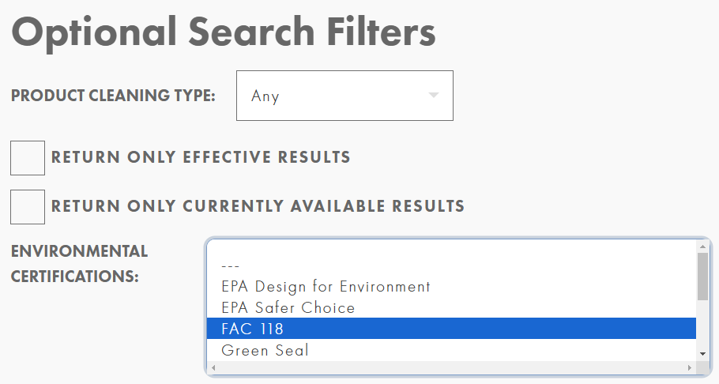

Screenshot from Cleaner Solutions Database showing FAC 118 filter

**TURI Safer Cleaning informational video:** TURI laboratory specialist Alicia McCarthy created and presented a video titled [Clean Break: Removing Toxics in Cleaning, Sanitizing, and Disinfection](https://www.youtube.com/watch?v=MA-lSlD-UIQ). This video serves as a training resource as part of the Green Cleaning section of an online Asthma Education course for future school nurses at Northeastern University. In the presentation, McCarthy explores safer cleaning products and disinfection methods, and references the FAC118 contract.

**DPH Educational Resources**: The Department of Public Health developed and shared resources to assist municipalities and businesses with the safe use of QAC-based cleaners and disinfectants. The Occupational Health Surveillance Program (OHSP) at the Massachusetts Department of Public Health held several webinars to public entities to deliver a presentation on *Cleaning and Disinfecting Products: Resources for Prevention*. With seasonal cases of COVID, RSV, and flu, OHSP highlighted several key resources available for facility departments and those responsible for cleaning and disinfecting to remind viewers of safer cleaning products and practices. As stated in the webinar, 12% of all work-related asthma cases are from cleaning and disinfecting products in five states including MA. The webinar reviewed resources for viewers, such as TURI’s Cleaner Solutions website, safer products available through OSD Statewide Contract [FAC118](https://www.mass.gov/doc/fac118/download): Environmentally Preferable Cleaning Products, Programs, Equipment and Supplies, as well as the Department of Labor Standards [On-Site Consultation Program](https://www.mass.gov/doc/on-site-consultation-program-brochure/download). The webinar also reviewed best practices around cleaning and disinfectant use and shared a work-related respiratory disease case where town workers were exposed to cleaning and disinfectant products to highlight issues with common cleaners and disinfectant use.

[Slides](https://www.mass.gov/doc/safer-use-of-disinfectants-post-covid-pandemic-presentation/download) and [video](https://www.youtube.com/watch?v=96bkEXdXM9g&feature=youtu.be) are available for the webinar as hosted by the Division of Capital Management and Maintenance (DCAMM)’s Massachusetts Facilities Management Association (MAFMA) on Feb 1, 2024.

# Per- and Polyfluoroalkyl Substances (PFAS)

The TRTF continued to discuss per- and poly-fluoroalkyl substances, a family of chemicals commonly referred to as PFAS. PFAS break down very slowly and can build up in people, animals, and the environment over time, posing environmental and health concerns.[2] PFAS may be found in products in statewide contracts, including firefighting foam and gear, cleaning products, personal care products, clothing, furniture, textiles, carpets, rugs, and non-slip additives for industrial applications or other surfactant property processing aids.

Because of the environmental, health and safety issues associated with this category of chemical[3], addressing PFAS requires coordinated actions involving regulatory frameworks, research into safer alternatives, and public awareness. The TRTF will continue to compile resources available from team members and will be working in FY25 on coordinating efforts for additional research and public awareness campaigns.

**Conference Planning:** Members of the TRTF are assisting in the early stages of organizing the Northeast Waste Management Officials’ Association (NEWMOA) 2026 conference *The Science of PFAS: Public Health & the Environment*, to be held April 14-16, 2026.[4] This conference, which is expected to include over 500 attendees, is intended to update state, local, and federal officials on the newest PFAS science; enable key stakeholders to share information about PFAS; and identify knowledge gaps in PFAS science and policy.

**Regulatory Action under the Toxics Use Reduction Act (TURA):**

The TURA Program has continued to reconcile the TURA List with recent additions to the list of the US EPA Toxics Release Inventory (TRI)-reportable substances, as required by the TURA statute (MGL Chapter 21I). To date, the TURA Program has amended its regulations to add a total of 196 PFAS to the TURA List at the 100 lb. threshold, consistent with their TRI reporting threshold, including seven that were added in FY24. Listing these PFAS individually under TURA will help manufacturers understand their use, identify opportunities for reduction or elimination, and reduce manufacturers’ liability.

In FY24, EPA finalized a rule to eliminate the *de minimis* exemption for chemicals added to the list of Lower Thresholds for Chemicals of Special Concern. TRI-listed PFAS have been added to this list, meaning the *de minimis* threshold no longer applies to the reporting and supplier notification requirements for these chemicals under TRI. Because TURA adopts TRI thresholds for TRI-listed substances, this change also applies to TURA reporting. This may enable facilities to capture more PFAS source information, supported by OTA’s updated [supplier notification letter template](https://www.mass.gov/doc/pfas-tri-and-tura-supplier-notification-letter-template/download).

OSD will continue to communicate regulatory changes in bids and to Statewide Contract vendors to encourage offering products without PFAS. OTA has developed several resources for companies to identify PFAS in their facilities and supply chains and is also available to offer companies technical assistance with identifying and eliminating potential sources of PFAS in their facilities.[5] TURI is also a resource for companies who wish to apply for grants to undertake research and development into PFAS alternatives for their facilities.[6]

# IC2 Procurement Workgroup

[The Interstate Chemicals Clearinghouse (IC2)](https://www.theic2.org/) is an association of state, local, and tribal governments that promotes a clean environment, healthy communities, and a vital economy through the development and use of safer chemicals and products. Members of the TRTF participate in the PFAS, Environmental Justice and Procurement subcommittees, bringing learning and information from the TRTF to the workgroups.

Julia Wolfe, Director of Environmental Purchasing at OSD, continues to serve as the chair of the IC2 Procurement Workgroup.  IC2’s Procurement Workgroup supports members’ advancement of low-toxicity product procurement. Specific areas of focus include how patterns of chemical use inform environmentally preferable procurement, facilitating state and municipal cooperation to enhance the market for less-toxic products, identifying product categories that are good targets for action, sharing specification language and informing individual or joint procurement, and working with large vendors to harmonize green product claims with state requirements.

***

This report underscores the ongoing dedication and collaborative efforts of the TRTF towards implementing EO 515. Throughout the year, the TRTF focused on safer disinfection practices and purchasing products free PFAS and QACs. The collaborative involvement in the Interstate Chemicals Clearinghouse (IC2) further amplifies the impact of TRTF's work, promoting the use of safer chemicals and products at a broader governmental level. The leadership roles assumed within IC2's Procurement Workgroup highlight the TRTF's commitment to driving actionable change and fostering cooperation among state and municipal entities for the procurement of less-toxic products.

As the TRTF moves forward into FY2025, it will continue to focus on addressing QACs, PFAS, and likely other emerging concerns. The TRTF has a shared commitment to safeguard public health and the environment through informed action and work to make public purchasing of safer products.

1. <https://www.turi.org/publications/alternatives/>
2. <https://www.epa.gov/pfas>
3. <https://www.turi.org/pfas/>
4. <https://www.newmoa.org/event/pfas-conference-2026/>
5. https://www.mass.gov/per-and-polyfluoroalkyl-substances-pfas-tur-resources
6. <https://www.turi.org/grants/>