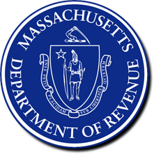
The Commonwealth of Massachusetts
Department of Revenue

Office of the Commissioner

PO Box 7091

Boston, MA 02204-7091
GEOFFREY E. SNYDER
COMMISSIONER

February 19, 2026

William J. McNamara, Comptroller
Office of the Comptroller
Commonwealth of Massachusetts
One Ashburton Place, Room 901
Boston, MA 02108

Dear Comptroller McNamara:
Pursuant to Section 20 of Chapter 28 of the 2023 Acts, the Department of Revenue (DOR) is required to certify to the State Comptroller, after each quarterly period during the fiscal year, the amount of tax revenues estimated to have been collected during the quarterly period due to the additional 4% income tax levied pursuant to Article XLIV of the Amendments of the Constitution of the Commonwealth.
The annual quarterly periods are as follows:
Period 1 (July 1 through September 30)
Period 2 (October 1 through January 31)
Period 3 (February 1 through April 30)
Period 4 (May 1 through June 30)
The table below shows the additional 4% income tax revenue estimates for each of the first two certification periods, and on a year-to-date basis during fiscal year 2026.

Additional 4% Income Tax Collections ($)
Period | Period total | Fiscal year-to-date total
Period 1 (July 1, 2025 to September 30, 2025) | $512,292,865.04 | $512,292,865.04
Period 2 (October 1, 2025 to January 31, 2026) | $790,412,057.75 | $1,302,704,922.79

Based on currently available data, DOR hereby certifies that tax revenue estimated to have been collected from the additional 4% income tax was $790,412,057.75 during Period 2 of FY2026 (October 1, 2025 through January 31, 2026). The year-to-date (July 1, 2025 through January 31, 2026) tax revenue estimated to have been collected from the additional 4% income tax was $1,302,704,922.79. Please note that these amounts are subject to revision in the Period 3 certification as DOR further analyzes tax data. If you have any questions concerning this letter, please contact Kazim P. Ozyurt, Director of the Office of Tax Analysis (ozyurtk@dor.state.ma.us).

Sincerely,
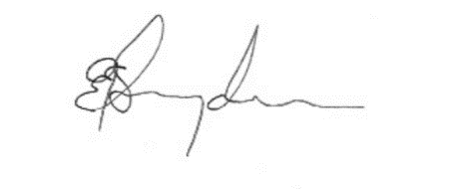
Geoffrey E. Snyder
Commissioner

cc: Secretary Matthew J. Gorzkowicz, Executive Office for Administration and Finance
The Honorable Michael J. Rodrigues, Chair, Senate Committee on Ways and Means
The Honorable Aaron Michlewitz, Chair, House Committee on Ways and Means

FY2024 Final Budget (https://malegislature.gov/Budget/FinalBudget)
Pursuant to FY2024 Final Budget (https://malegislature.gov/Budget/FinalBudget), section 28, the $1,000,000 taxable income threshold shall annually be subject to the cost-of-living adjustment. For tax year 2023, which was the first year the additional 4% income tax was in effect, the taxable income threshold was $1,000,000.00. On December 14, 2023, DOR certified that the taxable income threshold for tax year 2024 would be $1,053,750.00. On November 12, 2024, DOR certified that the taxable income threshold for tax year 2025 would be $1,083,150.00. On November 20, 2025, DOR certified that the taxable income threshold for tax year 2026 would be $1,107,750.00.

