Expression of Interest - Environment and Climate One Stop (ECO) FY28
Word Template
When you submit this form, it will not automatically collect your details like name and email address unless you provide it yourself.
Required*
- Applicant Organization*
- Applicant Type:*
Municipality
District
Public Board or Commission
Tribal Government
Regional Government or Planning Agency
Certified 501(c)3 Nonprofit
Public or Private School or University
- Name of Project Primary Contact*
- Contact Title/Role*
- Contact’s Agency/Department/Organization*
- Contact Phone Number*
- Contact Email (this is the email we reach out to when scheduling your feedback call)*
- Project Title (does not need to be final)*
- Did this project submit an application to the ECO One Stop for the previous grant cycle (FY27)?*
Yes
No
- Select your project type. Select the one that best fits.
This will help in sorting the EOIs. The project types listed represent projects that may be relevant to multiple grant programs. Do not be concerned if your project isn’t on this list – just select “other” and include your own key word/s. *
Culvert or Small Bridge Upgrade or Removal
Dam or Levee Upgrade
Dam Removal
Energy Resilience (e.g. microgrids, resilience hubs, etc.)
Land Acquisition
Land Use Planning
Tree Planting
Regulatory Updates
Seawall Upgrade or Removal
Social Resilience and Outreach
Stormwater Management (e.g. green infrastructure, nature-based solutions, structural BMPs)
Relocation or Retrofit of Critical Infrastructure (NOT culvert, dam, seawall, or structural stormwater BMP)
Wetland Restoration or Enhancement
11) Provide a brief description of your project idea, including key goals and how the project supports climate resilience and/or biodiversity. (1000 character limit)*
12) Will you be collaborating with municipal and/or local partners on this project? If yes, please list. *
13) Project Phase(s) - select all that apply:*
Assessment and Planning
Capacity building (e.g., education, training, etc.)
Regulatory updates
Design
Permitting
Construction
Implementation (non-construction)
Monitoring
Maintenance
14) What are the major tasks that the grant would be funding? Please list.*
15) What is the duration of this project?*
1 Year
2 Years
16) Approximately how much funding will be requested? (Please provide a dollar number)*
17) Latitude and longitude of the project site or central area impacted by the project in decimal degrees*
How to get latitude and longitude on Google Maps:
Right-click on an address or location and click the numbers at the top. They will be copied to your clipboard. The latitude (north-south position) is the one that is in the 40s. The longitude (east-west position) is the one that is in the -70s. You will need to separate them when pasting into the spreadsheet columns (be sure to keep the negative sign for the longitude).
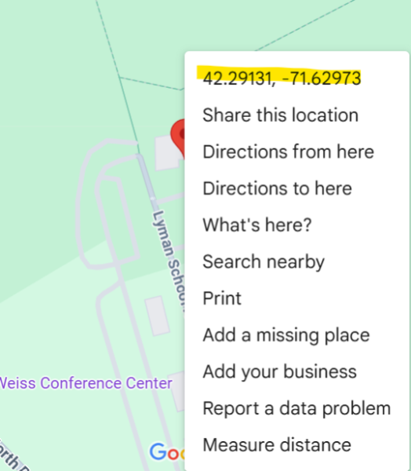

18) If applicable, who owns the project site?*
19) If the project will occur at more than one location please add additional latitudes and longitudes here.
20) Which grant program/s included in the ECO One Stop may be the best fit for this application? Select all that apply. If you do not know, select “I’m not sure.” *
I'm not sure
MVP Action - offers financial resources to communities that are seeking to advance priority climate adaptation actions to address climate change impacts in alignment with the MVP Core Principles.
CZM Coastal Resilience - provides financial and technical support for local and regional efforts to address coastal flooding, erosion, and sea level rise.
CZM Coastal Habitat and Water Quality - provides financial resources for projects that assess and treat stormwater pollution and advance habitat restoration.
Cooling Corridors - offers financial resources for conducting tree planting and related activities to assist with mitigating extreme heat and to enhance the tree canopy within neighborhoods and public spaces.
EEA Planning Assistance - supports sustainable land use practices, including zoning for diverse housing, climate change mitigation, and land conservation, in alignment with the state's Sustainable Development Principles.
Dams and Seawalls - offers grants for projects that will repair or remove dams, levees, seawalls, or other inland flood control and coastal protection infrastructure.
Culvert Replacement Municipal Assistance and Training - supports replacing or removing an undersized, perched, and/or degraded culverts located in an area of high ecological value.
21) Optional: Please provide any additional information you believe would be relevant for reviewers. You may provide a URL for an additional supporting document, if helpful.
22) Do you need assistance incorporating community engagement into your project?
Yes
No

23) Some ECO One Stop grants prioritize projects that support populations and areas disproportionately burdened by or vulnerable to pollution and climate hazards. Do you need assistance identifying Burdened Areas and priority populations?
Yes
No
24)
Do you need help identifying climate (natural hazard/weather) data products and data resources for your proposed project?
Yes
No
25) What other topics would you want feedback on related to this project?

