INDOOR AIR QUALITY ASSESSMENT

Galvin Middle School
525 Main St
Wakefield, MA

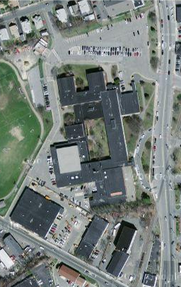

Prepared by:
The Massachusetts Department of Public Health
Bureau of Environmental Health
August 2010

Background/Introduction
In response to a referral from the National Institute for Occupational Safety and Health (NIOSH), the Massachusetts Department of Public Health (MDPH), Bureau of Environmental Health (BEH) provided assistance and consultation regarding indoor air quality and health concerns at the Galvin Middle School (GMS) located at 525 Main Street, Wakefield, Massachusetts. The indoor environmental assessment was conducted over two days, February 11, 2009 and May 13, 2009. Visits were made by Michael Feeney, Director of BEH’s Indoor air Quality (IAQ) Program and Sharon Lee and James Tobin, Environmental Analysts/Inspectors within BEH’s IAQ Program. Christine Gorwood, an Environmental Analyst/Risk Communication Specialist for BEH’s Community Assessment Program (CAP) accompanied IAQ staff to meet with concerned employees and to gather information specific to health concerns. In addition to MDPH/BEH staff, Peter Gray, former Wakefield Health Director and Timothy Healy, Building Manager, Wakefield Department of Public Works, as well as various GMS personnel were present during portions of these assessments.
The school is a two-story brick structure constructed in 1955. In 1974, the building was renovated and a new wing was added. The second floor consists of general classrooms. The first floor contains the cafeteria, wood shop, library, computer room, music room, teacher’s lounge, auditorium, gym and copier room, as well as the main office, teacher’s offices, general classrooms and several special needs rooms (Figures 1 to 3). Windows are openable in the building.

Methods
Air tests for carbon monoxide, carbon dioxide, temperature and relative humidity were conducted with the TSI, Q-Trak, IAQ Monitor, Model 7565. Air tests for airborne particle matter with a diameter less than 2.5 micrometers were taken with the TSI, DUSTTRAK™ Aerosol Monitor Model 8520. Screening for total volatile organic compounds (TVOCs) was conducted using a Thermo Environmental Instruments Inc., Model 580 Series Photo Ionization Detector (PID). BEH staff also performed visual inspection of building materials for water damage and/or microbial growth.

Results
This school houses approximately 1,050 students in fifth through eighth grades and a staff of approximately 100. Tests were taken under normal operating conditions. Test results appear in Tables 1 and 2.

Discussion

Ventilation
It can be seen from Table 1 that carbon dioxide levels were above 800 parts per million (ppm) in 36 of 51 areas surveyed on February 11, 2009 (Table 1) and 37 of 61 areas on May 13, 2009 (Table 2), indicating inadequate ventilation in approximately two-thirds the areas assessed throughout the building. Carbon dioxide levels exceeded 2,000 ppm in several areas during both days of assessment. These elevated carbon dioxide levels indicate poor air exchange in the building at the time of assessment, particularly in classrooms that were fully occupied. The elevated carbon dioxide levels measured are related to deactivated/non-functioning/poorly functioning ventilation equipment. It is also important to note that some areas were empty/sparsely populated, which can greatly reduce carbon dioxide levels. Carbon dioxide levels would be expected to increase with windows closed and higher occupancy.
Fresh air in classrooms throughout the school is supplied by unit ventilator (univent) systems. A univent draws outdoor air through an air intake located on the exterior wall of the building and returns air from the room through an air intake located at the base of the unit (Figure 4; Picture 1). Fresh and return air are mixed, filtered, heated, and delivered to the room through an air diffuser located in the top of the unit. Univents were deactivated in a number of areas during both days of assessment. Univents were obstructed by items such as chairs, tables, desks, and books in many classrooms (Pictures 1 and 2). In order to function as designed, univents must be activated and allowed to operate free of obstructions and blockages. Lastly, a container of sand was observed on the univent in classroom 248. Over time, sand and other particles that fall into the univent can result in damage to the unit.
Univents at the GMS were installed at the time the school was built in 1955 and for the new wing in 1974. According to the American Society of Heating, Refrigeration and Air-Conditioning Engineering (ASHRAE), the service life for a unit heater, hot water or steam is 20 years, assuming routine maintenance of the equipment (ASHRAE, 1991). The operational lifespan of this equipment has long passed. Given its age, continuing to maintain the balance of fresh air to exhaust air will be difficult at best.
Exhaust ventilation is provided by two different systems. The older wing consists of ducted wall vents. Airflow is controlled by a flue which is opened by a draw chain-pulley system. The flue is positioned at a desired angle by setting the draw chain into a locking mechanism. This system was found to be functional in most classrooms surveyed; however, several flues, chains and pulleys were found in disrepair. The chain pulley system must be repaired in order to control airflow into the exhaust system. In addition, several classrooms had exhaust vents that were shut or obstructed by papers, posters, bookcases and furniture (Picture 3). Blockages must be removed to allow for proper removal of air in classrooms.
The 1974 classroom wing employs unit exhaust ventilators (Picture 4). They are controlled by an internal thermostat, which activates the unit at a set temperature. Several of these units were not functioning at the time of assessment, despite high occupancy.
Mechanical ventilation for large/common areas such as the gymnasium, cafeteria and auditorium is provided by rooftop AHUs (Picture 5) or AHUs (Picture 6) in mechanical rooms. BEH staff observed conditions of these AHUs and noted breaches in flexible casing for one of the units (Picture 7). Airflow could be detected from this hole; such breaches should be sealed.
To maximize air exchange, the MDPH recommends that both supply and exhaust ventilation operate continuously during periods of building occupancy. In order to have proper ventilation with a mechanical supply and exhaust system, the systems must be balanced to provide an adequate amount of fresh air to the interior of a room while removing stale air from the room. It is recommended that HVAC systems be re-balanced every five years to ensure adequate air systems function (SMACNA, 1994).
The Massachusetts Building Code requires that each room have a minimum ventilation rate of 15 cubic feet per minute (cfm) per occupant of fresh outside air or openable windows (SBBRS, 1997; BOCA, 1993). The ventilation must be on at all times that the room is occupied. Providing adequate fresh air ventilation with open windows and maintaining the temperature in the comfort range during the cold weather season is impractical. Mechanical ventilation is usually required to provide adequate fresh air ventilation.
Carbon dioxide is not a problem in and of itself. It is used as an indicator of the adequacy of the fresh air ventilation. As carbon dioxide levels rise, it indicates that the ventilating system is malfunctioning or the design occupancy of the room is being exceeded. When this happens, a buildup of common indoor air pollutants can occur, leading to discomfort or health complaints. The Occupational Safety and Health Administration (OSHA) standard for carbon dioxide is 5,000 parts per million parts of air (ppm). Workers may be exposed to this level for 40 hours/week, based on a time-weighted average (OSHA, 1997).
The MDPH uses a guideline of 800 ppm for publicly occupied buildings. A guideline of 600 ppm or less is preferred in schools due to the fact that the majority of occupants are young and considered to be a more sensitive population in the evaluation of environmental health status. Inadequate ventilation and/or elevated temperatures are major causes of complaints such as respiratory, eye, nose and throat irritation, lethargy and headaches. For more information concerning carbon dioxide, consult Appendix A.
Indoor temperature measurements ranged from 71°F to 82°F on February 11, 2009, which were above the MDPH recommended comfort range in several areas (Table 1); and 69°F to 77°F on May 13, 2009 (Table 2), which were within or very close to the lower end of the MDPH recommended comfort range. The MDPH recommends that indoor air temperatures be maintained in a range of 70º F to 78º F in order to provide for the comfort of building occupants. A number of GMS staff expressed temperature control issues. Given the age, condition and operating status of ventilation equipment, temperature control would be expected to be difficult. In many cases concerning indoor air quality, fluctuations of temperature in occupied spaces are typically experienced, even in a building with an adequate fresh air supply.
The relative humidity measured in the building ranged from 25 to 42 percent on February 11, 2009 (Table 1) and 30 to 47 percent on May 13, 2009 (Table 2), some of which were below the MDPH recommended comfort range in all areas surveyed during both days of assessment (Table 1). The MDPH recommends a comfort range of 40 to 60 percent for indoor air relative humidity. Relative humidity levels in the building would be expected to drop during the winter months due to heating. The sensation of dryness and irritation is common in a low relative humidity environment. Low relative humidity is a very common problem during the heating season in the northeast part of the United States.

Microbial/Moisture Concerns
Spaces and breaches were observed around pipes in the interior cabinet of classroom univents (Picture 8). Holes were also observed between the cabinet wall and the fan compartment, which is above the filter bank (Picture 9). As the univent operates, air can be drawn through these holes instead of through the filter, allowing for particulates in the cabinet to become aerosolized. Since there are dirt crawlspaces below the building (Figure 3), odors, particulates and moisture from the crawlspace can be drawn into univents through spaces around the pipes and subsequently distributed to classrooms. The unit ventilator cabinet walls should be airtight and breaches around pipes should be sealed to allow filtration of air and prevent draw of odors, moisture and materials from the crawlspace.
Musty odors were detected in the music room, stage office and office 140, which are rooms that are located along the exterior of the building. Similarly, water penetration/flooding were reported in the storage adjacent to classroom 161 as well as adjacent bathrooms. The exterior of the building should be examined and breaches should be sealed to prevent moisture penetration through the exterior wall and tarmac. Consideration should also be given to re-grading the ground outside of these areas to direct water away from the building and prevent it from pooling against the building.
Considering the location of the music room, stage office and office 140 (above a dirt crawlspace) and the presence of crawlspace pits located outside the building in close proximity to these areas (Picture 10), it is possible that air penetrating these pits is creating temperature differences between the classroom air and the floor. Under certain conditions, such differences in temperature can result in condensation and moistening of materials. Repeated exposure of non-porous materials (i.e. carpet) and dust/debris can result in mold growth. Carpets in these areas should be removed and rooms should be cleaned thoroughly to prevent mold growth where dirt/dust can accumulate.
The GMS appears to have a number of water penetration issues related to the roof. It was reported that numerous of attempts to patch the roof have been made (Picture 11). BEH staff observed damaged roof flashing (Pictures 12 and 13). The purpose of flashing is to create a surface that allows water to roll down and away from the building. Where flashing is damaged, water can collect and penetrate in the building. In addition, since the building appears to be multiple joined sections (Picture 14), the roof of the building consists of a number of surfaces that are not level. The discontinuous roof surfaces can allow water to pool on the roof. Damage to the roof and flashing and the building exterior may be the cause of water damage/penetration to a number of areas, including the following:
- Library: GMS staff reported concerns regarding water penetration and leaks in the library. BEH staff observed a number of water-damaged and missing ceilings tiles in this area (Picture 15). Water stains observed on the carpet indicate repeated moistening of the carpeting in this area. BEH staff did not detect any odors from the carpet; however, carpeting that is wet repeatedly can be a source of mold growth if it is not dried properly.
- Hallway: A trash barrel catching water was observed in the hallway near classroom 163. BEH staff observed water dripping from a roof beam in this area (Pictures 16 and 17).
- Music Room: Occupants in this classroom reported roof leaks, which began around September 2008. BEH staff observed water accumulated in the light fixtures in the classroom during the February 2009 assessment, indicating active roof leaks in this area.
- Room 228: The thermostat reportedly short circuits due to water in the wall. BEH staff observed the thermostat and noted that the thermostat lens appeared foggy.
- Water-damaged ceiling tiles and wall plaster: These types of water-damaged materials were observed throughout the school (Tables 1 and 2); further indicating water penetration problems related to the roof and building exterior. A number of ceiling tiles are also missing throughout the school, likely related to water penetration.
- Building envelope: Leaks were observed from windows. In some areas, breaches and cracks were observed in cement around windows (Picture 18).
Other potential moisture/mold growth issues were observed throughout the building. Open seams between sink countertops and backsplashes were observed. If not watertight, water can penetrate through the seam, causing damage. Improper drainage or sink overflow can lead to water penetration into the countertop, cabinet interiors and areas behind cabinets. Water penetration and chronic exposure of porous and wood-based materials can cause these materials to swell and show signs of water damage, as observed in one classroom (Picture 19). Repeated moistening of porous materials can result in mold growth.
The US Environmental Protection Agency (US EPA) and the American Conference of Governmental Industrial Hygienists (ACGIH) recommend that porous materials be dried with fans and heating within 24 to 48 hours of becoming wet (US EPA, 2001; ACGIH, 1989). If not dried within this time frame, mold growth may occur. Once mold has colonized porous materials, they are difficult to clean and should be removed and discarded.
Plants were noted in several classrooms. In some instances, plants were located on univents (Picture 20). Plants can be a source of pollen and mold which can be respiratory irritants to some individuals. Plants should be properly maintained and equipped with drip pans and should be located away from univents to prevent the aerosolization of dirt, pollen and mold. Plants should also be located away from ventilation sources to prevent aerosolization of irritants.
An aquarium tank was observed with microbial/algal growth (Picture 21). Aquariums should be properly maintained to prevent microbial/algal growth as they can emit unpleasant odors into the classroom.

Other Indoor Air Evaluations
Indoor air quality can be negatively influenced by the presence of respiratory irritants, such as products of combustion. The process of combustion produces a number of pollutants. Common combustion emissions include carbon monoxide, carbon dioxide, water vapor, and smoke (fine airborne particle material). Of these materials, exposure to carbon monoxide and particulate matter with a diameter of 2.5 micrometers (μm) or less (PM2.5) can produce immediate, acute health effects upon exposure. To determine whether combustion products were present in the indoor environment, BEH staff obtained measurements for carbon monoxide and PM2.5.

Carbon Monoxide
Carbon monoxide is a by-product of incomplete combustion of organic matter (e.g., gasoline, wood and tobacco). Exposure to carbon monoxide can produce immediate and acute health affects. Several air quality standards have been established to address carbon monoxide and prevent symptoms from exposure to these substances. The MDPH established a corrective action level concerning carbon monoxide in ice skating rinks that use fossil-fueled ice resurfacing equipment. If an operator of an indoor ice rink measures a carbon monoxide level over 30 ppm, taken 20 minutes after resurfacing within a rink, that operator must take actions to reduce carbon monoxide levels (MDPH, 1997).
The American Society of Heating Refrigeration and Air-Conditioning Engineers (ASHRAE) has adopted the National Ambient Air Quality Standards (NAAQS) as one set of criteria for assessing indoor air quality and monitoring of fresh air introduced by HVAC systems (ASHRAE, 1989). The NAAQS are standards established by the US EPA to protect the public health from six criteria pollutants, including carbon monoxide and particulate matter (US EPA, 2006). As recommended by ASHRAE, pollutant levels of fresh air introduced to a building should not exceed the NAAQS levels (ASHRAE, 1989). The NAAQS were adopted by reference in the Building Officials & Code Administrators (BOCA) National Mechanical Code of 1993 (BOCA, 1993), which is now an HVAC standard included in the Massachusetts State Building Code (SBBRS, 1997). According to the NAAQS, carbon monoxide levels in outdoor air should not exceed 9 ppm in an eight-hour average (US EPA, 2006).
Carbon monoxide should not be present in a typical, indoor environment. If it is present, indoor carbon monoxide levels should be less than or equal to outdoor levels. Outdoor carbon monoxide concentrations were non-detect (ND) on both days of assessment (Tables 1 and 2). No measureable levels of carbon monoxide were detected inside the building on either day of the MDPH/BEH assessment (Tables 1 and 2).

Particulate Matter
The US EPA has established NAAQS limits for exposure to particulate matter. Particulate matter is airborne solids that can be irritating to the eyes, nose and throat. The NAAQS originally established exposure limits to particulate matter with a diameter of 10 μm or less (PM10). According to the NAAQS, PM10 levels should not exceed 150 micrograms per cubic meter (μg/m³) in a 24-hour average (US EPA, 2006). These standards were adopted by both ASHRAE and BOCA. Since the issuance of the ASHRAE standard and BOCA Code, US EPA established a more protective standard for fine airborne particles. This more stringent PM2.5 standard requires outdoor air particle levels be maintained below 35 μg/m³ over a 24-hour average (US EPA, 2006). Although both the ASHRAE standard and BOCA Code adopted the PM10 standard for evaluating air quality, MDPH uses the more protective PM2.5 standard for evaluating airborne particulate matter concentrations in the indoor environment.
Outdoor PM2.5 for February 11, 2009 was measured at 39 μg/m³ (Table 1), which slightly exceeded the NAAQS PM2.5 level of 35 μg/m³. PM2.5 levels measured indoors ranged from 18 to 33 μg/m³ (Table 1), which were below the NAAQS PM2.5 level of 35 μg/m³. Outdoor PM2.5 for May 13, 2009 was measured at 18 μg/m³ (Table 2). PM2.5 levels measured indoors ranged from 5 to 21 μg/m³ (Table 2), which were below the NAAQS PM2.5 level of 35 μg/m³. Frequently, indoor air levels of particulates (including PM2.5) can be at higher levels than those measured outdoors. A number of mechanical devices and/or activities that occur indoors can generate particulate during normal operations. Sources of indoor airborne particulates may include but are not limited to particles generated during the operation of fan belts in the HVAC system, use of stoves and/or microwave ovens in kitchen areas; use of photocopiers, fax machines and computer printing devices; operation of an ordinary vacuum cleaner and heavy foot traffic indoors.

Volatile Organic Compounds

Kytron
Several staff members reported concerns about potential contamination of school property from Kytron Circuits Corp., a former circuit board manufacturing company which abuts the GMS property. Staff were concerned about contamination of the school through flooding and groundwater. As reported by building staff, the area located to the south of the GMS was flooded in the spring of 2006. Building occupants also reported that the school was not affected by the flooding, but North Avenue (south of the GMS) had flooded, likely from overflow of Crystal Lake. The source of the flood was likely a stream that passes under North Street (Picture 22) and appears to pass under the Wakefield Public Works Yard. The stream then splits to run roughly parallel to the school to the east where it joins with the Mill River (Figure 5). Concerns were raised that flooding of the areas surrounding the school may have resulted in hazardous materials from the Kytron Circuits Corporation impacting the indoor environment of the GMS. The Kytron site is situated in a lot to the south of the GMS (Figure 6).
According to Wakefield town officials, a branch of the stream travels northwest under the portion of the building that contains the boiler room. BEH staff examined the interior of the boiler room and found a sump pump that had churning water that appears to be the branch of underground water reported by Wakefield officials (Pictures 23 and 24). This sump pump is located in the floor of the furnace room approximately 30 feet below the ceiling of the furnace room (above which is the floor for the hallway leading to the gymnasium). During the course of this assessment no measurable levels of volatile organic compounds (VOCs) were measured in the building, including the boiler room (Tables 1 and 2). These results would suggest that it is unlikely that the GMS were affected by contaminated flood water at the time of assessment. Please note, however, air measurements are only reflective of the indoor air concentrations present at the time of sampling.
MDPH also reviewed available information for Kytron Circuits Corp. on the Massachusetts Department of Environmental Protection (MDEP) Bureau of Waste Site Cleanup (BWSC) website. Groundwater sampling on the Kytron property conducted in 1985 and 1995 indicated the presence of chlorinated VOCs in the groundwater. To further investigate GMS staff concerns, BEH contacted the MDEP BWSC to obtain an update on the status of groundwater contamination beneath the Kytron property. Specifically, BEH discussed with MDEP whether it was possible that the VOCs previously detected in the groundwater could pose a vapor intrusion hazard at the GMS.
To evaluate the potential for vapor intrusion/IAQ impacts, MDEP installed five groundwater monitoring wells near the GMS, between the Department of Public Works and the former Kytron Circuits Corp. No VOCs were detected above MDEP groundwater standards designed to protect against potential vapor intrusion hazards. Based on these data, MDEP concluded that vapor intrusion into the school is not a concern (Personal Communication with A. Friedmann, MDEP, May 2010).

Indoor VOCs
Indoor air concentrations can be greatly impacted by the use of products containing VOCs within the building. VOCs are carbon-containing substances that have the ability to evaporate at room temperature. Frequently, exposure to low levels of total VOCs (TVOCs) may produce eye, nose, throat and/or respiratory irritation in some sensitive individuals. For example, chemicals evaporating from a paint can stored at room temperature would most likely contain VOCs.
In addition to addressing VOC concerns related to groundwater /vapor intrusion, BEH staff conducted air monitoring for total volatile organic compounds (TVOCs) to determine whether VOCs were present in the building. Outdoor air samples were taken for comparison. Outdoor TVOC concentrations on both days of the assessment were ND (Tables 1 and 2). No measureable levels of TVOCs were detected in the building during both days of assessment (Tables 1 and 2).
Please note, TVOC air measurements are only reflective of the indoor air concentrations present at the time of sampling. Indoor air concentrations can be greatly impacted by the use TVOC containing products. While no TVOC levels measured exceeded background levels, materials containing VOCs were present in the school.
During the course of this assessment, it was noted that the custodial staff use a dust mop treatment called “77 No Dust” (Picture 25). This product includes Stoddard solvent and mineral oil, which contain VOCs. As the mops are used on the floor, residue from the dust mop treatment is left on the floor which then evaporates. If used on a regular basis, this product can provide a source of additional air pollutants to the indoor environment. The constituents of Stoddard solvent and mineral oil can cause eye, nose, throat and respiratory system irritation.
Several classrooms contained dry erase boards and dry erase board markers. Materials such as permanent markers, dry erase markers and dry erase board cleaners may contain VOCs, such as methyl isobutyl ketone, n-butyl acetate and butyl-cellusolve (Sanford, 1999), which can be irritating to the eyes, nose and throat.
Cleaning products were also observed in a number of classrooms. Like dry erase materials, cleaning products contain VOCs and other chemicals. These chemicals can be irritating to the eyes, nose and throat and should be kept out of reach of students. Additionally, a Material Safety Data Sheet (MSDS) should be available at a central location for each product in the event of an emergency. Consideration should be given to providing teaching staff with school issued cleaning products and supplies to ensure that MSDS information is available for all products used at the school.
An assortment of air fresheners and deodorizing materials (i.e. fragrant oil reed diffusers, plug-ins and spray canisters) were observed in a number of areas (Picture 26). Air deodorizers contain chemicals that can be irritating to the eyes, nose and throat of sensitive individuals. Many air fresheners contain 1,4-dichlorobenzene, a VOC which may cause reductions in lung function (NIH, 2006). Furthermore, deodorizing agents do not remove materials causing odors, but rather mask odors that may be present in the area.
Flammable materials were observed on countertops in occupied areas (Picture 27). Flammable materials should be stored in flammable storage cabinets that meet the specifications of the National Fire Protection Association (NFPA) (NFPA, 1996). No flameproof cabinet observed.
Photocopiers were observed in a number of areas (tables 1 and 2). The machines produce VOCs and ozone, particularly if the equipment is older and in frequent use. Ozone is a respiratory irritant (Schmidt Etkin, 1992). Photocopiers should be located in areas with local exhaust ventilation or well-ventilated “open” areas to remove/dilute excess heat, VOCs and odors.
BEH staff also observed tennis balls which had been sliced open and placed on chair and/or table legs presumably to reduce noise (Picture 28). Tennis balls are made of a number of materials that are a source of respiratory irritants. Constant wearing of tennis balls can produce fibers and cause VOCs to off-gas. Tennis balls are made with a natural rubber latex bladder, which becomes abraded when used as a chair leg pad. Use of tennis balls in this manner may introduce latex dust into the school environment. Some individuals are highly allergic to latex (e.g., spina bifida patients) (SBAA, 2001). It is recommended that the use of materials containing latex be limited in buildings to reduce the likelihood of symptoms in sensitive individuals (NIOSH, 1997).

Other Concerns
Other conditions that can affect indoor air quality were observed during the assessment. Of note was the amount of materials stored inside classrooms. In several classrooms, items were observed on the floor, windowsills, tabletops, counters, bookcases and desks. The large number of items stored in classrooms provides a source for dusts to accumulate. These items (e.g., papers, folders, boxes) make it difficult for custodial staff to clean. Items should be relocated and/or cleaned periodically to avoid excessive dust build up.
Rodent droppings were observed in a univent (Picture 5) and on the stage area of the building (Table 2). Spaces were observed around the exterior doors of the cafeteria. Holes as small as ¼ inch provide enough space for rodents to enter the building.
Rodent infestation can result in indoor air quality related symptoms due to materials in their wastes. Mouse urine contains a protein that is a known sensitizer (US EPA, 1992). A sensitizer is a material that can produce symptoms (e.g., running nose or skin rashes) in sensitive individuals.
A three-step approach is necessary to eliminate rodent infestation:
- removal of the rodents;
- cleaning of waste products from the interior of the building; and
- reduction/elimination of pathways/food sources that are attracting rodents.
To eliminate exposure to allergens, rodents must be removed from the building. Please note that removal, even after cleaning, may not provide immediate relief since allergens can exist in the interior for several months after rodents are eliminated (Burge, 1995). Once the infestation is eliminated, a combination of cleaning and increased ventilation and filtration should serve to reduce allergens associated with rodents.
Dust was observed in univent cabinets, and filters were occluded with dust (Pictures 29 and 30). The univent filters installed in the building offer minimal filtration. The purpose of a filter is to provide filtration of respirable dusts. In order to decrease aerosolized particulates, disposable filters with an increased dust spot efficiency should be installed in place of current filter media. The dust spot efficiency is the ability of a filter to remove particulates of a certain diameter from air passing through the filter. Filters that have been determined by ASHRAE to meet its standard for a dust spot efficiency of a minimum of 40 percent (Minimum Efficiency Reporting Value equal to 9) would be sufficient to reduce many airborne particulates (Thornburg, 2000; MEHRC, 1997; ASHRAE, 1992).
A number of air diffusers, exhaust vents and personal fans were observed to have accumulated dust/debris (Pictures 31 and 32). These diffusers, vents and fans should be cleaned periodically in order to prevent dust/debris from being aerosolized and redistributed throughout the room.
Window-mounted air conditioners (ACs) were observed in some areas (Picture 33/Table 1). These units are normally equipped with filters, which should be cleaned or changed as per manufacturer’s instructions. AC filters had dirt, dust and debris accumulation. Accumulated chalk dust was observed on a classroom univent (Picture 1). Chalk dust is a fine particulate that can easily become airborne, irritating the eyes and respiratory system.
BEH staff observed wood dust and debris accumulated on wood cutting machines and flat surfaces in the woodshop at the time of assessment. Shop personnel should ensure woodshop equipment is properly vented to the outside of the building and that areas are properly cleaned after projects are completed.
Damaged and loose floor tiles were observed in some areas (Pictures 34 and 35). Given the age of the building, these floor tiles may contain asbestos. Intact asbestos-containing materials do not pose a health hazard. If damaged, asbestos-containing materials can be rendered friable and become aerosolized. Friable asbestos is a chronic (long-term) health hazard, but will not produce acute (short-term) health effects (e.g., headaches) typically associated with buildings believed to have indoor air quality problems. Where asbestos-containing materials are found damaged, these materials should be removed or remediated in a manner consistent with Massachusetts asbestos remediation laws (MDLI, 1993).

Health Concerns
As mentioned, the BEH received reports of staff health concerns at the GMS. To address these concerns, BEH staff obtained information through the following three sources:
- Interviews with GMS staff during the school inspections by BEH
- Information reported on a health concern form developed by GMS and completed by some staff at GMS
- Supplemental information given to BEH in a GMS facsimile
BEH’s Community Assessment Program (CAP) staff interviewed those school employees who wished to share their health concerns during the time of the February 11, 2009 and May 13, 2009 inspections. In addition, before the BEH inspections, some GMS employees had completed what was called a health concern form that had been developed by GMS; the completed forms were provided to BEH at the time of the school inspections. The GMS health concern form was developed to allow employees to share their health concerns and concerns about the quality of the indoor air in the school. Thirdly, on May 24, 2010, MDPH received by facsimile additional information regarding health concerns expressed by GMS staff, including a list of 20 current and former GMS employees who had been diagnosed with cancer from 1990 to the present. Information provided for these 20 individuals was limited to cancer type, year of diagnosis, age, gender, and whether the individual was still working at GMS. The names of individuals with cancer were not provided to BEH. The facsimile also mentioned that 12 employees were having severe respiratory problems, but no other specific information was provided.

Employee Interview Results

Health Effects
BEH staff interviewed 18 individuals who chose to be interviewed at the time of school inspections who also provided information on a teacher-generated health concern form. An additional 18 individuals completed the teacher-generated health concern form but did not meet with BEH staff. Finally, five people who did not complete a teacher-generated health concern form chose to be interviewed. In all, 23 GMS staff were interviewed by BEH staff. Each interview lasted approximately 10 to 20 minutes. Information from a total of 41 individuals, gathered from the 23 interviews and/or from the teacher-generated health concerns forms, is summarized below. Under both state and federal regulations, personally- identifying information shared by employees is confidential; thus, the following discussion provides summary information only.
All responses were reviewed to identify the types of diseases and symptoms reported, their frequency of occurrence, and whether any unusual patterns emerged suggestive of a possible association with indoor environmental conditions at the GMS. Symptoms were grouped by respiratory and central nervous system (CNS) effects. Respiratory symptoms included: sore or dry throat, stuffy or runny nose, sinus congestion/runny nose, and cough. CNS symptoms included: headache, dizziness or lightheadedness.

General Indoor Air Quality
The 41 GMS employees were asked about their concerns related to environmental conditions in their work environment. Their most common responses were as follows:
- 23 reported concerns regarding the presence of mold in the school
- 23 reported damaged/stained ceilings tiles
- 22 reported building leaks or water damage in the school
- 17 reported problems with the ventilation
Additionally, of the 41 employees, nine reported that the indoor temperature was inconsistent, seven reported concerns regarding pests in the school, and 10 reported that excessive dust was present.

Symptoms Discussion
Twenty- five of the 41 individuals reported experiencing at least one respiratory effect. The predominant symptom in this category was sinus congestion/respiratory infection. Eleven of these 25 individuals reported cough or bronchitis, shortness of breath, or asthma. Ten of the 25 individuals reported a diagnosis of some type of allergy. Two of the 25 individuals reported that their symptoms improved when they left the building. Fourteen of the 41 individuals reported experiencing at least one CNS symptom. The predominant symptom in this category was headaches, with all of the 14 individuals reporting this symptom.

Symptomology and Building Location
The locations where individuals who reported health concerns worked in the building were evaluated with respect to environmental test results collected by BEH/IAQ staff. Of the individuals who reported respiratory and/or CNS health symptoms, about half (n=13) worked in areas with carbon dioxide levels over the recommended 800 ppm on at least one of the two testing days. These test results are indicative of a lack of fresh air, which can result in the type of respiratory and CNS symptoms reported. In addition, while measured levels of PM_{2.5} were all under the recommended level of 35 μg/m³, the work areas of four of the 41 individuals who reported health/ indoor air quality concerns had PM_{2.5} levels of between 30 and 34 μg/m³.

Cancer Concerns
Eight of the 41 individuals mentioned that they were concerned about cancer, either because they had been personally diagnosed or because they felt the number of GMS staff diagnosed with cancer was unusual. Two of the individuals interviewed reported having been diagnosed with cancer. The facsimile received on May 24, 2010 reported 20 individuals who were current or former staff members at the GMS that had been diagnosed with cancer between 1990 and the present.
When BEH reviews information on cancer diagnoses, such as that provided for the GMS, BEH/CAP staff look at several factors to assess whether the pattern of cancer appears to be unusual:
- What types of cancer are involved?
- Do the cancer types share similar etiologies (i.e., causes/characteristics)?
- How does the relative frequency of the various types of cancer reported compare to what we know about the occurrence of the different types of cancer in the population of Massachusetts as a whole?
- Are there an unusual number of rare types of cancer?
As mentioned, limited information was provided for each individual. However, it appears that the cancer diagnosis information for the two individuals who were interviewed was also reported on the facsimile. The following summarizes the information provided on the facsimile for the 20 individuals reported to MDPH as having been diagnosed with cancer.
Among the total of 20 individuals reported with a diagnosis of cancer, there were nine different types of cancer diagnoses. Breast cancer was the most frequently reported type of cancer, with nine diagnoses. For the remaining eight types of cancer reported, either one or two diagnoses were reported among the 20 individuals. The years of diagnosis for the nine women diagnosed with breast cancer spanned 18 years, ranging from 1992 to 2009. Six of the nine women diagnosed with breast cancer were diagnosed between 2008 and 2009. The average age at diagnosis for these six individuals was about 55 years old.

Health Discussion
The respiratory and CNS health symptoms reported among participants in this health investigation are generally those most commonly experienced in buildings with indoor air quality problems. The symptoms most frequently reported by individuals at the GMS were respiratory/irritant effects including allergies, sinus congestion or sore, hoarse or dry throat as well as headaches. These symptoms are commonly associated with ventilation problems in buildings, although other factors (e.g., odors, microbiological contamination) may also contribute (Stolwijk et al., 1991; Burr et al., 1996; Nordstrom et al., 1995).
Ten of the 41 individuals reported having asthma and/or allergies. The onset of asthma or allergic reactions to mold/moisture can be either immediate or delayed. Allergic responses include hay fever-type symptoms such as runny nose and red eyes. Although it is unknown how many of the individuals were diagnosed with asthma and/or allergies prior to working at the GMS, exposure to mold/moisture can exacerbate pre-existing conditions.
Eight GMS employees expressed concerns about the incidence of cancer among school staff. As mentioned, information was also provided to MDPH via facsimile on a total of 20 cancer diagnoses dating back to the 1990s. These individuals were diagnosed with nine different types of cancer, with the most frequently diagnosed type being breast cancer.
In Massachusetts, breast cancer is the most common cancer diagnosed among women, representing approximately 28% of all new cancer diagnoses. Risk factors for breast cancer include family history, certain benign breast conditions, cumulative exposure to estrogen, early menstruation, late menopause, long-term use of hormone replacement therapy, having no children or having children later in life, previous radiation therapy to the chest, and possibly alcohol consumption, obesity, and increased socio-economic status (most likely reflecting particular reproductive patterns and lifestyle factors). At this time, some research efforts have suggested an association between environmental exposures and breast cancer; however, a clear link between increased breast cancer risk and exposure to environmental contaminants has not been established. More research is clearly needed in this area.
When considering whether the pattern of cancer may be unusual, it is important to remember that cancer is a common disease; cancer refers to a group of related yet distinct diseases. A perceived cancer cluster is more likely to be genuine if the diagnoses consist of one type of cancer, a rare type of cancer, or a type of cancer that is not usually found in an age group. According to ACS statistics, cancer is the second leading cause of death in Massachusetts and the United States. Not only will one out of three women and one out of two men develop cancer in their lifetime, but cancer will also affect three out of every four families.
For this reason, cancers often appear to occur in “clusters” and it is understandable that someone may perceive that there are an unusually high number of cancer cases in their neighborhood, community or workplace. Upon close examination, many “clusters” reported within a community are not unusual increases, as first thought, but are related to such factors as local population density, variations in reporting or chance fluctuations in occurrence. In other instances, the “cluster” in question includes a high concentration of individuals who possess related behaviors or risk factors for cancer. Some, however, are unusual; that is, they represent a true excess of cancer in a workplace, a community, or among a subgroup of people. A suspected cluster is more likely to be a true cancer cluster if it involves an unusually high number of diagnoses of one type of cancer in a relatively short time period rather than several different types diagnosed over a long period of time (i.e., 20 years), a rare type of cancer rather than common types, and/or a large number of diagnoses among individuals in age groups not usually affected by that cancer. These types of clusters may warrant further public health investigation.
Based upon the information reviewed by BEH from the interviews with GMS staff, the teacher-generated health concern forms submitted by GMS staff, and the information provided in the May 24th facsimile, the respiratory and CNS symptoms reported by some GMS staff appear to be consistent indoor air quality problems. With the exception of a number of diagnoses of breast cancer in the past two years among school staff, the overall pattern of cancer does not appear to be unusual. Breast cancer affects an estimated one of every eight women. Because a school's workforce is often primarily composed of women, as is the case with the GMS, it is not unusual to have several diagnoses of breast cancer reported among staff. Although some of these breast cancer diagnoses were within a relatively short time frame, the average age at diagnosis of these individuals is consistent with what would be expected based on the medical/epidemiological literature. Further, the female employee population within a school is generally composed of individuals who share some of the most common risk factors associated with the development of breast cancer (e.g., higher educational levels, later age at first child birth and fewer children than the general population, etc.). Results from the groundwater sampling conducted by MDEP indicate that vapor intrusion into the school is not likely at levels of health concern. No VOCs were detected in the groundwater above MDEP groundwater standards set at levels intended to protect against potential vapor intrusion hazards.

Conclusions/Recommendations
The capacity of mechanical ventilation equipment to provide adequate fresh air to classrooms is limited, since air testing shows inadequate fresh air supply (i.e., carbon dioxide levels above 800 ppm) to classrooms. Strong consideration should be given to replacing univents in classrooms. Consideration should also be given to replacing exhaust units. In view of the findings at the time of the visit, the following recommendations are provided:
- Operate all functional ventilation systems throughout the building (e.g., gym, cafeteria, classrooms) continuously during periods of school occupancy and independent of thermostat control. To increase airflow in classrooms, set univent controls to “high”.
- Improve air exchange in classrooms. An increase in the percentage of fresh air supply and/or increased exhaust capabilities is recommended. Contact an HVAC engineering firm to determine if univents/exhaust motors can be modified to increase the introduction of fresh air and/or removal of stale classroom air.
- Seal all holes in the walls of the univent air handling cabinets to limit filter bypass. Double sided, foil faced insulation with adhesive or aluminum insulation tape can be applied in a manner to create an airtight seal.
- Repair breach in AHU casing shown in Picture 7.
- Close classroom doors to facilitate air exchange.
- Inspect exhaust motors and belts for proper function. Repair and replace as necessary.
- Remove all blockages in classrooms from univents and exhaust vents to ensure adequate airflow.
- Install pleated disposable filters in univents. Clean change filters in HVAC equipment (univents and AHUs) as per the manufactures instructions or more frequently if needed.
- Clean/change filters for ACs as per the manufacturer’s instructions or more frequently if needed.
- Use openable windows in conjunction with classroom univents and exhaust vents to facilitate air exchange until repairs that are more permanent can be made. Care should be taken to ensure windows are properly closed at night and weekends to avoid the freezing of pipes and potential flooding.
- Contact an HVAC engineering firm for a full building-wide ventilation systems assessment. Based on historical issues with air exchange/indoor air quality complaints, age, physical deterioration and availability of parts for ventilation components, such an evaluation is necessary to determine the operability and feasibility of replacing the equipment.
- For buildings in New England, periods of low relative humidity during the winter are often unavoidable. Therefore, scrupulous cleaning practices should be adopted to minimize common indoor air contaminants whose irritant effects can be enhanced when the relative humidity is low. To control dusts, a high efficiency particulate arrestance (HEPA) filter equipped vacuum cleaner in conjunction with wet wiping of all surfaces is recommended. Avoid the use of feather dusters. Drinking water during the day can help ease some symptoms associated with a dry environment (throat and sinus irritations).
- Repair any existing water leaks (roof, windows, exterior walls) and replace any remaining water-damaged ceiling tiles. Examine the area above these tiles for mold growth. Disinfect areas of water leaks with an appropriate antimicrobial, as needed.
- Remove carpets in the music room, stage office and office 140; rooms should be cleaned thoroughly to prevent mold growth where dirt/dust has accumulated.
- Examine rooms and the exterior walls/doors of the building for means of rodent egress and seal appropriately. If doors do not seal at the bottom, install a weather strip as a barrier to rodents.
- Consider re-grading the exterior of the building outside the music room, stage office and office 140 to direct water away from the building and prevent water from pooling against the building.
- Ensure plants are equipped with drip pans. Examine drip pans periodically for mold growth and disinfect with an appropriate antimicrobial, as needed. Move plants away from fresh air supply sources.
- Seal areas around sinks to prevent water damage to the interior of cabinets and adjacent wallboard. Repair/replace damaged countertop shown in Picture 19.
- Clean and maintain aquariums and terrariums to prevent bacterial/mold growth.
- Store cleaning products properly and out of reach of students. All cleaning products used at the facility should be approved by the school department with MSDS’ available at a central location.
- Discontinue use of VOC-containing dust mop treatment.
- Consider obtaining flameproof cabinets that meet NFPA requirements. Store flammable materials in the flameproof cabinets in a manner consistent with state and local fire codes.
- Refrain from using plug-in air fresheners or other air deodorizers.
- Ensure photocopiers are located in areas with local exhaust ventilation; if not feasible locate to well-ventilated or “open” areas.
- Consider replacing tennis balls with latex-free tennis balls or glides.
- Clean chalk dust trays and pencil sharpeners periodically to prevent dust aerosolization.
- Relocate or consider reducing the amount of materials stored in classrooms to allow for more thorough cleaning of classrooms. Clean items regularly with a wet cloth or sponge to prevent excessive dust build-up.
- Clean accumulated dust and debris periodically from the surface of air diffusers, exhaust vents and blades of personal and ceiling fans.
- Ensure wood-cutting equipment is properly vented. Ensure that excess wood dust is cleaned after completion of projects.
- Determine whether floor tiles in question contain asbestos. If so, remediate damaged floor tiles in conformance with Massachusetts asbestos remediation and hazardous waste disposal laws.
- Consider adopting the US EPA (2000) document, “Tools for Schools”, as an instrument for maintaining a good indoor air quality environment in the building. This document is available at: http://www.epa.gov/iaq/schools/index.html.
- Refer to resource manual and other related indoor air quality documents located on the MDPH’s website for further building-wide evaluations and advice on maintaining public buildings. These documents are available at: http://mass.gov/dph/indoor_air.

References
ACGIH. 1989. Guidelines for the Assessment of Bioaerosols in the Indoor Environment. American Conference of Governmental Industrial Hygienists, Cincinnati, OH.
ASHRAE. 1989. Ventilation for Acceptable Indoor Air Quality. American Society of Heating, Refrigeration and Air Conditioning Engineers. ANSI/ASHRAE 62-1989.
ASHRAE. 1991. ASHRAE Applications Handbook, Chapter 33 “Owning and Operating Costs”. American Society of Heating, Refrigeration and Air Conditioning Engineers, Atlanta, GA.
ASHRAE. 1992. Gravimetric and Dust-Spot Procedures for Testing Air-Cleaning Devices Used in General Ventilation for Removing Particulate Matter. American Society of Heating, Refrigeration and Air Conditioning Engineers. ANSI/ASHRAE 52.1-1992.
BOCA. 1993. The BOCA National Mechanical Code/1993. 8th ed. Building Officials and Code Administrators International, Inc., Country Club Hill, IL.
Burge, H.A. 1995. Bioaerosols. Lewis Publishing Company, Boca Raton, FL.
Burr G, Malkin R [1996]. Case studies - investigations into the indoor environment quality of a school: a two-year educational experience. Appl. Occup. Environ. Hyg. 11(6):513-521

MDLI. 1993. Regulation of the Removal, Containment or Encapsulation of Asbestos, Appendix 2. 453 CMR 6,92(I)(i).
MDPH. 1997. Requirements to Maintain Air Quality in Indoor Skating Rinks (State Sanitary Code, Chapter XI). 105 CMR 675.000. Massachusetts Department of Public Health, Boston, MA.
MEHRC. 1997. Indoor Air Quality for HVAC Operators & Contractors Workbook. MidAtlantic Environmental Hygiene Resource Center, Philadelphia, PA.
NFPA. 1996. Flammable and Combustible Liquids Code. 1996 ed. National Fire Prevention Association, Quincy, MA. NFPA 30.
NIH. 2006. Chemical in Many Air Fresheners May Reduce Lung Function (#06-11). National Institutes of Health, Research Triangle Park, NC.
NIOSH. 1997. NIOSH Alert: Preventing Allergic Reactions to Natural Rubber Latex in the Workplace. National Institute for Occupational Safety and Health, Atlanta, GA.
Nordstrom K, et al [1995]. Influence of indoor air quality and personal factors on the sick building syndrome (SBS) in Swedish geriatric hospitals. Occupational and Environmental Medicine 52:170-1976

OSHA. 1997. Limits for Air Contaminants. Occupational Safety and Health Administration. Code of Federal Regulations. 29 C.F.R 1910.1000 Table Z-1-A.
Sanford. 1999. Material Safety Data Sheet (MSDS No: 198-17). Expo® Dry Erase Markers Bullet, Chisel, and Ultra Fine Tip. Sanford Corporation. Bellwood, IL.
SBAA. 2001. Latex In the Home And Community Updated Spring 2001. Spina Bifida Association of America, Washington, DC.
SBBRS. 1997. Mechanical Ventilation. State Board of Building Regulations and Standards. Code of Massachusetts Regulations. 780 CMR 1209.0
Schmidt Etkin, D. 1992. Office Furnishings/Equipment & IAQ Health Impacts, Prevention & Mitigation. Cutter Information Corporation, Indoor Air Quality Update, Arlington, MA.
SMACNA. 1994. HVAC Systems Commissioning Manual. 1st ed. Sheet Metal and Air Conditioning Contractors’ National Association, Inc., Chantilly, VA.
Stolwijk J [1991]. Sick-building syndrome. Environmental Health Perspectives 95:99-100.

Thornburg, D. 2000. Filter Selection: a Standard Solution. Engineering Systems 17:6 pp. 74-80.
US EPA. 1992. Indoor Biological Pollutants. US Environmental Protection Agency, Environmental Criteria and Assessment Office, Office of Health and Environmental Assessment, research Triangle Park, NC. EPA 600/8-91/202 January 1992.
US EPA. 2000. Tools for Schools. Office of Air and Radiation, Office of Radiation and Indoor Air, Indoor Environments Division (6609J). EPA 402-K-95-001, Second Edition. http://www.epa.gov/iaq/schools/tools4s2.html
US EPA. 2001. “Mold Remediation in Schools and Commercial Buildings”. Office of Air and Radiation, Indoor Environments Division, Washington, DC. EPA 402-K-01-001. March 2001. Available at: http://www.epa.gov/iaq/molds/mold_remediation.html
US EPA. 2006. National Ambient Air Quality Standards (NAAQS). US Environmental Protection Agency, Office of Air Quality Planning and Standards, Washington, DC. http://www.epa.gov/air/criteria.html.
Figure 1: Galvin Middle School, 2nd Floor Layout

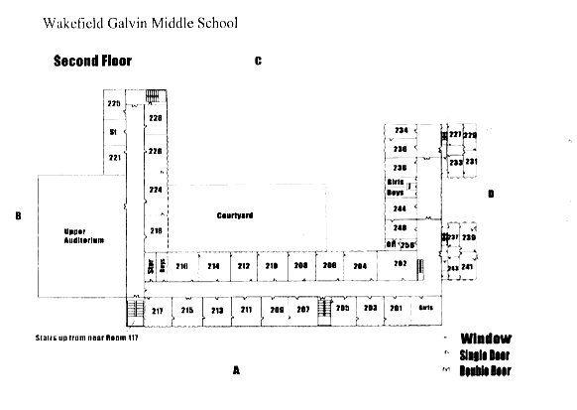
Figure 2: Galvin Middle School, 1st Floor Layout

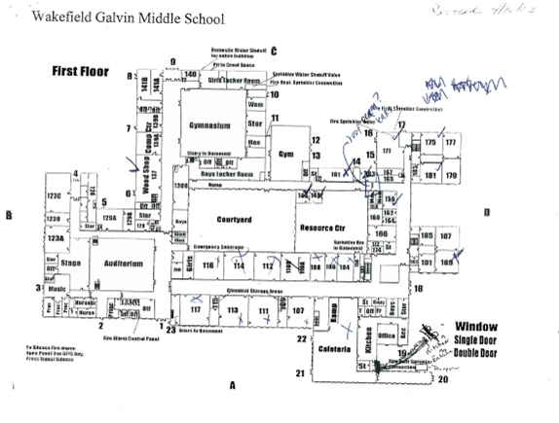
Figure 3: Galvin Middle School, Basement Layout

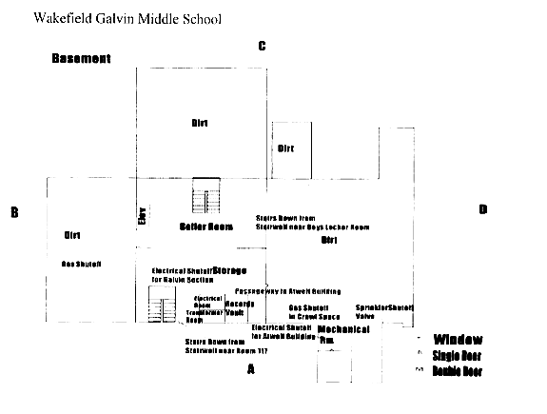
Figure 4: Unit Ventilator (Univent)

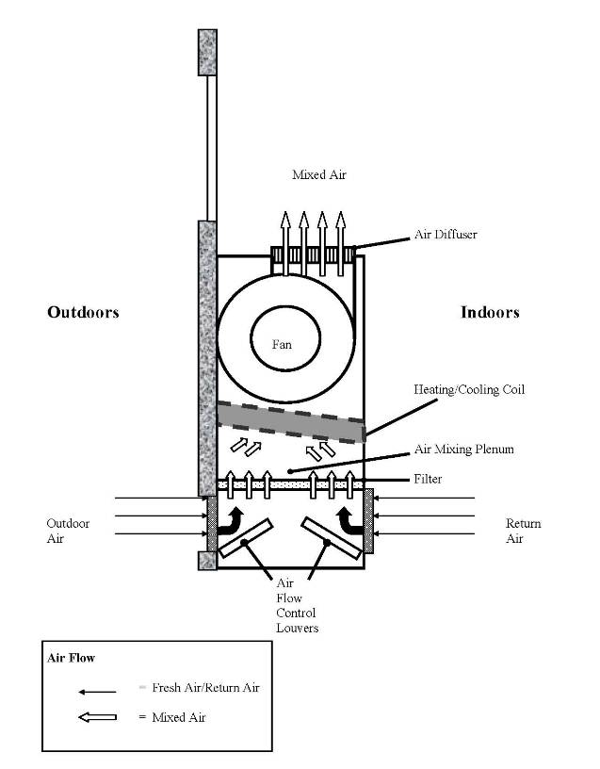
Figure 5: Reported Approximate Groundwater Flow
(as denoted by dotted white line)

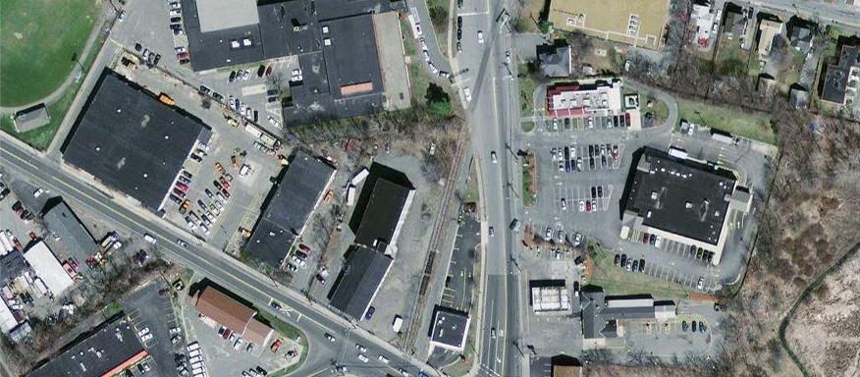
Figure 6: Galvin Middle School and Surrounding Building

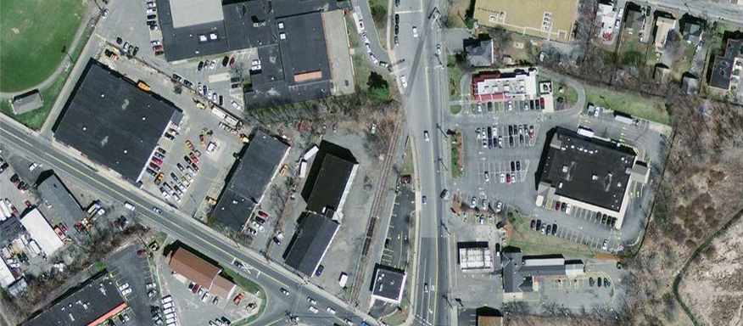
Culvert
Kytron
DPW
Kytron’s Sunken Parking Lot
Galvin Middle School
Picture 1

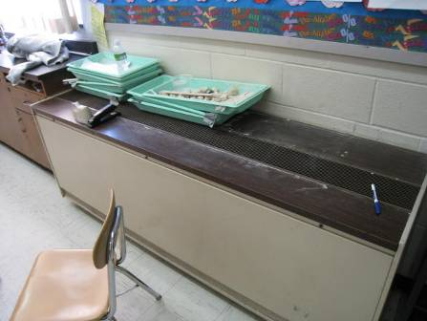

Classroom univent (early 1970s vintage), note chalk dust

Picture 2

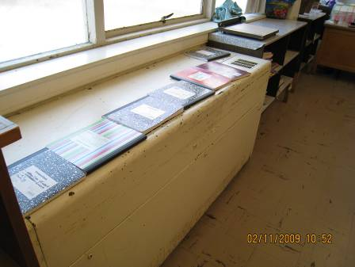

Univent (1950s vintage) fresh air intake blocked by notebooks

Picture 3

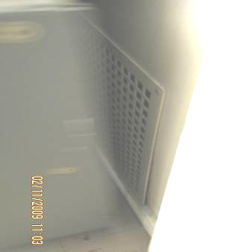

Wall-mounted exhaust vent blocked by bookcase

Picture 4

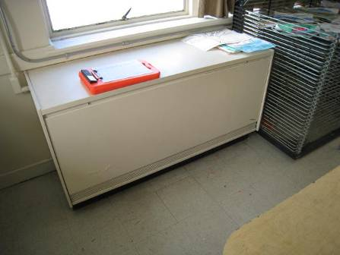

Unit exhaust ventilator

Picture 5

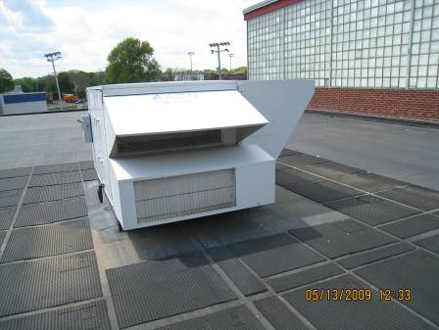

Rooftop AHU

Picture 6

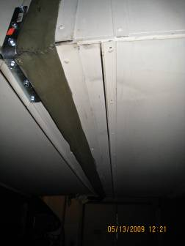

AHU in mechanical room

Picture 7

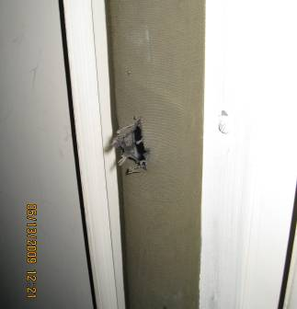

Breach in casing to AHU

Picture 8

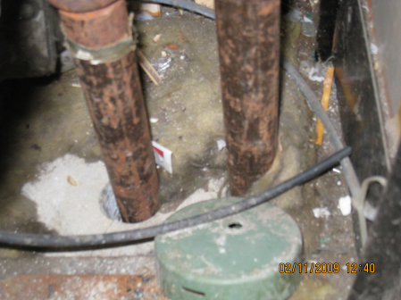
Rodent droppings
Spaces around pipes

Breaches around pipes in univent cabinet, note rodent droppings

Picture 9

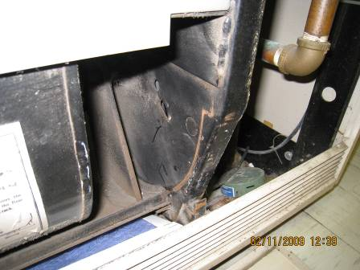
Spaces

Spaces in univent cabinet, post filter

Picture 10

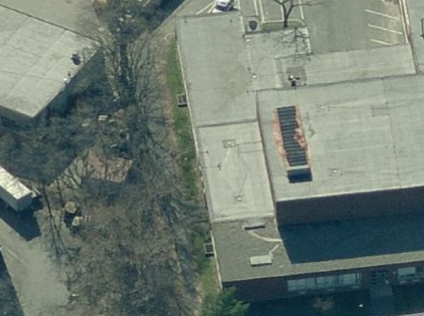
Subterranean Pit vent
General location of music room and stage office

Approximate location of music room and stage office relative to subterranean pit vent

Picture 11

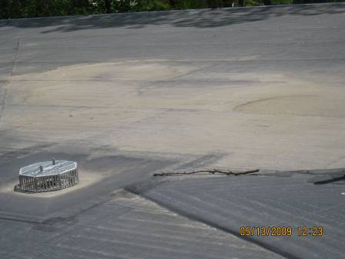

Roof

Roof patches

Picture 12

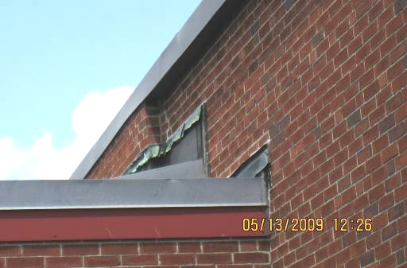

Damaged flashing

Picture 13

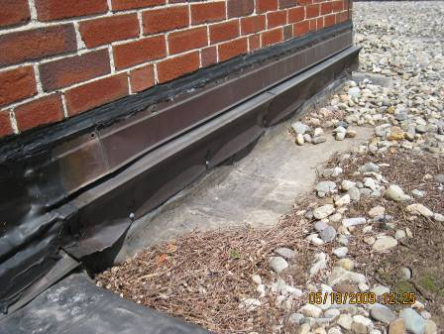

Damaged flashing, note debris and moss growth on roof

Picture 14

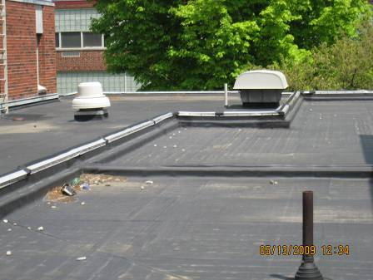

Discontinuous flat roof surface

Picture 15

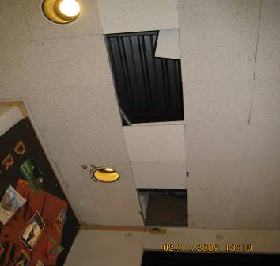

Missing tiles in library
Picture 16

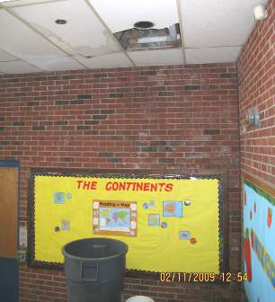

Water-damaged ceiling tiles, note barrel catching water

Picture 17

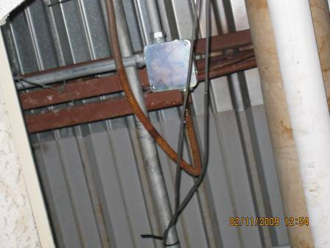

Water dripping from roof beams in hallway

Picture 18

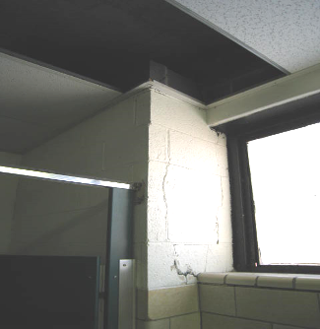

Missing ceiling tile reportedly from leaks, note damage to cement

Picture 19

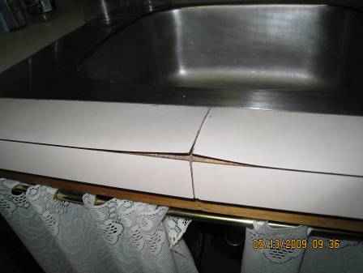

Damaged sink countertop

Picture 20

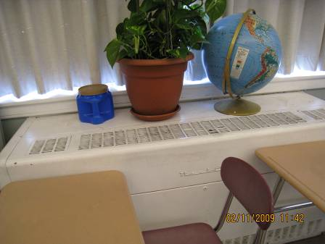

Plant on univent

Picture 21

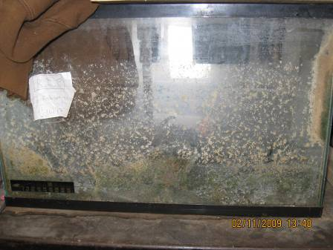

Microbial/algal growth in fish tank

Picture 22

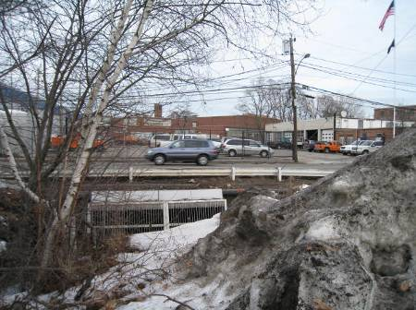

Culvert to stream passing beneath North Avenue

Picture 23

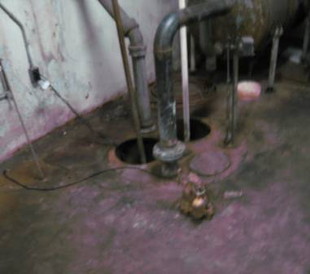

Sump pump in boiler room

Picture 24

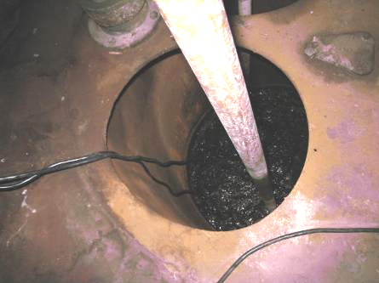

Bottom of sump pump in boiler room

Picture 25

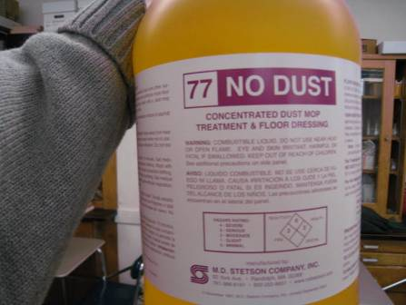

Dust mop treatment

Picture 26

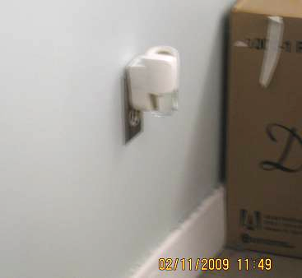

Plug-in air deodorizer

Picture 27

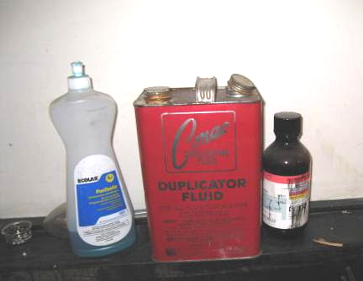

Flammables placed on counter

Picture 28

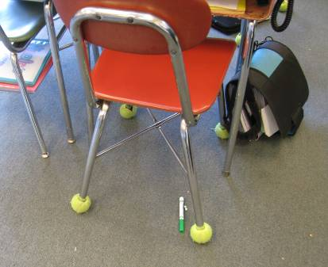

Tennis balls on chair legs

Picture 29

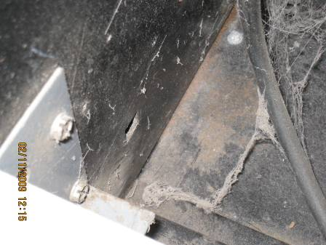

Dust accumulated in univent

Picture 30

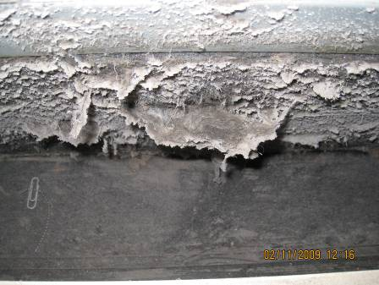

Dust accumulated in univent

Picture 31

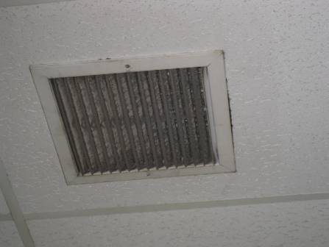

Exhaust vent occluded with dust
Picture 32

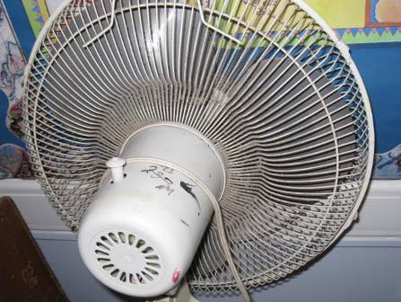

Personal fan occluded with dust

Picture 33

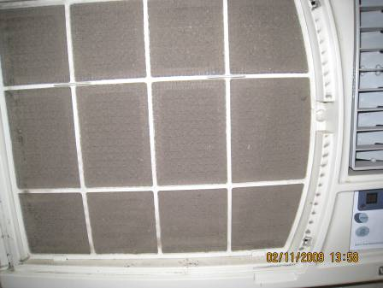

Air-conditioner filter occluded with dust

Picture 34

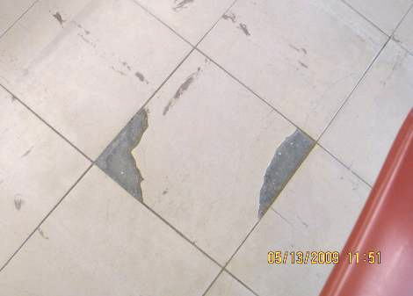

Damaged floor tiles

Picture 35

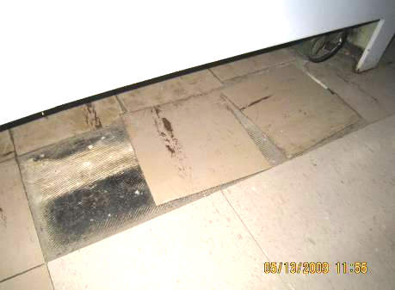

Floor tiles no longer adhering to floor
Location/ Room | Occupants  in Room | Temp  (°F) | Relative  Humidity  (%) | Carbon  Dioxide  (ppm) | Carbon Monoxide  (ppm) | PM2.5  (µg/m³) |  | Windows  Openable | Ventilation |  | Remarks
 |  |  |  |  |  |  | TVOCs (ppm) | Windows  Openable | Supply | Exhaust | Remarks
outdoors |  | 45 | 32 | 480 | ND | 39 | ND
Art | 11 | 74 | 30 | 749 | ND | 24 | ND | Y | Y |  | AC; WD CT; CPs; MT
Boys Room |  |  |  |  |  |  |  |  |  | Y | Wall cracks; MT
Café | 2 | 71 | 35 | 796 | ND | 27 | ND | Y | Y  6 UV off |  | Space around exterior door
Faculty | 1 | 74 | 32 | 552 | ND | 26 | ND | Y | Y  off | Y  off | Window AC; DO
Library | 2 | 72 | 30 | 375 | ND | 26 | ND | Y  2 of 4 open | Y  off | Y  off | Debris on CTs near supply; wall crack; leaks throughout
Music Room | 26 | 73 | 35 | 767 | ND | 31 | ND | Y  1 of 3 open | Y | Y | WD CTs; water in lights; PF
102 | 29 | 75 | 33 | 2187 | ND | 20 | ND | N | Y  off | Y  off | 30 computers; TB; 2 window ACs
104 | 0 | 73 | 31 | 641 | ND | 25 | ND | N | Y  off | Y  off | DO; PF
106 | 0 | 73 | 32 | 685 | ND | 32 | ND | N | Y | Y  dust, off | DEM; DO
107 | 18 | 74 | 37 | 1145 | ND | 26 | ND | Y  open | Y  UV off | Y  off | CPs; MT
108 | 8 | 75 | 32 | 761 | ND | 27 | ND | Y  1 of 1 open | Y | Y  off | Window AC
111 | 24 | 75 | 38 | 1565 | ND | 24 | ND | Y | Y  UV off | Y | PF; Plants
112 | 16 | 74 | 35 | 931 | ND | 30 | ND | Y | Y  UV off | Y  off | CPs; DEM with odors; DO; 2 AT; 1 MT
113 | 0 | 73 | 36 | 1028 | ND | 25 | ND | Y | Y  UV off | Y | Window AC; DO
116 | 1 | 74 | 36 | 1457 | ND | 26 | ND | Y | Y  UV off | Y  off | Items on UV; DEM; DO; accumulated items
117 | 14 | 74 | 38 | 1848 | ND | 25 | ND | Y | Y  UV off | Y | DEM – in use, odors
172 library office | 1 | 73 | 31 | 547 | ND | 20 | ND | N | Y | Y | DO
173 | 0 | 72 | 30 | 545 | ND | 26 | ND | N | Y | Y
201 | 23 | 74 | 42 | 2842 | ND | 33 | ND | Y | Y  UV blocked | Y | Books on UV; PF
202 | 20 | 75 | 37 | 2523 | ND | 23 | ND | Y | Y  UV off | Y  weak/off | Items on UV; plug in AD; accumulated items
203 | 0 | 73 | 30 | 721 | ND | 25 | ND | Y | Y | Y  weak/off | CPs; DO
204 | 23 | 75 | 36 | 1979 | ND | 18 | ND | Y | Y | Y | Items on UV; CPs; PF; AD
205 | 1 | 73 | 34 | 1194 | ND | 28 | ND | Y | Y | Y  blocked | 17 occupants gone 1 minute
206 | 21 | 75 | 37 | 1678 | ND | 23 | ND | Y | Y | Y  off | Plants on UV; DEM; PF - dust; 2 AT
207 | 0 | 74 | 32 | 961 | ND | 28 | ND | Y | Y | Y  blocked | PF dirt on blade; DO
208 | 21 | 75 | 35 | 1451 | ND | 24 | ND | Y  2 of 2 open | Y | Y  off | Radiator off; CPs; DEM; DO; PS; 4 AT
209 | 0 | 73 | 32 | 1029 | ND | 28 | ND | Y  3 of 4 open | Y | Y  weak/off | WD CTs; DO; MT
210 | 15 | 73 | 34 | 1193 | ND | 24 | ND | Y | Y | Y  blocked | 1 AT
211 | 1 | 73 | 34 | 1014 | ND | 24 | ND | Y  2 of 2 open | Y | Y  off | DO
212 | 19 | 73 | 32 | 1085 | ND | 20 | ND | Y | Y | Y  debris, weak/off | DEM; DO; CPs; 2 AT
213 | 26 | 73 | 33 | 879 | ND | 30 | ND | Y  2 of 2 open | Y |  | AC; PF
214 | 23 | 74 | 36 | 1629 | ND | 23 | ND | Y | Y | Y  weak/off | Pf; DEM; CPs; DO; AT
215 | 17 | 75 | 35 | 1584 | ND | 22 | ND | Y  1 of 1 open | Y  UV off | N | PFs
216 | 25 | 74 | 36 | 2023 | ND | 24 | ND | Y | Y  UV off | Y | UV disconnected; DEM; PF; 7 AT; WD windows
217 | 15 | 75 | 31 | 973 | ND | 25 | ND | Y  2 of 2 open | Y  UV off | Y  off | DO
224 | 22 | 74 | 31 | 1054 | ND | 23 | ND | Y  1 of 3 open | Y | Y  near door | DO; PF
226 | 22 | 74 | 31 | 965 | ND | 24 | ND | Y  1 of 2 open | Y | Y  blocked | CPs; DEM; PF
227 | 26 | 77 | 31 | 1272 | ND | 27 | ND | Y | Y | Y  dust | Items on UV; PF; UF; items
228 | 16 | 74 | 31 | 940 | ND | 20 | ND | Y | Y  UV blocked | Y  near door | Books on UV; 2 DO; plants; DEM; CD; CPs
229 | 28 | 76 | 33 | 1541 | ND | 20 | ND | Y | Y | Y  off | Items on UV; DEM; DO; 2 AT; plants
231 | 28 | 77 | 29 | 1013 | ND | 21 | ND | Y | Y | Y | Items on UV; DO
233 | 0 | 77 | 29 | 910 | ND | 27 | ND | Y  1 of 2 open | Y | Y | Plants and items on UV; CPs; DEM; DO
234 | 1 | 77 | 27 | 789 | ND | 24 | ND | Y  1 of 1 open | N | Y | CPs
236 | 29 | 81 | 28 | 849 | ND | 25 | ND | Y  1 of 1 open | Y | Y  weak/off | CPs; DEM
237 | 25 | 81 | 27 | 1274 | ND | 32 | ND | Y  2 of 2 open | Y  weak | Y | PF; DO
239 | 24 | 82 | 26 | 1072 | ND | 33 | ND | Y  2 of 2 open | Y | Y  off | CPs; DO; PF
241 | 5 | 78 | 28 | 1028 | ND | 30 | ND | Y  1 of 2 open | Y | Y  dust | TB; PF
243 | 0 | 78 | 28 | 823 | ND | 26 | ND | Y  2 of 2 open | Y  UV off | Y | TB; AD; DO; DEM; PS; accumulated items
244 | 26 | 82 | 27 | 806 | ND | 25 | ND | Y  open | Y | Y  near door | PF- on; DO
248 | 1 | 80 | 25 | 440 | ND | 21 | ND | Y | Y  2 UVs | Y | Containers with sand on UV; WD CTs; DO; DEM
256 office | 3 | 79 | 25 | 444 | ND | 28 | ND | Y  2 of 2 open | Y  blocked | Y  off | Books and magazines on UV; AP; PF – on; DEM; DO
256 | 4 | 79 | 27 | 672 | ND | 26 | ND | N | N | Y  off, dust | 2 WD CTs; DO

Location/ Room | Occupants  in Room | Temp  (°F) | Relative  Humidity  (%) | Carbon  Dioxide  (ppm) | Carbon Monoxide  (ppm) | PM2.5  (µg/m³) |  | Windows  Openable | Ventilation |  | Remarks
 |  |  |  |  |  |  | TVOCs (ppm) | Windows  Openable | Supply | Exhaust | Remarks
outdoors |  | 68 | 65 | 369 | ND | 18 | ND
Assistant Principal | 0 | 75 | 37 | 828 | ND | 13 | ND | Y | N | N | Window AC – off; DO
Auditorium | 0 | 73 | 36 | 664 | ND | 12 | ND | N | Y | Y | DO
Cafeteria | 280 | 74 | 42 | 1430 | ND | 16 | ND | Y  open | Y | Y
Gym (big) | 0 | 69 | 41 | 585 | ND | 8 | ND | N | Y | Y
Gym (small) | 0 | 70 | 41 | 894 | ND | 10 | ND | N | Y  off | Y  off
Livingston | 0 | 74 | 36 | 684 | ND | 13 | ND | N | Y  off | N | DO
Main Office | 3 | 73 | 35 | 740 | ND | 15 | ND | Y  1 of 2 open | Y | Y | DO; window AC; PC
Music | 3 | 73 | 36 | 725 | ND | 14 | ND | Y  1 of 3 open | Y | Y | WD CTs; musty odor; reportedly leaks when rain
Music Comp Office | 0 | 74 | 38 | 692 | ND | 14 | ND | Y | Y | N | DO; PF; accumulated items
Nurse office | 2 | 73 | 34 | 604 | ND | 13 | ND | Y | Y | Y | WD CTs; debris around CTs; PF; DO
Sorenson Office | 0 | 75 | 36 | 691 | ND | 14 | ND | Y  1 of 1 open | N | N | CF – off; DO
Stage |  |  |  |  |  |  |  |  |  |  | Mouse droppings; hole in roof
Stage Office | 0 | 72 | 30 | 436 | ND | 11 | ND | Y | N | Y | CPs; MTs; dampness odor
V-B Office | 0 | 74 | 37 | 649 | ND | 13 | ND | N | Y  off | N
Women’s Bathroom (163) |  |  |  |  |  |  |  |  |  |  | MT; WD CTs; reportedly bathroom floods
102 | 25 | 74 | 36 | 2002 | ND | 13 | ND | N | Y  weak | Y  off | Window ACs; TBs; DO
104 | 11 | 75 | 37 | 1206 | ND | 20 | ND | N | Y  off | Y  off | DO; DEM; PF
106 | 7 | 75 | 37 | 1101 | ND | 17 | ND | N | Y  off | Y  off | DO
107 | 20 | 77 | 46 | 1791 | ND | 17 | ND | Y | Y | Y  off | PF; CD; DEM; CPs
108 | 5 | 75 | 39 | 1285 | ND | 13 | ND | N | Y  off | Y  off | CPs
110 A | 5 | 74 | 34 | 893 | ND | 14 | ND | Y  1 of 2 open | Y | Y | Window ACs; vending machine; microwave; refrigerator
111 | 17 | 76 | 35 | 723 | ND | 14 | ND | Y  2 of 2 open | Y  off | Y  off | DEM; PF; Plants
112 | 16 | 73 | 32 | 824 | ND | 13 | ND | Y | Y | Y | DO
113 | 16 | 74 | 37 | 739 | ND | 12 | ND | Y  open | Y | Y | Items on UV; DO
114 | 8 | 74 | 30 | 602 | ND | 14 | ND | Y  2 of 2 open | Y | Y  off | CD; PF
116 | 23 | 76 | 45 | 2473 | ND | 17 | ND | Y | Y | Y  off | DEM
117 | 17 | 74 | 39 | 467 | ND | 11 | ND | Y  3 of 3 open | Y | Y | DO
123 A | 16 | 74 | 40 | 1206 | ND | 19 | ND | Y | Y | Y | PF; breach between sink counter and backsplash
123 B | 17 | 74 | 33 | 686 | ND | 16 | ND | Y  3 of 4 open | N | N | Loose floor tiles
123 C | 13 | 74 | 38 | 1153 | ND | 16 | ND | Y | Y | Y | DO; DEM; broken floor tiles
124 | 14 | 74 | 32 | 654 | ND | 15 | ND | Y  2 of 3 open | Y  off | Y
129 A | 23 | 75 | 32 | 712 | ND | 15 | ND | Y  2 of 3 open | Y | Y | Items on UV; TB; CPs; DEM; ATs; MTs
129 B | 1 | 75 | 36 | 711 | ND | 12 | ND | Y | N | N | Window AC – on; holes in ceiling; MT; DO
129 C | 0 | 74 | 31 | 609 | ND | 15 | ND | N | N | Y | DO
130 | 13 | 71 | 40 | 769 | ND | 10 | ND | Y  1 of 2 open | Y | Y  weak, behind door | DO; AC window
135 | 0 | 70 | 30 | 470 | ND | 11 | ND | Y | Y | Y | Wood dust collector operable
137 | 20 | 72 | 32 | 557 | ND | 10 | ND | Y | Y | N
138 A | 17 | 72 | 37 | 895 | ND | 9 | ND | N | Y | Y | 32 computers
139 B | 21 | 73 | 40 | 870 | ND | 5 | ND | N | Y  dust | Y  dust | WD CTs; DO
140 | 1 | 71 | 40 | 870 | ND | 13 | ND | Y | N | N | Carpet – musty; window AC – dust; temperature control concerns; WD CTs in hallway
141 | 12 | 73 | 40 | 864 | ND | 10 | ND | Y | Y  off | Y  off | Window AC – on; WD CTs; DO; PF; CPs
141 B | 0 | 71 | 38 | 783 | ND | 11 | ND | Y  1 of 1 open | Y | N | Wall AC; CPs; Exterior door
143 | 1 | 70 | 40 | 646 | ND | 9 | ND | N | Y | N | DO; reed AD
146 | 2 | 72 | 41 | 1072 | ND | 12 | ND | Y | Y  off | Y  off | Plants
148 | 0 | 72 | 40 | 918 | ND | 13 | ND | N | Y  off | Y  off | PF
156 | 0 | 74 | 38 | 1092 | ND | 19 | ND | N | Y  off | Y  off | CD; DO
161 | 6 | 71 | 39 | 878 | ND | 12 | ND | Y | Y | Y | WD CTs
161 storage  and bathrooms |  |  |  |  |  |  |  |  |  |  | Hole in wall  Reportedly bathroom floods
162 | 1 | 74 | 40 | 1003 | ND | 13 | ND | N | Y  off | Y  dust, off | AD; DEM
163 | 4 | 72 | 40 | 1052 | ND | 15 | ND | Y | Y  off | Y  off | WD CTs
166 | 6 | 73 | 41 | 1142 | ND | 11 | ND | N | Y  off | Y  dust | Aqua; WD; PF; plants
167 | 2 | 70 | 40 | 845 | ND | 10 | ND | Y | Y | Y | DEM; TB
171 | 30 | 74 | 41 | 1445 | ND | 21 | ND | Y | Y  off | Y  off | TB; CPs; window AC; CD
175 | 0 | 70 | 41 | 1169 | ND | 14 | ND | Y | Y | Y | Plants; DEM; DO
175 | 28 | 73 | 40 | 1678 | ND | 17 | ND | Y | Y | Y
177 | 30 | 70 | 40 | 1134 | ND | 14 | ND | Y | Y | Y | CP; DEM; DO
179 | 30 | 71 | 46 | 1831 | ND | 15 | ND | Y | Y | Y  blocked | CD; DO
181 Art Room | 0 | 70 | 46 | 1611 | ND | 14 | ND | Y | Y | Y | Stored items on UV
183 work room | 0 | 70 | 41 | 1232 | ND | 14 | ND | N | N | Y  dust | PC; DO
185 | 27 | 72 | 44 | 1342 | ND | 14 | ND | Y  1 of 2 open | Y  UV off | Y | Items on UV; CPs on sink; CD
187 | 26 | 73 | 47 | 1831 | ND | 17 | ND | Y | Y  off | Y  off | PF; CD; PS; 2 AT
189 | 24 | 74 | 30 | 1245 | ND | 17 | ND | Y  2 of 4 open | Y  off | Y  off | Items on UV; CPs; CD; PF
191 | 26 | 74 | 39 | 957 | ND | 12 | ND | Y  2 of 3 open | Y  off | Y  off | CD; CPs; DO
193 work room | 0 | 71 | 41 | 1133 | ND | 15 | ND | N | N | Y  dust | CP; PF; DO

The service life is the median time during which a particular system or component of … [an HVAC]… system remains in its original service application and then is replaced. Replacement may occur for any reason, including, but not limited to, failure, general obsolescence, reduced reliability, excessive maintenance cost, and change system requirements due to such influences as building characteristics or energy prices (ASHRAE, 1991).

