INDOOR AIR QUALITY ASSESSMENT

Galvin Middle School
525 Main Street
Wakefield

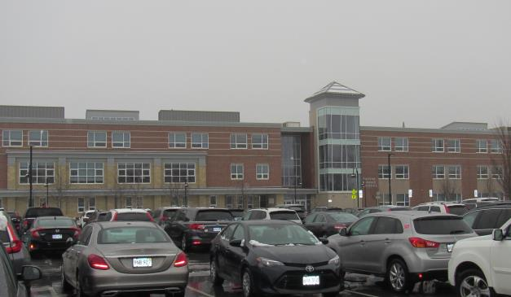

Prepared by:
Massachusetts Department of Public Health
Bureau of Environmental Health
Indoor Air Quality Program
August 2020

Background
Building: | Galvin Middle School (GMS)
Address: | 525 Main St, Wakefield
Requested by: | Bob Schiaroli, Director of Facilities,  Wakefield Public Schools (WPS)
Reason for Request: | Collaborative effort to perform general indoor air quality (IAQ) assessments throughout the WPS
Date of Assessment: | February 13, 2020
Massachusetts Department of Public Health/Bureau of Environmental Health (MDPH/BEH) Staff Conducting Assessment: | Ruth Alfasso, Environmental Engineer/Inspector, and Jason Dustin, Environmental Analyst/Inspector, IAQ Program
Building Description: | GMS is a three-story brick building
Windows: | Windows are openable in most areas of the school.

Methods
Please refer to the IAQ Manual for methods, sampling procedures, and interpretation of results (MDPH, 2015).

Results
The following is a summary of indoor air testing results (Table 1).
- Carbon dioxide levels were below the MDPH recommended level of 800 parts per million (ppm) in about ¾ of areas assessed, indicating adequate air exchange in most areas of the building.
- Temperature was within or close to the MDPH recommended range of 70°F to 78°F in occupied areas.
- Relative humidity was below the lower end of the MDPH recommended range of 40 to 60% in nearly all areas tested the day of assessment, which is typical of conditions during the heating season.
- Carbon monoxide levels were detected at low levels in a few areas. This is discussed further in the “Other Conditions” section of this report.
- Particulate matter (PM2.5) concentrations measured were below the National Ambient Air Quality (NAAQS) level of 35 μg/m³ in all areas tested.

Discussion

Ventilation
A heating, ventilating, and air conditioning (HVAC) system has several functions. First it provides heating and, if equipped, cooling. Second, it is a source of fresh air. Finally, an HVAC system will dilute and remove normally occurring indoor environmental pollutants by not only introducing fresh air, but by filtering the airstream and ejecting stale air to the outdoors via exhaust ventilation. Even if an HVAC system is operating as designed, point sources of respiratory irritation may exist and cause symptoms in sensitive individuals.
Fresh air ventilation in the GMS is supplied by air handing units (AHU) located on the roof. Fresh air is supplied to classrooms, offices and common areas via ceiling-mounted supply vents (Picture 1). Ceiling-mounted exhaust vents remove stale air.
Air in classrooms is additionally heated and filtered through the use of fan coil units (FCU) located on exterior walls (Picture 2). These units draw in room air through a vent along the bottom, and supply conditioned air via the vent on the top. In order to function effectively, top and bottom vents on units must remain unobstructed by furniture and items. Note that each unit is equipped with a fairly inefficient filter. The MDPH recommends pleated filters with a Minimum Efficiency Reporting Value (MERV) of 8, which are adequate in filtering out pollen and mold spores (ASHRAE, 2012). Filters should also be changed two to four times a year, or per the manufacturer’s recommendations. More importantly, the FCUs did not appear to have any sort of bracket or holder to keep the filters in place in the airstream of the unit, relying only on the pressure of the air flowing through the unit to hold the filter in place. Many of the filters in these units were found on the floor underneath (Table 1), where they provide no filtration and can become covered in dust and debris. Facility staff reported that this is due to a design issue with the units, and that a new method of holding filters in place was being implemented at the school.
To maximize air exchange, the MDPH recommends that both supply and exhaust ventilation operate continuously during periods of occupancy. In order to have proper ventilation with a mechanical supply and exhaust system, the systems must be balanced to provide an adequate amount of fresh air to the interior of a room while removing stale air from the room. It is recommended that HVAC systems be re-balanced every five years to ensure adequate air systems function (SMACNA, 1994).
Note that many of the exhaust vents and wall-mounted thermostats are located near the doors to the hallway (Picture 3). These are both designed to function most efficiently when the hallway doors are closed. When hallway doors are open, the exhaust vents tend to draw stale air from the hallway instead of the room, and thermostats measure hallway temperatures instead of room temperatures.

Microbial/Moisture Concerns
In order for building materials to support mold growth, a source of water exposure is necessary. Identification and elimination of the source of water moistening building materials is necessary to control mold growth. Water-damaged ceilings/tiles were observed in some classrooms and offices (Picture 4; Table 1), which can indicate current or historic roof/plumbing leaks. Water-damaged ceiling tiles can provide a source of mold and should be replaced after a water leak is discovered and repaired. The United States Environmental Protection Agency (US EPA) and the American Conference of Governmental Industrial Hygienists (ACGIH) recommend that porous materials be dried with fans and heating within 24 to 48 hours of becoming wet (US EPA, 2008; ACGIH, 1989). If porous materials are not dried within this time frame, they should be removed and discarded.
The refrigerator in the staff lunchroom had evidence of a spill (Picture 5; Table 1). Refrigerators should be cleaned out regularly to prevent odors and microbial growth. Stained gaskets should be cleaned with a mild antimicrobial solution; if they are too heavily stained/damaged, they should be replaced. Refrigerators should not be placed on carpet/porous materials to protect carpets from spills.
Plants were present in some classrooms and other areas (Picture 6). Plants should be well maintained, not overwatered, and not placed on porous materials or in the airstream of ventilation equipment.
There is a shower area in Room 107 which appears to be used for storage. If showers, floor drains or other fixtures are unused, the drain traps may dry out and allow sewer gases and odors into occupied spaces. Seldom used drains should be moistened periodically to maintain the trap seal. Drains/fixtures which are no longer needed should be properly cut and capped.
Door sweeps and weather stripping were worn out in some areas of the building (Picture 7). Doors should be made tight-fitting to prevent unconditioned air, moisture and pests from entering the building.

Other Conditions
Low levels of carbon monoxide (CO) were measured in a few areas, including outdoors. Background reading outside of the GMS measured 2 ppm prior to the assessment. Indoor levels ranged from trace levels (below 1ppm) to 2.9 ppm in one area of the kitchen (near dishwasher). A few rooms and a hallway in one small wing of the 1st floor measured between 1ppm and 2 ppm (Table 1). It is possible that the AHU serving the first floor wing is entraining some CO in the fresh air intake and then distributing it to that wing. Several outside sources of carbon monoxide where observed in close proximity to the GMS AHU fresh air intakes.
- The town Department of public works (DPW) building is close to the GMS (Picture 8). Trucks frequently drive to and from the building and may idle at times during repair work. DPW fleets are usually predominantly diesel which is much lower in CO emissions than gasoline engines.
- The GMS is in close proximity to major roadways which could have an impact on the background CO levels during certain wind directions.
- The GMS appears to have gas-fired boilers with flues that terminate a few feet above the roof line (Picture 9). It is possible that under certain weather conditions (e.g., temperature inversions), the AHUs may draw in products of combustion (including CO) from the flues and distribute them through supply air to the areas served by those AHUs affected.
The Facilities Director was informed of the low levels of CO on the day of this assessment and reported that he would have someone investigate the source. It should be stressed that the low levels of CO experienced during this assessment did not pose an immediate risk to health and safety but when any level is found indoors, the source should be identified and steps taken to mitigate chronic low levels from occurring. The American Conference of Governmental Industrial Hygienists (ACGIH) has assigned carbon monoxide a threshold limit value (TLV) of 25 ppm as a time-weighted average (TWA) for a normal 8-hour workday and a 40-hour workweek (ACGIH 1999).
Exposure to low levels of total volatile organic compounds (TVOCs) may produce eye, nose, throat, and/or respiratory irritation in some sensitive individuals. BEH/IAQ staff examined rooms for products containing VOCs. BEH/IAQ staff noted hand sanitizers, scented products, plug in air fresheners/diffusers and candles, home cleaning products, and dry erase materials in use within the building (Pictures 10 and 11). All of these products have the potential to be irritants to the eyes, nose, throat, and respiratory system of sensitive individuals.
Several of the science classrooms have laboratory hoods (Picture 12). These units are designed to draw pollutants up and out of the building during experiments. In order to ensure they are functioning properly, they need to be calibrated. In addition, no chemicals should be stored in the hoods. Some of the laboratory preparation rooms had storage cabinets for flammable and corrosive materials. These cabinets and other chemical storage should be kept clean and organized.
The wood shop area had several kinds of saws and other wood-cutting/shaving equipment. A vacuum system is present to collect wood chips and sawdust from the equipment (Pictures 13 and 14). A collection vessel was located both indoors and outdoors. These containers should be emptied regularly and the system maintained so that it is functioning well to remove wood chips and dust. At the time of the visit, there was wood dust and debris on the floor and counters in the room (Picture 15). Wood dust should be cleaned promptly to avoid becoming aerosolized where it can cause irritation; it can also be a slipping hazard when on the floor.
Dust and debris was noted on floors, other flat surfaces and in and on FCUs (Picture 16). This dust and debris should be cleaned periodically. Staff should avoid storing items on top of the vents and discourage students from putting items inside.
Missing ceiling tiles were noted in a few areas. Tiles that are missing from the ceiling system can allow unconditioned air and debris from above into occupied spaces.
A few areas of the school are carpeted and some classrooms have area rugs. Carpeting should be vacuumed regularly with a high efficiency particulate arrestance (HEPA) filter equipped vacuum cleaner to avoid particulates from causing further irritation or serving as a reservoir for microbial colonization. Also, carpeting and rugs should be cleaned at least once per year according to IICRC recommendations (IICRC 2012). Area rugs too worn to be effectively cleaned should be replaced. Area rugs should be rolled up and stored in a clean, dry place when rooms are not occupied during the summer months to prevent moistening due to condensation.
In many classrooms, large numbers of items were on floors, windowsills, tabletops, counters, bookcases and desks, which provide a source for dusts to accumulate. These items (e.g., papers, folders, boxes) make it difficult for custodial staff to clean. Items should be relocated and/or be cleaned periodically to avoid excessive dust build up. In addition, dust and debris can accumulate on flat surfaces (e.g., desktops, shelving and carpets) in occupied areas and subsequently be re-aerosolized causing further irritation.
Note that the Environmental Protection Agency (EPA) conducted a National School Radon Survey in which it discovered nearly one in five schools had “…at least one frequently occupied ground contact room with short-term radon levels above 4 [picocuries per liter] pCi/L” (US EPA 1993). The BEH/IAQ Program therefore recommends that every school be tested for radon, and that this testing be conducted during the heating season while school is in session in a manner consistent with USEPA radon testing guidelines. Radon measurement specialists and other information can be found at www.nrsb.org and http://aarst-nrpp.com/wp, with additional information at: http://www.mass.gov/eohhs/gov/departments/dph/programs/environmental-health/exposure-topics/iaq/radon.

Conclusions/Recommendations

Based on the observations made during the visit, the following is recommended:

Investigate the source of the low levels of carbon monoxide (CO) measured in Table 1. Ensure CO detectors are in proper working order. Rule out any possible internal CO source such as gas-fired combustion units (e.g. boilers, gas stoves, etc.). Then determine if flue stacks for boilers are at sufficient height/flow velocity to avoid CO entrainment in nearby AHU units. Lastly, determine if other sources of CO could be contributing to the low background levels found outside the GMS and take appropriate measures to mitigate entrainment into the affected AHUs.

Utilize a system to report and track maintenance issues so that concerns can be reported by staff and maintenance staff can indicate when issues have been resolved.

Operate the HVAC system to provide for continuous fresh air ventilation during occupied hours.

Remove furniture and items blocking the front and top of FCUs.

Consider closing classroom doors for most efficient exhaust vent and thermostat function.

Use openable windows to supplement fresh air during temperate weather. Ensure all windows are closed tightly at the end of each day. Do not use AC system while windows are opened to prevent condensation/mold growth.

Consider adopting a balancing schedule of every 5 years for all mechanical ventilation systems, as recommended by ventilation industrial standards (SMACNA, 1994).

Replace water-damaged ceiling tiles once a leak is discovered and repaired. Ensure that dust from cutting ceiling tiles is cleaned promptly.

Regularly fill any drains with water that are seldom used. If drains are to be abandoned, ensure they are properly capped.

Replace any missing or ajar ceiling tiles to avoid pathways to unconditioned areas.

Keep classroom/office plants in good condition, avoid overwatering, and keep them away from the airstream of ventilation equipment.

Ensure all refrigerators are kept clean to prevent microbial growth and odors. Clean gaskets and other surfaces with a mild antimicrobial solution to remove debris and mold. If they cannot be adequately cleaned-replace.

Replace worn out door sweeps. Check for light and drafts around doors.

Reduce or eliminate the use of air fresheners, scented cleaners, and dry erase materials to reduce irritation.

Ensure wood dust collection units, air filters and local exhaust fans are turned on whenever the equipment is operating. The collection system should be emptied and maintained regularly to prevent a build-up of wood shavings and filters should be changed per manufacturer recommendations.

Change filters in HVAC units at least twice a year with MERV 8 or higher filters. Clean HVAC and FCU cabinets of debris and dust when filters are changed.

Clean supply/exhaust vents and personal fans regularly to remove accumulated dust/debris. Replace surrounding ceiling tiles that cannot be adequately cleaned.

For buildings in New England, periods of low relative humidity during the winter are often unavoidable. Therefore, scrupulous cleaning practices should be adopted to minimize common indoor air contaminants whose irritant effects can be enhanced when the relative humidity is low. To control for dusts, a high efficiency particulate arrestance (HEPA) filter equipped vacuum cleaner in conjunction with wet wiping of all surfaces is recommended. Avoid the use of feather dusters. Drinking water during the day can help ease some symptoms associated with a dry environment (throat and sinus irritations).

Clean carpeting and area rugs at least once per year according to IICRC recommendations (IICRC 2012). Area carpets too worn to be effectively cleaned should be replaced. Roll up and store are rugs in a clean, dry place during the summer.

Relocate or consider reducing the amount of materials stored in classrooms to allow for more thorough cleaning of classrooms. Clean items regularly with a wet cloth or sponge to prevent excessive dust build-up.

Continue to utilize the US EPA’s (2000), “Tools for Schools”, as an instrument for maintaining a good IAQ environment in the building available at: http://www.epa.gov/iaq/schools/index.html.

The school should be tested for radon by a certified radon measurement specialist during the heating season when school is in session. Radon measurement specialists and other information can be found at: www.nrsb.org, and http://aarst-nrpp.com/wp.

Refer to resource manuals and other related IAQ documents for further building-wide evaluations and advice on maintaining public buildings. Copies of these materials are located on the MDPH’s website: http://mass.gov/dph/iaq.

References
ACGIH. 1989. Guidelines for the Assessment of Bioaerosols in the Indoor Environment. American Conference of Governmental Industrial Hygienists, Cincinnati, OH.
ACGIH. 1999. Guide to Occupational Exposure Values-1999. American Conference of Governmental Industrial Hygienists, Cincinnati, OH.
ASHRAE. 2012. American Society of Heating, Refrigeration and Air Conditioning Engineers (ASHRAE) Standard 52.2-2012 -- Method of Testing General Ventilation Air-Cleaning Devices for Removal Efficiency by Particle Size (ANSI Approved).
IICRC. 2012. Carpet Cleaning FAQ 4 Institute of Inspection, Cleaning and Restoration Certification. Institute of Inspection Cleaning and Restoration, Vancouver, WA.
MDPH. 2015. Massachusetts Department of Public Health. “Indoor Air Quality Manual: Chapters I-III”. Available at: http://www.mass.gov/eohhs/gov/departments/dph/programs/environmental-health/exposure-topics/iaq/iaq-manual/.
SMACNA. 1994. HVAC Systems Commissioning Manual. 1st ed. Sheet Metal and Air Conditioning Contractors’ National Association, Inc., Chantilly, VA.
US EPA. 1993. Radon Measurement in Schools, Revised Edition. Office of Air and Radiation, Office of Radiation and Indoor Air, Indoor Environments Division (6609J). EPA 402-R-92-014. https://www.epa.gov/sites/production/files/2014-08/documents/radon_measurement_in_schools.pdf.
US EPA. 2000. Tools for Schools. Office of Air and Radiation, Office of Radiation and Indoor Air, Indoor Environments Division (6609J). EPA 402-K-95-001, Second Edition. http://www.epa.gov/iaq/schools/index.html.
US EPA. 2008. “Mold Remediation in Schools and Commercial Buildings”. Office of Air and Radiation, Indoor Environments Division, Washington, DC. EPA 402-K-01-001. September 2008. Available at: http://www.epa.gov/mold/mold-remediation-schools-and-commercial-buildings-guide.​

Picture 1
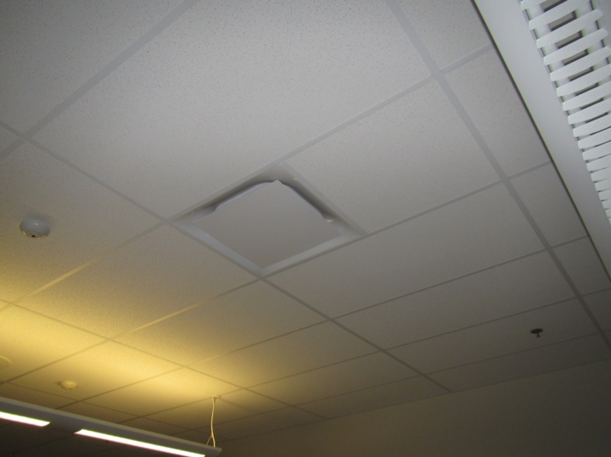
One style of supply vent
Picture 2
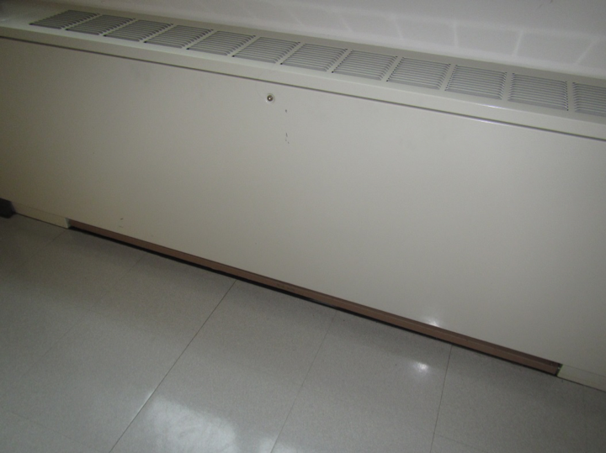
Fan coil unit (FCU)
Picture 3
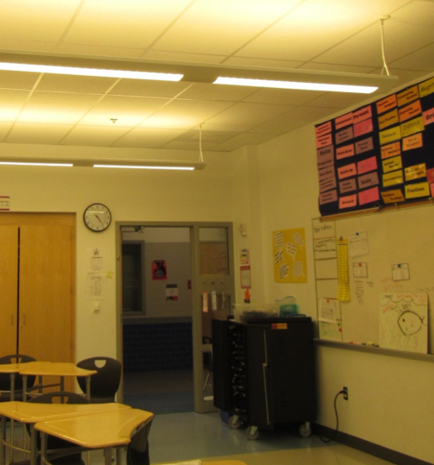
Return/exhaust vent next to door (arrow)
Picture 4
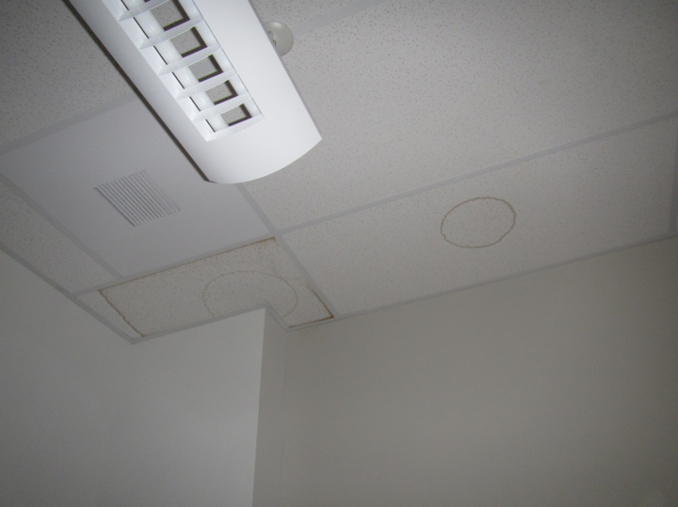
Water-damaged ceiling tile
Picture 5
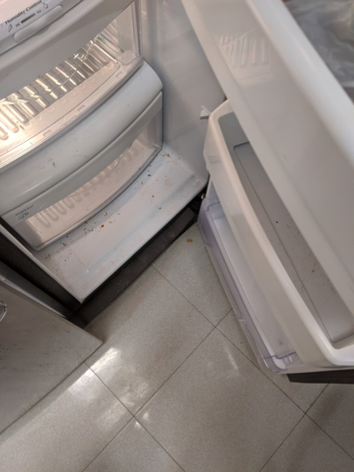
Spills/debris inside fridge in a teacher’s workroom
Picture 6
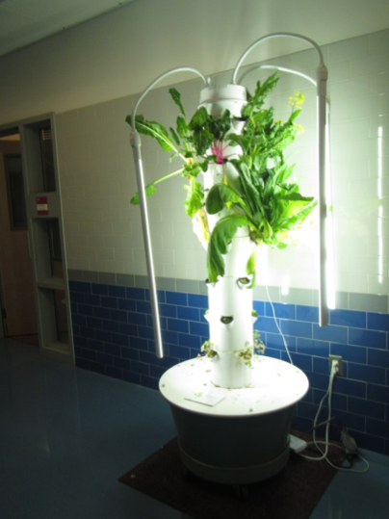
Hydroponic plant setup in hallway
Picture 7
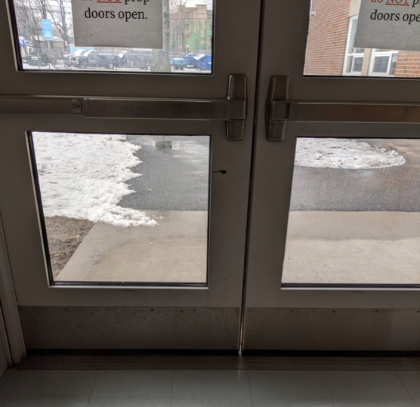
Light visible around door showing missing weather stripping
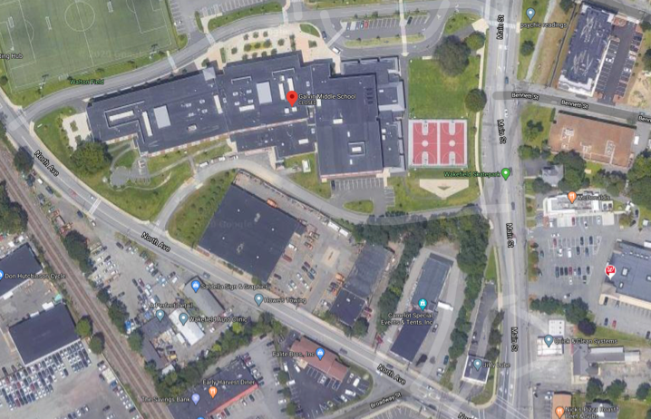
Picture 8

GMS showing close proximity to DPW to the south (arrow)

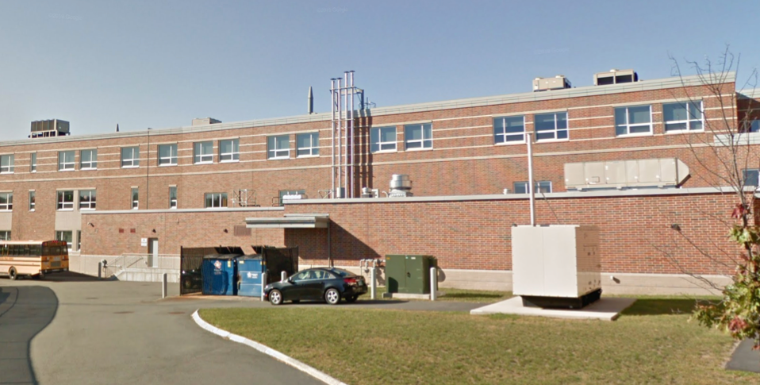
Picture 9
GMS showing gas boiler flues in close proximity to AHUs
Picture 10
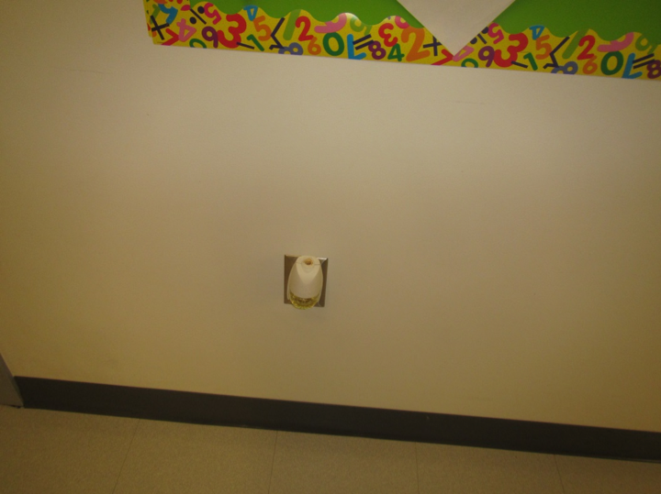
Plug-in air freshener
Picture 11
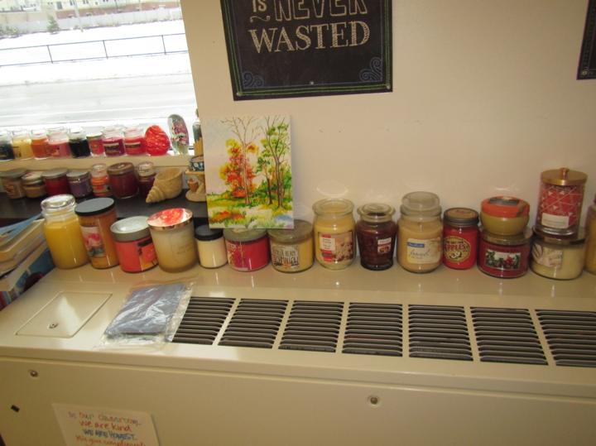
Scented candles on FCU
Picture 12
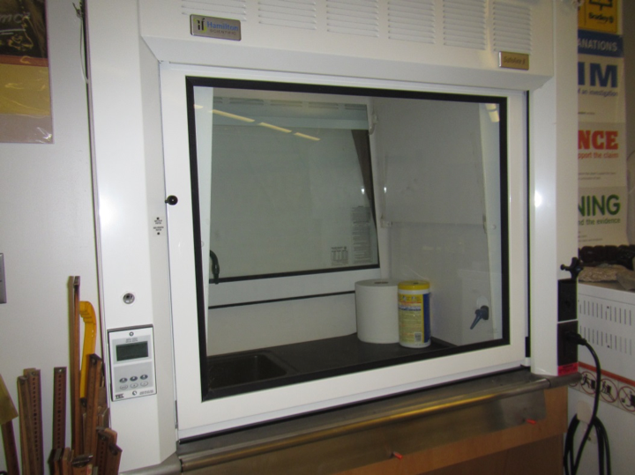
Laboratory hood in between science classroom and prep room
Picture 13
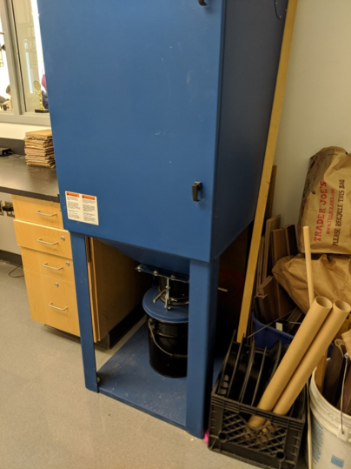
Wood chip collection inside wood shop room
Picture 14
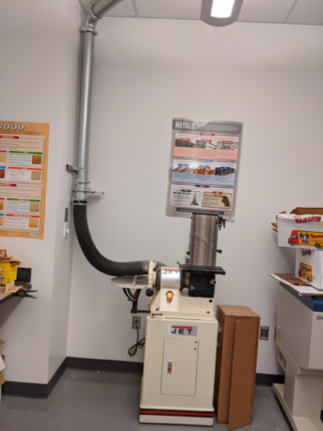
Wood shop equipment with vacuum system
Picture 15
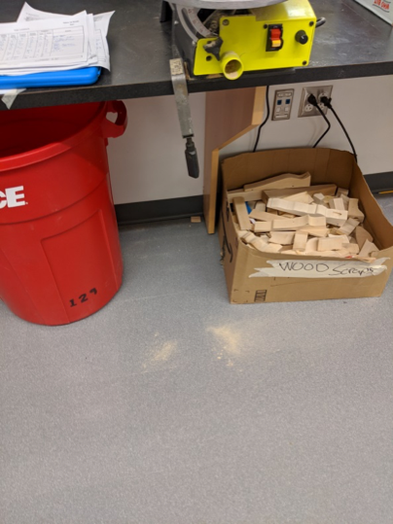
Wood dust/debris on floor
Picture 16
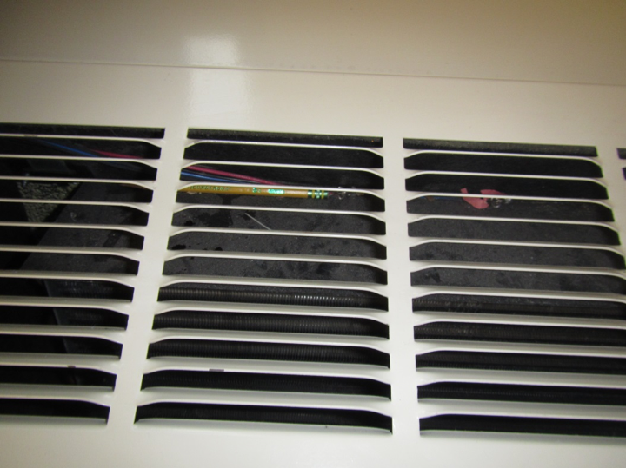
Debris inside FCU
Location | Carbon  Dioxide  (ppm) | Carbon Monoxide  (ppm) | Temp  (°F) | Relative  Humidity  (%) | PM2.5  (µg/m³) | Occupants  in Room | Windows  Openable | Ventilation |  | Remarks
 |  |  |  |  |  |  |  | Supply | Exhaust
Background | 402 | 2.0 | 46 | 58 | 25 | NA | - | - | - | Low level of carbon monoxide (CO) detected –GMS near DPW & busy street
Third Floor
308 | 673 | ND | 73 | 29 | 4 | 7 | Y | Y | Y | 2 WD CT, DEM, candle on FCU
309 | 618 | ND | 73 | 26 | 4 | 0 | Y 1 open | Y | Y | DEM, FCU
310 | 558 | ND | 72 | 26 | 4 | 1 class left 20 minutes ago | Y | Y | Y | DEM, 3 sinks and gas taps
301 prep room |  |  |  |  |  |  | N | Y | Y | Hood and exhaust vent. No calibration sticker for hood, sink and gas tap, microwave, refrigerator and dish washer
6th grade girls restroom |  |  |  |  |  |  | N | Y | Y dusty | Floor drains
313 locked |  |  |  |  |  |  | N | Y | Y
317 project room | 653 | ND | 72 | 28 | 4 | 10 | N | Y | Y | Sink, high ceilings, art items, messy storage closet, DEM
318 Teachers’ workroom | 519 | ND | 73 | 27 | 4 | 0 | N | Y | Y | DEM, food, sink, fridge, microwave, toaster oven, PC
319 | 715 | ND | 72 | 28 | 5 | 25 | N | Y | Y | Skylights, DEM, HS
076 | 535 | ND | 73 | 26 | 3 | 0 | N | Y | Y | Office, carpet, HS
031 | 552 | ND | 73 | 26 | 5 | 0 | N | Y | Y | Office, DEM, carpet, plants
320 | 543 | ND | 74 | 25 | 4 | 0 | N | Y | Y | Office/classroom, sinks, DEM, plants
307 | 540 | ND | 73 | 26 | 10 | 1 | Y | Y | Y | DEM, hood
307 prep room |  |  |  |  |  |  |  |  |  | Dishwasher, sink and gas tap, microwave, refrigerator, room is disorganized
306 | 623 | ND | 73 | 29 | 7 | 10 | Y | Y | Y | DEM, HS
336 | 1033 | ND | 72 | 31 | 5 | 16 | N | Y | Y | Skylights, sinks and gas taps, DEM, hood, fridge, emergency shower and eyewash
336 prep room is locked |  |  |  |  |  |  |  |  |  | Looks clean and organized, has dishwasher, microwave, sink and gas tap
337 | 624 | ND | 72 | 26 | 5 | 3 | N | Y | Y | Skylight, DEM, sink, HS
338 project room | 546 | ND | 73 | 27 | 4 | 4 | N | Y | Y | High ceilings, sink, DEM
339 | 512 | ND | 73 | 25 | 5 | 0 | N | Y | Y | Teachers workroom, DEM, food, microwave, toaster oven (crumbs)
340 | 496 | ND | 73 | 25 | 4 | 0 | N | Y | Y | Small office, DEM
349 | 939 | ND | 73 | 28 | 2 | 20 | Y | Y | Y | DEM, food/AF odor, plant over FCU
348 | 729 | ND | 73 | 27 | 3 | 21 | Y | Y | Y | DEM, emergency shower and eyewash, sinks and gas taps, hood, HS
348 prep room |  |  |  |  |  |  |  |  |  | Items on floor, dust/debris, appliances, hood
346 | 875 | ND | 74 | 28 | 3 | 19 | Y | Y | Y | DEM
328 | 580 | ND | 74 | 26 | 3 | 0 | Y | Y | Y | Plants, DEM, HS
326 | 512 | ND | 73 | 27 | 3 | 2 | Y | Y | Y | DEM
325 | 859 | ND | 73 | 29 | 3 | 7 more left during class change | Y | Y | Y | DEM, WD CT
300 | 712 | ND | 72 | 29 | 5 | 22 left 15 min ago | Y | Y | Y | DEM
301 | 652 | ND | 72 | 28 | 4 | 0 | Y | Y | Y | DEM
302 | 968 | ND | 72 | 31 | 4 | 23 | Y | Y | Y | DEM, WD CT
303 | 981 | ND | 72 | 31 | 4 | 17 | Y | Y | Y | DEM
304 | 732 | ND | 73 | 27 | 5 | 1 | Y | Y | Y | HS
305 | 700 | ND | 72 | 28 | 4 | 1 | Y | Y | Y | FCU with inefficient filters that keep falling down onto ground (no filter rack to secure in place)
331 | 1006 | ND | 72 | 29 | 1 | 14 | Y | Y | Y | DEM
332 | 1056 | ND | 73 | 31 | 3 | 20 | Y | Y | Y | DEM
333 | 928 | ND | 73 | 28 | 1 | 25 | Y | Y | Y | DEM
334 | 939 | ND | 73 | 28 | 3 | 17 | Y | Y | Y | DEM, DO with exhaust vent in close proximity
335 | 1001 | ND | 73 | 28 | 1 | 15 | Y | Y | Y | DEM
Hallway | - | - | - | - | - | - | - | - | - | WD above locker 3511
350 | 1140 | ND | 73 | 30 | 2 | 24 | Y | Y | Y | DEM
347 | 957 | ND | 74 | 29 | 1 | 14 | Y | Y | Y | CPs, DEM, HS
330 | 903 | ND | 73 | 29 | 1 | 18 | Y | Y | Y
329 | 538 | ND | 72 | 26 | 3 | 0 | Y | Y | Y | DO near exhaust vent, HS, WD CT x 2, AI
327 | 566 | ND | 71 | 27 | 1 | 2 | Y | Y | Y | Housekeeping needed, WD CTs x 3, CPs, FCU filter down
2nd floor
217 | 579 | ND | 73 | 29 | 4 | 0 | N | Y | Y | Workroom, microwave, fridge, DEM, PC, utility space behind/in workroom with missing CT and ductwork
218 project room | 507 | ND | 74 | 26 | 3 | 0 | N | Y | Y | Sink, microwave, food odors, skylights, high ceilings, DEM, HS
221 | 615 | ND | 73 | 26 | 5 | 0 | N | Y | Y | Office, area rug, DEM
220 | 533 | ND | 74 | 26 | 4 | 0 | N | Y | Y | Plug-in AF, PF
065D | 510 | ND | 73 | 24 | 5 | 1 | Y | Y | Y | Carpet and area rug
065 storage |  |  |  |  |  |  |  |  |  | Items on floor
Upper auditorium | 564 | ND | 73 | 24 | 7 | 0 | N | Y | Y | Carpet and UF
233 | 883 | ND | 73 | 28 | 4 | 16 | Y | Y | Y | FCU is making new loud noise, FCU filter on floor, DEM
232 | 704 | ND | 73 | 27 | 5 | 1 | Y | Y | Y | DEM, sinks, soiled floor
219 | 509 | ND | 73 | 25 | 4 | 0 | N | Y | Y | Plug-in AF, DEM, HS, heater
213 | 815 | ND | 76 | 25 | 3 | 0 | N | Y | Y | Small classroom, feels hot and stuffy
210 | 629 | ND | 74 | 27 | 4 | 13 | Y | Y | Y | Sink and gas taps, DEM, plants, HS
210 prep room |  |  |  |  |  |  |  |  |  | Sink and gas taps, fridge, microwave, chemical storage (not many chemicals)
209 | 790 | ND | 75 | 28 | 4 | 21 | Y | Y | Y | DEM, DO
208 | 586 | ND | 74 | 25 | 4 | 0 | Y | Y | Y | DEM, FCU, filter on floor
200 | 727 | ND | 74 | 28 | 4 | 21 | Y | Y | Y | DEM, FCU filter on floor, DO
201 | 941 | ND | 75 | 31 | 3 | 19 | Y | Y | Y | DEM
202A | 605 | ND | 74 | 27 | 4 | 3 | Y | Y | Y | DEM, UF, area rug, divider
202B | 578 | ND | 74 | 26 | 4 | 0 | Y | Y | Y | FCU filter on floor, FCU squeaks,  DEM
225 | 575 | ND | 71 | 28 | 1 | 12 | Y | Y | Y | DEM, HS, DO
226 | 1036 | ND | 72 | 33 | 2 | 23 | Y | Y | Y | DEM
227 | 955 | ND | 73 | 31 | 3 | 21 | Y | Y | Y | DEM
228 | 841 | ND | 73 | 30 | 3 | 21 | Y | Y | Y | DO w/nearby exhaust vent, HS
229 | 716 | ND | 72 | 28 | 2 | 21 | Y | Y | Y | Plants, DEM
065E | 542 | ND | 72 | 26 | 2 | 1 | Y | Y | Y | Carpet tiles
065C | 601 | ND | 74 | 27 | 2 | 2 | Y | Y | Y | Carpet
232 | 680 | ND | 73 | 27 | 2 | 1 | Y | Y | Y | Dusty vents
231 | 654 | ND | 72 | 27 | 1 | 0 | Y | Y | Y | Plants
230 | 753 | ND | 73 | 28 | 1 | 19 | Y | Y | Y | HS, FCU filter on ground
207 | 703 | ND | 73 | 28 | 2 | 25 | Y | Y | Y | HS, DEM, WD CT
206 | 738 | ND | 73 | 28 | 1 | 19 | Y | Y | Y | DEM
205 | 904 | ND | 74 | 30 | 1 | 18 | Y | Y | Y
204 | 877 | ND | 74 | 29 | 1 | 17 | Y | Y | Y | DEM
203 | 581 | ND | 74 | 26 | 2 | 1 | Y | Y | Y | HS, FCU filter fell down
1st floor
100 | 811 | ND | 73 | 30 | 4 | 20 | Y | Y | Y | DEM, students sitting on floors (and in adjacent classrooms and hallways), sink
101 | 797 | ND | 73 | 30 | 3 | 15 | Y | Y | Y | DEM, dust/debris on floor
102 | 778 | ND | 73 | 30 | 3 | 17 | Y | Y | Y | Sink, DEM, items on FCU, AI
103 | 755 | ND | 75 | 31 | 4 | 19 | Y | Y | Y | Many candles including on FCU, HS, DEM, plush toys
104 | 593 | ND | 74 | 25 | 4 | 3 | Y | Y | Y | Salt lamp, DEM
105 | 694 | ND | 74 | 28 | 5 | 17 | Y | Y | Y | Sink, dirty floor, FCU off, debris in FCU
106 | 858 | ND | 74 | 29 | 3 | 18 | Y | Y | Y | Dust and debris in FCU, plants, DEM
107 | 654 | ND | 73 | 27 | 4 | 5 | Y | Y | Y | UF, kitchen equipment, washer/dryer. Attached shower room appears unused, check drains, DEM
124 | 601 | ND | 72 | 27 | 5 | 16 | N | Y | Y | Computer, dirty floors, DEM
121 media classroom with TV studio | 521 | ND | 72 | 26 | 4 | 0 | N | Y | Y | DEM, computers
030 main office | 713 | ND | 72 | 29 | 4 | 5 | Y | Y | Y
Assistant Principal | 644 | ND | 73 | 27 | 5 | 0 | Y | Y | Y | Plants, DEM
Mr. Colantuoni | 615 | ND | 74 | 26 | 6 | 0 | Y | Y | Y | Tiny room, DEM, NC
031 SRO | 623 | ND | 74 | 27 | 5 | 0 | Y | Y | Y | Plants, carpet
044 | 741 | ND | 74 | 27 | 7 | 2 | Y | Y | Y | Carpet
036 | 684 | ND | 74 | 28 | 6 | 0 | N | Y | Y | Carpet, DEM, streamers
Admin kitchenette |  |  |  |  |  |  |  |  |  | Dishes in sink, toaster oven with crumbs, microwave
038 conference | 637 | ND | 74 | 27 | 6 | 0 | Y | Y | Y | Carpet, DEM
035 | 671 | ND | 73 | 26 | 5 | 0 | Y | Y | Y | Carpet
Staff women’s restroom |  |  |  |  |  |  | N | N | Y | AF odor
Cafeteria | 886 | 1.3 | 73 | 31 | 5 | ~400 | N | Y | Y | Low level of CO detected
107? (technology) | 714 | ND | 72 | 29 | 3 | 21 | Y | Y | Y | Sink, dusty floor, DEM
Wood shop |  |  |  |  |  |  | N | Y | Y | Wood dust collection system, wood cutting equipment, dust/debris on floor
125 |  | 1.2 | 71 | 30 | 4 | 0 | Y | Y | Y | DEM, dust/debris on floor, low level of CO detected
Nurse | 654 | ND | 71 | 30 | 5 | 2 |  | Y | Y | WD CT in rest area
050 | 612 | ND | 72 | 29 | 5 | 1 | Y | Y | Y | Faculty lunch, debris in fridge, vending
145 | 601 | ND | 72 | 28 | 2 | 1 | Y | Y | Y | Music mac lab, DEM
146 | 739 | ND | 72 | 30 | 3 | 40-50 | Y | Y | Y | Chorus, DEM, guitars, sink
147 | 711 | ND | 72 | 27 | 2 | 0 | Y | Y | Y | Sink, NC, guitars, drums
055 | 646 | ND | 72 | 29 | 3 | 3 | N | Y | Y
018 | 472 | ND | 67 | 29 | 9 | 0 | N | Y | Y | WD CT in hallway
108 | 607 | ND | 73 | 26 | 1 | 0 | Y | Y | Y | AI, boxes on slab floor, HS
109 | 903 | ND | 72 | 31 | 1 | 21 | Y | Y | Y | DEM, CP
110 | 921 | ND | 73 | 30 | 1 | 20 | Y | Y | Y | WD CT
111 | 660 | ND | 73 | 28 | 2 | 1 | Y | Y | Y | Boxes on slab floor
113 | 585 | ND | 72 | 27 | 1 | 1 | N | Y | Y
117 | 592 | ND | 72 | 27 | 1 | 4 | N | Y | Y
118 | 622 | ND | 72 | 27 | 1 | 0 | N | Y | Y | PC, paper stored on slab floor
119 | 593 | ND | 72 | 27 | 1 | 2 | N | Y | Y | DEM
Library-front | 645 | ND | 72 | 26 | 1 | 3 | N | Y | Y | Carpet tiles
Library-center | 640 | ND | 72 | 26 | 2 | 5 | N | Y | Y | PC
Café-front | 914 | 1.0 | 72 | 32 | 1 | 70+ | N | Y | Y | Low level of CO detected
Kitchen | - | 1.3-2.9 | - | - | - | - | - | - | Y | Low levels of CO detected, highest near dishwasher (dishwasher exhaust was off during assessment)
128 | 750 | ND | 72 | 30 | 1 | 1 | Y | Y | Y | CP, DEM, HS, FCU filter off
127 | 747 | 1.0 | 72 | 30 | 1 | 1 | Y | Y | Y | CPs, FCU filter off, CO low level
Hallway near 127 | - | 2.0 | - | - | - | - | - | - | - | Low level of CO detected
126 | 815 | 1.0 | 71 | 30 | 1 | 0 | Y | Y | Y | DEM, low level CO detected
Auditorium | 862 | ND | 69 | 30 | 1 | 40+ | N | Y | Y | Carpet
149 Instruments | 552 | ND | 70 | 30 | 1 | 0 | Y | Y | Y | WD x 10 in Hall, 1 WD CT inside
Gym | 774 | ND | 69 | 34 | 1 | ~50 | N | Y | Y | Wood floor
22 | 481 | 1.3 | 66 | 31 | 14 | 0 | N | Y | N | Hall door open to outside, low level CO detected

