{Insert – Grantee Organizational Letterhead}
Town/Grantee Name
{Insert Project Title and Location }
Final Report for MassDEP Gap IV Grant Funding

Project Description

Insert narrative

SCOPE OF WORK AND DELIVERABLES
The steps involved in constructing and completing of the {insert project title) included the following tasks:
{Insert all project tasks and deliverables from your Gap III approved scope of work and provide the steps / actions the grantee took to complete each project task}

Task One: Completion Date:

DESCRIPTION: The Town/Grantee worked with……

These tasks included {for example}:

- Preparation and finalization of one-line drawing set.
- Structural engineering review and design.
- An independent third-party structural engineering analysis
- Final design approval and modifications (i.e. removal of 4 panels to create a safety walk)
- Site preparation: Moving oseveral sewer vent pipes

Task Two: Permitting Completion Date:

DESCRIPTION: The Town/Grantee worked with the Installer and subcontractor to ensure that all appropriate permits and approvals required for project implementation were received to commence construction.
These included:
- Local approval of “Certificate of Appropriateness.”
- Building department review and permits, including electrical/wiring.
- Interconnection application submitted and reviewed by National Grid.
- National Grid Interconnection acceptance and agreement

Task Three: Project Installation and Commissioning Completion Date:

DESCRIPTION: The Town/Grantee worked with the Installer to ensure the successful installation and start-up of the…….,
Tasks included:

- Mobilization of equipment, electrical array wiring, inverter and monitoring connections, installation of solar panels, and local inspections and signoffs.
- Performance and testing evaluations, electrical acceptance, and final signoffs.

Task Four: Complete outreach/ communication component Completion Date:

DESCRIPTION: E.g. Upon completion of the project, the Town/Grantee issued several public outreach communications informing the community about the successful energization of the PV-system, including via social media posts, the Town’s website, a formal press release, and the Town Manager’s monthly newsletter (see enclosed).
E.g. Additionally, a ribbon-cutting ceremony with local and MassDEP officials and a public solar “show & tell”/tour were hosted at the facility on August 10, 2023.

Task Five: Reporting Completion Date:

- The Town/Grantee provided regular quarterly progress reports to MassDEP on tasks identified in Section III - Scope of Work and Deliverables noted above.
- For Municipal projects, the Grantee entered facility energy data into MassEnergyInsight (MEI).
a web-based no-cost energy tracking tool for municipalities: https://www.massenergyinsight.net/home.

  - The Grantee should include a MEI printout here in this Final Report of the energy usage data for all applicable facilities that were part of this grant project. This includes submission of one preceding year of monthly energy usage and cost information prior to the implementation of the approved Gap grant project(s).

  - Please note: Municipal Grantees shall verify and ensure the accuracy and completeness of facility data in MassEnergyInsight for three (3) years following completion of the funded project(s).

Project Photographs: Insert before and after photos of your project below (with actual or estimated dates equipment was removed, replaced; task completed etc.)

Site Visit:
The MassDEP officials conducted their site visit on……….
Public Outreach:
Extensive public outreach was conducted highlighting the Gap IV grant and the progress of the ……project. Examples of public outreach included (see enclosed/attached copy of outreach material):
- Creation of a project website:
- Press Release
- Social Media postings
- Town Website spotlight
- Local press advertisements
- Town Manager newsletter
Financial Information:
The Funds were used as follows:
Expense Category / Description | Total Final Costs | Grantee Cost (minimum 10% cost share) | Other Funding (energy utility incentives, grants etc.) | Gap Grant  Award | Start Date | Completion Date
Totals
For example…..The system will also be registered to receive additional incentives through the Commonwealth of Massachusetts’ SMART program and may be eligible for a direct payment grant through the Inflation Reduction Act.
Town/Grantee { } Project Team:
General questions about the project should be directed to
Facility Contact:
Grant Contact/Project Manager:

Public Outreach

Insert/attach the project outreach document(s) below e.g., advertisement placed in the local newspaper, website, etc….

Below, the Clean Energy Results Program (CERP) have provided some information regarding branding and messages that should be used for publicizing your Gap Energy Grant project.
Re: images
Below (and shared as PNG files) is the preferred image scheme that should be used for press or outreach materials:
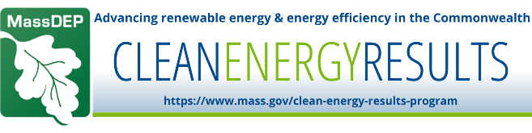
We have included a simplified version that could be incorporated into social media images:
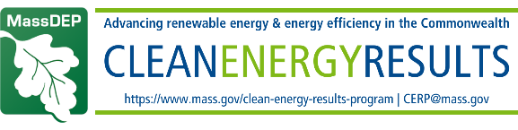
Re: messaging
- Traditional outlets (e.g. press release):
  - The Gap Energy Grant is funded by the Massachusetts Department of Environmental Protection’s Clean Energy Results Program (MassDEP, CERP). The Gap Energy Grant is an innovative and cost-effective funding model that produces energy-efficient and renewable energy project results!
- Social media
  - Twitter/X: The #GapEnergyGrant is funded by @MassDEP #CleanEnergyResultsProgram. The #GapEnergyGrant is an innovative and cost-effective funding model that produces energy-efficient and renewable energy project results!
  - Instagram: The #GapEnergyGrant is funded by @Mass_DEP #CleanEnergyResultsProgram. The #GapEnergyGrant is an innovative and cost-effective funding model that produces energy-efficient and renewable energy project results!
  - Facebook: The #GapEnergyGrant is funded by #MassDEP #CleanEnergyResultsProgram. The #GapEnergyGrant is an innovative and cost-effective funding model that produces energy-efficient and renewable energy project results!
  - LinkedIn: The #GapEnergyGrant is funded by @MassDEP #CleanEnergyResultsProgram. The #GapEnergyGrant is an innovative and cost-effective funding model that produces energy-efficient and renewable energy project results!

Gap IV Grant Invoicing and Payments

Invoicing and Payments: All grant funds are disbursed on a reimbursement basis, after receipt of supporting documentation and upon review and written approval of MassDEP. The Grantee shall submit invoices to MassDEP for the reimbursement of approved expenditures, accompanied by the supporting documentation. Invoices for the reimbursement of approved expenditures shall be accompanied by the following documentation (at a minimum): proof of purchase in the form of an invoice that lists the vendor name and address, items or services purchased, and the total cost. MassDEP reserves the right to require additional supporting documentation from the Grantee with respect to the review and approval of any request for reimbursement of Project costs.

