Background

INDOOR AIR QUALITY
ASSESSMENT

GAR Memorial Library
490 Main Street
West Newbury, Massachusetts

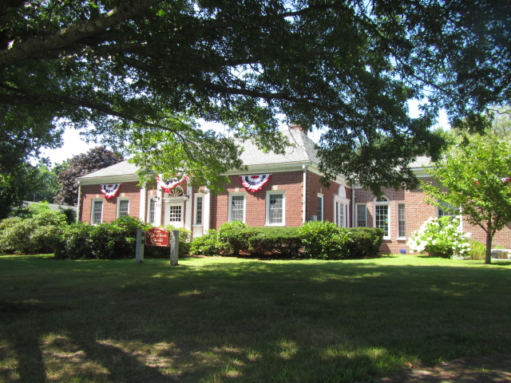

Prepared by:
Massachusetts Department of Public Health
Bureau of Environmental Health
Indoor Air Quality Program
August 2019
Building: | GAR Memorial Library
Address: | 490 Main Street, West Newbury, MA
Assessment requested by: | Angus Jennings, Town Manager
Reason for Request: | Mold concerns and general indoor air quality (IAQ).
Date of Assessment: | August 15, 2019
Massachusetts Department of Public Health/Bureau of Environmental Health (MDPH/BEH) Staff Conducting Assessment: | Cory Holmes, Environmental Analyst/Inspector, Indoor Air Quality (IAQ) Program
Date of Building Construction | Late 1800s early 1900s, additions 1980s
Building Description: | The building mainly consists on the ground floor with some storage/public common areas in the renovated attic space. The basement is used for mechanical equipment.
Windows: | Windows are openable.

Methods
Please refer to the IAQ Manual for methods, sampling procedures, and interpretation of results (MDPH, 2015).

IAQ Testing Results
The following is a summary of indoor air testing results (Table 1).
- Carbon dioxide levels were well below the MDPH guideline of 800 parts per million (ppm) in areas tested, indicating plenty of fresh air introduction/air exchange.
- Temperature was within the recommended range of 70°F to 78°F.
- Relative humidity was above the recommended range of 40% to 60% in all areas the day of assessment, which may indicate an unaccounted moisture source, which will be discussed in the Ventilation section of this report.
- Carbon monoxide levels were non-detectable (ND) in all areas assessed.
- Fine particulate matter (PM2.5) concentrations measured were below the National Ambient Air Quality Standard (NAAQS) level of 35 micrograms per cubic meter (μg/m³) in all areas assessed.

Ventilation
A heating, ventilating, and air conditioning (HVAC) system has several functions. First it provides heating and, if equipped, cooling. Second, it is a source of fresh air. Finally, an HVAC system will dilute and remove normally occurring indoor environmental pollutants by not only introducing fresh air, but also filtering the airstream and ejecting stale air to the outdoors via exhaust ventilation. At the time of assessment, the digital thermostat was set to fan “on” which provides a continuous source of outside/fresh air. It was reported that the HVAC system had been running in this setting for at least the last week due to IAQ concerns.
It is also important to note that the HVAC system for the building consists of four large air handling units (AHUs/Pictures 1 and 2), which may be over designed for the size of the building. In the MDPH/IAQ Program’s experience buildings of this size are typically serviced by one or two AHUs. It was not clear at the time of assessment how/if the fresh air intakes could be adjusted. For example on subzero/freezing cold days as well as hot/humid days, the air intakes are typically limited to a lower percentage (i.e., 20%) to improve comfort, and in the case of cold weather-to prevent freezing of pipes. In contrast, on comfortable spring/fall days air intakes would be open much further (50-100%).
Filters within the AHUs were not accessible during the assessment. The MDPH/IAQ Program recommends pleated filters of a Minimum Efficiency Reporting Value (MERV) of 8, which are adequate in filtering out pollen and mold spores (ASHRAE, 2012). In addition, filters should be changed 2-4 times a year or in accordance with the manufacture’s recommendations. In follow-up correspondence with Department of Public Works Director, Wayne Amaral, it was confirmed that the filters were MERV 8 or higher.

Microbial/Moisture Concerns
No current evidence of visible mold growth, water leaks or moisture to building materials was noted within the space during the assessment. In addition, no elevated moisture measurements were detected in building materials (i.e., walls, wooden shelving and carpeting). However, musty odors were detected, particulary in the Young Adult area, which was one of the primary areas of concern. Despite the recent addition of in-line dehumidification units (Picture 3) relative humidity measurements in the breathing zone/center of room ranged from 63-67%, whereas the air directly taken from the supply vent was 76%, over 11% higher than readings taken directly outside at the air intakes (65%).
These elevated relative humidity measurements may indicate a lack of control/excessive outside air introduction and/or a moisture source within the HVAC system, such as clogged/over flowing drip pans or a lack of drainage within the units. In addition, if units are oversized they may cycle on/off more frequently which prevents adequate dehumidification. Correctly sized AC units should have relative humidity levels below 60%.
During an inspection of the AHUs MDPH/IAQ staff noted a dent filled with water on top of one of the AHUs (Picture 4). Although not a current issue, over time this area may become corroded and a point of water entry, thus should be repaired.
Also noted along the exterior was:
- Some missing/damaged mortar around brickwork (Picture 5);
- Open spaces/utility holes (Picture 6);
- Damaged/exposed woodwork and missing soffit vents around exterior of roof (Pictures 7 and 8);
- Plants/shrubbery against exterior walls (Picture 9); and
- Branches/leaves overhanging roof/gutters (Picture 10).

Over time, these conditions can undermine the integrity of the building envelope and provide a means of water entry into the building via capillary action through foundation concrete and masonry (Lstiburek & Brennan, 2001). The freezing and thawing action of water during the winter months can create cracks and fissures in the foundation. These breaches may provide a means for moisture and pests to enter the building.

Other IAQ Evaluations
Carpets should be cleaned annually (or semi-annually in soiled/high traffic areas) in accordance with Institute of Inspection, Cleaning and Restoration Certification (IICRC) recommendations, (IICRC, 2012). The service life of carpeting is approximately 10-11 years (IICRC, 2002). Carpeting of this age and condition becomes increasingly difficult to clean and maintain and may be a source of particulate matter to the indoor environment. Regular cleaning with a high efficiency particulate air (HEPA) filtered vacuum in combination with an annual cleaning will help to reduce accumulation and potential aerosolization of materials from carpeting.
Portable air purifiers were also in use in a few areas (Table 1). These units also have filters, which should be cleaned/changed as per the manufacturer’s instructions.

Recommendations
The following recommendations are made to improve general IAQ:
- Work closely with HVAC engineering firm to determine best methods to obtain comfortable/optimal humidity conditions (i.e., 40-60%). These methods may include (but not limited to):
  - Performing a thorough cooling load calculation of the space to determine accurate cooling capacity required;
  - Adding additional in-line dehumidification units;
  - Adjusting the Fan control (auto vs on);
  - Adjusting outside air intake % (i.e., limiting fresh air during periods of elevated humidity > 70%); and
  - Ensuring proper drainage.
- In the interim continue to monitor relative humidity and consider employing portable dehumidifiers if needed.
- Ensure dehumidifiers are cleaned/maintained as per the manufacturer’s instructions to prevent standing water, odors and/or mold/bacterial growth.
- Consider adopting a balancing schedule of every 5 years for all mechanical ventilation systems, as recommended by ventilation industrial standards (SMACNA, 1994).
- Continue with plans to change HVAC filters (using MERV 8 or higher filters) 2-4 times a year or as per the manufacturer’s instructions.
- Make repairs to dent in AHU, where standing water accumulates (Picture 4)
- Make repairs to the building envelope (roof, walls, fascia, etc.) to prevent potential leaks/damage including:
  - Repoint brick/masonry;
  - Seal around open pipes/utilities;
  - Replace missing soffit vents;
  - Trim back plants/shrubbery to at least 5-feet from exterior walls; and
  - Ensure branches do not overhang roofs/gutters.
- Clean carpeting annually or semi-annually in soiled high traffic areas as per the recommendations of the Institute of Inspection, Cleaning and Restoration Certification (IICRC, 2012).
- Clean/change filters in portable air purifiers as per the manufacturer’s instructions.
- For buildings in New England, periods of low relative humidity during the winter are often unavoidable. Therefore, scrupulous cleaning practices should be adopted to minimize common indoor air contaminants whose irritant effects can be enhanced when the relative humidity is low. To control for dusts, a high efficiency particulate arrestance (HEPA) filter equipped vacuum cleaner in conjunction with wet wiping of all surfaces is recommended. Avoid the use of feather dusters. Drinking during the day can help ease some symptoms associated with a dry environment (throat and sinus irritation).
- For more information about mold consult the US EPA’s “Mold Remediation in Schools and Commercial Buildings” published by the US Environmental Protection Agency (US EPA, 2008) (https://www.epa.gov/mold/mold-remediation-schools-and-commercial-buildings-guide).
- Refer to resource manual and other related indoor air quality documents located on the MDPH’s website for further building-wide evaluations and advice on maintaining public buildings. These documents are available at http://www.mass.gov/dph/iaq.

References
ASHRAE. 2012. American Society of Heating, Refrigeration and Air Conditioning Engineers (ASHRAE) Standard 52.2-2012 -- Method of Testing General Ventilation Air-Cleaning Devices for Removal Efficiency by Particle Size (ANSI Approved).
IICRC. 2012. Institute of Inspection, Cleaning and Restoration Certification. Carpet Cleaning: FAQ.
Lstiburek, J. & Brennan, T. 2001. Read This Before You Design, Build or Renovate. Building Science Corporation, Westford, MA. U.S. Department of Housing and Urban Development, Region I, Boston, MA.
MDPH. 2015. Massachusetts Department of Public Health. Indoor Air Quality Manual: Chapters I-III. Available at: http://www.mass.gov/eohhs/gov/departments/dph/programs/environmental-health/exposure-topics/iaq/iaq-manual/.
SMACNA. 1994. HVAC Systems Commissioning Manual. 1st ed. Sheet Metal and Air Conditioning Contractors’ National Association, Inc., Chantilly, VA.
US EPA. 2008. Mold Remediation in Schools and Commercial Buildings. US Environmental Protection Agency, Office of Air and Radiation, Indoor Environments Division, Washington, D.C. EPA 402-K-01-001. http://www.epa.gov/mold/mold-remediation-schools-and-commercial-buildings-guide.
Picture 1
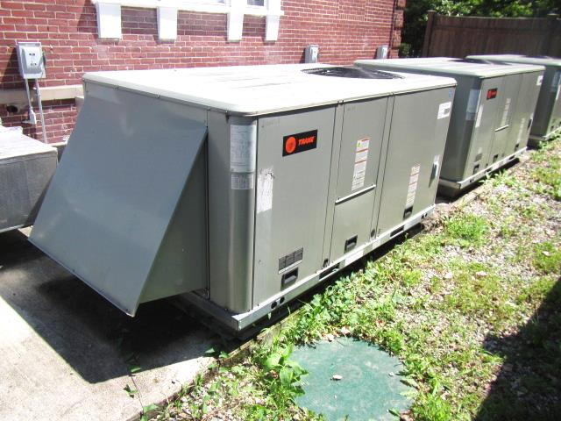
Three of four large AHUs
Picture 2
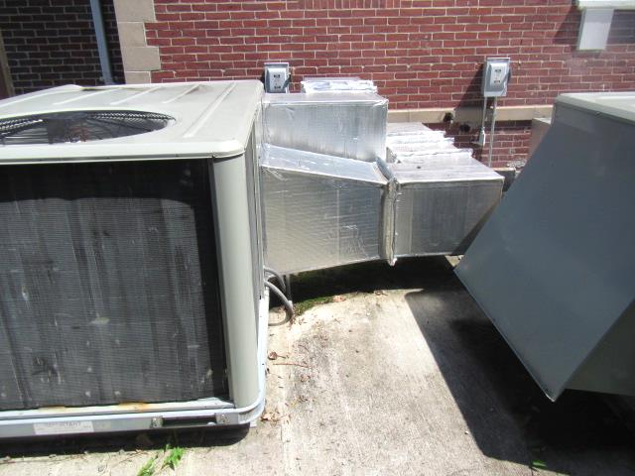
Fourth AHU
Picture 3
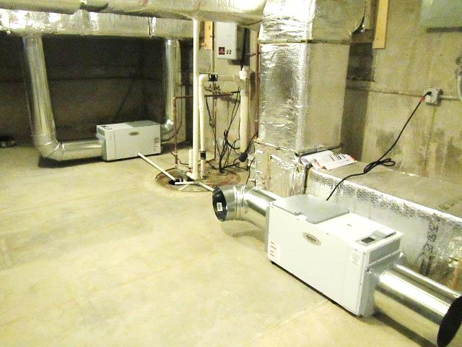
In-line dehumidification units (arrows)
Picture 4
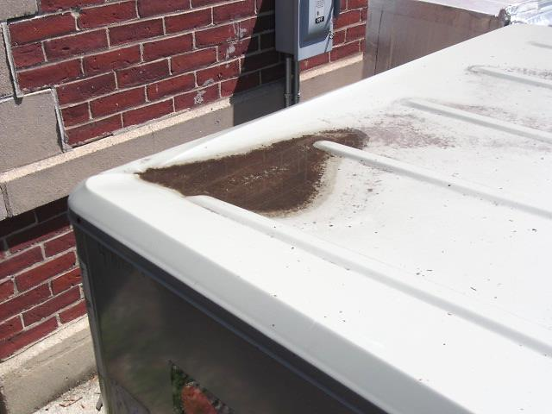
Dent in metal top of AHU filled with water/debris
Picture 5
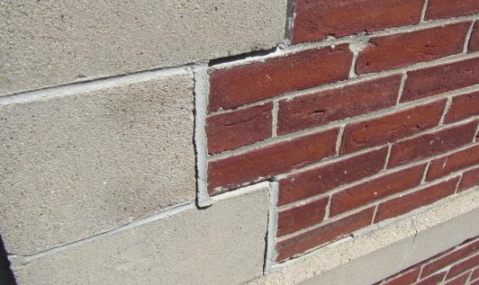
Missing/damaged mortar around masonry
Picture 6
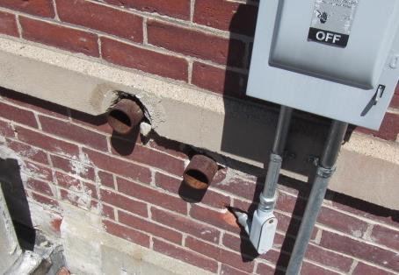
Spaces around utilities/pipes
Picture 7
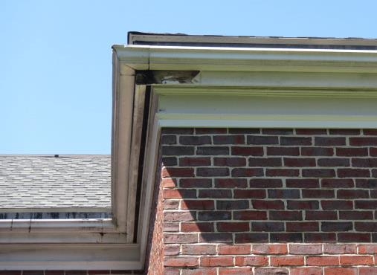
Damaged/exposed woodwork near roof
Picture 8
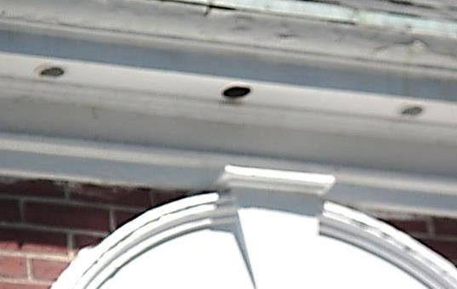
Missing soffit vent
Picture 9
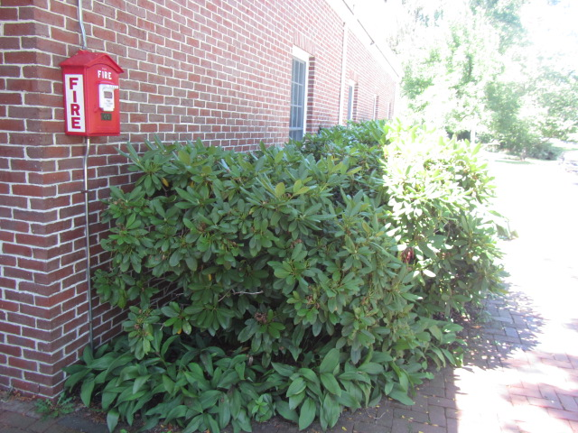
Plants/shrubbery against exterior wall
Picture 10
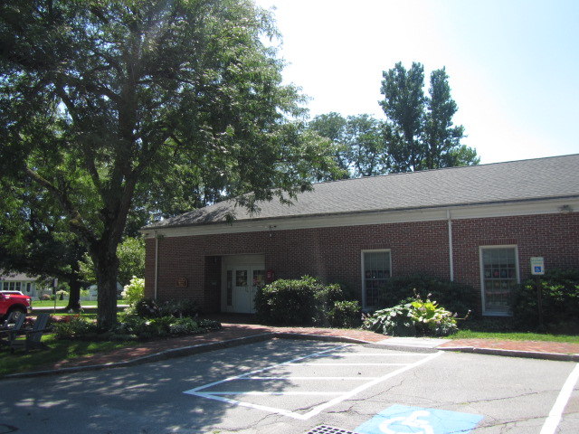
Branches/leaves overhanging roof/gutters
Location | Carbon  Dioxide  (ppm) | Carbon Monoxide  (ppm) | Temp  (°F) | Relative  Humidity  (%) | PM2.5  (µg/m³) | Occupants  in Room | Windows  Openable | Ventilation |  | Remarks
 |  |  |  |  |  |  |  | Supply | Exhaust
Background (outdoors) | 354 | ND | 85 | 65 | 15 |  |  |  |  | Hot, humid
Young Adult | 457 | ND | 73 | 67/76* | 3 | 0 | Y | Y | Y | Wall to wall carpeting, no visible signs of moisture/mold-moisture testing of walls, wood, carpet all dry, *relative humidity testing center of room = 67%; directly from vent = 76%
Stacks  Del-Go | 500 | ND | 73 | 68 | 3 | 0 | Y | Y | Y
Biography | 482 | ND | 73 | 67 | 3 | 0 | Y | Y | Y | Wall to wall carpeting
427-364 | 446 | ND | 73 | 66 | 3 | 0 | Y | Y | Y
636-700 | 474 | ND | 73 | 66 | 3 | 0 | Y | Y | Y | Wall to wall carpeting
Circulation Desk | 439 | ND | 73 | 66 | 3 | 0 | Y | Y | Y
DVD Area | 454 | ND | 73 | 61 | 3 | 0 | Y | Y | Y
Periodicals | 460 | ND | 73 | 66 | 4 | 0 | Y | Y | Y
Audio Books | 453 | ND | 73 | 67 | 3 | 0 | Y | Y | Y
Children’s Library | 416 | ND | 73 | 69 | 3 | 0 | Y | Y | Y | Carpet tile
Children’s Library Office | 495 | ND | 73 | 69 | 3 | 1 | Y | Y | Y | AP
Director Office | 505 | ND | 73 | 68 | 2 | 1 | Y | Y | Y | Wall to wall carpeting, AP
Upstairs Storage | 456 | ND | 74 | 65 | 3 | 0 | N | N | N
Main Area (tiled) | 444 | ND | 74 | 63 | 3 | 0 | Y | Y | Y
Main Area (carpet) | 416 | ND | 73 | 66 | 3 | 0 | Y | Y | Y | Old books/volumes
-

