INDOOR AIR QUALITY ASSESSMENT

**Gardner Elementary School**

278 Pearl Street

Gardner, MA

**July 2024**

Gardner Elementary School
278 Pearl Street
Gardner, MA


Prepared by:

Massachusetts Department of Public Health

Bureau of Climate and Environmental Health

Indoor Air Quality Program

Contents

EXECUTIVE SUMMARY 3

BACKGROUND 4

RESULTS AND DISCUSSION 4

Ventilation 4

HVAC System Maintenance 5

HVAC Types and Specific Conditions 5

Water Damage and Moisture Concerns 6

Sources of Respiratory Irritants/Possible Asthma Triggers 8

Other IAQ Issues 9

CONCLUSIONS AND RECOMMENDATIONS 10

REFERENCES 15

Figure 1 16

PICTURES 17

Table 1 29

Table 2A 32

Table 2B 33

Table 2C 34

Table 3 35

Table 4 37

The Massachusetts Department of Public Health’s, Indoor Air Quality Program (MDPH IAQ) conducted an IAQ walkthrough of the Gardner Elementary School located at 278 Pearl Street on March 1, 2024. This walkthrough was in conjunction with the Massachusetts Department of Public Health (DPH) Bureau of Climate and Environmental Health’s, Indoor Air Quality *(IAQ)* *Training and Awareness Program* to support asthma prevention and promote *Best Practices* in school settings.

# EXECUTIVE SUMMARY

Any building can have IAQ issues. These issues can be made worse through conditions common to marginalized communities (Environmental Justice communities or EJ) such as inequitable exposure to outdoor air pollution and a greater likelihood of poor building conditions leading to deterioration of IAQ resulting in higher asthma rates. Gardner Elementary School is within an EJ community. In addition, the pediatric asthma rate for this school as of 2023 is 12.0.% compared to the statewide pediatric prevalence rate of 9.9% (MAEPHT, 2024).

The assessment was conducted by evaluating several key elements within the school; a visual inspection of the heating, cooling, and ventilation (HVAC) systems, water/microbial damage, exterior building envelope evaluation, cleanliness, and point sources of respiratory irritants such as chemicals. Data is collected in this manner to identify potential asthma triggers, allergens, and other environmental factors that can cause indoor air quality symptoms. Please refer to the [Indoor Air Quality Manual](https://www.mass.gov/lists/indoor-air-quality-manual-and-appendices#indoor-air-quality-manual-) on the MDPH website for methods, sampling procedures, and interpretation of results.

Please note: this report contains a series of recommendations that should serve as *Best Practices* that apply to most public-school buildings across the Commonwealth and should be shared amongst other buildings in the school district.

# BACKGROUND

|  |  |
| --- | --- |
| Building: | Gardner Elementary School (GES) |
| Address: | 278 Pearl Street  Gardner, Massachusetts |
| Coordinated Via: | Wayne Anderson, Facilities Director,  Gardner Public Schools |
| Reason for Request: | General indoor air quality (IAQ) |
| Date of Assessment: | March 1, 2024 |
| Massachusetts Department of Public Health/Bureau of Climate and Environmental Health (MDPH/BCEH) Staff Conducting Assessment: | Mike Feeney, Director, and Cory Holmes, Assistant Director, IAQ Program |
| Building Description: | GES is a modern 3-story brick building that was opened in 2022 and houses grades pre-K through 4. The building contains the main office, guidance suite, library, general classrooms, and specialty areas such as breakout areas, music/band rooms, auditorium, gymnasium, and cafeteria. |
| Windows: | Most windows in the building are openable. |

# RESULTS AND DISCUSSION

The following is a summary of conditions observed during the indoor air quality walkthrough (Table 1)

## Ventilation

Ventilation refers to both the supply of fresh air and the removal of stale air from a room. The introduction of fresh air into an occupied space will dilute normally occurring pollutants that are generated by occupancy and other activities. In addition, an HVAC system will remove pollutants from a building if operating appropriately. All ventilation systems throughout the building should operate continuously during periods of occupancy.

Fresh/conditioned air for most classrooms at GES is provided by rooftop air handing units (AHUs, Picture 1) that supply air via a ducted vent (Picture 2) and exhaust air through wall or ceiling-mounted exhaust vents (Pictures 3 and 4) that return air back to the AHUs.

AHUs for common areas such as the gym and cafeteria are suspended from the ceiling (Pictures 5 and 6).

Some areas utilize “cassette” HVAC units that are mounted in the ceiling tile system (Picture 7), for comfort and air circulation.

The various types of ventilation components as well as devices that can move/redirect airflow are listed in Table 2A, Table 2B and Table 2C.

### HVAC System Maintenance

### HVAC Types and Specific Conditions

**Balancing**

To have proper ventilation with a mechanical supply and exhaust system, a system must be balanced to provide an adequate amount of fresh air to the interior of a room while also removing stale air from the room.

It is recommended that HVAC systems be re-balanced every five years to ensure adequate air systems function (SMACNA, 1994).

(see HVAC pictures)

* **Some supply vents were blocked** with furniture or items (Pictures 8 and 9; Table 1).
* **AHUs were equipped with filters with a minimum efficiency reporting value (MERV) of 13** (Picture 10). The MDPH IAQ program recommends that filters be changed 2-4 times a year (or in accordance with the manufactures recommendations) and be of at least MERV 8, or higher if the equipment can handle them, without a degradation in airflow, as these are adequate to filter out pollen, mold, and similar particulates (ASHRAE, 2012).

**Classroom Exhaust vents**:

* **Some exhaust vents in classrooms are located near the hallway door** (Picture 3). When the door is open, the vent may draw air from the hallway into the classroom rather than removing stale air from the room. For better operation/air exchange, classroom doors should be closed.

**Additional HVAC Conditions:**

* Most classrooms have openable windows (Picture 1; Table 1). **The occupant in classroom B318 reported that two of the windows were inoperable**. Windows can be used for additional fresh air during temperate weather. Windows should be kept closed during wet weather, when air conditioning is operating in the room, during freezing weather (to prevent pipe bursts), and at the end of the school day.
* **A few locations had wall-mounted ductless air conditioning units** (Picture 11). These units, also known as “mini-splits” do not supply fresh air. They are equipped with filters that need to be cleaned periodically.
* **Note that when any air conditioning is operating, the windows and room door should be kept closed.**
* **A few staff expressed issues with temperature/comfort control** (Table 1). **Staff in room C106 reported the room was excessively warm**. It is important to note that the GES is equipped with radiant floor heating.

## Water Damage and Moisture Concerns

Please note that the IAQ Program does not recommend conducting mold testing in a typical water damage remediation. For details, please consult [Guidance Regarding Testing for Mold in Water-Damaged Public Buildings](https://www.mass.gov/info-details/guidance-regarding-testing-for-mold-in-water-damaged-public-buildings) | Mass.gov

The application of a mildewcide to moldy porous materials is not recommended.

Molds are found naturally in our environment both indoors and outdoors. Inside, mold growth may occur when items, particularly porous products such as paper or gypsum wallboard, are exposed to moisture. Typical water sources include leaks, floods, and condensation. To avoid mold growth, dry all water-damaged items and affected areas within 24-48 hours and reduce indoor humidity. Some people with chronic respiratory conditions, such as asthma, are more likely to experience health symptoms associated with molds, including allergic reactions and respiratory irritation. Controlling moisture is the key to preventing mold growth and potential health symptoms.

Hot humid summers are becoming more frequent due to climate change. Massachusetts has experienced hot, humid, and rainy summers in 2018, 2021, and 2023. July of 2021 was the wettest ever recorded in Massachusetts, and the three-month period from June through August, known as the meteorological summer, was the fourth wettest on record, according to the National Oceanic and Atmospheric Administration’s (NOAA) Centers for Environmental Information (NOAA, 2021). The summer of 2023 was also hot, and wet, being measured as the second rainiest on record (WBUR, 2023). These conditions are challenging for buildings, particularly those without air conditioning.

During these hot and wet summers, extended periods of outdoor relative humidity above 70% occurred. Under these weather periods, public buildings experienced extended periods of water vapor exposure from high relative humidity. When exposed to these conditions, porous materials such as gypsum wallboard, cardboard, and other materials may develope mold colonization, particularly if located in areas that are prone to condensation on floors and walls (e.g., below grade space).

(see Water Damage and Moisture Concern Pictures)

* **Plants were noted in some classrooms and offices**. Plants can be a source of pollen or mold especially if overwatered or not well maintained. Plants should also not be placed in the airstream of univents to prevent the aerosolization of pollen and mold.
* **Window and ductless/mini-split air conditioners (Picture 11) create condensation which needs to be drained**. Drain tubing and associated pumps should be checked periodically to prevent leaks due to clogs or malfunctions. Porous items should not be stored underneath these units.
* **In the Art/Kiln Room some piles of newspapers and cardboard boxes were directly on the floor.** Porous items should be elevated on shelves or pallets, etc. to prevent getting wet from condensation on the cool surface of the floor.

A list of water damage issues identified inside and outside the building is included as Table 3.

* **The GES exterior has a curtain wall system that allows for rainwater drainage.** The structure of the curtain wall system consists of an exterior brick and mortar structure with an interior wall (Figure 1). An air space exists between the curtain wall and interior wall. The interior wall is covered with a water-resistant material to prevent moisture penetration into the building and to create a drainage plane for water to drain downwards by gravity to the bottom of the curtain wall system, to exit the wall through weep holes.
* **In order to drain water that penetrates through curtain wall brick and mortar, the base of walls is equipped with weepholes** (Picture 12). Weepholes allow for water to exit the space behind the curtain wall and allow for air to enter and dry the brick and mortar. In order to allow for even drying of curtain walls, all weepholes should be unblocked. In addition, weepholes have a plastic honeycomb insert to prevent insect nest inside the curtain wall space. Noted were significant spaces that allow for insects to bypass the weephole honeycomb to enter and nest inside the curtain wall.
* **Other structures exist in exterior wall of unidentified purpose** (Picture 13). Some of these structures appear to be open, and some filled. If the purpose of these structures is to aid in drying the curtain wall brick and mortar, ensure that each is functioning as designed.
* **Water wetting brickwork was noted beneath windows in some areas** (Picture 14). This source of water appears to be melting ice that was noted on windowsills. Accumulation of ice on the windowsill shows that the windowsills are flat. Windowsills should have an angle to allow water to drain away from window frames. If water accumulates against the window frame and/or its caulking, moisture may cause damage to allow moisture to enter the building through the window frame. In addition, some undersides of windowsills have drip edges (Picture 15) that appear to be filled with cement. Ineffective drip edges allow water to damaging caulking and the mortar at the sill/curtain wall joint and potentially enter the building.
* **A joint where metal flashing is installed exists between the base and the curtain wall to allow water to exit the curtain wall**. In general, the curtain wall and foundation wall are built so that each exterior surface is flush (Picture 16). In some locations the foundation wall extends beyond the curtain wall to form a flat ledge (Picture 17). Accumulated ice was found on this flat flashing. Over time, ice, and water pooling can damage brick and mortar.
* **Some walls have** **stylized bas-relief tree art that was constructed with brick extending outward from the flat curtain wall** (Picture 18).One location has a wall made of a stepped brick structure (Picture 19). In general, protrusions that disrupt the flat surface of an exterior wall should be avoided in areas with significant rain or snowstorms. Rain and snow can accumulate to damage mortar on the topmost surface of the extended brick, which can be indicated by a white powdery material on or around brick protruding from the exterior wall.

**Mold Growth**

Porous materials (e.g., gypsum wallboard, ceiling tiles and carpeting) can be dried with fans and heating within 24 to 48 hours of becoming wet (US EPA, 2008).

If porous materials are not dried within this time frame, mold growth may occur.

## Sources of Respiratory Irritants/Possible Asthma Triggers

Asthma is a lung disease that can make breathing difficult. Without careful management of asthma, some people can have symptoms, like a tight feeling in the chest, shortness of breath, coughing, or wheezing. Although there is no cure for asthma, people with asthma can live healthy, active lives. A safe and healthy environment helps to reduce asthma symptoms.

**Comparison of Most Recent Local and State-wide Asthma Rates (2023)**

14.1% of children

have asthma

**Gardner**

9.9% of children

have asthma

**Massachusetts**

12.0% of children

have asthma

**Gardner Elementary School**

* Sometimes, learning tools and personal items in a classroom can be a source of irritants. For example, a bird or insect nest is a great learning tool for students but may harbor microbes and allergens. Similarly, food-based projects can attract pests that carry disease or trigger allergies.
* Personal products, particularly those with volatile organic compounds (VOCs) including scents, can also be a source of respiratory irritation. VOCs are carbon-containing substances that have the ability to evaporate at room temperature. Frequently, exposure to low levels of total VOCs (TVOCs) may produce eye, nose, throat and/or respiratory irritation in some sensitive individuals.
* Dust, a common respiratory and eye irritant, can collect on surfaces and items. Although janitorial and maintenance staff perform routine cleaning in classrooms, they may not be able to clean as effectively if classroom items are not picked up or surfaces are cluttered.
* Even with a properly functioning ventilation system, it is necessary to either eliminate or reduce the use of materials that can be a source of respiratory irritants to prevent symptoms in individuals who have sensitivity to such pollutants.

For guidance on maintaining an asthma-friendly healthy school environment, please consult the MDPH Asthma Prevention and Control Program’s [Clearing the Air: An Asthma Toolkit for Healthy Schools](https://www.maasthma.org/schooltoolkit).

Possible asthma triggers and/or airborne pollutants exist in the building. These are listed below as well as in (Table 4).

(see Sources of Respiratory Irritant Pictures)

* **Teachers’ work areas contain photocopiers and laminators**. Photocopiers produce heat and ozone, and laminators melt plastic and produce odors when in use.
* **Some classrooms and storage rooms had an excess of items** such as books, craft materials, papers, and other materials. Items need to be reduced/stored neatly so that effective cleaning can be performed.
* **Area rugs and carpeting were noted in some areas** (Table 1). All rugs and carpeting should be cleaned regularly to remove dust, debris, and odors. Used area rugs should not be brought into classrooms as they may harbor allergens such as pet dander. Area rugs should be stored in a climate-controlled area off the floor over the summer to prevent moistening due to condensation and high humidity.
* **Exposure to low levels of total volatile organic compounds (TVOCs)** may produce eye, nose, throat, and/or respiratory irritation in some sensitive individuals. MDPH IAQ staff examined rooms for products containing VOCs and noted hand sanitizers, cleaners, dry erase materials, and a variety of scented products/air fresheners (Table 1, Pictures 20 through 22) in use within the building. These products have the potential to be irritants to the eyes, nose, throat, and respiratory system of sensitive individuals. Consult “[Clean Air Is Odor Free](https://www.mass.gov/doc/clean-air-is-odor-free-removing-fragrances-to-improve-indoor-air-quality-in-schools-and-offices-0/download)” for more information on fragrances in schools and other buildings.
* **The building has several “Breakout” rooms, equipped with rubber flooring and walls** (Picture 23). Breakout room C115 did not have any exhaust/return ventilation. These materials can off-gas and be a source of irritating odors.
* **In some areas personal fans were dusty** (Table 1). This dust can be aerosolized under certain conditions and can also be a medium for mold growth.
* **Finally, as mentioned the exterior of the building is accented with three-dimensional brickwork** (Picture 24). Unfortunately, these outcroppings are being used by wasps to build nests (Picture 25).

## 

## Other IAQ Issues

*Radon*

Radon is a naturally occurring radioactive gas that seeps into buildings from the surrounding soil and at elevated levels can increase the risk of lung cancer.

The Environmental Protection Agency (EPA) conducted a National School Radon Survey “in which it discovered nearly one in five schools has at least one schoolroom with a short-term radon level above the action level of 4pCi/L (picocuries per liter) – the level at which the EPA recommends that schools take action to reduce the level” (US EPA, 1993).

**The MDPH IAQ Program therefore recommends that every school be tested for radon, and that this testing be conducted during the heating season while school is in session in a manner consistent with US EPA radon testing guidelines**. Radon measurement specialists and other information can be found at [www.nrsb.org](http://www.nrsb.org) and <http://aarst-nrpp.com/wp>, with additional information at: <https://www.mass.gov/radon>.

# CONCLUSIONS AND RECOMMENDATIONS

Please note: this report contains a series of recommendations that should serve as *Best Practices* that apply to most public-school buildings across the Commonwealth and should be shared amongst other buildings in the School District.

Issues typical to many schools were found in this building. Issues described can be mitigated with repairs or modifications to the exterior building components, and with changes to occupant behaviors to reduce blockages of supply/exhaust vents and exposure to VOC-generating products and items.

**Short-term recommendations** can be implemented as soon as practicable, however **long-term measures** are more complex and will require planning and resources to adequately address overall indoor air quality concerns within the building.

|  |  |  |
| --- | --- | --- |
| **Short-term Recommendations** | | |
| **HVAC System** | | **Helpful Links** |
|  | Ensure supply and exhaust are operating *continuously* during occupied periods. |  |
|  | Remove blockages from supply and exhaust vents. |  |
|  | Periodically check the function of all local and restroom exhaust vents and repair as needed. |  |
|  | Close classroom doors for improved exhaust vent function and air exchange. |  |
|  | Continue with regular filter changes for HVAC equipment using a minimum efficiency rating value (MERV) 8 or the best quality/highest MERV-rated filter that can be used without affecting airflow.  Ensure filters fit flush within their racks to prevent filter bypass. | [ANSI/ASHRAE Standard 52.2-2017](https://www.ashrae.org/File%20Library/Technical%20Resources/COVID-19/52_2_2017_COVID-19_20200401.pdf) |
|  | During filter changes, clean dust and debris from the inside of HVAC system cabinets. |  |
|  | Use openable windows for additional fresh air during temperate weather.  Tightly close windows at the end of the day and avoid opening windows when air conditioning is in use or during extreme cold to prevent freezing of pipes. |  |
|  | Examine windows in classroom B318 and make repairs as needed. |  |
|  | Clean and maintain window, mini-split, and portable air conditioners in accordance with manufacturer’s instructions.  Keep windows closed in rooms where air conditioners are operating to avoid condensation. |  |
|  | Encourage staff to use a system to report and track temperature, comfort, and/or maintenance issues so that concerns can be addressed, and maintenance staff can report when issues have been resolved. |  |
|  | Investigate chronic heat complaint in room C106 and make adjustments to improve comfort. |  |
|  | Have the HVAC system balanced every 5 years in accordance with SMACNA recommendations. (SMACNA, 1994). |  |
| **Water Damage Sources** | | |
|  | Properly maintain plants to avoid mold and odors. Keep plants away from airflow of HVAC equipment. |  |
|  | During summer months, pull furniture away (1 to 2 inches) from walls to prevent mold growth due to lack of airflow and remove impermeable wall coverings that can trap moisture such as laminated posters. |  |
|  | Ensure that condensation can drain from air conditioning equipment and that chilled air does not lead to condensation on adjacent materials. |  |
|  | Do not store paper, cardboard, or other porous items directly on floors to prevent mold growth due to condensation on cool surfaces.  Elevate items with pallets or store on shelving. |  |
|  | Render weep hole spaces around honeycombs airtight to block pests. |  |
|  | Identify the purpose of the structures in Picture 13 and ensure each is functioning as intended. |  |
|  | Identify if windowsills are flat and take steps to prevent ice and rain accumulation. |  |
|  | Examine flashing over foundation wall extending beyond curtain wall for snow and ice accumulation. Remove snow and ice as needed. |  |
|  | Routinely examine brickwork extending from exterior walls and columns for cracking of brick, damage to mortar, or accumulation of efflorescence after rainstorms. |  |
|  | Examine all windowsill drip edges. Restore drip edges if sealed/non-continuous. |  |
| **Respiratory Irritants/Possible Asthma Triggers** | | |
|  | Clean personal fans, supply, and exhaust/return vents periodically to remove dust and debris. |  |
|  | Reduce use of products and equipment that create irritating volatile organic compounds (VOCs) and only use in well-ventilated areas. Minimize the use of air fresheners (e.g., plug-ins), deodorizers and scented products. | <https://www.mass.gov/cleaner-greener-healthier-schools> |
|  | Use only District-approved cleaning products. Keep spray bottles properly labeled and out of the reach of children. |  |
|  | Ensure local exhaust ventilation is provided or move photocopiers and laminators to a well-ventilated area with an exhaust vent. |  |
|  | Periodically sort classroom and stored items to remove unwanted items. Store remaining items neatly and off the floor. Where/if rooms have a history of moisture issues, consider storing items in waterproof totes. |  |
|  | Clean area rugs frequently using a HEPA-equipped vacuum cleaner.  Avoid bringing used area rugs into the school. |  |
|  | Plush and upholstered items such as couches, cushions and pillows should be cleaned regularly to remove the build-up of oils, dust, and debris. |  |
|  | Provide supply and exhaust/return ventilation to Breakout room C115 (and any others that may need it). |  |
|  | Remove wasp’s nests from exterior of building and inspect periodically for further activity. |  |
| **Other Recommendations to Improve Air Quality Conditions** | | |
|  | Test the school for radon by a certified radon measurement specialist during the heating season when school is in session. | Radon measurement specialists and other information can be found at: [www.nrsb.org](http://www.nrsb.org), and <http://aarst-nrpp.com/wp> |
|  | To learn more about radon, review the MDPH’s Radon in Schools and Child Care Programs factsheet. | <https://www.mass.gov/radon> |
|  | Utilize the US EPA’s (2000), “Tools for Schools”, as an instrument for maintaining a good IAQ environment in the building. | <https://www.epa.gov/iaq-schools> |
|  | For guidance on maintaining an asthma-friendly healthy school environment, please consult the MDPH Asthma Prevention and Control Program’s *Clearing the Air: An Asthma Toolkit for Healthy Schools*. | <https://www.maasthma.org/schooltoolkit> |
|  | Include an IAQ component in the school’s Wellness Advisory Committee program. An IAQ plan should have an IAQ liaison/teacher representative, a member of maintenance/facilities and administration that conduct regular walk-throughs to identify on-going and/or potential environmental issues. |  |

|  |  |  |
| --- | --- | --- |
| **Long-term Recommendations** | | |
|  | Consider installing sensor technology in classrooms to provide continuous monitoring of the following indoor air parameters (particularly temperature and relative humidity). Sensors should be re-calibrated quarterly or according to manufacturer’s specifications and building management software updated as per manufacturers’ instructions, industrial standards, and/or change in operating systems. As an example, the link to the right illustrates how this technology is serving Boston Public Schools to improve air quality (i.e., carbon dioxide, temperature, relative humidity, carbon monoxide, and particulate matter). | [COVID-19 Health & Safety Information / Indoor Air Quality Sensor Dashboard (bostonpublicschools.org)](https://www.bostonpublicschools.org/Page/8810) |
|  | Consider resetting flashing over foundation wall extending beyond curtain wall with a necessary angle to prevent for snow and ice accumulation. |  |
|  | Consider resetting flat metal windowsills with a necessary angle to prevent for snow and ice accumulation against the window frame and caulking. |  |

# REFERENCES

ASHRAE. 2012. American Society of Heating, Refrigeration and Air Conditioning Engineers (ASHRAE) Standard 52.2-2012 – Method of Testing General Ventilation Air-Cleaning Devices for Removal Efficiency by Particle Size (ANSI Approved).

MAEPHT. 2024. Massachusetts Environmental Public Health Tracking. Massachusetts Department of Public Health - Bureau of Climate and Environmental Health. <https://matracking.ehs.state.ma.us/>

NOAA. 2021. Summer 2021 neck and neck with Dust Bowl summer for hottest on record. National Oceanic and Atmospheric Administration, 1401 Constitution Avenue NW, Room 5128, Washington, DC 20230 <https://www.noaa.gov/news/summer-2021-neck-and-neck-with-dust-bowl-summer-for-hottest-on-record>

SMACNA. 1994. HVAC Systems Commissioning Manual. 1st ed. Sheet Metal and Air Conditioning Contractors’ National Association, Inc., Chantilly, VA.

US EPA. 1993. Radon Measurement in Schools, Revised Edition. Office of Air and Radiation, Office of Radiation and Indoor Air, Indoor Environments Division (6609J). EPA 402-R-92-014.

US EPA. 2000. Tools for Schools. Office of Air and Radiation, Office of Radiation and Indoor Air, Indoor Environments Division (6609J). EPA 402-K-95-001, Second Edition. <http://www.epa.gov/iaq/schools/index.html>.

US EPA. 2008. Mold Remediation in Schools and Commercial Buildings. US Environmental Protection Agency, Office of Air and Radiation, Indoor Environments Division, Washington, D.C. EPA 402-K-01-001. <http://www.epa.gov/mold/mold-remediation-schools-and-commercial-buildings-guide>.

WBUR. 2023. “It’s been a summer of rain and flooding misery in Mass.” WBUR local news. September 12, 2023. <https://www.wbur.org/news/2023/09/12/summer-flooding-rain-massachusetts>.

**Figure 1**

**Drainage Plane Function: Weep Holes Drain Water from the Wall System to**

**Prevent Moisture Penetration into the Interior**

# PICTURES

(Click to link back to report)

HVAC pictures

**Picture 1**

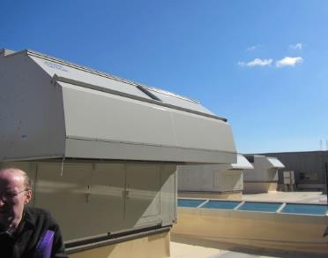

**Rooftop AHUs**

**Picture 2**

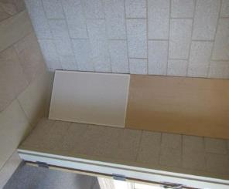

**Ducted classroom supply vent**

**Picture 3**

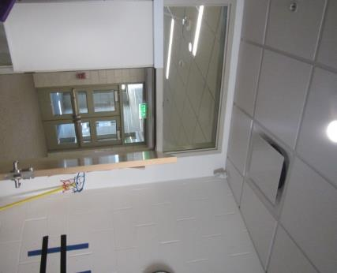

**Classroom exhaust vent, note open classroom door which draws air from the hallway (arrow) instead of removing stale air from classroom**

**Picture 4**

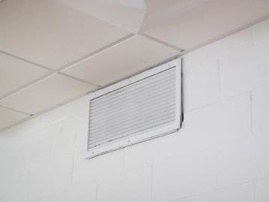

**Wall-mounted exhaust vent**

**Picture 5**

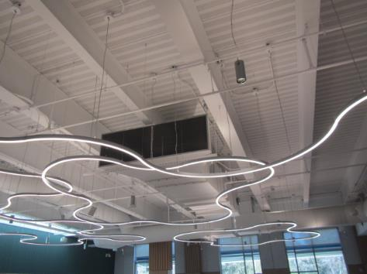

**Ceiling-mounted AHU in Cafeteria**

**Picture 6**

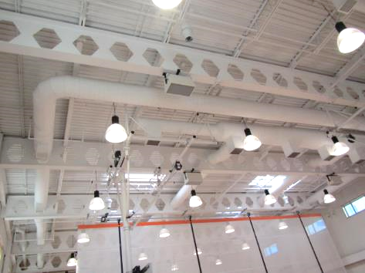

**Ceiling-mounted AHU in Gymnasium**

**Picture 7**

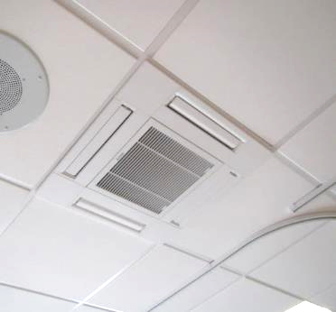

**Ceiling-mounted “cassette” HVAC unit**

**Picture 8**

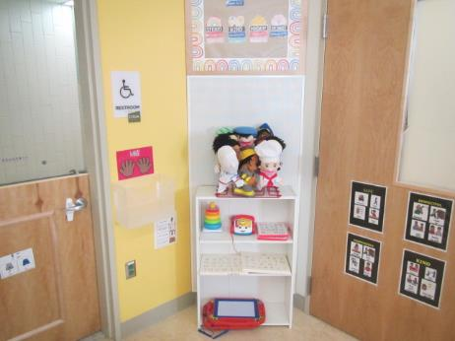

**Supply vent partially blocked by furniture and other items**

**Picture 9**

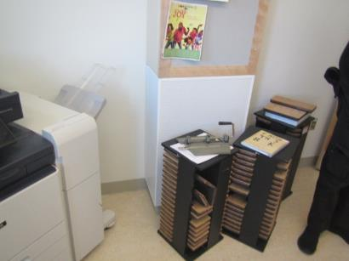

**Supply vent partially blocked**

**Picture 10**

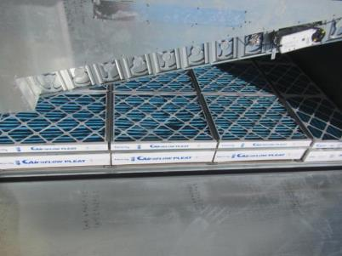

**Pleated MERV 13 Filters in rooftop AHU**

**Picture 11**

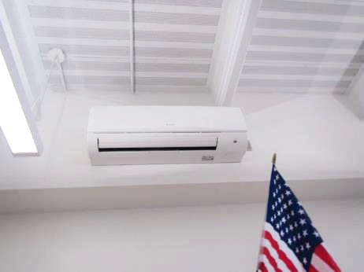

**Wall-mounted mini-split**

Water Damage and Moisture Concern Pictures

(click to link back to report)

**Picture 12**

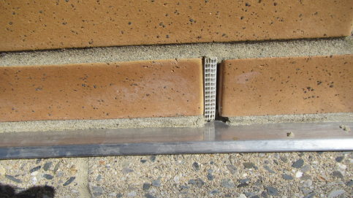

**Weephole with honeycomb insert; note spaces around honeycomb that can allow insects to penetrate wall**

**Picture 13**

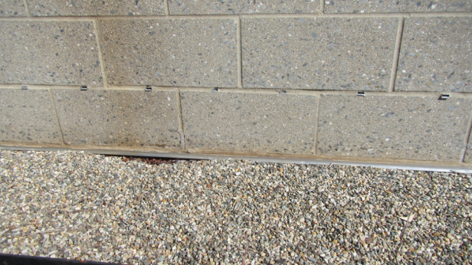

**Unidentified structures (arrows), may be part of curtain wall drainage system**

**Picture 14**

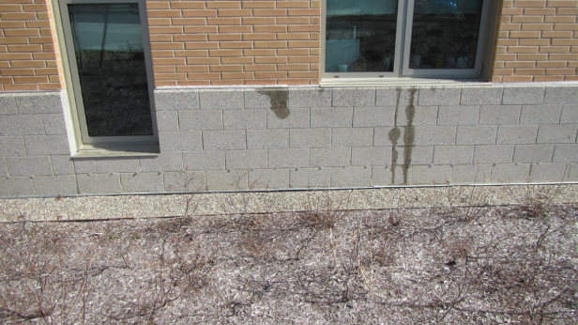

**Water wetting brickwork beneath windows**

**Picture 15**

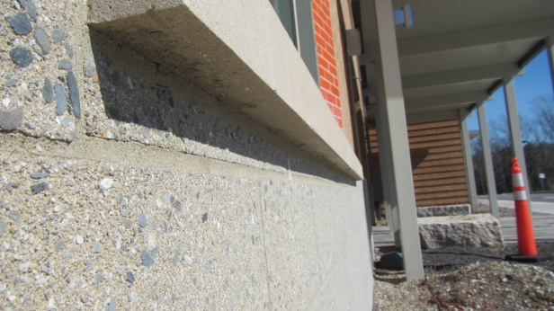

**Windowsill drip edge (arrow)**

**Picture 16**

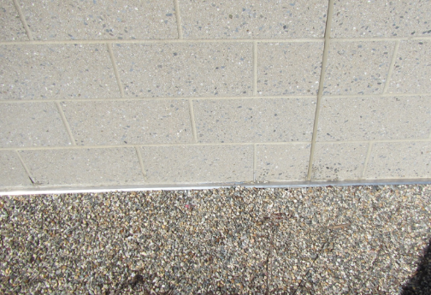

**Curtain wall and exterior foundation walls creating a flush, flat exterior wall plane**

**Picture 17**

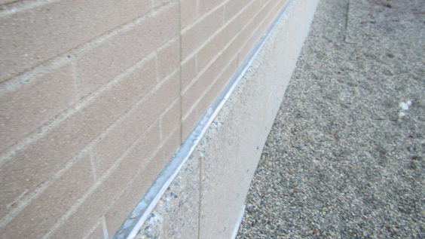

**Ice accumulation on lip extending beyond the curtain wall**

**Picture 18**

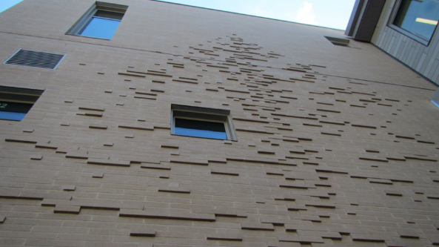

**A stylized bas-relief tree art that was constructed with brick extending outward from the flat curtain wall**

**Picture 19**

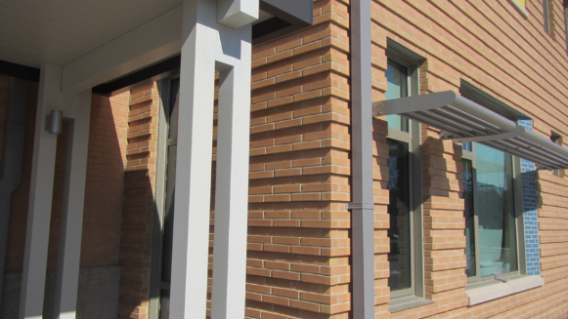

**Stepped brick wall**

Sources of Respiratory Irritant Pictures

(Click to link back to report)

Picture 20

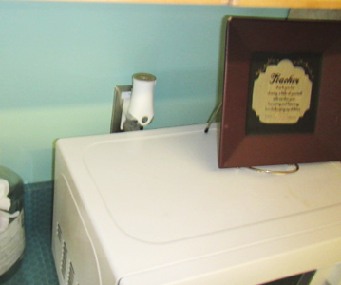

Plug-in air freshener in classroom

Picture 21

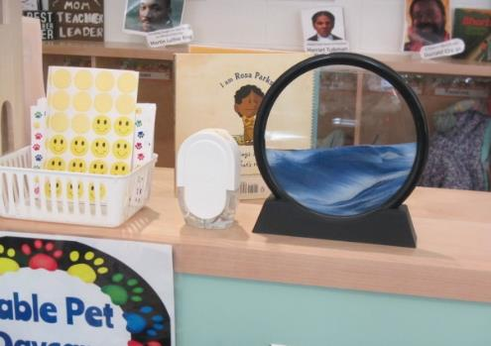

Air freshener in classroom

Picture 22

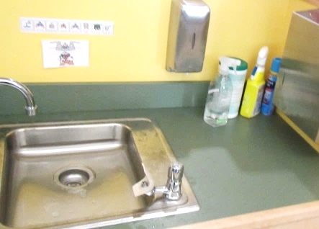

Spray cleaning products on sink countertop

Picture 23

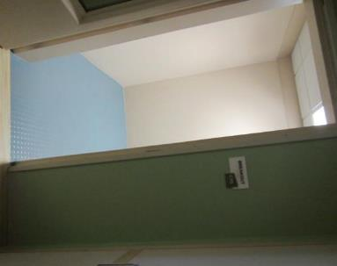

Rubber floor/walls in Breakout room C115

Picture 24

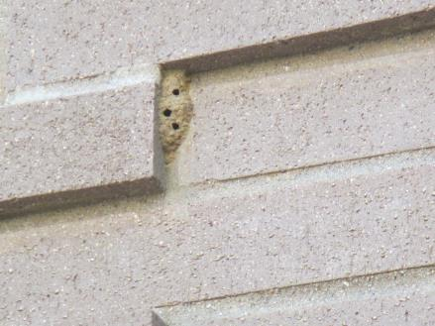

Wasp nest built up against ornamental brickwork

Click to link back to report

# Table 1

| **Room** | **Openable Windows** | **HVAC** | **Ventilation** | | **Ceiling Tiles/Staining (Y or N)**  **Bowed = B** | **Comments** |
| --- | --- | --- | --- | --- | --- | --- |
| **Intake** | **Exhaust** |
| C101B | Y | Y | Y | Y | N | Fresh air supply blocked |
| C101F |  | Y | Y | Y | N | Carpet squares |
| C102 |  | Y | Y | Y | N | Area rugs |
| C105 | Y | Y | Y | Y | N | AF in use, fresh air supply blocked |
| C106 |  | Y | Y | Y | N | Portable AC, area rugs, chronically warm complaints |
| C107 Computer Network Room | Y | Y | Y | N | N | Mini-split |
| C109 | Y | Y | Y | Y | N | Ammonia-containing wipes |
| C110 |  | Y | Y | Y | N | Mini-split, supply vent blocked, spray cleaning products on countertop, area rugs |
| C111 | Y | Y | Y | Y |  |  |
| C112 |  | Y | Y | Y | N | Mini-split, hand sanitizer, area rugs |
| C113 | Y | Y | Y | Y | N |  |
| C115 Breakout Room | N |  |  |  | N | Rubberized floor covering – odor |
| C117 |  | Y | Y | Y | N | DO, area rugs |
| C201 | Y | Y | Y | Y | N | Laminator |
| C202 | Y | Y | Y | Y | N | Ammonia-containing wipes |
| C203 | Y | Y | Y | Y | N | Area rugs, hand sanitizer |
| C204 | Y | Y | Y | Y | N | Ammonia-containing wipes |
| C205 | N | Y | Y | Y | N | Hand sanitizer |
| C207 | Y | Y | Y | Y | N | Area rugs, hand sanitizer |
| C208 | Y | Y | Y | Y | N |  |
| C209 | Y | Y | Y | Y | N | Area rugs, supply vent blocked |
| C210 | Y | Y | Y | Y | N |  |
| C211 | N | Y | Y | Y | N |  |
| C212 | N | Y | Y | Y | N | Mini-split |
| C213 | Y | Y | Y | Y | N | Area rugs, hand sanitizer |
| C214 | N | Y | Y | Y | N | Mini-split |
| C215 | Y | Y | Y | Y | N |  |
| C216 | N | Y | Y | Y | N | Rubberized floor covering – odor |
| C217 | N | Y | Y | Y | N | Area rugs, air freshener |
| C219 | Y | Y | Y | Y | N | Area rugs, hand sanitizer |
| B113 |  | Y | Y | Y | N |  |
| Music |  | Y | Y | Y | N |  |
| B201 Music | Y | Y | Y | Y | N | Area rugs |
| B206 Staff Breakroom | Y | Y | Y | Y | N |  |
| B207 | Y | Y | Y | Y | N | Carpet squares, PF (2) |
| B208 | Y | Y | Y | Y | N | AC ceiling-mounted cassette unit |
| B209 | Y | Y | Y | Y | N | Plant, area rugs |
| B217 art room | N | Y | Y | Y | N |  |
| B217 art room  kiln room | N | Y | Y | Y | N | Cardboard boxes |
| B301 | Y | Y | Y | Y | N |  |
| B302 | Y | Y | Y | Y | N | Area rugs, PF-dusty |
| B303 | Y | Y | Y | Y | N | Plants |
| B304 | Y | Y | Y | Y | N | Laminator and photocopier |
| B308 | Y | Y | Y | Y | N | Hand sanitizer |
| B311 | N | Y | Y | Y | N | Carpeting |
| B312 | Y | Y | Y | Y | N | AC ceiling-mounted cassette unit, carpet squares, PF |
| B314 | Y | Y | Y | Y | N | AC ceiling-mounted cassette unit, carpet squares, PF, plant |
| B316 | Y | Y | Y | Y | N | AF-plug in, DO, PF, microwave, area rug |
| B318 | Y | Y | Y | Y | N | 2 Windows, one reported inoperable, plant, area rug |
| B317 | Y | Y | Y | Y | N |  |
| B319 | Y | Y | Y | Y | N |  |
| B321 | Y | Y | Y | Y | N |  |
| Cafeteria |  | Y | Y | Y | N |  |

(Click to link back to report)

# Table 2A

|  |  |  |  |  |  |
| --- | --- | --- | --- | --- | --- |
| **Equipment Present in Building**  **(X = Yes)** | **Type of Heating/Cooling Ventilation**  **Equipment** | **Fresh**  **Air**  **Supply**  **(X = Yes)** | **Type of Location(s)** | **Air Filters Installed**  **MERV Rating**  **(1-15, U*)**  **(X = Yes)** | **Comments** |
|  | Univents |  |  |  |  |
| X | Rooftop Air Handling Units | X | Science rooms, common areas | X 13 |  |
|  | Outdoor, Ground-Installed Air Handling Units |  |  |  |  |
|  | Attic/Crawlspace Air Handling Units |  |  |  |  |
| X | Ceiling-Mounted Air Handling Units (including inside plenum) | X | Gym, cafeteria | X 13 |  |
|  | Basement/Crawlspace-Installed Air Handling Units |  |  |  |  |
|  | Mechanical Room-installed Air Handling Units |  |  |  |  |
|  | Fan Coil Units |  |  |  |  |
|  | Window-Mounted Air Conditioners |  |  |  |  |
|  | Wall Louver-Controlled Gravity Air Supply |  |  |  |  |
| X | Windows |  | Most areas |  |  |
|  | Fan in window (blowing in) |  |  |  |  |
|  | Built in wall fan (switched) |  |  |  |  |
|  | Heat recovery ventilator unit |  |  |  |  |
| X | Energy recovery ventilator unit | X | Rooftop AHUs |  |  |
|  | Chilled Beam |  |  |  |  |
|  | Passive combustion supply vent in basement/boiler room |  |  |  |  |

*U = Filter Rating underdetermined due to inaccessibility during building visit

(Click to link back to report)

# Table 2B

|  |  |  |  |  |
| --- | --- | --- | --- | --- |
| **Equipment Present in Building**  **(X = Yes)** | **Type of Exhaust Ventilation**  **Equipment** | **Ducted**  **To Outdoors**  **(X = Yes)** | **Type of Location(s)** | **Comments** |
| X | Rooftop Motors/Fans | X | Rooftop, bathrooms, local exhaust |  |
|  | Unit Exhaust |  |  |  |
| X | Ceiling Return Vent | X | Most areas |  |
|  | Ceiling Return Vent, Plenum |  |  |  |
| X | Wall Return Vent | X | Some areas |  |
| X | Kitchen Stove Hood | X | Kitchen |  |
| X | Restroom Exhaust Vent | X |  |  |
| X | Photocopier Exhaust Vent |  | Work rooms |  |
|  | Garage |  |  |  |
|  | Chemical Hood(s) |  |  |  |
|  | Locker Rooms |  |  |  |
|  | Showers |  |  |  |
|  | Clothes Dryers |  |  |  |
|  | Gas Water Heaters |  |  |  |
|  | Furnace-Flue to Chimney |  |  |  |
| X | Furnace/Boiler direct vent or power vent (no combustion air supply) | X | Boiler room |  |
| X | Kiln, Pottery | X | Art Room |  |
|  | Dark Room |  |  |  |
|  | Generator Room |  |  |  |
|  | Wood Shop Dust Collector |  |  |  |
|  | Spray Paint Booths |  |  |  |
|  | Fan in window (blowing out) |  |  |  |

# Table 2C

|  |  |  |  |
| --- | --- | --- | --- |
| **Equipment Present in Building**  **(X = Yes)** | **Type of Equipment** | **Type of Location(s)** | **Comments** |
|  | Floor Fans, pedestal |  |  |
| X | Fans, portable | Classrooms, offices |  |
|  | Air Purifier (HEPA, other) |  |  |
|  | Floor heaters, portable |  |  |
| X | Refrigerators, Cold Beverage Vending Machines | Breakrooms |  |
|  | Radiator, wall-mounted |  |  |
|  | Radiator, floor-mounted |  |  |
| X | Radiant flooring | Classrooms |  |
|  | Passive Vents (Wall/Door) |  |  |

(Click to link back to report)

# Table 3

| **Found in Building**  **X = Yes** | **Water-Damaged Materials, Building Components or Stored Materials** | **Location** | **Visible Microbial Growth?**  **X = Yes** | **Musty odor detected?**  **X = Yes** | **Comments** |
| --- | --- | --- | --- | --- | --- |
|  | Books-other bound materials |  |  |  |  |
|  | Brick walls – broken, missing mortar |  |  |  |  |
|  | Brick walls – blocked weep holes |  |  |  |  |
|  | Cardboard boxes |  |  |  |  |
|  | Carpet tiles |  |  |  |  |
|  | Carpet - Area rugs |  |  |  |  |
|  | Carpet wall-to-wall |  |  |  |  |
|  | Ceiling tiles - affixed directly to ceiling surface |  |  |  |  |
|  | Ceiling tiles - bowing-in suspended ceiling |  |  |  |  |
|  | Ceiling tiles - water-stained in splined ceiling |  |  |  |  |
|  | Ceiling tiles - water-stained in suspended ceiling |  |  |  |  |
|  | Chairs - laminated |  |  |  |  |
|  | Cloth |  |  |  |  |
|  | Countertops (around sinks) |  |  |  |  |
|  | Curtains |  |  |  |  |
|  | Dust/debris within AHU, uninvent, HVAC, chilled beam units, etc. (WD through condensation, humidity, or leaks) |  |  |  |  |
| X | Efflorescence (i.e., mineral deposits) | Outdoor masonry |  |  |  |
|  | Engineered woods - particleboard, plywood, Masonite |  |  |  |  |
|  | Flooring – loosened tiles |  |  |  |  |
|  | Flooring - wooden |  |  |  |  |
|  | Furniture - laminated |  |  |  |  |
|  | Furniture - upholstered |  |  |  |  |
|  | Gypsum wallboard - ceiling |  |  |  |  |
|  | Gypsum wallboard - restroom wall |  |  |  |  |
|  | Gypsum wallboard - interior wall |  |  |  |  |
|  | Gypsum wallboard – located on exterior wall |  |  |  |  |
|  | HVAC drain pan – lack of draining |  |  |  |  |
|  | HVAC filters |  |  |  |  |
|  | Insulation- attic (paper-backed) |  |  |  |  |
|  | Insulation - inside air handling unit |  |  |  |  |
|  | Insulation - on pipe(s) fiberglass |  |  |  |  |
|  | Insulation - on pipe(s) other/plaster-like material |  |  |  |  |
|  | Insulation - wall cavity |  |  |  |  |
|  | Insulation – ceiling plenum |  |  |  |  |
|  | Modular furniture – walls/cloth partitions |  |  |  |  |
|  | Musical instrument cases |  |  |  |  |
|  | Plaster ceilings |  |  |  |  |
|  | Records/files |  |  |  |  |
|  | Refrigerator - door gasket |  |  |  |  |
|  | Refrigerator - drip pan |  |  |  |  |
|  | Refrigerator - Interior surfaces |  |  |  |  |
|  | Room divider - ceiling-mounted, sliding |  |  |  |  |
|  | Sink backsplash |  |  |  |  |
|  | Tables – laminated |  |  |  |  |
|  | Wallpaper |  |  |  |  |
|  | Wood - attic/roof materials |  |  |  |  |
|  | Wood - floor joists in basement ceiling |  |  |  |  |
|  | Wood - wall framing |  |  |  |  |
|  | Wood - window sills |  |  |  |  |
|  | Wood - window-mounted air conditioner framing |  |  |  |  |
|  | OTHER |  |  |  |  |

WHAT ARE ENVIRONMENTAL ASTHMA TRIGGERS?

Asthma triggers are any chemical, pollutant, or allergen that can make your asthma worse. Asthma triggers can also be strong chemical smells, dust, or pets. Your asthma triggers may be different from those of other people. Not all asthma triggers affect people the same way. Environmental asthma triggers are found both indoors and outdoors. DPH link: [Asthma and Your Environment (mass.gov)](https://www.mass.gov/doc/asthma-and-your-environment-english/download)

(click to link back to report)

# Table 4

| **Condition Present**  **X = Yes** | **Possible asthma symptom-inducing environmental pollutant** | **Recommendation to reduce or eliminate the pollutant** |
| --- | --- | --- |
|  | Water Damage and/or Mold  (allergen) | Identify water source and repair to eliminate.  Clean non-porous materials.  Remove and replace porous materials susceptible to mold growth.  Perform regular water damage assessments as a tool to ensure timely mitigation as needed.  Use NIOSH water damage assessment protocol as a guide: [NIOSH water damage assessment guideline](https://www.cdc.gov/niosh/docs/2019-115/pdfs/2019-115.pdf?id=10.26616/NIOSHPUB2019115&inf_contact_key=241b5c2ed98c27d94b530dedc36f1623f651f238aa2edbb9c8b7cff03e0b16a0). |
|  | Moistening of building components during hot, humid weather (>2 days in length) (mold, allergen) | Remove materials not dried in <2 days in a manner consistent with [US EPA Mold Removal in Commercial Buildings guideline](https://www.epa.gov/mold/pdf-version-checklist-mold-remediation-mold-remediation-schools-and-commercial-buildings).  Use dehumidification in occupied basement areas and other areas with chronic dampness. |
|  | Vegetation against exterior of building (water damage-mold) | Remove all vegetation preventing building exterior drying.  Remove all vegetation capable of falling onto a building or depositing debris onto the roof. |
|  | Personal humidifiers (lack of proper maintenance)  (pollutant and allergen) | Clean and maintain properly.  Use distilled water to eliminate metal and water treatment odors.  Maintain hydration by increasing water consumption. |
|  | Drains: Floor drains, Sink drains (abandoned use)  Water bubblers (abandoned use) | If in use, pour water into drain at least twice a week.  If not in use, seal the drain with an appropriate material in accordance with Massachusetts Plumbing Code (248 CMR 10.00). |
|  | Live Animals (turtles, gerbils, birds, rabbits, etc.) | Ensure cleanliness or remove animals from the location. |
|  | Improperly maintained aquariums and terrariums (allergen) | Maintain such equipment properly to eliminate odor.  Discontinue use. |
| X | Plants and flowers  (allergen and mold) | Keep indoor plants well maintained and not overwatered. Monitor for signs of mold and pests.  Ensure water for cut flowers does not become stagnant.  Ensure dried plant material is free of odors, mold, and pests and handled carefully  If asthma risks are high, eliminate plants and flowers. |
|  | HVAC system moisture issues  (mold, allergen) | Consult ASHRAE’s minimum standards for HVAC maintenance and inspection of commercial HVAC systems (<https://www.ashrae.org/technical-resources/bookstore/standards-180-and-211>). |
|  | HVAC system contaminant issues (allergen) | Consult ASHRAE’s minimum standards for HVAC maintenance and inspection of commercial HVAC systems (<https://www.ashrae.org/technical-resources/bookstore/standards-180-and-211>). |
|  | Indoor swimming pool odors outside of swimming pool (mold, chemical) | Maintain and operate pool HVAC systems to vent odors from building.  Ensure locker room exhaust vents are operating during building hours.  All doors leading to pool should be rendered airtight and be closed. |
|  | Pollen (allergen) | Recommend installation of MERV 8 or better filters if HVAC engineer confirms HVAC system can be so equipped without adversely affecting function.  Cut grass after hours.  Cut grass in a pattern to direct clippings away from exterior wall.  Remove trees and shrubs from in front of windows and air intakes. |
|  | Dry air | Maintain hydration.  Avoid overheating of air. |
| X | Dust mites  (allergen) | Recommendation to remove non-official upholstered furniture, area rugs, pillows, cushions, etc.  Cleaning with use of HEPA-filtered vacuum cleaner.  Eliminating clutter, storing items in dust and moisture-proof containers, and regularly removing dust through wet wiping. |
|  | Pests, including rodents and cockroaches  (allergen) | Use of integrated pest management guidelines, including:   * Proper disposal of food containers * Proper storage of food products in airtight containers * Elimination of use of food as art projects * Remove pest harborages/clutter * Regular monitoring for pests   [EPA IPM guideline link](https://www.epa.gov/ipm/introduction-integrated-pest-management) |
|  | Latex-containing materials | Remove tennis balls from furniture legs. |
| X | Fragrances  (chemical) | Eliminate point sources, such as:   * Plug-in air fresheners * Aroma/oil reed diffusers * Scented sprays * Discontinue use of other scented materials * Consult DPH fragrance guideline: [*Clean air is odor-free*](https://www.mass.gov/doc/clean-air-is-odor-free-removing-fragrances-to-improve-indoor-air-quality-in-schools-and-0/download) |
|  | Strong smells from /use of Chemicals (such as cleaning products)  (chemical) | Use building-issued cleaning products.  Use products in accordance with manufacturer’s instructions including dilution, application, and ventilation.  Avoid using products that are stronger than needed for the situation. |
| X | Strong odors from new building materials (carpeting/furniture)  (chemical) | Use low VOC-emitting materials.  Air out materials (outside or in unoccupied area) prior to installation. |
|  | Tobacco smoke  Secondhand Smoke  (pollutant) | Eliminate tobacco smoking.  Seal all shared wall penetrations. |
| X | Products with a strong odor such as paint, perfume, hairspray, air fresheners, bug-spray, laminators, candles, wax melters, dry erase markers and other VOC-containing products  (chemical) | If essential:   * Provide proper exhaust ventilation to eject aerosolized product directly outdoors. * Avoid/reduce use during occupied hours.   If not necessary, remove and eliminate. |
|  | Vehicle exhaust  (pollutant) | Enforce anti-idling regulations and post signs to give notice.  Relocate vehicles away from fresh air intakes.  Require cars to park face-in at building walls.  [MA anti-idling law FAQs](https://www.mass.gov/files/documents/2018/02/20/idling-faq.pdf#:~:text=The%20Massachusetts%20Anti-Idling%20Law%20The%20goal%20of%20the,sometime%20wonder%20when%20idling%20might%20be%20considered%20necessary.) |
|  | Vapors and or fumes from gas, oil, or kerosene stoves  (pollutant) | Operate stove hood when stove in use.  Install stove hood if not present.  Ensure equipment is in good working order. |
|  | Ozone (pollutant) | Eliminate use of ozone generating equipment. |
|  | Window Air Conditioners (if not properly maintained) (allergen) | Equip with proper filter and clean periodically.  Clean drip pans.  Install in window with weathertight, non-mold-growth sustaining material. |
| X | Pottery (pollutant) | Do not operate kiln during occupied hours.  Operate kiln with exhaust system activated.  Seal all seams and holes in kiln vent.  Ensure kiln exhaust discharge terminates outdoors. |
| X | Carpeting (allergen) | Clean carpeting in a manner consistent with IICRC standards, including regular vacuuming with a high efficiency particulate air (HEPA) filtered vacuum in combination with annual cleaning or semi-annual cleaning in soiled high traffic areas. |
|  | Sweeping/dusting vs HEPA vacuuming/wet wiping  (allergen or pollutant) | Refrain from using feather dusters or brooms.  Utilize HEPA vacuums and wet wiping to minimize aerosolizing particulate matter. |
|  | Lack of adequate air exchange/mechanical ventilation | Make repairs as necessary and ensure all HVAC system components are operating continuously when building is occupied. |
|  | Lack of local exhaust at source of pollution (vocational shop activities, kitchen exhaust hood) (all) | Recommend installation of exhaust ventilation to direct pollutants directly outdoors. |
|  | Renovating buildings while occupied  (chemical) | Use all SMACNA guidelines for Renovation While Buildings Are Occupied. For information, visit <https://www.mass.gov/service-details/construction-and-renovation-generated-pollutants-in-occupied-buildings>. |
|  | Chemistry program chemical storage  (chemical) | Repair (if needed) and operate chemical storeroom vents appropriately.  Reduce or eliminate unneeded or overstocked chemicals.  Store all chemicals in a manner to separate incompatible chemicals.  Keep chemical storerooms clean. |
| X | Photocopiers/duplicating machines | All machines should have dedicated exhaust vents. |