INDOOR AIR QUALITY ASSESSMENT

**Gardner High School**

200 Catherine Street

Gardner, MA

**April 2024**

Gardner High School
200 Catherine Street
Gardner, MA


Prepared by:

Massachusetts Department of Public Health

Bureau of Climate and Environmental Health

Indoor Air Quality Program

Contents

EXECUTIVE SUMMARY 3

BACKGROUND 5

RESULTS AND DISCUSSION 5

Ventilation 5

HVAC System Maintenance 6

HVAC Types and Specific Conditions 7

Water Damage and Moisture Concerns 8

Sources of Respiratory Irritants/Possible Asthma Triggers 10

Other IAQ Issues 12

CONCLUSIONS AND RECOMMENDATIONS 12

REFERENCES 19

FIGURES 20

PICTURES 22

Table 1 42

Table 2A 42

Table 2B 43

Table 2C 44

Table 3 45

Table 4 47

# R an EXECUTIVE SUMMARY

The Massachusetts Department of Public Health’s, Indoor Air Quality Program (MDPH IAQ) conducted an IAQ walkthrough of the Gardner High School located at 200 Catherine Street on March 8, 2024. This walkthrough was in conjunction with the “Asthma in Schools: Data to Action Project”- a collaboration between Massachusetts Department of Public Health (DPH) programs, comprised of the Bureau of Climate and Environmental Health’s Indoor Air Quality Program and Environmental Epidemiology Program; and the Bureau of Community Health and Prevention’s Asthma Prevention and Control Program and School Health Unit, in partnership with local health departments, and local school health and administration officials to support asthma prevention and intervention efforts in school settings.

Any building can have IAQ issues. These issues can be made worse through conditions common to marginalized communities (Environmental Justice communities or EJ) such as inequitable exposure to outdoor air pollution and a greater likelihood of poor building conditions leading to deterioration of IAQ resulting in higher asthma rates. Gardner High School is within an EJ community. In addition, the pediatric asthma rate for this school as of 2018 is 17.8% compared to the statewide pediatric prevalence rate of 11.8%.

The assessment was conducted by evaluating several key elements within the school; a visual inspection of the heating, cooling, and ventilation (HVAC) systems, water/microbial damage, exterior building envelope evaluation, cleanliness, and point sources of respiratory irritants such as chemicals. Data is collected in this manner to identify potential asthma triggers, allergens, and other environmental factors that can cause indoor air quality symptoms. Please refer to the [Indoor Air Quality Manual](https://www.mass.gov/lists/indoor-air-quality-manual-and-appendices#indoor-air-quality-manual-) on the MDPH website for methods, sampling procedures, and interpretation of results.

As a result of this walkthrough, there are several findings: conditions in this school are typical of public schools of this age and type, univents and other heating, ventilation, and air conditioning (HVAC) components may be beyond their lifespan, some water-stained ceiling tiles were observed, and there are occupant induced issues such as clutter and blockage of HVAC units. What is unique about Gardner High School is the HVAC design and the lack of mechanical exhaust, which limits air exchange. (Results and Discussion)

Upon review of these findings, recommendations are made to optimize existing HVAC systems and improve air exchange. It is a credit to the Facilities/Maintenance staff that the original HVAC units in the building are still operating (> 50 years old). However, the age of univents and other HVAC components make maintenance increasingly difficult. Issues regarding the presence of point sources of irritation such as clutter can be addressed to reduce dust and odors. (Conclusions)

Based on the results of the assessment, the following primary recommendations are made:

* Operate supply and exhaust ventilation *continuously* when the building is occupied.
* Educate teachers and staff on the operation of univents and exhaust vents so they can avoid blocking units and can report off or inoperable units to facility staff.
* Reduce the number of items stored in rooms to make cleaning easier.
* Work with an HVAC engineer to examine Long-Term plans for the feasibility of providing mechanical exhaust to classrooms.

(Conclusions and Recommendations)

Please note: this report contains a series of recommendations that should serve as Best Practices that apply to most public-school buildings across the Commonwealth and should be shared amongst other buildings in the school district.

# R an BACKGROUND

|  |  |
| --- | --- |
| Building: | Gardner High School (GHS) |
| Address: | 200 Catherine Street  Gardner, Massachusetts |
| Coordinated Via: | Gardner school administration and nursing leaders. |
| Reason for Request: | Pediatric Asthma Pilot Project and General IAQ |
| Date of Assessment: | March 8, 2024 |
| Massachusetts Department of Public Health/Bureau of Climate and Environmental Health (MDPH/BCEH) Staff Conducting Assessment: | Mike Feeney, Director, and Cory Holmes, Assistant Director, IAQ Program |
| Building Description: | GHS is comprised of three circular brick-faced buildings connected by common hallways constructed in the late 1970s. The main building is three-stories with a central courtyard that contains the main office, guidance suite, library, general classrooms, and science classrooms. The additional buildings contain art rooms, shop areas, and accessory rooms including music/band rooms, auditorium, two gymnasiums, locker rooms, and cafeteria. |
| Windows: | Most windows in the building are openable. |

# R an RESULTS AND DISCUSSION

The following is a summary of conditions observed during the indoor air quality walkthrough (Table 1)

## Ventilation

Ventilation refers to both the supply of fresh air and the removal of stale air from a room. The introduction of fresh air into an occupied space will dilute normally occurring pollutants that are generated by occupancy and other activities. In addition, an HVAC system will remove pollutants from a building if operating appropriately. All ventilation systems throughout the building should operate continuously during periods of occupancy.

Most classrooms at GHS have a combination of unit ventilators (univents, Picture 1) and ceiling-mounted (Picture 2) or rooftop air handing units (AHUs, Picture 3) for science rooms and common areas like the gym and library. It was reported that the AHU for the science rooms (e.g., 302-304) was under repair at the time of the visit. Univents bring in fresh air from a vent on the outside of the building (Picture 4), filter it, heat it, and supply the air through a vent on the top. Some room air is recirculated along with the fresh air through a vent at the bottom (Figure 1). The air handling units bring in fresh air from the roof or exterior wall, filter it, heat it, and distribute it through ceiling-mounted supply vents (Picture 5) and return or exhaust via ceiling (Picture 6) or wall-mounted vents. As previously mentioned, the most unique feature of the HVAC system at GHS are the non-mechanical/passive exhaust vents. This system is designed to function due to pressurization, where the univents supply fresh air increasing the air pressure in the room (“positive pressure”) and forcing air through open grates located at floor level covered by a movable flap (Picture 7).

This design differs from almost all school buildings in the Commonwealth, which are equipped with mechanical exhaust that uses motors to facilitate air exchange. This passive/pressurized exhaust system provides minimal removal of indoor air pollutants and is compromised if classroom doors are open (Picture 8) or if ceiling tiles are missing (Picture 9).

Also preventing proper air exchange is the location of both the supply and exhaust vents on the same interior wall of some classrooms (Picture 1). This condition is known as *short circuiting* (Figure 2), “Short circuiting of ventilation air occurs when ventilation air enters and leaves a space or duct before it has a chance to mix well enough with room air to do the job it was intended to do—that is, to adequately dilute pollutants…Lack of ventilation air distribution always occurs when short circuiting occurs” (Building Science Corporation, 2013).

It was reported that the AHUs for the Auditorium were scheduled for replacement. In addition to new HVAC equipment, the ceiling tile system will be removed.

The various types of ventilation components as well as devices that can move/redirect airflow are listed in Table 2A, Table 2B and Table 2C.

### HVAC System Maintenance

* **Univents, and other HVAC components may be beyond their service life**. According to the American Society of Heating, Refrigeration, and Air-Conditioning Engineering (ASHRAE), the service life of this type of unit is 15-20 years, assuming routine maintenance of the equipment (ASHRAE, 1991).
* **It was reported that HVAC system controls have been updated by the district’s HVAC contractor, Honeywell.**
* It is important to note that the classroom HVAC system cannot be balanced without a mechanical exhaust ventilation system. In essence, the amount of fresh air introduced into a classroom should be adjusted to equal the air removed from the classroom by the mechanical exhaust ventilation. Since the building does not have mechanical exhaust, balancing the ventilation system would likely not be possible. In addition, since the HVAC equipment is beyond its service life, adjustment to univents may be difficult.

### HVAC Types and Specific Conditions

**Balancing**

To have proper ventilation with a mechanical supply and exhaust system, a system must be balanced to provide an adequate amount of fresh air to the interior of a room while also removing stale air from the room.

It is recommended that HVAC systems be re-balanced every five years to ensure adequate air systems function (SMACNA, 1994).

(see HVAC pictures)

**Classroom Unit ventilators**:

* **Some univents were blocked with furniture or items (Pictures 10 and 11; Table 1).**
* **Univents were equipped with filters with a minimum efficiency reporting value (MERV) of 8 (Picture 12) that are reportedly changed 3-4 times a year.** The MDPH IAQ program recommends that filters be changed 2-4 times a year (or in accordance with the manufactures recommendations) and be of at least MERV 8, if the equipment can handle them without a degradation in airflow, as these are adequate to filter out pollen, mold, and similar particulates (ASHRAE, 2012).

**Classroom Exhaust vents**:

* **Some exhaust vents were blocked with items (Pictures 13 and 14; Table 1).**

**Additional HVAC Conditions:**

* **Some science classrooms were equipped with lab hoods** to conduct experiments (Picture 15). A program should be in place to ensure that these lab hoods are in proper working order/recalibrated as per the manufacturer’s instructions.
* **Several staff expressed issues with temperature/comfort control.** It is important to note that thermal comfort conditions can be challenging to set/control in a building of this age (1970s), with an HVAC system of this design (short-circuiting, passive exhaust vents) with equipment that is past it’s lifecycle (univents ~50 years old).
* **Local exhaust ventilation is provided in the wood/shop area** as well as specialty air filtration units (Picture 16) to remove airborne odors and particulates from wood burning and cutting activities. These should be activated at all times that odor and/or particulate-generating activities are being conducted. Shop/wood odors were noted in adjacent hallways/areas, doors should remain shut during class/activities.

## Water Damage and Moisture Concerns

Please note that the IAQ Program does not recommend conducting mold testing in a typical water damage remediation. For details, please consult [Guidance Regarding Testing for Mold in Water-Damaged Public Buildings](https://www.mass.gov/info-details/guidance-regarding-testing-for-mold-in-water-damaged-public-buildings) | Mass.gov

The application of a mildewcide to moldy porous materials is not recommended.

Molds are found naturally in our environment both indoors and outdoors. Inside, mold growth may occur when items, particularly porous products such as paper or gypsum wallboard, are exposed to moisture. Typical water sources include leaks, floods, and condensation. To avoid mold growth, dry all water-damaged items and affected areas within 24-48 hours and reduce indoor humidity. Some people with chronic respiratory conditions, such as asthma, are more likely to experience health symptoms associated with molds, including allergic reactions and respiratory irritation. Controlling moisture is the key to preventing mold growth and potential health symptoms.

Hot humid summers are becoming more frequent due to climate change. Massachusetts has experienced hot, humid, and rainy summers in 2018, 2021, and 2023. July of 2021 was the wettest ever recorded in Massachusetts, and the three-month period from June through August, known as the meteorological summer, was the fourth wettest on record, according to the National Oceanic and Atmospheric Administration’s (NOAA) Centers for Environmental Information (NOAA, 2021). The summer of 2023 was also hot, and wet, being measured as the second rainiest on record (WBUR, 2023). These conditions are challenging for buildings, particularly those without air conditioning.

During these hot and wet summers, extended periods of outdoor relative humidity above 70% occurred. Under these weather periods, public buildings experienced extended periods of water vapor exposure from high relative humidity. When exposed to these conditions, porous materials such as gypsum wallboard, cardboard, and other materials may develope mold colonization, particularly if located in areas that are prone to condensation on floors and walls (e.g., below grade space).

* **Water-damaged ceiling tiles were found in several locations (Table 1),** which can indicate current/historic roof/plumbing leaks or other water infiltration (Pictures 17 and 18). Water-damaged ceiling tiles can provide a source of mold and should be replaced after a water leak is discovered and repaired. Possible leaks were reported over windows in room 230.
* **Plants were noted in some classrooms and offices.** Plants can be a source of pollen or mold especially if overwatered or not well maintained. Plants should also not be placed in the airstream of univents to prevent the aerosolization of pollen and mold.
* **Bowed or sagging ceiling tiles were noted in some areas (Table 1).** This is not a mold issue but an indication that these rooms have been subject to an extended period of high humidity.
* **Peeling paint and efflorescence were observed** on walls of the boys’ locker room and gym office (Picture 19). Efflorescence results when rainwater penetrates into brick and mortar. A suspension of water and salts forms in the brick and mortar, which then travels to wall surface. As the water evaporates, a white, powdery material is formed (efflorescence). While efflorescence is a sign of water exposure to brick, and water intrusion, it is not mold growth.
* **Gaps were noted around univent air intakes (Picture 4)** which can allow drafts, moisture, and pests into the building.
* **Window and ductless/mini-split air conditioners create condensation which needs to be drained.** Drain tubing and associated pumps should be checked periodically to prevent leaks due to clogs or malfunctions. Porous items should not be stored underneath these units.
* **Visible mold was observed on gaskets of the refrigerator** in the chemical storeroom near science rooms 302 and 304 (Picture 20).
* **Plants blocking univent fresh air intakes were noted in the courtyard (Picture 21)**
* **A large water-damaged rotting wood structure exist in the interior courtyard** on close proximity to univent fresh air intakes (Picture 22).
* **Fresh air intakes are located in close proximity to soil covered with mulch (Picture 23).** Water vapor from moistened soil can readily be captured by first floor univent, which may moisten air filters to result in mold growth.
* **Damage to courtyard surface may reduce water drainage to cause standing water (Picture 24).** If standing water persists, mold and other microbiological growth may occur. In addition, standing water can allow mosquitos to lay eggs.
* **A classroom contains a door vent that opens to a room (Rm 101) that contains a large sink, potting soil, and an acid cabinet that is presumed for use in a greenhouse that exists in the interior courtyard (Picture 25).** The door opening into the greenhouse also has a passive door vent. The greenhouse has a large exhaust vent in its wall which was not operating (Picture 26). If the greenhouse mechanical exhaust fan is operating, air is drawn through the passive door vent leading to the greenhouse which in turn, draws air from the classroom via the passive door vent in Picture 25. Without the greenhouse exhaust fan operating, mold, odors, and other pollutants from the sink room and greenhouse can readily enter the classroom by this passive door vent.

A list of water damage issues identified inside and outside the building s were identified which can contribute to water issues, is included as Table 3.

(see Water Damage and Moisture Concern Pictures)

**Mold Growth**

Porous materials (e.g., gypsum wallboard, ceiling tiles and carpeting) can be dried with fans and heating within 24 to 48 hours of becoming wet (US EPA, 2008).

If porous materials are not dried within this time frame, mold growth may occur.

## Sources of Respiratory Irritants/Possible Asthma Triggers

Asthma is a lung disease that can make breathing difficult. Without careful management of asthma, some people can have symptoms, like a tight feeling in the chest, shortness of breath, coughing, or wheezing. Although there is no cure for asthma, people with asthma can live healthy, active lives. A safe and healthy environment helps to reduce asthma symptoms.

**Comparison of Most Recent Local and State-wide Asthma Rates (2018)**

15.8% of children

have asthma

**<Gardner >**

11.8% of children

have asthma

**Massachusetts**

17.8% of children

have asthma

**Gardner High School**

* **Sometimes, learning tools and personal items in a classroom can be a source of irritants.** For example, a bird or insect nest is a great learning tool for students but may harbor microbes and allergens. Similarly, food-based projects can attract pests that carry disease or trigger allergies.
* **Personal products, particularly those with volatile organic compounds (VOCs) including scents, can also be a source of respiratory irritation.** VOCs are carbon-containing substances that have the ability to evaporate at room temperature. Frequently, exposure to low levels of total VOCs (TVOCs) may produce eye, nose, throat and/or respiratory irritation in some sensitive individuals.
* **Dust, a common respiratory and eye irritant, can collect on surfaces and items.** Although janitorial and maintenance staff perform routine cleaning in classrooms, they may not be able to clean as effectively if classroom items are not picked up or surfaces are cluttered.
* Even with a properly functioning ventilation system, it is necessary to either eliminate or reduce the use of materials that can be a source of respiratory irritants to prevent symptoms in individuals who have sensitivity to such pollutants.

For guidance on maintaining an asthma-friendly healthy school environment, please consult the MDPH Asthma Prevention and Control Program’s [Clearing the Air: An Asthma Toolkit for Healthy Schools](https://www.maasthma.org/schooltoolkit).

Possible asthma triggers and/or airborne pollutants exist in the building. These are listed below as well as in (Table 4).

(see Sources of Respiratory Irritant Pictures)

* **Teachers’ work areas contain photocopiers and laminators.** Photocopiers produce heat and ozone, and laminators melt plastic and produce odors when in use.
* **Some classrooms and storage rooms had an excess of items such as books, craft materials, papers, and other materials.** Items need to be reduced/stored neatly so that effective cleaning can be performed.
* **Area rugs and carpeting were noted in some areas (Table 1).** All rugs and carpeting should be cleaned regularly to remove dust, debris, and odors. Used area rugs should not be brought into classrooms as they may harbor allergens such as pet dander. Area rugs should be stored in a climate-controlled area off the floor over the summer to prevent moistening due to condensation and high humidity. The carpet in the Food Service office was worn. Carpeting in schools has a service life of approximately 10-11 years (IICRC, 2002). Carpeting that is beyond its service life becomes increasingly difficult to clean and may release fibers which can be irritating if airborne.
* **Plush items such as pillows and cushions were noted in some class and accessory rooms (Table 1).** These items should be cleaned periodically to remove dust and odors.
* **Air purifiers were noted in many areas (Table 1).** Air purifiers should be cleaned and maintained in accordance with manufacturer’s instructions.
* **Exposure to low levels of total volatile organic compounds (TVOCs) may produce eye, nose, throat, and/or respiratory irritation in some sensitive individuals.** BCEH IAQ staff examined rooms for products containing VOCs and noted hand sanitizers, cleaners, dry erase materials, and a variety of scented products/air fresheners (Table 1) in use within the building. These products have the potential to be irritants to the eyes, nose, throat, and respiratory system of sensitive individuals. Consult “[Clean Air Is Odor Free](https://www.mass.gov/doc/clean-air-is-odor-free-removing-fragrances-to-improve-indoor-air-quality-in-schools-and-offices-0/download)” for more information on fragrances in schools and other buildings.
* **The chemical storeroom near science rooms 302 and 304 was examined and several issues were noted.** The cap on one chemical container was damaged (Picture 27), which can allow for off-gassing/mixing of chemicals. Containers should be labeled with the chemical name of the contents so an untrained person can identify the material in case of an emergency. Some containers had glass or rubber stoppers, which are not a permanent storage method; one such container was dated 2019, which would make it over 5 years old (Picture 28).
* **In some areas supply/exhaust vents and personal fans were dusty** (Table 1; Picture 6). This dust can be aerosolized under certain conditions and can also be a medium for mold growth. Univent cabinets can also accumulate dust and debris; these are reportedly cleaned when the filters are changed and appeared clean during the walkthrough.
* **Unused showers in locker rooms and sinks in science areas** may be subject to dry drain traps (Pictures 29 and 30). If the U- or P-trap seals on plumbing become dry, sewer gases can enter occupied spaces. Unused sinks and other plumbing fixtures should be wetted periodically to prevent dry traps, or, if no longer needed, should be properly removed or capped.
* **Wood dust, smoke, as well as odors and fumes from woodworking activities**, can be irritating to the skin, eyes, and respiratory tract, and collected wood dust or shavings can become mold colonized if moistened, or pest food/harborage if left unattended for long periods of time.
* **Food and food-storage and preparation equipment** **were noted in classrooms** **and offices** such as refrigerators, toaster ovens, and coffee makers. Food should be kept in tightly sealed pest-proof containers. Food preparation equipment should be kept clean to prevent smoke and odors.
* **The food laboratory (Rm 103) has stoves that do not have hoods equipped with mechanical exhaust fans to remove water vapor and associated cooking generated particles and fumes.** Products involved in the food preparation can be irritating to the eyes, nose, and throat. Since classrooms do not have mechanical exhaust fans as part of the general ventilation system, all cooking-generated pollutant stay in the food lab room.

## Other IAQ Issues

*Radon*

Radon is a naturally occurring radioactive gas that seeps into buildings from the surrounding soil and at elevated levels can increase the risk of lung cancer.

The Environmental Protection Agency (EPA) conducted a National School Radon Survey “in which it discovered nearly one in five schools has at least one schoolroom with a short-term radon level above the action level of 4pCi/L (picocuries per liter) – the level at which the EPA recommends that schools take action to reduce the level” (US EPA, 1993).

**The BCEH IAQ Program therefore recommends that every school be tested for radon, and that this testing be conducted during the heating season while school is in session in a manner consistent with USEPA radon testing guidelines**. Radon measurement specialists and other information can be found at [www.nrsb.org](http://www.nrsb.org) and <http://aarst-nrpp.com/wp>, with additional information at: <https://www.mass.gov/radon>.

# R an CONCLUSIONS AND RECOMMENDATIONS

Please note: this report contains a series of recommendations that should serve as *Best Practices* that apply to most public-school buildings across the Commonwealth and should be shared amongst other buildings in the School District.

Issues typical to many schools were found in this building. The age of the HVAC equipment will make controlling temperature and airflow more difficult as time goes on. Other issues described can be mitigated with repairs or modifications to the HVAC systems, and with changes to occupant behaviors to reduce blockages of univents and exhaust vents.

**Short-term recommendations** can be implemented as soon as practicable, however **long-term measures** are more complex and will require planning and resources to adequately address overall indoor air quality concerns within the building.

|  |  |  |
| --- | --- | --- |
| **Short-term Recommendations** | | |
| **HVAC System** | | **Helpful Links** |
|  | Ensure all univents are on and operating *continuously* during occupied periods. If univent fan operation is linked to thermostat, work with HVAC vendor to operate independently as to not cycle off/on during the school day. |  |
|  | Continue with plans to make repairs on HVAC unit for science wing and replacement of HVAC system for Auditorium. |  |
|  | Remove blockages from exhaust vents and the top/front of univents, including furniture and items. |  |
|  | Periodically check the function of all local and restroom exhaust vents and repair as needed. |  |
|  | Close classroom doors and replace ceiling tiles for improved exhaust vent function and air exchange. |  |
|  | Continue with regular filter changes for HVAC equipment using a minimum efficiency rating value (MERV) 8 or the best quality/highest MERV-rated filter that can be used without affecting airflow.  Ensure filters fit flush within their racks to prevent filter bypass. | [ANSI/ASHRAE Standard 52.2-2017](https://www.ashrae.org/File%20Library/Technical%20Resources/COVID-19/52_2_2017_COVID-19_20200401.pdf) |
|  | During filter changes, clean dust and debris from the inside of univent and HVAC system cabinets. |  |
|  | Use openable windows for additional fresh air during temperate weather. Tightly close windows at the end of the day and avoid opening windows when air conditioning is in use or during extreme cold to prevent freezing of pipes. |  |
|  | Clean and maintain window, mini-split, and portable air conditioners in accordance with manufacturer’s instructions. Keep windows closed in rooms where air conditioners are operating to avoid condensation. |  |
|  | Use shop vent hoods when doing activities that create dust, smoke, fumes or vapors in order to vent these materials directly outdoors. |  |
|  | Ensure laboratory hoods are operating as designed, make repairs or adjustments as needed. |  |
|  | Encourage staff to use system to report and track temperature, comfort, and/or maintenance issues so that concerns can be addressed and maintenance staff can report when issues have been resolved. |  |
| **Water Damage Sources** | | |
|  | Replace water-damaged ceiling tiles. Repeated water damage to ceiling tiles indicates leaks from the roof or plumbing/HVAC system which should be repaired. | <http://www.epa.gov/mold/mold-remediation-schools-and-commercial-buildings-guide> |
|  | Ensure roof/window leaks are repaired (room 230). |  |
|  | Seal spaces around univent air intakes to prevent drafts, moisture, and pest entry. |  |
|  | Properly maintain plants to avoid mold and odors. Keep plants away from airflow of HVAC equipment. |  |
|  | Clean scrape efflorescence from walls in locker rooms and gym office using a HEPA-filtered vacuum. |  |
|  | Use these guidelines to control for moisture and increase comfort in a non-air-conditioned school especially during heatwaves. | * Mold Growth Prevention During Hot, Humid Weather <https://www.mass.gov/service-details/preventing-mold-growth-in-massachusetts-schools-during-hot-humid-weather> * Remediation and Prevention of Mold Growth and Water Damage in Public Schools <https://www.mass.gov/service-details/remediation-and-prevention-of-mold-growth-and-water-damage-in-public-schools-and> * Methods for Increasing Comfort in Non-air-conditioned Schools <https://www.mass.gov/doc/methods-for-increasing-comfort-in-non-air-conditioned-schools/download> |
|  | While bowed/sagging ceiling tiles are not a source of mold, this indicates extended exposure to high humidity. Therefore, care should be taken with storage of materials in these areas during hot, humid weather and over the summer. |  |
|  | During summer months, pull furniture away (1 to 2 inches) from walls to prevent mold growth due to lack of airflow and remove impermeable wall coverings that can trap moisture such as laminated posters. |  |
|  | Ensure all drains in the greenhouse sink room have wet traps. Repair and operate the greenhouse mechanical exhaust fan when the GHS is occupied. If the greenhouse mechanical exhaust fan is not repaired, seal both passive door vent in greenhouse sink room and clean dirt, debris and accumulated. In addition, clean all dirt, debris and other contaminants from floor, walls and sink in sink room. |  |
|  | Ensure all refrigerators are kept clean to prevent microbial growth and odors. Clean gaskets and other surfaces with a mild antimicrobial solution to remove debris and mold. Replace gaskets that cannot be adequately cleaned. |  |
|  | Consider removed the structure with water damaged/rotting wood from the interior courtyard. |  |
|  | Remove plants in the courtyard in close proximity to the univent fresh air intakes. |  |
| **Respiratory Irritants/Possible Asthma Triggers** | | |
|  | Conduct a regular inventory of science chemicals and properly discard all expired or unwanted items. |  |
|  | Clean personal fans, supply, and exhaust/return vents periodically to remove dust and debris. |  |
|  | Reduce use of products and equipment that create irritating volatile organic compounds (VOCs) and only use in well-ventilated areas. Minimize the use of air fresheners (e.g., plug-ins), deodorizers and scented products. | <https://www.mass.gov/cleaner-greener-healthier-schools> |
|  | Use only District-approved cleaning products. Keep spray bottles properly labeled and out of the reach of children. |  |
|  | Move copiers and laminators to a well-ventilated area with an exhaust vent. |  |
|  | Periodically sort classroom and stored items to remove unwanted items. Store remaining items neatly and off the floor. Where rooms have a history of moisture issues, consider storing items in waterproof totes |  |
|  | Clean area rugs frequently using a HEPA-equipped vacuum cleaner. Avoid bringing used area rugs into the school. |  |
|  | Replace carpeting that is beyond its service life (i.e., > 11 yrs.). |  |
|  | Plush and upholstered items such as couches, cushions and pillows should be cleaned regularly to remove the build-up of oils, dust, and debris. |  |
|  | Clean and maintain air purifiers in accordance with manufacturer’s instructions. Avoid the use of air purifiers that may product ozone. | <https://www.epa.gov/indoor-air-quality-iaq/ozone-generators-are-sold-air-cleaners> |
|  | Ensure that all sink and floor drains have sufficiently wetted traps. Pour water into each drain a minimum of once a week to maintain trap integrity. Consider sealing or properly abandoning any sinks and drains that are no longer needed. |  |
|  | Keep food in tightly closed pest-proof containers and keep food preparation equipment clean and free of spills and crumbs. |  |
|  | Use filtration units, local/direct exhaust ventilation, and dust collection systems for workshop equipment and ensure the dust collection system is regularly emptied. Clean surfaces in the wood shop regularly using methods that don’t aerosolize dusts (e.g., wet wiping or a HEPA-equipped vacuum). |  |
|  | Keep shop doors closed to prevent/reduce associated odors from migrating into hallways and adjacent areas. |  |
|  | Repair shop exhaust ventilation hood if inoperable. Use shop vents to draw pollutants away from hallways. Position shop activities in a location so that generated pollutants are captured by the shop exhaust ventilation hood to reduce occupant exposure. |  |
| **Other Recommendations to Improve Air Quality Conditions** | | |
|  | Test the school for radon by a certified radon measurement specialist during the heating season when school is in session. | Radon measurement specialists and other information can be found at: [www.nrsb.org](http://www.nrsb.org), and <http://aarst-nrpp.com/wp> |
|  | To learn more about radon, review the MDPH’s Radon in Schools and Child Care Programs factsheet. | <https://www.mass.gov/radon>. |
|  | Utilize the US EPA’s (2000), “Tools for Schools”, as an instrument for maintaining a good IAQ environment in the building. | <https://www.epa.gov/iaq-schools>. |
|  | For guidance on maintaining an asthma-friendly healthy school environment, please consult the MDPH Asthma Prevention and Control Program’s *Clearing the Air: An Asthma Toolkit for Healthy Schools*. | <https://www.maasthma.org/schooltoolkit> |
|  | Include an IAQ component in the school’s Wellness Advisory Committee program. An IAQ plan should have an IAQ liaison/teacher representative, a member of maintenance/facilities and administration that conduct regular walk-throughs to identify on-going and/or potential environmental issues. |  |
| **Long-term Recommendations** | | |
|  | Since the HVAC system is likely beyond its service life contact an HVAC engineering firm for advice regarding conditions noted, including a building-wide HVAC equipment assessment to determine:   * Whether the existing HVAC system can be balanced as recommended. * If the equipment should be replaced due to age, physical deterioration, and availability of parts for ventilation components. |  |
|  | Work with HVAC engineering firm to evaluate design of interior wall vents (short circuiting) and make recommendations to facilitate proper distribution/mixing of air in classrooms. | [BSD-016: Top Ten Issues in Residential Ventilation Design | buildingscience.com](https://buildingscience.com/documents/insights/bsi-016-ventilation-top-ten-list) |
|  | Examine the feasibility to install kitchen hoods over every stove in the food lab. Kitchen hoods should be ducted outdoors in a manner to not have exhaust air captured by any univent fresh air intakes. |  |
|  | Consider installing sensor technology in classrooms to provide continuous monitoring of the following indoor air parameters (particularly temperature and relative humidity). Sensors should be re-calibrated quarterly or according to manufacturer’s specifications and building management software updated as per manufacturers’ instructions, industrial standards, and/or change in operating systems. As an example, the link to the right illustrates how this technology is serving Boston Public Schools to improve air quality (i.e., carbon dioxide, temperature, relative humidity, carbon monoxide, and particulate matter). | [COVID-19 Health & Safety Information / Indoor Air Quality Sensor Dashboard (bostonpublicschools.org)](https://www.bostonpublicschools.org/Page/8810) |
|  | Resurface the interior courtyard to improve drainage. This may include removing plants, garden and soil from the interior courtyard to reduce univent draw of pollen, mold, water vapor and other materials that can degrade fresh air supply. |  |

# REFERENCES

ASHRAE. 1991. ASHRAE Applications Handbook, Chapter 33 “Owning and Operating Costs”. American Society of Heating, Refrigeration and Air Conditioning Engineers, Atlanta, GA.

ASHRAE. 2012. American Society of Heating, Refrigeration and Air Conditioning Engineers (ASHRAE) Standard 52.2-2012 -- Method of Testing General Ventilation Air-Cleaning Devices for Removal Efficiency by Particle Size (ANSI Approved).

Building Science Corporation. 2013. BSD-016: Top Ten Issues in Residential Ventilation Design. Armin Rudd. January 15, 2013. [BSD-016: Top Ten Issues in Residential Ventilation Design | buildingscience.com](https://buildingscience.com/documents/insights/bsi-016-ventilation-top-ten-list)

MDPH. 2015. Massachusetts Department of Public Health. Indoor Air Quality Manual: Chapters I-III. Available at: <https://www.mass.gov/lists/indoor-air-quality-manual-and-appendices>.

NOAA. 2021. Summer 2021 neck and neck with Dust Bowl summer for hottest on record. National Oceanic and Atmospheric Administration, 1401 Constitution Avenue NW, Room 5128, Washington, DC 20230 <https://www.noaa.gov/news/summer-2021-neck-and-neck-with-dust-bowl-summer-for-hottest-on-record>

SMACNA. 1994. HVAC Systems Commissioning Manual. 1st ed. Sheet Metal and Air Conditioning Contractors’ National Association, Inc., Chantilly, VA.

US EPA. 1993. Radon Measurement in Schools, Revised Edition. Office of Air and Radiation, Office of Radiation and Indoor Air, Indoor Environments Division (6609J). EPA 402-R-92-014.

US EPA. 2000. Tools for Schools. Office of Air and Radiation, Office of Radiation and Indoor Air, Indoor Environments Division (6609J). EPA 402-K-95-001, Second Edition. <http://www.epa.gov/iaq/schools/index.html>.

US EPA. 2008. Mold Remediation in Schools and Commercial Buildings. US Environmental Protection Agency, Office of Air and Radiation, Indoor Environments Division, Washington, D.C. EPA 402-K-01-001. <http://www.epa.gov/mold/mold-remediation-schools-and-commercial-buildings-guide>.

US EPA. 2023. Indoor Air Quality (IAQ),<https://www.epa.gov/indoor-air-quality-iaq>

WBUR. 2023. “It's been a summer of rain and flooding misery in Mass.” WBUR local news. September 12, 2023. <https://www.wbur.org/news/2023/09/12/summer-flooding-rain-massachusetts>.

# R an FIGURES

**Figure 1**

**Unit Ventilator (Univent)**

Mixed Air

Air Diffuser

**Outdoors Indoors**

Fan

Heating/Cooling Coil

Air Mixing Plenum

Filter

Outdoor Return

Air Air

Air

Flow

Control

Louvers

**Air Flow**

= Fresh Air/Return Air

= Mixed Air

**Figure 2**

**HVAC “Short-Circuiting” Both Supply and Exhaust Vents on Same Interior Wall, Limiting Air Circulation across Classroom**

Exhaust Supply

E

# 

# R an PICTURES

(Click to link back to report)

HVAC pictures

**Picture 1**

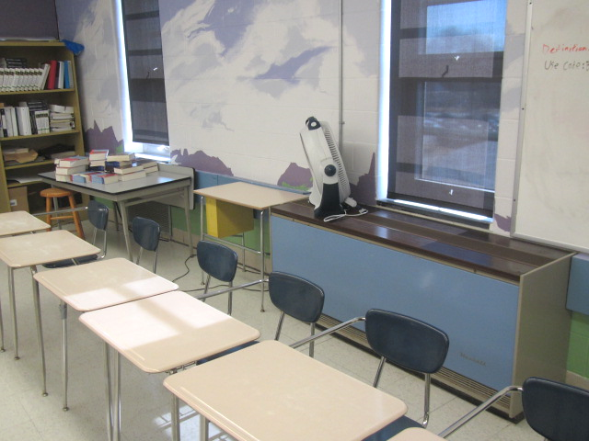**1970s era unit ventilator (univent) and non-mechanical pressurized**

**exhaust vent (arrow) along same/exterior wall in classroom**

**Picture 2**

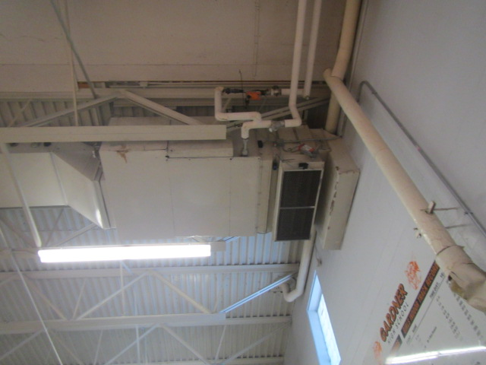**Ceiling-mounted air handling unit in gym**

**Picture 3**

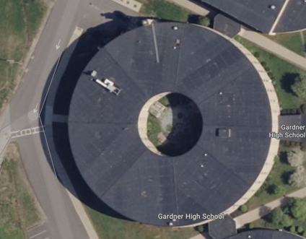**Rooftop air handling unit for Library (arrow)**

**Picture 4**

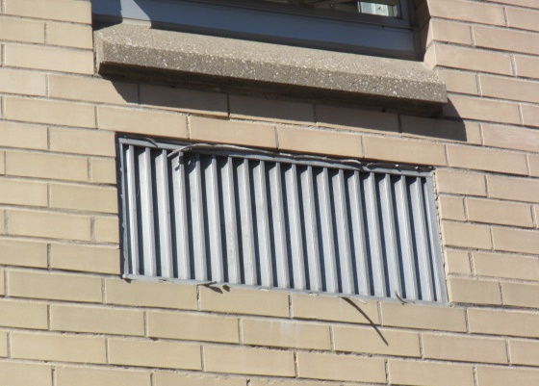**Univent air intake under windows, note missing/damaged caulking around vent**

**Picture 5**

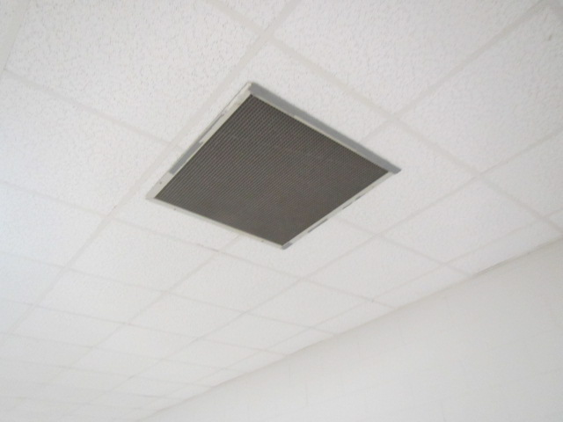**Ceiling-mounted supply vent in cafeteria**

**Picture 6**

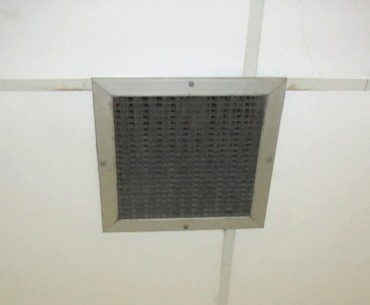**Ceiling-mounted exhaust vent, note accumulated dust and debris on vent**

**Picture 7**

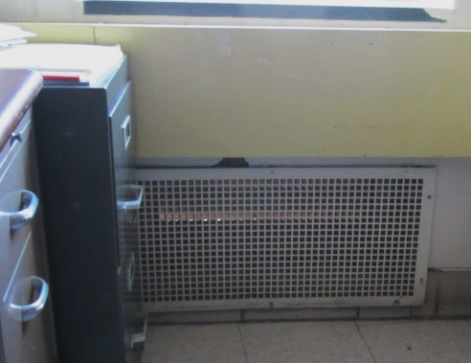**Passive/pressurized exhaust vent along floor in classroom, note light penetration due to movable flap**

**Picture 8**

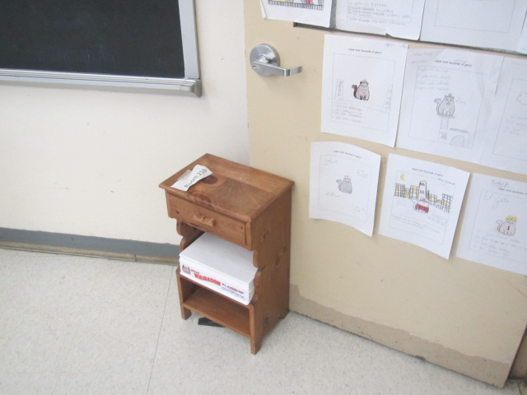**Classroom door held open by furniture**

**Picture 9**

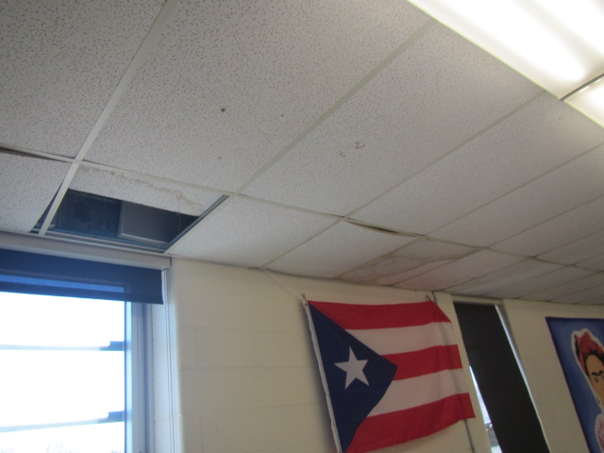**Missing and water-damaged ceiling tiles in classroom**

**Picture 10**

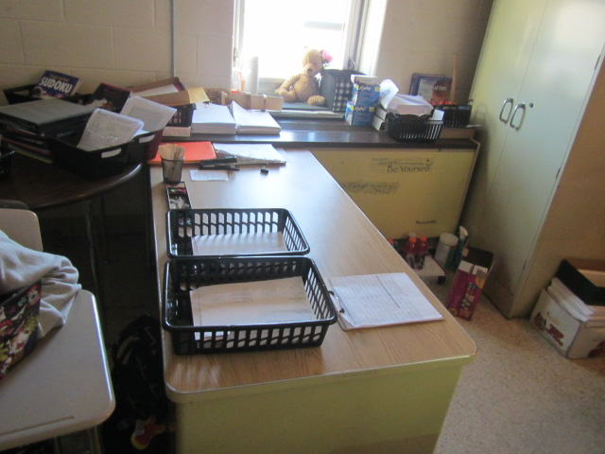**Univent obstructed by items on top (supply vent) and along front (return vent)**

**Picture 11**

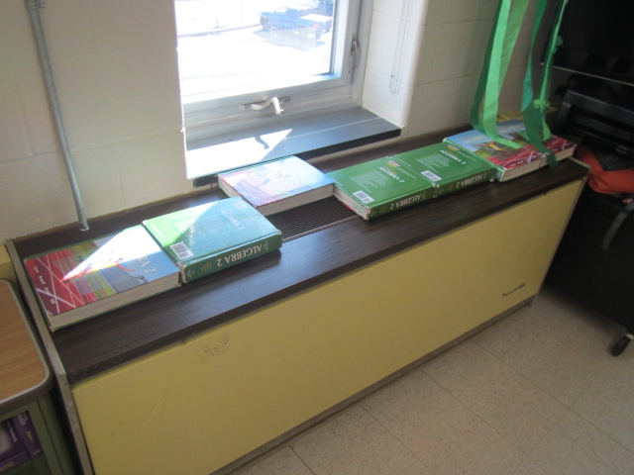**Univent obstructed by items on top (supply vent)**

**Picture 12**

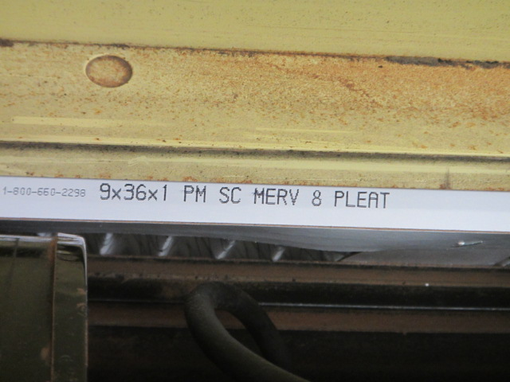**MERV 8 filter in classroom univent (arrow)**

**Picture 13**

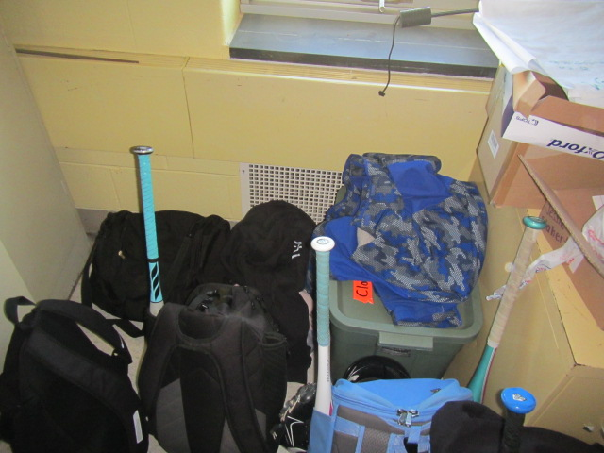**Exhaust vent obstructed by items**

**Picture 14**

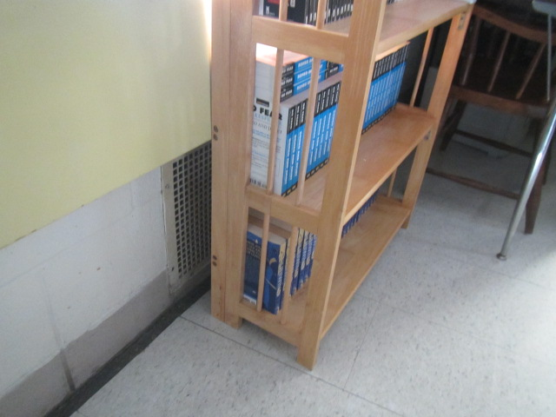**Exhaust vent obstructed by bookcase**

**Picture 15**

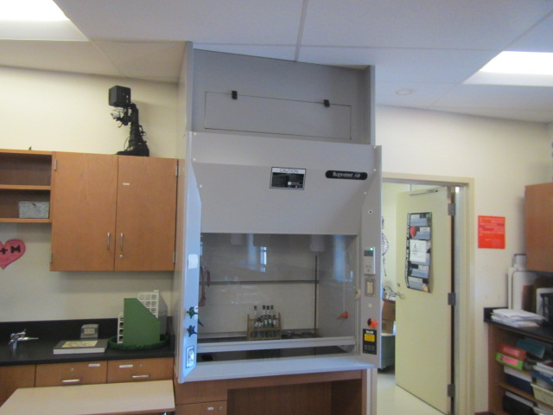**Lab hood in science room**

**Picture 16**

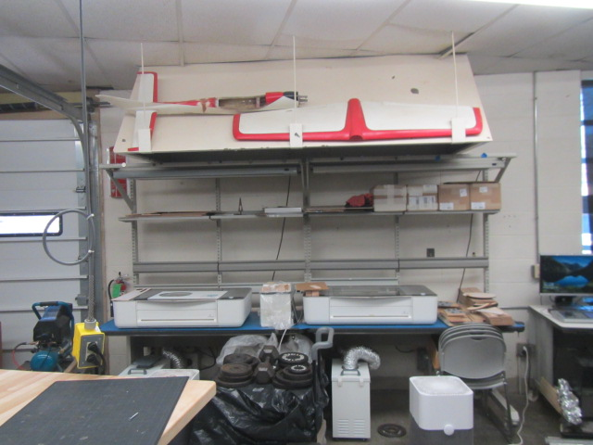**Local exhaust and filtration unit in wood shop area**

Water Damage and Moisture Concern Pictures

(click to link back to report)

**Picture 17**

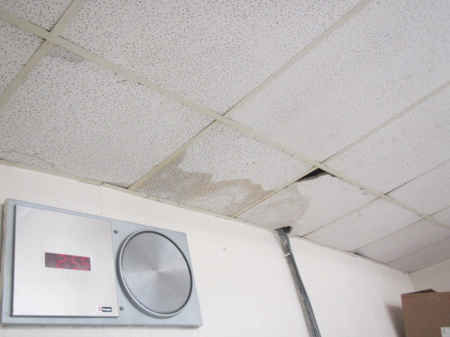**Water-damaged ceiling tiles in classroom**

**Picture 18**

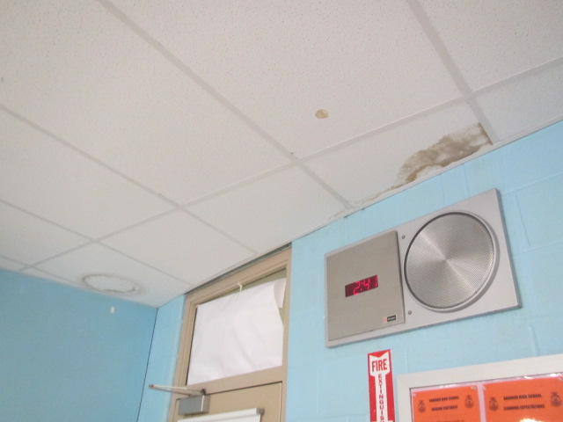**Water-damaged ceiling tiles in classroom**

**Picture 19**

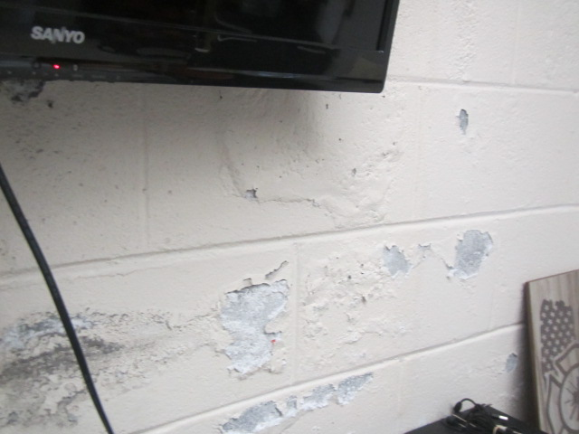**Peeling paint and efflorescence in gym office**

**Picture 20**

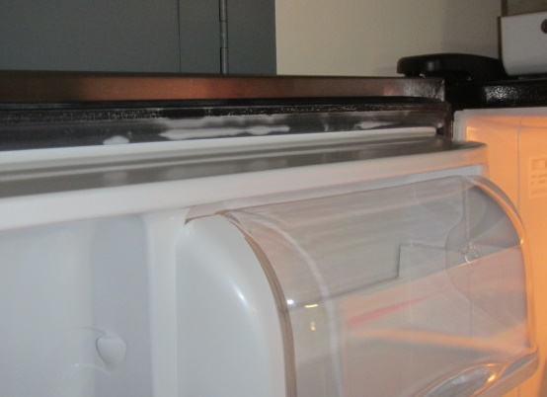**Mold growth (light staining) on gasket of refrigerator in chemical storeroom**

**near science rooms 302 and 304**

**Picture 21**

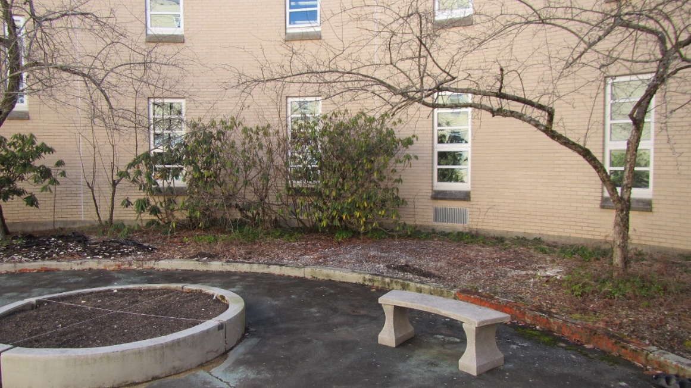**Plants blocking univent fresh air intakes were noted in the courtyard**

**Picture 22**

A large water-damaged rotting wood structure exist in the interior courtyard 
on close proximity to univent fresh air intakes
**A large water-damaged rotting wood structure exist in the interior courtyard**

**on close proximity to univent fresh air intakes**

**Picture 23**

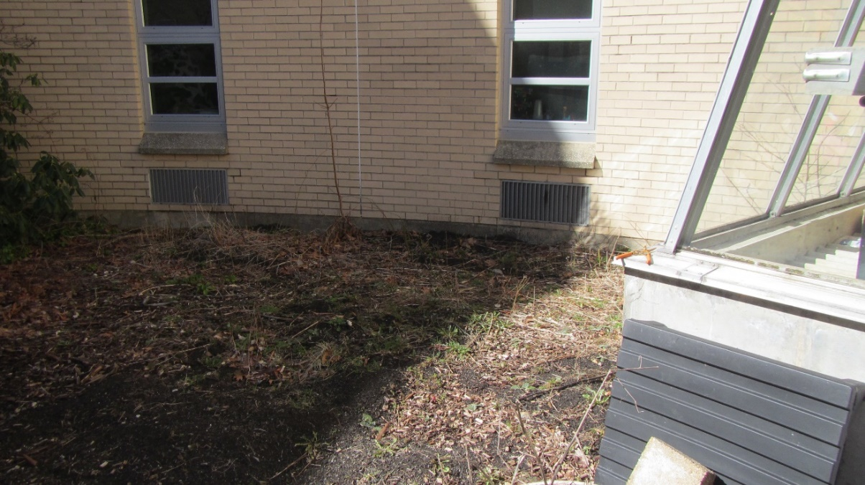

**Fresh air intakes are located in close proximity to soil covered with plant debris**

**Picture 24**

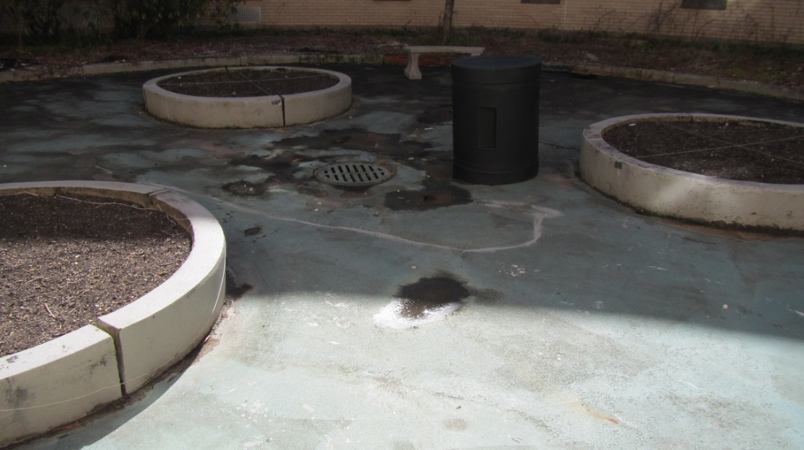

**Damage to courtyard floor may reduce water drainage from courtyard to**

**cause standing water**

**Picture 25**

**Door opening into the greenhouse sink room (arrow) with passive door vent
Note door opening into green house has a passive door vent (dotted line arow)
**

**Door opening into the greenhouse sink room (arrow) with passive door vent**

**Note door opening into green house has a passive door vent (dotted line arow)**

**Picture 26**

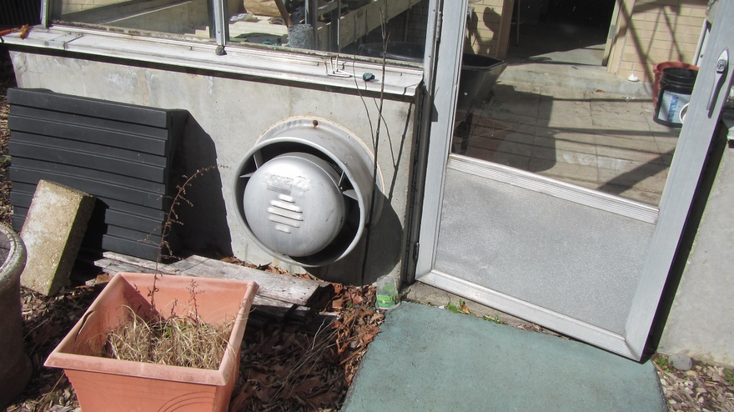

**Greenhouse exhaust fan not operating**

Sources of Respiratory Irritant Pictures

(Click to link back to report)

**Picture 27**

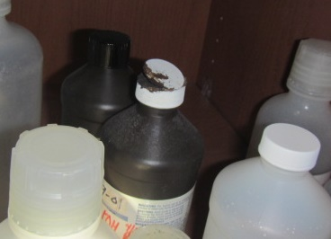**Damaged chemical bottle cap in science storeroom near science rooms 302 and 304**

**Picture 28**

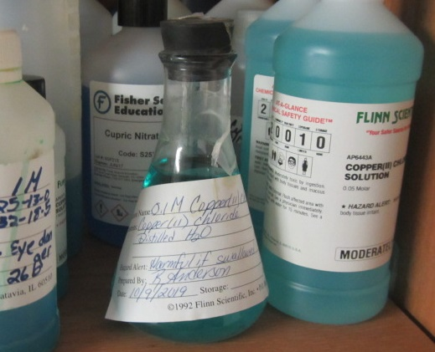**Chemical mixture in container with rubber stopper dated 2019**

Picture 29

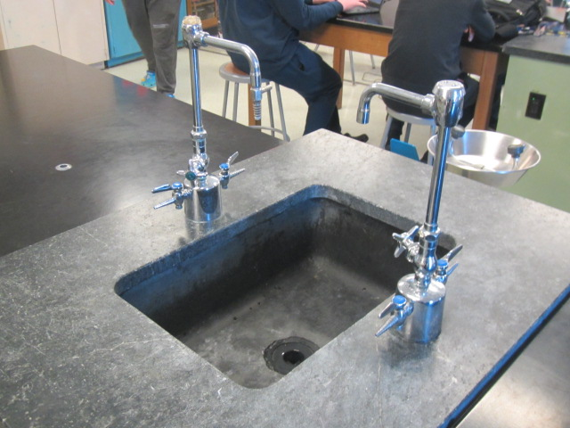Lab sink in science room

Picture 30

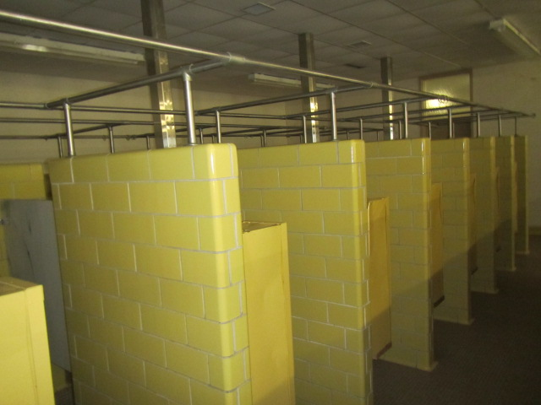Little-used showers in locker room

Click to link back to report

# Table 1

| **Room** | **Openable Windows** | **HVAC** | **Ventilation** | | **Ceiling Tiles/Staining (Y or N)**  **Bowed = B** | **Comments** |
| --- | --- | --- | --- | --- | --- | --- |
| **Intake** | **Exhaust** |
| 301 | Y | Y | Y | Y | B |  |
| 302 | Y | Y | Y | Y | Y-1 | Rooftop unit off/under repair |
| 303 | Y | Y | Y | Y | B |  |
| 304 | Y | Y | Y | Y | N | Rooftop unit off/under repair, lab hood, DO |
| 305 | Y | Y | Y | Y | B |  |
| Chemical Storeroom | Y | Y | Y | Y | N | Visible mold-fridge, damaged cap on chemical bottle, rubber stopper in bottles, items labeled from 2019 |
| 306 | Y | Y | Y | Y | N | DO, PF |
| 307 | Y | Y | Y | Y | B |  |
| 308 | Y | N | N | N | N | Wall-to-wall carpet, AP, cushion, area rug |
| 309 | Y | N | N | N | B | Radiator |
| 310 | Y | Y | Y | Y | N | PF, AP |
| 312 | Y | Y | Y | Y | N | DO, UV return partially obstructed by desk |
| 314 | Y | Y | Y | Y | N | UV supply vent covered by books, PF, AP, cold complaints |
| 315 | Y | N | N | N | B | Radiator, window AC |
| 316 | Y | Y | Y | Y | N | DO, AP |
| 317 | Y | N | N | N | B | Radiator |
| 318 | Y | Y | Y | Y | N | UV obstructed front/top, AP-off |
| 319 | Y | N | N | N | B | Radiator |
| 320 | Y | Y | Y | Y | N | Exhaust vent obstructed by furniture, AP, PF (3) |
| 321 | Y | Y | Y | Y | B | Air freshener, exhaust vent obstructed |
| 322 | Y | Y | Y | Y | N | AP, PF, DO |
| 323 | Y | Y | Y | Y | B |  |
| 324 | Y | Y | Y | Y | N | DO |
| 326 | Y | Y | Y | Y | N | DO |
| 328 | Y | Y | Y | Y | N | AP |
| 330 | Y | Y | Y | Y | N | DO, AP |
|  |  |  |  |  |  |  |
| 201 | Y | Y | Y | Y | B | Plants over UV fresh air supply, window AC |
| 202 | Y | Y | Y | Y | Y-2 |  |
| 203 | Y | Y | Y | Y | B | Plants over UV fresh air supply |
| 204 | Y  Open | Y | Y | Y | N |  |
| 205 | Y | Y | Y | Y | B | Plants over UV fresh air supply |
| 206 | Y | Y | Y | Y | Y-4 | Pillows, PF |
| 207 | Y | N | N | N | Y, B |  |
| 208 | Y | Y | Y | Y | N |  |
| 209 | Y | N | N | N | B |  |
| 210 | Y | Y | Y | Y | N | PF |
| 211 | Y | N | N | N | B | Radiator |
| 212 | Y | Y | Y | Y | N | Exhaust obstructed, DO, PF |
| 213 | Y | N | N | N | B |  |
| 214 | Y | Y | Y | Y | Y-6 | DO |
| 215 | Y | Y | Y | Y | B | Window AC |
| 216 | Y | Y | Y | Y | Y | Water-damaged/missing tiles along exterior wall, PF |
| 217 | Y | Y | Y | Y | B | Window AC, fresh air supply – obstructed |
| 218 | Y | Y | Y | Y | Y-3 | Photocopier, fridge, coffee maker, microwave |
| 220 | Y | Y | Y | Y | Y-7 | DO, UV obstructed by books/top, AP, |
| 222 | Y | N | N | N | Y | AC in window, water-damaged ceiling tiles near windows |
| 224 | Y | Y | Y | Y | N | DO |
| 226 | Y  Open | Y | Y | Y | Y-3 | PF |
| 228 | Y  Open | Y | Y | Y | N | UV obstructed top, PF |
| 230 | Y | Y | Y | Y | Y-6 | Possible roof leaks reported over exterior windows, exhaust obstructed, PF |
| 101 | Y | Y | Y | Y | Y, B |  |
| 102 | Y | Y | Y | Y | Y, B |  |
| 103 Food Lab | N | N | N | N | Y, B |  |
| 104 | Y | N | N | N | Y, B |  |
| 105 | Y | Y | Y | Y | Y, B |  |
| 107 | Y | Y | Y | Y | B |  |
| Main Office | Y | N | N | N | B | Window AC |
| Principal | Y | N | N | N | B | Radiator |
| Guidance | Y | N | N | N | B | Plants |
| 110 Network Room | Y | N | N | N | B | Mini-split AC |
| 111 TV Studio | Y | N | N | N | Y, B |  |
| 112 | Y | N | N | N | B |  |
| 114 | Y | N | N | N | B | Cardboard |
| 116 | Y | Y | Y | Y | B | Plants, carpeting |
| Girls Locker Room | Y  Open | Y | Y | Y | N | Shower drains |
| Gym 1 | N | Y | Y | Y | N |  |
| Gym 2 | N | Y | Y | Y | N | Auxiliary exhaust system |
| Weight Room | Y | Y | Y | Y | N |  |
| Gym Office | Y | N | N | N | N | Missing ceiling tiles, efflorescence wall plaster |
| Boys Locker Room | Y | Y | Y | Y | N | PF-dusty, efflorescence wall plaster |
| Trainer’s Room | Y | N | N | N | N |  |
| Cafeteria | Y | Y | Y | Y | N | AP-large |
| Food Service Office | Y | N | N | N | N | Wall-to-wall carpet (worn) |
| A1 | Y | Y | Y | Y | B |  |
| A2 | Y | Y | Y | Y | B |  |
| A3 | Y | Y | Y | Y | B |  |
| A4 | Y  Open | Y | Y | Y | N | AP near exhaust vent |
| A5 | Y  Open | Y | Y | Y | N | DO |
| A6 | Y  Open | Y | Y | Y | N | Local exhaust vent |
| A7 | Y  Open | Y | Y | Y | N | AP near exhaust vent, kiln-vented, microwave, fridge |
| A8 | Y | N | N | N | N | Auxiliary heater |
| Auditorium | N | Y | Y | Y | Y-3 | HVAC scheduled for replacement |
| A2 | Y | Y | Y | Y | Y | DO, water-damaged ceiling tiles along front wall, local exhaust and filtration units |
| Music | N | Y | Y | Y | N | 2 UVs – off, AP |

(Click to link back to report)

# Table 2A

|  |  |  |  |  |  |
| --- | --- | --- | --- | --- | --- |
| **Equipment Present in Building**  **(X = Yes)** | **Type of Heating/Cooling Ventilation**  **Equipment** | **Fresh**  **Air**  **Supply**  **(X = Yes)** | **Type of Location(s)** | **Air Filters Installed**  **MERV Rating**  **(1-15, U*)**  **(X = Yes)** | **Comments** |
| X | Univents | X | Classrooms | X 8 |  |
| X | Rooftop Air Handling Units | X | Science rooms, common areas | X 8 |  |
|  | Outdoor, Ground-Installed Air Handling Units |  |  |  |  |
|  | Attic/Crawlspace Air Handling Units |  |  |  |  |
| X | Ceiling-Mounted Air Handling Units (including inside plenum) | X | Gym, Auditorium | X 8 |  |
|  | Basement/Crawlspace-Installed Air Handling Units |  |  |  |  |
|  | Mechanical Room-installed Air Handling Units |  |  |  |  |
|  | Fan Coil Units |  |  |  |  |
| X | Window-Mounted Air Conditioners | X | Classrooms, offices |  |  |
|  | Wall Louver-Controlled Gravity Air Supply |  |  |  |  |
| X | Windows |  | Most areas |  |  |
|  | Fan in window (blowing in) |  |  |  |  |
|  | Built in wall fan (switched) |  |  |  |  |
|  | Heat recovery ventilator unit |  |  |  |  |
|  | Energy recovery ventilator unit |  |  |  |  |
|  | Chilled Beam |  |  |  |  |
|  | Passive combustion supply vent in basement/boiler room |  |  |  |  |

*U = Filter Rating underdetermined due to inaccessibility during building visit

(Click to link back to report)

# Table 2B

|  |  |  |  |  |
| --- | --- | --- | --- | --- |
| **Equipment Present in Building**  **(X = Yes)** | **Type of Exhaust Ventilation**  **Equipment** | **Ducted**  **To Outdoors**  **(X = Yes)** | **Type of Location(s)** | **Comments** |
| X | Rooftop Motors/Fans | X | Science classrooms |  |
|  | Unit Exhaust |  |  |  |
| X | Ceiling Return Vent | X | Science classrooms |  |
|  | Ceiling Return Vent, Plenum |  |  |  |
| X | Wall Return Vent | X | Cafetoria, gym, auditorium |  |
|  | Kitchen Stove Hood |  |  |  |
| X | Restroom Exhaust Vent |  |  |  |
|  | Photocopier Exhaust Vent |  |  |  |
|  | Garage |  |  |  |
| X | Chemical Hood(s) | Y | Science areas |  |
| X | Locker Rooms | Y |  |  |
| X | Showers | Y |  |  |
|  | Clothes Dryers |  |  |  |
|  | Gas Water Heaters |  |  |  |
|  | Furnace-Flue to Chimney |  |  |  |
|  | Furnace/Boiler direct vent or power vent (no combustion air supply) |  |  |  |
| X | Kiln, Pottery | Y |  |  |
|  | Dark Room |  |  |  |
|  | Generator Room |  |  |  |
| X | Wood Shop Dust Collector | Y |  |  |
|  | Spray Paint Booths |  |  |  |
|  | Fan in window (blowing out) |  |  |  |

# Table 2C

|  |  |  |  |
| --- | --- | --- | --- |
| **Equipment Present in Building**  **(X = Yes)** | **Type of Equipment** | **Type of Location(s)** | **Comments** |
|  | Floor Fans, pedestal |  |  |
| X | Floor Fans, portable | Classrooms, offices |  |
| X | Air Purifier (HEPA, other) | Classrooms, offices |  |
|  | Floor heaters, portable |  |  |
| X | Refrigerators, Cold Beverage Vending Machines |  |  |
|  | Radiator, wall-mounted |  |  |
|  | Radiator, floor-mounted |  |  |
| X | Passive Vents (Wall/Door) | Classroom exhaust vents | Pressure relief design |

(Click to link back to report)

# Table 3

| **Found in Building**  **X = Yes** | **Water-Damaged Materials, Building Components or Stored Materials** | **Location** | **Visible Microbial Growth?**  **X = Yes** | **Musty odor detected?**  **X = Yes** | **Comments** |
| --- | --- | --- | --- | --- | --- |
|  | Books-other bound materials |  |  |  |  |
|  | Brick walls – broken, missing mortar |  |  |  |  |
|  | Brick walls – blocked weep holes |  |  |  |  |
|  | Cardboard boxes |  |  |  |  |
|  | Carpet tiles |  |  |  |  |
|  | Carpet - Area rugs |  |  |  |  |
|  | Carpet wall-to-wall |  |  |  |  |
|  | Ceiling tiles - affixed directly to ceiling surface |  |  |  |  |
| X | Ceiling tiles - bowing-in suspended ceiling |  |  |  |  |
|  | Ceiling tiles - water-stained in splined ceiling |  |  |  |  |
| X | Ceiling tiles - water-stained in suspended ceiling |  |  |  |  |
|  | Chairs - laminated |  |  |  |  |
|  | Cloth |  |  |  |  |
|  | Countertops (around sinks) |  |  |  |  |
|  | Curtains |  |  |  |  |
|  | Dust/debris within AHU, uninvent, HVAC, chilled beam units, etc. (WD through condensation, humidity, or leaks) |  |  |  |  |
| X | Efflorescence (i.e., mineral deposits) | Locker rooms and gym office |  |  |  |
|  | Engineered woods - particleboard, plywood, Masonite |  |  |  |  |
|  | Flooring – loosened tiles |  |  |  |  |
|  | Flooring - wooden |  |  |  |  |
|  | Furniture - laminated |  |  |  |  |
|  | Furniture - upholstered |  |  |  |  |
|  | Gypsum wallboard - ceiling |  |  |  |  |
|  | Gypsum wallboard - restroom wall |  |  |  |  |
|  | Gypsum wallboard - interior wall |  |  |  |  |
|  | Gypsum wallboard – located on exterior wall |  |  |  |  |
|  | HVAC drain pan – lack of draining |  |  |  |  |
|  | HVAC filters |  |  |  |  |
|  | Insulation- attic (paper-backed) |  |  |  |  |
|  | Insulation - inside air handling unit |  |  |  |  |
|  | Insulation - on pipe(s) fiberglass |  |  |  |  |
|  | Insulation - on pipe(s) other/plaster-like material |  |  |  |  |
|  | Insulation - wall cavity |  |  |  |  |
|  | Insulation – ceiling plenum |  |  |  |  |
|  | Modular furniture – walls/cloth partitions |  |  |  |  |
|  | Musical instrument cases |  |  |  |  |
|  | Plaster ceilings |  |  |  |  |
|  | Records/files |  |  |  |  |
| X | Refrigerator - door gasket | Chem storeroom 302-304 |  |  |  |
|  | Refrigerator - drip pan |  |  |  |  |
|  | Refrigerator - Interior surfaces |  |  |  |  |
|  | Room divider - ceiling-mounted, sliding |  |  |  |  |
|  | Sink backsplash |  |  |  |  |
|  | Tables – laminated |  |  |  |  |
|  | Wallpaper |  |  |  |  |
|  | Wood - attic/roof materials |  |  |  |  |
|  | Wood - floor joists in basement ceiling |  |  |  |  |
|  | Wood - wall framing |  |  |  |  |
|  | Wood - window sills |  |  |  |  |
|  | Wood - window-mounted air conditioner framing |  |  |  |  |
|  | OTHER |  |  |  |  |

WHAT ARE ENVIRONMENTAL ASTHMA TRIGGERS?

Asthma triggers are any chemical, pollutant, or allergen that can make your asthma worse. Asthma triggers can also be strong chemical smells, dust, or pets. Your asthma triggers may be different from those of other people. Not all asthma triggers affect people the same way. Environmental asthma triggers are found both indoors and outdoors. DPH link: [Asthma and Your Environment (mass.gov)](https://www.mass.gov/doc/asthma-and-your-environment-english/download)

(click to link back to report)

# Table 4

| **Condition Present**  **X = Yes** | **Possible asthma symptom-inducing environmental pollutant** | **Recommendation to reduce or eliminate the pollutant** |
| --- | --- | --- |
| X | Water Damage and/or Mold  (allergen) | Identify water source and repair to eliminate.  Clean non-porous materials.  Remove and replace porous materials susceptible to mold growth.  Perform regular water damage assessments as a tool to ensure timely mitigation as needed.  Use NIOSH water damage assessment protocol as a guide: [NIOSH water damage assessment guideline](https://www.cdc.gov/niosh/docs/2019-115/pdfs/2019-115.pdf?id=10.26616/NIOSHPUB2019115&inf_contact_key=241b5c2ed98c27d94b530dedc36f1623f651f238aa2edbb9c8b7cff03e0b16a0). |
|  | Moistening of building components during hot, humid weather (>2 days in length) (mold, allergen) | Remove materials not dried in <2 days in a manner consistent with [US EPA Mold Removal in Commercial Buildings guideline](https://www.epa.gov/mold/pdf-version-checklist-mold-remediation-mold-remediation-schools-and-commercial-buildings).  Use dehumidification in occupied basement areas and other areas with chronic dampness. |
|  | Vegetation against exterior of building (water damage-mold) | Remove all vegetation preventing building exterior drying.  Remove all vegetation capable of falling onto a building or depositing debris onto the roof. |
|  | Personal humidifiers (lack of proper maintenance)  (pollutant and allergen) | Clean and maintain properly.  Use distilled water to eliminate metal and water treatment odors.  Maintain hydration by increasing water consumption. |
| X | Drains: Floor drains, Sink drains (abandoned use)  Water bubblers (abandoned use) | If in use, pour water into drain at least twice a week.  If not in use, seal the drain with an appropriate material in accordance with Massachusetts Plumbing Code (248 CMR 10.00). |
|  | Live Animals (turtles, gerbils, birds, rabbits, etc.) | Ensure cleanliness or remove animals from the location. |
|  | Improperly maintained aquariums and terrariums (allergen) | Maintain such equipment properly to eliminate odor.  Discontinue use. |
| X | Plants and flowers  (allergen and mold) | Keep indoor plants well maintained and not overwatered. Monitor for signs of mold and pests.  Ensure water for cut flowers does not become stagnant.  Ensure dried plant material is free of odors, mold, and pests and handled carefully  If asthma risks are high, eliminate plants and flowers. |
|  | HVAC system moisture issues  (mold, allergen) | Consult ASHRAE’s minimum standards for HVAC maintenance and inspection of commercial HVAC systems (<https://www.ashrae.org/technical-resources/bookstore/standards-180-and-211>). |
|  | HVAC system contaminant issues (allergen) | Consult ASHRAE’s minimum standards for HVAC maintenance and inspection of commercial HVAC systems (<https://www.ashrae.org/technical-resources/bookstore/standards-180-and-211>). |
|  | Indoor swimming pool odors outside of swimming pool (mold, chemical) | Maintain and operate pool HVAC systems to vent odors from building.  Ensure locker room exhaust vents are operating during building hours.  All doors leading to pool should be rendered airtight and be closed. |
|  | Pollen (allergen) | Recommend installation of MERV 8 or better filters if HVAC engineer confirms HVAC system can be so equipped without adversely affecting function.  Cut grass after hours.  Cut grass in a pattern to direct clippings away from exterior wall.  Remove trees and shrubs from in front of windows and air intakes. |
|  | Dry air | Maintain hydration.  Avoid overheating of air. |
| X | Dust mites  (allergen) | Recommendation to remove non-official upholstered furniture, area rugs, pillows, cushions, etc.  Cleaning with use of HEPA-filtered vacuum cleaner.  Eliminating clutter, storing items in dust and moisture-proof containers, and regularly removing dust through wet wiping. |
|  | Pests, including rodents and cockroaches  (allergen) | Use of integrated pest management guidelines, including:   * Proper disposal of food containers * Proper storage of food products in airtight containers * Elimination of use of food as art projects * Remove pest harborages/clutter * Regular monitoring for pests   [EPA IPM guideline link](https://www.epa.gov/ipm/introduction-integrated-pest-management) |
|  | Latex-containing materials | Remove tennis balls from furniture legs. |
| X | Fragrances  (chemical) | Eliminate point sources, such as:   * Plug-in air fresheners * Aroma/oil reed diffusers * Scented sprays * Discontinue use of other scented materials * Consult DPH fragrance guideline: [*Clean air is odor-free*](https://www.mass.gov/doc/clean-air-is-odor-free-removing-fragrances-to-improve-indoor-air-quality-in-schools-and-0/download) |
|  | Strong smells from /use of Chemicals (such as cleaning products)  (chemical) | Use building-issued cleaning products.  Use products in accordance with manufacturer’s instructions including dilution, application, and ventilation.  Avoid using products that are stronger than needed for the situation. |
|  | Strong odors from new building materials (carpeting/furniture)  (chemical) | Use low VOC-emitting materials.  Air out materials (outside or in unoccupied area) prior to installation. |
|  | Tobacco smoke  Secondhand Smoke  (pollutant) | Eliminate tobacco smoking.  Seal all shared wall penetrations. |
| X | Products with a strong odor such as paint, perfume, hairspray, air fresheners, bug-spray, laminators, candles, wax melters, dry erase markers and other VOC-containing products  (chemical) | If essential:   * Provide proper exhaust ventilation to eject aerosolized product directly outdoors. * Avoid/reduce use during occupied hours.   If not necessary, remove and eliminate. |
|  | Vehicle exhaust  (pollutant) | Enforce anti-idling regulations and post signs to give notice.  Relocate vehicles away from fresh air intakes.  Require cars to park face-in at building walls.  [MA anti-idling law FAQs](https://www.mass.gov/files/documents/2018/02/20/idling-faq.pdf#:~:text=The%20Massachusetts%20Anti-Idling%20Law%20The%20goal%20of%20the,sometime%20wonder%20when%20idling%20might%20be%20considered%20necessary.) |
|  | Vapors and or fumes from gas, oil, or kerosene stoves  (pollutant) | Operate stove hood when stove in use.  Install stove hood if not present.  Ensure equipment is in good working order. |
|  | Ozone (pollutant) | Eliminate use of ozone generating equipment. |
| X | Window Air Conditioners (if not properly maintained) (allergen) | Equip with proper filter and clean periodically.  Clean drip pans.  Install in window with weathertight, non-mold-growth sustaining material. |
| X | Pottery (pollutant) | Do not operate kiln during occupied hours.  Operate kiln with exhaust system activated.  Seal all seams and holes in kiln vent.  Ensure kiln exhaust discharge terminates outdoors. |
| X | Carpeting (allergen) | Clean carpeting in a manner consistent with IICRC standards, including regular vacuuming with a high efficiency particulate air (HEPA) filtered vacuum in combination with annual cleaning or semi-annual cleaning in soiled high traffic areas. |
|  | Sweeping/dusting vs HEPA vacuuming/wet wiping  (allergen or pollutant) | Refrain from using feather dusters or brooms.  Utilize HEPA vacuums and wet wiping to minimize aerosolizing particulate matter. |
| X | Lack of adequate air exchange/mechanical ventilation | Make repairs as necessary and ensure all HVAC system components are operating continuously when building is occupied. |
| X | Lack of local exhaust at source of pollution (vocational shop activities, kitchen exhaust hood) (all) | Recommend installation of exhaust ventilation to direct pollutants directly outdoors. |
|  | Renovating buildings while occupied  (chemical) | Use all SMACNA guidelines for Renovation While Buildings Are Occupied. For information, visit <https://www.mass.gov/service-details/construction-and-renovation-generated-pollutants-in-occupied-buildings>. |
| X | Chemistry program chemical storage  (chemical) | Repair (if needed) and operate chemical storeroom vents appropriately.  Reduce or eliminate unneeded or overstocked chemicals.  Store all chemicals in a manner to separate incompatible chemicals.  Keep chemical storerooms clean. |
| X | Photocopiers/duplicating machines | All machines should have dedicated exhaust vents. |