INDOOR AIR QUALITY ASSESSMENT

Gardner Public Schools’ Administration Building
70 Waterford Street
Gardner, Massachusetts



Prepared by:
Massachusetts Department of Public Health
Bureau of Environmental Health
Indoor Air Quality Program
January 2014

Background/Introduction
At the request of Christopher Casavant, Business Administrator for the Gardner Public Schools, the Massachusetts Department of Public Health (MDPH), Bureau of Environmental Health (BEH) provided assistance and consultation regarding indoor air quality (IAQ) at the Gardner School Administration (GSA) building, located at 70 Waterford Street, Gardner, Massachusetts. The request was prompted by concerns of odors, potential mold growth inside the building, and general IAQ. On November 15, 2013, a visit to conduct an indoor air assessment was made by Mike Feeney, Director of BEH’s IAQ Program and Kathleen Gilmore, Environmental Analyst/Regional Inspector within BEH’s IAQ Program. Mr. Robert O’Brien, Director of Facilities for the Gardner Public Schools, accompanied Mr. Feeney and Ms. Gilmore on the visit.
The GSA is a one-story building constructed in the early 1970’s to provide additional classroom space for the adjacent Waterford Street Elementary School. The building was renovated in approximately 2004, and converted into the GSA offices. Renovations included installation of a new roof, vinyl siding, heating system and subdivision of classrooms into offices. A crawlspace is located under the building. Windows are openable throughout the building. Heat is provided by a gas-fired furnace connected to wall-mounted heaters. Most areas have wall-to wall carpeting.

Methods
Air tests for carbon dioxide, temperature, relative humidity and carbon monoxide were conducted with the TSI, Q-Trak, IAQ Monitor, Model 7565. Air tests for airborne particle matter with a diameter less than 2.5 micrometers were taken with the TSI, DUSTTRAK™ Aerosol Monitor Model 8520. BEH/IAQ staff also performed visual inspection of building materials for water damage and/or microbial growth.

Results
The GSA has an employee population of approximately 20 and is visited by up to 30 individuals daily. Tests were taken during normal operations and results appear in Table 1.

Discussion

Ventilation
It can be seen from Table 1 that carbon dioxide levels were below 800 parts per million (ppm) in 15 out of 18 areas surveyed, indicating adequate air exchange in most areas at the time of the assessment. It is important to note that several areas were empty/sparsely populated, which can greatly reduce carbon dioxide levels. Carbon dioxide levels would be expected to increase with higher occupancy.
Mechanical ventilation in the original building was provided by unit ventilators (univents) (Picture 1). A univent draws fresh air from a vent on the exterior of the building and returns air through an air intake at the base of the unit. Fresh and return air are mixed, filtered, heated and provided to rooms through an air diffuser located in the top of the unit. It was reported that the univent system had been deactivated during the 2004 renovations and the exterior vents were sealed (Picture 2). Therefore, no mechanical ventilation currently exists in the building. The sole means of introducing fresh air into the building is through open windows. Window and wall-mounted air conditioners provide cooling in these areas during warm weather.
Mechanical exhaust ventilation does not exist in the building, with the exception of local exhaust vents in the restrooms (Table 1). Exhaust ventilation is necessary to remove occupant-generated and other pollutants from occupied areas. Ceiling-mounted exhaust vents in the restrooms are activated via light switches; these exhausts also vent into the attic space (Picture 3). It is recommended that exhaust ventilation in bathrooms be continuous during occupied hours rather than in response to a light switch. Restroom exhaust should vent directly to the outside to prevent the entrapment of odors and moisture into interior portions of the building. As with supply ventilation, in order to function properly, exhaust vents must be activated and allowed to operate while rooms are occupied. Without adequate supply and exhaust ventilation, excess heat and environmental pollutants can accumulate, leading to indoor air/comfort complaints.
To maximize air exchange, the MDPH recommends that both supply and exhaust ventilation operate continuously during periods of occupancy. In order to have proper ventilation with a mechanical supply and exhaust system, the systems must be balanced to provide an adequate amount of fresh air to the interior of a room while removing stale air from the room. It is recommended that HVAC systems be re-balanced every five years to ensure adequate air systems function (SMACNA, 1994). Minimum design ventilation rates are mandated by the Massachusetts State Building Code (MSBC). Until 2011, the minimum ventilation rate in Massachusetts was higher for both occupied office spaces and general offices, with similar requirements for other occupied spaces (BOCA, 1993). The current version of the MSBC, promulgated in 2011 by the State Board of Building Regulations and Standards (SBBRS), adopted the 2009 International Mechanical Code (IMC) to set minimum ventilation rates. Please note that the MSBC is a minimum standard that is not health-based. At lower rates of cubic feet per minute (cfm) per occupant of fresh air, carbon dioxide levels would be expected to rise significantly. A ventilation rate of 20 cfm per occupant of fresh air provides optimal air exchange resulting in carbon dioxide levels at or below 800 ppm in the indoor environment in each area measured. MDPH recommends that carbon dioxide levels be maintained at 800 ppm or below. This is because most environmental and occupational health scientists involved with research on IAQ and health effects have documented significant increases in indoor air quality complaints and/or health effects when carbon dioxide levels rise above the MDPH guidelines of 800 ppm for schools, office buildings and other occupied spaces (Sundell et al., 2011). The ventilation must be on at all times that the room is occupied. Providing adequate fresh air ventilation with open windows and maintaining the temperature in the comfort range during the cold weather season is impractical. Mechanical ventilation is usually required to provide adequate fresh air ventilation.
Carbon dioxide is not a problem in and of itself. It is used as an indicator of the adequacy of the fresh air ventilation. As carbon dioxide levels rise, it indicates that the ventilating system is malfunctioning or the design occupancy of the room is being exceeded. When this happens, a buildup of common indoor air pollutants can occur, leading to discomfort or health complaints. The Occupational Safety and Health Administration (OSHA) standard for carbon dioxide is 5,000 parts per million parts of air (ppm). Workers may be exposed to this level for 40 hours/week, based on a time-weighted average (OSHA, 1997).
The MDPH uses a guideline of 800 ppm for publicly occupied buildings. A guideline of 600 ppm or less is preferred in schools due to the fact that the majority of occupants are young and considered to be a more sensitive population in the evaluation of environmental health status. Inadequate ventilation and/or elevated temperatures are major causes of complaints such as respiratory, eye, nose and throat irritation, lethargy and headaches. For more information concerning carbon dioxide, consult Appendix A.
Indoor temperature measurements ranged from 73º F to 76º F, which were within the MDPH recommended comfort range (Table 1). The MDPH recommends that indoor air temperatures be maintained in a range of 70º F to 78º F in order to provide for the comfort of building occupants. In many cases concerning indoor air quality, fluctuations of temperature in occupied spaces are typically experienced, even in a building with an adequate fresh air supply.
The relative humidity in the building ranged from 21 to 33 percent, which was below the MDPH recommended comfort range in all areas evaluated on the day of the a+++++-ssessment (Table 1). The MDPH recommends a comfort range of 40 to 60 percent for indoor air relative humidity. Relative humidity levels in the building would be expected to drop during the winter months due to heating. The sensation of dryness and irritation is common in a low relative humidity environment. Low relative humidity is a very common problem during the heating season in the northeast part of the United States.

Microbial/Moisture Concerns
In order for building materials to support mold growth, a source of water exposure is necessary. Identification and elimination of the source of water moistening building materials is necessary to control mold growth.
On entering the building, a musty odor was noted in the building. BEH/IAQ staff examined building materials for water damage and/or microbial growth. Odors were likely due to the crawlspace being pressurized through passive vents in its foundation and the lack of mechanical ventilation in occupied areas due to the deactivation of univents. Mr. O’Brien reported that the western side of the crawlspace is subject to water penetration following heavy rainstorms. Two sump pumps are located in the crawlspace but it was not known if they were functional at the time of the assessment. Mold colonization/growth would be expected to be present in an unconditioned crawlspace that is subjected to moisture. Efforts should be made to reduce moisture, circulate air and reduce/eliminate potential pathways for mold, spores, and associated odors to migrate into occupied areas.
Passive vents were observed in the exterior walls of the crawlspace (Picture 4). These vents are typically designed to allow water vapor and odors to be removed or diluted and are installed in a manner to create cross-ventilation in the crawlspace. Some vents were observed to be obstructed with dislodged insulation (Picture 5) and one had a utility pipe extending from it (Picture 6). Due to the current configuration of passive vents, the crawlspace is likely to become pressurized under typical wind conditions, resulting in air-flow into occupied areas of the building. The pressurization could be reduced/eliminated by sealing the crawlspace vents on the windward side of the building and installing a mechanical exhaust fan in the leeward side. This would result in air/odors from the crawlspace being vented outside the building rather than the migration of odors into the occupied floor above.
In addition, pathways exist between the crawlspace and the occupied areas including spaces around utility pipes. Airflow tends to rise and these breaches can serve as pathways to draw air, odors and particulates from the crawlspace into hallways and office spaces. These types of breaches and all holes and gaps should be sealed with fire-rated sealant foam or other appropriate material.
BEH/IAQ staff examined the exterior of the building to identify breaches in the building envelope and/or other issues that could provide a source of water penetration into the below-grade crawlspace or into occupied areas. Several potential sources were identified:
- The contour of the land around the GSA grounds, including areas, slope toward the building, therefore the foundation is subjected to chronic water impingement, resulting in moisture infiltration into the crawlspace.
- The building foundation is surrounded by grass, plant growth and debris (Pictures 6 and 7), which can result in the accumulation of rainwater and subsequent water penetration into the crawlspace. In addition, the growth of grass and roots against exterior walls can bring moisture in contact with the foundation, eventually leading to cracks and/or fissures.
- The building is not equipped with gutters or downspouts. As a result, rainwater runs off the roof onto the ground at the base of the building. The runoff has created a depression parallel to the base of the wall, which allows rainwater and melting snow to pool against the foundation. In addition, rainwater runoff has resulted in water damage to concrete stairs as evidenced by cracks/erosion in the concrete and adjacent foundation (Picture 7). In the same area, rainwater empties onto accumulated leaves and mulch. Leaves and grass hold moisture in contact with the building’s foundation. The entire building structure should be fitted with gutters and rainspouts directed at least five feet away from the building and kept clear of debris.
Over time, these conditions can undermine the integrity of the building envelope and provide a means of water entry into the building through capillary action through foundation concrete and/or masonry (Lstiburek & Brennan, 2001).
Water-damaged ceiling tiles were observed in the GSA, primarily where the suspended ceiling meets the exterior walls of the office space (Tables 1, Picture 8) which may be indicative of a roof or exterior wall leak or plumbing problems. If repeatedly moistened, ceiling tiles can be a medium on which mold can grow. Water-damaged tiles should be replaced after a water leak is discovered and repaired.
Mr. O’Brien reported that the roof of the building is prone to developing ice dams, providing a means for water to penetrate into the attic space. Ice dams occur when snow in contact with the upper section of the roof melts and refreezes on the lower portion of a roof. Heated air from occupied spaces rises and gathers in the peak of the roof. Heated air at the peak then warms roofing materials. Once roof materials are warmed above water’s melting point (32º F), snow in contact with these materials melts. As water rolls down the sloped roof, it freezes on the lower section of the roof when it comes into contact with materials that are below 32º F, creating an ice dam. The dam collects and holds melting snow or rainwater against the roof where pooling water can then penetrate through the roof materials via cracks and crevices, wetting the interior of the building.
A combination of standard building practices is used to prevent ice dams. These practices include the following:
- Insulating the floor of the attic space to prevent air movement and heat loss from the occupied space.
- Installing ridge vents along the roof ridge to allow heat to exhaust from the attic space.
- Installing soffit vents beneath the eave in the roof to provide a means for cold outdoor air to enter and replace heated air that escapes through the ridge vent.
Although a roof ridge and insulation exist in the attic space, BEH/IAQ staff observed that the soffits vents were sealed. Soffits vents must be opened to allow air flow to prevent ice dam formation.
In the mechanical room, a water-damaged ceiling tile above the furnace had been removed, and water damage was observed on the insulation and wood flooring of the attic space (Picture 9). Water-damaged insulation should be removed and the area should be cleaned and disinfected thoroughly.
A water-damaged wood pallet was observed in a hallway (Picture 10). All water-damaged items should be removed/discarded. BEH/IAQ staff also observed water in a mop pail in the mechanical room (Picture 11). Stagnant water can be a source of odors; mop buckets should be emptied and dried after every use.
As mentioned, restroom vents were found to be open into the attic space. Restroom vents should be vented directly to the outdoors to remove restroom odors and water vapor from the GSA.
In order to become colonized with mold, a material must be exposed to water and remain moist. If sufficiently moistened, porous materials such as books, paper, insulation covering, and carpeting can support mold growth (US EPA, 2001). The US EPA and the American Conference of Governmental Industrial Hygienists (ACGIH) recommend that porous materials be dried with fans and heating within 24 to 48 hours of becoming wet (US EPA, 2001; ACGIH, 1989). If porous materials are not dried within this time frame, mold growth may occur. Once mold has colonized porous materials, they are difficult to clean and should be removed and discarded.
A plant was observed in one room (Table 1). Plants, soil and drip pans can serve as sources of mold growth. Plants can also be a source of pollen. Plants should not be placed on porous materials, since water damage to porous materials may lead to microbial growth. Over-watering of plants should be avoided and drip pans should be inspected periodically for mold growth.

Other IAQ Evaluations
IAQ can be negatively influenced by the presence of respiratory irritants, such as products of combustion. The process of combustion produces a number of pollutants. Common combustion emissions include carbon monoxide, carbon dioxide, water vapor and smoke (fine airborne particle material). Of these materials, exposure to carbon monoxide and particulate matter with a diameter of 2.5 micrometers (μm) or less (PM2.5) can produce immediate, acute health effects upon exposure. To determine whether combustion products were present in the indoor environment, BEH/IAQ staff obtained measurements for carbon monoxide and PM2.5.

Carbon Monoxide
Carbon monoxide is a by-product of incomplete combustion of organic matter (e.g., gasoline, wood and tobacco). Exposure to carbon monoxide can produce immediate and acute health effects. Several air quality standards have been established to address carbon monoxide and prevent symptoms from exposure to these substances. The MDPH established a corrective action level concerning carbon monoxide in ice skating rinks that use fossil-fueled ice resurfacing equipment. If an operator of an indoor ice rink measures a carbon monoxide level over 30 ppm, taken 20 minutes after resurfacing within a rink, that operator must take actions to reduce carbon monoxide levels (MDPH, 1997).
The American Society of Heating, Refrigerating and Air-Conditioning Engineers (ASHRAE) has adopted the National Ambient Air Quality Standards (NAAQS) as one set of criteria for assessing indoor air quality and monitoring of fresh air introduced by HVAC systems (ASHRAE, 1989). The NAAQS are standards established by the US EPA to protect the public health from six criteria pollutants, including carbon monoxide and particulate matter (US EPA, 2006). As recommended by ASHRAE, pollutant levels of fresh air introduced to a building should not exceed the NAAQS levels (ASHRAE, 1989). The NAAQS were adopted by reference in the Building Officials & Code Administrators (BOCA) National Mechanical Code of 1993 (BOCA, 1993), which is now an HVAC standard included in the Massachusetts State Building Code (SBBRS, 2011). According to the NAAQS, carbon monoxide levels in outdoor air should not exceed 9 ppm in an eight-hour average (US EPA, 2006).
Carbon monoxide should not be present in a typical, indoor environment. If it is present, indoor carbon monoxide levels should be less than or equal to outdoor levels. The day of assessment, outdoor carbon monoxide concentrations were non-detect (ND) (Table 1). No measurable levels of carbon monoxide were detected in the building during the assessment (Table 1).

Particulate Matter (PM2.5)
The US EPA has established NAAQS limits for exposure to particulate matter. Particulate matter includes airborne solids, which can result in eye and respiratory irritation if exposure occurs. The NAAQS originally established exposure limits to particulate matter with a diameter of 10 μm or less (PM10). According to the NAAQS, PM10 levels should not exceed 150 micrograms per cubic meter (μg/m³) in a 24-hour average (US EPA, 2006). These standards were adopted by both ASHRAE and BOCA. Since the issuance of the ASHRAE standard and BOCA Code, US EPA established a more protective standard for fine airborne particles. This more stringent PM2.5 standard requires outdoor air particle levels be maintained below 35 μg/m³ over a 24-hour average (US EPA, 2006). Although both the ASHRAE standard and BOCA Code adopted the PM10 standard for evaluating air quality, MDPH uses the more protective PM2.5 standard for evaluating airborne particulate matter concentrations in the indoor environment.
Outdoor PM2.5 concentrations measured 8 μg/m³ on the day of the visit (Table 1). PM2.5 levels measured inside the GSA ranged from 4 to 6 μg/m³ (Table 1). Both indoor and outdoor PM 2.5 levels were below the NAAQS PM2.5 level of 35 μg/m³). Frequently, indoor air levels of particulates (including PM2.5) can be at higher levels than those measured outdoors. A number of mechanical devices and/or activities that occur in buildings can generate particulate during normal operations. Sources of indoor airborne particulates may include but are not limited to particles generated during the operation of fan belts in the HVAC system, use of stoves and/or microwave ovens in kitchen areas; use of photocopiers, fax machines and computer printing devices; operation of an ordinary vacuum cleaner and heavy foot traffic indoors.

Volatile Organic Compounds
Indoor air concentrations can be greatly impacted by the use of products containing volatile organic compounds (VOCs). VOCs are carbon-containing substances that have the ability to evaporate at room temperature. Frequently, exposure to low levels of total VOCs (TVOCs) may produce eye, nose, throat and/or respiratory irritation in some sensitive individuals. For example, chemicals evaporating from a paint can stored at room temperature would most likely contain VOCs. In an effort to identify materials that can potentially increase indoor VOC concentrations, BEH/IAQ staff examined the office space for products containing respiratory irritants.
Cleaning products were found in a number of areas throughout the building (Table 1). Cleaning products contain chemicals that can be irritating to the eyes, nose and throat of sensitive individuals.
Hand sanitizer was observed in some areas (Picture 12). Hand sanitizer products may contain ethyl alcohol and/or isopropyl alcohol which are highly volatile and may be irritating to the eyes and nose, and may also contain fragrances to which some people may be sensitive.
There are several photocopiers in the building. Photocopiers can be sources of pollutants such as VOCs, ozone, heat and odors, particularly if the equipment is older and in frequent use. Both VOCs and ozone are respiratory irritants (Schmidt Etkin, 1992). Photocopiers and laminators should be kept in well ventilated rooms, and should be located near windows or exhaust vents.
A plug-in air freshener was found (unplugged but with a strong odor) and other deodorizing materials were observed in a few areas as (Table1; Picture 13). Air deodorizers contain chemicals that can be irritating to the eyes, nose and throat of sensitive individuals. Many air fresheners contain 1,4-dichlorobenzene, a VOC which may cause reductions in lung function (NIH, 2006). Furthermore, deodorizing agents do not remove materials causing odors, but rather mask odors that may be present in the area.
The conference room contained a dry erase board and related materials. In some areas, dry erase material debris was collected on the marker tray (Picture 19). Materials such as dry erase markers and dry erase board cleaners may contain VOCs, such as methyl isobutyl ketone, n-butyl acetate and butyl-cellusolve (Sanford, 1999), which can be irritating to the eyes, nose and throat.

Other Conditions
As mentioned, wall-mounted air conditioners (ACs) were observed in several areas (Table 1, Picture 14). These units are normally equipped with filters, which should be cleaned or changed as per manufacturer’s instructions.
In several rooms, items were observed on the floors, windowsills, tabletops, counters, bookcases and desks (Table 1; Picture 15). Large number of items stored in occupied areas provides a source for dusts to accumulate. These items (e.g., papers, folders, boxes) make it difficult for custodial staff to clean. Items should be relocated and/or be cleaned periodically to avoid excessive dust build up. In addition, these materials can accumulate on flat surfaces (e.g., desktops, shelving and carpets) in occupied areas and subsequently be re-aerosolized causing further irritation.
An upholstered chair was observed in one room (Picture 16). Upholstered furniture is covered with fabrics that are exposed to human skin. This type of contact can leave oils, perspiration, hair and skin cells. Dust mites feed upon human skin cells and excrete waste products that contain allergens. In addition, if relative humidity levels increase above 60 percent, dust mites tend to proliferate (US EPA, 1992). In order to remove dust mites and other pollutants, frequent vacuuming of upholstered furniture is recommended (Berry, 1994). It is also recommended that upholstered furniture be professionally cleaned on an annual basis. If an excessively dusty environment exists due to outdoor conditions or indoor activities (e.g., renovations), cleaning frequency should be increased (every six months) (IICRC, 2000).
Floors in most rooms are covered by wall-to-wall carpeting. It was not clear whether a carpet cleaning program in place at the GSA. The Institute of Inspection, Cleaning and Restoration Certification (IICRC), recommends that carpeting be cleaned annually (or semi-annually in soiled high traffic areas) (IICRC, 2005). If the carpeting is beyond its service life, consideration should be given towards replacement.

Conclusions/Recommendations
In view of these findings at the time of the visit, the following conclusions and recommendations are provided:
- Seal all crawlspace vents in the windward side of the building and install a mechanical exhaust fan in a vent on the leeward side of the building to facilitate the movement of air from the crawlspace to the outdoors.
- Consider consulting with a heating, ventilation and cooling (HVAC ) engineer concerning the feasibility of installing a mechanical ventilation system in the building such as replacing or recommissioning univents.
- Open windows (weather permitting) to temper rooms and provide fresh outside air. Care should be taken to ensure windows are properly closed at night and weekends during winter months to avoid the freezing of pipes and potential flooding. In addition, keep windows closed during hot, humid weather to maintain indoor temperatures and to avoid condensation problems when air conditioning is activated.
- For buildings in New England, periods of low relative humidity during the winter are often unavoidable. Therefore, scrupulous cleaning practices should be adopted to minimize common indoor air contaminants whose irritant effects can be enhanced when the relative humidity is low. To control for dusts, a high efficiency particulate arrestance (HEPA) filter equipped vacuum cleaner in conjunction with wet wiping of all surfaces is recommended. Avoid the use of feather dusters. Drinking water during the day can help ease some symptoms associated with a dry environment (throat and sinus irritations).
- Seal all utility pipes, conduits and other penetrations in the ceiling and walls of the crawlspace, in the floor of ground floor rooms, inside unit ventilators and utility pipes using an expandable, fire-rated sealing compound.
- Ensure that crawlspace and attic insulation are positioned so as not to obstruct crawlspace and exhaust vents.
- Continue inspection of the building envelope and repair/replace missing or damaged caulking and seal all cracks and holes in walls to prevent water penetration.
- Remove grass, plants and debris away from the exterior wall/foundation of the building to prevent water penetration into basement and crawlspace.
- Install gutters and downspouts on the roof to direct rainwater at least 5 feet away from the foundation.
- Replace all water-damaged ceiling tiles and monitor for future leaks.
- Remove all water-damaged porous materials and discard. Water-damaged insulation should be removed and replaced.
- Empty and dry janitorial mop pail after each use. Do not allow stagnant water to accumulate in pail.
- Open soffit vents on roof to allow air-flow to prevent ice dam formation and resulting water damage in the attic space. Insulate around the attic access door.
- Vent restroom exhaust directly to the outdoors.
- Ensure plants have drip pans and avoid over-watering. Examine drip pans periodically for mold growth. Disinfect with an appropriate antimicrobial where necessary.
- Refrain from use of air deodorizers/fresheners.
- Relocate or consider the amount of stored materials to allow for more thorough cleaning.
- Consider cleaning carpeting annually (or semi-annually in soiled high traffic areas).
- Vacuum upholstered furniture/pillows/cushions frequently and clean annually. If not feasible, consider removal.
- Refer to resource manuals and other related indoor air quality documents for further building-wide evaluations and advice on maintaining public buildings. Copies of these materials are located on the MDPH’s website: http://mass.gov/dph/iaq.

References
ACGIH. 1989. Guidelines for the Assessment of Bioaerosols in the Indoor Environment. American Conference of Governmental Industrial Hygienists, Cincinnati, OH.
ASHRAE. 1989. Ventilation for Acceptable Indoor Air Quality. American Society of Heating, Refrigeration and Air Conditioning Engineers. ANSI/ASHRAE 62-1989.
Berry, M.A. 1994. Protecting the Built Environment: Cleaning for Health, Michael A. Berry, Chapel Hill, NC.
BOCA. 1993. The BOCA National Mechanical Code/1993. 8th ed. Building Officials and Code Administrators International, Inc., Country Club Hill, IL.
IICRC. 2000. IICRC S001 Reference Guideline for Professional On-Location Cleaning of Textile Floor Covering Materials Institute of Inspection, Cleaning and Restoration Certification. Institute of Inspection Cleaning and Restoration, Vancouver, WA.
IICRC. 2005. Carpet Cleaning FAQ 4 Institute of Inspection, Cleaning and Restoration Certification. Institute of Inspection Cleaning and Restoration, Vancouver, WA.
Lstiburek, J. & Brennan, T. 2001. Read This Before You Design, Build or Renovate. Building Science Corporation, Westford, MA. U.S. Department of Housing and Urban Development, Region I, Boston, MA.
MDPH. 1997. Requirements to Maintain Air Quality in Indoor Skating Rinks (State Sanitary Code, Chapter XI). 105 CMR 675.000. Massachusetts Department of Public Health, Boston, MA.
NIH. 2006. Chemical in Many Air Fresheners May Reduce Lung Function. NIH News. National Institute of Health. July 27, 2006. http://www.nih.gov/news/pr/jul2006/niehs-27.htm
OSHA. 1997. Limits for Air Contaminants. Occupational Safety and Health Administration. Code of Federal Regulations. 29 C.F.R 1910.1000 Table Z-1-A.
Sanford. 1999. Material Safety Data Sheet (MSDS No: 198-17). Expo® Dry Erase Markers Bullet, Chisel, and Ultra Fine Tip. Sanford Corporation. Bellwood, IL.
Schmidt Etkin, D. 1992. Office Furnishings/Equipment & IAQ Health Impacts, Prevention & Mitigation. Cutter Information Corporation, Indoor Air Quality Update, Arlington, MA.
SBBRS. 2011. Mechanical Ventilation. State Board of Building Regulations and Standards. Code of Massachusetts Regulations, 8th edition. 780 CMR 1209.0.
SMACNA. 1994. HVAC Systems Commissioning Manual. 1st ed. Sheet Metal and Air Conditioning Contractors’ National Association, Inc., Chantilly, VA.
Sundell. 2011. Sundell, J., H. Levin, W. W. Nazaroff, W. S. Cain, W. J. Fisk, D. T. Grimsrud, F. Gyntelberg, Y. Li, A. K. Persily, A. C. Pickering, J. M. Samet, J. D. Spengler, S. T. Taylor, and C. J. Weschler. Ventilation rates and health: multidisciplinary review of the scientific literature. Indoor Air, Volume 21: pp 191–204.
US EPA. 1992. Indoor Biological Pollutants. US Environmental Protection Agency, Environmental Criteria and Assessment Office, Office of Health and Environmental Assessment, research Triangle Park, NC. EPA 600/8-91/202. January 1992.
US EPA. 2001. “Mold Remediation in Schools and Commercial Buildings”. Office of Air and Radiation, Indoor Environments Division, Washington, DC. EPA 402-K-01-001. March 2001. Available at: http://www.epa.gov/iaq/molds/mold_remediation.html
US EPA. 2006. National Ambient Air Quality Standards (NAAQS). US Environmental Protection Agency, Office of Air Quality Planning and Standards, Washington, DC. http://www.epa.gov/air/criteria.html.
Picture 1

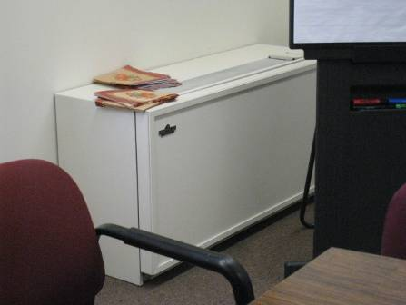

Example of deactivated univent in GSA

Picture 2

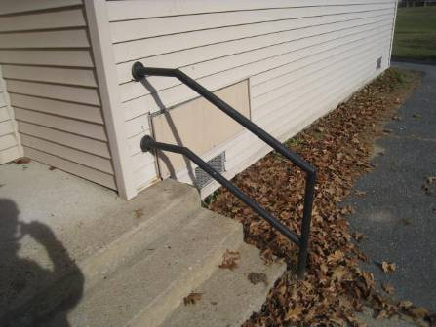

Sealed univent fresh air intake (arrow)

Picture 3

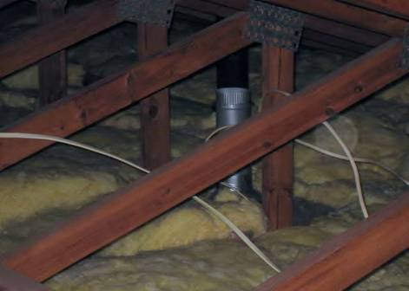

Restroom exhaust vent terminating in attic space

Picture 4

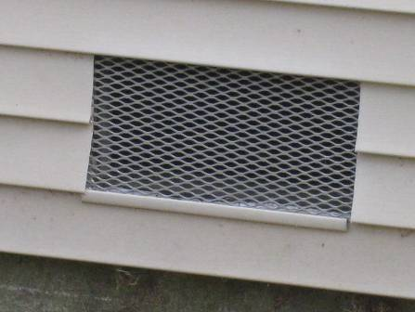

Crawlspace vent

Picture 5

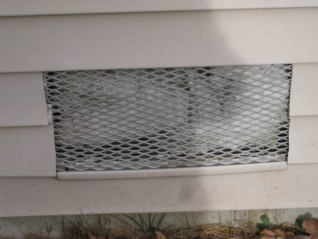

Crawlspace vent obstructed with insulation

Picture 6
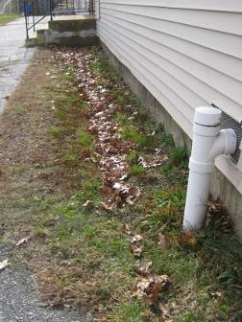

Crawlspace vent with utility pipe (note: grass and leaves against the foundation)

Picture 7

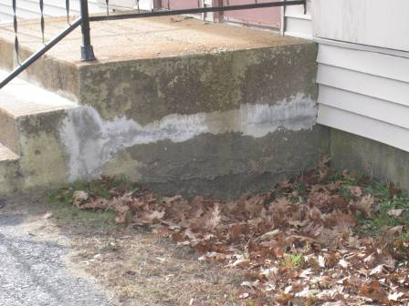

Cracks and erosion of concrete stairs (note: grass, accumulation of leaves, and debris along the foundation)

Picture 8

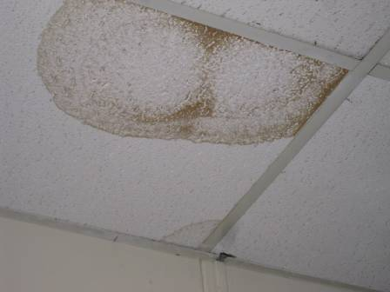

Water-damaged ceiling tiles
Picture 9

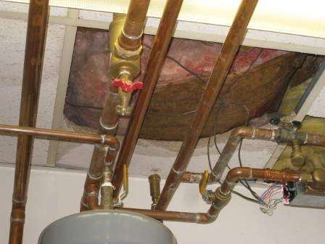

Water-damaged ceiling tile and insulation in the mechanical room

Picture 10

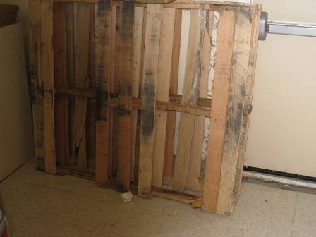

Water-damaged pallet

Picture 11

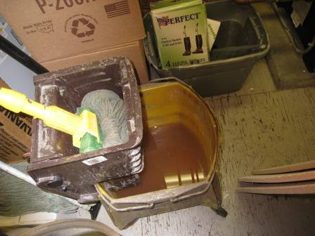

Stagnant water in mop pail

Picture 12

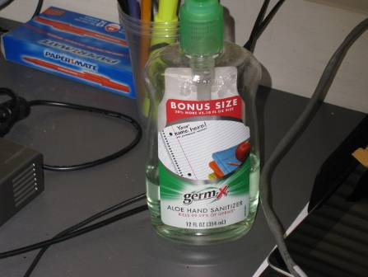

Hand-sanitizer

Picture 13

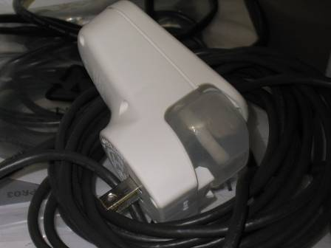

Plug-in air deodorizer found unplugged in IT office

Picture 14

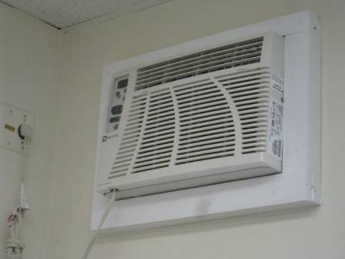

Wall-mounted air-conditioner

Picture 15

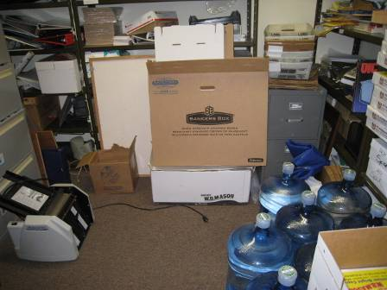

Boxes and clutter on floor

Picture 16

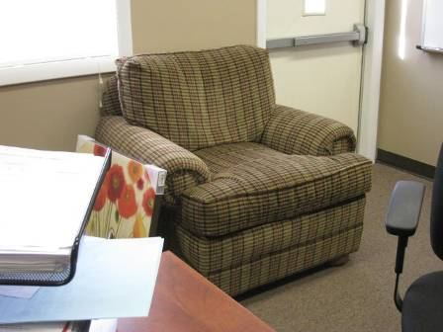

Upholstered chair in office
Location | Carbon  Dioxide  (ppm) | Carbon Monoxide  (ppm) | Temp  (°F) | Relative  Humidity  (%) | PM2.5  (µg/m³) | Occupants  in Room | Windows  Openable | Ventilation |  | Remarks
 |  |  |  |  |  |  |  | Supply | Exhaust | Remarks
Background | 380 | ND | 60 | 13 | 8 |  |  |  |  | Partly sunny
Assistant Superintendent 1 | 737 | ND | 74 | 23 | 6 | 1 | N | N | N | DO, PC, plant, upholstered chair
Assistant Superintendent 2 | 747 | ND | 74 | 23 | 5 | 0 | Y | N | N | DO
Business office 1 | 814 | ND | 73 | 25 | 6 | 1 | N | N | N | PC, boxes on floor, clutter
Business office 2 | 749 | ND | 73 | 25 | 5 | 0 | N | N | N | DO, PC, fax/scanner
Business office 3 | 781 | ND | 73 | 24 | 5 | 0 | Y | N | N | DO, WD-CT, AC
Business office 4 | 751 | ND | 73 | 25 | 6 | 0 | Y | N | N | WD-CT, PF, AC
Conference room | 742 | ND | 76 | 21 | 6 | 4 | Y | N | N | DO, AC, DEM
IT room | 665 | ND | 74 | 22 | 5 | 1 | Y | N | N | AC, boxes on floor, clutter, PF, plug-in AD
Lunch room | 789 | ND | 75 | 23 | 5 | 3 | N | N | N | Refrigerator, microwave, hand sanitizer
Mechanical room | 676 | ND | 76 | 22 | 5 | 0 | Y | N | N | WD-CTs, MT with exposed insulation, boxes on floor, clutter, janitorial mop pail with water
Restroom (men’s) | 520 | ND | 76 | 33 | 6 |  | N | N | Y | Exhaust activated by light switch
Restroom (women’s) | 593 | ND | 74 | 30 | 6 |  | N | N | Y | Exhaust activated by light switch
Special education 1 | 824 | ND | 73 | 26 | 4 | 0 | N | N | N | PC, plants
Special education 2 | 791 | ND | 73 | 25 | 5 | 0 | Y | N | N | DO, AC, clutter
Special education 3 | 790 | ND | 73 | 24 | 5 | 1 | Y | N | N | DO, AC, PF
Special education 4 | 823 | ND | 73 | 24 | 5 | 0 | Y | N | N | AC
Superintendent 1 | 776 | ND | 75 | 22 | 5 | 0 | N | N | N | DO
Superintendent 2 | 706 | ND | 76 | 21 | 6 | 0 | Y | N | N | DO, AC, hand sanitizer

