Case Study 14: GEM Car Fleets on College Campuses
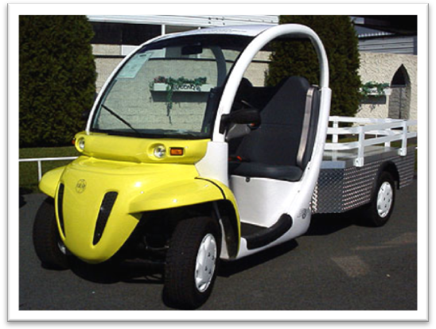
Across Massachusetts, state colleges and universities are using electric vehicles for campus travel and maintenance. Cape Cod Community College, Fitchburg State College and Mount Wachusett Community College have all purchased vehicles that run entirely on electricity. These “Neighborhood Electric Vehicles,” or NEVs, provide more than enough versatility for campus-wide activities.
GEMs, or Global Electric Motorcars, have zero tailpipe emissions and are nearly silent in operation. Reaching top speeds of 25 miles-per-hour, the vehicles can usually travel between 30 to 40 miles before needing to be recharged. Smaller models take between eight to ten hours to charge, while larger models require ten to fourteen. All the vehicles are equipped with an in-board charger that plugs into a standard 110-volt outlet. Base models range in price between $6,800-$12,500 depending on size and desired luxury.
Cape Cod Community College, Fitchburg State College and Mount Wachusett Community College are using “Neighborhood Electric Vehicles”
Cape Cod Community College was the first state school to experiment with the vehicles back in 1996. Since then, they have stopped using regular compact pick-up trucks in favor of the more environmentally friendly electric trucks. The school estimates that they have reduced emissions by over thirty tons of carbon dioxide per year.
In 2007, Fitchburg State College purchased twelve GEM vehicles for campus travel. With an electricity cost of $0.13/kWh and an average projected mileage of 40 miles per day, the college anticipates spending only $2,999 per year to charge its fleet. The cost of running the vehicles is significantly less than running traditional pick-up trucks. With gasoline above three dollars per gallon and the trucks running on an average of twelve miles per gallon, fuel costs would run well above $40,000 for the same travel distance. These vehicles result in significant savings on a yearly basis.

