
“…the mouth reflects general health and well-being.”1
“…the mouth reflects general health and well-being.”

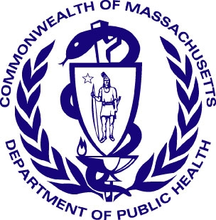
Oral Health in Massachusetts: A Fact Sheet
What is the public health issue?
Oral health affects people physically, mentally, and socially by influencing how they grow, enjoy life, look, speak, chew, taste food, and feel about themselves. Many diseases, conditions, and medical treatments show symptoms and side effects in the mouth. Dental professionals may be the first to find them and recommend a medical check-up from your doctor. For your general health, it is important to have a complete dental exam from a dentist at least two times every year. Dental cleanings from a Registered Dental Hygienist might also be needed two times every year.

How does oral health affect general health?
Poor oral hygiene can affect the health of the body, causing bacterial infections like tooth decay and periodontal (gum) disease. Oral diseases share common risk factors with the four serious diseases – cardiovascular (heart) diseases, cancer, respiratory diseases (pneumonia), and diabetes. Some of these risk factors include overweight/obesity, tobacco use, and harmful alcohol use.
- Periodontal disease may be as a risk factor for other diseases that cause inflammation (swelling) in the body such as heart disease and rheumatoid arthritis.
- Periodontal disease can influence diabetes control, and vice versa.
- People who have long-term respiratory diseases and use inhalers have a higher risk for oral fungal infections, dry mouth, and tooth decay.
- Many medicines from the pharmacy have the side effect of dry mouth because they decrease the amount of saliva (spit) the body makes and delivers to the mouth. Too little saliva increases the risk for both tooth decay and periodontal disease, affects eating, and can be very uncomfortable.
Programs at the Massachusetts Department of Public Health
- The Diabetes Prevention and Control Program (DPCP)
- The Massachusetts Heart Disease and Stroke Prevention and Control Program (HSPC)
- The Massachusetts Tobacco Control Program (MTCP)

How is Massachusetts doing?
A National Health Interview Survey showed that in the Northeast:
- 8% of Massachusetts adults are suffering from diabetes, which is 0.6% lower than the U.S. Median.
- 10% of Massachusetts adults have suffered from a myocardial infarction, angina, or stroke.
- 26% of adults suffer from hypertension (high blood pressure).
- 36% of Massachusetts smokers didn’t visit a dentist in the last year, which is 15% higher than for non-smokers.
- While the incidence or oral/pharyngeal cancer and its mortality rates have fallen significantly in Massachusetts from 1995 to 2005, the percentage of tobacco use in adolescents has increased.

For more information, contact:
Office of Oral Health
Massachusetts Department of Public Health
250 Washington Street
Boston, MA 02108-4619
Oral.Health@state.ma.us

