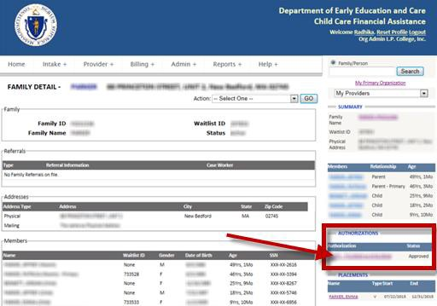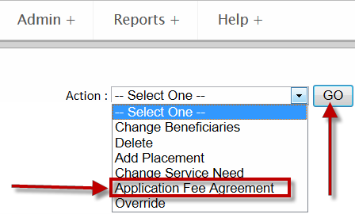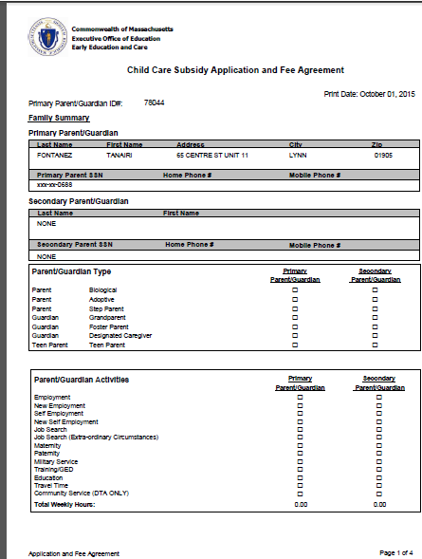CCFA HOW TO: GENERATE AN APPLICATION AND FEE AGREEMENT

Please follow the steps listed below to generate the Application and Fee Agreement

- Click on the Authorization on the right summary section

[SCREEN SHOT OF CCFA FAMILY DETAIL SCREEN WITH THE AUTHORIZATION SECTION HIGHLIGHTED.]

- Navigate to the Action dropdown on the Authorization details page

- Select Application and Fee Agreement from the dropdown menu

[SCREEN SHOT OF A DROP DOWN MENU SHOWING "APPLICATION FEE AGREEMENT" SELECTED.]

- A message will be displayed asking if you want to Open or Save the report or Cancel the Action.

[SCREEN SHOT OF THE POP UP WINDOW.]

- The system open the report as a PDF document.

[SCREEN SHOT OF THE APPLICATION AND FEE AGREEMENT REPORT..]

