Geographic Access to Community-based Opioid Treatment Programs in Massachusetts

prepared by:

Thomas J. Stopka, Olivia Lewis, Jack Cordes, Ric Bayly, Sumeeta Srinivasan,
Max O’Reilly, and Shikhar Shrestha

the department of public health and community medicine
tufts university school of medicine
in collaboration with the
Massachusetts Department of Public Health

May 23, 2024



Recommended citation: Stopka TJ, Lewis O, Cordes J, Bayly R, Srinivasan S, O’Reilly M, Shrestha S. Geographic Access to Community-Based Opioid Treatment Programs in Massachusetts. May 23, 2024. Department of Public Health and Community Medicine. Tufts University School of Medicine.

For questions about this report, contact:
Thomas J. Stopka, PhD, MHS
Professor
Department of Public Health and Community Medicine
Tufts University School of Medicine
Thomas.stopka@tufts.edu
617-636-2110

acknowledgments:
The Tufts team would like to thank the following individuals for their contributions to this community-based OTP access assessment:
Nicole Schmitt
Alex Walley
Sarah Ruiz
Jen Babich
Mike Gurney
Hermik Babakhanlou-Chase

Sensitivity Notice
This report includes maps, figures, and text that focus on fatal opioid-related overdoses across Massachusetts. The maps and figures we present represent lives lost to the tragic, ongoing opioid overdose crisis. The color-coded symbols on our maps represent relatives, friends, coworkers, peers, and local community members who experienced a fatal overdose. These symbols are “geo-masked” or placed at a random distance and location from the actual location on the map to respect the confidentiality of local family members and neighbors. We hope that these maps and our geospatial and statistical analyses can help to inform public health and clinical policy that will ultimately help bend the curve of the opioid overdose epidemic.

Table of Contents
Glossary of terms 5
Executive Summary 6
Background 10
Methods 12
Results 15
Discussion 33
Conclusion 36
References 37
Appendices 41

FIGURES AND TABLES Page
Table 1. Core Opioid Treatment Program Measures and Data Sources 12
Figure 1. Steps in the Analytical Process, Massachusetts, 2020-2022 13
Table 2. Percentage of the Population Living within a Community-Based Opioid Treatment Program (OTP) Walk- or Drive-Service Area, OTP Counts and Access Rates, and Decedent Counts and Rates, Massachusetts Counties, 2020-2022 15
Table 3. Percentage of the Non-Hispanic Black and Hispanic Populations within a Community-Based Opioid Treatment Program (OTP) Walk or Drive Service Area 16
Figure 2. Community-Based Opioid Treatment Program by Issue Year in Massachusetts through 2023 17
Figure 3. Community-Based Opioid Treatment Program Locations by Site Type in Massachusetts through 2023 18
Figure 4. Walking and Driving Times Towards Community-Based Opioid Treatment Program Locations in Massachusetts, as of 2023 19
Figure 5. Community-Based Opioid Treatment Program Access in Massachusetts Based on Drive-time Service Areas, 2023 20
Figure 6. Percentage of Opioid-Involved Decedent Overdose Decedent Residences within Driving and Walking Distance of a Community-Based Opioid Treatment Program, 2023 21
Figure 7. Community-Based Opioid Treatment Program Access: Chester, Middlefield, Worthington 22
Figure 8. Community-Based Opioid Treatment Program Access: Falmouth, Martha’s Vineyard, and Nantucket 23
Figure 9. Community-Based Opioid Treatment Program Access: Monson, Brimfield, Palmer, and Wilbraham 24
Figure 10. Community-Based Opioid Treatment Program Access: Winchendon and Gardner 25
Figure 11. Community-Based Opioid Treatment Program Access: Hardwick, Ware, and Oakham 26
Figure 12. Community-Based Opioid Treatment Program Access: Concord, Clinton, and Marlborough 27
Figure 13. Community-Based Opioid Treatment Program Access: Norwood and Walpole 28
Figure 14. Community-Based Opioid Treatment Program Access: Pembroke, Marshfield, and Scituate 29
Figure 15. Community-Based Opioid Treatment Program Access: Uxbridge, Millville, and Blackstone 30
Figure 16. Community-Based Opioid Treatment Program Access: Wilmington, Billerica, Tewksbury 31

Glossary of terms
DEA: Drug Enforcement Agency
FDA: Federal Drug Administration
FOD: Fatal overdose
FQHC: Federally Qualified Health Centers
GIS: Geographic Information Systems
GTFS: General transit feed specification
ICD-10 CM: International Classification of Disease, 10th Revision, Clinical Modification
MOUD: Medication for opioid use disorder
NFOD: Nonfatal overdose
OD: Overdose
OTP: Community-based opioid treatment programs (provide methadone treatment)
OUD: Opioid use disorder
PWUO: People who use opioids
SAMHSA: Substance Abuse and Mental Health Services Administration
SUD: Substance use disorder

Executive Summary
The current opioid overdose crisis has presented one of the most significant challenges to public health in the United States in decades. Over the past 25 years, the United States has experienced a rapid rise in opioid-involved overdose deaths growing ten-fold from 8,050 in 1999 to an estimated 83,907 in 2022. Similar patterns have been reported in Massachusetts where there were 2,357 opioid-related fatal overdoses in 2022, and the highest fatal overdose rate to date, with 33.6 deaths per 100,000 population. Since 2016, there have been more than 2,000 overdoses per year with more than 90% of overdose deaths attributed to synthetic opioids (e.g., fentanyl and its analogs).
Although the opioid overdose epidemic is a public health issue of national concern, medications for opioid use disorder (MOUD) are highly successful at treating opioid use disorder (OUD). MOUD treatment can be accessed through prescribed buprenorphine and naltrexone outside of an opioid treatment program (OTP), though methadone treatment can only be accessed through an OTP. According to the Substance Abuse and Mental Health Services Administration (SAMHSA), an OTP is an “accredited treatment program with SAMHSA certification and DEA registration to administer and dispense opioid agonist medications that are approved by FDA to treat opioid addiction. Currently, these include methadone and buprenorphine products. Other pharmacotherapies, such as naltrexone, may be provided but are not subject to these regulations. OTPs must provide adequate medical, counseling, vocational, educational, and other assessment and treatment services either onsite or by referral to an outside agency or practitioner through a formal agreement.” Most patients must attend the programs on a daily basis and take their medication on-site. Federal and Massachusetts regulations allow for a significant number of patients to receive take-home methadone based on specific criteria, which include time in treatment and other requirements. In addition, a recent (February 2, 2024) final rule modification makes permanent pandemic-era flexibilities such as 28-day “take-home” methadone doses and the ability to prescribe MOUD via telehealth and enacts new measures to further reduce barriers to MOUD access (effective date: April 2, 2024.)
In Massachusetts, methadone treatment has been associated with a 59% decrease in fatal overdose among people who experienced a prior nonfatal overdose. However, access can be impeded by many barriers, most of which interact with each other and all of which can reflect and contribute to inequities. These barriers include restrictive aspects of federal and state regulations for methadone providers, reimbursement rates, requirements of methadone treatment patients, such as initial daily or near-daily attendance for observed medication administration and counseling attendance, cost to patients, insurance limitations, work and school conflicts, family and childcare responsibilities, provider availability, accessible appointment slots, transportation access, and stigma, including difficulty with securing OTP site locations due to “not in my backyard” attitudes. This study focuses on geographic access to methadone treatment through community-based OTPs, which is limited in many areas of the state. Geographic (spatial) access to OTPs has not been thoroughly assessed to date in Massachusetts. In this report, we do not include OTP-certified inpatient programs that provide methadone nor medication units that are located at residential institutions, although we note that coordinated transitions from inpatient to community-based OTPs (for example upon release from incarceration) can be critical in reducing risk of relapse for those in treatment.
Geographic Information Systems (GIS) and spatial epidemiology provide tools to assess the spatial distribution of public health resources, juxtaposed with salient public health outcomes of interest, facilitating exploration of access to services. A growing body of research has employed GIS, exploratory spatial data analyses, and spatial epidemiology to assess the geographic distribution of treatment locations that provide MOUD, as well as risk maps and geostatistical analyses to explore fatal opioid-related overdose burden across geographic regions.
In 2023 and 2024, our team, comprised of epidemiologists and public health researchers from the Department of Public Health and Community Medicine at the Tufts University School of Medicine, collaborated with staff from the Bureau of Substance Addiction Services at the Massachusetts Department of Public Health to assess geographic access to OTPs across Massachusetts. We employed GIS and exploratory spatial data analyses to assess the geographic distribution of OTPs, fatal opioid-related overdoses by race and ethnicity, and walk- and drive-time service areas surrounding OTPs. We ultimately aimed to identify locations with distant or limited spatial access to OTPs and high fatal opioid-related overdose burden. To identify these areas, we mapped walk- and drive-time catchment areas surrounding OTPs, and overlaid places of residence (approximated for privacy) of people who were victims of fatal opioid-related overdoses between the years 2020 to 2022.
We defined geographically limited access to OTPs as being within the service or catchment area of a 15- to 30-minute drive of an OTP. We defined geographically distant access as beyond a 30-minute drive (one-hour round trip). Both geographically distant and limited access can translate into a substantial burden for OTP patients, considering factors such as employment hours, health care responsibilities, and transportation costs, especially when required on a daily or nearly daily basis. For those whose OTP access is limited to walking, we defined distant geographic access as more than a 30-minute walk (one-hour round trip) and limited geographic access as between a 30-minute and 15-minute one-way walk.
Through our risk mapping and spatial analyses, we found that 98% of opioid-related overdose decedents had resided within a 30-minute drive of an OTP and 80% had resided within a 15-minute drive at the time of their death. Geographic access declined when considering walk times, as only 32% of decedents were residents within a 30-minute walk and 9% were residents within a 15-minute walk. Based on our service or catchment area definition of being within a 30-minute drive time to the nearest OTP, we identified areas as distant from OTPs in western Massachusetts, from New Hampshire to Connecticut, east of the Berkshires and west of the Connecticut River; Winchendon, above Gardner and next to the New Hampshire border; west of Worcester, near the Quabbin Reservoir; between Springfield and Sturbridge, from the Massachusetts Turnpike (Interstate 90) to the Connecticut border; and Falmouth on Cape Cod, along with the Islands of Martha’s Vineyard and Nantucket. All areas that we identified as having the lowest geographic access to OTPs were located in less populous and rural areas of Massachusetts. We also identified areas with significant numbers of opioid overdose fatalities that were located at the edges of 30-minute drive time boundaries, requiring long drives to OTPs. Many of these areas fall within regions of the state that have been hard hit by the opioid overdose epidemic, including the Merrimack Valley in northeastern Massachusetts, as well as southeastern and north-central Massachusetts. These areas were often suburban.

While we found that most Massachusetts residents, as well as those who died of an opioid-related overdose, resided within a 30-minute drive from an OTP, geographic access dramatically decreased when considering walking time to an OTP. This discrepancy underscores the disparity in automobile access to OTPs.

Further research on OTP access is needed and should focus specifically on equity in access to MOUD employing additional definitions and metrics, including OTP patient census numbers and treatment slots, patient waitlists, and public transit OTP service areas. In addition, a review of methadone inductions within medical settings, such as emergency departments, carceral facilities, and 24-hour diversionary programs is merited. Calculations of rates and ratios that take into consideration treatment levels and fatal overdose burden are needed. Our team can, for instance, calculate ratios that include methadone-treated persons per overdose decedents. These ratios can be incorporated into our maps. In addition, future analyses should focus on additional person-level and community-level measures, including gender, income, veteran status, and race and ethnicity, which are tied to inequitable OUD rates and overdose burden. While these characteristics are spatially patterned to a certain extent and are associated with inequities in terms of access to transportation to OTPs, research that is explicitly focused on measuring these disparities is warranted. Additionally, further population-based analysis is needed to understand gaps in OTP access in urban areas that result from other barriers. In future analyses, our Tufts team, in collaboration with BSAS, plans to incorporate measures of OTP capacity as it relates to waitlists and wait times in the context of each OTP’s service area. These geospatial mapping approaches can be applied to other substance use care services, including access to buprenorphine and naltrexone treatment, harm reduction services, and recovery support services. This work will provide a nuanced understanding of regions of the state that may appear well-served from a geographic perspective when, in reality, the OTP service supply is not currently meeting MOUD treatment demand in hard-hit communities.

Background
Over the past 25 years, the United States (US) has experienced a rapid rise in opioid-involved overdose deaths growing ten-fold from 8,050 in 1999 to an estimated 83,907 in 2022.¹ While opioid-involved overdose deaths in the US were holding steady from 2017 through 2019 at about 48,000 per year, the COVID-19 pandemic exacerbated this burden, leading to steep rises in 2020 and 2021.¹ In 2021, the Kaiser Family Foundation analyzed Centers for Disease Control and Prevention Data that indicated that age-adjusted opioid overdose mortality rates were highest in West Virginia at 77.2 per 100,000 people.² Other high-burden states were Delaware, Kentucky, and Tennessee. The proportion of drug overdose deaths involving synthetic opioids (e.g., fentanyl and its analogs) in the US has been steadily increasing, and by 2021, accounted for over 75% of deaths in the Northeastern US and over 50% in most other states.³
In Massachusetts, it was estimated that opioid use disorder (OUD) affected approximately 4.6% of the population in 2015.^{4,5} In 2022, the age-adjusted fatal opioid overdose rate in the state, 32.5 per 100,000 population, was higher than the national average and ranked 17th out of the 50 states and Washington D.C.² Fatal opioid-related overdose trends in Massachusetts have paralleled those of the US with 2,357 opioid-related fatal overdoses in 2022, and the highest fatal overdose rate to date, at 33.6 per 100,000.⁶ Since 2016, there have been more than 2,000 overdoses per year with more than 90% of overdose deaths attributed to fentanyl.⁶ Between 2016 and 2021, clusters of fatal opioid-related overdoses were identified in Worcester, Greater Springfield, and Western Massachusetts, and along the Massachusetts Turnpike corridor and southeastern Massachusetts.⁷ Massachusetts ZIP Codes identified as persistent fatal opioid overdose hotspot clusters were more likely to have a higher proportion of Black and Hispanic residents and individuals living in poverty.⁸
Federal Drug Administration (FDA) approved medications for opioid use disorder (MOUD, i.e., methadone, buprenorphine, naltrexone) may be administered at opioid treatment programs (OTPs), which are accredited by the Substance Abuse and Mental Health Services Administration (SAMHSA) and registered with the Drug Enforcement Agency (DEA), with facilities in Massachusetts licensed by the Bureau of Substance Addiction Services.^{9,10} Methadone is only available to patients via OTPs. According to SAMHSA, OTPs “must provide medical, counseling, vocational, educational, and other assessment and treatment services either onsite or by referral to an outside agency or practitioner through a formal agreement.”¹⁰ MOUD has been shown to be highly successful at treating OUD, reducing the risk of opioid overdose death by nearly 5-fold for methadone and 3-fold for buprenorphine, compared to no treatment.¹¹ It is estimated that only 28 percent of people who need OUD treatment in the US received any form of MOUD (methadone, buprenorphine, naltrexone)¹² In Massachusetts, methadone and buprenorphine treatment after a nonfatal opioid overdose have been demonstrated to be associated with 59% and 38% decreased risks of subsequent opioid-related mortality, respectively.¹³ Racial inequities in access to MOUD are well documented. In a survey conducted with adolescents and adults in the US during 2019, 31% of non-Hispanic White individuals living with OUD were receiving any MOUD, while only 20% of non-Hispanic Black individuals with OUD, and 15% of Hispanic individuals with OUD reported that they were receiving MOUD.¹² Several studies have shown that residential segregation predicted that areas with more residents identifying as Black or Hispanic had higher methadone capacity while areas with more residents identifying as White had higher buprenorphine capacity.¹⁴⁻¹⁶ Gender disparities in access to MOUD have also been documented. Marsh et al. found that women had longer wait times to enter methadone treatment, but higher treatment retention than men within programs in Los Angeles.¹⁷ Further, Mauro et al. found that MOUD treatment, in general, was lower among women after accounting for income, insurance, urbanicity, and prevalence of OUD.¹² An additional major risk factor for fatal opioid overdose is release from incarceration. It is critically important that individuals receive reentry planning and referrals to a sustainable community-based MOUD treatment leading up to and upon release from carceral settings to moderate their high risk for fatal opioid overdose at a time when they may have reduced opioid tolerance.¹⁸ To preserve access to MOUD during the COVID-19 pandemic, the Substance Abuse and Mental Health Services Administration (SAMHSA) and the Department of Health and Human Services (HHS) allowed for flexibilities such as take-home of more doses and telehealth prescribing for MOUDs.¹⁹ Thirty-five states applied both of these flexibilities, eight states applied only the flexibility for more take-home doses, and one state applied only the flexibility for telehealth buprenorphine initiation.²⁰ On February 2nd, 2024, SAMHSA and HHS revised the Code of Federal Regulations (42 CFR Part 8 Final Rule) making the pandemic era flexibilities permanent, citing the evidence that these flexibilities had improved access and care.^{21,22} Additional rule changes further removed barriers to methadone treatment. Among these, providers are allowed to use their judgment to initiate take-home methadone doses immediately upon a patient’s entry into treatment.
Access to MOUD services can be impeded by many barriers, most of which interact with each other and all of which can reflect and contribute to inequities. These barriers include cost, insurance, stigma, work conflicts, provider availability, accessible appointment slots, and transportation access.²³⁻²⁷ Impediments to methadone treatment access can be particularly acute because of the small number of OTPs, stigma, the daily requirement to attend OTPs to receive medication, and transportation difficulties. Multiple prior studies have found geographical disparities in OTP access, with less access in rural settings, small towns, and micropolitan areas compared to metropolitan areas.²⁸⁻³² Recent studies in Georgia and Ohio found that expansion of methadone treatment access through provision at Federally Qualified Health Centers (FQHC) would greatly increase overall access.^{33,34} In Georgia, for instance, counties with the highest opioid overdose death rates would greatly benefit from OTPs at FQHCs.³³ Methadone treatment access through pharmacies would benefit individuals in rural and all other types of areas in Massachusetts. While the pharmacy co-location of satellite medication units supervised by OTPs has been allowed by federal regulations, only a few states (not including Massachusetts) have supported such units to date.³⁴ However, in Canada, Australia, and the United Kingdom, physicians, not affiliated with an OTP, can directly prescribe methadone for observed consumption at a pharmacy.³⁴ Since, according to the National Association of Chain Drug Stores, 89% of the U.S. population lives within five miles of a pharmacy, regulatory approval of a physician/pharmacy mode of dispensation, independent of OTPs, could greatly increase geographic access.³⁵
Prior published OTP service area and accessibility studies have only analyzed driving access,^{28-32,36,37} despite the importance of bus and walking access for many OTP clients. ^{38,39} This can be particularly true of individuals who have been recently released from incarceration, many of whom will have lost vehicle ownership prior to reentering local communities.⁴⁰ We know of no prior studies that have analyzed spatial access to methadone treatment in Massachusetts. Because methadone remains the preferred medication for many patients, especially since the advent of fentanyl in the drug supply, it is critical to spatially analyze its accessibility and identify areas far from OTPs.
The overarching goal of the current study was to assess the geographic distribution of and spatial access to community-based OTPs across Massachusetts. In this report, we present descriptive maps and spatial analyses that depict geographic access to OTPs, denoting walk- and drive-time access juxtaposed with opioid-related fatal overdose data, at the address level, and by the race and ethnicity of decedents. This report can help to inform state and local public health and clinical policy decisions related to targeted responses to enhance OTP and other MOUD access.

Methods
Collaborative Efforts. Our collaborative team of researchers and public health experts from the Tufts University School of Medicine, BSAS, and the Massachusetts Department of Public Health (MDPH) met regularly during November and December of 2023 via video conference calls to discuss project goals, analytical methods, results, interpretations, and policy implications.
Community-Based Opioid Treatment Program (OTP) Data. We obtained address-level data for the location of community-based OTPs in Massachusetts from BSAS. This included both brick-and-mortar facilities and mobile OTP treatment service locations.
Opioid Overdose Data. We analyzed opioid overdose mortality data from the Massachusetts Registry of Vital Records and Statistics (RVRS) for the years 2020, 2021, and 2022. These data encompassed incidents classified as opioid-related overdoses as the underlying cause of death, designated by International Classification of Disease (ICD)-10 codes X40-X44, X60-X64, X85, Y10-Y14, involving opioids alone or in combination with other drugs (ICD-10 codes T.40.0-T40.4, or T40.6). We focused on people who were residents of Massachusetts at the time of their fatal overdose. As a result, the total numbers of fatal overdoses included in our maps may be smaller than those represented in other MDPH reports. We also report MDPH-specific fatal overdose numbers and rates that were included in recent MDPH reports.
Geocoding. Geocoding is the process of obtaining X (longitude) and Y (latitude) coordinates for addresses of interest prior to developing maps and running spatial analyses. By geocoding address-level data, we are ultimately able to map geolocations like pushpins on a map. Our address identification methodology for fatal overdoses aligns with prior work.^{41,42} We used the MassGIS address locator, updated as of 2023, to geocode addresses for OTPs and fatal overdose decedent residence data, obtaining a 100% and 96% match rate, respectively. We excluded decedent residences, which the locator could not match to an existing address from our analyses. We used ArcGIS Pro v3.1.3 (ESRI, Redlands, CA) for basic geoprocessing tasks (geocoding and joining tables and boundary files).
Geomasking. Geomasking is the process of mapping and spatially analyzing data such that the precise location of sensitive activities is masked or slightly displaced from the original location on maps. For our current analyses, we geomasked the geocoded decedent residence data by employing a methodology adapted from Allshouse, Zandbergen, and Hampton et al.⁴³⁻⁴⁵ Coordinates of addresses were displaced or jittered in a random direction and by a random distance (between a minimum and maximum distance around the original point [picture 2 concentric circles that resemble a donut encircling a given point]) using a bivariate Gaussian distribution method (bivariate gaussian distribution is a distribution of two random variables (in this case the x and y coordinates) both of which are normally distributed), introducing a maximum jittered value of 175 meters (outer ring of the donut) and a minimum of 25 meters (inner ring of the donut). We determined the jittering distance range based on spatial proximity, ensuring compliance with spatial K-anonymity principles (defined as the number of individuals (k) with similar attributes in a spatial area of study so that a particular individual cannot be directly identified). We used the Python programming language (v3.10; https://www.python.org/) for data cleaning and jittering the location of the decedents’ residences.
Walk- and Drive-time Street Network Analyses. We conducted walk- and drive-time analyses to assess access to OTP programs in Massachusetts using the ArcGIS Pro v3.1.3 Service Area Analysis Layer method. Through these analyses, we aimed to assess accessibility and proximity to opioid treatment facilities during designated timeframes, considering both driving and walking durations. We conducted walk- and drive-time analyses to produce maps representing 15- and 30-minute travel distances to OTP services based on accessibility parameters from prior studies.^{29,33} These analyses rely on street network data that include all surface streets and major thoroughfares, as well as speed limits, and 2-way vs. 1-2-way roads across Massachusetts. We developed separate drive-time maps for OTPs and overlaid map layers that highlighted county boundaries and fatal overdoses by race and ethnicity, providing information to facilitate comparative opioid-related overdose mortality across all regions of the state.
Parameters for Walk- and Drive-time Analyses:
- Travel Direction: Toward facilities
- Street network data source: ArcGIS online street network
- Cutoff Time: 15 minutes, 30 minutes
- Time of the day: 8 a.m., on Thursdays; this time was selected as weekday morning travel times were considered to be what most OTP patients experience on a daily basis, and 8 a.m. travel times may be among the most challenging given rush hour travel delays.
Table 1. Core Opioid Treatment Program Measures and Data Sources.
Measure | Years | Source
Core
Opioid overdose death rate (per 100,000 population) | 2020-22 | Massachusetts Department of Public Health
Opioid overdose decedent data by residence address and race/ethnicity | 2020-22 | Registry of Vital Records and Statistics
Opioid treatment program (OTPs) addresses | 2023 | Bureau of Substance Addiction Services
American Community Survey (ACS) | 2017-2021 | US Census Bureau 5-Year Population Estimates

Descriptive mapping. We developed a series of thematic risk maps, within a GIS, to depict the spatial distribution of all OTPs by type, as well as fatal opioid-related overdoses by race and ethnicity, as well as place of residence.

Figure 1. Steps in the Analytical Process, Massachusetts, 2020-2022.

OTP Access. For our analysis, we classify OTP access based on drive-times to the location. We classify accessibility to OTPs into three categories:
1) High access areas: Areas that are within a 15-minute drive-time from the closest OTP.
2) Limited access areas: Areas that are between 16-minute and 30-minute drive-time from the closest OTP. Such areas fall outside of the high access area definition and are present in locations that appear to be underserved given roundtrip drive-times that remain relatively long while also having a high burden of fatal overdoses.
3) Geographically distant or Low access: Areas that are more than a 30-minute drive-time from the closest OTP. These areas have very limited access to OTPs and daily visits from these locations would require a significant time and resource commitment.
In addition, we also used walk-time analysis to examine access to OTPs. We created three categories for walk-times: less than 15 minutes, between 15-30 minutes, and more than 30-minute walk-times.
Descriptive Statistics. First, we calculated monthly trends in fatal opioid-related overdoses between 2020 and 2022, overall, and by race and ethnicity. Next, we calculated descriptive statistics for all counties in Massachusetts, focusing on OTP counts and access per 100,000 population, as well as the percentage of the overall population by county that lived within 15- and 30-minute drive-times of OTPs, and fatal overdose counts and rates per 100,000. We also calculated the overall percentage of the non-Hispanic Black and Hispanic population within 15- and 30-minute OTP walk-and-drive service areas to assess equity in OTP access. Descriptive statistics were run in ArcGIS Pro v3.1.1 (Esri, Redlands, CA) and MS Excel v2311 (Microsoft, Seattle, WA).
To calculate the percentages of decedent resident addresses within the walk- and drive-time service areas, we first overlaid the decedent data on the walk-and-drive service areas in ArcGIS Pro. We utilized the select by location tool to identify the addresses that were within or outside of the 15- and 30-minute walk- and drive-time service areas. Next, we created variables in the decedent data table representing the service area within which each address was located (less than 15 minutes, between 16-30 minutes, or further than 30 minutes). Finally, we imported the decedent table into MS Excel and created pie charts to summarize the percentages of decedent resident addresses in each service area.
Spatial Analysis. The drive-time and walk-time buffers were overlaid with census block groups with ACS tables for population by race and ethnicity using the intersect tool in ArcGIS Pro v3.1.1 (Esri, Redlands, CA). The results were summarized for the entire state of Massachusetts and its fourteen counties.

Results
We present initial fatal opioid-related overdose trends and descriptive statistics for all 14 Massachusetts counties in Tables 1 and 2. Across the state, there were 6,706 confirmed fatal opioid-involved overdose deaths between the years 2020 and 2022. The number of geocoded fatal opioid-involved overdoses increased steadily with 2,092 (30 per 100,000 people) in 2020, 2,283 (32.7 per 100,000 people) in 2021, and 2,331 (33.6 per 100,000 people) in 2022.⁴⁶ Over the study period, opioid-involved overdose deaths varied significantly among different racial and ethnic subpopulations. The rate of confirmed opioid-involved overdoses in the non-Hispanic White population remained fairly constant ranging from 33.8 per 100,000 in 2020, 36.5 per 100,000 in 2021, and 33.3 per 100,000 in 2022.⁴⁷ However, there were steep increases in the rates of confirmed fatal opioid-involved overdoses among non-Hispanic Black, Hispanic, and American Indian populations. Among non-Hispanic Black residents, the rates increased from 37.5 per 100,000 in 2020 to 51.7 per 100,000 in 2022. For the Hispanic population, the rates increased from 35.4 in 2020 to 45.5 per 100,000 in 2022. We observed the highest rates and highest rates of change among non-Hispanic American Indians – in 2020 the confirmed fatal opioid-involved overdose rate was 94.2 per 100,000, which increased to 143.6 per 100,000 in 2022.⁴⁷
There were 55 brick-and-mortar and three mobile OTP sites in Massachusetts (Table 2). Worcester County had the largest number of sites, followed by Bristol and Essex (Table 2). Franklin County had the highest rate of OTPs at 42 per million population followed by Berkshire County at 23 per million (Table 2). The three most densely populated counties, Suffolk, Middlesex, and Norfolk had OTP rates lower than 8 per million (Table 2), indicating that there was limited availability of OTP treatment slots per capita in the urban and more populous counties of Massachusetts. Hampden, Bristol, Berkshire, and Suffolk counties had the highest rate of opioid-related decedents per 100,000 population, whereas Middlesex and Nantucket counties had the lowest overdose decedent rate per 100,000 (Table 2). We observed a crude positive correlation (coefficient of correlation = 0.58) between OTP access rates and decedent rates at the county level in Massachusetts, demonstrating a higher number of OTPs per capita in areas with higher number of overdose decedents per capita.

Table 2. Percentage of the Population Living within a Community-Based Opioid Treatment Program (OTP) Walk- or Drive-Service Area, OTP Counts and Access Rates, and Decedent Counts and Rates, Massachusetts Counties, 2020-2022.

County | Walk-time (max.)  in minutes  (% of population) |  | Drive-time (max.) in minutes  (% of population) |  | OTP  count | OTP Rate  (OTPs per 1 million population) | Decedent count | Fatal Opioid Overdose Rate  (Decedents  per 100,000)
 | 15 | 30 | 15 | 30
Barnstable | 4 | 10 | 56 | 98 | 2 | 9 | 220 | 32.2
Berkshire | 10 | 19 | 88 | 100 | 3 | 23 | 153 | 39.5
Bristol | 30 | 64 | 95 | 100 | 8 | 14 | 725 | 42.0
Essex | 12 | 36 | 88 | 100 | 8 | 10 | 751 | 31.1
Franklin | 27 | 51 | 80 | 100 | 3 | 42 | 74 | 34.7
Hampden | 17 | 42 | 90 | 100 | 6 | 13 | 597 | 42.7
Hampshire | 5 | 17 | 59 | 95 | 1 | 6 | 109 | 22.5
Middlesex | 10 | 28 | 87 | 100 | 6 | 4 | 945 | 19.4
Norfolk | 5 | 16 | 67 | 100 | 2 | 3 | 441 | 20.4
Plymouth | 9 | 25 | 78 | 100 | 4 | 8 | 505 | 31.9
Suffolk | 22 | 78 | 98 | 100 | 6 | 8 | 836 | 35.2
Worcester | 14 | 30 | 80 | 99 | 9 | 11 | 819 | 31.9
Dukes | 0 | 0 | 0 | 0 | 0 | 0 | 15 | 24.7
Nantucket | 0 | 0 | 0 | 0 | 0 | 0 | 7 | 16.9
Massachusetts | 13* | 36* | 83* | 99* | 58** | 8* | 6,197*** | 29.5*
Notes:
*Mean of 14 counties.
**Total OTPs, including 55 brick-and-mortar sites and three mobile medication units
***Total decedent count for all 14 counties
Coverage: For 30-minute drive-times that indicate 100% coverage, care should be taken in interpreting the results, as the underlying data for population were from census block groups. Even if part of a census block group was within the buffer the overlay assumes that the entire population was within the buffer.
Data Sources: OTPs as of 2023, from the Massachusetts Bureau of Substance Addiction Services (BSAS); Fatal opioid-related overdoses are summed across the years 2020 – 2022, from Registry of Vital Records and Statistics; Population census data: American Community Survey, US Census Bureau, 2017 – 2021.

Initial descriptive statistics for marginalized communities across all 14 Massachusetts counties represented a different picture with regard to accessibility. Massachusetts counties had a mean count of four OTPs and eight OTPs per million population. The mean county-level number and rate of geocoded fatal overdoses in Massachusetts was 443 per county and 29.5 per 100,000 population, respectively. Eighty-three percent (83%) of the state population was within a 15-minute drive-time of an OTP. The island counties, Dukes (Martha’s Vineyard) and Nantucket, had no OTPs with access limited by the requirement of a boat or plane ride in addition to a drive on the mainland. Only 56% of Barnstable County and 59% of Hampshire County residents lived within a 15-minute drive of an OTP site. Walkable access was much lower than driving, with 64% of Massachusetts residents living more than a 30-minute walk from an OTP site (Table 1).
Table 3. Percentage of the Non-Hispanic Black and Hispanic Populations within a Community-Based Opioid Treatment Program (OTP) Walk or Drive Service Area.
 | Walk-time maximum |  |  |  | Drive-time maximum
 | 15 minutes |  | 30 minutes |  | 15 minutes |  | 30 minutes
County | Black | Hispanic | Black | Hispanic | Black | Hispanic | Black | Hispanic
Barnstable | 1 | 5 | 13 | 7 | 78 | 69 | 98 | 97
Berkshire | 7 | 10 | 26 | 15 | 97 | 91 | 100 | 100
Bristol | 53 | 69 | 100 | 100 | 95 | 98 | 100 | 100
Essex | 17 | 26 | 54 | 84 | 95 | 95 | 100 | 100
Franklin | 64 | 40 | 100 | 73 | 93 | 80 | 100 | 100
Hampden | 23 | 39 | 63 | 81 | 98 | 98 | 100 | 100
Hampshire | 6 | 9 | 11 | 22 | 46 | 56 | 96 | 94
Middlesex | 13 | 12 | 34 | 38 | 92 | 91 | 100 | 100
Norfolk | 4 | 6 | 11 | 19 | 75 | 68 | 100 | 100
Plymouth | 36 | 18 | 91 | 64 | 97 | 89 | 100 | 100
Suffolk | 14 | 25 | 69 | 74 | 98 | 99 | 100 | 100
Worcester | 24 | 30 | 52 | 57 | 94 | 91 | 100 | 100
Dukes | 0 | 0 | 0 | 0 | 0 | 0 | 0 | 0
Nantucket | 0 | 0 | 0 | 0 | 0 | 0 | 0 | 0
Massachusetts* | 18 | 27 | 56 | 68 | 93 | 93 | 99 | 100
Notes:
*Mean of 14 counties.
Coverage: For 30-minute drive-times that indicate 100% coverage, care should be taken in interpreting the results, as the underlying data for populations were from census block groups. Even if part of a census block group was within the buffer the overlay assumes that the entire population was within the buffer.
Data: OTPs as of 2023, from Bureau of Substance Addiction Services (BSAS); Opioid overdose fatality decedents are summed for the years 2020 – 2022, from the Registry of Vital Records and Statistics; Population census data: American Community Survey, US Census Bureau, 2017 – 2021.

Descriptive Mapping. The overall spatial distribution of OTPs in Massachusetts indicates that OTPs follow population density patterns across the state. Urban areas, and especially the Greater Boston Area and Springfield, have relatively large numbers of OTPs, while less populous areas of the state have smaller numbers of OTPs (Figure 3).
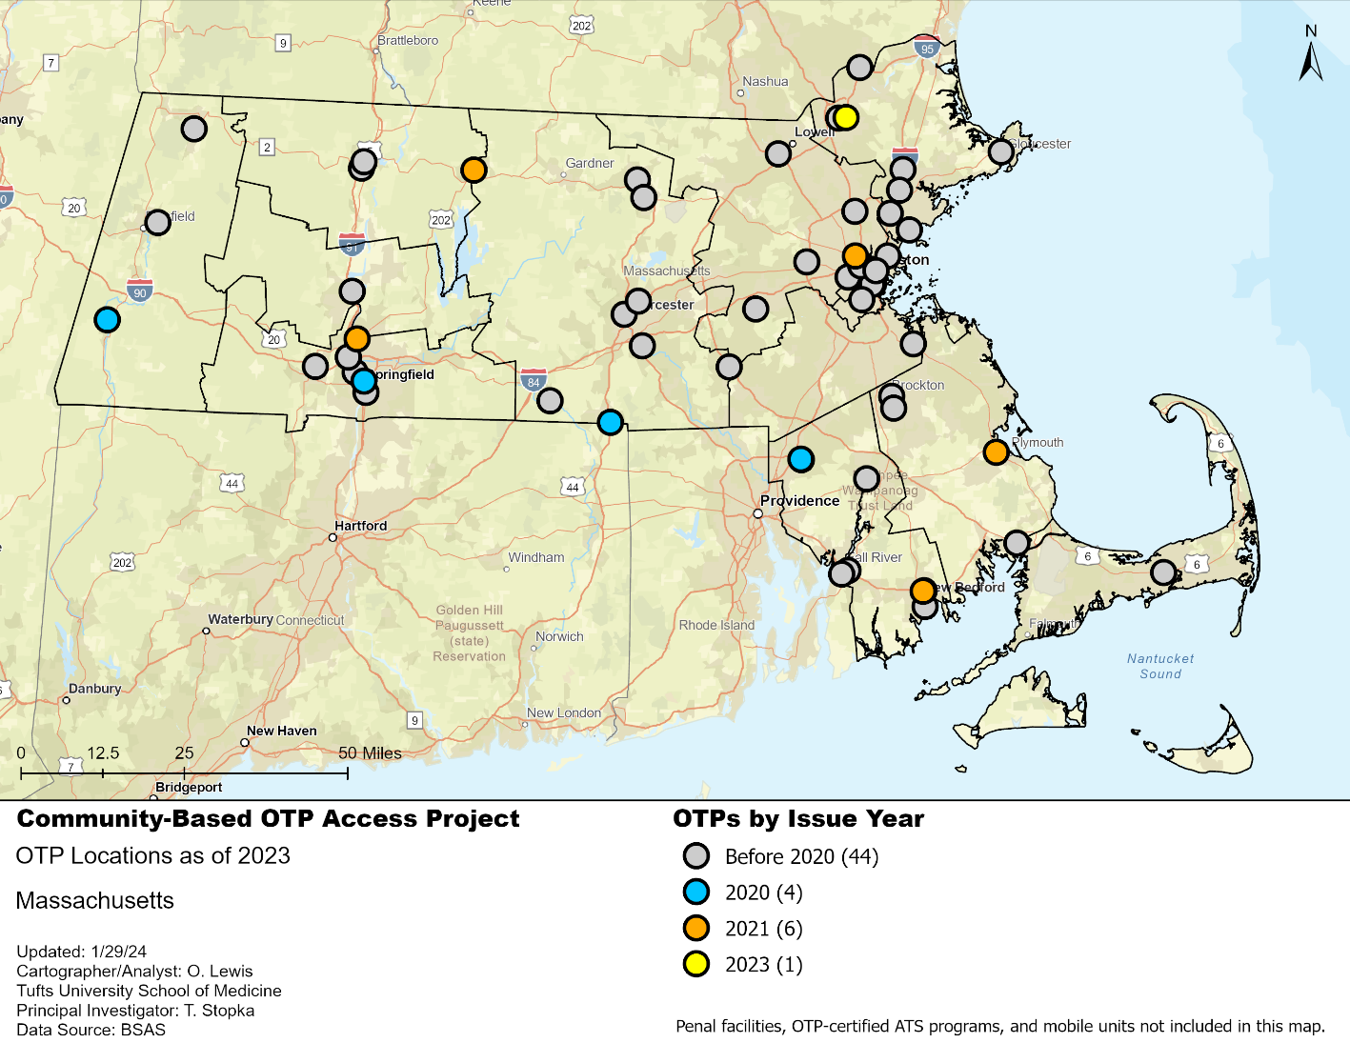
Figure 2. Community-Based Opioid Treatment Programs by Issue Year in Massachusetts through 2023.

The number of OTPs has grown over time, with the addition of several new programs between 2020 and 2023. While most OTPs in Massachusetts were implemented before 2020, four locations across the state (in Great Barrington, Springfield, Webster, and Attleboro) began taking admissions in 2020 (Figure 3). In 2021, six new locations opened, in Holyoke, Orange, Somerville, Plymouth, New Bedford, and Attleboro. In 2023, one new location opened in Lawrence (Figure 2). In addition to new brick-and-mortar OTPs, two mobile OTPs launched in Worcester and Wellfleet in 2023. Of note, some of these cities and towns already had existing OTPs.

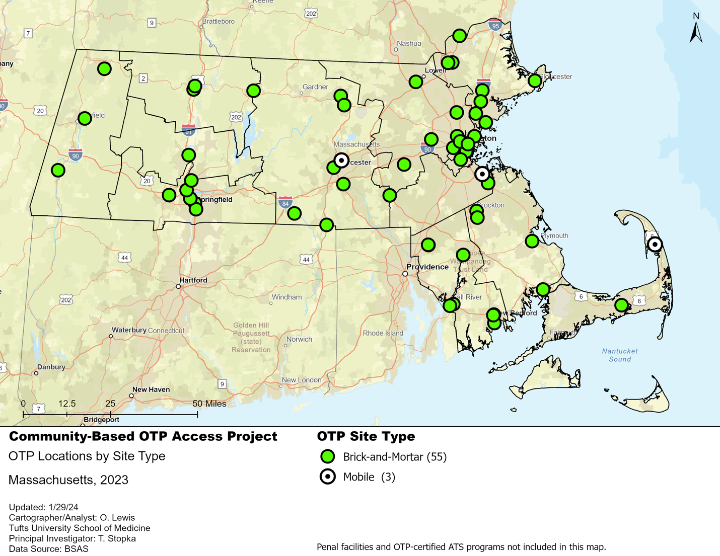
Figure 3. Community-Based Opioid Treatment Program Locations by Site Type in Massachusetts through 2023.

As of 2023, most (55) of the OTP locations in Massachusetts were brick-and-mortar sites, meaning that MOUD was dispensed to patients in a physical building. There are three RV- or van-based mobile OTP medication units in Worcester, Quincy, and Wellfleet, which travel to various locations to provide MOUD treatment (Figure 3).
Network Analysis. Through our network analyses, we calculated 15- and 30-minute drive-times to OTPs. Most regions of the state were within a 30-minute drive-time of a local OTP (Figure 4). However, parts of Central and Western Massachusetts, especially in rural communities adjacent to Berkshire and Worcester Counties, were not within 30-minute drive-times of OTPs.
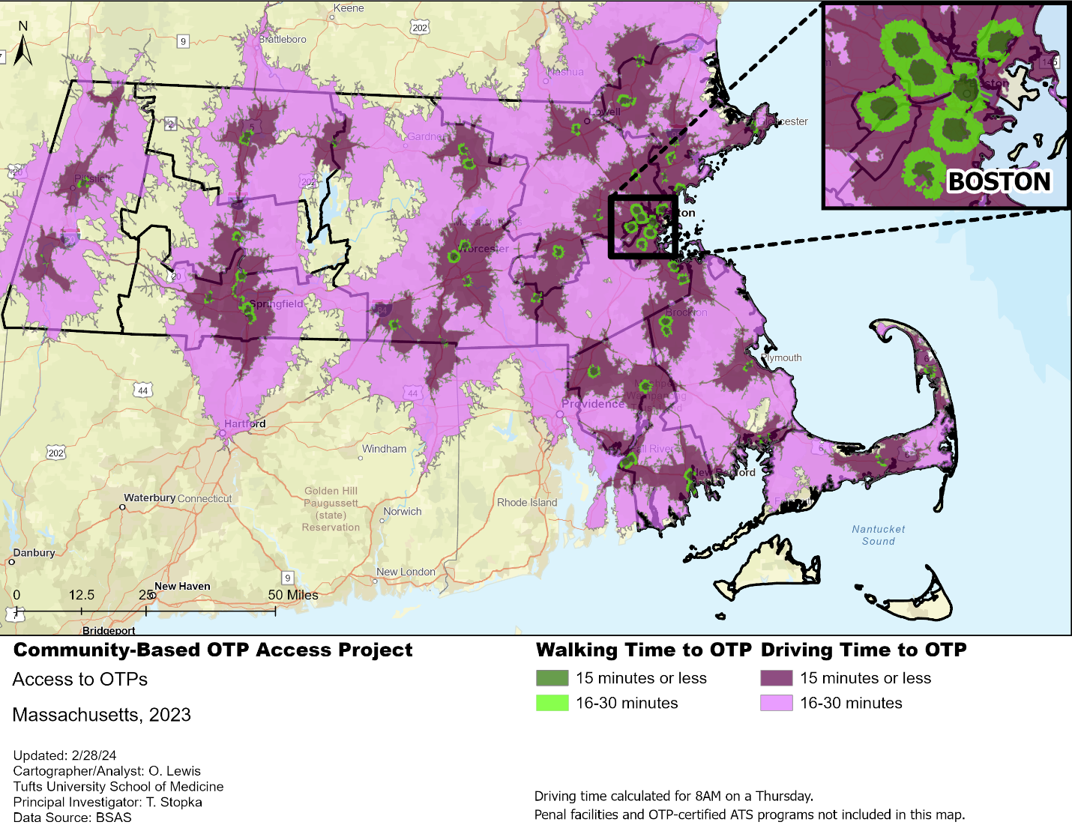
Figure 4. Walking and Driving Times Towards Community-Based Opioid Treatment Program Locations in Massachusetts, as of 2023.
When calculating walk- and drive-time service areas towards OTPs, it became clear that access to OTPs by walking has been very limited throughout the state (Figure 4). In addition, there were large areas outside of a 30-minute drive-time in western Massachusetts, east of Springfield along the southern state border, northeast of Orange along the northern border, in central Massachusetts around Ware, and on the islands of Nantucket and Martha’s Vineyard. Much of the state was within 15-30 minutes driving of an OTP, which would translate into at least a 30-minute to 1-hour daily round trip to and from an OTP by car to obtain treatment, assuming there were no traffic or weather-related delays. A zoom-in of the Boston area shows that much of the city is within at least 30 minutes of an OTP by walking.
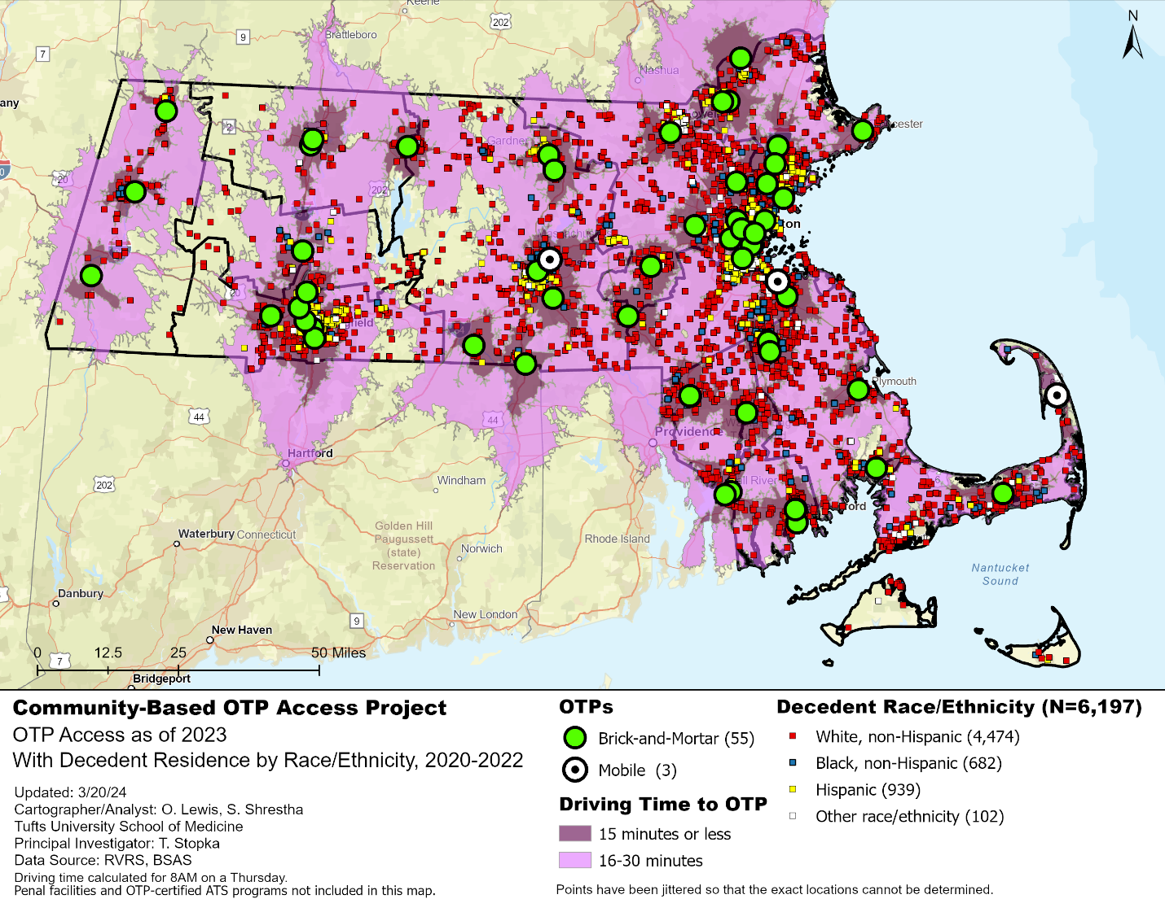
Figure 5. Community-Based Opioid Treatment Program Access in Massachusetts Based on Drive-time Service Areas, 2023.
OTP access in Massachusetts was determined by overlaying walk- and drive-times to OTPs with decedent residences symbolized by the decedent’s race/ethnicity (Figure 5). We were ultimately able to geocode 6,197 decedent residences for the 2020 to 2022 timeframe. The residences of decedents who were non-Hispanic White were a majority (4,474, 72.2%), followed by those of decedents who were Hispanic (939, 15.2%), non-Hispanic Black, (682, 11.0%), and of another race/ethnicity (102, 1.6%). While residences of decedents who were non-Hispanic White were located throughout the state, residences of decedents who were Hispanic were clustered around urban areas, such as Springfield, Worcester, Boston, and Lynn. Geographically distant areas, beige areas farther than 30 minutes driving from an OTP that had multiple decedent residences, existed around Chesterfield, Monson, Winchendon, Ware, Martha’s Vineyard, and Nantucket, as noted in the following maps.

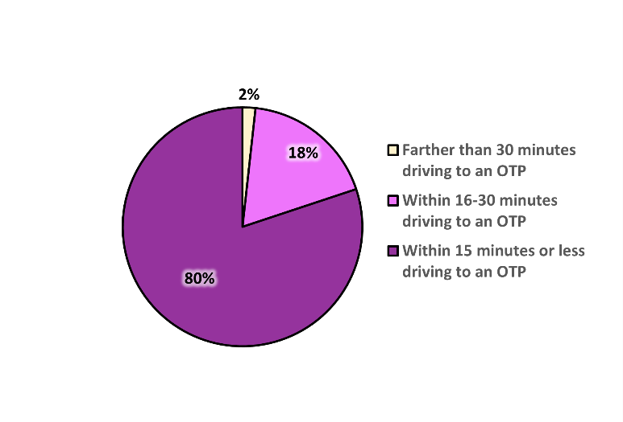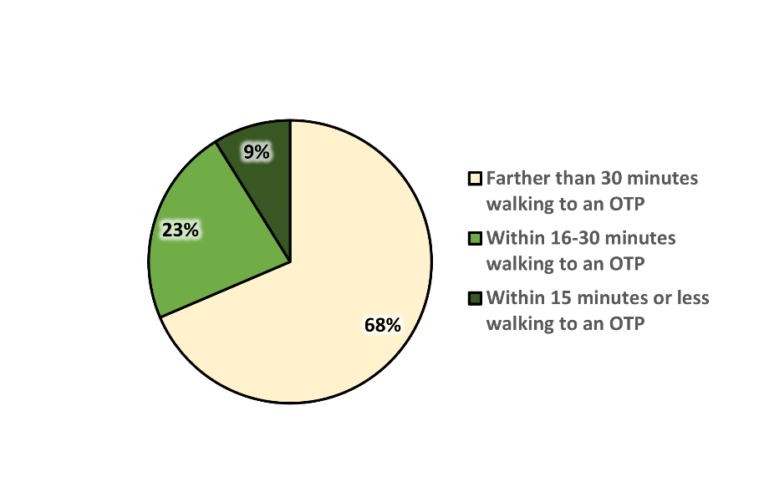
Figure 6. Percentage of Opioid-Involved Overdose Decedent Residences within Driving and Walking Distance of a Community-Based Opioid Treatment Program, 2023.
Most overdose decedent residences (80%) were located within 15 minutes driving from an OTP, while only 9% of residences were within a 15-minute walk-time to an OTP (Figure 6). Eighteen percent (18%) of decedent residences were within 16-30 minutes driving, and 23% of decedent residences were within 16-30 minutes walking from an OTP. While only 2% of decedent residences were located more than a 30-minute drive-time from an OTP, a majority (68%) of decedent residences were further than a 30-minute walk-time from an OTP, complicating access to treatment for those who did not have a car.
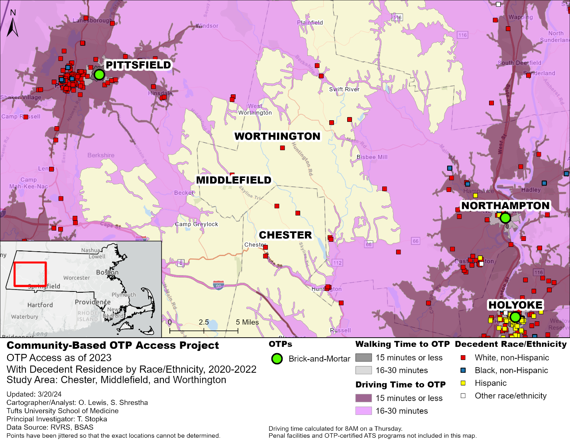
Figure 7. Community-Based Opioid Treatment Program Access: Chester, Middlefield, and Worthington, 2023.
Decedents in the western corridor of Massachusetts, east of the Berkshires and west of the Connecticut River, were located farther than a 30-minute drive-time from an OTP (Figure 7). Most of the decedents in this geographically distant area were non-Hispanic White. Anyone living with OUD in this area, and on the outskirts of the 16-30-minute drive-time service areas, would have a round-trip drive of at least one hour to access methadone treatment.

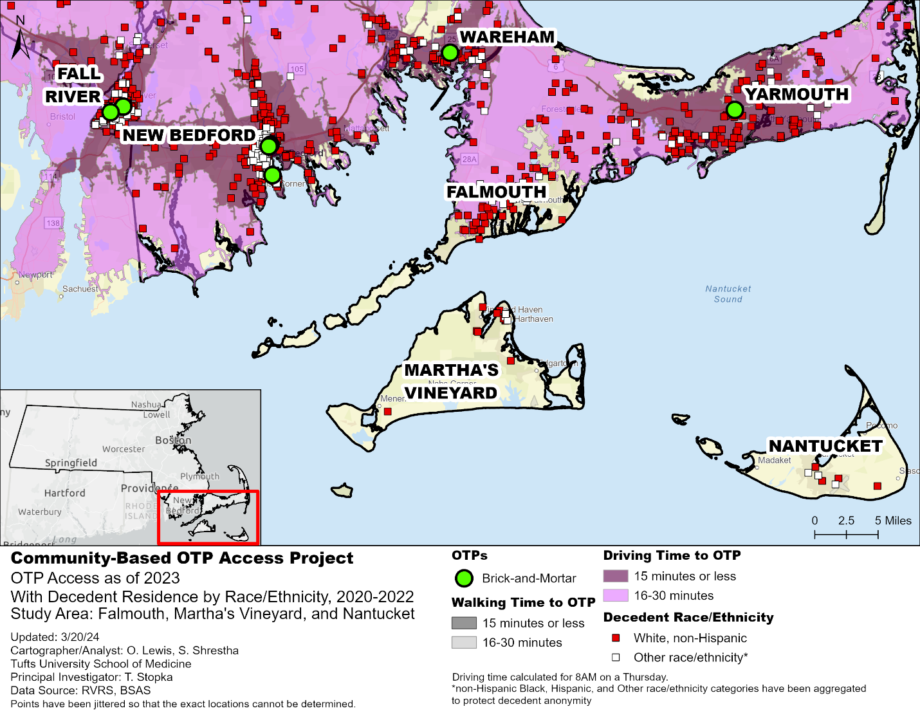
Figure 8. Community-Based Opioid Treatment Program Access: Falmouth, Martha’s Vineyard, and Nantucket, 2023.
While multiple decedent residences were located on Martha’s Vineyard and Nantucket, there were no OTPs on either island (Figure 8). The only access to an OTP would require a two-hour-plus round-trip ferry ride (or use of a plane or private boat.) The ferry landings in Falmouth (Woods Hole for cars and Falmouth Harbor for bikes and pedestrians) are still geographically distant from the nearest OTPs in Yarmouth or Wareham, making it even more difficult to access methadone treatment.

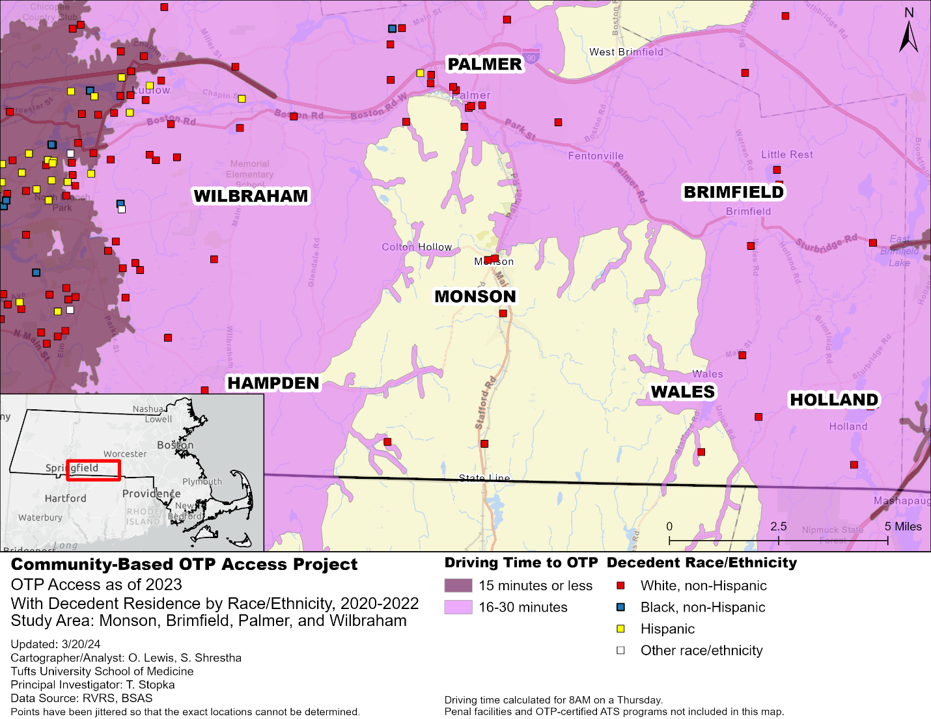
Figure 9. Community-Based Opioid Treatment Program Access: Monson, Brimfield, Palmer, and Wilbraham, 2023.
Decedent residences in the geographically distant area of south-central Massachusetts pertained predominantly to decedents who were non-Hispanic White. All of these decedent residences were located further than 30 minutes driving from an OTP (Figure 9). Additionally, there were decedent residences in this area that were scattered around the outskirts of the 30-minute drive-time service areas of the OTPs, meaning that residents in those limited-access areas would have a round-trip commute time of about an hour to access treatment.
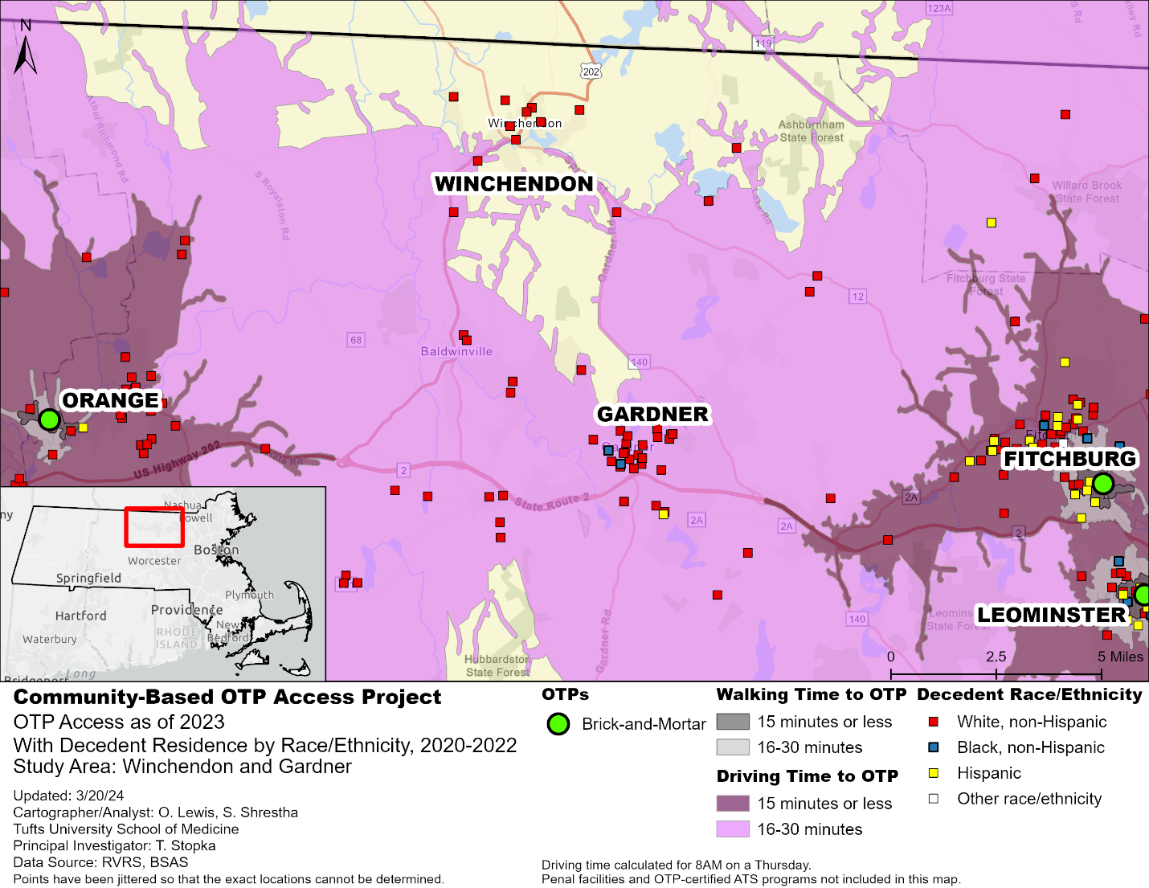
Figure 10. Community-Based Opioid Treatment Program Access: Winchendon and Gardner, 2023*.
*As of February 2024, the OTP in Leominster has submitted a closure application.
Much of the Winchendon area, west of Worcester near the Quabbin Reservoir, can be categorized as geographically distant from the nearest OTPs in Orange, Fitchburg, and Leominster, with decedent residences located farther than, or just under, 30 minutes driving from the treatment centers (Figure 10). The residences in the limited-access areas, the edges of the 30-minute drive-time areas, would have a roundtrip commute time of just under one hour to an OTP, posing a barrier to methadone treatment.

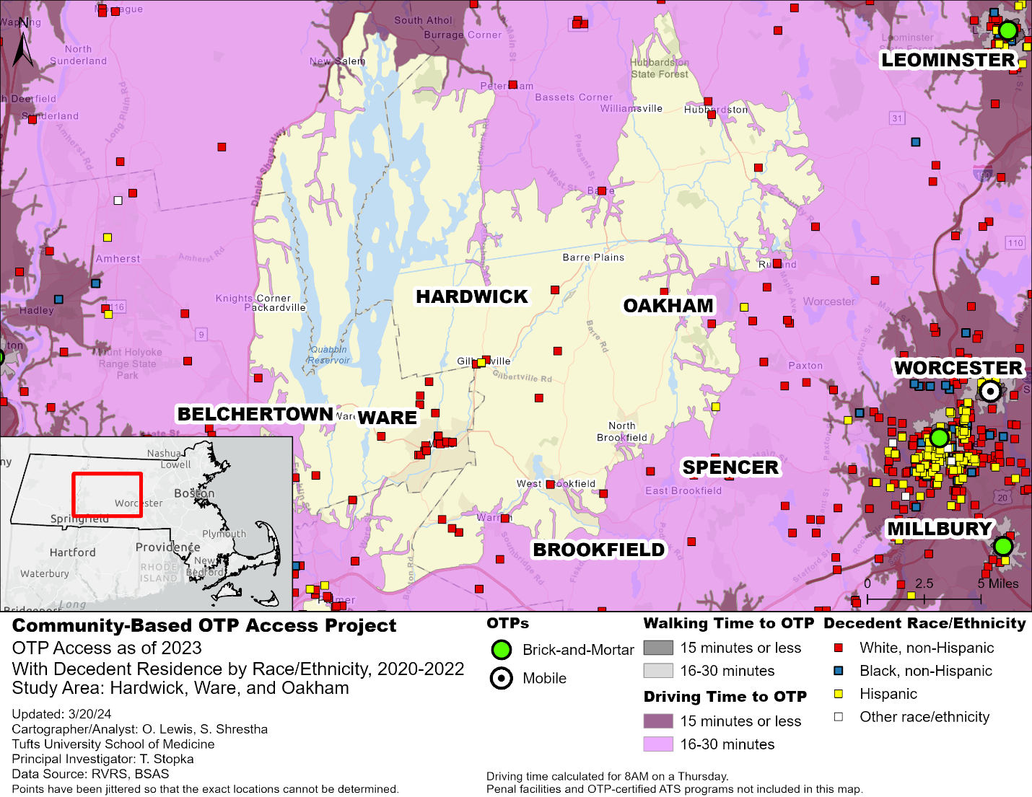
Figure 11. Community-Based Opioid Treatment Program Access: Hardwick, Ware, and Oakham, 2023*.
*As of February 2024, the OTP in Leominster has submitted a closure application.
Many of the decedent residences in the area between Worcester and the Connecticut River were located farther than a 30-minute drive from an OTP, limiting access to methadone treatment provided by the OTPS in Worcester, Millbury, and Leominster to the east, as well as Holyoke and Northampton to the west (Figure 11). In Brookfield, Spencer, Paxton, and Belchertown, there were resident addresses for decedents who had lived in limited-access areas at just under 30 minutes driving, one-way, to nearby OTPs, which translates to a roundtrip of an hour, at minimum, to access treatment.
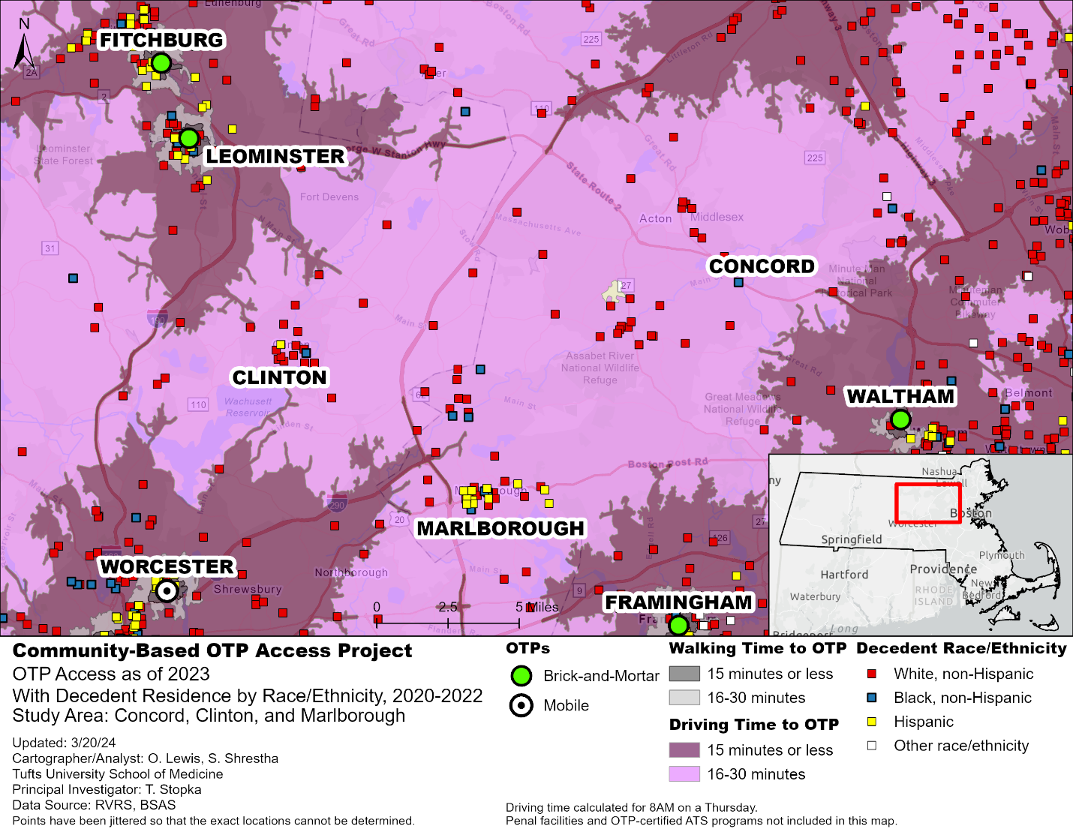
Figure 12. Community-Based Opioid Treatment Program Access: Concord, Clinton, and Marlborough, 2023*.
*As of February 2024, the OTP in Leominster has submitted a closure application.
We also identified additional communities across Massachusetts that fit our definition of limited-access areas given drive-times that remained relatively long, while also having a high burden of fatal overdoses. Areas located on the edge of 16 to 30-minute drive-times from an OTP, for instance, with a high number of fatal overdoses, could also be considered geographically distant. The area east of Worcester, west of Boston, and south of Lowell in western Middlesex County (Figure 12), for instance, included a relatively high number of fatal overdoses among decedents who were mostly non-Hispanic White, although there were a notable number of fatal overdoses among Hispanic residents in Marlborough.
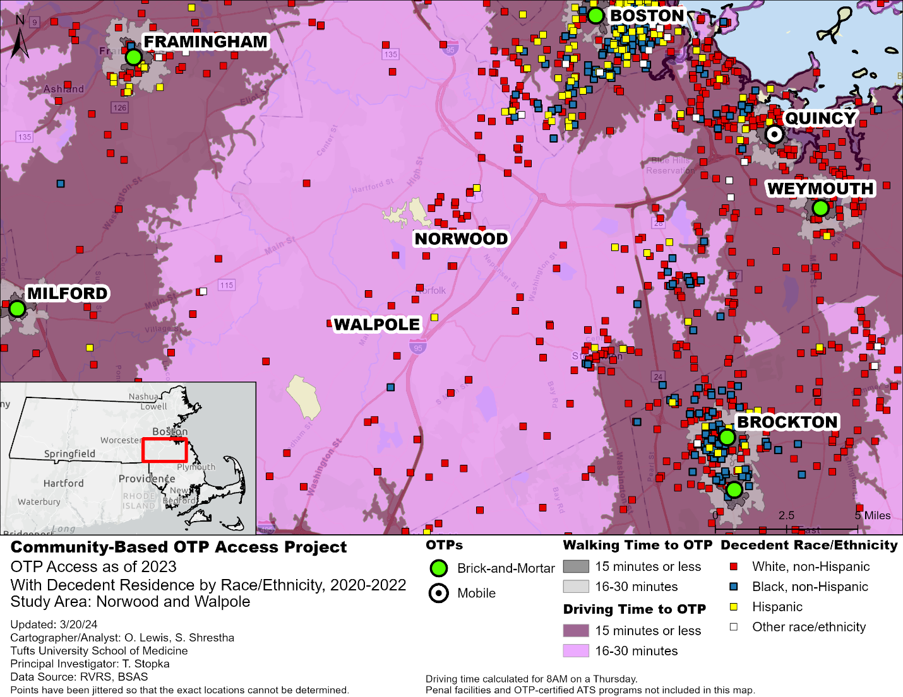
Figure 13. Community-Based Opioid Treatment Program Access: Norwood and Walpole, 2023.
The area between Brockton and Framingham appeared as another limited-access area. Despite being surrounded by OTPs in Milford, Framingham, Boston, Quincy, Weymouth, and Brockton, this area had a concentration of decedent residences who were non-Hispanic White located approximately 30 minutes driving from an OTP (Figure 13).

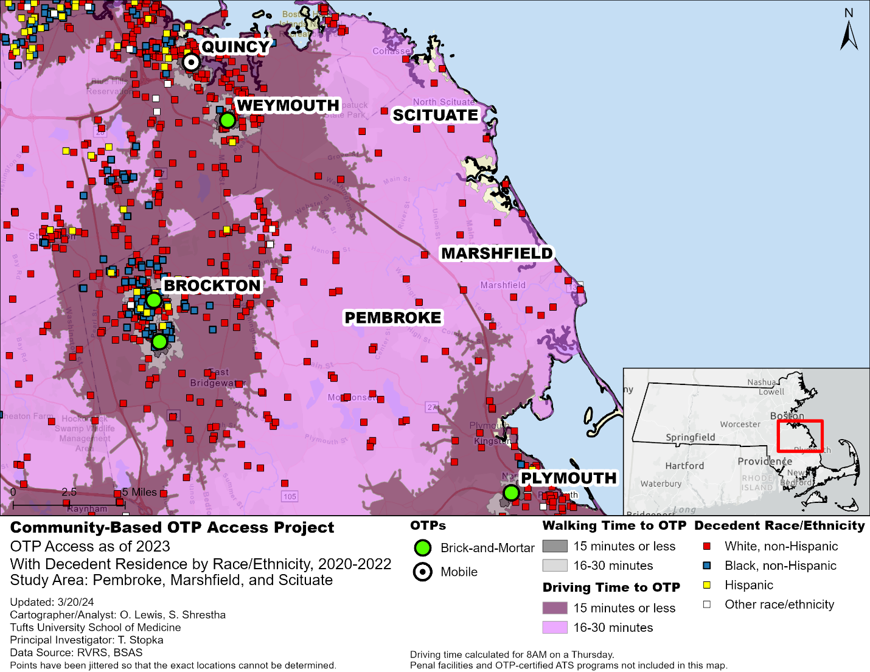
Figure 14. Community-Based Opioid Treatment Program Access: Pembroke, Marshfield, and Scituate, 2023.
In Southeastern Massachusetts, the area East of Brockton that stretches to the coast had a number of decedent residences who were non-Hispanic White (Figure 14). Some of these residences were at the far reaches of the 16 to 30-minute drive-time service areas, making for an hourlong roundtrip drive to the closest OTPs in Quincy, Brockton, Weymouth, and Plymouth.
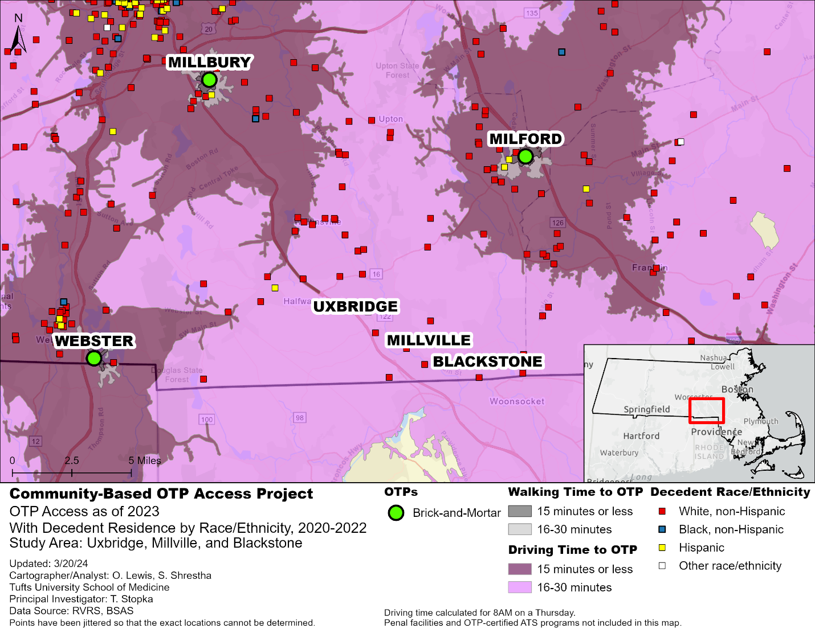
Figure 15. Community-Based Opioid Treatment Program Access: Uxbridge, Millville, and Blackstone, 2023.
Close to the southern border of Massachusetts and just north of Rhode Island, there were decedent residences who were mostly non-Hispanic White in the area between the border and Milford (Figure 15). These locations were scattered on the outer reaches of 16-30-minute drive-time areas, an hour round-trip from the closest OTPs in Milford, Millbury, or Webster.
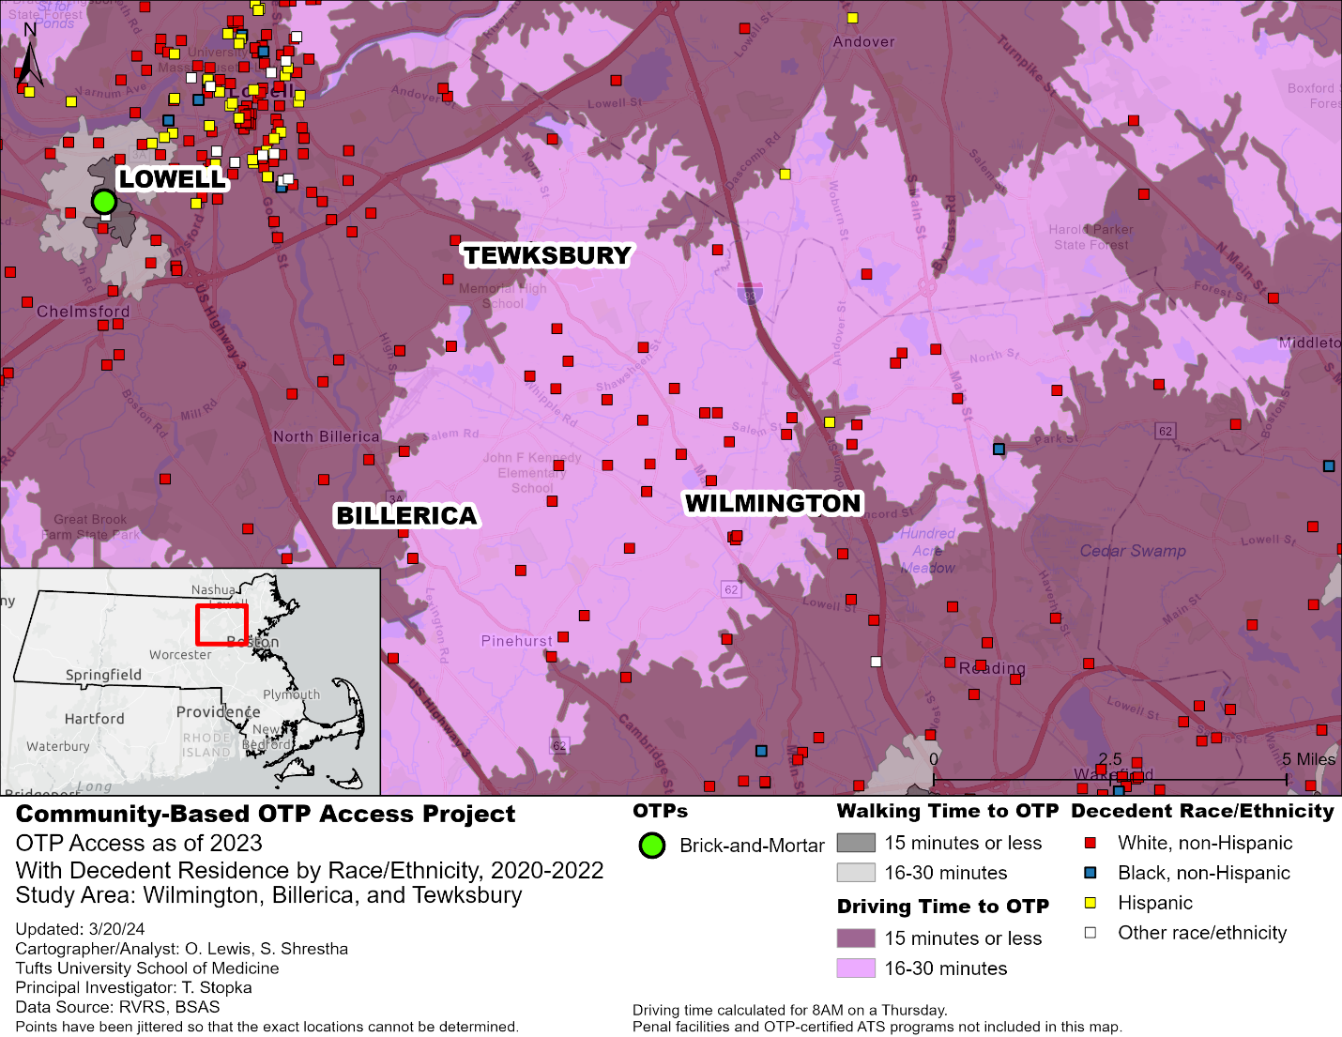
Figure 16. Community-Based Opioid Treatment Program Access: Wilmington, Billerica, and Tewksbury, 2023.
In the area stretching from Lawrence to Woburn, there were a number of residences of decedents who were primarily non-Hispanic White. These residences were located within the 16- to 30-minute drive-time area to OTPs in Lowell, Lawrence, and Woburn (Figure 16).

Discussion
In this assessment, our team developed GIS risk maps and ran exploratory spatial data analyses to evaluate data representing OTPs across the Commonwealth, as well as fatal overdose decedent data, to identify geographic regions with limited walk- and drive-time access to methadone treatment. Overall, Massachusetts has good geographic coverage for OTPs: 98% of opioid overdose decedents lived within a 30-minute drive of an OTP (one hour roundtrip) and 80% lived within a 15-minute drive. Geographic access declined when considering walk times: only 32% of decedents lived within a 30-minute walk and 9% lived within a 15-minute walk. Based on our definition of a 30-minute drive-time to the nearest OTP, we identified areas with limited spatial access to OTPs in: western Massachusetts from New Hampshire to Connecticut, east of the Berkshires and west of the Connecticut River; Winchendon, north of Gardner and adjacent to the New Hampshire border; west of Worcester near the Quabbin Reservoir; between Springfield and Sturbridge, from the Massachusetts Turnpike to the Connecticut border; and Falmouth on Cape Cod, along with the islands of Martha’s Vineyard and Nantucket. We also identified areas with significant numbers of opioid overdose fatalities that were located at the edges of the 30-minute drive-time boundaries, including south of the Merrimack Valley in northeastern Massachusetts, as well as southeastern, and north-central Massachusetts. These areas were often suburban. Some of these areas, including the South Shore, have been previously identified as having relatively low OTP access, validating our results.³²
While most Massachusetts residents, including those who suffered a fatal opioid overdose, resided within a 30-minute drive from an OTP, geographic access dramatically decreased when considering walking time to an OTP. This discrepancy underscores the disparity in access to OTPs based on whether individuals have access to a car. In one study of access to buprenorphine providers (but not OTP access), the investigators found that 99% of census tracts were within a 30-minute drive of a provider in St. Louis, MO; Dayton, OH; Charleston, WV; and Philadelphia, PA. However, of the four cities, only in St. Louis and Philadelphia were providers widely accessible by public transit.⁴⁸
All areas with low geographic access to OTPs identified in this report were located in relatively rural areas of Massachusetts. Prior research has shown that rural areas, in general, have lower density and access to MOUD treatment, including OTPs and buprenorphine providers.^{32,49} Similar to the findings in our study, Mitchell et al. identified a relative lack of access to OTPs in north-central Massachusetts, south-central Massachusetts, and Martha’s Vineyard and Nantucket.³²
Even a 30-minute drive-time, which equates to a one-hour roundtrip, can represent a substantial burden for OTP patients when factoring in employment, family commitments, and other responsibilities. This distance is compounded when considering the fact that OTP patients must typically travel to an OTP clinic every day to receive this essential treatment, incurring substantial time and travel costs.
Further research on OTP access should focus specifically on equity in access to MOUD beyond geographic locations, to include other measures such as gender, income, veteran status, and race and ethnicity. While these characteristics are spatially patterned to a certain extent and are associated with inequities in terms of access to transportation to OTPs, research that is explicitly focused on measuring these disparities is warranted. In Phase 2 of our analyses, we plan to incorporate measures of OTP capacity as it relates to patient census data, waitlists, and wait times in the context of each OTP’s service area. We will also explore public transit access to OTPs through mass transit (see Appendix maps A15 to A22 for examples). The rates that we calculated for Table 2, namely OTPs per million population, begin to point to inequities in access to OTPs, even in locations where a number of OTPs are present, due to higher densities of people in need of methadone treatment. Furthermore, it is important to acknowledge that people living in urban areas, where the majority of overdose deaths occur and the majority of overdose deaths among Black and Latino people occur are also underserved. These areas are within 30-minute and often 15-minute drives, yet the OTPs in these areas may not have open treatment capacity, may not be accessible by public transportation, or may be located in areas that are dangerous or triggering due to stigma and NIMBYism (Not In My Back Yard). This work will highlight areas that may appear to be well-served from a geospatial perspective but that, in reality, have limited access to OTPs given a lack of supply in open methadone treatment slots in areas with high treatment demand.
There are several limitations to this analysis that should be considered when interpreting results. First, while fatal opioid overdose is an important outcome for tailored prevention, it is only one measure of unmet OUD treatment needs. The identified areas that have low access to OTPs, based on fatal opioid overdose and walk- and drive-times, may not be the same for nonfatal opioid overdose or untreated OUD. Second, travel times are only one measure of access. Lack of access to OTP services may exist in areas not identified in this analysis due to financial hardship, comorbid mobility disabilities, care responsibilities, and OTP capacity, among others. OTP capacity, measured by several metrics, is of particular interest moving forward. Third, only walk- and drive-times are considered in this report. Further analyses will incorporate other forms of transportation such as mass transit.
For our analysis, we have employed a straightforward definition for geographic access to OTP services, using driving time as the primary metric for evaluation. While this measure is easy to grasp and can provide a good estimate of access, it does not consider additional variables that affect access. For example, a commonly used measure for food research—“food deserts”—considers both poverty rates and access to supermarkets in urban and rural areas.⁵⁰ The health professional shortage area (HPSA), a widely used measure of access to health services, considers patient-provider ratios, socioeconomic indicators, health indicators, and travel time. Another measure of access to health services—“maternity care deserts”—not only considers the availability of hospital or birth center offerings for obstetric care, but further considers patient-provider ratios and health insurance indicators to classify counties as providing low access, moderate access, or full access to maternity care.⁵¹ While there are limited studies that evaluate “OTP deserts”, Hyder et al., in a local-level assessment within the Columbus Fire Department jurisdiction, defined “opioid treatment deserts” as areas that were more than a mile in driving distance from treatment and more than 30-minutes away by public transport.⁵² During the next phase of our research, we look forward to collaborative efforts with BSAS and MDPH to further explore novel metrics to assess OTP and broader MOUD accessibility to further inform health policy priorities and targeted harm reduction, prevention, and treatment-focused responses.

Conclusion
We developed GIS risk maps and ran exploratory spatial data analyses to assess geographic access to OTPs and methadone treatment sites throughout Massachusetts. We found that the state has good geographic OTP coverage in terms of drive-times, but access is lacking when considering walk-times. Areas with low geographic access to OTPs were identified in the north-central and south-central regions of the Commonwealth, as well as on the islands of Martha’s Vineyard and Nantucket. Additional areas of need at the edges of 30-minute drive-times were identified along the South Shore, in western Massachusetts, and within the northwest and southwest suburbs of Boston. Mobile units, primary care, pharmacy, and telemedicine-based MOUD may provide valuable added access to underserved rural and suburban areas.
The results in this report can help to inform data-driven public health and clinical policy in Massachusetts. The risk maps, statistics, and accessibility analyses can help to guide the targeting of resources and the opening of new OTPs, which can provide much-needed and enhanced MOUD treatment, helping to meet the demand for OUD treatment and bending the opioid overdose epidemic curve.

References
1. National Center for Health Statistics. Provisional Drug Overdose Death Counts. Centers for Disease Control and Prevention. Updated October 17, 2023. Accessed December 7, 2023, https://www.cdc.gov/nchs/nvss/vsrr/drug-overdose-data.htm
2. Kaiser Family Foundation. Opioid Overdose Death Rates and All Drug Overdose Death Rates per 100,000 Population (Age-Adjusted). Accessed December 6, 2023, https://www.kff.org/other/state-indicator/opioid-overdose-death-rates/
3. Baumgartner J, Radley D. Overdose Deaths Declined but Remained Near Record Levels During the First Nine Months of 2022 as States Cope with Synthetic Opioids. To the Point blog. December 6, 2023,
4. Barocas JA, White LF, Wang J, et al. Estimated Prevalence of Opioid Use Disorder in Massachusetts, 2011–2015: A Capture–Recapture Analysis. Am J Public Health. 2018;108(12):1675-1681. doi:10.2105/ajph.2018.304673
5. Wang J, Doogan N, Thompson K, et al. Massachusetts Prevalence of Opioid Use Disorder Estimation Revisited: Comparing a Bayesian Approach to Standard Capture–Recapture Methods. Epidemiology. 2023;34(6):841-849. doi:10.1097/ede.0000000000001653
6. Massachusetts Department of Public Health. Opioid‐Related Overdose Deaths among Massachusetts Residents. Data Brief. June 2023.
7. Stopka TJ, Larochelle MR, Li X, et al. Opioid-related mortality: dynamic temporal and spatial trends by drug type and demographic subpopulations, Massachusetts, 2005-2021. Drug Alcohol Depend. 2023:109836. doi:10.1016/j.drugalcdep.2023.109836
8. Srinivasan S, Pustz J, Marsh E, Young LD, Stopka TJ. Risk factors for persistent fatal opioid-involved overdose hotspots in Massachusetts 2011-2021: A spatial statistical analysis with socio-economic, access and prescription factors. Pre-print. 2023;doi:10.21203/rs.3.rs-3249650/v1
9. Bureau of Substance Addiction Services. Updates to Regulations 105 CMR 164.300 - Requirements Related to Opioid Treatment Programs. In: Health MDoP, editor. 105 CMR 1643002022.
10. SAMHSA Substance Abuse and Mental Health Services Administration. Medications for Opioid Use Disorder, TIP 63. 2021. Treatnent Improvement Protocol. https://store.samhsa.gov/product/tip-63-medications-opioid-use-disorder-full-document/pep21-02-01-002
11. Sordo L, Barrio G, Bravo MJ, et al. Mortality risk during and after opioid substitution treatment: systematic review and meta-analysis of cohort studies. BMJ. 2017;357:j1550. doi:10.1136/bmj.j1550
12. Mauro PM, Gutkind S, Annunziato EM, Samples H. Use of Medication for Opioid Use Disorder Among US Adolescents and Adults With Need for Opioid Treatment, 2019. JAMA Network Open. 2022;5(3):e223821-e223821. doi:10.1001/jamanetworkopen.2022.3821
13. Larochelle MR, Bernson D, Land T, et al. Medication for opioid use disorder after nonfatal opioid overdose and association with mortality: a cohort study. Ann Intern Med. 2018;169(3):137-145. doi:10.7326/M17-3107
14. Corry B, Underwood N, Cremer LJ, Rooks-Peck CR, Jones C. County-level sociodemographic differences in availability of two medications for opioid use disorder: United States, 2019. Drug Alcohol Depend. 2022/07/01/ 2022;236:109495. doi:10.1016/j.drugalcdep.2022.109495
15. Goedel WC, Shapiro A, Cerdá M, Tsai JW, Hadland SE, Marshall BDL. Association of Racial/Ethnic Segregation With Treatment Capacity for Opioid Use Disorder in Counties in the United States. JAMA Network Open. 2020;3(4):e203711-e203711. doi:10.1001/jamanetworkopen.2020.3711
16. Hansen HB, Siegel CE, Case BG, Bertollo DN, DiRocco D, Galanter M. Variation in Use of Buprenorphine and Methadone Treatment by Racial, Ethnic, and Income Characteristics of Residential Social Areas in New York City. The Journal of Behavioral Health Services & Research. 2013/07/01 2013;40(3):367-377. doi:10.1007/s11414-013-9341-3
17. Marsh JC, Amaro H, Kong Y, Khachikian T, Guerrero E. Gender disparities in access and retention in outpatient methadone treatment for opioid use disorder in low-income urban communities. Journal of Substance Abuse Treatment. 2021/08/01/ 2021;127:108399. doi:https://doi.org/10.1016/j.jsat.2021.108399
18. Stopka TJ, Rottapel RE, Ferguson WJ, et al. Medication for opioid use disorder treatment continuity post-release from jail: A qualitative study with community-based treatment providers. Int J Drug Policy. 2022;110:103803.
19. SAMHSA Substance Abuse and Mental Health Services Administration. Opioid Treatement Program (OTP) Guidance. 3/16/2020 (Updated 3/19/2020). Rockville, MD.
20. SAMHSA Substance Abuse and Mental Health Services Administration. Methadone Take-Home Flexibilities Extension Guidance. Updated 1/23/2024. Accessed March 1, 2024. https://www.samhsa.gov/medications-substance-use-disorders/statutes-regulations-guidelines/methadone-guidance
21. Adams A, Blawatt S, Magel T, et al. The impact of relaxing restrictions on take-home doses during the COVID-19 pandemic on program effectiveness and client experiences in opioid agonist treatment: a mixed methods systematic review. Substance Abuse Treatment, Prevention, and Policy. 2023;18(1):56. doi:10.1186/s13011-023-00564-9
22. SAMHSA Substance Abuse and Mental Health Services Administration. Medications for the Treatment of Opioid Use Disorder. In: Department of Health and Human Services, editor. 42 CFR Part 8. Volume 89, Number 23 ed. Rockville MD: Federal Register; 2024. p. 7528-7563.
23. Chen KL, Brozen M, Rollman JE, et al. How is the COVID-19 pandemic shaping transportation access to health care? Transportation Research Interdisciplinary Perspectives. 2021;10:100338.
24. Gryczynski J, Schwartz RP, Salkever DS, Mitchell SG, Jaffe JH. Patterns in admission delays to outpatient methadone treatment in the United States. Journal of substance abuse treatment. 2011;41(4):431-439.
25. Meinhofer A, Witman AE. The role of health insurance on treatment for opioid use disorders: Evidence from the Affordable Care Act Medicaid expansion. Journal of Health Economics. 2018/07/01/ 2018;60:177-197. doi:https://doi.org/10.1016/j.jhealeco.2018.06.004
26. Pasman E, Kollin R, Broman M, et al. Cumulative barriers to retention in methadone treatment among adults from rural and small urban communities. Addiction Science & Clinical Practice. 2022;17(1):35.
27. Woo J, Bhalerao A, Bawor M, et al. “Don’t judge a book by its cover”: A qualitative study of methadone patients’ experiences of stigma. Substance abuse: research and treatment. 2017;11:1178221816685087.
28. Amiri S, McDonell MG, Denney JT, Buchwald D, Amram O. Disparities in access to opioid treatment programs and office-based buprenorphine treatment across the rural-urban and area deprivation continua: a US nationwide small area analysis. Value in Health. 2021;24(2):188-195.
29. Iloglu S, Joudrey PJ, Wang EA, Thornhill IV TA, Gonsalves G. Expanding access to methadone treatment in Ohio through federally qualified health centers and a chain pharmacy: a geospatial modeling analysis. Drug Alcohol Depend. 2021;220:108534.
30. Kiang MV, Barnett ML, Wakeman SE, Humphreys K, Tsai AC. Robustness of estimated access to opioid use disorder treatment providers in rural vs. urban areas of the United States. Drug Alcohol Depend. 2021;228:109081.
31. Kleinman RA. Comparison of driving times to opioid treatment programs and pharmacies in the US. JAMA Psychiatry. 2020;77(11):1163-1171.
32. Mitchell P, Samsel S, Curtin KM, et al. Geographic disparities in access to Medication for Opioid Use Disorder across US census tracts based on treatment utilization behavior. Soc Sci Med. 2022/06/01/ 2022;302:114992. doi:https://doi.org/10.1016/j.socscimed.2022.114992
33. Anwar T, Duever M, Jayawardhana J. Access to methadone clinics and opioid overdose deaths in Georgia: A geospatial analysis. Drug Alcohol Depend. 2022/09/01/ 2022;238:109565. doi:https://doi.org/10.1016/j.drugalcdep.2022.109565
34. Joudrey PJ, Chadi N, Roy P, et al. Pharmacy-based methadone dispensing and drive time to methadone treatment in five states within the United States: a cross-sectional study. Drug Alcohol Depend. 2020;211:107968. doi:https://doi.org/10.1016/j.drugalcdep.2020.107968
35. Response to Federal Trade Commission Notice “Examining Health Care Competition”, 79 Federal Regulation 10153 (2014) (NACDS) (2014).
36. Amiri S, Hirchak K, McDonell MG, Denney JT, Buchwald D, Amram O. Access to medication-assisted treatment in the United States: comparison of travel time to opioid treatment programs and office-based buprenorphine treatment. Drug Alcohol Depend. 2021;224:108727.
37. Joudrey PJ, Kolak M, Lin Q, Paykin S, Anguiano V, Jr, Wang EA. Assessment of Community-Level Vulnerability and Access to Medications for Opioid Use Disorder. JAMA Network Open. 2022;5(4):e227028-e227028. doi:10.1001/jamanetworkopen.2022.7028
38. Davidson P, Bowles J, Faul M, Gaines T. Spatial proximity and access to buprenorphine or methadone treatment for opioid use disorder in a sample of people misusing opioids in Southern California. Journal of Substance Abuse Treatment. 2022;132:108634.
39. Mitchell SG, Harmon-Darrow C, Lertch E, et al. Views of barriers and facilitators to continuing methadone treatment upon release from jail among people receiving patient navigation services. Journal of Substance Abuse Treatment. 2021/08/01/ 2021;127:108351. doi:https://doi.org/10.1016/j.jsat.2021.108351
40. Turney K, Schneider D. Incarceration and household asset ownership. Demography. 2016;53(6):2075-2103.
41. Pustz J, Srinivasan S, Larochelle MR, Walley AY, Stopka TJ. Relationships between places of residence, injury, and death: Spatial and statistical analysis of fatal opioid overdoses across Massachusetts. Spatial and spatio-temporal epidemiology. 2022;43:100541.
42. Pustz J, Srinivasan S, Shrestha S, et al. Applied risk mapping and spatial analysis of address-level decedent data to inform opioid overdose interventions: The Massachusetts HEALing Communities Study. Drug Alcohol Depend. 2023/10/01/ 2023;251:110947. doi:https://doi.org/10.1016/j.drugalcdep.2023.110947
43. Allshouse WB, Fitch MK, Hampton KH, et al. Geomasking sensitive health data and privacy protection: an evaluation using an E911 database. Geocarto Int. Oct 1 2010;25(6):443-452. doi:10.1080/10106049.2010.496496
44. Hampton KH, Fitch MK, Allshouse WB, et al. Mapping health data: improved privacy protection with donut method geomasking. Am J Epidemiol. Nov 1 2010;172(9):1062-9. doi:10.1093/aje/kwq248
45. Zandbergen PA. Ensuring Confidentiality of Geocoded Health Data: Assessing Geographic Masking Strategies for Individual-Level Data. Advances in Medicine. 2014/04/29 2014;2014:567049. doi:10.1155/2014/567049
46. Massachusetts Department of Public Health. Data Brief: Opioid-Related Overdose Deaths among Massachusetts Residents. December 2023. https://www.mass.gov/doc/opioid-related-overdose-deaths-among-ma-residents-december-2023/download
47. Massachusetts Department of Public Health. Opioid-Related Overdose Deaths, All Intents, MA Residents – Demographic Data Highlights. December 2023. https://www.mass.gov/doc/opioid-related-overdose-deaths-demographics-december-2023/download
48. Drake C, Donohue JM, Nagy D, Mair C, Kraemer KL, Wallace DJ. Geographic access to buprenorphine prescribers for patients who use public transit. Journal of Substance Abuse Treatment. 2020/10/01/ 2020;117:108093. doi:10.1016/j.jsat.2020.108093
49. Lister JJ, Weaver A, Ellis JD, Himle JA, Ledgerwood DM. A systematic review of rural-specific barriers to medication treatment for opioid use disorder in the United States. The American Journal of Drug and Alcohol Abuse. 2020/05/03 2020;46(3):273-288. doi:10.1080/00952990.2019.1694536
50. Dutko P, Ver Ploeg M, Farrigan T. Characteristics and Influential Factors of Food Deserts. Vol. ERR-140. August 2012.
51. Brigance C, Lucas R, Jones E, et al. Nowhere to Go: Maternity Care Deserts Across the U.S. Vol. Report No. 3. 2022. https://www.marchofdimes.org/sites/default/files/2022-10/2022_Maternity_Care_Report.pdf
52. Hyder A, Lee J, Dundon A, et al. Opioid treatment deserts: concept development and application in a US Midwestern urban county. Plos one. 2021;16(5):e0250324.

Appendices
Maps of county-level Opioid Treatment Program access juxtaposed with opioid-related overdose decedent residences (geomasked), categorized by race and ethnicity:
Figure A1. Community-Based Opioid Treatment Program Access: Barnstable County, 2023 40
Figure A2. Community-Based Opioid Treatment Program Access Berkshire County, 2023 41
Figure A3. Community-Based Opioid Treatment Program Access: Bristol County, 2023 42
Figure A4. Community-Based Opioid Treatment Program Access: Dukes County, 2023 43
Figure A5. Community-Based Opioid Treatment Program Access: Essex County, 2023 44
Figure A6. Community-Based Opioid Treatment Program Access : Franklin County, 2023 45
Figure A7. Community-Based Opioid Treatment Program Access: Hampden County, 2023 46
Figure A8. Community-Based Opioid Treatment Program Access: Hampshire, 2023 47
Figure A9. Community-Based Opioid Treatment Program Access: Middlesex County, 2023 48
Figure A10. Community-Based Opioid Treatment Program Access: Nantucket County, 2023 49
Figure A11. Community-Based Opioid Treatment Program Access: Norfolk County, 2023 50
Figure A12. Community-Based Opioid Treatment Program Access: Plymouth County, 2023 51
Figure A13. Community-Based Opioid Treatment Program Access: Suffolk County, 2023 52
Figure A14. Community-Based Opioid Treatment Program Access: Worcester County, 2023 53

Maps of mass transit-based access to Opioid Treatment Programs (OTP) in Boston-area towns receiving Metropolitan Boston Transit Authority (MBTA) service:
Figure A15. Transit-Based Access to Opioid Treatment Programs in Towns Receiving Metropolitan Boston Transit Authority (MBTA) Service 54
Figure A16. Transit-Based Access to OTPs in Towns Receiving MBTA Service Compared to Walk-times 55
Figure A17. Transit-Based Access to OTPs in Towns Receiving MBTA Service and Decedent Residence (geomasked) 56
Figure A18. Transit-Based Access to OTPs in Towns receiving MBTA Service with Walk-times and Decedent Residences (geomasked) 57
Figure A19. Transit-Based OTP Access in the Northern MBTA region, with Decedent Residences (geomasked) 58
Figure A20. Transit-Based OTP Access in Central MBTA Region, with Decedent Residences (geomasked) 59
Figure A21. Transit-Based OTP Access in the Southern MBTA Region, with Decedent Residences (geomasked) 60
Figure A22. Transit-Based OTP Access in Boston Proper, with Decedent Residences (geomasked) 61

Figure A23. Walking and Driving Times Towards Community-Based Opioid Treatment Program Locations in Massachusetts, as of 2023 62

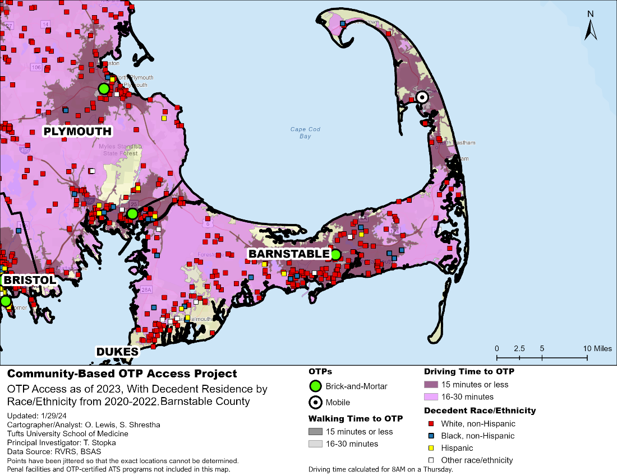
Figure A1. Community-Based Opioid Treatment Program Access: Barnstable County, 2023.
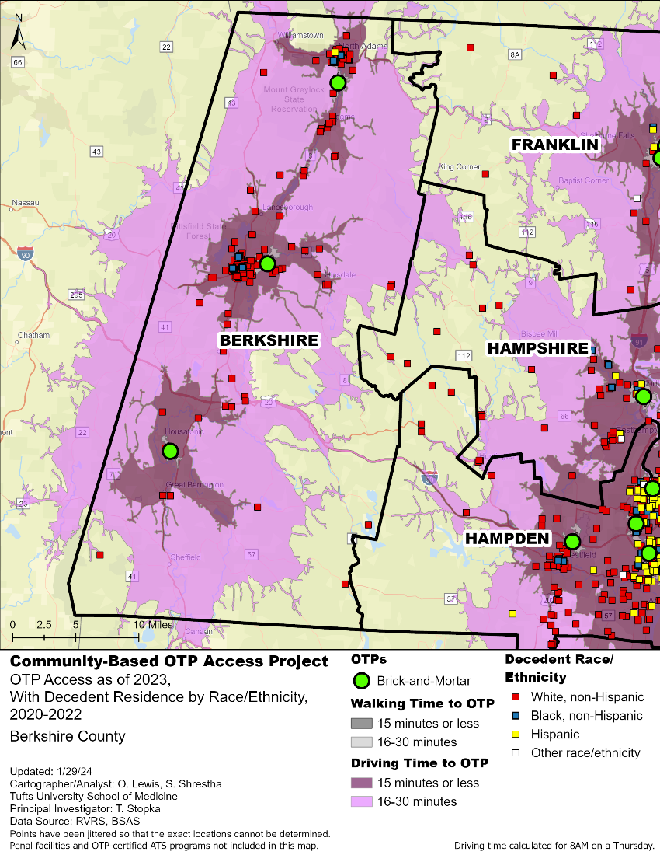
Figure A2. Community-Based Opioid Treatment Program Access: Berkshire County, 2023.
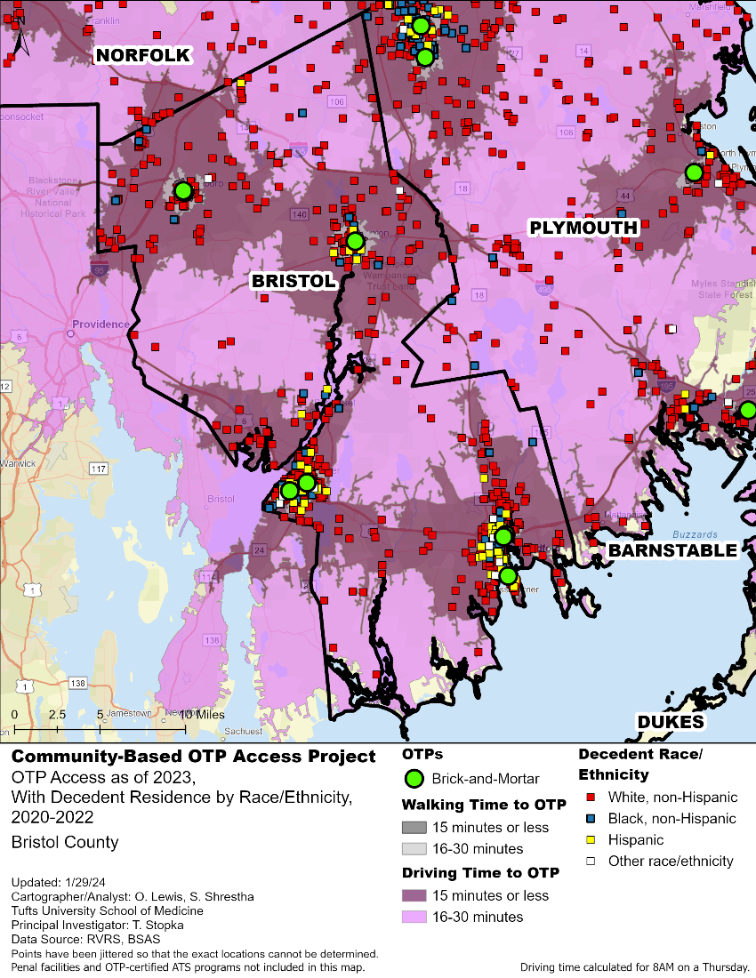
Figure A3. Community-Based Opioid Treatment Program Access: Bristol County, 2023.
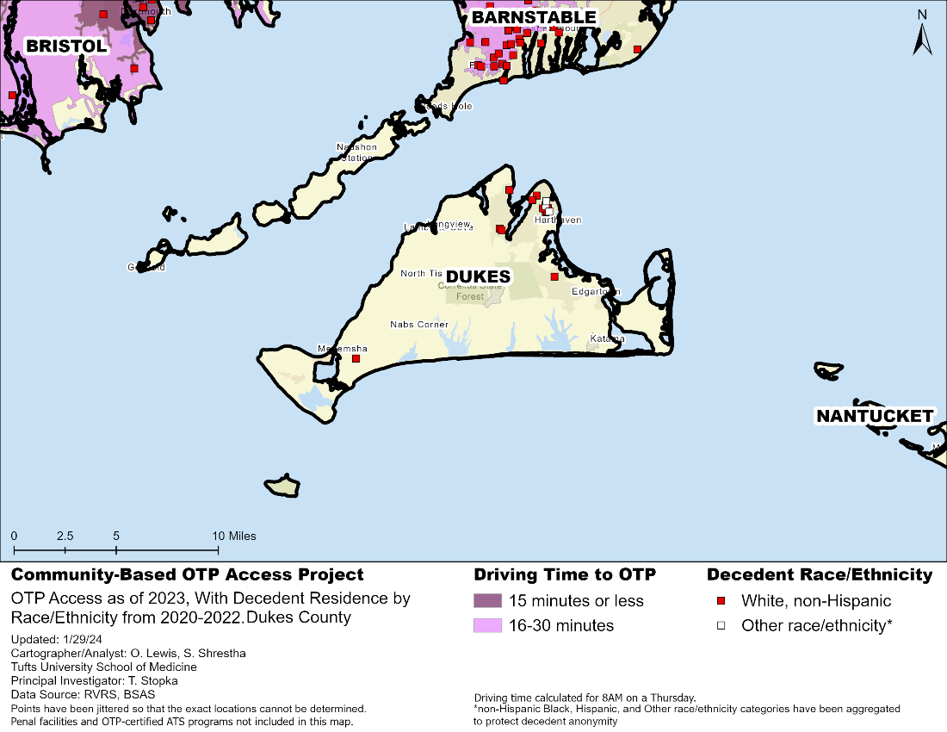
Figure A4. Community-Based Opioid Treatment Program Access: Dukes County, 2023.

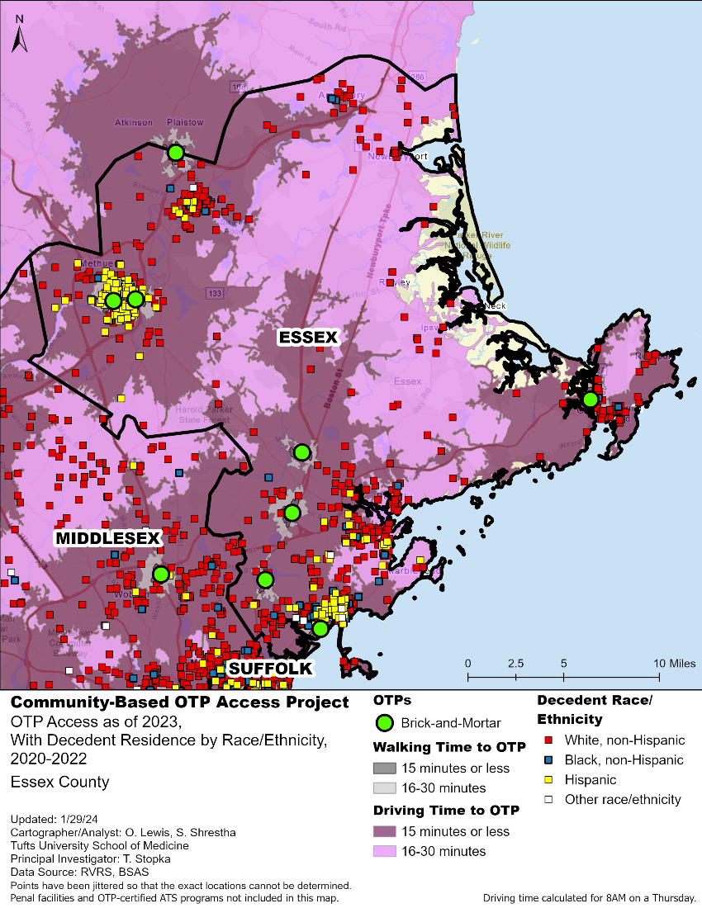
Figure A5. Community-Based Opioid Treatment Program Access: Essex County, 2023.

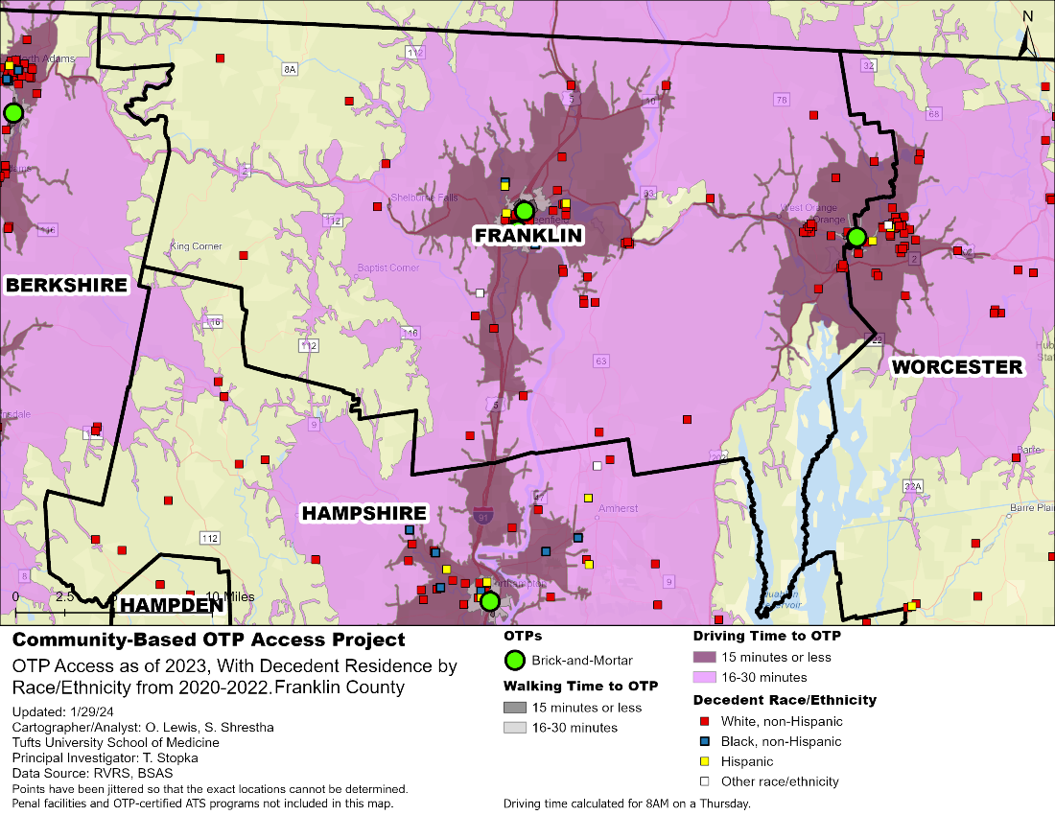
Figure A6. Community-Based Opioid Treatment Program Access: Franklin County, 2023.

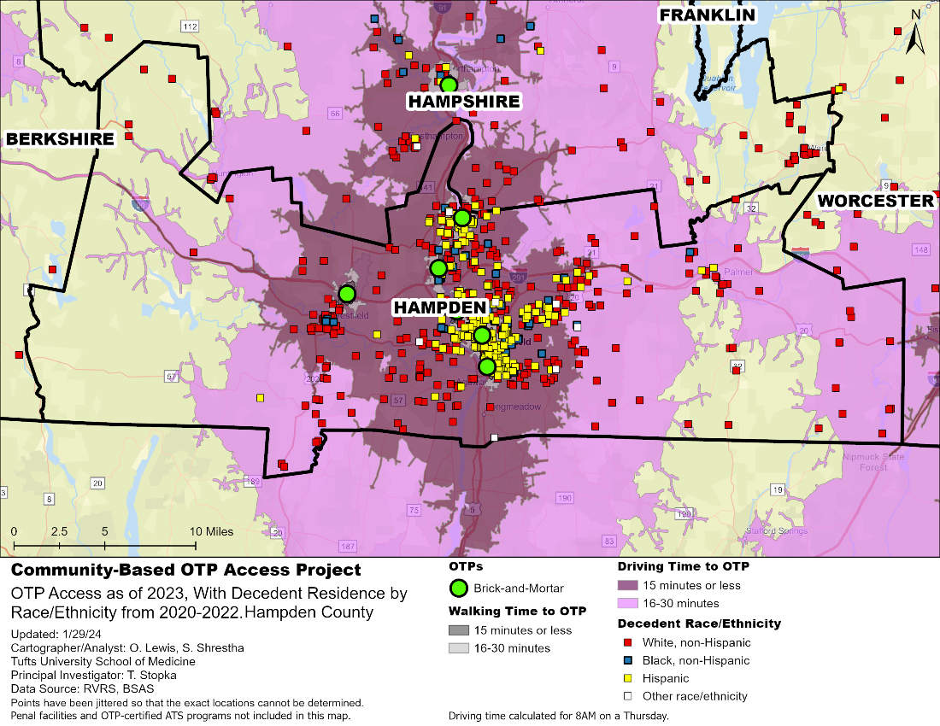
Figure A7. Community-Based Opioid Treatment Program Access: Hampden County, 2023.

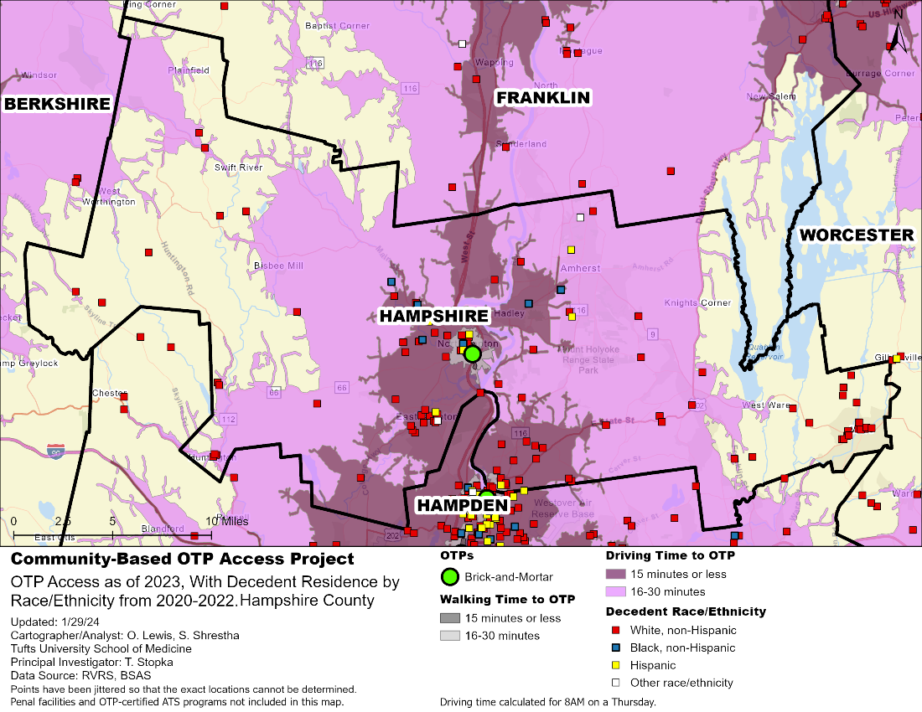
Figure A8. Community-Based Opioid Treatment Program Access: Hampshire, 2023.

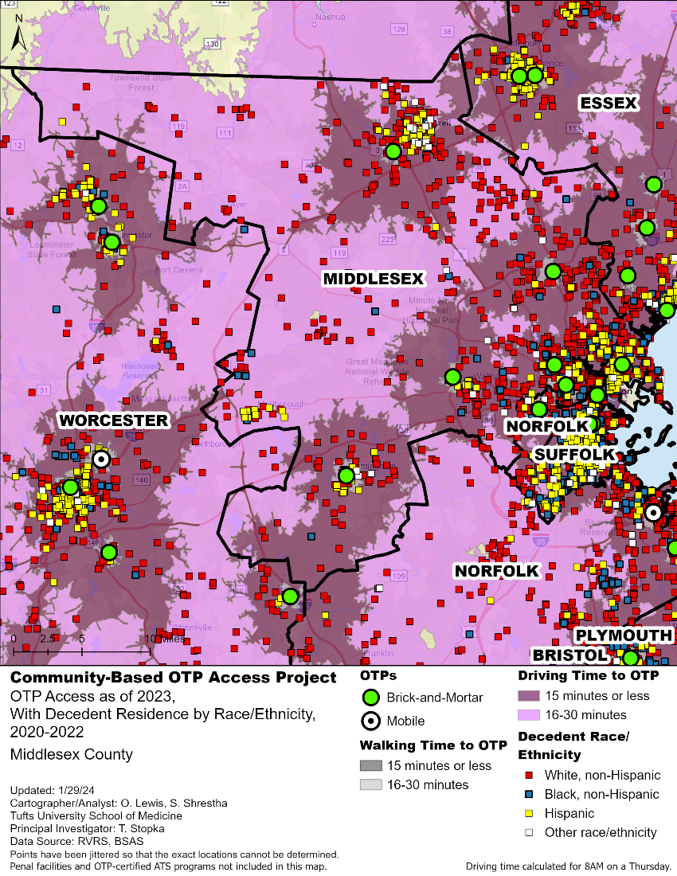
Figure A9. Community-Based Opioid Treatment Program Access: Middlesex County, 2023.

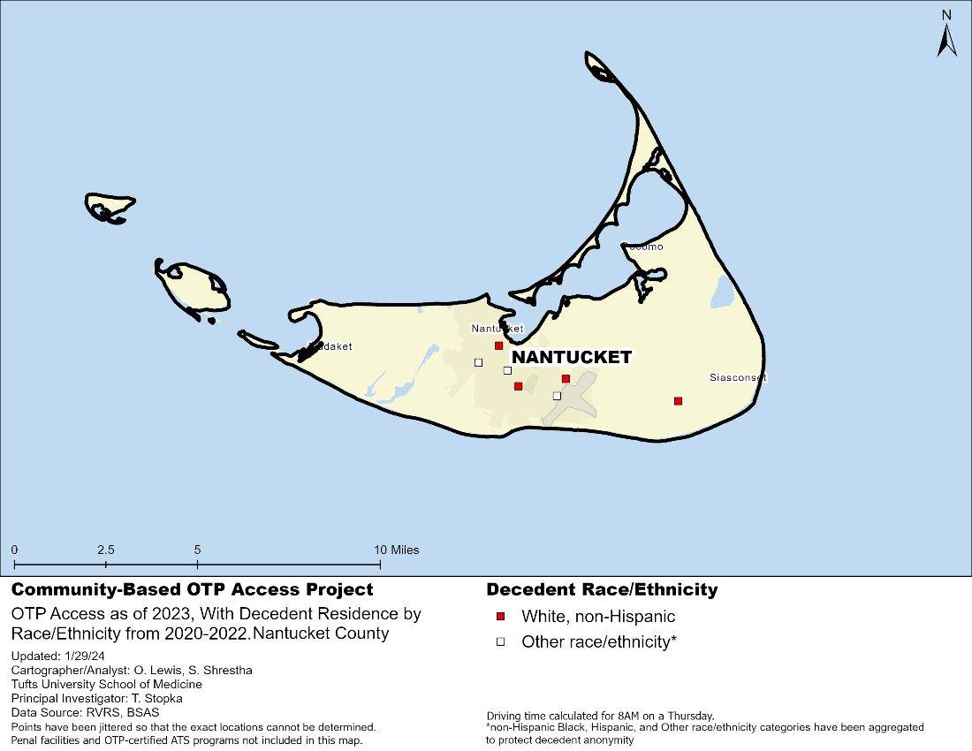
Figure A10. Community-Based Opioid Treatment Program Access: Nantucket County, 2023.

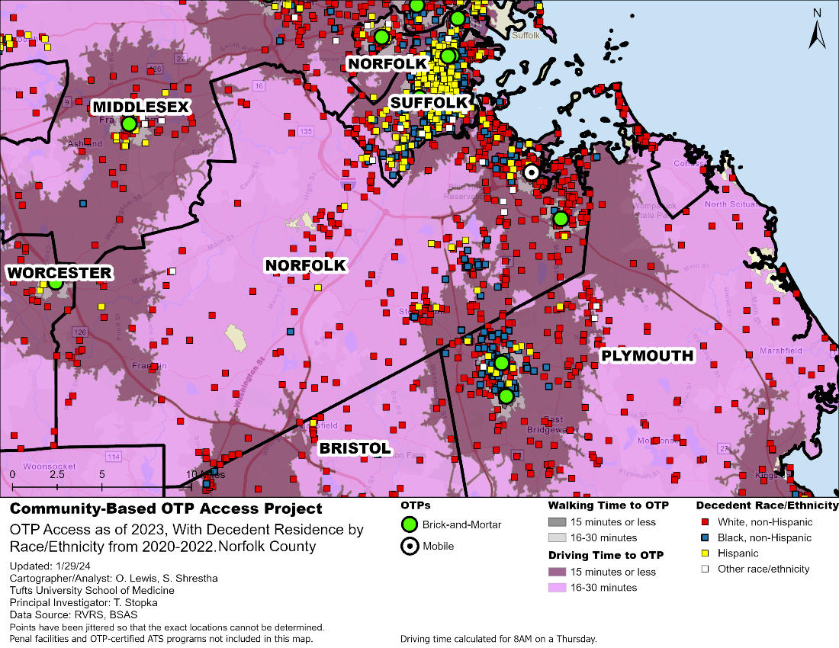
Figure A11. Community-Based Opioid Treatment Program Access: Norfolk County, 2023.
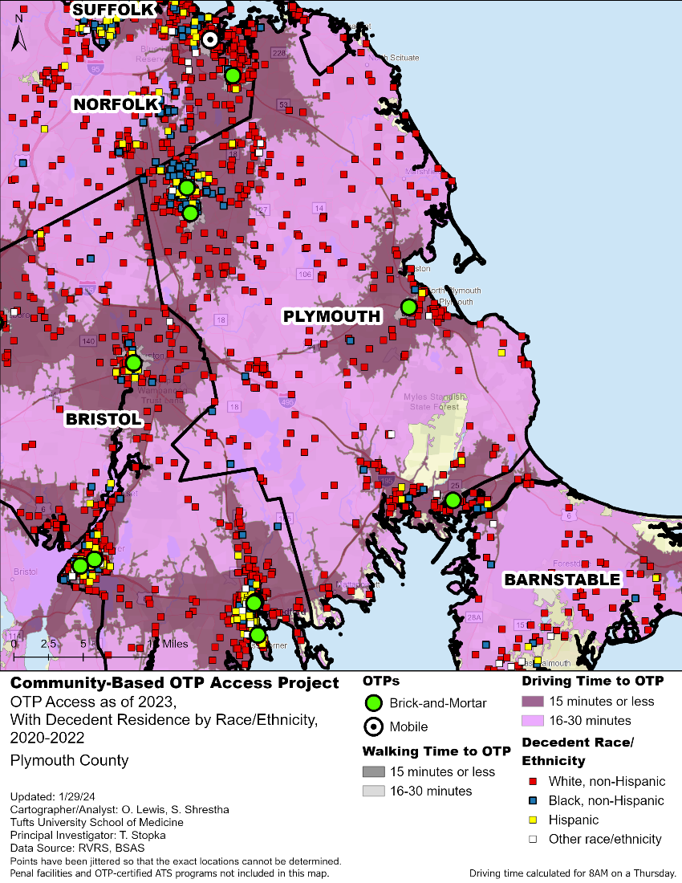
Figure A12. Community-Based Opioid Treatment Program Access: Plymouth County, 2023.
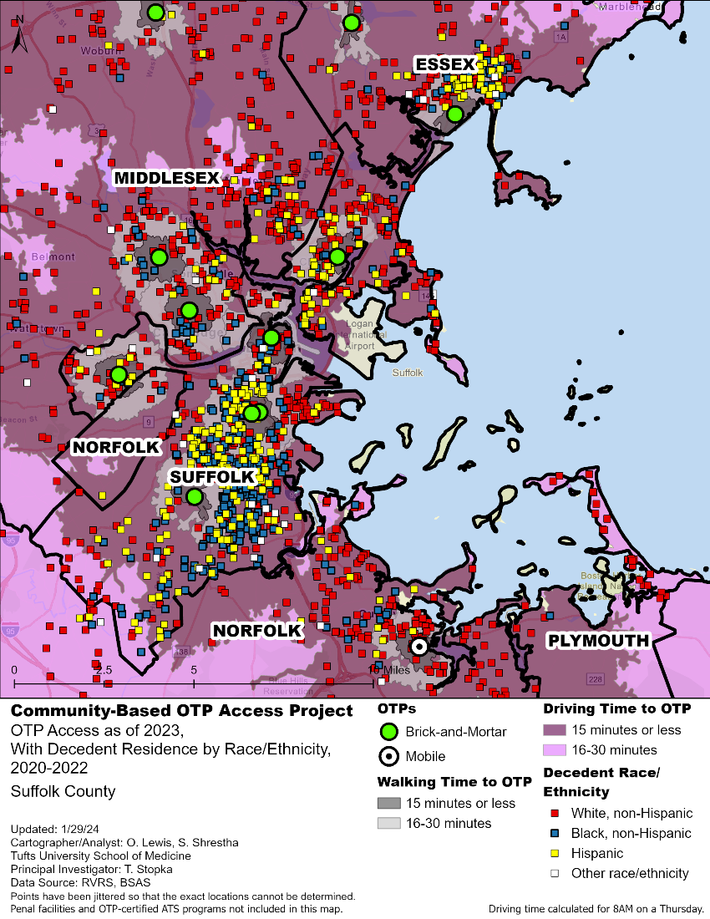
Figure A13. Community-Based Opioid Treatment Program Access: Suffolk County, 2023.

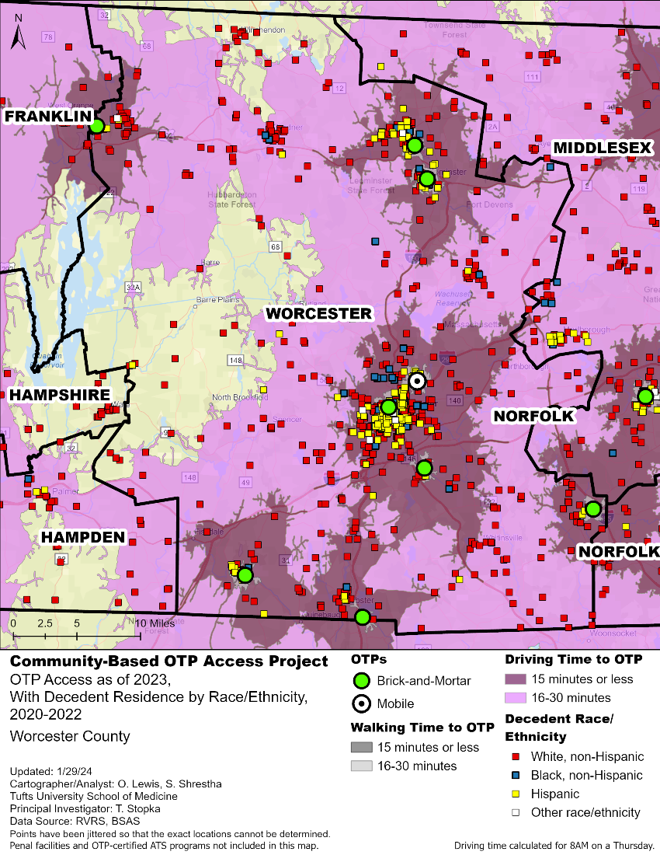
Figure A14. Community-Based Opioid Treatment Program Access: Worcester County, 2023.
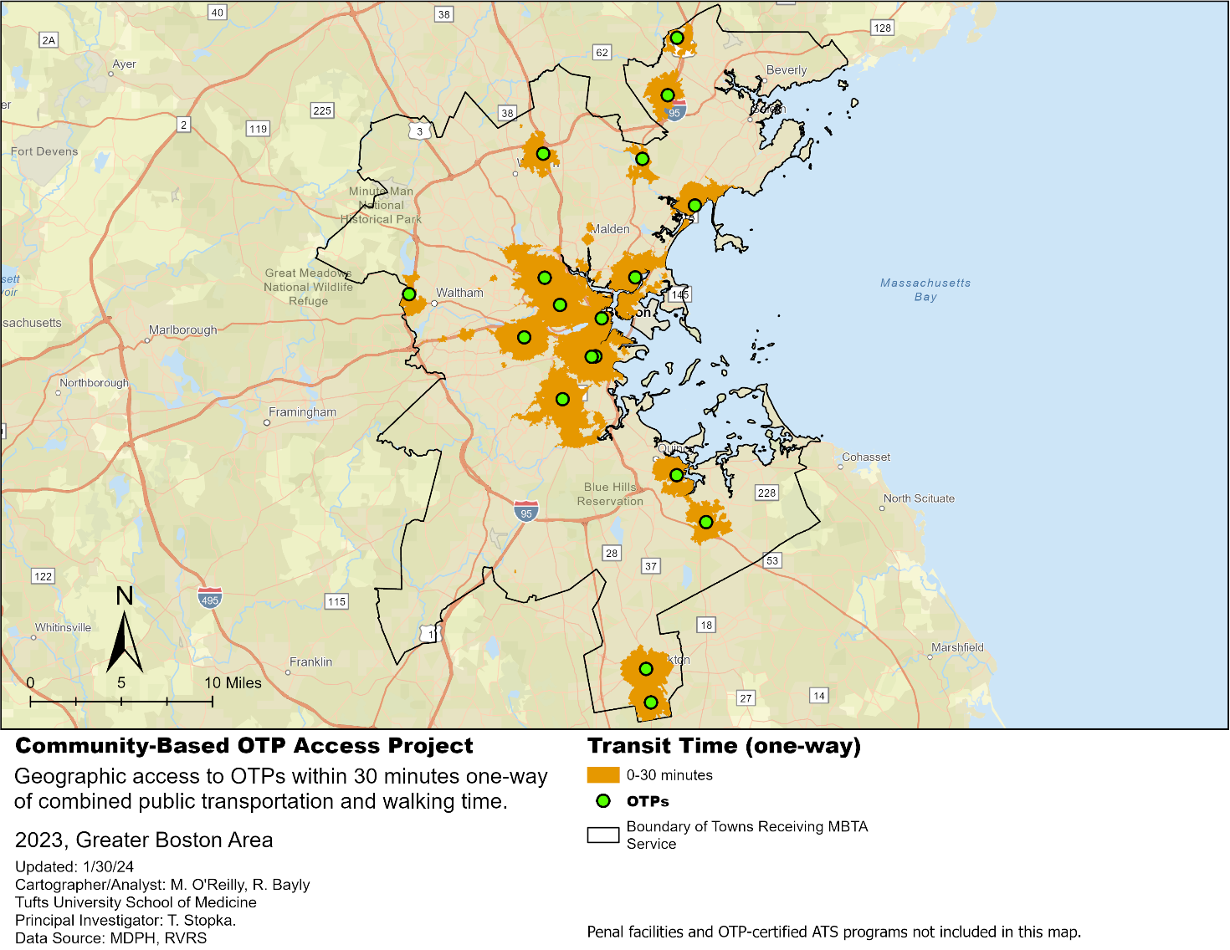
Figure A15. Transit-Based Access to Opioid Treatment Programs (OTP) in Towns receiving Metropolitan Boston Transit Authority (MBTA) Service, 2023.

Public transit network analysis is similar to the walk- and drive-time analyses used earlier in this report, and derives service areas using street data to account for walking routes to transit stops and General Transit Feed Specification (GTFS) files that contain data on bus/subway routes and schedules. The orange areas show locations where a pedestrian could walk to a bus/train stop, wait for the bus/train, take it to the stop closest to the OTP, and then walk to the OTP in 30 minutes or less. This area represents a reliable service area (one in which an OTP client could have confidence relative to budgeting travel time) between 8-8:30am on a Thursday and makes the assumption that connections are sometimes missed. Note that transit users may want to be even more conservative in their estimation of travel time to account for transit system delays and traffic events.

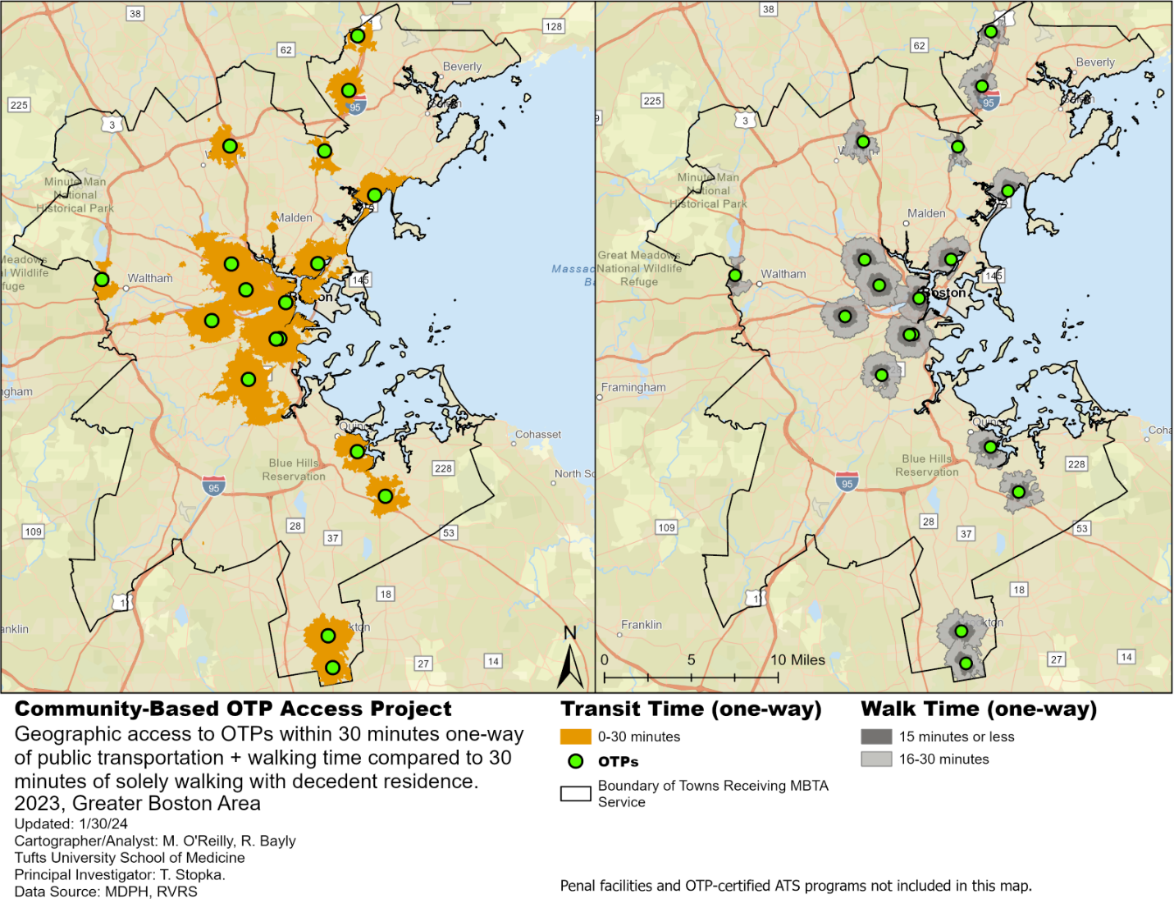
Figure A16. Transit-Based Access to Opioid Treatment Programs (OTP) in Towns receiving Metropolitan Boston Transit Authority (MBTA) Service, 2023.

Walking-time and transit-based service areas share substantial overlap (Figure A16). Eighty percent of decedents within a 30-minute transit-based time to an OTP were also within a 30-minute walk time.
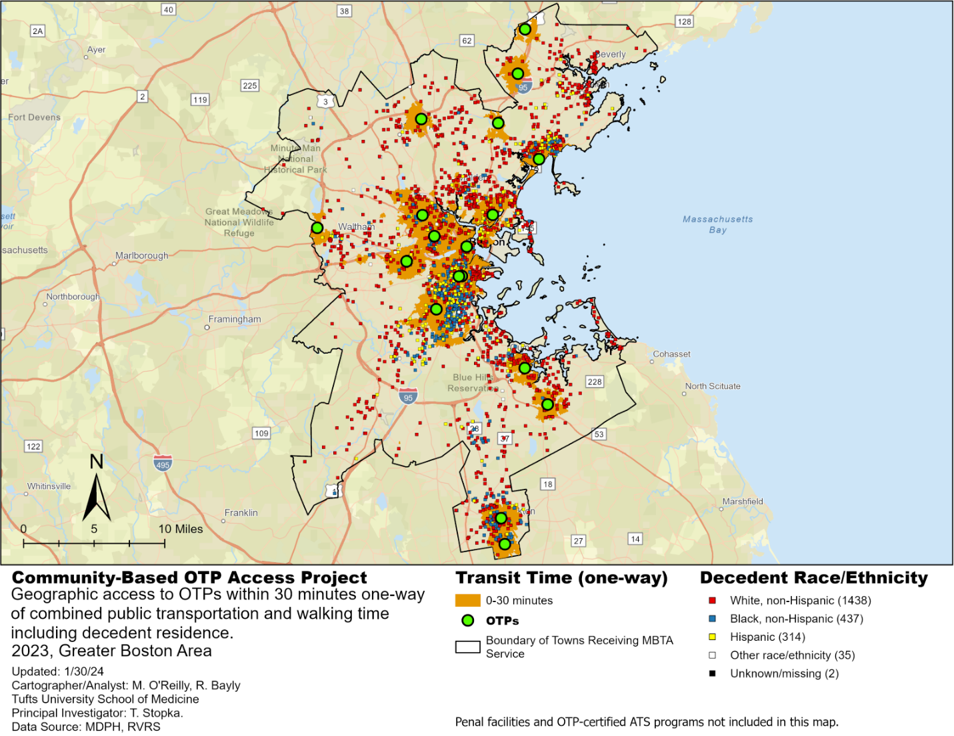
Figure A17. Transit-Based Access to Opioid Treatment Programs (OTP) in Towns receiving Metropolitan Boston Transit Authority (MBTA) Service and Decedent Residences (geomasked), 2023.

Many OTP transit access areas with limited access to OTPs appear as the distance from Boston increases (Figure A17). Most suburbs receive MBTA service, but that service is often only by commuter bus or rail, running at comparatively lower frequencies and incurring greater travel costs. In many of these areas, there are no other options for transit, presenting a large obstacle for an OTP patient without a car. A relatively higher proportion of Hispanic and non-Hispanic Black decedents appear to have lived within OTP transit-based service areas than outside those areas.
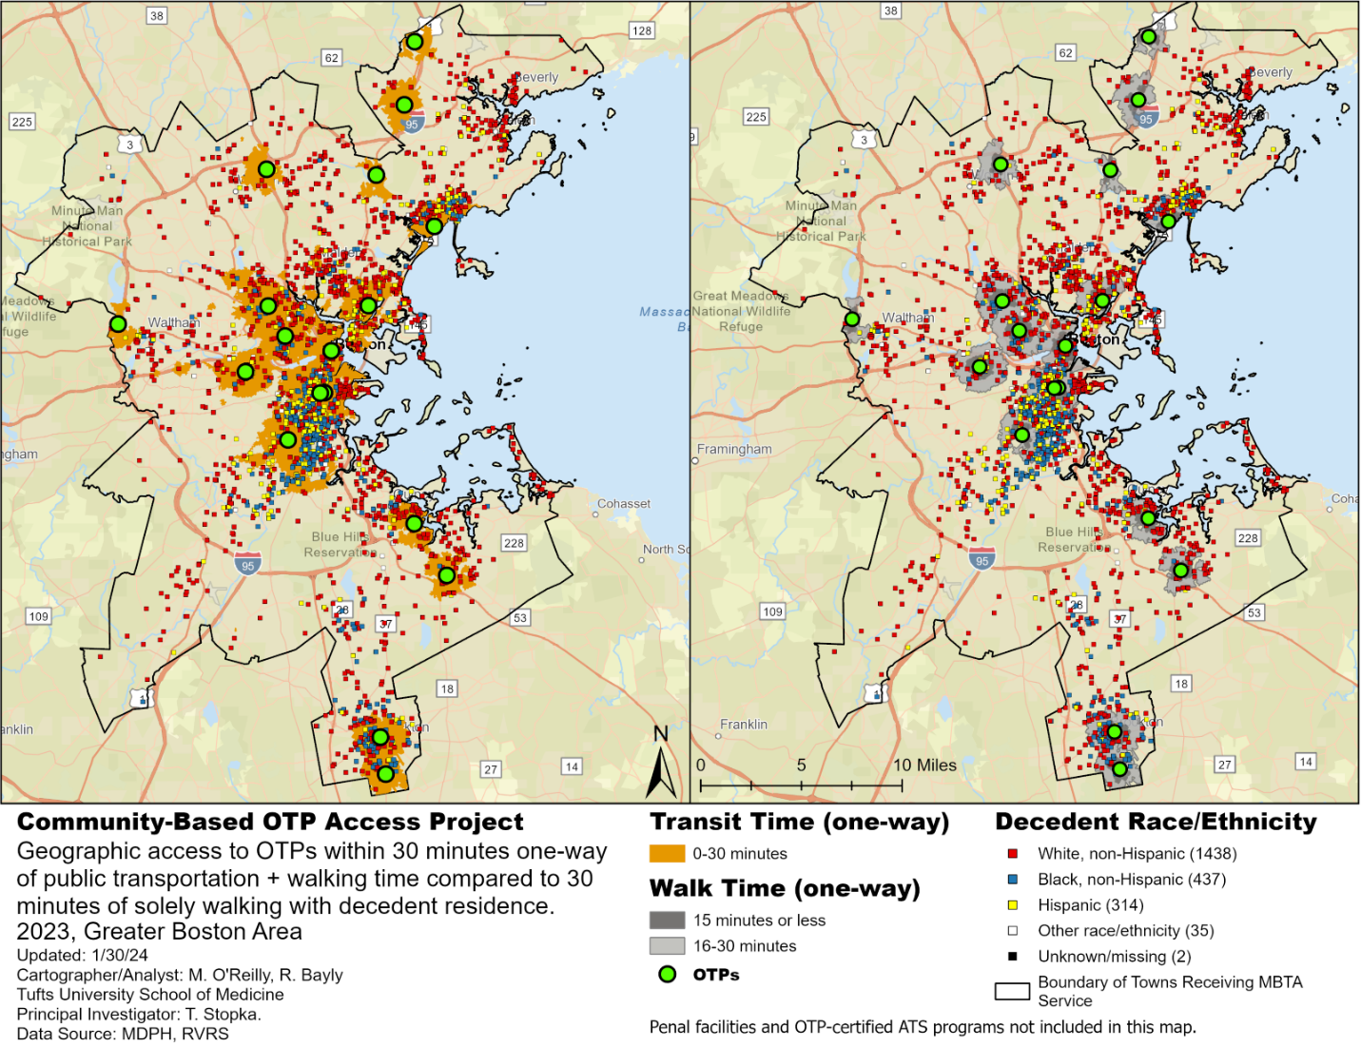
Figure A18. Transit-Based Access to Opioid Treatment Programs (OTP) in Towns receiving Metropolitan Boston Transit Authority (MBTA) Service, with Walk-times and Decedent Residences (geomasked), 2023.

A relatively higher proportion of Hispanic and non-Hispanic Black decedents appear to have lived within OTP transit-based catchment areas and within walking service areas than outside those areas (Figure A18).
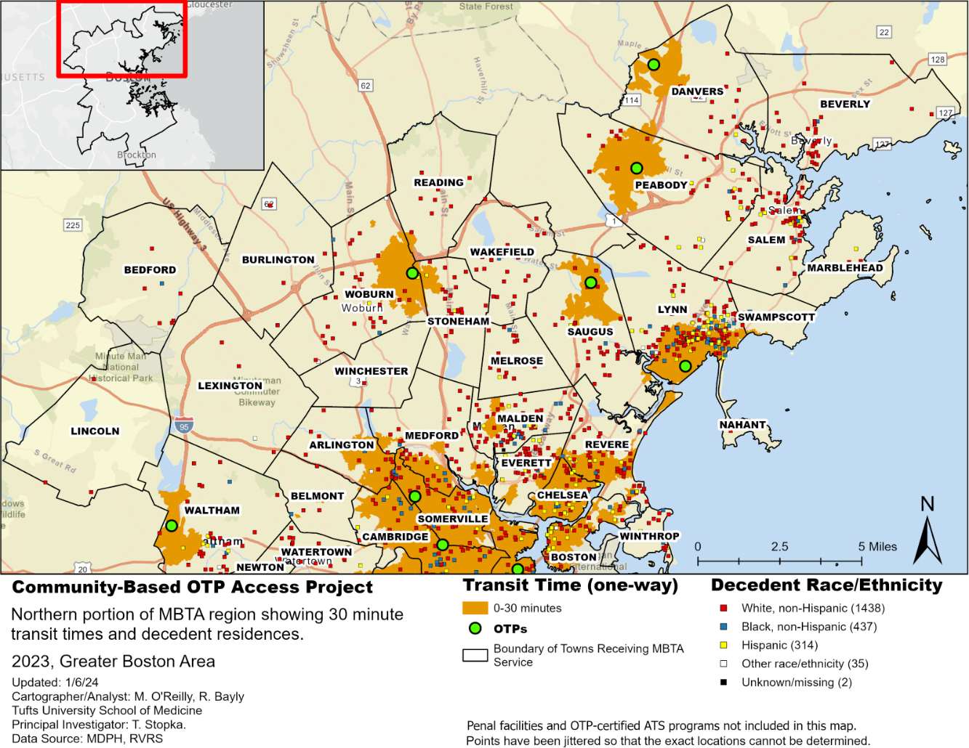
Figure A19. Geographically Distant Areas from OTPs Based on Public Transportation in Northern MBTA Region with Decedent Residences (geomasked)

Many towns receiving MBTA coverage lack access to an OTP within 30 minutes of transit-based travel, including Malden and Everett, which are close to Boston and receive rapid transit service (Figure A19). Other geographically distant areas include Waltham, Lincoln, Bedford, Lexington, Burlington, Woburn, Reading, Stoneham, Wakefield, Melrose, Saugus, Lynn, Salem, Peabody, Marblehead, Danvers, and Beverly. In the northern MBTA region, relatively higher proportions of Hispanic and non-Hispanic Black, decedents appear to have lived within OTP transit-based and walking service areas than outside those areas.
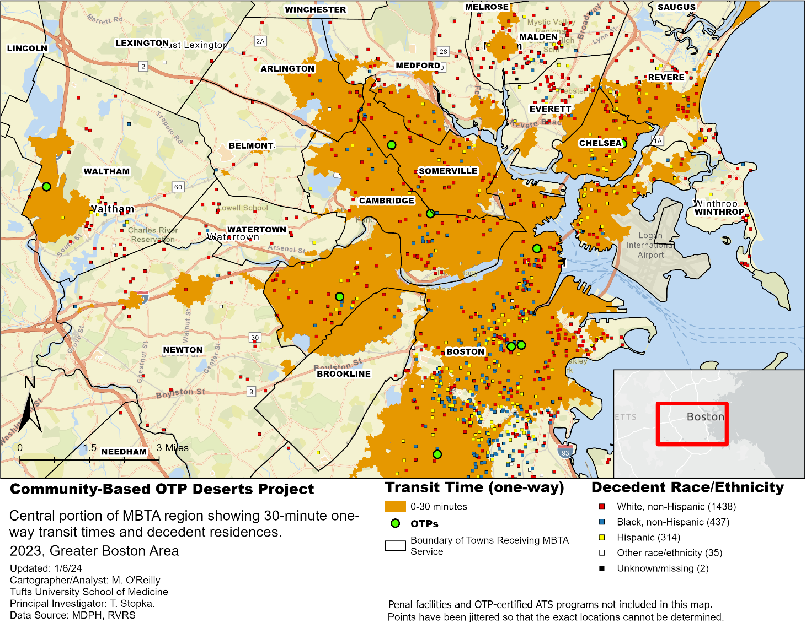
Figure A20. Geographically Distant Areas from OTPs Based on Public Transportation in Central MBTA Region with Decedent Residences (geomasked)

Many of the towns in the central region served by MBTA receive MBTA rapid transit, but geographically distant areas based on transit appear in Winthrop, Watertown, Waltham, and Newton (Figure A20). Distant areas in Everett and Malden are seen in detail.
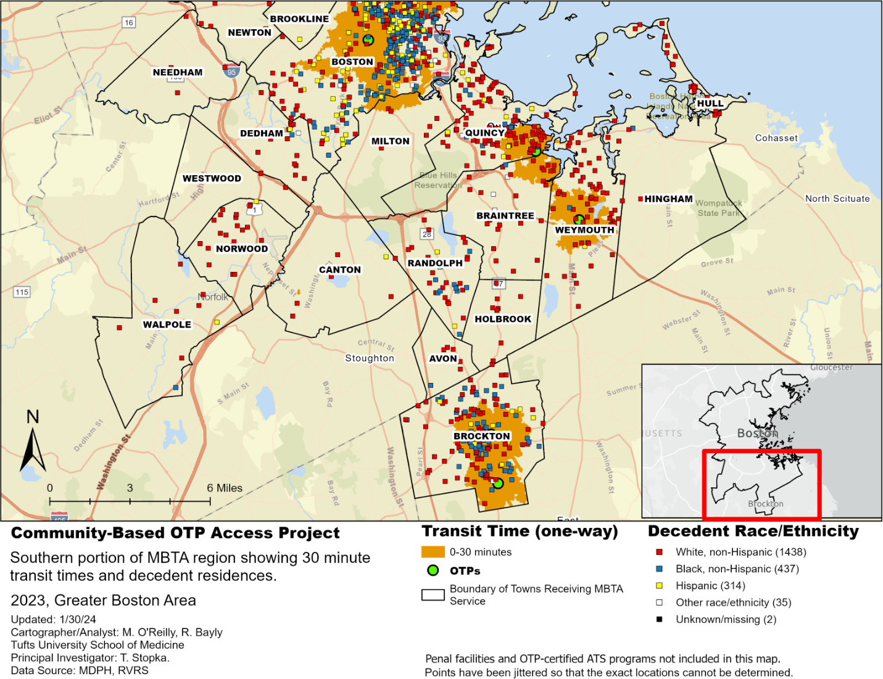
Figure A21. Geographically Distant Areas from OTPs Based on Public Transportation in Southern MBTA Region with Decedent Residences (geomasked)

Many towns south of Boston and in southwestern Boston itself lack access to an OTP within 30 minutes of transit-based travel (Figure A21). Geographically distant areas, with limited access to public transportation to OTPs, include Needham, Dedham, Norwood, Walpole, Canton, Quincy, Randolph, Braintree, Holbrook, Avon, Weymouth, and Hull.
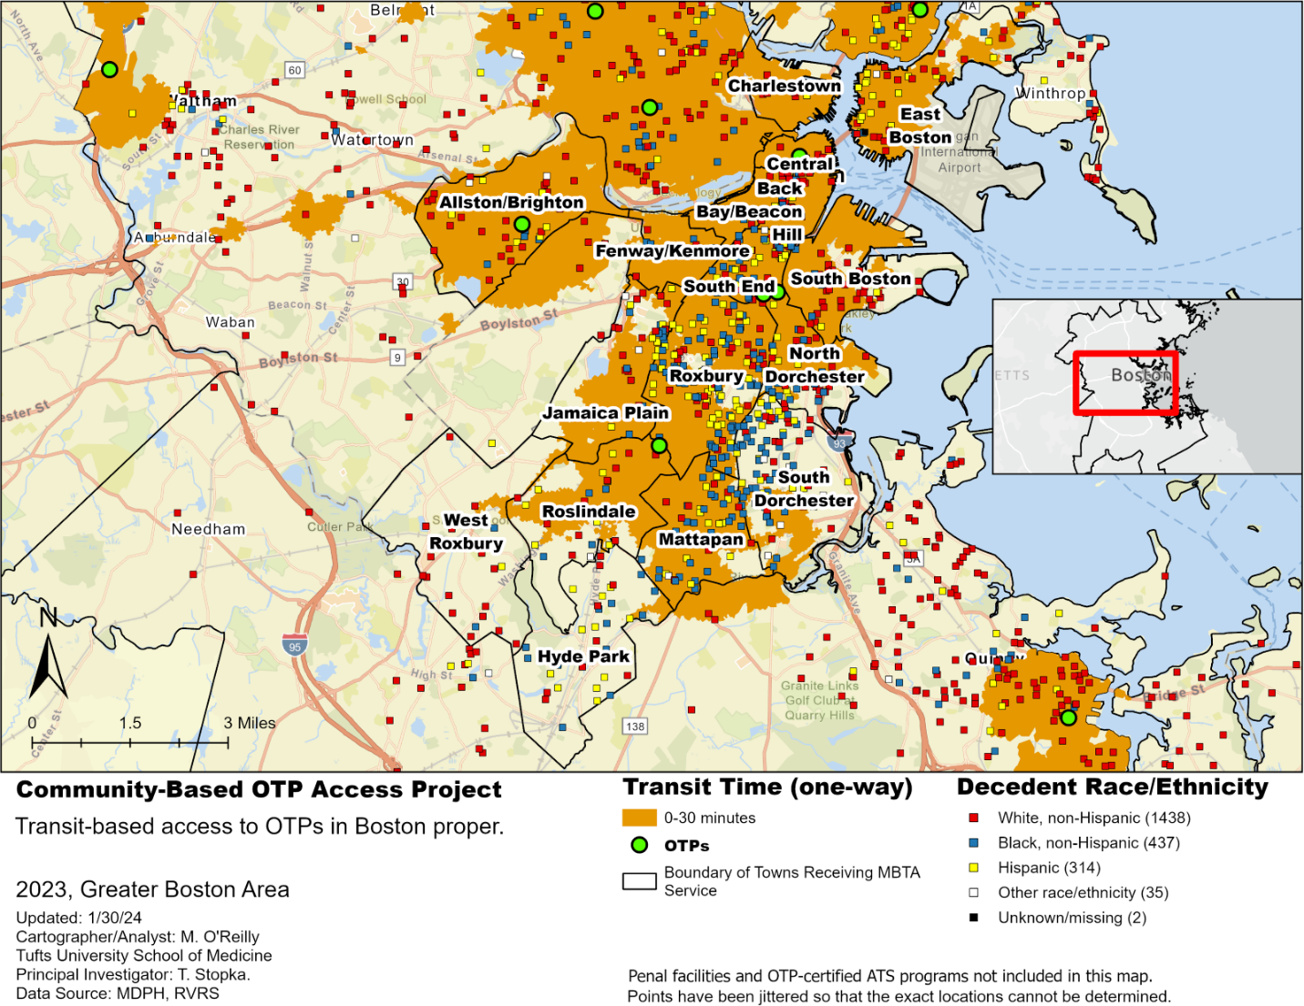
Figure A22. Geographically Distant Areas from OTPs Based on Public Transit Access in Boston with Decedent Residences (geomasked)
All of the communities within Boston have both rapid transit and bus service but distant areas, with limited access to public transportation to OTPs, were found in Hyde Park, West Roxbury, and South Dorchester (Figure A22).

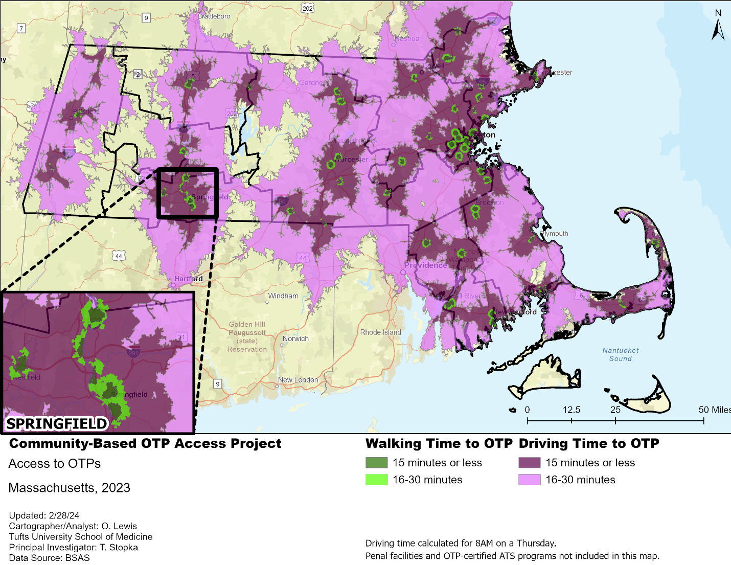
Figure A23: Walking and Driving Times Towards Community-Based Opioid Treatment Program Locations in Massachusetts, as of 2023.

