**GEOGRAPHIC ACCESS TO COMMUNITY-BASED OPIOID TREATMENT PROGRAMS**

**IN MASSACHUSETTS**

**May 2024 Report: Synopsis**

In Massachusetts (MA), there have been more than 2,000 opioid-related overdose deaths per year from 2016 to 2022, with 2,359 in 2022. The MA 2022 opioid overdose death rate of 33.6 per 100,000 population exceeded the national average. The MA rates per 100,000 for non-Hispanic Black (51.7), Hispanic (45.5), and non-Hispanic American Indian residents (143.6) were far higher than the rate for non-Hispanic White residents (33.3). Overdose deaths can be reduced through methadone treatment provided at Opioid Treatment Programs (OTPs). This report assesses spatial access to community-based OTPs across MA to help inform policy decisions to enhance OTP access.

**MAIN FINDINGS**

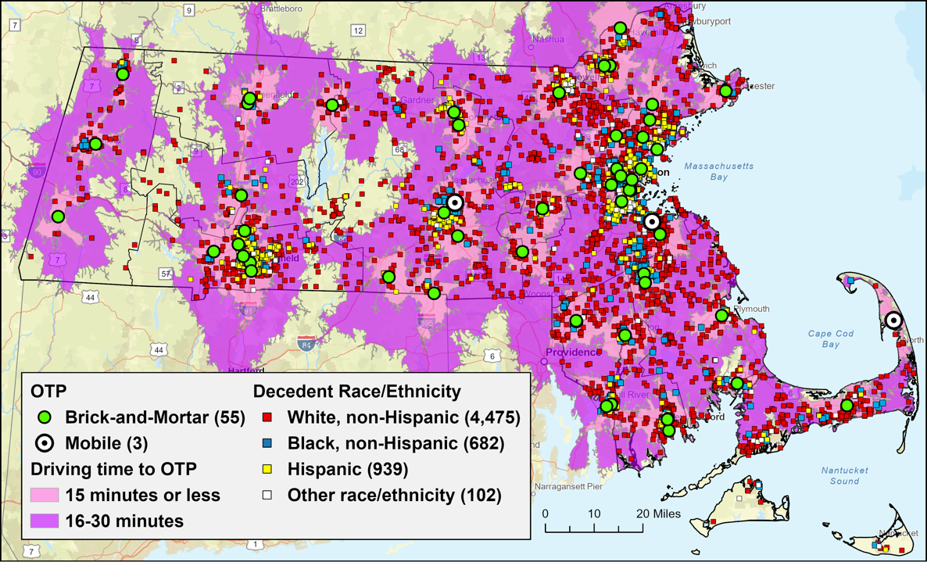MA has 55 brick-and-mortar and three mobile OTPs as of 2024. Among MA residents who died of opioid overdoses from 2020 to 2022, 98% lived within a 30-minute and 80% lived within a 15-minute drive to an OTP (see map). There are areas far from any OTP (areas more than a 30-minute one-way drive from an OTP), including western MA between the Berkshires and the Connecticut River; the Winchendon area, near the New Hampshire border; between Worcester and the Quabbin Reservoir; between Springfield and Sturbridge, from the Mass Pike to the Connecticut border; and Falmouth on Cape Cod, along with the Islands. We also identified areas with many opioid overdose deaths located at the edges of 30-minute drive-time areas (one-hour roundtrip). Many of these limited geographic access areas are in regions that have been hard hit by the opioid overdose epidemic, including just south of the Merrimack Valley, southeastern MA, and north-central MA. Thirty-minute walking access to an OTP (a one-hour round trip walk) from decedents’ places of residence was available to only 32% of individuals at the time of their death; 15-minute walking access was available to only 9%. This is an equity concern, as many individuals who would benefit from OTP access do not own a vehicle. The three most populous counties, Suffolk, Middlesex, and Norfolk, have the lowest rates of OTP access per population (excluding Dukes and Nantucket counties, which have none).

**Community-based OTPs and drive-time service areas.** OTP access is juxtaposed with approximate residence locations for fatal opioid-related overdose decedents from 2020-2022, by race and ethnicity. Resident locations of overdose fatalities are a proxy for current fatal opioid-related overdose risks.

**NEXT STEPS IN NEEDED RESEARCH**

This report lays the groundwork to examine other equity measures in OTP access by demographics, socioeconomics, and public transit accessibility, among others. Furthermore, analyses can also measure access by incorporating OTP capacity, waitlists, and wait times, as well as calculating OTP rates by population to identify gaps in services in densely populated areas. These analyses may also be applied to assess statewide access to buprenorphine treatment, harm reduction services, and recovery support.



Prepared for the Massachusetts Department of Public Health by Thomas J. Stopka et al.,

Dept. of Public Health and Community Medicine, Tufts University School of Medicine.

Questions to: [Thomas.stopka@tufts.edu](mailto:Thomas.stopka@tufts.edu), (617) 636-2110.



Prepared for the Massachusetts Department of Public Health by Thomas J. Stopka et al.,

Dept. of Public Health and Community Medicine, Tufts University School of Medicine.

Questions to: [Thomas.stopka@tufts.edu](mailto:Thomas.stopka@tufts.edu), (617) 636-2110.

