INDOOR AIR QUALITY ASSESSMENT

George H. Dunbar Elementary School
338 Dartmouth Street
New Bedford, Massachusetts 02740

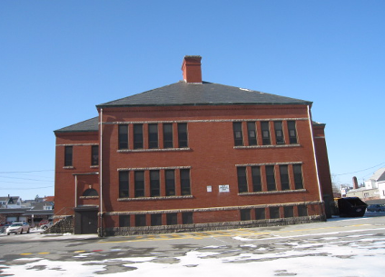

Prepared by:
Massachusetts Department of Public Health
Bureau of Environmental Health
Indoor Air Quality Program
March 2009

Background/Introduction
At the request of Mayor Scott Lang, the Massachusetts Department of Public Health (MDPH), Bureau of Environmental Health (BEH) provided assistance and consultation regarding indoor air quality (IAQ) at the Dunbar Elementary School (DES) located at 338 Dartmouth Street, New Bedford, Massachusetts. The assessment was coordinated with the Mayor’s Office, the New Bedford Health Department (NBHD), and the New Bedford Public School Department (NBSD) in an on-going effort to monitor and improve IAQ conditions in New Bedford’s public schools.
On January 16, 2009, a visit was made to this building by Cory Holmes, Environmental Analyst/Inspector for BEH’s Indoor Air Quality (IAQ) Program. During the assessment, Mr. Holmes was accompanied by Marianne De Souza, Director of Public Health, NBHD and Bruce Feno, Supervisor of Custodians, NBSD.
The DES is a two-story, red brick building reportedly built in the late 1800s. The school contains general classrooms, computer lab and limited office space. The basement contains an open floor area that serves as the library. The main office/administration area is located in the second floor hallway. The building has undergone minor renovations over the years. Most building materials are of original construction, such as plaster walls, ceilings, heating/ventilation and the original slate roof. Windows were reportedly replaced approximately 10-15 years ago and are openable throughout the building.
Methods
Air tests for carbon monoxide, carbon dioxide, temperature and relative humidity were conducted with the TSI, Q-Trak, IAQ Monitor, Model 8554. Air tests for airborne particle matter with a diameter less than 2.5 micrometers were taken with the TSI, DUSTTRAK™ Aerosol Monitor Model 8520. BEH staff also performed visual inspection of building materials for water damage and/or microbial growth.
Results
The school houses approximately 135 students in grades K through 5 with approximately 15 staff members. Tests were taken during normal operations at the school and results appear in Table 1.
Discussion
Ventilation
It can be seen from Table 1 that carbon dioxide levels were below 800 parts per million (ppm) in all but one area (the lunch room), indicating adequate air exchange at the time of the assessment. It is important to note that although air exchange appeared adequate, the school does not have a functioning mechanical ventilation system. The school’s original natural/gravity feed ventilation system has been abandoned, thus the sole source of ventilation in the building is openable windows. A few classrooms had open windows or were empty/sparsely populated, which can greatly reduce carbon dioxide levels. Carbon dioxide levels would be expected to increase with higher occupancy and windows closed.
Originally, ventilation was provided by a series of louvered vents. Each classroom has an approximately 3' x 3' grated air vent in the center of an interior wall near the ceiling (Picture 1) which is connected by a ventilation shaft to a vault-like “air-mixing” room in the basement (Picture 2). A corresponding 3' x 3' vent exists in each room (Picture 3) near the floor that is connected to an exhaust ventilation shaft that runs from the roof to the basement. Classrooms were constructed around these shafts to provide exhaust ventilation. The draw of air into these vents is controlled by a draw chain pulley system. The chains of the pulley system were designed to set the flue in the ventilation shaft at a desired angle to adjust fresh air intake (Pictures 1 and 4).
Air movement is provided by the stack effect. Heating elements located in the base of the ventilation shaft warm the air, which rises up the ventilation shafts (Picture 5). As the heated air rises, negative pressure is created, which draws cold air from the enclosed air-mixing room in the basement into the heating elements/ventilation shaft. This system was designed to draw in outside air from windows in the air-mixing room. The percentage of fresh air is controlled by a hinged window-pulley system (Pictures 6 and 7).
As mentioned previously, this ventilation system has been abandoned. Without a functional ventilation system, normally occurring environmental pollutants can build up. If this system is not to be restored, care should be taken to ensure ventilation shafts are rendered airtight in classrooms, in basement air-mixing rooms and at the top of abandoned chimney/ventilation stacks to prevent the egress of pests, dirt, dust and drafts into occupied areas.
Currently, ventilation in the school is controlled by the use of openable windows in classrooms. Classrooms were originally configured in a manner to use cross-ventilation to provide comfort for building occupants. The building is equipped with windows on opposing exterior walls. In addition, the building has hinged windows located above the hallway doors. This hinged window (called a transom) (Picture 8) enables classroom occupants to close the hallway door while maintaining a pathway for airflow. The design allows for airflow to enter an open window, pass through a classroom and subsequently pass through the open transom. Airflow then enters the hallway, passing through the opposing open classroom transom, into the opposing classroom and finally exits the building on the leeward side (opposite the windward side) (Figure 1). Transoms are opened using a rod/hinge system. With all windows and transoms open, airflow can be maintained in a building regardless of the direction of the wind. This system fails if the windows or transoms are closed (Figure 2).
Of note was the lack of mechanical ventilation or openable windows in the cafeteria and lunch room in the basement. Without supply/exhaust ventilation, indoor air pollutants can build up and lead to indoor air quality/comfort complaints. BEH did observe mechanical local exhaust ventilation in student restrooms; however, these vents were not operating and appeared not to have operated for some time. Exhaust ventilation is necessary in restrooms to remove excess moisture and to prevent restroom odors from penetrating into adjacent areas.
The Massachusetts Building Code requires a minimum ventilation rate of 15 cubic feet per minute (cfm) per occupant of fresh outside air or have openable windows in each room (SBBRS, 1997; BOCA, 1993). The ventilation must be on at all times that the room is occupied. Providing adequate fresh air ventilation with open windows and maintaining the temperature in the comfort range during the cold weather season is impractical. Mechanical ventilation is usually required to provide adequate fresh air ventilation.
Carbon dioxide is not a problem in and of itself. It is used as an indicator of the adequacy of the fresh air ventilation. As carbon dioxide levels rise, it indicates that the ventilating system is malfunctioning or the design occupancy of the room is being exceeded. When this happens, a buildup of common indoor air pollutants can occur, leading to discomfort or health complaints. The Occupational Safety and Health Administration (OSHA) standard for carbon dioxide is 5,000 parts per million parts of air (ppm). Workers may be exposed to this level for 40 hours/week, based on a time-weighted average (OSHA, 1997).
The MDPH uses a guideline of 800 ppm for publicly occupied buildings. A guideline of 600 ppm or less is preferred in schools due to the fact that the majority of occupants are young and considered to be a more sensitive population in the evaluation of environmental health status. Inadequate ventilation and/or elevated temperatures are major causes of complaints such as respiratory, eye, nose and throat irritation, lethargy and headaches. For more information concerning carbon dioxide, consult Appendix A.
Temperature measurements in the school ranged from 66° F to 78° F, which were within the MDPH recommended range in all but one of the areas surveyed (Table 1). The MDPH recommends that indoor air temperatures be maintained in a range of 70º F to 78º F in order to provide for the comfort of building occupants. In many cases concerning indoor air quality, fluctuations of temperature in occupied spaces are typically experienced, even in a building with an adequate fresh air supply. In addition, it is difficult to control temperature and maintain comfort without a functioning ventilation system. Of note was a lack of air conditioning (as well as a means for air exchange) in the first floor computer room. This room contains a large number of computers, printers and related-equipment that produce additional waste heat, which can lead to comfort complaints as well as damage to equipment from overheating.
The relative humidity measured in the building ranged from 11 to 24 percent at the time of the assessment, which was below the MDPH recommended comfort range (Table 1). The MDPH recommends a comfort range of 40 to 60 percent for indoor air relative humidity. Relative humidity levels in the building would be expected to drop during the winter months due to heating. The sensation of dryness and irritation is common in a low relative humidity environment. Low relative humidity is a very common problem during the heating season in the northeast part of the United States.

Microbial/Moisture Concerns
Water damaged wall plaster, peeling paint and efflorescence were observed in a number of areas throughout the building, most notably on the top floor (Pictures 9 through 14). Efflorescence is a characteristic sign of water damage to brick and mortar, but it is not mold growth. As moisture penetrates and works its way through mortar, brick or plaster, water-soluble compounds dissolve, creating a solution. As the solution moves to the surface of the material, the water evaporates, leaving behind white, powdery mineral deposits. In one case, wooden slats were affixed to the ceiling to prevent falling plaster (Picture 15). Water damage is most likely the result of water penetration through the building envelope (roof and exterior brick), as evidenced by numerous buckets and tarps in the attic to catch leaks through the original slate roof (Pictures 16 through 19). Another obvious source of water penetration was through a broken skylight (Picture 20).
Other potential moisture sources were noted around the exterior of the building, including damaged gutters/downspouts (Pictures 21 and 22); and missing/damaged mortar and exterior brick (Pictures 23 through 26). These conditions represent potential moisture penetration sources. Over time, these conditions can undermine the integrity of the building envelope and provide a means of water entry into the building via capillary action through foundation concrete and masonry (Lstiburek & Brennan, 2001). The freezing and thawing of water during winter months can lead to further damage and subsequent water penetration into the interior of the building. In addition, these breaches may provide a means for pests/rodents into the building.
Water damaged/mold colonized cardboard boxes and paper was observed in the air-mixing room near the girl’s restroom (Picture 27). The US Environmental Protection Agency (US EPA) and the American Conference of Governmental Industrial Hygienists (ACGIH) recommend that porous materials be dried with fans and heating within 24 to 48 hours of becoming wet (US EPA, 2001; ACGIH, 1989). If not dried within this time frame, mold growth may occur. Once mold has colonized porous materials, they are difficult to clean and should be removed/discarded.

Other IAQ Evaluations
Indoor air quality can be negatively influenced by the presence of respiratory irritants, such as products of combustion. The process of combustion produces a number of pollutants. Common combustion emissions include carbon monoxide, carbon dioxide, water vapor and smoke (fine airborne particle material). Of these materials, exposure to carbon monoxide and particulate matter with a diameter of 2.5 micrometers (μm) or less (PM2.5) can produce immediate, acute health effects upon exposure. To determine whether combustion products were present indoor, BEH staff obtained measurements for carbon monoxide and PM2.5.
Carbon Monoxide
Carbon monoxide is a by-product of incomplete combustion of organic matter (e.g., gasoline, wood and tobacco). Exposure to carbon monoxide can produce immediate and acute health affects. Several air quality standards have been established to address carbon monoxide and prevent symptoms from exposure to these substances. The MDPH established a corrective action level concerning carbon monoxide in ice skating rinks that use fossil-fueled ice resurfacing equipment. If an operator of an indoor ice rink measures a carbon monoxide level over 30 ppm, taken 20 minutes after resurfacing within a rink, that operator must take actions to reduce carbon monoxide levels (MDPH, 1997).
The American Society of Heating Refrigeration and Air-Conditioning Engineers (ASHRAE) has adopted the National Ambient Air Quality Standards (NAAQS) as one set of criteria for assessing indoor air quality and monitoring of fresh air introduced by HVAC systems (ASHRAE, 1989). The NAAQS are standards established by the US EPA to protect the public health from six criteria pollutants, including carbon monoxide and particulate matter (US EPA, 2006). As recommended by ASHRAE, pollutant levels of fresh air introduced to a building should not exceed the NAAQS levels (ASHRAE, 1989). The NAAQS were adopted by reference in the Building Officials & Code Administrators (BOCA) National Mechanical Code of 1993 (BOCA, 1993), which is now an HVAC standard included in the Massachusetts State Building Code (SBBRS, 1997). According to the NAAQS, carbon monoxide levels in outdoor air should not exceed 9 ppm in an eight-hour average (US EPA, 2006).
Carbon monoxide should not be present in a typical, indoor environment. If it is present, indoor carbon monoxide levels should be less than or equal to outdoor levels. On the day of the assessment, outdoor carbon monoxide concentrations were non-detect (ND). No levels of carbon monoxide were detected inside the building during the assessment (Table 1).
Particulate Matter (PM2.5)
The US EPA has established NAAQS limits for exposure to particulate matter. Particulate matter is airborne solids that can be irritating to the eyes, nose and throat. The NAAQS originally established exposure limits to particulate matter with a diameter of 10 μm or less (PM10). According to the NAAQS, PM10 levels should not exceed 150 microgram per cubic meter (μg/m³) in a 24-hour average (US EPA, 2006). These standards were adopted by both ASHRAE and BOCA. Since the issuance of the ASHRAE standard and BOCA Code, US EPA established a more protective standard for fine airborne particles. This more stringent PM2.5 standard requires outdoor air particle levels be maintained below 35 μg/m³ over a 24-hour average (US EPA, 2006). Although both the ASHRAE standard and BOCA Code adopted the PM10 standard for evaluating air quality, MDPH uses the more protective PM2.5 standard for evaluating airborne particulate matter concentrations in the indoor environment.
Outdoor PM2.5 concentrations were measured at 10 μg/m³ (Table 1). Indoor PM2.5 levels ranged from 8 to 11 μg/m³ (Table 1), which were below the NAAQS PM2.5 level of 35 μg/m³. Frequently, indoor air levels of particulates (including PM2.5) can be at higher levels than those measured outdoors. A number of mechanical devices and/or activities that occur in schools can generate particulate during normal operations. Sources of indoor airborne particulates may include but are not limited to particles generated during the operation of fan belts in the HVAC system, cooking in the cafeteria stoves and microwave ovens; use of photocopiers, fax machines and computer printing devices; operation of an ordinary vacuum cleaner and heavy foot traffic indoors. Although no measurable levels of carbon monoxide or elevated PM2.5 were detected, the potential for combustion products to migrate into occupied areas from the boiler room was observed via spaces under boiler room doors (Picture 28).
Volatile Organic Compounds
Indoor air quality can also be impacted by the presence of materials containing volatile organic compounds (VOCs). VOCs are substances that have the ability to evaporate at room temperature. Frequently, exposure to low levels of total VOCs (TVOCs) may produce eye, nose, throat and/or respiratory irritation in some sensitive individuals. For example, chemicals evaporating from a paint can stored at room temperature would most likely contain VOCs. In an effort to identify materials that can potentially increase indoor VOC concentrations, BEH staff examined classrooms for products containing these respiratory irritants.
The majority of classrooms contained dry erase boards and related materials. Materials such as dry erase markers and dry erase board cleaners may contain VOCs, such as methyl isobutyl ketone, n-butyl acetate and butyl-cellusolve (Sanford, 1999), which can be irritating to the eyes, nose and throat.
Other Conditions
Other conditions that can affect indoor air quality were observed during the assessment. In several classrooms, items were observed on windowsills, tabletops, counters, bookcases and desks. The large number of items stored in classrooms provides a source for dusts to accumulate. These items (e.g., papers, folders, boxes) make it difficult for custodial staff to clean. Items should be relocated and/or be cleaned periodically to avoid excessive dust build up. In addition, these materials can accumulate on flat surfaces (e.g., desktops, shelving and carpets) in occupied areas and subsequently be re-aerosolized causing further irritation (Pictures 29 and 30).
Window-mounted air conditioners (ACs) were observed in a few areas. These units are normally equipped with filters, which should be cleaned or changed as per manufacturer’s instructions to avoid the build-up and re-aerosolization of dirt, dust and particulate matter. Exposed fiberglass pipe insulation was observed in classroom 3 (Picture 31). Fiberglass insulation can provide a source of skin, eye and respiratory irritation.
Finally, in an effort to prevent scratching from sliding tables, tennis balls had been sliced open and placed on the table legs (Picture 32). Tennis balls are made of a number of materials that are a source of respiratory irritants. Constant wearing of tennis balls can produce fibers and cause TVOCs to off-gas. Tennis balls are made with a natural rubber latex bladder, which becomes abraded when used as a chair leg pad. Use of tennis balls in this manner may introduce latex dust into the school environment. Some individuals are highly allergic to latex (e.g., spina bifida patients) (SBAA, 2001). It is recommended that the use of materials containing latex be limited in buildings to reduce the likelihood of symptoms in sensitive individuals (NIOSH, 1997).
Conclusions/Recommendations
The general building conditions, maintenance, work hygiene practices and the condition/abandonment of HVAC equipment, if considered individually, present conditions that could degrade indoor air quality. When combined, these conditions can serve to further degrade indoor air quality. Of note was the obvious water damage to plaster ceilings and walls in classrooms directly related to the condition of the original slate roof and numerous leaks into the attic. Without repair/replacement of the roof, these leaks and resultant water damage will continue. Some of the conditions observed can be remedied by actions of building occupants. Other remediation efforts will require alteration to the building structure and equipment. For these reasons, a two-phase approach is required for remediation. The first consists of short-term measures to improve air quality and the second consists of long-term measures that will require planning and resources to adequately address the overall indoor air quality concerns.

The following short-term measures should be considered for implementation:
- Regulate airflow in classrooms using windows and transoms (for cross-ventilation) to control for comfort. Care should be taken to ensure windows are properly closed at night and weekends to avoid the freezing of pipes and potential flooding. Contact the window manufacturer concerning proper operation/maintenance of window systems.
- Seal abandoned supply and exhaust vents in classrooms on the roof and in the basement to prevent drafts and the egress of odors, dust and particulate matter into occupied areas.
- Consider installing portable/window-mounted AC in computer room to reduce heat.
- Examine the feasibility of installing a means of mechanical ventilation to the basement cafeteria and lunchroom. In the interim, use stand-up/industrial fans to circulate air.
- For buildings in New England, periods of low relative humidity during the winter are often unavoidable. Therefore, scrupulous cleaning practices should be adopted to minimize common indoor air contaminants whose irritant effects can be enhanced when the relative humidity is low. To control for dusts, a high efficiency particulate arrestance (HEPA) filter equipped vacuum cleaner in conjunction with wet wiping of all surfaces is recommended. Avoid the use of feather dusters. If used store them away from occupied areas. Drinking water during the day can help ease some symptoms associated with a dry environment (throat and sinus irritations).
- Consider having exterior brick foundation re-pointed and waterproofed to prevent further water intrusion. Repair/replace water damaged interior plaster. Examine surrounding non-porous areas for mold growth and disinfect with an appropriate antimicrobial if necessary.
- Repair/replace missing/damaged sections of gutter/downspout system to direct water away from the foundation of the building.
- Repair or seal leaking skylight in attic.
- Discard water damaged/mold-colonized boxes in air-mixing room near girl’s restroom (Picture 27).
- Relocate or consider reducing the amount of materials stored in classrooms to allow for more thorough cleaning of classrooms. Clean items regularly with a wet cloth or sponge to prevent excessive dust build-up.
- Clean/change filters for ACs as per the manufacture’s instructions or more frequently if needed.
- Install weather stripping underneath boiler room/hallway doors to prevent the migration of odors and particulates.
- Wrap exposed fiberglass pipe insulation in classroom 3 and in any other areas.
- Replace latex-based tennis balls with latex-free tennis balls or glides.
- Restore restroom exhaust ventilation. Repair and replace parts/motors as necessary.
- Consider adopting the US EPA document, “Tools for Schools” to maintain a good indoor air quality environment on the building (US EPA, 2000). This document can be downloaded from the Internet at: http://www.epa.gov/iaq/schools/index.html.
- Refer to resource manuals and other related indoor air quality documents for further building-wide evaluations and advice on maintaining public buildings. These materials are located on the MDPH’s website: http://mass.gov/dph/indoor_air.
The following long-term measures should be considered:
- Based on the age, physical deterioration and availability of parts, the BEH strongly recommends that an HVAC engineering firm evaluate options for providing adequate ventilation.
- Examine the feasibility of restoring the original gravity feed ventilation system. This may entail repair or replacement of heating elements located in ventilation shafts; repair of broken or missing warm air and cool air pulley chain/louver door systems to provide ventilation in this building as designed; repair of the hinged-pulley system and/or installation of openable windows in basement area to provide fresh air to classrooms. If restoration is not an option, consideration should be given to installing a mechanical ventilation system in the original building.
- Consider consulting with an architect, masonry firm or general contractor regarding the integrity of the building envelope, primarily concerning water penetration through the roof/exterior walls.
- Replace or make repairs to original slate roof. Once roof is repaired, repair/replace any remaining water-damaged building materials. Examine above and around these areas for microbial growth. Disinfect areas of water leaks with an appropriate antimicrobial.
References

ACGIH. 1989. Guidelines for the Assessment of Bioaerosols in the Indoor Environment. American Conference of Governmental Industrial Hygienists, Cincinnati, OH.
ASHRAE. 1989. Ventilation for Acceptable Indoor Air Quality. American Society of Heating, Refrigeration and Air Conditioning Engineers. ANSI/ASHRAE 62-1989
BOCA. 1993. The BOCA National Mechanical Code/1993. 8th ed. Building Officials and Code Administrators International, Inc., Country Club Hill, IL.

Lstiburek, J. & Brennan, T. 2001. Read This Before You Design, Build or Renovate. Building Science Corporation, Westford, MA. U.S. Department of Housing and Urban Development, Region I, Boston, MA
MDPH. 1997. Requirements to Maintain Air Quality in Indoor Skating Rinks (State Sanitary Code, Chapter XI). 105 CMR 675.000. Massachusetts Department of Public Health, Boston, MA.
NIOSH. 1997. NIOSH Alert Preventing Allergic Reactions to Natural Rubber latex in the Workplace. National Institute for Occupational Safety and Health, Atlanta, GA.
OSHA. 1997. Limits for Air Contaminants. Occupational Safety and Health Administration. Code of Federal Regulations. 29 C.F.R 1910.1000 Table Z-1-A.
Sanford. 1999. Material Safety Data Sheet (MSDS No: 198-17). Expo® Dry Erase Markers Bullet, Chisel, and Ultra Fine Tip. Sanford Corporation. Bellwood, IL.
SBAA. 2001. Latex In the Home And Community Updated Spring 2001. Spina Bifida Association of America, Washington, DC.
SBBRS. 1997. Mechanical Ventilation. State Board of Building Regulations and Standards. Code of Massachusetts Regulations. 780 CMR 1209.0
US EPA. 2000. Tools for Schools. Office of Air and Radiation, Office of Radiation and Indoor Air, Indoor Environments Division (6609J). EPA 402-K-95-001, Second Edition. http://www.epa.gov/iaq/schools/tools4s2.html

US EPA. 2001. “Mold Remediation in Schools and Commercial Buildings”. Office of Air and Radiation, Indoor Environments Division, Washington, DC. EPA 402-K-01-001. March 2001. Available at: http://www.epa.gov/iaq/molds/mold_remediation.html

US EPA. 2006. National Ambient Air Quality Standards (NAAQS). US Environmental Protection Agency, Office of Air Quality Planning and Standards, Washington, DC. http://www.epa.gov/air/criteria.html.
Picture 1

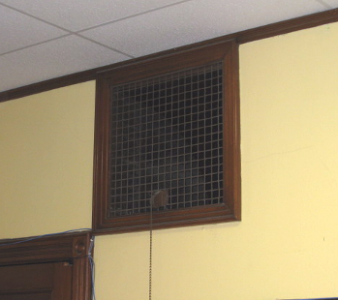

Natural Gravity Supply Vent near Classroom Ceiling, Note Pull Chain
for Adjustable Flue

Picture 2

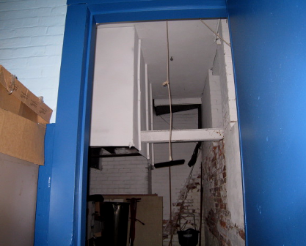

“Air-Mixing Room” in Basement

Picture 3

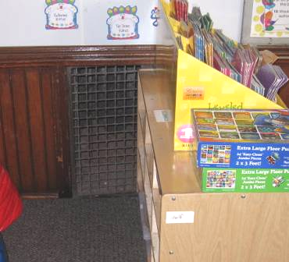

Natural Gravity Exhaust Vent near Classroom Floor

Picture 4

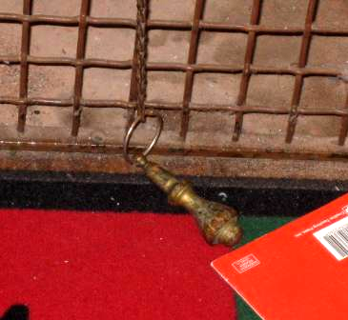

Pull Chain for Adjustable Flue

Picture 5

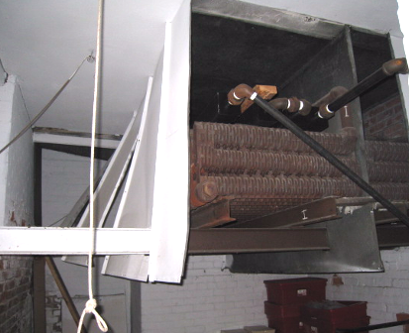

Ventilation Shaft with Heating Element/Radiator in Basement “Air-Mixing Room”

Picture 6

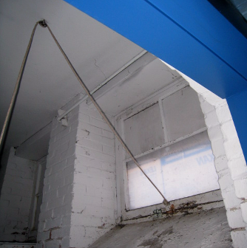

Basement Window in “Air Mixing Room” with Rope & Pulley System

Picture 7

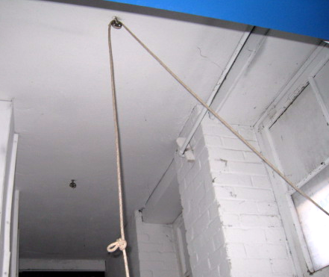

Basement Window in “Air Mixing Room” with Rope & Pulley System

Picture 8

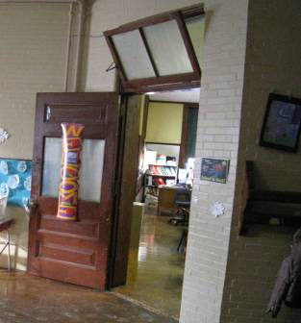

Transom Open over Classroom Door

Picture 9

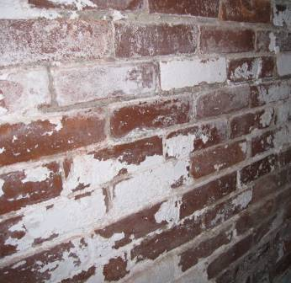

Efflorescence (i.e., Mineral Deposits) on Interior Brick

Picture 10

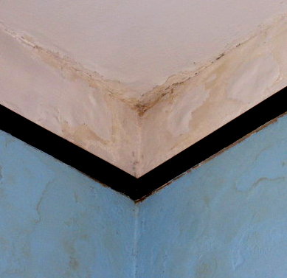

Water Damaged Ceiling/Wall Plaster and Efflorescence

Picture 11

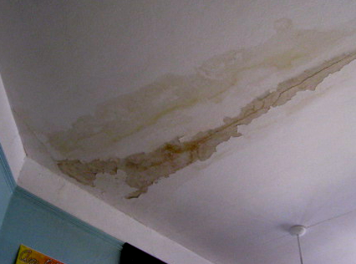

Water Damaged Ceiling Plaster and Efflorescence

Picture 12
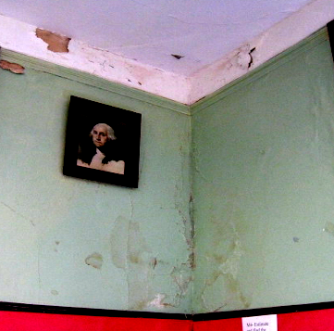

Water Damaged Ceiling/Wall Plaster and Efflorescence

Picture 13

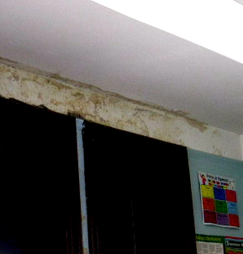

Water Damaged Ceiling/Wall Plaster and Efflorescence

Picture 14



Efflorescence and Peeling Paint in the Basement

Picture 15

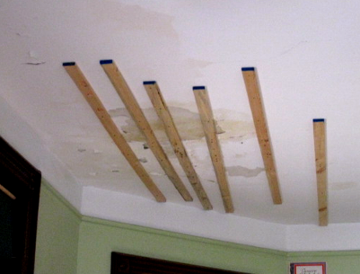

Water Damaged Ceiling Plaster, Note Wooden Slats to Prevent Falling

Picture 16

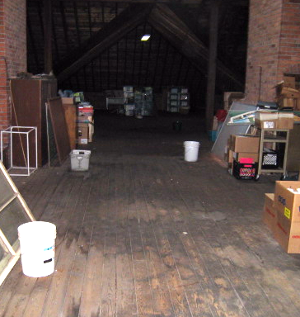

Buckets/Containers in Attic to Catch Rainwater, Note Water Stained Wooden Floor

Picture 17

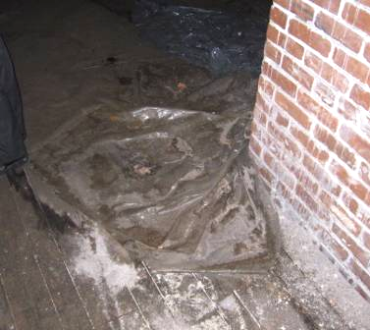

Plastic/Tarp on Attic Floor to Catch Rainwater

Picture 18

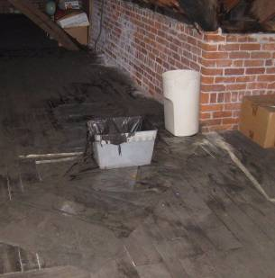

Plastic Tarp/Containers on Attic Floor to Catch Rainwater

Picture 19

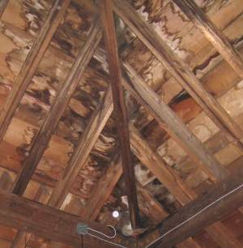

Water Damaged Attic Ceiling Due to Leaks
Picture 20

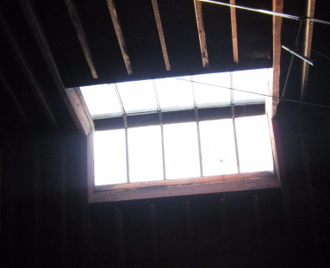

Broken (Glass) Skylight in Attic

Picture 21

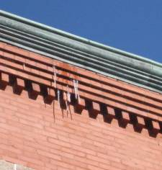

Icicles Forming Indicating Leak/Damaged Gutter System

Picture 22

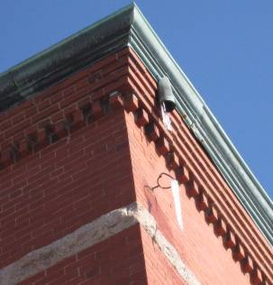

Missing/Damaged Downspout

Picture 23

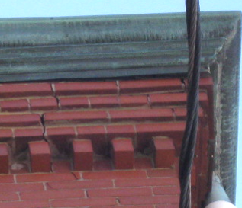

Missing/Damaged Mortar/Exterior Brick

Picture 24

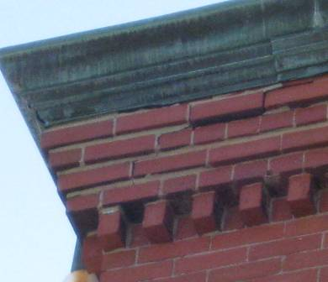

Missing/Damaged Mortar/Exterior Brick

Picture 25



Missing/Damaged Mortar/Exterior Brick

Picture 26

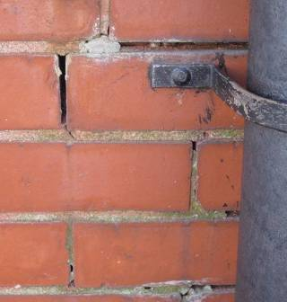

Missing/Damaged Mortar/Exterior Brick

Picture 27

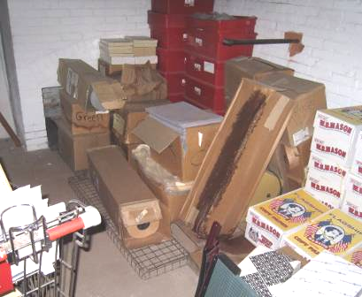

Water Damaged/Mold Colonized Cardboard Boxes and Paper in
Basement “Air-Mixing” Room (near Girl’s Restroom)

Picture 28

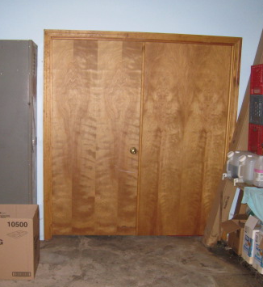

Spaces underneath Boiler Room Doors

Picture 29

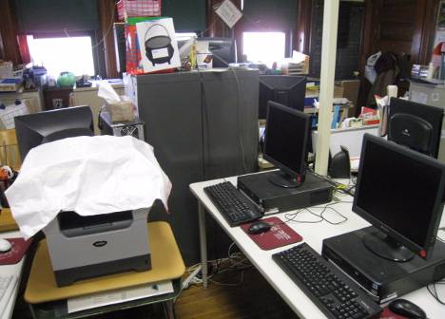

Accumulated Items in Classroom

Picture 30

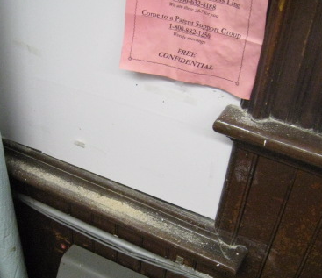

Dust/Debris on Flat Surfaces in Classroom 1

Picture 31

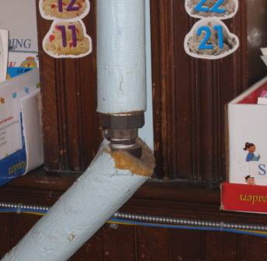

Exposed Fiberglass Insulation around Pipes in Classroom 3

Picture 32

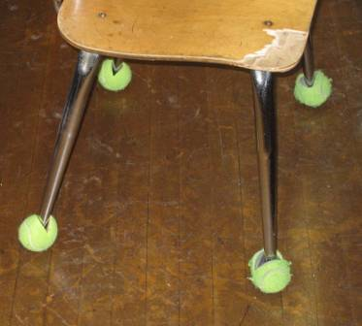

Tennis Balls on Chair Legs
Location/ Room | Occupants  in Room | Temp  (°F) | Relative  Humidity  (%) | Carbon  Dioxide  (ppm) | Carbon Monoxide  (ppm) | PM2.5  (µg/m³) | Windows  Openable | Ventilation |  | Remarks
 |  |  |  |  |  |  |  | Supply | Exhaust | Remarks
background |  | <32 | 12 | 356 | ND | 10 |  |  |  | Extreme cold, clear skies, sunny
Boy’s Basement Restroom |  |  |  |  |  |  | N | N | Y | Exhaust not operating-antiquated
Library | 12 | 66 | 24 | 499 | ND | 9 | N | N | N
Boiler Room |  |  |  |  | ND | 10 | N | N | Y | Spaces under door
Computer Room 4 | 1 | 73 | 17 | 521 | ND | 11 | Y | Y | Y | DO, no AC, DO
1 | 9 | 78 | 18 | 568 | ND | 9 | Y | Y | Y | WD CP, efflorescence walls, DO, plants, dust accumulation flat surfaces
Lunch Room | 17 | 71 | 20 | 804 | ND | 10 | N | N | N
Air Mixing Room (near girl’s restroom) |  |  |  |  |  |  |  |  |  | WD, mold-colonized stored boxes/paper-leak
Cafeteria | 33 | 74 | 22 | 679 | ND | 11 | N | N | N
7 | 11 | 75 | 13 | 581 | ND | 10 | Y | Y | Y | TB, WD walls/ceiling plaster & peeling paint, window open
8 | 0 | 78 | 16 | 564 | ND | 9 | Y | Y | Y | ~ 20 occupants gone 20 mins, DO
5 | 16 | 77 | 15 | 679 | ND | 10 | Y | Y | Y | DO, WD walls/ceiling plaster & peeling paint/efflorescence
6 | 13 | 75 | 11 | 459 | ND | 11 | Y | Y | Y | DO, WD ceiling plaster, window open
Principal’s Office | 3 | 77 | 13 | 501 | ND | 9 | Y | N | N | Window AC
Faculty Lounge | 5 | 76 | 14 | 539 | ND | 8 | Y | N | N
3 | 21 | 71 | 17 | 683 | ND | 9 | Y | Y | Y | Exposed fiberglass-pipe,  2 WD CTs
2 | 17 | 73 | 15 | 718 | ND | 11 | Y | Y | Y

