INDOOR AIR QUALITY ASSESSMENT

George H. Mitchell Elementary School
500 South Street
Bridgewater, Massachusetts 02324



Prepared by:
Massachusetts Department of Public Health
Bureau of Environmental Health
Indoor Air Quality Program
May 2009

Background/Introduction
At the request of Mr. Al Baroncelli, Facilities Director for the Bridgewater-Raynham Regional School District, the Massachusetts Department of Public Health (MDPH), Bureau of Environmental Health (BEH) provided assistance and consultation in an on-going effort to monitor and improve IAQ conditions in each of the Bridgewater-Raynham Regional schools.
On October 10, 2008, Susan Koszalka, Environmental Analyst/Regional Inspector for BEH’s Indoor Air Quality (IAQ) Program conducted an assessment at the George H. Mitchell Elementary School (MES), 500 South Street, Bridgewater, Massachusetts.
The MES has been visited by MDPH a number of times over the years, most recently in 2003 to conduct an assessment as part of the Bureau’s environmental health tracking project, a cooperative agreement with the US Centers for Disease Control and Prevention (CDC). That assessment was coordinated with the Bridgewater Health Department (BHD). During the 2003 academic school year the MES was visited four times (once during each season). Concurrent with each of the general IAQ assessments, health data for the school was collected by BEH’s Environmental Epidemiology Program. In November of 2005 a report was released that discussed results of all four general IAQ assessments, as well as the health data provided (MDPH, 2005).

Methods
In the current assessment, air tests for carbon monoxide, carbon dioxide, temperature and relative humidity were conducted with the TSI, Q-Trak, IAQ Monitor, Model 7565. Air tests for airborne particle matter with a diameter less than 2.5 micrometers were taken with the TSI, DUSTTRAK™ Aerosol Monitor Model 8520. BEH staff also performed visual inspection of building materials for water damage and/or microbial growth.

Discussion
Ventilation
It can be seen from Table 1 that carbon dioxide levels were below 800 parts per million (ppm) in 57 of 73 areas surveyed at the time of the assessment, indicating adequate air exchange in the majority of areas surveyed. It is important to note that a number of classrooms had open windows and/or were empty/sparsely populated, which can greatly reduce carbon dioxide levels. Carbon dioxide levels would be expected to increase with full occupancy and windows closed.
Fresh air in classrooms is supplied by a unit ventilator (univent) system. Univents draw air from the outdoors through a fresh air intake located at the base of each unit (Figure 1). Univents in the first (ground) floor are ceiling mounted in most areas (Picture 1), with fresh air intakes located above windows on the exterior walls. Univents in other areas are located at floor level. Most univents were operating at the time of the assessment. The univent in room 224 was reportedly deactivated due to excessive noise, which may indicate a mechanical problem. Obstructions to airflow such as papers and books stored on top of univents and bookcases, carts and other items placed in front of univent returns were seen in many classrooms. In order for univents to provide fresh air as designed, intakes must be allowed to operate and remain free of obstructions.
The mechanical exhaust ventilation system consists of ducted, grated wall vents. Exhaust vents were found obstructed by cabinets, desks and other items throughout the school (Pictures 2, 3 and 4). Exhaust in most classrooms was found to be either weak or off, and dust accumulation was noted on the exhaust grates (Picture 5). As with the univents, exhaust vents must also remain free of obstructions in order to function as designed.
To maximize air exchange, the MDPH recommends that both supply and exhaust ventilation operate continuously during periods of school occupancy. In order to have proper ventilation with a mechanical supply and exhaust system, the systems must be balanced to provide an adequate amount of fresh air to the interior of a room while removing stale air from the room. It is recommended that HVAC systems be re-balanced every five years to ensure adequate air systems function (SMACNA, 1994). The systems at MES were reportedly balanced in 2005; univent filters are changed four times per year, and roof air handling unit (AHU) filters are changed at least once per year, as necessary.
The Massachusetts Building Code requires a minimum ventilation rate of 15 cubic feet per minute (cfm) per occupant of fresh outside air or have openable windows in each room (SBBRS, 1997; BOCA, 1993). The ventilation must be on at all times that the room is occupied. Providing adequate fresh air ventilation with open windows and maintaining the temperature in the comfort range during the cold weather season is impractical. Mechanical ventilation is usually required to provide adequate fresh air ventilation.
Carbon dioxide is not a problem in and of itself. It is used as an indicator of the adequacy of the fresh air ventilation. As carbon dioxide levels rise, it indicates that the ventilating system is malfunctioning or the design occupancy of the room is being exceeded. When this happens, a buildup of common indoor air pollutants can occur, leading to discomfort or health complaints. The Occupational Safety and Health Administration (OSHA) standard for carbon dioxide is 5,000 parts per million parts of air (ppm). Workers may be exposed to this level for 40 hours/week, based on a time-weighted average (OSHA, 1997).
The MDPH uses a guideline of 800 ppm for publicly occupied buildings. A guideline of 600 ppm or less is preferred in schools due to the fact that the majority of occupants are young and considered to be a more sensitive population in the evaluation of environmental health status. Inadequate ventilation and/or elevated temperatures are major causes of complaints such as respiratory, eye, nose and throat irritation, lethargy and headaches. For more information concerning carbon dioxide, consult Appendix A.
Temperature measurements in the MES ranged from 70° F to 76° F, which were within the MDPH recommended range in the areas surveyed (Table 1). The MDPH recommends that indoor air temperatures be maintained in a range of 70º F to 78º F in order to provide for the comfort of building occupants. In many cases concerning indoor air quality, fluctuations of temperature in occupied spaces are typically experienced, even in a building with an adequate fresh air supply.
The relative humidity measured in the building ranged from 33 to 46 percent at the time of the assessment, which was within or close to the lower end the MDPH recommended comfort range (Table 1). The MDPH recommends a comfort range of 40 to 60 percent for indoor air relative humidity. Relative humidity levels in the building would be expected to drop during the winter months due to heating. The sensation of dryness and irritation is common in a low relative humidity environment. Low relative humidity is a very common problem during the heating season in the northeast part of the United States.

Microbial/Moisture Concerns
Most water-damaged ceiling tiles observed on previous assessments have been replaced; only four classrooms were found to still have water-damaged ceiling tiles in place (Table 1/Picture 6). Open seams between the sink countertops and backsplashes were observed in several rooms during previous assessments; however, all breaches had been sealed during the October, 2008 assessment.
Dehumidifiers were observed in many classrooms and were not operating at the time of the October, 2008 assessment. BEH staff were informed that the dehumidifiers are set on a timer; and drain directly into sinks. Compromised window molding was noted in previous assessments. Only two areas (admin office and room 229) were found to have compromised window molding during the October 2008 assessment (Table 1/Picture 7). Damaged window molding can lead to water penetration through the window system.
The US Environmental Protection Agency (US EPA) and the American Conference of Governmental Industrial Hygienists (ACGIH) recommend that porous materials be dried with fans and heating within 24 to 48 hours of becoming wet (US EPA, 2001; ACGIH, 1989). If not dried within this time frame, mold growth may occur. Once mold has colonized porous materials, they are difficult to clean and should be removed and discarded.

Other IAQ Evaluations
Indoor air quality can be negatively influenced by the presence of respiratory irritants, such as products of combustion. The process of combustion produces a number of pollutants. Common combustion emissions include carbon monoxide, carbon dioxide, water vapor and smoke (fine airborne particle material). Of these materials, exposure to carbon monoxide and particulate matter with a diameter of 2.5 micrometers (μm) or less (PM2.5) can produce immediate, acute health effects upon exposure. To determine whether combustion products were present in the school environment, BEH staff obtained measurements for carbon monoxide and PM2.5.
Carbon Monoxide
Carbon monoxide is a by-product of incomplete combustion of organic matter (e.g., gasoline, wood and tobacco). Exposure to carbon monoxide can produce immediate and acute health affects. Several air quality standards have been established to address carbon monoxide and prevent symptoms from exposure to these substances. The MDPH established a corrective action level concerning carbon monoxide in ice skating rinks that use fossil-fueled ice resurfacing equipment. If an operator of an indoor ice rink measures a carbon monoxide level over 30 ppm, taken 20 minutes after resurfacing within a rink, that operator must take actions to reduce carbon monoxide levels (MDPH, 1997).
The American Society of Heating Refrigeration and Air-Conditioning Engineers (ASHRAE) has adopted the National Ambient Air Quality Standards (NAAQS) as one set of criteria for assessing indoor air quality and monitoring of fresh air introduced by HVAC systems (ASHRAE, 1989). The NAAQS are standards established by the US EPA to protect the public health from six criteria pollutants, including carbon monoxide and particulate matter (US EPA, 2006). As recommended by ASHRAE, pollutant levels of fresh air introduced to a building should not exceed the NAAQS levels (ASHRAE, 1989). The NAAQS were adopted by reference in the Building Officials & Code Administrators (BOCA) National Mechanical Code of 1993 (BOCA, 1993), which is now an HVAC standard included in the Massachusetts State Building Code (SBBRS, 1997). According to the NAAQS, carbon monoxide levels in outdoor air should not exceed 9 ppm in an eight-hour average (US EPA, 2006).
Carbon monoxide should not be present in a typical, indoor environment. If it is present, indoor carbon monoxide levels should be less than or equal to outdoor levels. On the day of assessment, outdoor carbon monoxide concentrations were non-detect (ND) (Table 1). Carbon monoxide levels measured in the school were also ND.
Particulate Matter (PM2.5)
The US EPA has established NAAQS limits for exposure to particulate matter. Particulate matter is airborne solids that can be irritating to the eyes, nose and throat. The NAAQS originally established exposure limits to particulate matter with a diameter of 10 μm or less (PM10). According to the NAAQS, PM10 levels should not exceed 150 microgram per cubic meter (μg/m³) in a 24-hour average (US EPA, 2006). These standards were adopted by both ASHRAE and BOCA. Since the issuance of the ASHRAE standard and BOCA Code, US EPA established a more protective standard for fine airborne particles. This more stringent PM2.5 standard requires outdoor air particle levels be maintained below 35 μg/m³ over a 24-hour average (US EPA, 2006). Although both the ASHRAE standard and BOCA Code adopted the PM10 standard for evaluating air quality, MDPH uses the more protective PM2.5 standard for evaluating airborne particulate matter concentrations in the indoor environment.
Outdoor PM2.5 concentrations the day of the assessment were measured at 7 μg/m³ and PM2.5 levels measured inside the school ranged from 4 to 13 μg/m³ (Table 1), both of which were below the NAAQS PM2.5 level of 35 μg/m³. Frequently, indoor air levels of particulates (including PM2.5) can be at higher levels than those measured outdoors. A number of mechanical devices and/or activities that occur in schools can generate particulate during normal operations. Sources of indoor airborne particulates may include but are not limited to particles generated during the operation of fan belts in the HVAC system, cooking in the cafeteria stoves and microwave ovens; use of photocopiers, fax machines and computer printing devices; operation of an ordinary vacuum cleaner and heavy foot traffic indoors.
Volatile Organic Compounds
Indoor air concentrations can be greatly impacted by the use of products containing volatile organic compounds (VOCs). VOCs are carbon-containing substances that have the ability to evaporate at room temperature. Frequently, exposure to low levels of total VOCs (TVOCs) may produce eye, nose, throat and/or respiratory irritation in some sensitive individuals. For example, chemicals evaporating from a paint can stored at room temperature would most likely contain VOCs.
In an effort to identify materials that can potentially increase indoor VOC concentrations,
BEH staff examined classrooms for products containing these respiratory irritants. Many classrooms contained dry erase boards and dry erase markers. Materials such as dry erase markers and dry erase board cleaners may contain VOCs, (e.g., methyl isobutyl ketone, n-butyl acetate and butyl-cellusolve) (Sanford, 1999), which can be irritating to the eyes, nose and throat (Picture 8).
Cleaning products were found on countertops in some classrooms (Picture 9). Like dry erase materials, cleaning products contain VOCs and other chemicals that can be irritating to the eyes, nose and throat of sensitive individuals. Unlabeled/poorly labeled spray bottles were also observed in some classrooms. Products should be kept in their original containers and be clearly labeled as to their contents for identification purposes in the event of an emergency. Further, material safety data sheets (MSDS) for all cleaning products must be available at a central location in the building.
Air fresheners and deodorizing materials were observed in several areas. Air deodorizers
contain chemicals that can be irritating to the eyes, nose and throat of sensitive individuals.
Many air fresheners contain 1,4-dichlorobenzene, a VOC which may cause reductions in lung
function (NIH, 2006). Furthermore, deodorizing agents do not remove materials causing odors,
but rather mask odors that may be present in the area.
Other Conditions
Other conditions that can affect indoor air quality were observed during the assessment. In several classrooms, items were observed on the floor, windowsills, tabletops, counters, bookcases and desks. The large number of items stored in classrooms provides a source for dusts to accumulate. These items (e.g., papers, folders, boxes) make it difficult for custodial staff to clean. Items should be relocated and/or be cleaned periodically to avoid excessive dust build up. In addition, these materials can accumulate on flat surfaces (e.g., desktops, shelving and carpets) in occupied areas and subsequently be re-aerosolized causing further irritation.
Accumulated chalk dust was noted in some classrooms (Picture 10). Chalk dust is a fine particulate that can easily become airborne, irritating the eyes and respiratory system. Several rooms had missing, broken, and/or dislodged ceiling tiles (Pictures 11, 12 and 13). Missing and/or dislodged ceiling tiles can provide a pathway for the movement of drafts, dusts and particulate matter between rooms and floors. Items were also observed hanging from ceiling tiles (Pictures 14, 15 and 16). The movement or damage to ceiling tiles can release accumulated dirt, dust, and particulates that accumulate in the ceiling plenum into occupied areas. Building occupants should refrain from hanging objects from the ceiling tile system.
A variety of drying fruit, plants and vegetables were found in some classrooms. Plants should be properly maintained and equipped with drip pans. Plants should be located away from ventilation sources (e.g., air intakes or univent diffusers) to prevent the entrainment and/or aerosolization of dirt, pollen, or mold. Food and vegetables left to dry in classrooms can attract insects and rodents (Picture 17). Food items should be stored in airtight containers or removed from the classrooms at the end of each school day.
Large upholstered throw pillows and stuffed toys were seen in a few classrooms (Table 1/Picture 18). These items are covered with fabric that comes in contact with human skin. This type of contact can leave oils, perspiration, hair and skin cells. Dust mites feed upon human skin cells and excrete waste products that contain allergens. Further, increased relative humidity levels above 60 percent can perpetuate dust mite proliferation (US EPA, 1992).
Finally, several personal fans were observed to be occluded with dust and debris (Picture 19). Dust can be a source for eye and respiratory irritation. Personal fan housings and blades should be cleaned periodically with a wet paper towel or cloth in order to avoid the redistribution of accumulated dust into classrooms.

Conclusions/Recommendations
In view of the findings at the time of the assessment, the following recommendations are made:
- Operate all ventilation systems throughout the building (e.g., gym, cafeteria, classrooms) continuously during periods of school occupancy.
- Examine univent in room 224, which was reportedly deactivated due to excessive noise. Make adjustments/repairs as necessary.
- Inspect exhaust motors and belts periodically for proper function. Repair and replace as necessary.
- Remove all blockages from univents and exhaust vents to ensure adequate airflow.
- Investigate chronic temperature complaints by occupants in rooms 201 and 202, make adjustments/repairs to ventilation/thermostat system as necessary.
- Use openable windows in conjunction with mechanical ventilation to facilitate air exchange. Care should be taken to ensure windows are properly closed at night and weekends to avoid the freezing of pipes and potential flooding.
- Consider adopting a balancing schedule of every 5 years for all mechanical ventilation systems, as recommended by ventilation industrial standards (SMACNA, 1994).
- Change filters for air-handling equipment (e.g., univents, AHUs and ACs) as per the manufacturer’s instructions or more frequently if needed. Vacuum interior of units prior to activation to prevent the aerosolization of dirt, dust and particulates. Ensure filters fit flush in their racks with no spaces in between allowing bypass of unfiltered air into the unit.
- For buildings in New England, periods of low relative humidity during the winter are often unavoidable. Therefore, scrupulous cleaning practices should be adopted to minimize common indoor air contaminants whose irritant effects can be enhanced when the relative humidity is low. To control for dusts, a high efficiency particulate arrestance (HEPA) filter equipped vacuum cleaner in conjunction with wet wiping of all surfaces is recommended. Avoid the use of feather dusters. Drinking water during the day can help ease some symptoms associated with a dry environment (throat and sinus irritations).
- Replace the remainder of the water damaged ceiling tiles and ensure that all leaks have been repaired.
- Repair/replace failing window molding/strip caulking in admin office and room 229 as shown in Picture 7.
- Store cleaning products properly and out of reach of students. Ensure spray bottles are properly labeled. All cleaning products used at the facility should be approved by the school department with MSDS’ available at a central location.
- Discontinue the use of air fresheners in classrooms.
- Relocate or consider reducing the amount of materials stored in classrooms to allow for more thorough cleaning of classrooms. Clean items regularly with a wet cloth or sponge to prevent excessive dust build-up.
- Remove objects hanging from the ceiling tile system in order to avoid introducing ceiling tile material into classrooms.
- Replace missing/damaged ceiling tiles.
- Clean large cushions/pillows and/or upholstered items according to the manufacturers’ recommendations, and more frequently if soiled or stained.
- Store food items in airtight containers or remove from the classrooms at the end of each school day. It highly recommended that the principles of integrated pest management (IPM) be used to prevent pest infestation. A copy of the IPM recommendations can be obtained from the Massachusetts Department of Food and Agriculture (MDFA) website at the following website: http://www.state.ma.us/dfa/pesticides/publications/IPM_kit_for_bldg_mgrs.pdf. Activities that can be used to eliminate pest infestation may include the following:
  - Avoid having food preparation or storage equipment in classrooms.
  - Rinse out recycled food containers. Seal recycled containers in a tight-fitting lid to prevent rodent access.
  - Remove non-food items that rodents are consuming.
  - Stored foods in tight fitting containers.
  - To the extent possible, avoid eating at workstations. In areas were food is consumed, periodic vacuuming to remove crumbs are recommended.
  - Regularly clean crumbs and other food residues from ovens, toasters, toaster ovens, microwave ovens coffee pots and other food preparation equipment;
  - Holes as small as ¼” are enough space for rodents to enter an area. Examine each room and the exterior walls of the DSS office for means of rodent egress and seal. If doors do not seal at the bottom, install a weather strip as a barrier to rodents. Reduce harborages (e.g. discarded equipment and cardboard boxes) where rodents may reside (MDFA, 1996).
- Consider adopting the US EPA (2000) document, “Tools for Schools”, as an instrument for maintaining a good indoor air quality environment in the building. This document is available at: http://www.epa.gov/iaq/schools/index.html.
- Refer to resource manual and other related indoor air quality documents located on the MDPH’s website for further building-wide evaluations and advice on maintaining public buildings. These documents are available at: http://mass.gov/dph/indoor_air.

References

ACGIH. 1989. Guidelines for the Assessment of Bioaerosols in the Indoor Environment. American Conference of Governmental Industrial Hygienists, Cincinnati, OH.
ASHRAE. 1989. Ventilation for Acceptable Indoor Air Quality. American Society of Heating, Refrigeration and Air Conditioning Engineers. ANSI/ASHRAE 62-1989
BOCA. 1993. The BOCA National Mechanical Code/1993. 8th ed. Building Officials and Code Administrators International, Inc., Country Club Hill, IL.

MDFA. 1996. Integrated Pest Management Kit for Building Managers. Massachusetts Department of Food and Agriculture, Pesticide Bureau, Boston, MA. http://www.mass.gov/agr/pesticides/publications/IPM_kit_for_bldg_mgrs.pdf

MDPH. 1997. Requirements to Maintain Air Quality in Indoor Skating Rinks (State Sanitary Code, Chapter XI). 105 CMR 675.000. Massachusetts Department of Public Health, Boston, MA.
MDPH. 2005. Indoor Air Quality Assessment, Bridgewater Elementary School, Bridgewater, MA, Dated: November 2005. Massachusetts Department of Public Health, Bureau of Environmental Health, Boston, MA.
NIH. 2007. Chemical in Many Air Fresheners May Reduce Lung Function (#06-11). National Institutes of Health, Research Triangle Park, NC.
OSHA. 1997. Limits for Air Contaminants. Occupational Safety and Health Administration. Code of Federal Regulations. 29 C.F.R 1910.1000 Table Z-1-A.
Sanford. 1999. Material Safety Data Sheet (MSDS No: 198-17). Expo® Dry Erase Markers Bullet, Chisel, and Ultra Fine Tip. Sanford Corporation. Bellwood, IL.
SBBRS. 1997. Mechanical Ventilation. State Board of Building Regulations and Standards. Code of Massachusetts Regulations. 780 CMR 1209.0
SMACNA. 1994. HVAC Systems Commissioning Manual. 1st ed. Sheet Metal and Air Conditioning Contractors’ National Association, Inc., Chantilly, VA.

US EPA. 1992. Indoor Biological Pollutants. US Environmental Protection Agency, Environmental Criteria and Assessment Office, Office of Health and Environmental Assessment, Research Triangle Park, NC. EPA 600/8-91/202 January 1992.
US EPA. 2000. Tools for Schools. Office of Air and Radiation, Office of Radiation and Indoor Air, Indoor Environments Division (6609J). EPA 402-K-95-001, Second Edition. http://www.epa.gov/iaq/schools/tools4s2.html
US EPA. 2001. “Mold Remediation in Schools and Commercial Buildings”. Office of Air and Radiation, Indoor Environments Division, Washington, DC. EPA 402-K-01-001. March 2001. Available at: http://www.epa.gov/iaq/molds/mold_remediation.html

US EPA. 2006. National Ambient Air Quality Standards (NAAQS). US Environmental Protection Agency, Office of Air Quality Planning and Standards, Washington, DC. http://www.epa.gov/air/criteria.html.
Picture 1

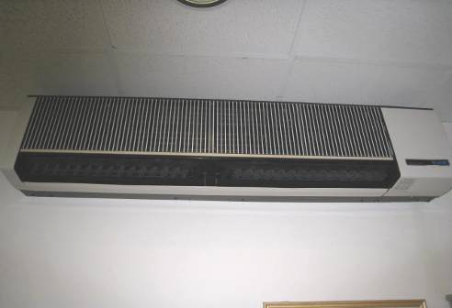

Ceiling Mounted Univent

Picture 2

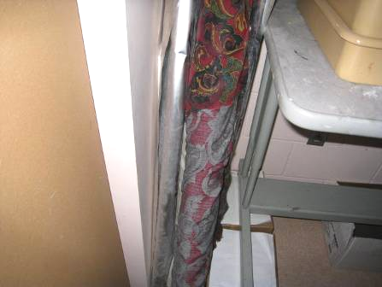

Exhaust Blocked

Picture 3

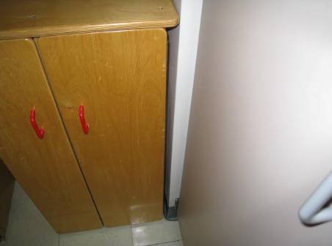

Exhaust Blocked by Cabinet

Picture 4

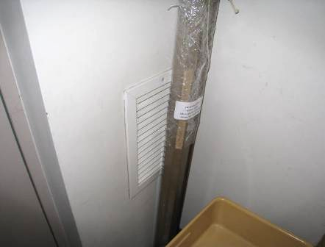

Exhaust Partially Blocked

Picture 5

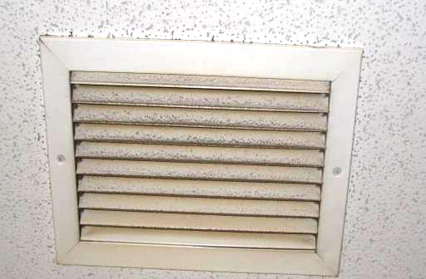

Dusty Exhaust Grate

Picture 6

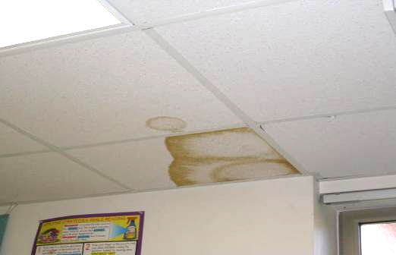

Water Damaged Ceiling Tiles

Picture 7

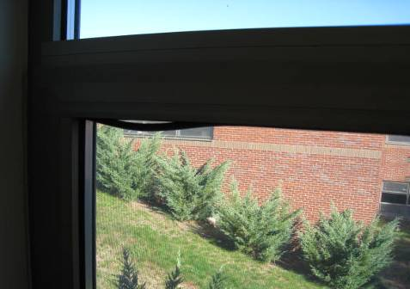

Loose Window Molding

Picture 8

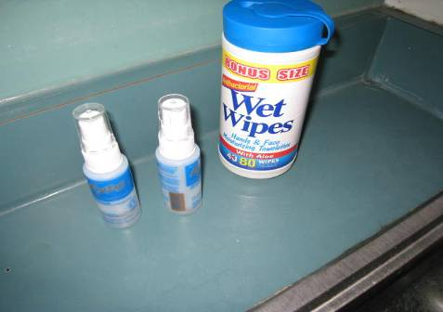

Expo Dry Erase Board Cleaners

Picture 9

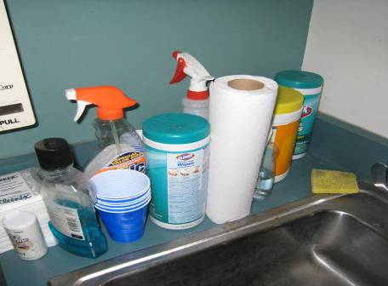

Cleaning Products on Sink Countertop

Picture 10



Chalk Dust on Eraser Tray

Picture 11

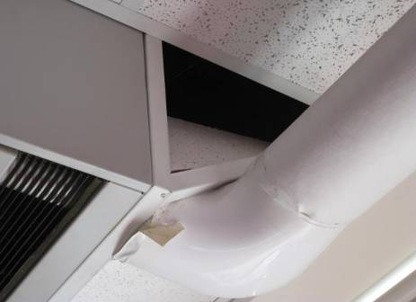

Breached Ceiling Tile near Univent

Picture 12

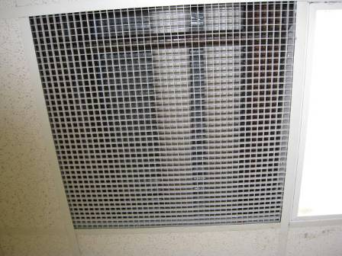

Exposed Grill Leading to Ceiling Plenum

Picture 13

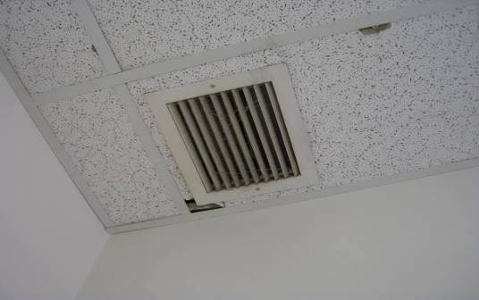

Damaged Ceiling Tiles

Picture 14

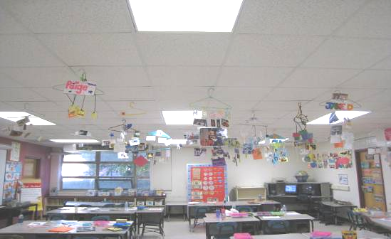

Objects Hanging From Ceiling Tile System

Picture 15

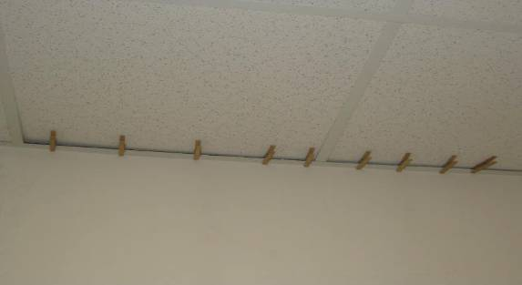

Clothespins on Ceiling (note displacement of ceiling tiles)

Picture 16

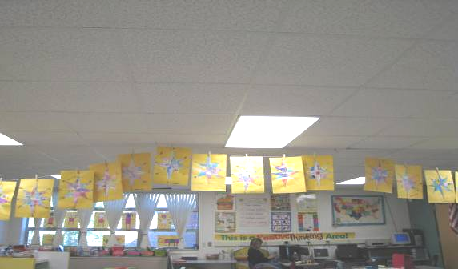

Objects Hanging From Ceiling Tile System

Picture 17

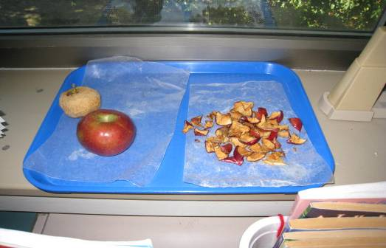

Drying Fruit

Picture 18

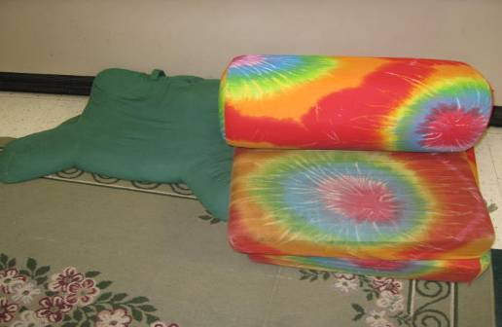

Upholstered Furniture and Pillows

Picture 19

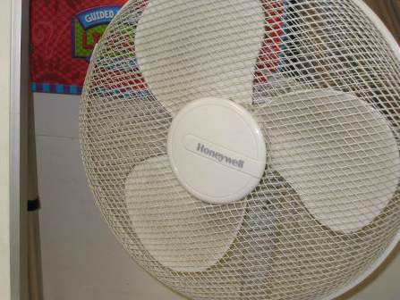

Accumulated Dust/Debris on Personal Fan

Location/ Room | Occupants  in Room | Temp  (°F) | Relative  Humidity  (%) | Carbon  Dioxide  (ppm) | Carbon Monoxide  (ppm) | PM2.5  (µg/m3) | Windows  Openable | Ventilation |  | Remarks
 |  |  |  |  |  |  |  | Supply | Exhaust | Remarks
background | - | 58 | 60 | 349 | ND | 7 | - | - | - | Fair weather, wind from the west at 5 MPH
Admin. Office | 1 | 74 | 42 | 641 | ND | 8 | Y | Y | Y | Loose window molding
Nurse’s Office | 1 | 73 | 44 | 703 | ND | 10 | N | Y | N
Conference | 0 | 73 | 43 | 620 | ND | 8 | Y | Y | Y | Exhaust dusty
Guidance | 0 | 73 | 43 | 629 | ND | 8 | Y | Y | Y
232 | 26 | 74 | 43 | 677 | ND | 7 | Y | Y | Y | Exhaust blocked, DO, DEM, CD, window open
225 | 26 | 74 | 43 | 871 | ND | 8 | Y | Y | Y | Exhaust blocked, objects hanging from ceiling, DO, DEM
231 | 26 | 74 | 41 | 799 | ND | 10 | Y | Y | Y | DO, DEM, window open
226 | 27 | 75 | 46 | 1337 | ND | 9 | Y | Y | Y | Exhaust weak or off, DEM, CD, clutter and food near UV
230 | 25 | 75 | 43 | 868 | ND | 7 | Y | Y | Y | Exhaust weak or off, DEM, CD, window open
227 | 1 | 73 | 39 | 598 | ND | 5 | Y | Y | Y | Exhaust blocked, objects hanging on clothesline from ceiling, DEM, CD
226 | 30 | 74 | 46 | 1231 | ND | 8 | Y | Y | Y | Exhaust weak or off, DO, DEM, CD, diced apples drying near UV, objects hanging on clothesline from ceiling
229 | 1 | 74 | 37 | 504 | ND | 5 | Y | Y | Y | Exhaust off, DO, loose window molding
228 | 0 | 74 | 39 | 514 | ND | 4 | Y | Y | Y | Exhaust off, DEM
235 | 29 | 75 | 46 | 1156 | ND | 10 | Y | Y | Y | Exhaust over door dusty, DEM, objects hanging from ceiling, DO, radiator
234 | 27 | 75 | 44 | 1013 | ND | 13 | Y | Y | Y | DO, DEM, objects hanging from ceiling, food near UV, stuffed animals, clutter, dusty exhaust above door
233 | 21 | 75 | 41 | 899 | ND | 8 | Y | Y | N | Exhaust not located, DO, stuffed animals, DEM, chemicals on sink, clutter, air purifier, AT-2, window open
217 | 5 | 73 | 42 | 660 | ND | 8 | Y | Y | Y | DEM, CD, exercise ball on UV
218-Art | 27 | 74 | 42 | 850 | ND | 8 | Y | Y | Y | Exhaust blocked, CD, clutter
216 | 8 | 73 | 43 | 759 | ND | 6 | Y | Y | Y | Chemicals on sink, plants near UV
215 | 0 | 72 | 38 | 524 | ND | 6 | Y | Y | Y | Exhaust blocked by cabinet, chemicals on sink, clutter
220 | 3 | 74 | 38 | 577 | ND | 5 | Y | Y | Y
221 | 0 | 73 | 37 | 497 | ND | 5 | Y | Y | Y | CD, objects hanging from ceiling, DO, clutter on UV
224 | 6 | 71 | 39 | 650 | ND | 9 | Y | Y  off | Y | Noisy UV turned off, fridge, microwave, toaster oven, chestnuts and straw wreath near UV, window A/C, respiratory and temperature complaints from occupants
223 | 3 | 73 | 40 | 730 | ND | 12 | Y | Y | Y | Top grill of UV dirty, DO
222 | 5 | 73 | 40 | 606 | ND | 11 | Y | Y | Y | Clutter on UV, easel /board in front of UV
Office-Central | 1 | 73 | 40 | 572 | ND | 6 | Y | Y | N | Air freshener
Nurse | 0 | 73 | 43 | 577 | ND | 7 | N | Y | N
112 | 0 | 71 | 41 | 465 | ND | 5 | Y | Y | Y | Easel/boards in front of ceiling mounted UV
113 | 0 | 72 | 40 | 458 | ND | 4 | Y | Y | Y | Furniture storage room, not occupied
Girls’ room Central 1 | 0 | 70 | 42 | 551 | ND | 11 | N | N | Y | Exhaust off, door vent
119 | 0 | 71 | 43 | 569 | ND | 8 | Y | Y | Y | Exhaust dusty, CD, DEM, chemicals on sink, AT-1 above UV, DO
114 | 0 | 71 | 41 | 494 | ND | 5 | Y | Y | Y | Room used for storage, musty smell, no visible mold, DEM, CD
115 | 0 | 70 | 42 | 497 | ND | 6 | Y | Y | Y | DEM, CD
118 | 0 | 74 | 42 | 557 | ND | 6 | Y | Y | Y | Exhaust dusty, DEM, CD, chemicals on sink, AT-1 over UV
116 | 0 | 71 | 41 | 571 | ND | 10 | Y | Y | Y | Chemicals on sink, dehumidifier (unplugged)
Computer Lab | 0 | 72 | 37 | 497 | ND | 6 | N | Y | Y | 30 computers, 2 printers
Cafetorium 1 | 50+ | 72 | 41 | 615 | ND | 10 | Y | Y | Y | Combination café and auditorium, PF
Cafetorium 2 | 50+ | 73 | 40 | 740 | ND | 11 | N | Y | Y
Cafetorium 3 | 50+ | 73 | 39 | 681 | ND | 10 | Y | N | N | PF
126-South | 1 | 74 | 38 | 561 | ND | 6 | Y | Y | Y | Several copy machines, window A/C, AT-1 over UV, electrical smell
125 | 0 | 73 | 38 | 549 | ND | 7 | Y | Y | Y | Multiple cardboard boxes on floor, no visible mold detected, DEM, DO to Room 126
124 | 23 | 73 | 37 | 719 | ND | 6 | Y | Y | Y | Chemicals on sink, objects hanging from ceiling, AT-1 by UV, exposed grill to plenum; pipes visible, DEM, CD
127 | 0 | 72 | 38 | 628 | ND | 7 | Y | Y | Y | DEM, CD, objects hanging from ceiling, plants on window, ceiling UV, DO, exposed grill to plenum; pipes visible
123 | 0 | 73 | 35 | 536 | ND | 5 | Y | Y | Y | Objects hanging from ceiling, dehumidifier, DEM, AT-1 by UV, exposed grill to plenum; pipes visible, DO, clothes pins on ceiling/wall junction, window open
128 | 0 (lunch) | 73 | 36 | 546 | ND | 5 | Y | Y | Y | Exhaust weak, chemicals on sink, dehumidifier, DEM, objects hanging from ceiling, PF, window open
129 | 0 (lunch) | 74 | 35 | 542 | ND | 5 | Y | Y | Y | Exhaust weak or off, partially blocked by white board, AT-2 near UV, DEM, window open
122 | 1 | 74 | 34 | 517 | ND | 6 | Y | Y | Y | Exhaust weak or off, partially blocked, objects hanging from ceiling
121 | 1 | 73 | 33 | 467 | ND | 6 | Y | Y | Y | Exhaust weak or off, dusty PF, CT-3, AT-1 near UV
Gymnasium | 0 | 73 | 43 | 673 | ND | 8 | N | Y | Y
105-North | 0 | 72 | 34 | 405 | ND | 5 | Y | Y | Y | DEM, MT-1, AT-1 near UV, dehumidifier, window open
106 | 35 | 73 | 40 | 636 | ND | 6 | Y | Y | Y | Exhaust weak, food and paper bags on sink, DEM, CD, CT-1 (cracked), exposed grill to plenum; pipes visible, CT-1 near UV, window open
104 | 0 | 71 | 39 | 516 | ND | 5 | Y | Y | Y | Dehumidifier, DEM, exposed grill to plenum; pipes and wires visible
107 | 0 | 72 | 40 | 502 | ND | 6 | Y | Y | Y | CD, DEM, CT-1 cut away near UV, DO to Room 108
108 | 2 | 73 | 41 | 561 | ND | 6 | Y | Y | Y | CT-1 cut away near UV, dehumidifier
103 | 27 | 73 | 39 | 821 | ND | 8 | Y | Y | Y | Exhaust weak or off, dehumidifier, DEM, CD, objects hanging from ceiling, AT-1 (cracked) near UV
102 | 29 | 73 | 40 | 658 | ND | 9 | Y | Y | Y | Dehumidifier, PF (dusty), DEM, exposed grill to plenum; pipes visible, window open
109 | 27 | 74 | 38 | 603 | ND | 9 | Y | Y | Y | Exhaust blocked by boxes, DEM, dehumidifier, AT-4 by UV, window open
101 | 0 | 73 | 38 | 610 | ND | 7 | Y | Y | Y | Room used for storage, dehumidifier, AT-1 near UV, DO to Room 102
Storage S-1 |  |  |  |  |  |  | N | Y | Y | DO to Room 102, chemical smell
110 | 32 | 72 | 38 | 650 | ND | 11 | Y | Y | Y | Dehumidifier, DEM, CT-2 near UV, AT-1 over exposed grill to plenum, CD, window open
111 | 28 | 74 | 42 | 892 | ND | 7 | Y | Y | Y | Exhaust blocked by clutter, DEM, PF (on), AT-1, exposed grill to plenum, window screen ajar
203-North | 20 | 75 | 45 | 1045 | ND | 11 | Y | Y | Y | DEM, clutter near UV
202 | 3 (students gone 5 minutes) | 74 | 37 | 637 | ND | 8 | Y | Y | Y | Exhaust dusty; louvers warped, DEM, PF on UV, clutter on UV, temperature complaints by occupants, window open
201 | 26 | 75 | 42 | 1057 | ND | 10 | Y | Y | Y | Exhaust by door, UV partially blocked by clutter, temperature complaints by occupants
204 | 26 | 75 | 44 | 1111 | ND | 7 | Y | Y | Y | DEM
213 | 26 | 76 | 40 | 826 | ND | 12 | Y | Y | Y | DEM, stuffed toys near and on UV
205 | 22 | 76 | 35 | 652 | ND | 6 | Y | Y | Y | DEM, Fabric covered standing easel in front of UV, gourds, vegetables displayed in room, window open
212 | 29 | 76 | 38 | 720 | ND | 7 | Y | Y | Y | PF, objects hanging from ceiling
206 | 29 | 76 | 38 | 800 | ND | 10 | Y | Y | Y | Exhaust dusty, DO
211 | 2 | 76 | 38 | 472 | ND | 7 | Y | Y | Y | DEM, objects hanging from ceiling, window open
207 | 30 | 75 | 36 | 667 | ND | 9 | Y | Y | Y | Exhaust weak , CT-1, clothes line on ceiling with clothes pins, DEM, window open
210 | 26 | 76 | 39 | 733 | ND | 9 | Y | Y | Y | Exhaust weak, DEM, window open
208 | 27 | 75 | 38 | 936 | ND | 8 | Y | Y | Y | Exhaust weak and blocked by clutter, PF, clutter on UV, stuffed toys
209 | 22 | 76 | 38 | 749 | ND | 9 | Y | Y | Y | Clutter around UV, objects hanging from ceiling, DO, window open

