ODOR INVESTIGATION

George R. Martin Elementary School
455 Cole Street
Seekonk, Massachusetts

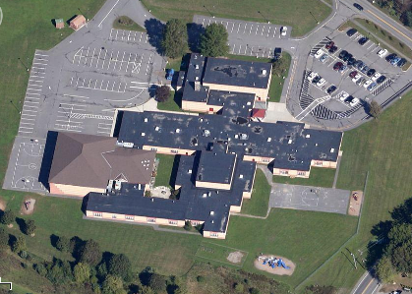

Prepared by:
Massachusetts Department of Public Health
Bureau of Environmental Health
Indoor Air Quality Program
January 2014

Background/Introduction
In response to a request by Mr. Jim Roy, Facilities Director, Seekonk Public Schools, the Massachusetts Department of Public Health (MDPH), Bureau of Environmental Health (BEH) provided assistance and consultation regarding indoor air quality (IAQ) at the George R. Martin Elementary School (MES), 455 Cole Street, Seekonk, Massachusetts. On November 21, 2013, Cory Holmes, Environmental Analyst/Regional Inspector in BEH’s IAQ Program visited the MES to conduct an assessment. Mr. Holmes was accompanied by Mr. Roy and Principal Bart Lush during the assessment. The request was prompted by concerns of chronic/musty odors in classroom B226. Mr. Holmes returned on December 26, 2013, accompanied by Mike Feeney, Director of BEH’s IAQ Program to conduct further evaluation.

Methods
BEH/IAQ staff performed visual inspection of building materials for water damage and/or microbial growth and examined the building for the presence of odors and/or other environmental concerns. On November 21, 2013, air testing for carbon monoxide was conducted with the TSI, Q-Trak, IAQ Monitor, Model 7565. Air tests for airborne particle matter with a diameter less than 2.5 micrometers were taken with the TSI, DUSTTRAK™ Aerosol Monitor Model 8520. Screening for total volatile organic compounds (TVOCs) was conducted using a Thermo Environmental Instruments Inc., Model 580 Series Photo Ionization Detector (PID). Air tests for ultrafine particulates (UFPs) were conducted with the TSI, P-Trak ™ Ultrafine Particle Counter Model 8525. On December 26, 2013 BEH/IAQ staff conducted further evaluation and testing of TVOCs and UFPs. In addition to background, BEH/IAQ staff took measurements in classrooms that were not experiencing odor issues for comparison purposes on both days of assessment. Classrooms were not occupied at the time of either evaluations were conducted.

Results and Discussion
On both days of assessment, a pungent/musty odor could be detected upon entry into classroom B226. The odor was noticeably potent towards the southeast wall of the classroom where the unit ventilator (univent) is located (Picture 1). A univent draws air from the outdoors through a fresh air intake located on the exterior wall of the building (Picture 2). Return air from the classroom is drawn through an air intake located at the base of the unit (Figure 1). Fresh and return air are mixed, filtered, heated and provided to classrooms through an air diffuser located in the top of the unit. A wall panel directly above the univent was removed and BEH/IAQ staff noted a space between the wall and windowsill (Picture 3). Cold drafts and odors were noted from this space, which makes the wall cavity (or the univent itself) the most likely source of the odors. However, to fully evaluate the wall cavity behind the univent, the hot water supply pipes must be cut and the entire unit must be pulled out.
Typical installation of a univent will have a short section of ductwork that provides an airtight connection from the outdoor air intake directly to the unit. It was not clear if the univent in classroom B226 had this ductwork in place or if it was drawing air from both the fresh air intake and wall cavity. If odors are being drawn from the wall cavity they can be distributed via the univent and/or they can be drawn across the classroom by the exhaust vent located near the hallway door.
At the time of the December 26, 2013 visit, Mr. Roy reported that a new univent had been ordered and once received; the current unit would be removed. It is important that this activity be conducted as weather permits to avoid the freezing of pipes, which can lead to flooding/water damage. At the time of removal to aid in the odor investigation, BEH/IAQ staff agreed to be present for the replacement if schedules are coordinated.

Microbial/Moisture Concerns
In order for building materials to support mold growth, a source of water exposure is necessary. Identification and elimination of the source of water moistening building materials is necessary to control mold growth. No visible mold growth or obvious signs of moisture were observed in classroom B226, with the exception of a water-damaged ceiling tile near the interior wall opposite the univent. BEH/IAQ staff inspected the ceiling plenum above this tile. No current moisture intrusion was evident, and no odors were detected. The stained tile appeared to be related to a previous leak that has since been repaired. However, as stated previously, the most likely source of odors is suspected to be behind/beneath the uninvent being replaced.
The US Environmental Protection Agency (US EPA) and the American Conference of Governmental Industrial Hygienists (ACGIH) recommends that porous materials be dried with fans and heating within 24 to 48 hours of becoming wet (US EPA, 2001; ACGIH, 1989). If porous materials are not dried within this time frame, mold growth may occur. Water-damaged porous materials cannot be adequately cleaned to remove mold growth. The application of a mildewcide to moldy porous materials is not recommended.

IAQ Pollutant Evaluations
Indoor air quality can be negatively influenced by the presence of respiratory irritants, such as products of combustion. The process of combustion produces a number of pollutants. Common combustion emissions include carbon monoxide, carbon dioxide, water vapor, and smoke (fine airborne particle material). Of these materials, exposure to carbon monoxide and particulate matter with a diameter of 2.5 micrometers (μm) or less (PM2.5) can produce immediate, acute health effects upon exposure. To determine whether combustion products were present in the indoor environment, BEH/IAQ staff obtained measurements for carbon monoxide and PM2.5 and ultrafine particulates.

Carbon Monoxide
Carbon monoxide is a by-product of incomplete combustion of organic matter (e.g., gasoline, wood and tobacco). Exposure to carbon monoxide can produce immediate and acute health effects. Several air quality standards have been established to address carbon monoxide and prevent symptoms from exposure to these substances. The MDPH established a corrective action level concerning carbon monoxide in ice skating rinks that use fossil-fueled ice resurfacing equipment. If an operator of an indoor ice rink measures a carbon monoxide level over 30 ppm, taken 20 minutes after resurfacing within a rink, that operator must take actions to reduce carbon monoxide levels (MDPH, 1997).
The American Society of Heating Refrigeration and Air-Conditioning Engineers (ASHRAE) has adopted the National Ambient Air Quality Standards (NAAQS) as one set of criteria for assessing indoor air quality and monitoring of fresh air introduced by HVAC systems (ASHRAE, 1989). The NAAQS are a reference standard used by the US EPA and others to protect the public health from six criteria pollutants, including particulate matter (US EPA, 2006). As recommended by ASHRAE, pollutants in indoor air should not exceed the NAAQS levels (ASHRAE, 1989). The NAAQS were adopted by reference in the Building Officials & Code Administrators (BOCA) National Mechanical Code of 1993 (BOCA, 1993), which is now an HVAC standard included in the Massachusetts State Building Code (SBBRS, 1997). According to the NAAQS, carbon monoxide levels in outdoor air should not exceed 9 ppm in an eight-hour average (US EPA, 2006).
Carbon monoxide should not be present in a typical, indoor environment. If it is present, indoor carbon monoxide levels should be less than or equal to outdoor levels. Outdoor carbon monoxide concentrations were non-detect (ND) at the time of the November 21, 2013 assessment (Table 1). No measurable levels of carbon monoxide were detected in the building during the assessment (Table 1).

Particulate Matter PM2.5
The US EPA has established NAAQS limits for exposure to particulate matter. Particulate matter (PM) is airborne solids that can be irritating to the eyes, nose and throat. The NAAQS originally established exposure limits to PM with a diameter of 10 μm or less (PM10). In 1997, US EPA established a more protective standard for fine airborne particulate matter with a diameter of 2.5 μm or less (PM2.5). The NAAQS has subsequently been revised, and PM2.5 levels were reduced. This more stringent PM2.5 standard requires outdoor air particle levels be maintained below 35 μg/m³ over a 24-hour average (US EPA, 2006). Although both the ASHRAE standard and BOCA Code adopted the PM10 standard for evaluating air quality, MDPH uses the more protective PM2.5 standard for evaluating airborne PM concentrations in the indoor environment.
The outdoor PM2.5 concentration on November 21, 2013 was measured at 18 μg/m³. PM2.5 levels measured indoors ranged from 11 to 12 μg/m³ (Table 1), which were below outdoor levels as well as the NAAQS PM2.5 level of 35 μg/m³. Frequently, indoor air levels of particulates (including PM2.5) can be at higher levels than those measured outdoors. A number of mechanical devices and/or activities that occur indoors can generate particulate during normal operations. Sources of indoor airborne particulates may include but are not limited to: particles generated during the operation of fan belts in the HVAC system; cooking in the cafeteria stoves and microwave ovens; use of photocopiers, fax machines and computer printing devices; operation of an ordinary vacuum cleaner; and, heavy foot traffic indoors.

Ultrafine Particulates (UFPs)
BEH/IAQ staff conducted air monitoring for airborne particulate with a TSI, P-TrakTM Ultrafine Particle Counter (UPC) Model 8525, which counts the number of particles that are suspended in a cubic centimeter (cm³) of air. This type of air monitoring is useful for tracking and identifying the source of airborne pollutants by counting the actual number of airborne particles. The source of particles can be identified by moving the UPC through a building towards the highest measured concentration of airborne particles. This equipment can ascertain whether unusual sources of ultrafine particles exist in a building or whether particles are penetrating through spaces in doors or walls. The primary purpose of this testing is to identify and reduce/prevent pollutant pathways.
UFPs testing was conducted during both site visits in classroom B226 while odors were present, and compared to outdoor/background levels and non-effected areas. All levels indoors, including classroom B226, were similar and/or below background levels on both days of assessment (Tables 1 and 2).

Volatile Organic Compounds
Indoor air can be greatly impacted by the use of products containing volatile organic compounds (VOCs). VOCs are carbon-containing substances that have the ability to evaporate at room temperature. Frequently, exposure to low levels of total VOCs (TVOCs) may produce eye, nose, throat, and/or respiratory irritation in some sensitive individuals. For example, chemicals evaporating from a paint can stored at room temperature would most likely contain VOCs.
In an effort to determine whether VOCs were present in the building, particularly classroom B226, air monitoring for TVOCs was conducted using a PID on both November 21 and December 26, 2013. Samples in outdoor air and non-effected areas were taken for comparison. Outdoor TVOC concentrations were ND (Tables 1 and 2), and no measurable levels of TVOCs were detected in the building during the assessments (Tables 1 and 2).

Conclusions/Recommendations
In view of the findings at the time of the assessments, the following is recommended:
- Continue with plans to replace univent (weather permitting) and windowsill/trim to investigate conditions behind/beneath unit for:
  - Breaches in exterior wall or window frames that can allow for drafts/moisture infiltration;
  - Water-damaged building components/debris;
  - Broken down/deteriorating/odor-producing building/HVAC components and/or other items in wall cavity; and
  - Evidence of pests/rodents.
- Determine if current univent has ductwork/metal airtight sleeve connecting unit to exterior fresh air intake.
- Prior to installation of new univent, consult with manufacturer/HVAC engineering firm regarding connection of ductwork/metal airtight sleeve to exterior fresh air intake to prevent draw of air, odors and particulates from the wall cavity.
- Contact BEH’s IAQ Program to coordinate scheduling for further investigation during univent removal/replacement.

References
ACGIH. 1989. Guidelines for the Assessment of Bioaerosols in the Indoor Environment. American Conference of Governmental Industrial Hygienists, Cincinnati, OH.
ASHRAE. 1989. Ventilation for Acceptable Indoor Air Quality. American Society of Heating, Refrigeration and Air Conditioning Engineers. ANSI/ASHRAE 62-1989.
BOCA. 1993. The BOCA National Mechanical Code/1993. 8th ed. Building Officials and Code Administrators International, Inc., Country Club Hill, IL.
MDPH. 1997. Requirements to Maintain Air Quality in Indoor Skating Rinks (State Sanitary Code, Chapter XI). 105 CMR 675.000. Massachusetts Department of Public Health, Boston, MA.
US EPA. 2001. Mold Remediation in Schools and Commercial Buildings. US Environmental Protection Agency, Office of Air and Radiation, Indoor Environments Division, Washington, D.C. EPA 402-K-01-001. March 2001.
US EPA. 2006. National Ambient Air Quality Standards (NAAQS). US Environmental Protection Agency, Office of Air Quality Planning and Standards, Washington, DC. http://www.epa.gov/air/criteria.html.
Picture 1
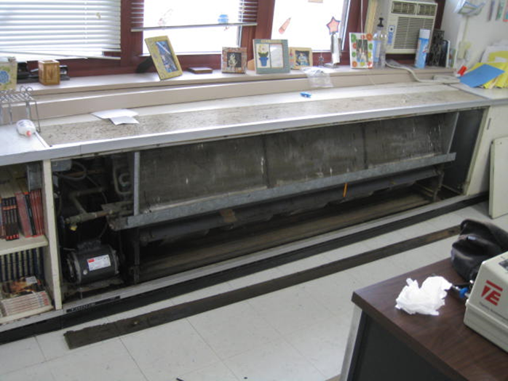
Univent on southeast wall of classroom B226, with cover removed for inspection
Picture 2
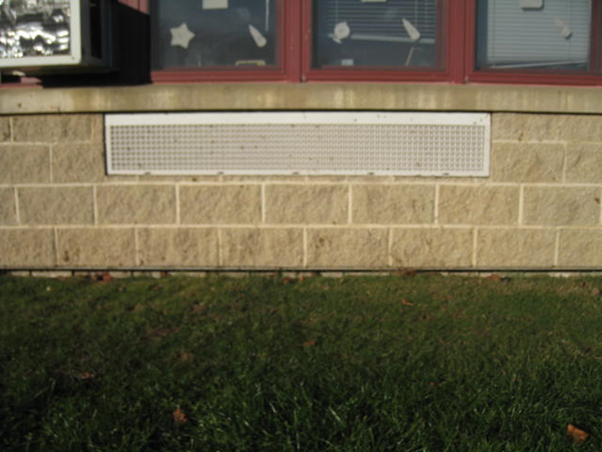
Univent fresh air intake

Picture 3
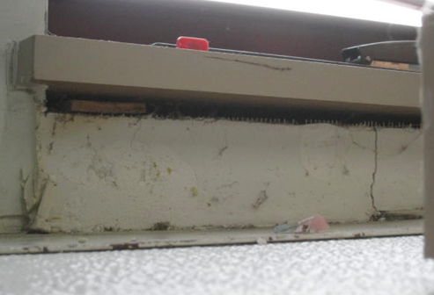
Space between wall and windowsill (near univent) where drafts/odors were detected in classroom B226
Location | TVOCs  (ppm) | Carbon  Monoxide  (ppm) | Number of Ultrafine Particulates per cm³ of air (in thousands) | PM2.5  (µg/m³) | Windows  Openable | Ventilation
Background | ND | ND | 16.2-18.5 | 18 |  |  |  | Cold, scattered clouds, moderate traffic on Rte. 195, winds WSW 2-9 mph, gusts up to 18 mph
B215 | ND | ND | 12.0 | 13 | Y | Y | Y
B216 | ND | ND | 12.1 | 13 | Y | Y | Y
B225 | ND | ND | 11.7-12 | 11 | Y | Y | Y
B226 | ND | ND | 11.8-12.9 | 11 | Y | Y | Y | Odors detected upon entry into classroom, stronger near exhaust vent and univent
B228 | ND | ND | 12.7 | 12 | Y | Y | Y
Hallway outside of B226 | ND | ND | 10.2-10.8 | 12
B232 | ND | ND | 12.6 | 11 | Y | Y | Y

Location | TVOCs  (ppm) | Number of Ultrafine Particulates per cm³ of air (in thousands) | Windows  Openable | Ventilation
Background | ND | 10.9-14.4 |  |  |  | Cold, overcast, moderate traffic on Rte. 195, winds NW 5-15 mph, gusts up to 20 mph
B218 | ND | 9.7 | N | Y | Y
B225 | ND | 9.3 | Y | Y | Y
B226 | ND | 9.5 | Y | Y | Y | Odors detected upon entry into classroom, stronger near exhaust vent and univent
Hallway outside of B226 | ND | 9.5
B232 | ND | 9.6 | Y | Y | Y

