INDOOR AIR QUALITY ASSESSMENT

Georgetown Middle/High School
11 Winter Street
Georgetown, Massachusetts 01833

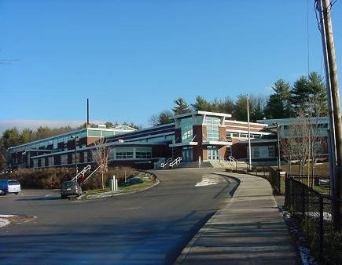

Prepared by:
Massachusetts Department of Public Health
Bureau of Environmental Health
Indoor Air Quality Program
August 2009

Background/Introduction
At the request of Terry Wiggin, Director of Finance and Operations for Georgetown Public Schools, the Massachusetts Department of Public Health (MDPH), Bureau of Environmental Health (BEH) provided assistance and consultation regarding indoor air quality concerns at the Georgetown Middle/High School (GMHS), 11 Winter Street, Georgetown, Massachusetts. The request was prompted by reports of water damage, possible mold growth and musty odors in the band room. On October 30, 2008, a visit to conduct an assessment was made to the GMHS by Susan Koszalka and James Tobin, Environmental Analysts/Inspectors in BEH’s Indoor Air Quality (IAQ) Program.
The school is a multi-level brick building originally constructed in 1962. An addition was built in 1969. In 1997, renovations were made to the building, which included an upgrade of mechanical ventilation components, a new roof and wall-to-wall carpeting in classrooms and hallways on the second and third floors. The third floor houses middle school classrooms and the band room. The second floor houses high school classrooms, a computer lab and media center. The first floor houses the auditorium, office space, TV studio, photography dark room, art room, science classrooms, woodshop, kitchen, cafeteria and the two gymnasiums. Windows throughout the building are openable. A visit was made previously to the GMHS by BEH staff on December 19, 2001. A report detailing conditions observed at the time of the visit with recommendations for improving indoor air quality was issued (MDPH, 2002).

Methods
Air tests for carbon dioxide, carbon monoxide, temperature and relative humidity were conducted with the TSI, Q-TRAK™ IAQ Monitor, Model 7565. Air tests for airborne particulate matter with a diameter less than 2.5 micrometers were taken with the TSI, DUSTTRAK™ Aerosol Monitor Model 8520. BEH staff also performed a visual inspection of building materials for water damage and/or microbial growth.

Results
The GMHS houses both middle and high school students in grades 6 through 12 with a student population of approximately 800 and a staff of approximately 110. Tests were taken during normal operations at the school and results appear in Table 1.

Discussion
Ventilation
It can be seen from Table 1 that carbon dioxide levels were above 800 parts per million (ppm) in 56 of 62 areas surveyed with 14 of those areas near or exceeding 2,000 ppm at the time of the assessment. Unit ventilators (univents) were deactivated on the day of the assessment. These elevated levels of carbon dioxide indicate poor air exchange throughout the building, mainly due to deactivated/non-functioning heating, ventilating and air conditioning (HVAC) equipment. At the conclusion of the assessment, BEH staff explained to school officials that ventilation equipment was not operating; therefore, carbon dioxide levels were above 800 ppm. Following the MDPH assessment, the school’s HVAC vendor reportedly inspected the roof to find that exhaust motors were deactivated. It is also important to note that several areas were sparsely populated or unoccupied, which can greatly reduce carbon dioxide levels. Carbon dioxide levels would be expected to be higher with full occupancy.
Fresh air for classrooms is supplied by unit ventilator (univent) systems (Pictures 1 and 2). A univent draws fresh, outdoor air through an air intake located on the exterior wall or roof of the building (Picture 3), and return air from the room through an air intake located at the base of the unit (Figure 1). Fresh and return air are mixed, filtered, heated and provided to occupied areas through an air diffuser located in the top of the unit.
Univents were operating in the majority of rooms at the time of the assessment; however, BEH staff found several of them in the ‘off’ position, preventing fresh air from being introduced into these rooms (Table 1). Further, univents were blocked by books, furniture and other stored items, thereby limiting airflow in these rooms (Picture 4). In order for univents to provide fresh air as designed, they must remain free of obstructions. Importantly, these units must remain “on” and be allowed to operate while rooms are occupied.
Exhaust ventilation in classrooms is provided by ceiling and wall-mounted vents (Picture 5). However, little or no draw of air was noted in most classrooms, indicating that the exhaust ventilation was off, or rooftop motors were not functioning. In addition, a number of exhaust vents were obstructed by furniture and other stored materials (Picture 6). It is also important to note that some classroom exhaust vents are located at the base of the wall near the classroom door. The exhaust capabilities of these vents can be diminished when classrooms doors are left open. In one instance, the vent was drawing air from the hallway due to its proximity to the open door. In another, an open door blocked the vent and prevented air from flowing toward the vent (Picture 7). In order to function properly, exhaust vents must be activated and allowed to operate while rooms are occupied. Without adequate exhaust ventilation, excess heat and stale air can build up leading to indoor air/comfort complaints.
Science classrooms are equipped with three separate ventilation controls. One control activates an air conditioning system during the warmer months; a second controls the unit ventilator and a third control activates an additional exhaust vent installed to facilitate ventilation during science experiments.
Mechanical ventilation for common areas such as the auditorium, cafeteria and gymnasiums is provided by rooftop or ceiling-mounted air handling units (AHUs). AHUs distribute fresh air via ceiling-mounted air diffusers and returns stale air back to AHUs via exhaust (Picture 8). The elevated carbon dioxide level in the main gymnasium indicates that the AHU was deactivated at the time of the assessment resulting in poor air exchange.
To maximize air exchange, the MDPH recommends that both supply and exhaust ventilation operate continuously during periods of school occupancy. In order to have proper ventilation with a mechanical supply and exhaust system, the systems must be balanced to provide an adequate amount of fresh air to the interior of a room while removing stale air from the room. It is recommended that HVAC systems be re-balanced every five years to ensure adequate air systems function (SMACNA, 1994). The systems at GMHS were reportedly balanced in 2006.
The Massachusetts Building Code requires a minimum ventilation rate of 15 cubic feet per minute (cfm) per occupant of fresh outside air or have openable windows in each room (SBBRS, 1997; BOCA, 1993). The ventilation must be on at all times that the room is occupied. Providing adequate fresh air ventilation with open windows and maintaining the temperature in the comfort range during the cold weather season is impractical. Mechanical ventilation is usually required to provide adequate fresh air ventilation.
Carbon dioxide is not a problem in and of itself. It is used as an indicator of the adequacy of the fresh air ventilation. As carbon dioxide levels rise, it indicates that the ventilating system is malfunctioning or the design occupancy of the room is being exceeded. When this happens, a buildup of common indoor air pollutants can occur, leading to discomfort or health complaints. The Occupational Safety and Health Administration (OSHA) standard for carbon dioxide is 5,000 parts per million parts of air (ppm). Workers may be exposed to this level for 40 hours/week, based on a time-weighted average (OSHA, 1997).
The MDPH uses a guideline of 800 ppm for publicly occupied buildings. A guideline of 600 ppm or less is preferred in schools due to the fact that the majority of occupants are young and considered to be a more sensitive population in the evaluation of environmental health status. Inadequate ventilation and/or elevated temperatures are major causes of complaints such as respiratory, eye, nose and throat irritation, lethargy and headaches. For more information concerning carbon dioxide, consult Appendix A.
Temperature measurements in the school ranged from 68° F to 76° F, which were within, or close to the lower end of the MDPH recommended range in areas surveyed (Table 1). The MDPH recommends that indoor air temperatures be maintained in a range of 70º F to 78º F in order to provide for the comfort of building occupants. In many cases concerning indoor air quality, fluctuations of temperature in occupied spaces are typically experienced, even in a building with an adequate fresh air supply. In addition, it is difficult to control temperature and maintain comfort without operating the ventilation equipment as designed (e.g., univents/exhaust vents deactivated/obstructed).
The relative humidity in the building ranged from 20 to 43 percent, which was below the MDPH recommended comfort range in the majority of areas surveyed (Table 1). The MDPH recommends a comfort range of 40 to 60 percent for indoor air relative humidity. Relative humidity levels in the building would be expected to drop during the winter months due to heating. The sensation of dryness and irritation is common in a low relative humidity environment. Low relative humidity is a very common problem during the heating season in the northeast part of the United States.

Microbial/Moisture Concerns
BEH staff performed a visual inspection of building materials for water damage and/or microbial growth. As previously mentioned, concerns about water damage and possible mold issues in the band room prompted the assessment. It was reported that band uniforms worn by students during a period of rain had been stored wet in the room. In the band room, metal storage cabinets stand on a carpeted floor. BEH staff found rust at the base of the cabinets which can indicate that the carpet was wet in this area. However, the carpet was not wet at the time of the assessment. A storage room off the band room houses an AHU, band equipment and instrument cases. Upon entering the storage room, BEH staff noted a musty odor that was emanating from old instrument cases, which were water damaged (Pictures 9 and 10). There was no visible mold growth on the carpet or instrument cases.
Water damaged/missing ceiling tiles were noted in a number of areas throughout the building (Picture 11). Water-damaged ceiling tiles can indicate sources of water penetration and provide a source of mold. Ceiling tiles should be replaced after a water leak is discovered and repaired. Chronic water leaks were reported at the base of a hallway that connects exterior door to the main corridor on a slope (Figure 2). Water runs down and pools at the base of the hallway in the main corridor (Picture 12). In the area of the leak, ceiling tiles were missing or significantly water-damaged (Picture 13). Water penetration was also evident in a storage room in the same section of the school as the hallway. Water stains were seen on the floor and walls of the storage room. Rust was observed on and around carpeting beneath stored metal furniture (Picture 14).
Water bubblers/fountains were observed to be located over carpeted floors in the hallways. Condensation can form on the surface of the metal water fountain in a warm, moist environment, subsequently dripping from the metal surface to the carpeted floor. Overflow of the water fountain or spills that often occur around water sources can also moisten carpet, which can lead to mold growth.
The US Environmental Protection Agency (US EPA) and the American Conference of Governmental Industrial Hygienists (ACGIH) recommend that porous materials be dried with fans and heating within 24 to 48 hours of becoming wet (US EPA, 2001; ACGIH, 1989). If not dried within this time frame, mold growth may occur. Once mold has colonized porous materials, they are difficult to clean and should be removed/discarded.
Plants were noted in several classrooms. Plants can be a source of pollen and mold, which can be respiratory irritants for some individuals. Plants should be properly maintained and equipped with drip pans to prevent water damage to porous building materials, which can lead to mold growth. Plants should also be located away from ventilation sources (e.g., air intakes, univent diffusers) to prevent the entrainment and/or aerosolization of dirt, pollen or mold.
Animal cages and aquariums were located in a number of classrooms. Cages lined with wood shavings can absorb animal wastes, and can act as a reservoir for mold and bacterial growth (NIOSH, 1998). Animal dander, fur and wastes can all be sources of respiratory irritants. Animal cages and aquariums should be cleaned regularly to prevent microbial/algae growth and unpleasant odors.
BEH staff examined the exterior of the school to identify breaches in the building envelope and other conditions that could provide a source of water penetration. Gutters and downspouts were missing and/or damaged, allowing water to empty against the side of the building and stain the exterior wall. Gutters and downspouts are designed to collect and divert rainwater away from the building. Storm drains around the building were blocked by accumulated debris and leaves (Picture 15). The combination of missing/damaged downspouts and blocked drains allows water to pool at the base of the building. Trees and plants were observed growing at the base of the exterior wall of the building (Picture 16). The growth of roots against exterior walls can bring moisture in contact with the foundation. Plant roots can eventually penetrate, leading to cracks and/or fissures in the sublevel foundation. The conditions listed above can undermine the integrity of the building envelope and create/provide a means of water entry by capillary action into the building through exterior walls, foundation concrete and masonry (Lstiburek & Brennan, 2001).

Other IAQ Evaluations
Indoor air quality can be negatively influenced by the presence of respiratory irritants, such as products of combustion. The process of combustion produces a number of pollutants. Common combustion emissions include carbon monoxide, carbon dioxide, water vapor and smoke (fine airborne particle material). Of these materials, exposure to carbon monoxide and particulate matter with a diameter of 2.5 micrometers (μm) or less (PM2.5) can produce immediate, acute health effects upon exposure. To determine whether combustion products were present in the school environment, BEH staff obtained measurements for carbon monoxide and PM2.5.
Carbon Monoxide
Carbon monoxide is a by-product of incomplete combustion of organic matter (e.g., gasoline, wood and tobacco). Exposure to carbon monoxide can produce immediate and acute health affects. Several air quality standards have been established to address carbon monoxide and prevent symptoms from exposure to these substances. The MDPH established a corrective action level concerning carbon monoxide in ice skating rinks that use fossil-fueled ice resurfacing equipment. If an operator of an indoor ice rink measures a carbon monoxide level over 30 ppm, taken 20 minutes after resurfacing within a rink, that operator must take actions to reduce carbon monoxide levels (MDPH, 1997).
The American Society of Heating Refrigeration and Air-Conditioning Engineers (ASHRAE) has adopted the National Ambient Air Quality Standards (NAAQS) as one set of criteria for assessing indoor air quality and monitoring of fresh air introduced by HVAC systems (ASHRAE, 1989). The NAAQS are standards established by the US EPA to protect the public health from six criteria pollutants, including carbon monoxide and particulate matter (US EPA, 2006). As recommended by ASHRAE, pollutant levels of fresh air introduced to a building should not exceed the NAAQS levels (ASHRAE, 1989). The NAAQS were adopted by reference in the Building Officials & Code Administrators (BOCA) National Mechanical Code of 1993 (BOCA, 1993), which is now an HVAC standard included in the Massachusetts State Building Code (SBBRS, 1997). According to the NAAQS, carbon monoxide levels in outdoor air should not exceed 9 ppm in an eight-hour average (US EPA, 2006).
Carbon monoxide should not be present in a typical, indoor environment. If it is present, indoor carbon monoxide levels should be less than or equal to outdoor levels. On the day of assessment, outdoor carbon monoxide concentrations were non-detect (ND) (Table 1). No measurable levels of carbon monoxide were detected in the building at the time of the assessment (Table 1).
Particulate Matter
The US EPA has established NAAQS limits for exposure to particulate matter. Particulate matter is airborne solids that can be irritating to the eyes, nose and throat. The NAAQS originally established exposure limits to particulate matter with a diameter of 10 μm or less (PM10). According to the NAAQS, PM10 levels should not exceed 150 microgram per cubic meter (μg/m³) in a 24-hour average (US EPA, 2006). These standards were adopted by both ASHRAE and BOCA. Since the issuance of the ASHRAE standard and BOCA Code, US EPA established a more protective standard for fine airborne particles. This more stringent PM2.5 standard requires outdoor air particle levels be maintained below 35 μg/m³ over a 24-hour average (US EPA, 2006). Although both the ASHRAE standard and BOCA Code adopted the PM10 standard for evaluating air quality, MDPH uses the more protective PM2.5 standard for evaluating airborne particulate matter concentrations in the indoor environment.
Outdoor PM2.5 concentrations the day of the assessment were measured at 5 μg/m³. PM2.5 levels measured inside the school were below the NAAQS PM2.5 level of 35 μg/m³ in all but one area, the woodshop, which measured 257 μg/m³. Indoor measurements in all other areas ranged from 1 to 16 μg/m³ (Table 1). Elevated PM2.5 levels in the woodshop were the result of aerosolized saw dust and debris, which had accumulated on the floor, wood cutting machines and flat surfaces throughout the shop (Pictures 17 and 18). It is important to note that the woodshop did not contain local exhaust or a dedicated wood dust collection system. Although the shop had general exhaust ventilation, it was either deactivated or not functioning at the time of the assessment. It is also important to note that BEH staff entered the shop at the end of class when clean-up activities were in progress. This activity further disturbed the settled saw dust and debris. Wood dust is a fine particulate, which can be easily aerosolized and become irritating to the eyes, nose, throat and respiratory system. In addition, under certain conditions, wood dust can be a fire hazard.
Frequently, indoor air levels of particulates (including PM2.5) can be at higher levels than those measured outdoors. A number of mechanical devices and/or activities that occur indoors can generate particulate during normal operations. Sources of indoor airborne particulates may include but are not limited to: particles generated during the operation of fan belts in the HVAC system; cooking in the cafeteria stoves and microwave ovens; use of photocopiers, fax machines and computer printing devices; operation of an ordinary vacuum cleaner; and, heavy foot traffic indoors.
Volatile Organic Compounds
Indoor air quality can also be impacted by the presence of materials containing volatile organic compounds (VOCs). VOCs are substances that have the ability to evaporate at room temperature. Frequently, exposure to low levels of total VOCs (TVOCs) may produce eye, nose, throat and/or respiratory irritation in some sensitive individuals. For example, chemicals evaporating from a paint can stored at room temperature would most likely contain VOCs. In an effort to identify materials that can potentially increase indoor VOC concentrations, BEH staff examined rooms for products containing these respiratory irritants.
Several classrooms contained dry erase boards and related materials. Materials such as dry erase markers and dry erase board cleaners may contain VOCs, such as methyl isobutyl ketone, n-butyl acetate and butyl-cellusolve (Sanford, 1999), which can be irritating to the eyes, nose and throat. Cleaning products were also found on countertops and sinks in some classrooms (Picture 19). Like dry erase materials, cleaning products contain VOCs and other chemicals that can be irritating to the eyes, nose and throat of sensitive individuals.
Plug-in air fresheners and air deodorizing materials were observed in several areas. Air deodorizers contain chemicals that can be irritating to the eyes, nose and throat of sensitive individuals. Many air fresheners contain 1,4-dicholorobenzene, a VOC that can cause reductions in lung function (NIH, 2006). Furthermore, deodorizing agents do not remove materials causing odors, but rather, mask odors that may be present in the area.
BEH staff observed tennis balls that had been sliced open and placed on chair and/or table legs (Picture 20). Tennis balls are made of a number of materials that are a source of respiratory irritants. Constant wearing of tennis balls can produce fibers and cause VOCs to off-gas. Tennis balls are made with a natural rubber latex bladder, which becomes abraded when used as a chair leg pad. Use of tennis balls in this manner may introduce latex dust into the school environment. Some individuals are highly allergic to latex (e.g., spina bifida patients) (SBAA, 2001). It is recommended that the use of materials containing latex be limited in buildings to reduce the likelihood of symptoms in sensitive individuals (NIOSH, 1997).
Other Conditions
Other conditions that can affect indoor air quality were observed during the assessment. The chemical storage area, room 1322, is adjacent to science classroom 1320. A number of conditions were observed in this room that could have a negative impact on indoor air quality:
- A number of materials appeared to be of extreme age.
- Re-use of original containers for storage of other chemicals was apparent.
- Shelves do not have guardrails to prevent accidental breaks of chemical containers. A ¾” high guardrail is recommended.
- A number of bottles and other containers were labeled by chemical formula, rather than the name of the chemical. Containers should be labeled with the chemical name of its contents so that an untrained person can identify the material in case of an emergency.

In several classrooms, items were observed on the floor, windowsills, tabletops, counters, bookcases and desks (Picture 21). The large number of items stored in classrooms provides a source for dusts to accumulate. These items (e.g., papers, folders, boxes) make it difficult for custodial staff to clean. Items should be relocated and/or be cleaned periodically to avoid excessive dust build up. In addition, these materials can accumulate on flat surfaces (e.g., desktops, shelving and carpets) in occupied areas and subsequently be re-aerosolized causing further irritation.
A number of exhaust vents, univent air diffusers and personal fans were observed to have accumulated dirt, dust and debris (Picture 22). If exhaust vents are not functioning, backdrafting can occur, which can re-aerosolize accumulated dirt and dust particles. Re-activated univents and fans can also aerosolize dirt and dust accumulated on vents/fan blades.
Carpeting in several areas was stained (Pictures 23 and 24). Carpet acts as a reservoir for allergens such as dirt, dust and other particulates, which are present outdoors and are introduced into the indoor environment from occupants’ shoes. To help ensure longer life, maintain appearance and improve indoor air quality, carpet requires regular vacuuming and cleaning.
Finally, exposed fiberglass insulation was observed in several classrooms (Picture 25). Fiberglass insulation can provide a source of skin, eye and respiratory irritation.

Conclusions/Recommendations
In view of the findings at the time of the assessment, the following recommendations are made to improve indoor air quality:
- Operate all ventilation systems throughout the building (e.g., gymnasiums, cafeteria, classrooms) continuously during periods of school occupancy and independent of thermostat control. To increase airflow in classrooms, set univent controls to “high”. School staff should be encouraged not to deactivate classroom univents; rather to report any complaints concerning temperature control to the facilities department.
- Restore exhaust ventilation. Inspect exhaust motors and belts for proper function. Repair and replace as necessary.
- Remove all blockages from univents and exhaust vents to ensure adequate airflow.
- Close classroom doors to maximize air exchange.
- Change filters for air-handling equipment (e.g., univents, AHUs and ACs) as per the manufacturer’s instructions or more frequently if needed. Vacuum interior of units prior to activation to prevent the aerosolization of dirt, dust and particulates. Ensure filters fit flush in their racks with no spaces in between allowing bypass of unfiltered air into the unit.
- Use openable windows in conjunction with mechanical ventilation to facilitate air exchange. Care should be taken to ensure windows are properly closed at night and weekends to avoid the freezing of pipes and potential flooding.
- Consider adopting a balancing schedule of every 5 years for all mechanical ventilation systems, as recommended by ventilation industrial standards (SMACNA, 1994).
- For buildings in New England, periods of low relative humidity during the winter are often unavoidable. Therefore, scrupulous cleaning practices should be adopted to minimize common indoor air contaminants whose irritant effects can be enhanced when the relative humidity is low. To control for dusts, a high efficiency particulate arrestance (HEPA) filter equipped vacuum cleaner in conjunction with wet wiping of all surfaces is recommended. Avoid the use of feather dusters. Drinking water during the day can help ease some symptoms associated with a dry environment (throat and sinus irritations).
- Ensure band uniforms are properly cleaned and dried prior to storage.
- Remove and discard water damaged instrument cases in band room. Monitor for moisture, consider using dehumidifier to protect instruments/cases against excessive moisture (e.g., RH > 70%) for extended periods of time.
- Repair any existing water leaks and replace any remaining water-damaged ceiling tiles. Examine the area above these tiles for mold growth. Disinfect areas of water leaks with an appropriate antimicrobial, as needed.
- Clean water stains from walls/floors and repaint/refinish. Monitor areas for further leaks for prompt remediation.
- Remove leaves and debris from exterior drains, examine for proper drainage periodically. Make repairs as needed.
- Trim overhanging branches and remove plants/trees from close proximity to exterior walls.
- Replace missing/damaged gutters and downspouts, inspect periodically for proper drainage.
- Provide nonabsorbent mats beneath bubblers/fountains to prevent water damage to carpeting.
- Ensure plants are equipped with drip pans. Examine drip pans periodically for mold growth and disinfect with an appropriate antimicrobial, as needed. Move plants away from univents.
- Clean and maintain animal cages and aquariums to prevent mold growth and associated odors.
- Refrain from using plug-in air fresheners or other air deodorizers to prevent VOC exposure.
- Have a chemical inventory done in all storage areas and classrooms. Properly store flammable materials in a manner consistent with the local fire code. Discard hazardous materials or empty containers of hazardous materials in a manner consistent with environmental statutes and regulations. Follow proper procedures for storing and securing hazardous materials.
- Label chemical containers with the chemical name of its contents.
- Install ¾” high guardrails on chemical storage shelves.
- Discard or replace materials of extreme age.
- Do not reuse containers for alternate chemicals.
- Store cleaning products properly and out of reach of students. Ensure spray bottles are properly labeled. All cleaning products used at the facility should be approved by the school department with MSDS’ available at a central location.
- Consider discontinuing the use of tennis balls on chairs to prevent latex dust generation.
- Relocate or consider reducing the amount of materials stored in classrooms to allow for more thorough cleaning of classrooms. Clean items regularly with a wet cloth or sponge to prevent excessive dust build-up.
- Clean personal fans, univent air diffusers and exhaust vents periodically of accumulated dust and debris.
- Clean carpeting annually (or semi-annually in soiled/high traffic areas) as per recommendations of The Institute of Inspection, Cleaning and Restoration Certification (IICRC). Copies of the IICRC fact sheet can be downloaded at: http://www.cleancareseminars.com/carpet_cleaning_faq4.htm (IICRC, 2005).
- Consider replacing carpet in building with floor tile when funds become available.
- Remove objects hanging from the ceiling tile system in order to avoid introducing ceiling tile material into classrooms.
- Consider installing a local exhaust/wood dust collection system in the woodshop.
- Increase cleaning of wood dust from woodshop surfaces. This can include the use of a vacuum cleaner equipped with a high efficiency particle arrestance (HEPA) filter from machines and flat surfaces.
- Encapsulate exposed fiberglass insulation.
- Consider adopting the US EPA (2000) document, “Tools for Schools”, as an instrument for maintaining a good indoor air quality environment in the building. This document is available at: http://www.epa.gov/iaq/schools/index.html.
- Refer to resource manual and other related indoor air quality documents located on the MDPH’s website for further building-wide evaluations and advice on maintaining public buildings. These documents are available at: http://mass.gov/dph/indoor_air.
References
ACGIH. 1989. Guidelines for the Assessment of Bioaerosols in the Indoor Environment. American Conference of Governmental Industrial Hygienists, Cincinnati, OH.
ASHRAE. 1989. Ventilation for Acceptable Indoor Air Quality. American Society of Heating, Refrigeration and Air Conditioning Engineers. ANSI/ASHRAE 62-1989
BOCA. 1993. The BOCA National Mechanical Code/1993. 8th ed. Building Officials and Code Administrators International, Inc., Country Club Hill, IL.
IICRC. 2005. Carpet Cleaning FAQ 4 Institute of Inspection, Cleaning and Restoration Certification. Institute of Inspection Cleaning and Restoration, Vancouver, WA.
Lstiburek, J. & Brennan, T. 2001. Read This Before You Design, Build or Renovate. Building Science Corporation, Westford, MA. U.S. Department of Housing and Urban Development, Region I, Boston, MA
MDPH. 1997. Requirements to Maintain Air Quality in Indoor Skating Rinks (State Sanitary Code, Chapter XI). 105 CMR 675.000. Massachusetts Department of Public Health, Boston, MA.
MDPH. 2002. Indoor Air Quality Assessment. Georgetown Senior/Middle School, Georgetown, MA. Massachusetts Department of Public Health, Bureau of Environmental Health Assessment, Boston, MA. March, 2002.
NIH. 2006. Chemical in Many Air Fresheners May Reduce Lung Function. NIH News. National Institute of Health. July 27, 2006. http://www.nih.gov/news/pr/jul2006/niehs-27.htm
NIOSH. 1997. NIOSH Alert: Preventing Allergic Reactions to Natural Rubber latex in the Workplace. National Institute for Occupational Safety and Health, Atlanta, GA.
NIOSH. 1998. NIOSH Alert: Preventing Asthma in Animal Handlers. U.S. Department of Health and Human Services, Public Health Service, Centers for Disease Control, National Institute for Occupational Safety; DHHS/NIOSH Publication no. 97-116; January 1998.
OSHA. 1997. Limits for Air Contaminants. Occupational Safety and Health Administration. Code of Federal Regulations. 29 C.F.R 1910.1000 Table Z-1-A.
Sanford. 1999. Material Safety Data Sheet (MSDS No: 198-17). Expo® Dry Erase Markers Bullet, Chisel, and Ultra Fine Tip. Sanford Corporation. Bellwood, IL.
SBAA. 2001. Latex In the Home And Community Updated Spring 2001. Spina Bifida Association of America, Washington, DC.
SBBRS. 1997. Mechanical Ventilation. State Board of Building Regulations and Standards. Code of Massachusetts Regulations. 780 CMR 1209.0
SMACNA. 1994. HVAC Systems Commissioning Manual. 1st ed. Sheet Metal and Air Conditioning Contractors’ National Association, Inc., Chantilly, VA.
US EPA. 2000. Tools for Schools. Office of Air and Radiation, Office of Radiation and Indoor Air, Indoor Environments Division (6609J). EPA 402-K-95-001, Second Edition. http://www.epa.gov/iaq/schools/tools4s2.html.
US EPA. 2001. “Mold Remediation in Schools and Commercial Buildings”. Office of Air and Radiation, Indoor Environments Division, Washington, DC. EPA 402-K-01-001. March 2001. Available at: http://www.epa.gov/iaq/molds/mold_remediation.html.
US EPA. 2006. National Ambient Air Quality Standards (NAAQS). US Environmental Protection Agency, Office of Air Quality Planning and Standards, Washington, DC. http://www.epa.gov/air/criteria.html.
Figure 2

Pooling Water in Hallway below Exterior Door

Exterior
Door

Pooling Water

Path of Water
Picture 1

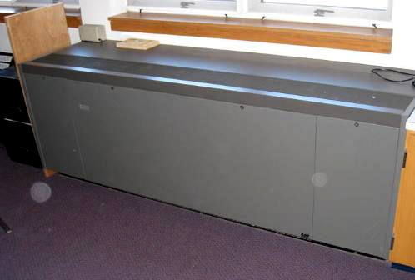

Classroom Univent

Picture 2

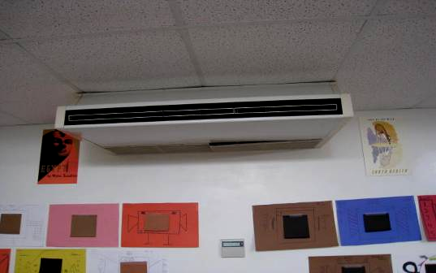

Ceiling/Wall-Mounted Univent

Picture 3

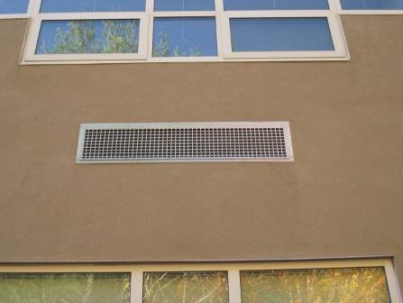

Univent Air Intake on Exterior Wall

Picture 4

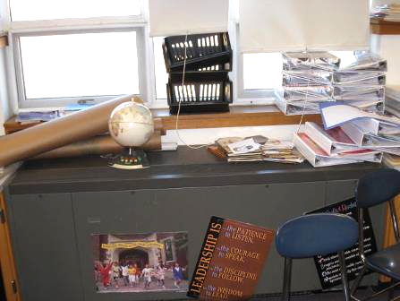

Classroom Univent Blocked by Books and Stored Items

Picture 5

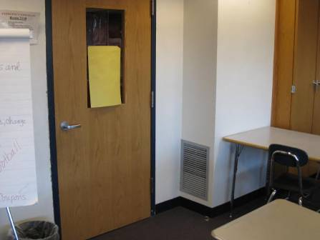

Classroom Exhaust Vent on Wall near Door

Picture 6

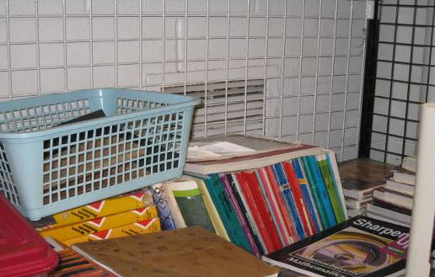

Exhaust Blocked by Stored Items

Picture 7

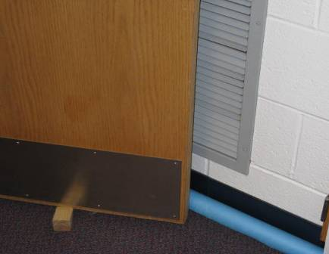

Exhaust Vent Partially Obstructed by Open Door

Picture 8

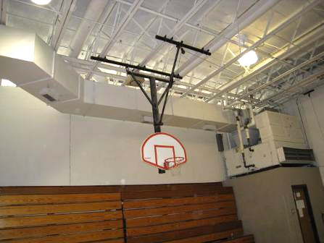

Air Handling Unit in Gymnasium

Picture 9

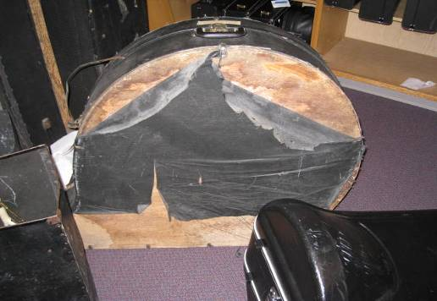

Water Damaged Instrument Case

Picture 10

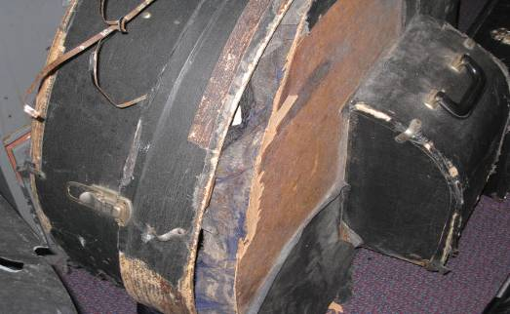

Water Damaged Instrument Case

Picture 11

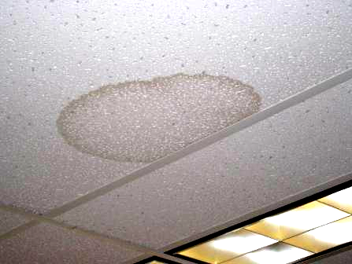

Water Damaged Ceiling Tile

Picture 12

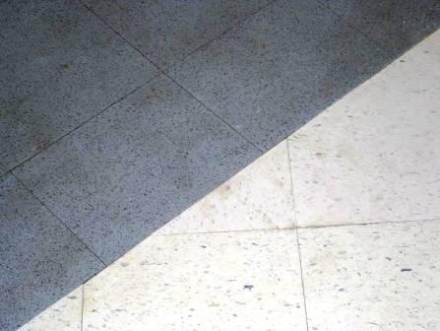

Water Stains on Hallway Tile from Pooling Water

Picture 13

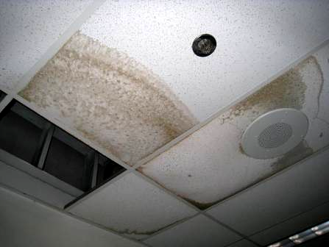

Water Damaged Ceiling Tiles around Hallway Leak

Picture 14

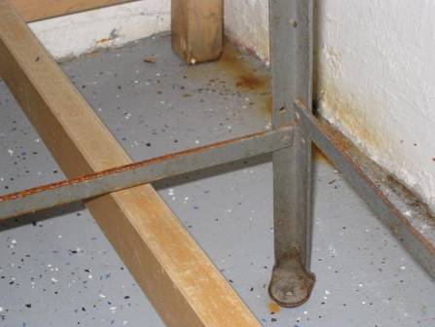

Water Damage and Rust in Storage Room

Picture 15

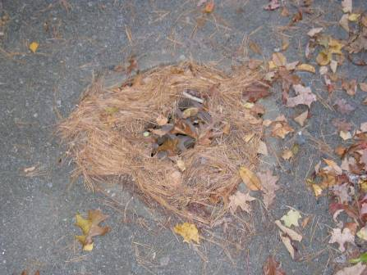

Storm Drain Blocked by Debris and Leaves

Picture 16

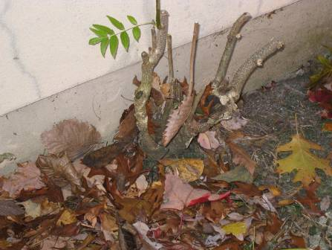

Plants/Tree Stump Growing at Base of Building

Picture 17

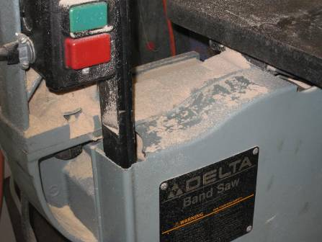

Accumulated Saw Dust and Debris in Woodshop

Picture 18

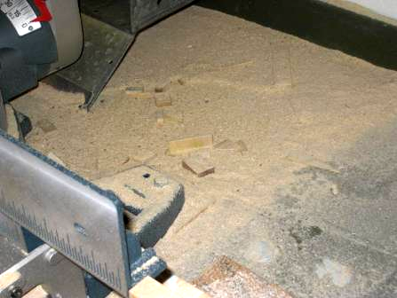

Accumulated Saw Dust and Debris in Woodshop

Picture 19

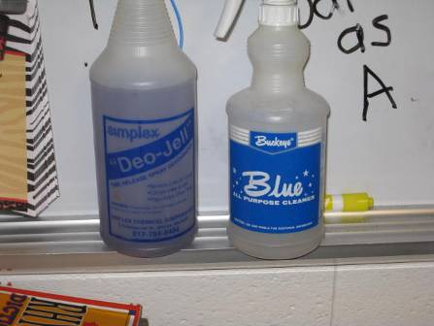

Cleaning Products

Picture 20

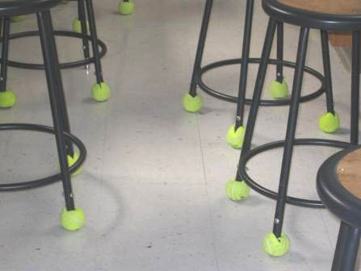

Tennis Balls on Chair Legs

Picture 21

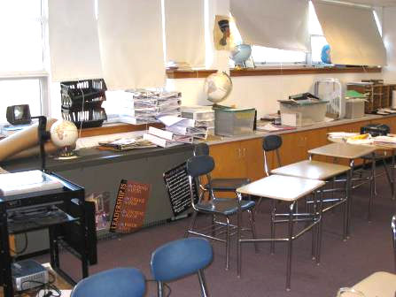

Stored Items in Classroom

Picture 22

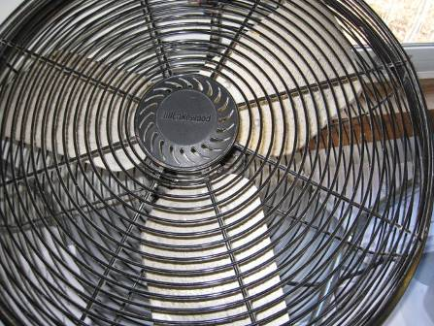

Personal Fan, Note Dust on Blades

Picture 23



Carpet Stain

Picture 24

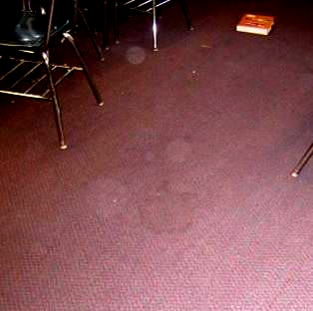

Carpet Stains

Picture 25

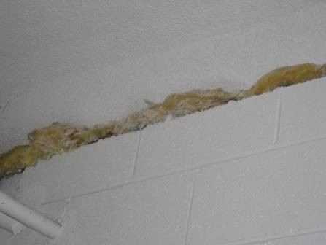

Exposed Fiberglass Insulation
Location/ Room | Occupants  in Room | Temp  (°F) | Relative  Humidity  (%) | Carbon  Dioxide  (ppm) | Carbon Monoxide  (ppm) | PM2.5  (µg/m³) | Windows  Openable | Ventilation |  | Remarks
 |  |  |  |  |  |  |  | Supply | Exhaust | Remarks
background | 0 | 42 | 58 | 340 | ND | 5
1090 | 3 | 74 | 23 | 726 | ND | 3 | Y | Y | Y  off | PCs; DEM; plants; WD CTs; refrigerator; microwave; toaster
1150  Woodshop | 14 | 73 | 36 | 987 | ND | 257 | N | Y  weak | Y  off | Sawdust accumulated on equipment, floor and flat surfaces; Sawdust in air kicked up by clean up
1152 | 0 | 76 | 31 | 1149 | ND | 8 | N | Y  off | Y  off | 20+ computers
1170 | 1 | 72 | 31 | 1101 | ND | 13 | Y | Y | Y | Dehumidifier; Moisture control problem; Room is subgrade; vinyl coving
1172 Kiln Room  1171 Storage |  |  |  |  |  |  |  | N | Y  debris | Closed Door Firings during school hours; MTs
1190 | 17 | 73 | 33 | 1304 | ND | 3 | Y | Y | Y  off | DEM; WD CTs
1200 | 4 | 72 | 29 | 1061 | ND | 5 | Y | Y | Y | Exhaust over door; DO; DEM; tile floor; WD CT
1230 Science Prep | 0 | 71 | 34 | 1276 | ND | 13 | N | N | N | Unlabeled chemical containers; Food container reuse; Hole in wall; Suspended ceiling; microwave
1240 | 20 | 74 | 32 | 1395 | ND | 9 | N | Y | Y | DEM; 20+ computers
1250 | 19 | 72 | 32 | 1288 | ND | 10 | N | Y | Y | Exposed insulation; CD; Objects hanging from ceiling; Unlabeled containers; plant; DEM; sump pump; DO
1270 | 1 | 72 | 36 | 1766 | ND | 5 | N | Y | Y | Sump pump; glass block windows; PS; old chemicals
1290 | 6 | 75 | 33 | 1421 | ND | 11 | N | Y  off | Y  off | DEM; tile floor
1291 | 0 | 76 | 31 | 1386 | ND | 9 | N | Y  off | Y  off | Thermostat off; Exhaust deactivated
1320 | 18 | 73 | 27 | 1006 | ND | 8 | N | Y | Y | Sewer drain; MTs; PF; glass block windows; exposed insulation in ceiling
1322 Science Prep | 0 | 72 | 29 | 1634 | ND | 6 | N | N | could not locate | No guardrail on chemical storage shelves; Unlabeled chemical containers; Old chemicals; Containers labeled with chemical formulas only
1330 Foods Room | 3 | 75 | 29 | 871 | ND | 7 | N | Y | Y | Microwaves; stoves
1330 Storage | 0 | 76 | 31 | 1120 | ND | 12 | N | Y | Y | UVs ducted to 1330; Dryer water vented inside
2010 | 34 | 75 | 40 | 2942 | ND | 7 | Y | Y | could not locate | CPs; DEM
2020 | 1 | 76 | 34 | 2358 | ND | 6 | N | Y  off | Y | 25 computers; DEM
2030 | 24 | 76 | 41 | 3238 | ND | 5 | Y | Y | Y  off
2040 | 6 | 76 | 35 | 1998 | ND | 5 | Y | Y | could not locate | DEM; PF
2060 | 18 | 74 | 38 | 2675 | ND | 5 | Y | Y | Y | 22 computers
2070 | 27 | 75 | 43 | 3080 | ND | 5 | N | Y | Y | AD; CPs; DEM
2090 | 23 | 74 | 30 | 1703 | ND | 5 | Y | Y | Y | DO; DEM
2100 | 28 | 76 | 38 | 2776 | ND | 9 | Y | Y  off | Y  off | DEM; PF
2130 | 24 | 75 | 40 | 2723 | ND | 11 | N | Y | Y  off | DEM
2140 | 31 | 74 | 29 | 1578 | ND | 9 | Y | Y  weak | Y  off | DEM; PFs
2150 | 3 | 73 | 26 | 1075 | ND | 5 | Y | Y | Y  off | UV blocked; DEM; DO; plant; PF
2170 | 0 | 74 | 24 | 1015 | ND | 3 | Y | Y | Y | Stored materials on UV; DO; DEM, DO to Rm 2150
2210 | 13 | 74 | 24 | 1627 | ND | 6 | Y | Y | Y | UV blocked by books and shelving; DEM
2220 | 0 | 74 | 29 | 1188 | ND | 2 | Y | Y | Y  off | Exhaust blocked by furniture; DEM; PF; musty odor
2240 | 24 | 75 | 40 | 2429 | ND | 5 | Y | Y  off | Y  off | Exhaust blocked by furniture; DEM; PF; stuffy
2250 | 19 | 74 | 28 | 1016 | ND | 2 | Y | Y | Y  off | 3 WD CT; DEM
3030 | 3 | 72 | 35 | 864 | ND | 3 | N | Y  UV off | Y | Open utility hole in wall; PCs; UF; DEM; refrigerator; toaster; microwave
3070 | 1 | 73 | 33 | 1526 | ND | 5 | N | Y  off | Y  off | DEM
3080 | 1 | 71 | 36 | 2052 | ND | 5 | Y | Y | Y  off | UV blocked; DEM; DO; 2 PFs; plants
3090 | 3 | 71 | 31 | 1186 | ND | 9 | Y | Y  UV off | could not locate | Multiple book shelves and file cabinets along wall; PFs; CPs; DEM; DO
3100 | 2 | 72 | 27 | 930 | ND | 1 | Y | Y | Y  off | UV blocked by stored materials; DEM; PF
3110 | 1 | 72 | 32 | 1314 | ND | 7 | Y | Y | Y  off | DEM, 1 of 2 DO
3120 | 0 | 73 | 35 | 1749 | ND | 2 | N | Y | Y  off | DEM; fabric covering overhead light fixtures; animal cages; food on countertops; paint cans on floor; PS
3130 | 25 | 73 | 36 | 1990 | ND | 15 | Y | Y | could not locate | DEM; 2 PFs
3140 | 0 | 73 | 31 | 1484 | ND | 6 | N | Y | Y | DEM; TB
3150 | 0 | 71 | 29 | 1059 | ND | 6 | Y | Y | Y  off | Exhaust blocked by door; stored materials on UV; DEM; PFs; DO
3160 | 31 | 74 | 30 | 1232 | ND | 5 | N | Y  UV off | Y  off | DO; DEM
3180 | 0 | 71 | 34 | 1292 | ND | 6 | Y | Y | Y | DEM; PFs; DO
3190 | 0 | 70 | 28 | 892 | ND | 2 | Y | Y | N | Stored materials on UV; Stains on carpet; DEM; CPs; PF
3210 | 30 | 71 | 35 | 1642 | ND | 11 | Y | Y | Y  off | Exhaust blocked; DEM; PF
3220 | 1 | 69 | 36 | 1192 | ND | 8 | Y | Y  off | Y  off | Stored materials on UV; Exhaust blocked; Stains on carpet; DEM; 2 PFs
3240 | 1 | 70 | 43 | 2265 | ND | 11 | Y | Y | Y  off | Exhaust blocked; PF; plants
3250 | 24 | 73 | 42 | 2761 | ND | 16 | Y | Y | Y  off | 5 WD CTs; DEM; 2 PFs
3260 | 27 | 73 | 40 | 2391 | ND | 11 | Y | Y | could not locate | PF
3270 | 1 | 69 | 24 | 840 | ND | 2 | Y | Y | Y  off | DEM, carpet wet by teacher’s desk
3280 | 0 | 71 | 32 | 1209 | ND | 3 | Y | Y | Y  off | DEM; PF
3290 | 20 | 73 | 33 | 1476 | ND | 9 | Y | Y  weak | Y | CPs; PF
Admin. Office | 5 | 73 | 26 | 684 | ND | 7 | Y | Y | Y
Alt. Gym | 0 | 68 | 27 | 557 | ND | 5 | N | Y | Y
Auditorium | 40+ | 74 | 20 | 673 | ND | 3 | N | Y | Y
Band | 0 | 70 | 23 | 653 | ND | 1 | N | Y | Y | Dehumidifier; AHU in storage area (musty smell); Stains on carpet
Café | 0 | 73 | 20 | 454 | ND | 4 | Y | Y | Y | WD CTs
Dark Room | 0 | 75 | 34 | 1419 | ND | 7 | N | N | Y
Library | 7 | 73 | 34 | 1440 | ND | 6 | Y | Y  1 of 4 UVs on | Y | Wall-mounted UV
Main Gym | 0 | 69 | 31 | 968 | ND | 9 | N | Y | Y
Principal’s Office | 3 | 68 | 41 | 1294 | ND | 3 | Y | Y | N | Wall-mounted AC

