INDOOR AIR QUALITY ASSESSMENT

Georgetown Town Hall
1 Library Street
Georgetown, MA

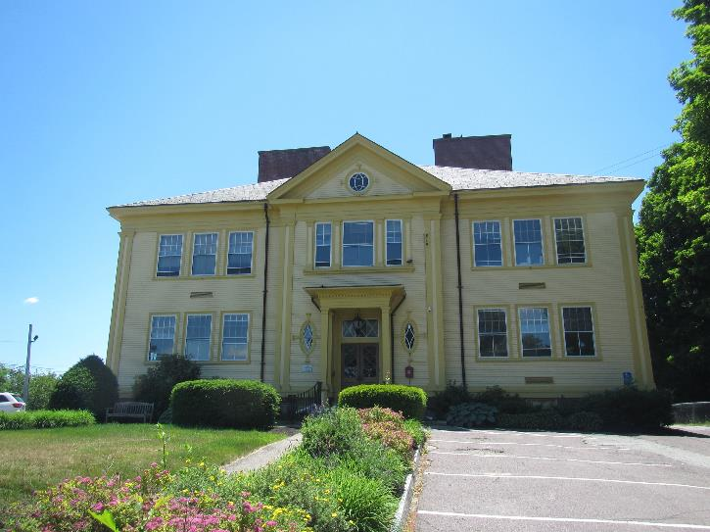

Prepared by:
Massachusetts Department of Public Health
Bureau of Environmental Health
Indoor Air Quality Program
June 2022

BACKGROUND
Building: | Georgetown Town Hall (GTH)
Address: | 1 Library Street, Georgetown, MA
Assessment Requested By: | Orlando Pacheco, Town Administrator
Reason for Request: | General indoor air quality (IAQ) assessment
Date of Assessment: | June 14, 2022
Massachusetts Department of Public Health/Bureau of Environmental Health (MDPH/BEH) Staff Conducting Assessment: | Ruth Alfasso and Jennifer Lajoie,  Environmental Inspectors, IAQ  Program
Building Description: | This building was originally constructed in 1905 as a school. It became the Town Hall in the 1970s. In 2000, major renovations took place, and an energy efficiency project was conducted around 2011. The GTH has two stories with a basement, a brick and clapboard exterior, and a hipped roof.
Windows: | Openable

METHODS
Please refer to the IAQ Manual for methods, sampling procedures, and interpretation of results (MDPH, 2015).

IAQ TESTING RESULTS
The following is a summary of indoor air testing results (Table 1).
- Carbon dioxide levels were below 800 parts per million (ppm) in all but two areas assessed, indicating sufficient fresh air for most areas tested. Note that the occupancy of the building was low at the time of the assessment, levels of carbon dioxide may be higher with higher occupancy.
- Temperature was within or slightly above the recommended range of 70°F to 78°F in areas assessed.
- Relative humidity was within the recommended range of 40% to 60% in all areas assessed.
- Carbon monoxide levels were non-detectable (ND) in all areas assessed.
- Fine particulate matter (PM2.5) concentrations measured were below the National Ambient Air Quality Standard (NAAQS) level of 35 μg/m³ in all areas assessed

Ventilation
A heating, ventilating, and air conditioning (HVAC) system has several functions. First it provides heating and, if equipped, cooling. Second, it is a source of fresh air. Finally, an HVAC system will dilute and remove normally occurring indoor environmental pollutants by not only introducing fresh air, but by filtering the airstream, and ejecting stale air to the outdoors via exhaust ventilation. Even if an HVAC system is operating as designed, point sources of respiratory irritation may exist and cause symptoms in sensitive individuals. The following analysis examines and identifies components of the HVAC system and likely sources of respiratory irritant/allergen exposure due to water damage, aerosolized dust, and/or chemicals found in the indoor environment.
Air circulation in the GTH is provided by an air handling unit (AHU) located in the attic. Air is distributed to ceiling-mounted supply vents (Picture 1) and returned to the AHU through ceiling-mounted return vents (Picture 2). Additional HVAC distribution equipment is located in the ceiling above the suspended ceiling tiles and in a closet on the second floor. There may also be a separate HVAC unit serving the basement area. It could not be determined at the time of the visit if any of the AHUs are supplied with fresh air from outdoors, or if the units only recirculate air.
If no fresh air is supplied by the HVAC equipment, openable windows would be the only source of fresh air into the building. The windows of the building were not included in the recent renovations, so the windows may be over 100 years old. All of the window frames and windowsills examined were weathered with a number in poor condition (Pictures 3 and 4). Occupants reported that windows are difficult to open and must be propped open The AHU in the attic has a slot for a filter installation. The filter inside was labeled “6-1-2020” (Picture 5) indicating that it has not been changed in at least two years. Filters should be changed more frequently, every six months or more often depending on factors such as outdoor air pollution, indoor sources of pollution, and the condition of the filters when they are removed. This filter also appears bowed, potentially indicating it has been exposed to moisture. Replacement filters in various sizes and types were observed in the attic and in the basement boiler room. These filters were stored in open boxes or on surfaces where they can become covered in dust, or water-damaged before they are used (Picture 6).
It is recommended that HVAC systems be balanced every five years to ensure adequate air systems function (SMACNA, 1998). It is not known when the last time this system was balanced.
Work on the HVAC system to engage or repair the air conditioning was occurring the day of the assessment. Temperature concerns were expressed by some occupants. Windows were open in at least one room on the second floor while the air conditioning was operating. Occupants should work with facilities staff to enable better control of temperature. In addition, windows should not be opened when air conditioning is in use in the building, as this can create conditions where condensation can occur on surfaces chilled by the air conditioner and lead to microbial growth and odors. Windows should also be closed at the end of each day (Picture 7).

Microbial/Moisture Concerns
Water-damaged ceiling tiles were noted in several areas of the building (Table 1; Pictures 8 and 9). In a few areas, water stains were also observed on walls (Table 1). In addition, occupants reported that significantly water-damaged tiles in offices on the second floor, including tiles that were so saturated they broke and fell, had recently been replaced. Based on the location of many of these areas, most of the water damage to ceiling tiles appears to result from drainage/leaks from the HVAC or plumbing system.
Leaks from the HVAC system frequently occur due to excessive condensation that is unable to drain properly. Excess condensation may occur when humidity in the building becomes unusually high. Infiltration of hot, humid outdoor air during summer heat waves may overwhelm the ability of the HVAC system to remove condensation. This is one reason it is important to keep the doors and windows closed while the air conditioner is in use. Reducing other sources of humidity indoors during humid weather is also important, including ensuring restroom exhaust vents are operating when the building is occupied.
Note that Massachusetts experienced extended periods of high relative humidity during the summer of 2021. July of 2021 was the wettest ever recorded in Massachusetts, and the three-month period from June through August, known as the meteorological summer, was the fourth wettest on record, according to the National Oceanic and Atmospheric Administration’s (NOAA) Centers for Environmental Information. The three-month period also was the third warmest ever in the state and was tied for the warmest on record across the United States (HG, 2021, NOAA, 2021).
Periodic maintenance of the HVAC system, including cleaning and monitoring drip pans used to collect condensation, can help prevent leaks. Monitoring should be increased during extended periods of hot, humid weather.
Drainage issues from HVAC equipment in the basement and attic were also noted. A condensation pump and drain (Picture 10) for attic equipment was also equipped with a water sensor, which is helpful to detect leaks from this equipment. The condensation from this pump appeared to discharge in a bathroom sink located a fair distance from the pump (Picture 11). If this drain is not able to fully empty, the stagnant water can produce odors. A condensation drain tube in the basement (Pictures 12 and 13) showed signs of clogging and microbial growth.
The sink in the kitchen area was dripping and had signs of corrosion likely from water leaks. Plumbing leaks should be repaired to prevent water damage.
Note that the GTH has an occupied basement, which contains a meeting room for the public. Many of the rooms in the basement are carpeted; carpeting may become moistened by condensation which may occur on floors in contact with the ground. Carpeting is not recommended in below-grade areas for this reason. Another potential source of water to carpeting was the water fountain in the basement area (Picture 14) which was located above carpet. Storage in below-grade areas should also be kept up off the floor and away from exterior walls to avoid moistening due to leaks or condensation.
A few issues were noted on the exterior of the building that could lead to water infiltration and other IAQ issues. Bushes were found growing against the building, including against basement windows (Picture 15). Plants can hold moisture against the building leading to water damage. They can also be attractive to pests. Questing roots can also damage mortar. Several holes were noted in the building envelope (Picture 16), and it could not be determined if these were due to removal of attached equipment, deterioration of building materials, or pest activity. Holes in the building envelope should be sealed.
Cracks were observed in wall plaster in a few areas of the building (Picture 17). This is likely due to settling of the building over long periods of time. If cracks are present in exterior walls, they may allow pathways for moisture, unconditioned air and pests to enter the building. Cracks may also create dust and debris.
Several areas of carpeting on the upper floors were found to be in poor condition, including wrinkles and stains (Picture 18; Table 1), potentially indicating water damage. Carpeting that has been exposed to water and not promptly dried can become colonized with mold. In addition, if this carpeting was installed during the 2000 renovations or earlier, it may be beyond its service life.
It is recommended that porous material be dried with fans and heating within 24 to 48 hours of becoming wet (US EPA, 2008, ACGIH, 1989). If porous materials are not dried within this time frame, mold growth may occur. Water-damaged porous materials cannot be adequately cleaned to remove mold growth.

Other Concerns
Exposure to low levels of total volatile organic compounds (TVOCs) may produce eye, nose, throat, and/or respiratory irritation in some sensitive individuals. BEH/IAQ staff noted hand sanitizers, cleaners, and dry erase materials in the office space (Picture 19; Table 1). All of these products have the potential to be irritants to the eyes, nose, throat, and respiratory system of sensitive individuals.
Unfinished attic/basement areas had a variety of stored materials (e.g., Picture 20). Improperly stored materials can become water-damaged, mold-colonized and dusty. In addition, they can become harborage for pests.
Doors between conditioned/occupied areas and unoccupied areas, such as between the unfinished and finished portions of the attic, should be tight-fitting and equipped with weatherstripping to reduce the infiltration of unconditioned air, moisture, dust/debris, and pests.
The building has a kitchen, and food is stored/eaten in other areas as well. Cooking equipment, such as toasters (Picture 21), refrigerators, and microwaves should be kept clean to prevent odors, microbial growth, smoke, and pests.
Flaking paint was noted in the basement (Picture 22). This material may contain lead and should be tested and remediated in accordance with the Department of Labor Standards requirements (https://www.mass.gov/deleading-and-lead-safety).
Some supply and return vents, including restroom exhaust vents, were found to be dusty. This dust can be reaerosolized when the HVAC system cycles on and off. In addition, it can become a medium for mold growth if moistened by condensation or exposure to very humid air.
Lastly, a number of fluorescent lightbulb tubes were noted stored loosely in the basement (Picture 23). These items contain mercury which can be released if they are broken. Fluorescent light tubes should be properly stored, and the spent ones removed for proper disposal on a regular basis.

CONCLUSIONS AND RECOMMENDATIONS
In view of the findings at the time of the visit, the following recommendations are made. These recommendations are separated into short-term recommendations, and long-term recommendations that may require planning and capital funds to achieve:

Short-Term Recommendations

Ventilation Recommendations
- Operate supply and return ventilation during occupied periods.
- All windows should be closed when air-conditioning is operating.
- Determine if the HVAC system has a fresh air intake.
- To increase fresh air exchange, windows can be opened during temperate weather. However, when the air conditioning is running windows should remain closed.
- Change filters in AHU equipment regularly in accordance with manufacturer’s instructions. Use high-quality filters with a Minimum Efficiency Rating Value (MERV) rating of at least 8, or higher if the HVAC equipment can operate with more restrictive filters.
- Store unused HVAC filters in closed containers in a dry and clean environment.
- Consider having the HVAC system balanced every five years in accordance with The Sheet Metal and Air Conditioning Contractors' National Association (SMACNA) recommendations (SMACNA, 1994).
- Ensure restroom exhaust fans operate when the building is occupied to remove odors and moisture.

Water Damage Recommendations
- Remove any remaining water-damaged ceiling tiles. Examine for source of leaks and repair as needed. Clean any additional water-damaged material above the ceiling tile system.
- Wash water stains from wall paint.
- Ensure HVAC components can drain properly, including checking drip pans, drain hoses and pumps periodically for clogs and leaks. Ensure any drainage is directed to an appropriate location and that drain hoses can empty completely to prevent stagnant water.
- Repair the sink in the kitchen to prevent leaks.
- Protect the carpeting under the basement water fountain with a waterproof mat.
- Trim bushes and plants away from the exterior of the building a minimum of five feet. Remove any clinging ivy from the building.
- Examine holes in building exterior such as the one shown in Picture 16 to determine the cause and repair as needed.
- Examine areas of cracked plaster to determine if the building envelope is breached. Repair as needed. Clean/remove flaking plaster and paint to reduce dust generation.

Other Recommendations
- Reduce the amount of cleaning products and particularly scented products used in the office. Use only in accordance with package instructions.
- Keep stored materials organized and in closed containers, on shelves, or in cabinets to protect from moisture, dust and pests. Do not store porous items on the basement floor, against basement walls or in other potentially damp environments. Sort through stored items and discard unneeded items regularly.
- Ensure exterior doors and doors between conditioned and unconditioned spaces are tight-fitting and have appropriate weatherstripping.
- Keep food storage and preparation equipment clean. Only store food in sealed pest-proof containers.
- Clean all carpeting in accordance with IICRC recommendations (IICRC 2012). This includes daily vacuuming with a HEPA-equipped vacuum cleaner, and annual or semi-annual deep cleaning.
- Clean dust from supply, return and bathroom vents periodically.
- Store new and spent fluorescent bulbs securely, and remove spent bulbs on a regular basis to prevent breakage and release of mercury.
- Refer to resource manual and other related IAQ documents located on the MDPH’s website for further building-wide evaluations and advice on maintaining public buildings. These documents are available at: http://mass.gov/dph/iaq.

Long Term Recommendations
- Consider removal of the wall-to-wall carpet in the basement level and replacement with a non-porous floor covering.
- Consider replacing other carpeting in the building that may be stained, worn or otherwise beyond its service life.
- Consider replacing all windows in the building, including repair or replacement of interior frames and sills.
- If it is determined that the HVAC system lacks any fresh air intake, consult with an HVAC engineering contractor to determine the feasibility of adding fresh air intakes to the system.

REFERENCES
ACGIH. 1989. Guidelines for the Assessment of Bioaerosols in the Indoor Environment. American Conference of Governmental Industrial Hygienists, Cincinnati, OH.
HG. 2021. Mold keeps South Hadley High School shuttered. Hampshire Gazette. https://www.gazettenet.com/South-Hadley-High-School-still-closed-amid-mold-remediation-42413519.
IICRC. 2012. Institute of Inspection, Cleaning and Restoration Certification. Carpet Cleaning: FAQ.
MDPH. 2015. Massachusetts Department of Public Health. Indoor Air Quality Manual: Chapters I-III. Available at: https://www.mass.gov/lists/indoor-air-quality-manual-and-appendices.
NOAA. 2021. Summer 2021 neck and neck with Dust Bowl summer for hottest on record. National Oceanic and Atmospheric Administration, 1401 Constitution Avenue NW, Room 5128, Washington, DC 20230 https://www.noaa.gov/news/summer-2021-neck-and-neck-with-dust-bowl-summer-for-hottest-on-record
SMACNA. 1998. Indoor Air Quality: A Systems Approach. 3rd ed. Sheet Metal and Air Conditioning Contractors’ National Association, Inc, Chantilly, VA.

US EPA. 2008. “Mold Remediation in Schools and Commercial Buildings”. Office of Air and Radiation, Indoor Environments Division, Washington, DC. EPA 402-K-01-001. September 2008. Available at: http://www.epa.gov/mold/mold-remediation-schools-and-commercial-buildings-guide.
Picture 1
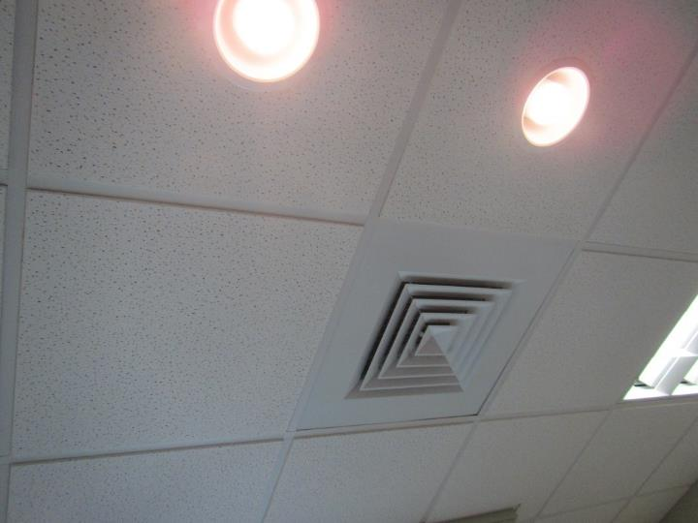
Typical supply vent
Picture 2
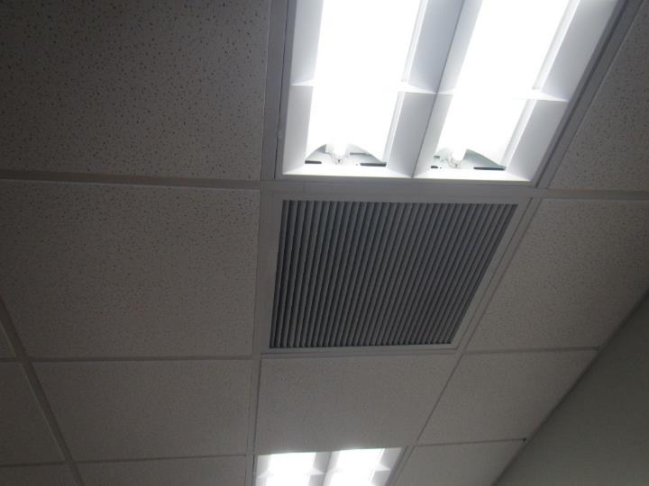
Return vent
Picture 3
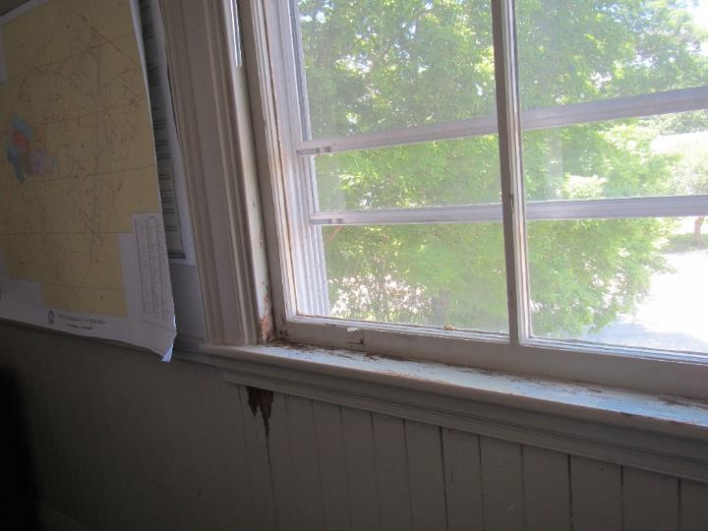
Damaged window frame and sill
Picture 4
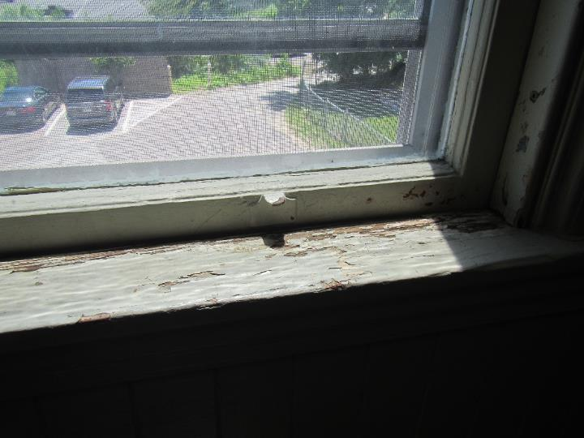
Damaged window frame and sill
Picture 5
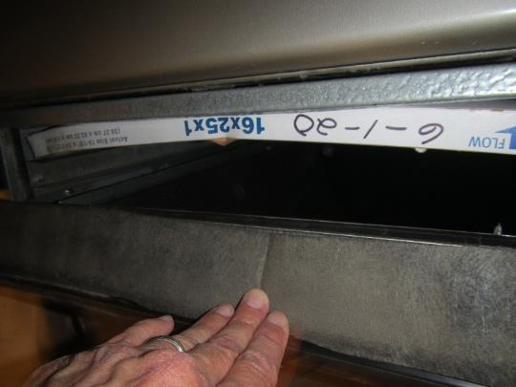
Filter in attic AHU showing date of 6-1-20, note bowing
Picture 6
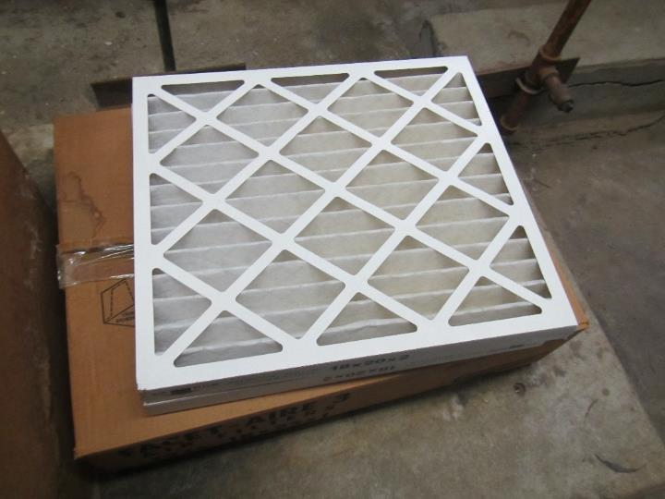
HVAC filter stored in the open in the attic
Picture 7
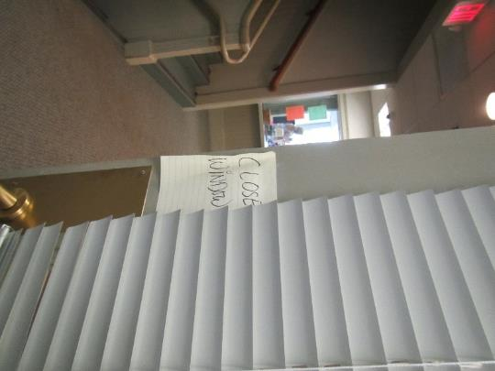
Reminder to close windows on office door
Picture 8
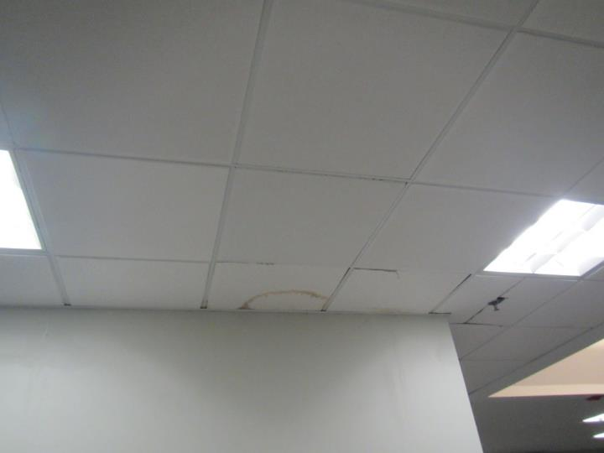
Water-damaged ceiling tile
Picture 9
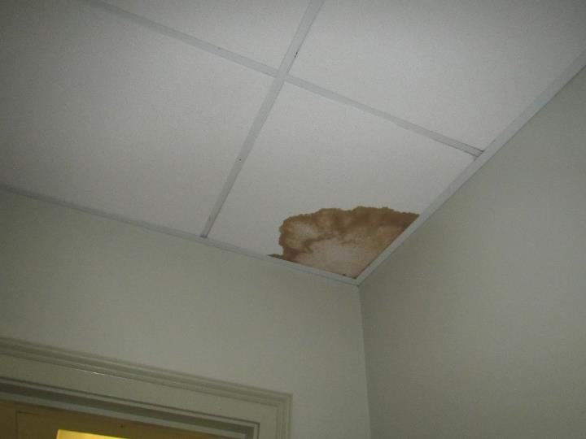
Water-damaged ceiling tile
Picture 10
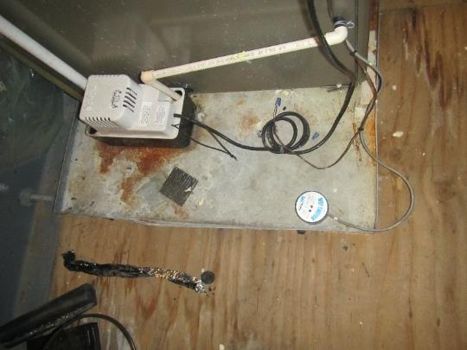
Condensation pump in attic, note water sensor (round object in lower left)
Picture 11
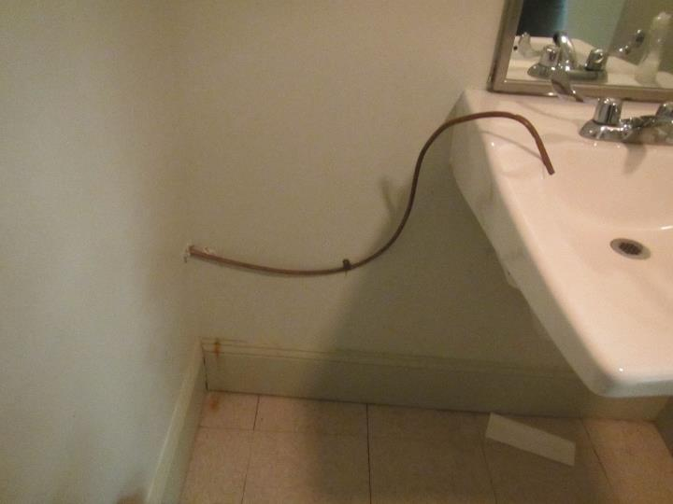
Outlet of condensation drain in attic restroom
Picture 12
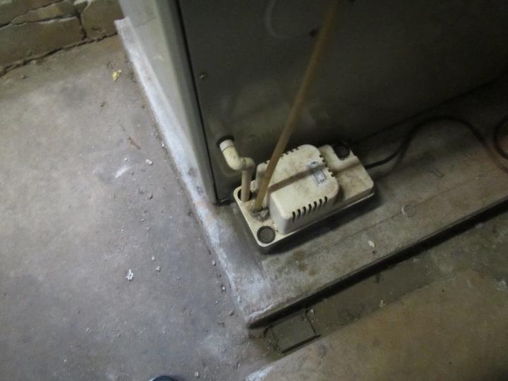
Condensation pump in the basement
Picture 13
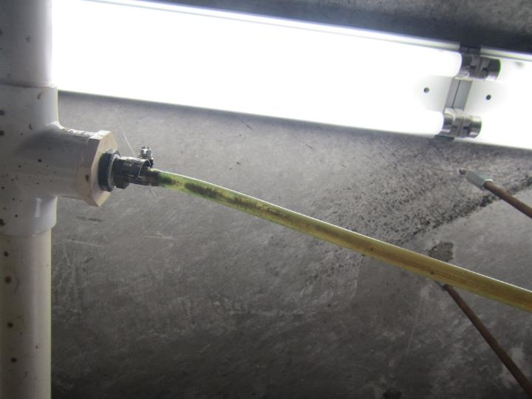
Condensation tube showing signs of stagnant water and algae growth
Picture 14
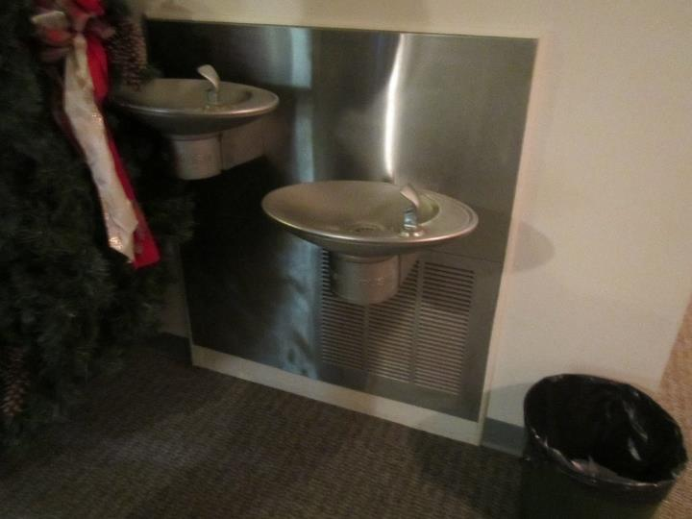
Water fountain over carpeted area
Picture 15
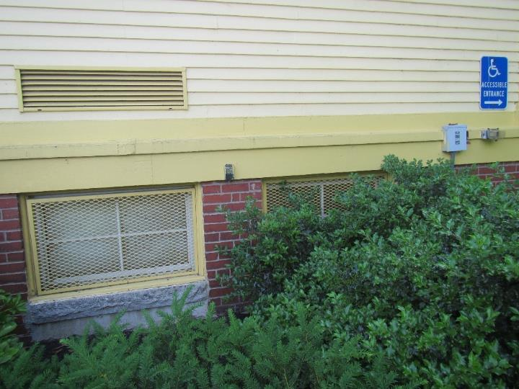
Bushes up against the building, including in front of basement windows
Picture 16
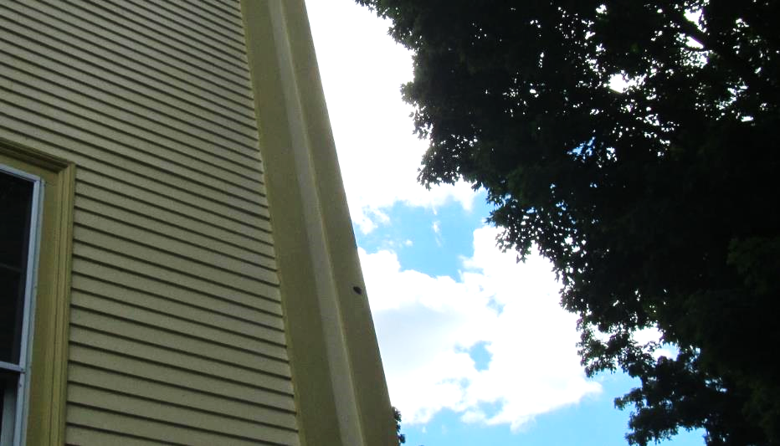
Hole in corner of building (arrow)
Picture 17
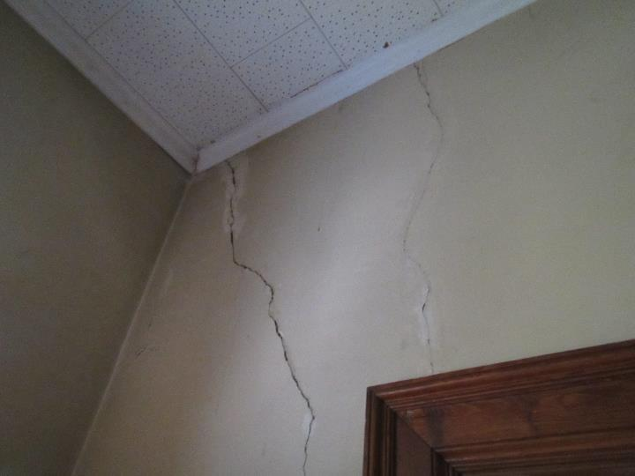
Cracks in wall plaster
Picture 18
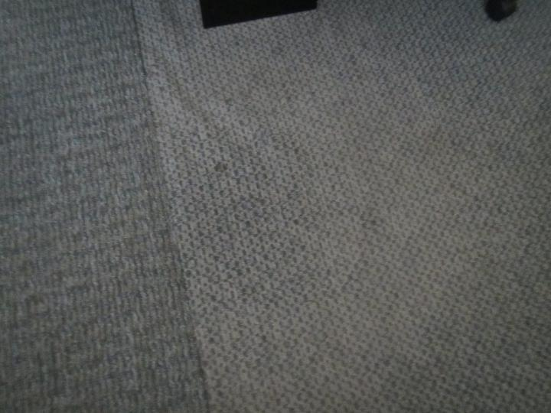
Wrinkled carpet
Picture 19
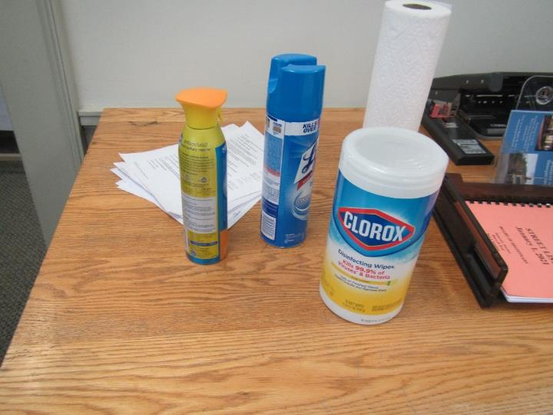
Cleaners/disinfectants in an office
Picture 20
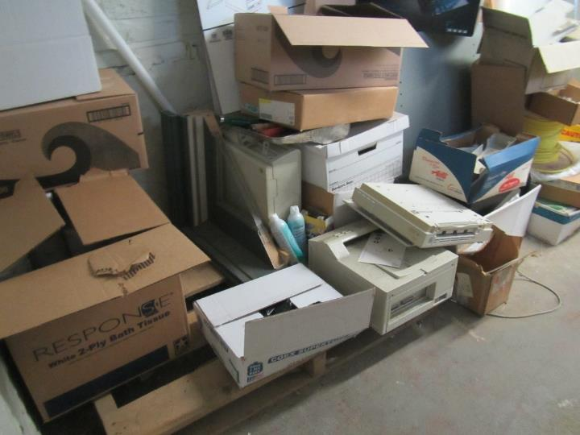
Items stored in the basement
Picture 21
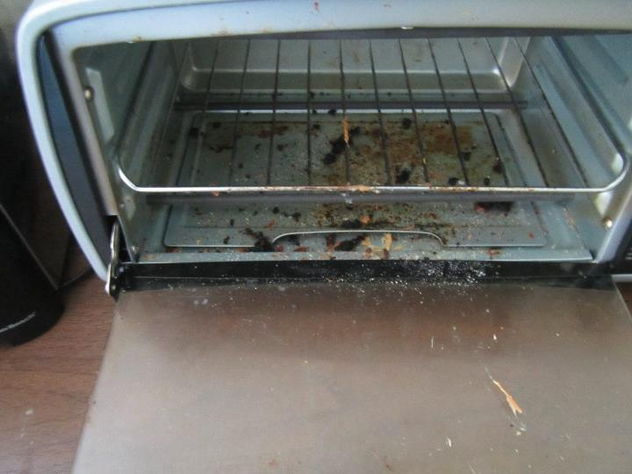
Toaster with crumbs
Picture 22
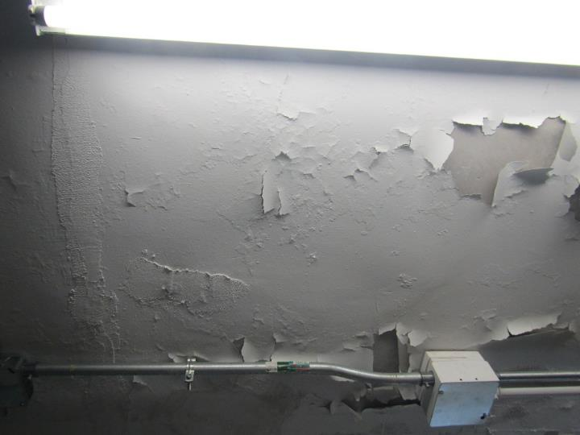
Flaking paint in the basement
Picture 23
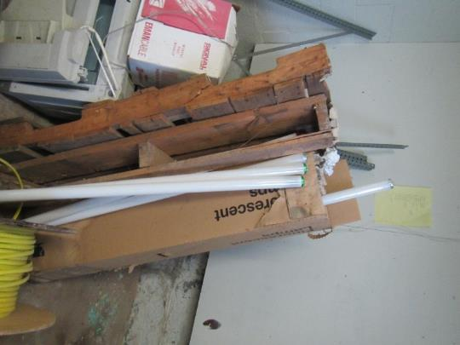
Loosely stored fluorescent lightbulbs
Location | Carbon  Dioxide  (ppm) | Carbon Monoxide  (ppm) | Temp  (°F) | Relative  Humidity  (%) | PM2.5  (µg/m³) | Occupants  in Room | Windows  Openable | Ventilation |  | Remarks
 |  |  |  |  |  |  |  | Supply | Exhaust
Background | 382 | ND | 81 | 36 | 2 |  |  |  |  | Sunny
Selectman’s Office | 607 | ND | 80 | 42 | ND | 1 | Y | Y | Y | Copy machine in office, WD CTs
Town Administrators Office | 566 | ND | 79 | 44 | ND | 0 | Y | Y | Y | DEM, cleaning products, pet bed
Room 207- mail room | 565 | ND | 77 | 47 | ND | 0 | Y | Y | Y | Missing CTs, WD CTs
Conservation – main office | 673 | ND | 75 | 50 | ND | 1 | Y | Y | Y
Conservation- back office | 671 | ND | 73 | 53 | ND | 1 | Y | Y | Y | Carpet buckled, wall stained
Room 208 | 477 | ND | 72 | 51 | ND | 0 | Y | Y | Y | Window open, AC on
Room 204 | 546 | ND | 72 | 55 | ND | 1 | Y | Y | Y | Carpet buckled
Building Inspector | 556 | ND | 73 | 53 | ND | 0 | Y | Y | Y | Carpet buckled, window open, AC on, HVAC system in closet, debris on floor of closet
Kitchen | 539 | ND | 73 | 52 | ND | 0 | Y | Y | Y | Toaster has food debris, microwave dirty, faucet leaking, non-carpeted
Planning Board | 476 | ND | 72 | 50 | ND | 0 | Y | Y | Y | WD CTs, damage around window and wall
AV office | 521 | ND | 72 | 59 | ND | 0 | N/A | Y | Y | WD CTs, water stain down wall
3rd floor meeting room | 495 | ND | 72 | 59 | ND | 2 | N/A | Y | Y | WD CTs
AV control room | 530 | ND | 72 | 59 | ND | 0 | N/A | Y | Y | Dusty vent
3rd floor bathroom |  |  |  |  |  |  |  |  |  | Dusty vent, drain into sink
Town Clerk | 807 | ND | 73 | 49 | ND | 1 | Y | Y | Y
Town Accounting | 840 | ND | 73 | 51 | ND | 1 | Y | Y | Y
Tax Collector- main office | 797 | ND | 74 | 47 | ND | 1 | Y | Y | Y | Carpet stained
Tax Collector- back office | 841 | ND | 74 | 47 | ND | 1 | Y | Y | Y | Wall in closet cracked, stained carpet
Assessors- main office | 689 | ND | 74 | 45 | ND | 1 | Y | Y | Y | Painted over WD CT
Assessors- back office | 741 | ND | 74 | 44 | ND | 1 | Y | Y | Y
Assessors meeting room | 683 | ND | 73 | 45 | ND | 0 | Y | Y | Y | Cleaning products
Health Dept- front office | 663 | ND | 73 | 52 | ND | 1 | Y | Y | Y | Cracked wall
Health Dept- back office | 710 | ND | 74 | 53 | ND | 0 | Y | Y | N | Painted CT
Health Dept kitchen |  |  |  |  |  |  |  |  |  | Holes around pipes in closet
Meeting room 1 | 586 | ND | 74 | 51 | ND | 0 | Y | Y | Y | Carpeted

