INDOOR AIR QUALITY ASSESSMENT

Gerard A. Guilmette Elementary and Middle Schools
80 Bodwell Street
Lawrence, MA

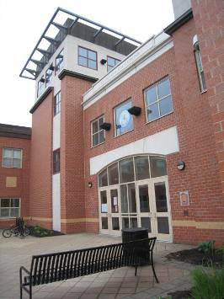

Prepared by:
Massachusetts Department of Public Health
Bureau of Environmental Health
Indoor Air Quality Program
June 2013

Introduction/Background
In response to a referral from the Occupational Safety and Health Administration (OSHA), the Massachusetts Department of Public Health (MDPH), Bureau of Environmental Health (BEH) provided assistance and consultation regarding indoor air quality (IAQ) at the Gerard A. Guilmette Elementary and Middle Schools, collectively known as the Guilmette School (GS) located at 80 Bodwell Street, Lawrence, Massachusetts. The visit was prompted by ongoing concerns about mold and general IAQ in the building. On May 21, 2013, Michael Feeney, Director of BEH’s IAQ Program visited the school accompanied by Cory Holmes, Environmental Analyst/Regional Inspector, Sharon Lee, Environmental Analyst/Inspector, and Ruth Alfasso, Environmental Engineer/Inspector in BEH’s IAQ Program.
The GS is a three-story brick building with a footprint consisting of one long section and two wings offset to either sides. The construction of this building was completed in 2001. Classrooms for grades 1 through 3 are located on the first floor, grades 4 and 5 and shared middle school classrooms are located on the second floor, and the third floor contains middle school classrooms for Grades 6 through 8 and middle school administrative offices. The elementary school administrative offices are located on the first floor, along with access to the gymnasium, auditorium, and nurse’s suite. The building also has a lower level (basement), which contains a cafeteria, art and music rooms, and provides access to the school’s physical plant. Windows throughout the building are openable.
Water damage and mold have been a recurring issue in this building. School officials reported that water leaking from piping in 2004 resulted in water-damaged building materials and mold growth. Materials that were damaged by water from the pipe leak were removed and replaced. The building was closed between October 2010 and April 2011 due to conditions resulting from condensation moistening the insulation on coolant-filled pipes used for the air-conditioning system. Although water-damaged materials were removed, the air-conditioning system has remained deactivated since that time. Most recently, reports of moldy odors were traced to a science experiment in Room 105. In response to concerns, the Lawrence School Department had a consultant conduct air sampling and had this room cleaned. More information on water damage issues in the building can be found in the Microbial/Moisture Concerns section of this report.

Methods
Air tests for carbon monoxide, carbon dioxide, temperature and relative humidity were conducted with the TSI, Q-Trak, IAQ Monitor, Model 7565. Air tests for airborne particle matter with a diameter less than 2.5 micrometers were taken with the TSI, DUSTTRAK™ Aerosol Monitor Model 8520. BEH/IAQ staff also performed visual inspection of building materials for water damage and/or microbial growth.

Results
The school houses approximately 540 students in grades 1 through 4, with another 515 students in grades 5 through 8, and approximately 150 staff members for all grades combined. The IAQ tests were taken during normal operations. Test results appear in Table 1.

Discussion

Ventilation
It can be seen from Table 1 that carbon dioxide levels were elevated above 800 parts per million (ppm) in 20 out of 107 areas indicating adequate ventilation in greater than three quarters of the areas tested. However, it is important to note that several classrooms were empty/sparsely populated or had windows open, which can greatly reduce carbon dioxide levels. Carbon dioxide levels would be expected to increase with higher occupancy and windows shut.
Rooftop air-handling units (AHUs) provide mechanical ventilation to all rooms. Fresh air is ducted to classrooms via ceiling-mounted supply diffusers (Picture 1). Exhaust air is drawn through ceiling-mounted vents and ducted back to the AHUs (Picture 2). In many rooms, airflow from supply and exhaust vents was observed to be low or nonexistent. School maintenance staff is reportedly aware of issues with some of the heating, ventilating and air-conditioning (HVAC) systems, which are in the process of being fixed. The library in particular was reported to have no operating mechanical ventilation at the time of the BEH/IAQ visit. Given that the library windows do not open, there was no source of fresh air for the library at the time of assessment.
The rooftop AHU was examined and found to be equipped with a highly effective baghouse/fabric type filter that has a low efficiency pre-filter. The baghouse filters are efficient at removing particulates from the incoming air, but require a pre-filter to remove large debris from the airstream. Airborne debris filtration is necessary to reduce the need for excessive bag house filter replacement, since this type of filter is expensive.
Fan coil units (FCUs) provide auxiliary heating and filtration in most classrooms (Picture 3). Tempered air is provided by wall vents at the top of the unit, and air is returned via a wall vent at the bottom of the unit. In some rooms, FCUs were found deactivated, ajar, with supply/return vents broken, or blocked by materials (Pictures 3 through 5). In order to operate as designed, units must remain “on” and allowed to operate while rooms are occupied. Importantly, FCUs must remain free of obstructions.
FCUs are designed to operate with a filter to remove particulates from the indoor environment. The FCU filters examined were of a disposable type with an open mesh construction; filters were observed to be placed in the units without any stabilizing clips. Ill-fitting filters can allow unfiltered air to bypass and re-circulate in the room. New clips should be installed to enhance filtering capacity. In order to decrease aerosolized particulates, disposable filters with an increased dust spot efficiency can be installed.
The dust spot efficiency is the ability of a filter to remove particulates of a certain diameter from air passing through the filter. Filters that have been determined by the American Society of Heating, Refrigerating and Air-Conditioning Engineers (ASHRAE) to meet its standard for a dust spot efficiency of a minimum of 40 percent (Minimum Efficiency Reporting Value equal to 9) would be sufficient to reduce many airborne particulates (Thornburg, 2000; MEHRC, 1997; ASHRAE, 1992). Note that increasing filtration can reduce airflow (called pressure drop), which can subsequently reduce the efficiency of the unit due to increased resistance. Prior to any increase of filtration, each FCU should be evaluated by a ventilation engineer to ascertain whether it can maintain function with more efficient filters.
To maximize air exchange, the MDPH recommends that both supply and exhaust ventilation operate continuously during periods of occupancy. In order to have proper ventilation with a mechanical supply and exhaust system, the systems must be balanced to provide an adequate amount of fresh air to the interior of a room while removing stale air from the room. It is recommended that heating, ventilating and air-conditioning (HVAC) systems be re-balanced every five years to ensure adequate air systems function (SMACNA, 1994). The date of the last balancing/commissioning of these systems reportedly occurred in 2012.
Minimum design ventilation rates are mandated by the Massachusetts State Building Code (MSBC). Until 2011, the minimum ventilation rate in Massachusetts was higher for both occupied office spaces and general classrooms, with similar requirements for other occupied spaces (BOCA, 1993). The current version of the MSBC, promulgated in 2011 by the State Board of Building Regulations and Standards (SBBRS), adopted the 2009 International Mechanical Code (IMC) to set minimum ventilation rates. Please note that the MSBC is a minimum standard that is not health-based. At lower rates of cubic feet per minute (cfm) per occupant of fresh air, carbon dioxide levels would be expected to rise significantly. A ventilation rate of 20 cfm per occupant of fresh air provides optimal air exchange resulting in carbon dioxide levels at or below 800 ppm in the indoor environment in each area measured. MDPH recommends that carbon dioxide levels be maintained at 800 ppm or below. This is because most environmental and occupational health scientists involved with research on IAQ and health effects have documented significant increases in indoor air quality complaints and/or health effects when carbon dioxide levels rise above the MDPH guidelines of 800 ppm for schools, office buildings and other occupied spaces (Sundell et al., 2011). The ventilation must be on at all times that the room is occupied. Providing adequate fresh air ventilation with open windows and maintaining the temperature in the comfort range during the cold weather season is impractical. Mechanical ventilation is usually required to provide adequate fresh air ventilation.
Carbon dioxide is not a problem in and of itself. It is used as an indicator of the adequacy of the fresh air ventilation. As carbon dioxide levels rise, it indicates that the ventilating system is malfunctioning or the design occupancy of the room is being exceeded. When this happens, a buildup of common indoor air pollutants can occur, leading to discomfort or health complaints. The Occupational Safety and Health Administration (OSHA) standard for carbon dioxide is 5,000 parts per million parts of air (ppm). Workers may be exposed to this level for 40 hours/week, based on a time-weighted average (OSHA, 1997).
The MDPH uses a guideline of 800 ppm for publicly occupied buildings. A guideline of 600 ppm or less is preferred in schools due to the fact that the majority of occupants are young and considered to be a more sensitive population in the evaluation of environmental health status. Inadequate ventilation and/or elevated temperatures are major causes of complaints such as respiratory, eye, nose and throat irritation, lethargy and headaches. For more information concerning carbon dioxide, consult Appendix A.
Temperature measurements ranged from 71 °F to 78 °F, which were within the MDPH recommended comfort guidelines at the time of assessment (Table 1). The MDPH recommends that indoor air temperatures be maintained in a range of 70 F to 78 F in order to provide for the comfort of building occupants. In many cases concerning indoor air quality, fluctuations of temperature in occupied spaces are typically experienced, even in a building with an adequate fresh air supply.
Relative humidity measurements ranged from 58 to 74 percent in areas surveyed (Table 1), most of which were above the MDPH recommended comfort range. The MDPH recommends a comfort range of 40 to 60 percent for indoor air relative humidity. Note that at the time of assessment, the relative humidity outdoors was measured at 59 percent, which influenced the relative humidity inside the building, especially with windows open. Humidity measurements above background may also indicate that the ventilation system is not operating effectively to remove occupant-generated moisture from the building. Moisture removal is important since higher humidity at a given temperature reduces the ability of the body to cool itself by perspiration; “heat index” is a measurement that takes into account the impact of a combination of heat and humidity on how hot it feels. At a given indoor temperature, the addition of humid air increases occupant discomfort and may generate heat complaints. If moisture levels are decreased, the comfort of the individuals increases. In addition, as discussed in the Microbial/Moisture Concerns section of this report, relative humidity in excess of 70 percent for extended periods of time can provide an environment for mold and fungal growth (ASHRAE, 1989).
Note that as described in the Background section, the GS is designed to operate with cooling/air-conditioning as well as heating systems. The cooling systems are currently non-operational and will remain so for the foreseeable future. Therefore, temperature control in hot weather can only be accomplished through use of operable windows and/or fans. Please see the MDPH/BEH guidance in Appendix B, “Methods for Increasing Comfort in Non-Air-Conditioned Schools” for additional guidance in operating a building in hot, humid weather.
Relative humidity levels in the building would be expected to drop during the winter months due to heating. The sensation of dryness and irritation is common in a low relative humidity environment.

Microbial/Moisture Concerns

Room 105
The most recent reports of mold in the GS, which occurred in the month prior to the BEH/IAQ visit, were reportedly linked to a science experiment in classroom 105. The item in question was reportedly removed and the room cleaned. At the time of assessment, classroom 105 was closed from use.
On the day of assessment, conditions noted in room 105 and the adjacent restroom were of particular concern. At the time of assessment, room 105 was not occupied due to the science project related mold issue previously discussed. Restrooms in the building have walls covered with tile. Restrooms are also equipped with floor drains. Restroom floors are typically sloped towards the drains to allow for water drainage. One floor drain examined in the restroom appeared to be installed above the level of the floor, and GS staff reported that drains in other restrooms were configured similarly. Without a slope, water will not drain from the floor and staying in extended contact with wall and floor tile. In this condition, the gypsum wallboard (GW) can become moistened by standing water seeping thought the tile grout/seams. In addition, if a plumbing failure were to occur, standing water would likely penetrate the wall cavity, affecting rooms/walls adjacent to and below the restroom. Restroom floors should be re-graded to have a proper slope that allows for drainage.
A steel-backed radiator was installed against the wall shared between in room 105 and the adjoining restroom interior wall (Picture 12). If water were to enter the wall cavity, the tile and steel plate of the heater could prevent moisture/water vapor from exiting the wall cavity, resulting extended wetting of the GW. There were signs of water damage to the GW of this wall, including water-damaged ceiling tiles and water stains. In addition, an electrical outlet below the damaged ceiling tile exhibited a pattern of staining that indicated that water may have seeped from the wall cavity into room 105 through the bottom of the socket cover (Pictures 12 and 13). A musty/damp odor was also detected at the base of the radiator. These signs suggest that the wallboard and associated materials along the shared wall may be damp and possibly colonized with mold. The shared wallboard along this area should be examined, and all water-damaged materials removed and replaced. Water-damaged electrical equipment is also a fire hazard and should be remediated.
In addition, the radiator in room 105 was not flush with the wall, unlike those installed elsewhere in the building. A number of items, including wax crayons, could be seen in the gap (Picture 14). It is likely that when the radiator is operating (i.e., during the heating season), odors from water-damaged/mold-colonized materials as well as heated crayons and other items inside this gap would result and be distributed throughout the room. This radiator should either be moved or properly sealed to prevent items such as crayons from being inserted into the adjacent gap.

Air-Handling Units (AHUs)
As described in the Background section, the GS has reportedly been subject to several water events resulting in damage/mold growth in the building. At the time of the BEH/IAQ visit, water-damaged materials from the 2004 and 2010 incidents had reportedly been removed, and the impacted areas had been repaired. As also discussed, the air-conditioning systems have been remained off and rendered inoperable to prevent a reoccurrence of the condensation issues that had previously moistened insulation materials on cooling-fluid pipes. Before the air-conditioning systems can be allowed to operate, conditions leading to the condensation moistening materials must be remedied, including:
- Appropriate insulation of all pipes and accessories carrying chilled fluid to end uses;
- Proper control of cooling fluid temperature to prevent excessive chilling of pipes and FCU components; and
- Appropriate repair to FCU units to allow for drainage of condensate generated during air-conditioning operation.
If the air-conditioning systems are rendered operable and turned on in the future, care must be taken that windows and doors remain closed during operations to prevent the ingress of hot, humid air into the building which will increase the potential for condensation both inside FCUs and along coolant pipes.
Note that the dew point is determined by air temperature and relative humidity that indicates the temperature at which the water in the air will begin to condense. For example, at a temperature of 73º F and relative humidity of 57 percent indoors, the dew point for water to collect on a surface is approximately 57º F (IICRC, 2000). Therefore, any surface that had a temperature below the dew point, such as an insufficiently-insulated coolant pipe, would be prone to condensation generation under those temperature and relative humidity conditions.
With the air-conditioning systems inoperable, the building can experience relative humidity in excess of outdoor relative humidity, which can bring the indoor humidity above 70 percent during hot, humid weather. According ASHRAE, if relative humidity exceeds 70 percent for an extended time, mold growth may occur due to wetting of building materials (ASHRAE, 1989). Condensation is most likely to occur on surfaces which are in contact with materials at cooler temperatures, such as basement floors or walls along the shaded sides of buildings. Porous materials, such as paper, cardboard, carpeting and cloth, should be stored away from areas prone to condensation generation during hot, humid weather.

Building-wide observations
Previously water-damaged gypsum wallboard (GW) in basement areas was observed to have been replaced with cement board at the time of assessment. Cement board is not clad in paper and is resistant to water and mold.
Water-damaged ceiling tiles were observed in some classrooms (Table 1; Picture 6), and a water-damaged windowsill and adjacent wallboard were noted in classroom 319 (Table 1; Picture 7). These appear to be from current and historic roof and/or building envelope leaks. Water-damaged building materials can provide a source of mold and should be replaced after a water leak is discovered and repaired. School maintenance staff reported that a capital project to reseal the building envelope (including all windows) had been put out to bid with work expected to occur over the summer of 2013.
Many classrooms in the school had sinks, and BEH/IAQ staff observed that many of the backsplashes were open or not fully sealed (Table 1; Picture 8). If not watertight, water can penetrate through the seam, causing water damage. Several classrooms were also found to have porous materials (e.g., cardboard, paper, cloth) stored beneath sinks where the materials can be subject to water exposure. Repeated moistening of porous materials can result in mold growth.
Plants and terrariums were noted in several classrooms (Table 1; Picture 9). In some cases, plants were observed near ventilation sources. Plants, soil and drip pans can serve as sources of mold growth. Plants should be properly maintained, over-watering of plants should be avoided and drip pans should be inspected periodically for mold growth. Plants should also be located away from ventilation sources to prevent aerosolization of dirt, pollen or mold. Aquariums were also observed in several classrooms (Table 1; Picture 10). Aquariums can be a source of moisture or spills and, if not cleaned regularly, can emit unpleasant odors.
As mentioned, a science project reportedly resulted in mold growth in classroom 105. Although no specific sources of mold or moldy odors from science experiments were noted during the BEH/IAQ assessment, one area had a science project which included the use of bags of moist soil which can be a source of mold. Science experiments and art projects should be carefully monitored to prevent the growth of mold and associated odors.
Refrigerators and water dispensing equipment were observed to be located on carpeting (Picture 11). These appliances can leak or spill, which can moisten carpet. It is recommended that these items be located on a non-porous surface.
Open floor drains were noted in a few areas of the building (Table 1). If these and other drains in the building, such as those found in sinks, are not used or filled with water on a regular basis, the drain traps can dry out, which will allow sewer gas/odors and additional moisture to enter the building. A strong unpleasant odor was detected in the ground floor of the building at the beginning of the assessment. Building staff reported that this odor appears to emanate from two floor drains located in the furnace room. This condition may indicate that either dry drain traps are allowing sewer odors or these drains were not installed with traps.
It was reported that this floor drainage system is connected to the kitchen drain system, which may force air from the furnace room drains when kitchen drains are in use; kitchen odors were also reported to occur in the furnace room. A licensed plumber should be consulted regarding the conditions of these drains and associated traps/vents to ensure appropriate repairs are made as needed.

Building Exterior
The exterior of the building was examined for possible sources of water infiltration and related conditions. The building’s roof was examined and areas of poor drainage were noted. Water pooling on the roof’s membrane can lead to leaks into the building and indicate that there are problems with the slope or that drains are clogged or undersized. Roof drains and membranes should be inspected periodically, especially after severe weather, to ensure integrity.
The building is equipped with weep holes along exterior walls to drain away moisture that enters under the façade (Figure 1; Picture 15). These holes were found to be operating correctly in draining moisture; however some of the weep holes appeared to not have any mesh covering and/or were covered by mulch. Without a mesh covering, insects such as bees or wasps may enter through the holes into the interior walls of the building. Covered weep holes can inhibit proper drainage.
Plants, trees and shrubbery were in close proximity to the building (Picture 16). The growth of roots against exterior walls can bring moisture in contact with the foundation. Plant roots can eventually penetrate, leading to cracks and/or fissures in the sublevel foundation. Over time, this process can undermine the integrity of the building envelope, providing a means of water entry into the building via capillary action through foundation concrete and masonry (Lstiburek & Brennan, 2001).
Doors to the outside were found to lack weather-stripping or were not tightly fitted to the doorframe. Breaches around exterior doors can allow unconditioned air, moisture and pests to enter the building. Further, exterior doors that are propped open can also allow unwanted pests and unconditioned air to enter the building.

Other IAQ Evaluations
Indoor air quality can be negatively influenced by the presence of respiratory irritants, such as products of combustion. The process of combustion produces a number of pollutants. Common combustion emissions include carbon monoxide, carbon dioxide, water vapor and smoke (fine airborne particle material). Of these materials, exposure to carbon monoxide and particulate matter with a diameter of 2.5 micrometers (μm) or less (PM2.5) can produce immediate, acute health effects upon exposure. To determine whether combustion products were present in the indoor environment, BEH/IAQ staff obtained measurements for carbon monoxide and PM2.5.

Carbon Monoxide
Carbon monoxide is a by-product of incomplete combustion of organic matter (e.g., gasoline, wood and tobacco). Exposure to carbon monoxide can produce immediate and acute health affects. Several air quality standards have been established to address carbon monoxide and prevent symptoms from exposure to these substances. The MDPH established a corrective action level concerning carbon monoxide in ice skating rinks that use fossil-fueled ice resurfacing equipment. If an operator of an indoor ice rink measures a carbon monoxide level over 30 ppm, taken 20 minutes after resurfacing within a rink, that operator must take actions to reduce carbon monoxide levels (MDPH, 1997).
The American Society of Heating Refrigeration and Air-Conditioning Engineers (ASHRAE) has adopted the National Ambient Air Quality Standards (NAAQS) as one set of criteria for assessing indoor air quality and monitoring of fresh air introduced by HVAC systems (ASHRAE, 1989). The NAAQS are standards established by the US EPA to protect the public health from six criteria pollutants, including carbon monoxide and particulate matter (US EPA, 2006). As recommended by ASHRAE, pollutant levels of fresh air introduced to a building should not exceed the NAAQS levels (ASHRAE, 1989). The NAAQS were adopted by reference in the Building Officials & Code Administrators (BOCA) National Mechanical Code of 1993 (BOCA, 1993), which is now an HVAC standard included in the MSBC (SBBRS, 2011). According to the NAAQS, carbon monoxide levels in outdoor air should not exceed 9 ppm in an eight-hour average (US EPA, 2006).
Carbon monoxide should not be present in a typical, indoor environment. If it is present, indoor carbon monoxide levels should be less than or equal to outdoor levels. Outdoor carbon monoxide concentrations were non-detect (ND) at the time of assessment (Table 1). No measureable levels of carbon monoxide were detected inside the building during the assessment (Table 1).

Particulate Matter
The US EPA has established NAAQS limits for exposure to particulate matter. Particulate matter is airborne solids that can be irritating to the eyes, nose and throat. The NAAQS originally established exposure limits to particulate matter with a diameter of 10 μm or less (PM10). According to the NAAQS, PM10 levels should not exceed 150 micrograms per cubic meter (μg/m³) in a 24-hour average (US EPA, 2006). These standards were adopted by both ASHRAE and BOCA. Since the issuance of the ASHRAE standard and BOCA Code, US EPA established a more protective standard for fine airborne particles. This more stringent PM2.5 standard requires outdoor air particle levels be maintained below 35 μg/m³ over a 24-hour average (US EPA, 2006). Although both the ASHRAE standard and BOCA Code adopted the PM10 standard for evaluating air quality, MDPH uses the more protective PM2.5 standard for evaluating airborne particulate matter concentrations in the indoor environment.
Outdoor PM2.5 concentrations the day of assessment were measured at 15 μg/m³. PM2.5 levels measured inside the building ranged from 2 to 31 μg/m³ (Table 1). Both indoor and outdoor PM 2.5 levels were below the NAAQS PM2.5 level of 35 μg/m³. Frequently, indoor air levels of particulates (including PM2.5) can be at higher levels than those measured outdoors. A number of activities that occur indoors and/or mechanical devices can generate particulate during normal operations. Sources of indoor airborne particulates may include but are not limited to particles generated during the operation of fan belts in the HVAC system, use of stoves and/or microwave ovens in kitchen areas; use of photocopiers, fax machines and computer printing devices; operation of an ordinary vacuum cleaner and heavy foot traffic indoors.

Volatile Organic Compounds
Indoor air concentrations can be greatly impacted by the use of products containing volatile organic compounds (VOCs). VOCs are carbon-containing substances that have the ability to evaporate at room temperature. Frequently, exposure to low levels of total VOCs (TVOCs) may produce eye, nose, throat and/or respiratory irritation in some sensitive individuals. For example, chemicals evaporating from a paint can stored at room temperature would most likely contain VOCs. In an effort to identify materials that can potentially increase indoor VOC concentrations, BEH/IAQ staff examined rooms for products containing these respiratory irritants.
Cleaning products were found in a number of rooms throughout the building (Table 1). Cleaning products contain chemicals that can be irritating to the eyes, nose and throat of sensitive individuals. These products should be properly labeled and stored in an area inaccessible to children. In addition, Material Safety Data Sheets (MSDS) should be available at a central location for each product in the event of an emergency. Consideration should be given to providing teaching staff with school issued cleaning products and supplies to prevent any potential for adverse chemical interactions between residues left from cleaners used by the facilities staff and those left by cleaners brought in by others.
In an effort to reduce noise, tennis balls had been sliced open and placed on the base of desk/chair legs in some classrooms (Picture 17). Tennis balls are made of a number of materials that are a source of respiratory irritants. Constant wearing of tennis balls can produce latex fibers and cause VOCs to off-gas. Tennis balls are made with a natural rubber latex bladder, which becomes abraded when used as a chair leg pad. Use of tennis balls in this manner may introduce latex dust into the school environment. Some individuals are highly allergic to latex (e.g., spina bifida patients) (SBAA, 2001). It is recommended that the use of materials containing latex be limited in buildings to reduce the likelihood of symptoms in sensitive individuals (NIOSH, 1997).
There are several rooms in the building containing photocopiers and lamination machines. Photocopiers and lamination machines can be sources of pollutants such as VOCs, ozone, heat and odors, particularly if the equipment is older and in frequent use. Both VOCs and ozone are respiratory irritants (Schmidt Etkin, 1992). Photocopiers should be kept in well ventilated rooms, and should be located near windows or exhaust vents.
Air fresheners, deodorizing materials and other scented products were observed in some areas (Table 1; Picture 18). Air deodorizers contain chemicals that can be irritating to the eyes, nose and throat of sensitive individuals. Many air fresheners contain 1,4-dichlorobenzene, a VOC which may cause reductions in lung function (NIH, 2006). Furthermore, deodorizing agents do not remove materials causing odors, but rather mask odors that may be present in the area.
Many classrooms contained dry erase boards and related materials. Materials such as dry erase markers and dry erase board cleaners may contain VOCs, such as methyl isobutyl ketone, n-butyl acetate and butyl-cellusolve (Sanford, 1999), which can be irritating to the eyes, nose and throat.

Other Conditions
Other conditions that can affect indoor air quality were observed during the assessment. Upholstered furniture, plush toys and area carpets were observed in some classrooms (Table 1; Picture 19). Upholstered furniture is covered with fabrics that are exposed to human skin. This type of contact can leave oils, perspiration, hair and skin cells. Dust mites feed upon human skin cells and excrete waste products that contain allergens. In addition, if relative humidity levels increase above 60 percent, dust mites tend to proliferate (US EPA, 1992). In order to remove dust mites and other pollutants, frequent vacuuming of upholstered furniture is recommended (Berry, 1994). It is also recommended that upholstered furniture in schools be professionally cleaned on an annual basis. Where an excessively dusty environment exists due to outdoor conditions or indoor activities (e.g., renovations), cleaning frequency should be increased (every six months) (IICRC, 2000).
Food is an attractant to pests, such as rodents. Food and food preparation equipment were found in classrooms and offices (Pictures 11 and 20). Proper food storage is an integral component in maintaining indoor air quality. Food should be properly stored and clearly labeled. Reuse of food containers is not recommended since food residue adhering to the container surface may serve to attract pests. Food storage and preparation equipment should be regularly cleaned and maintained or kept in a centralized location to reduce the presence of pests.
In some classrooms and offices, items were observed on windowsills, tabletops, counters, bookcases and desks (Table 1). The large number of items stored in classrooms provides a source for dusts to accumulate. These items make it difficult for custodial staff to clean. Items should be reduced, relocated and/or be cleaned periodically to avoid excessive dust build up. In addition, these materials can accumulate on flat surfaces (e.g., desktops, shelving and carpets) in occupied areas and subsequently be re-aerosolized causing further irritation. Items were also observed hanging from ceiling tiles (Picture 21). The movement or damage to ceiling tiles can release accumulated dirt, dust and particulates that accumulate in the ceiling plenum into occupied areas.
A number of classroom ceiling and FCU vents had accumulated dust/debris. If vents are not operating, back drafting may occur, resulting in re-aerosolization of accumulated dust particles. Personal fans in some rooms were also found to be dusty. Vents and fans should be cleaned periodically to prevent dust/debris accumulation on louvers and fan blades.
Many classrooms and other areas in the GS are carpeted. The Institute of Inspection, Cleaning and Restoration Certification (IICRC), recommends that carpeting be cleaned annually (or semi-annually in soiled high traffic areas) (IICRC, 2005).

Recommendations
As a result of the findings during this assessment, the BEH/IAQ Program recommends a two-phase approach to improving indoor environmental conditions at the GS. The first consists of short-term measures to improve air quality and the second consists of long-term measures that will require planning and resources to adequately address overall indoor air quality/building concerns.

Short term measures:
- Operate, supply and exhaust ventilation and FCUs continuously during periods of school occupancy to maximize air exchange. Remove blockages from the fronts/sides of vents to allow for airflow.
- Consider adopting a balancing schedule for mechanical ventilation systems every 5 years, as recommended by ventilation industrial standards (SMACNA, 1994).
- Continue with plans to make repairs to building HVAC systems.
- Consider improving the efficiency of the pre-filter in rooftop AHUs to supplement and protect the baghouse filter. Consult with an HVAC engineer to determine the most appropriate pre-filter type that can be used with this equipment.
- Install filter clip and repair the housing and louvers of classroom FCUs. Ensure that properly-fitted filters are installed.
- Consider upgrading to a disposable filter with an increased dust spot efficiency in FCUs. Continue to change the filters regularly.
- Use openable windows to provide additional fresh air as weather permits. Ensure that windows are sealed at the end of the school day to prevent water infiltration and freezing of pipes during winter months.
- Consider installing openable windows in the library to provide ventilation when the HVAC system is inoperable.
- For buildings in New England, periods of low relative humidity during the winter are often unavoidable. Therefore, scrupulous cleaning practices should be adopted to minimize common indoor air contaminants whose irritant effects can be enhanced when the relative humidity is low. To control for dusts, a high HEPA filter equipped vacuum cleaner in conjunction with wet wiping of all surfaces is recommended. Drinking water during the day can help ease some symptoms associated with a dry environment (e.g., throat and sinus irritations).
- Continue with plans to reseal building envelope/windows over the summer. Particular attention should be made to areas where water infiltration has resulted in water-damaged building materials (e.g., room 319). Once project is completed, make repairs to water-damaged windowsill and wall in room 319 as well as other areas.
- Determine the feasibility of re-grading restroom floors, especially the one adjacent to room 105, to ensure proper drainage of water.
- Remove and replace any water-damaged wall materials in room 105. Repair the radiator in this room and ensure that no gap into which items can be inserted remains. Relocate the electrical service and socket from this area if it may become wet in the future.
- Ensure all floor or sink drains that are not used regularly are wetted down to prevent dry traps and the infiltration of sewer odors into occupied areas. Regularly pour water into drains to maintain the trap seal, and consider permanently capping/removing those that are no longer needed.
- Consider having a licensed plumber investigate the connections between drains in the kitchen and furnace room.
- Ensure roof/plumbing leaks are repaired and replace/repair any remaining water-damaged ceiling tiles and building materials. Examine the area above these tiles for mold growth. Disinfect areas of water leaks with an appropriate antimicrobial, as needed. Notify staff prior to ceiling tile replacement to prevent collection of dust on area items.
- Repair sweeps and weather-stripping on exterior doors. Ensure tightness by monitoring for light penetration and drafts around doorframes.
- Monitor the roof membrane and drains for proper operation, particularly after severe weather events, and repair as needed.
- Ensure that building weep holes uncovered and are equipped with mesh screens.
- Seal breaches, seams, and spaces between sink countertops and backsplashes to prevent water damage.
- Carefully monitor science and art projects which use moist materials or standing water to prevent the proliferation of microbial growth. Consider avoiding projects with the potential for standing water.
- Consider moving refrigerators and water dispensing equipment to areas with tile floors or place them on waterproof mats to avoid moistening of carpeting.
- Avoid storage of porous materials in areas that may be prone to condensation in hot, humid weather, such as the lower level floors and ensure that air can flow around non-porous items in these areas to facilitate drying.
- Ensure plants have drip pans. Avoid over watering and examine drip pans periodically for mold growth. Disinfect with an appropriate antimicrobial where necessary.
- Ensure that aquariums and terrariums are kept clean to prevent odors.
- Trim back plants, trees and shrubs at least five feet away from exterior walls/foundation of the building.
- For more information on mold consult Mold Remediation in Schools and Commercial Buildings published by the US EPA (2001). This document is available from the US EPA website: http://www.epa.gov/mold/mold_remediation.html.
- Clean chalk and dry erase boards and trays, as well as pencil sharpeners regularly to avoid build-up of particulates.
- Relocate or consider reducing the amount of materials stored in classrooms to allow for more thorough cleaning. Clean items regularly with a wet cloth or sponge to prevent excessive dust build-up. To control for dusts, a HEPA filter equipped vacuum cleaner should be used.
- Ensure food is properly stored and clearly labeled. Reuse of food containers is not recommended since food residue adhering to the container surface may serve to attract pests. Food storage and preparation equipment should be regularly cleaned and maintained or kept in a centralized location. Consideration should be given to centralizing food storage and preparation equipment to reduce the potential for pests.
- Store cleaning products properly and out of reach of students. Ensure spray bottles are properly labeled. All cleaning products used at the facility should be approved by the school department with MSDS’ available at a central location.
- Ensure local exhaust is operating in areas with photocopiers and lamination machines; if not feasible consider relocating to areas with local exhaust ventilation or install local exhaust ventilation in areas where this equipment is used to reduce excess heat and odors.
- Refrain from using air fresheners and deodorizers to prevent exposure to VOCs.
- Replace latex-based tennis balls on chair/table legs with latex-free tennis balls or glides.
- Clean exhaust/return vents, ceiling fans, and personal fans periodically to prevent excessive dust accumulation.
- Refrain from hanging objects from the ceiling tile system in order to avoid introducing dust/debris from the ceiling plenum into classrooms.
- Clean plush toys, upholstered furniture, and area rugs frequently to remove dust and mites.
- Use the principles of integrated pest management (IPM) to prevent pest infestation. The IPM Guide can be obtained at the following Internet address: http://www.mass.gov/eea/docs/agr/pesticides/publications/ipm-kit-for-bldg-mgrs.pdf
- Clean carpeting annually or semi-annually in soiled high traffic areas as per the recommendations of the Institute of Inspection, Cleaning and Restoration Certification (IICRC). Copies of the IICRC fact sheet can be downloaded at: http://1.cleancareseminars.net/?page_id=185 (IICRC, 2005).
- Consider adopting the US EPA (2000) document, “Tools for Schools”, as an instrument for maintaining a good indoor air quality environment in the building. This document is available at: http://www.epa.gov/iaq/schools/index.html
- Refer to resource manual and other related indoor air quality documents located on the MDPH’s website for further building-wide evaluations and advice on maintaining public buildings. These documents are available at: http://mass.gov/dph/iaq.

Long-term measures:
- Ensure that an HVAC engineering firm completes and/or evaluates the needed repairs to the air-conditioning system, including appropriate software operating systems, insulation of pipes and attachments, and properly constructed condensation drains. When operating in air-conditioning mode, ensure that doors and windows are closed to prevent the infiltration of hot humid air and resulting condensation.

References
ASHRAE. 1989. ASHRAE Standard: Ventilation for Acceptable Indoor Air Quality. Sections 5.11, 5.12. American Society of Heating, Refrigerating and Air-Conditioning Engineers, Inc. Atlanta, GA.
ASHRAE. 1992. Gravimetric and Dust-Spot Procedures for Testing Air-Cleaning Devices Used in General Ventilation for Removing Particulate Matter. American Society of Heating, Refrigeration and Air Conditioning Engineers. ANSI/ASHRAE 52.1-1992.
Berry, M.A. 1994. Protecting the Built Environment: Cleaning for Health. Michael A. Berry, Chapel Hill, NC.
BOCA. 1993. The BOCA National Mechanical Code/1993. 8th ed. Building Officials and Code Administrators International, Inc., Country Club Hill, IL.
IICRC. 2000. IICRC S001. Reference Guideline for Professional On-Location Cleaning of Textile Floor Covering Materials. Institute of Inspection, Cleaning and Restoration Certification. Institute of Inspection Cleaning and Restoration, Vancouver, WA.
IICRC. 2005. Carpet Cleaning FAQ 4 Institute of Inspection, Cleaning and Restoration Certification. Institute of Inspection Cleaning and Restoration, Vancouver, WA.
Lstiburek, J. & Brennan, T. 2001. Read This Before You Design, Build or Renovate. Building Science Corporation, Westford, MA. U.S. Department of Housing and Urban Development, Region I, Boston, MA.
MDPH. 1997. Requirements to Maintain Air Quality in Indoor Skating Rinks (State Sanitary Code, Chapter XI). 105 CMR 675.000. Massachusetts Department of Public Health, Boston, MA.
MEHRC. 1997. Indoor Air Quality for HVAC Operators & Contractors Workbook. MidAtlantic Environmental Hygiene Resource Center, Philadelphia, PA.
NIH. 2006. Chemical in Many Air Fresheners May Reduce Lung Function. NIH News. National Institute of Health. July 27, 2006. http://www.nih.gov/news/pr/jul2006/niehs-27.htm
NIOSH. 1997. NIOSH Alert Preventing Allergic Reactions to Natural Rubber latex in the Workplace. National Institute for Occupational Safety and Health, Atlanta, GA.
OSHA. 1997. Limits for Air Contaminants. Occupational Safety and Health Administration. Code of Federal Regulations. 29 C.F.R 1910.1000 Table Z-1-A.
Sanford. 1999. Material Safety Data Sheet (MSDS No: 198-17). Expo Dry Erase Markers Bullet, Chisel, and Ultra Fine Tip. Sanford Corporation. Bellwood, IL.
SBAA. 2001. Latex In the Home And Community Updated Spring 2001. Spina Bifida Association of America, Washington, DC.
SBBRS. 2011. Mechanical Ventilation. State Board of Building Regulations and Standards. Code of Massachusetts Regulations, 8th edition. 780 CMR 1209.0.
Schmidt Etkin, D. 1992. Office Furnishings/Equipment & IAQ Health Impacts, Prevention & Mitigation. Cutter Information Corporation, Indoor Air Quality Update, Arlington, MA.
SMACNA. 1994. HVAC Systems Commissioning Manual. 1st ed. Sheet Metal and Air Conditioning.
Sundell. 2011. Sundell, J., H. Levin, W. W. Nazaroff, W. S. Cain, W. J. Fisk, D. T. Grimsrud, F. Gyntelberg, Y. Li, A. K. Persily, A. C. Pickering, J. M. Samet, J. D. Spengler, S. T. Taylor, and C. J. Weschler. Ventilation rates and health: multidisciplinary review of the scientific literature. Indoor Air, Volume 21: pp 191–204.
Thornburg, D. 2000. Filter Selection: a Standard Solution. Engineering Systems 17:6 pp. 74-80.
US EPA. 1992. Indoor Biological Pollutants. US Environmental Protection Agency, Environmental Criteria and Assessment Office, Office of Health and Environmental Assessment, research Triangle Park, NC. EPA 600/8-91/202. January 1992.
US EPA. 2000. Tools for Schools. Office of Air and Radiation, Office of Radiation and Indoor Air, Indoor Environments Division (6609J). EPA 402-K-95-001, Second Edition. http://www.epa.gov/iaq/schools/actionkit.html.
US EPA. 2001. “Mold Remediation in Schools and Commercial Buildings”. Office of Air and Radiation, Indoor Environments Division, Washington, DC. EPA 402-K-01-001. March 2001. Available at: http://www.epa.gov/mold/mold_remediation.html.
US EPA. 2006. National Ambient Air Quality Standards (NAAQS). US Environmental Protection Agency, Office of Air Quality Planning and Standards, Washington, DC. http://www.epa.gov/air/criteria.html.
Drainage Plane

Driving Rain

Water
Movement

Exterior Curtain Wall

Weep Hole

Picture 1

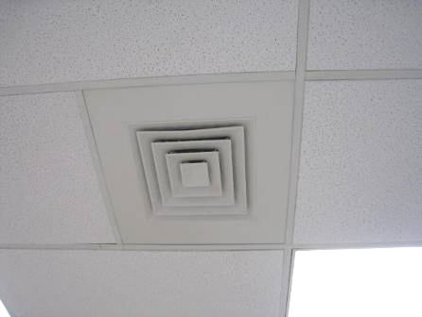

Ceiling-mounted fresh air diffuser

Picture 2

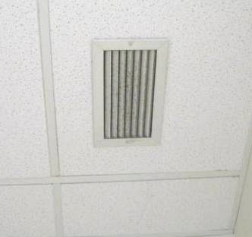

Ceiling-mounted exhaust vent, note vent louvers are dusty

Picture 3

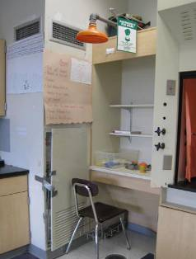

Classroom fan coil unit with cover ajar/taped shut, note emergency shower and drain which is likely to be dry

Picture 4

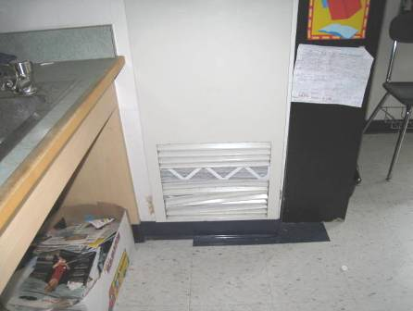

Classroom fan coil unit with broken louvers exposing filter

Picture 5

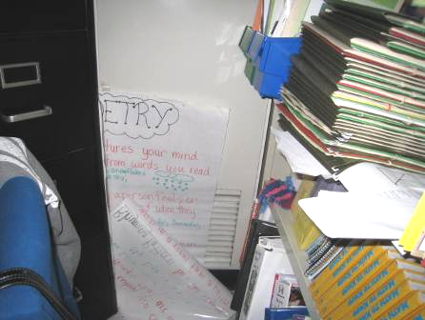

Classroom fan coil unit with return vent blocked by paper

Picture 6

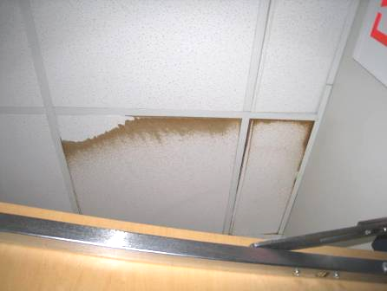

Water-damaged ceiling tile

Picture 7

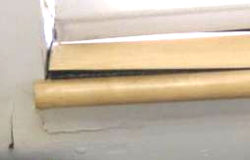

Water-damaged window sill and wall in classroom 319

Picture 8

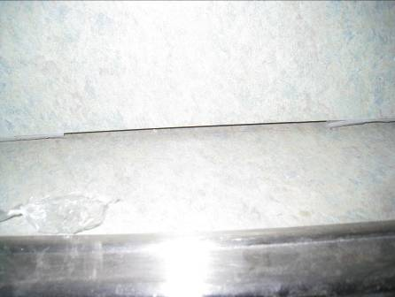

Gap in sealant of sink backsplash

Picture 9

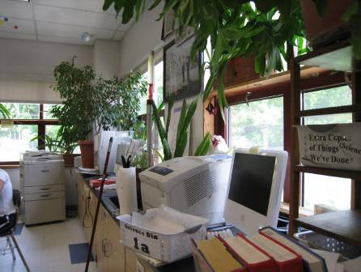

Plants in classroom

Picture 10

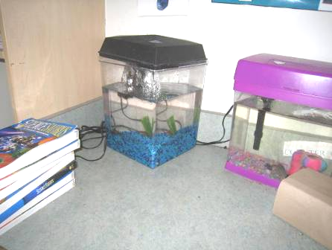

Aquariums in classroom

Picture 11

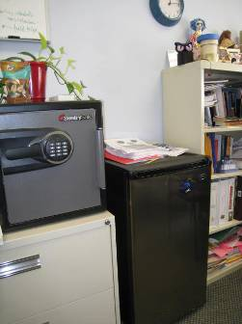

Refrigerator on carpet

Picture 12

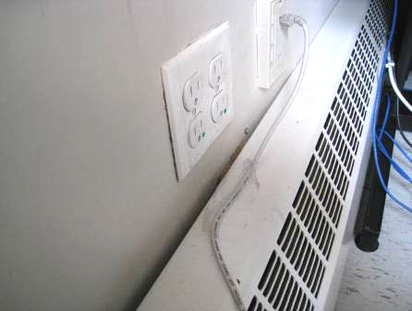

Radiator in room 105, note signs of water infiltration around the electrical socket

Picture 13

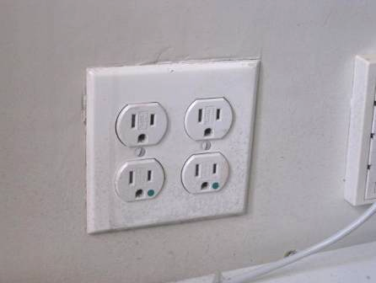

Electrical socket in room 105 with signs of water infiltration

Picture 14

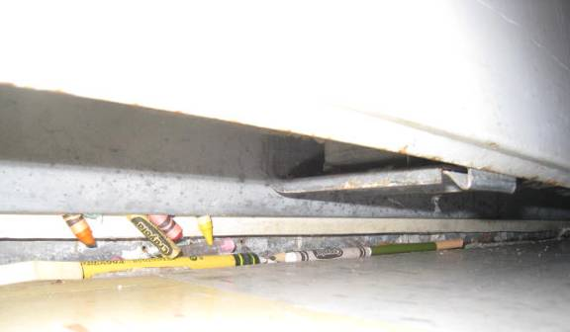

Crayons inside radiator in room 105

Picture 15

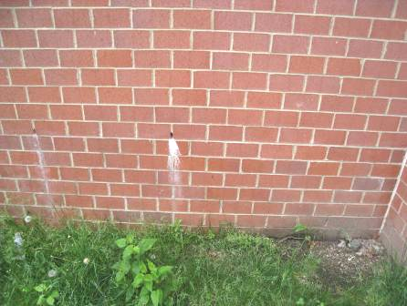

Building weepholes

Picture 16

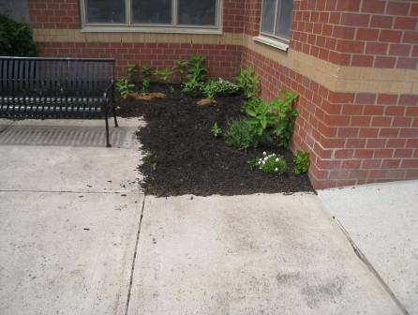

Plants/soil/mulch against building foundation

Picture 17

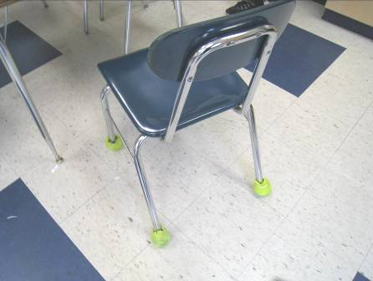

Tennis balls used as glides

Picture 18

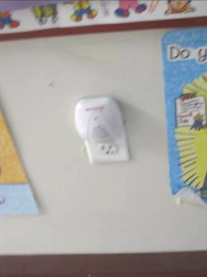

Plug-in air freshener

Picture 19

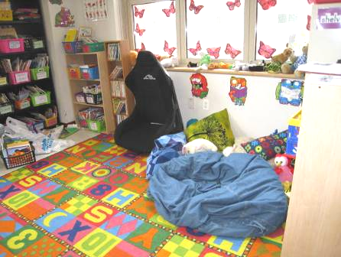

Upholstered items, area rug and plush toys

Picture 20

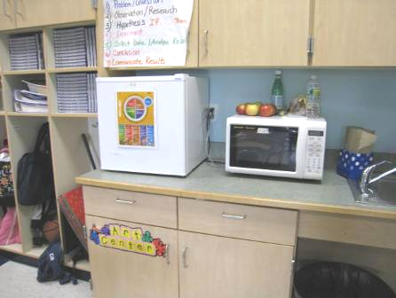

Food preparation area in classroom

Picture 21

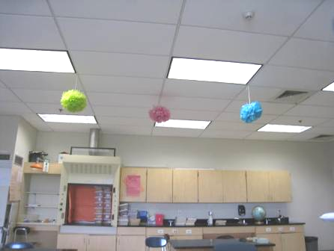

Items hanging from the ceiling
Location | Carbon  Dioxide  (ppm) | Carbon Monoxide  (ppm) | Temp  (°F) | Relative  Humidity  (%) | PM2.5  (ug/m³) | Occupants  in Room | Windows  Openable | Ventilation |  |  | Remarks
 |  |  |  |  |  |  |  | Intake | Exhaust |  | Remarks
Background | 375 | ND | 72 | 59 | 15 |  |  |  |  |  | Mostly cloudy
051 Art | 983 | ND | 73 | 63 | 15 | 24 | N | Y off |  | N | DO, PF, items
053 Band | 964 | ND | 73 | 62 | 16 | 25 | N | Y |  | Y | Tile floor, sink, area rug
101 | 782 | ND | 75 | 65 | 13 | 29 | Y open | Y FCU |  | Y on | CPs, microwave, food, items, broken windows
102 | 1302 | ND | 75 | 64 | 17 | 22 | Y | Y FCU off |  | Y | DEM, CPs
103 | 1173 | ND | 77 | 61 | 13 | 21 | Y | Y FCU on |  | Y | CPs, items, DEM
104 | 1109 | ND | 76 | 61 | 12 | 0 | Y | Y |  | Y | PF
105 | 545 | ND | 73 | 62 | 13 | 0 | Y | Y FCU off |  | Y | Presently closed
106 | 437 | ND | 73 | 65 | 21 | 0 | Y 2 open | Y FCU on |  | Y | PF, terra, plants, 1 WD CT
110 | 870 | ND | 75 | 66 | 10 | 9 | Y | Y |  | Y | 1 WD CT (near TV), DEM
113 | 556 | ND | 74 | 65 | 18 | 25 | Y open | Y |  | Y | Area rug, DEM
114 | 724 | ND | 74 | 66 | 14 | 0 | Y | Y |  | Y | DO, area rugs, wall vents obstructed, DEM, sink loose, space between sink wall and backsplash
116 | 707 | ND | 73 | 63 | 5 | 0 | N | Y |  | Y | DEM
117 | 1160 | ND | 74 | 66 | 16 | 25 | Y | Y |  | Y | Area rug
118 | 1101 | ND | 74 | 67 | 9 | 24 | Y | Y |  | Y | Dusty vents, tripping hazard in floor, area rug, CP/deodorizers, DEM
119 | 484 | ND | 73 | 65 | 20 | 0 | Y 1 open | Y |  | Y | DEM, small carpet, upholstered furniture, items
123 | 546 | ND | 72 | 66 | 21 | 23 | Y 2 open | Y |  | Y | Chalk and DEM, area rug
124 | 438 | ND | 73 | 64 | 15 | 0 | Y open | Y |  | Y | Wall vents blocked, DEM, area rug, open floor drain
125 Nurse | 630 | ND | 73 | 65 | 14 | 1 | N | Y |  |  | Carpet
125 B | 625 | ND | 72 | 62 | 10 | 1 | Y | Y |  | Y | Carpet
125 E | 675 | ND | 73 | 63 | 10 | 0 | N | Y |  |  | DO
125 F | 648 | ND | 73 | 63 | 11 | 0 | N | Y |  |  | DO
125 G | 622 | ND | 73 | 63 | 12 | 0 | N | Y |  |  | DO
125 H | 685 | ND | 73 | 65 | 15 | 2 | N | Y |  |  | DO
125 I | 586 | ND | 72 | 63 | 10 | 0 | N | Y |  |  | Chalk, carpet
131 | 680 | ND | 75 | 63 | 10 | 0 | Y | Y |  | Y | DO, TB, dust/debris on supply vent, area rugs, space between sink and countertop, DEM
134 | 690 | ND | 74 | 65 | 16 | 0 | Y open | Y |  | Y | DO, space between sink and countertop, 1 WD CT over windows, area rug, DEM, blocked wall vent
135 | 472 | ND | 75 | 62 | 14 | 0 | Y open | Y |  | Y | DO, TB, dust/debris on supply vent, area rugs, space between sink and countertop, DEM
136 | 796 | ND | 74 | 65 | 10 | 9 | Y | Y |  | Y | DO, area rugs, pillows, DEM
137 | 440 | ND | 73 | 62 | 13 | 0 | Y open | Y |  | Y | DO, dust/debris on supply vent, area rugs, space between sink and countertop, DEM, wall vent partly obstructed
138 | 686 | ND | 74 | 63 | 10 | 0 | Y | Y |  | Y | DO, area rug, DEM
141 | 678 | ND | 74 | 63 | 10 | 0 | Y | Y |  | Y | DO, area rug, DEM, pencil shavings on windowsill
150 Main elementary office | 637 | ND | 73 | 65 | 11 | 4 | N | Y |  | Y
150 B | 546 | ND | 73 | 63 | 10 | 0 | Y open | Y |  | Y | Carpet, plants
150 C | 538 | ND | 72 | 63 | 7 | 0 | Y | Y |  | Y | Full size fridge on carpet, boxes, microwave
151 Art 2 | 511 | ND | 73 | 65 | 14 | 4 | Y | Y |  | Y | Pads and items, food preparation equipment
153 Art 1 | 417 | ND | 72 | 65 | 18 | 7 | Y 3 open | Y |  | Y | Toys, items, pads, food preparation equipment
156 OT PT | 572 | ND | 73 | 61 | 13 | 0 | Y | Y |  | Y | DO, area rug, DEM, porous items under sink (no sink cabinet)
157 A (office) | 474 | ND | 72 | 63 | 16 | 0 | N | Y |  |  | Rubber sport balls, pad over supply vent removed
158 A (office) | 407 | ND | 71 | 65 | 20 | 1 | N | Y |  |  | Rubber sport balls, microwave, fridge, pad over supply vent
160 | 466 | ND | 72 | 62 | 8 | 40 | N | Y |  | Y
201 | 498 | ND | 75 | 62 | 20 | 0 | Y 2 open | Y FCU off |  | Y | Aqua, DEM
202 | 831 | ND | 75 | 63 | 18 | 0 | Y | Y FCU off |  | Y off | Aqua, space between sink and backsplash, DEM, CPs
203 | 445 | ND | 75 | 62 | 22 | 0 | N | Y |  | Y
204 (office) | 497 | ND | 75 | 62 | 23 | 0 | N | Y FCU off |  | N | DO
205 | 408 | ND | 74 | 63 | 23 | 0 | Y 5 open | Y |  | Y | FCU broken
206 | 806 | ND | 75 | 63 | 20 | 0 | Y 6 open | Y |  | Y | DEM
207 | 395 | ND | 74 | 63 | 26 | 0 | Y 6 open | Y |  | Y | FCU broken, aqua, space between sink and backsplash, small area rugs
208 | 620 | ND | 75 | 65 | 20 | 1 | Y | Y off |  | Y off | CPs, DO, plants, space between sink and backsplash, packaged dirt for science project
210 | 636 | ND | 75 | 65 | 26 | 17 | Y 2 open | Y |  | Y | Carpets, area rug
211 | 407 | ND | 75 | 63 | 25 | 0 | Y 3 open | Y |  | Y | Plants
213 | 590 | ND | 75 | 61 | 18 | 7 | Y | Y |  | Y off | DEM, food preparation equipment
216 Science | 957 | ND | 75 | 68 | 16 | 25 | Y | Y |  | Y | Area rug, sink, DEM, plants
217 | 667 | ND | 73 | 66 | 31 | 0 | Y | Y off |  | Y off | DO, DEM, space between sink and backsplash
219 | 655 | ND | 75 | 64 | 8 | 0 | Y | Y |  | Y | DEM, area rug, wall vents blocked, cracked window pane, pillows/cushions on floor
220 | 566 | ND | 72 | 62 | 7 | 1 | N | Y
221 (office) | 586 | ND | 73 | 63 | 2 | 0 | N | Y |  | N | Storage
222 | 428 | ND | 74 | 64 | 22 | 0 | Y 1 open | Y |  | Y | Broken exhaust vent, area rug, DEM, DO
223 | 619 | ND | 75 | 63 | 8 | 2 | U | Y |  | Y | DO, DEM, space between backsplash and sink
225 | 483 | ND | 73 | 66 | 19 | 0 | Y 1 open | Y |  | Y | Area rug, DEM, sink
226 LEAP | 516 | ND | 74 | 64 | 26 | 5 | Y 2 open | Y |  | Y | DEM
227 (office) | 517 | ND | 73 | 62 | 10 | 0 | N | Y |  | Y | Area rug
229 | 560 | ND | 73 | 64 | 13 | 0 | Y | Y |  | Y | DEM, DO, exhaust partially blocked
231 | 861 | ND | 75 | 62 | 12 | 0 | Y | Y off |  | Y off
232 | 534 | ND | 75 | 63 | 16 | 2 | Y | Y |  | Y | Area rug, DEM, backsplash open, FCU broken
235 | 601 | ND | 76 | 62 | 18 | 10 | Y 3 open | Y off |  | Y off | PF, DEM
237 | 468 | ND | 76 | 61 | 16 | 5 | Y 1 open | Y |  | Y | TB, PF, microwave, DO, CPs, breach FCU wall
241 | 387 | ND | 74 | 69 | 23 | 0 | Y, 5 open | Y |  | Y | Area rug, backsplash not sealed
248 | 568 | ND | 73 | 65 | 5 | 1 | U | Y |  | Y | Wall to wall carpet, DEM, DO
250 Teacher’s Workroom | 508 | ND | 72 | 64 | 3 | 0 | Y | Y |  | Y | DO, PF-dusty
255 B | 538 | ND | 76 | 59 | 21 | 3 | N | Y |  | Y | PF on, sink, tile floor
255 F | 482 | ND | 76 | 58 | 15 | 0 | N | Y |  | Y | Items, carpet
301 | 606 | ND | 76 | 62 | 20 | 22 | Y open | Y |  | Y | PF, DEM
305 | 739 | ND | 76 | 62 | 21 | 16 | Y 3 open | Y |  | Y
306 | 674 | ND | 78 | 60 | 20 | 0 | Y 2 open | Y FCU on |  | Y | Ripped window screen, DEM, fridge, 31 computers, portable AC
307 | 307 | ND | 76 | 60 | 26 | 18 | Y 6 open | Y |  | Y | DEM, PF
308 | 777 | ND | 78 | 60 | 21 | 22 | Y 6 open | Y FCU on |  | Y | PF, CPs, strong cleaning product odor
309 (office) | 704 | ND | 77 | 58 | 20 | 0 | N |  |  |  | Water and coffeemaker, dirty filter on vent
310 | 622 | ND | 76 | 63 | 19 | 23 | Y | Y |  | Y | Dust and debris on vents, DEM
311 | 902 | ND | 77 | 59 | 15 | 0 | Y | Y |  | Y | Items hanging from ceiling, DEM, emergency shower/drain
313 | 931 | ND | 75 | 66 | 25 | 23 | Y 3 open | Y off |  | Y off | Science hood – unused, DEM, PF dusty
316 | 477 | ND | 74 | 66 | 22 | 0 | Y 3 open | Y FCU off |  | Y filter dusty | Space between sink and backsplash, microwave, CPs, DO, DEM, laminator
317 | 761 | ND | 76 | 64 | 21 | 27 | Y 4 open | Y FCU on |  | Y dusty | PF, DEM
319 | 727 | ND | 76 | 66 | 17 | 23 | Y | Y |  | Y | WD windows (GW and wooden sill), 1 WD CT, DEM, moisture meter shows material is dry
323 | 601 | ND | 74 | 68 | 19 | 18 | Y open | Y |  | Y | DEM
325 | 1102 | ND | 78 | 63 | 6 | 29 | Y | Y |  | Y | Hole in GW, DEM, wall fan broken
328 | 659 | ND | 77 | 58 | 14 | 7 | N | Y |  | Y | DEM
329 | 748 | ND | 75 | 67 | 16 | 20 | Y 3 open | Y |  | Y | DEM, 1 AT
331 | 735 | ND | 75 | 67 | 21 | 15 | Y 1 open | Y |  | Y off | DEM
332 | 1120 | ND | 77 | 64 | 20 | 16 | Y | Y |  | Y | Many plants, DEM, science equipment
335 | 969 | ND | 77 | 66 | 17 | 15 | Y 1 open | Y on |  | Y | DEM
336 | 819 | ND | 77 | 61 | 23 | 14 | Y 2 open | Y |  | Y | DEM, computers
337 | 846 | ND | 77 | 62 | 18 | 14 | Y 2 open | Y |  | Y | PF on, DEM
341 | 823 | ND | 77 | 62 | 22 | 19 | Y 4 open | Y |  | Y | DEM, 3 PF dusty
350 Main middle school office | 730 | ND | 75 | 61 | 10 | 4 | N | Y |  | Y | PC
350 C | 662 | ND | 75 | 62 | 13 | 1 | Y 1 open | Y |  | N | DO, fridge on carpet
350 D Middle School Principal | 675 | ND | 75 | 61 | 15 | 0 | Y | Y |  | Y | Food, fridge on carpet, items
350 E Conference | 658 | ND | 75 | 61 | 10 | 1 | N | Y |  | Y | Carpet stained, fridge
350 F Work room | 791 | ND | 75 | 60 | 6 | 0 | N | Y |  | N | PC, DO
Auditorium | 539 | ND | 73 | 61 | 18 | 0 | N | Y |  | Y | Carpet
Auditorium upstairs | 540 | ND | 74 | 62 | 11 | 0 | N | Y |  | Y | Mesh over vents
Cafeteria 1 | 444 | ND | 71 | 71 | 25 | ~150 | Y | Y |  | Y dusty | Exterior door, DO, wrapped bubbler
Cafeteria 2 | 764 | ND | 74 | 74 | 16 | ~150 | Y | Y |  | Y dusty | 2 MT, FCUs uncovered, DO, PF on
Elementary Assistant Principal | 551 | ND | 72 | 65 | 16 | 0 | Y 1 open | Y |  | Y | Fridge and microwave
Elementary Copy/mail | 588 | ND | 72 | 64 | 13 | 0 | N | Y |  | Y | PC, laminator, sink
Elementary Main office, back | 586 | ND | 72 | 65 | 11 | 3 | Y | Y |  | Y | Plants, PC, carpet, PF
Library | 688 | ND | 74 | 64 | 17 | 0 | Y 5 open | Y off |  | Y off | DEM, PFs
Lower level Teacher’s lounge | 543 | ND | 75 | 62 | 8 | 0 | Y | Y |  | Y
Staff Restroom outside library |  |  |  |  |  |  | N | N |  | Y | No draw from exhaust

