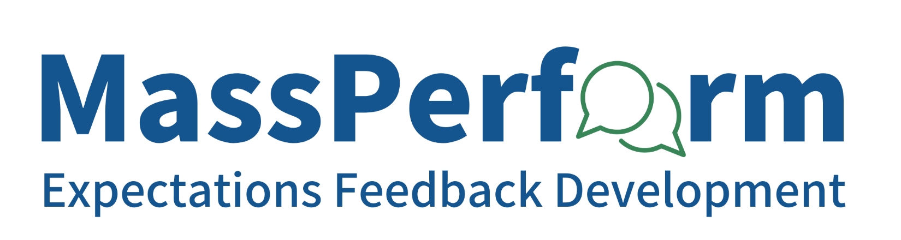
Getting Started Guide:
Kickoff Phase for Expectations & Goals Setting

Kickoff Phase: Expectations and Goals Setting
This guide will provide information and instructions for completing the Kickoff phase of MassPerform, including required steps (outlined in blue and starred*), best practices and additional resources to ensure a successful Kickoff for both managers and employees.
Both Managers and Employees:
- Complete the Intro to MassPerform Training before your Kickoff Check-in Meeting.
- Watch the video demonstration of a MassPerform Kickoff Check-in.
- Complete the Turning Feedback into Change when offered by your Secretariat.

Managers:
Clear expectations are key to the employee’s success and an effective relationship with your team, so ensure that you have clarity of your own expectations before having these conversations.

  - Before the Kickoff Check-in:
Best Practice: Employees are typically assigned 2 to 4 Expectations.

- In MyPath, Managers schedule Kickoff Check-in, select cadence of future Check-ins and enter Expectations. *
  - Send Outlook invites to employee for Kickoff and future Check-ins.
- Prepare for the Kickoff Check-in by:
  - Completing the Setting Expectations Planning Tool for each expectation.
  - Reviewing the Asking Questions Job Aid.
  - During the Kickoff Check-in:
- Use your Setting Expectations Planning Tool to keep the conversation on track.
  - Be transparent and explain what is expected of you as a manager of this team.
  - Explain each of your expectations for the employee, and that expectations may need to be adjusted if the business goals or priorities change.
  - Clarify that you will hold the employees accountable to these expectations, so the employee should let you know if they need to discuss for clarity at any point.
  - Use the Job Aid: SARAH Cycle and 3 Triggers to clarify perspective and intentions and to manage defensiveness.
- Finalize SMART goals drafted by the Employee for each expectation*
  - Ensure the employee’s goals are SMART, outlining specific actions that describe not only what they will do but also how they will achieve your expectations.
- Debrief your conversation using the Setting Expectations Planning Tool debrief section.
  - After the Kickoff Check-in
- Observe employee progress between Check-ins: What’s working? What’s not working?
- Be prepared to adjust expectations based on changes to business needs and priorities.

Employees:
Having a clear understanding of what is expected of you will enable you to set and achieve goals that are aligned with top business needs and priorities.
  - Before the Kickoff Check-in:
- View your manager’s expectations in MyPath. *
  - Note: this task is not accessible until you receive an email notifying you that your manager has entered their expectations for you in MyPath.
- Draft SMART goals to support your achievement of each expectation. *
  - Your goals should describe not only what you will do but also how you will achieve them and meet expectations.
  - Review the SMART goal definition in the MassPerform Program Guide & Toolkit.
- Prepare for the Kickoff Check-in by:
  - Reviewing the Asking Questions Job Aid.
  - During the Kickoff Check-in:
- Use the Job Aid: SARAH Cycle and 3 Triggers to clarify perspective and intentions and to manage defensiveness.
- Debrief your conversation with your manager using the debrief section of the Setting Expectations Planning Tool.
  - After the Kickoff Check-in:
- Enter the agreed upon SMART goals for each assigned expectation in MyPath. *
  - Leverage the MyPath system to track progress on your goals and record notes from your Check-in conversations with your manager.
- Reflect on your progress between Check-ins. What has been more difficult/easier than you thought?

