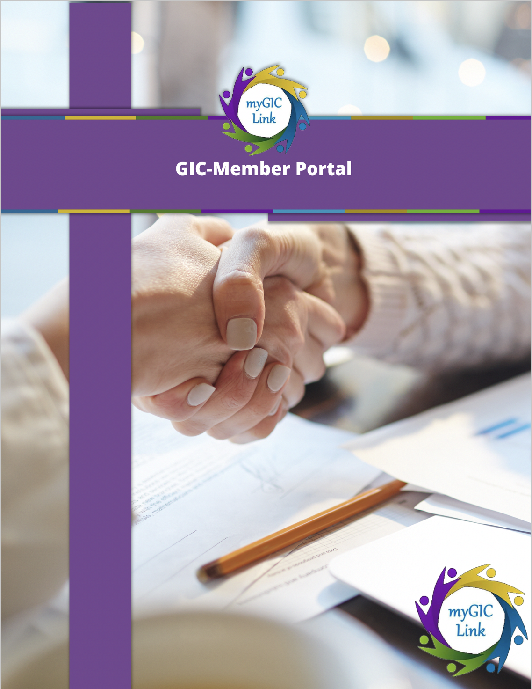

**Introduction 3**

**Homepage 3**

**Benefits 5**

**My Profile 6**

**Benefit Decision 13**

**Support Cases 15**

**Health Plan/ Carrier Directory 17**

**Plan Comparison Tool 19**

**Live agent 21**

# Introduction

Welcome to the GIC Member Portal user guide. This document will help you guide members on how to navigate through the Portal. The GIC portal gives its members 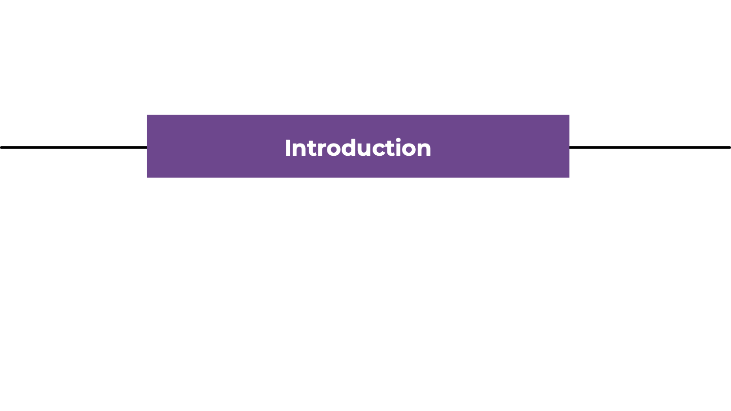easy access to enroll and keep track of their benefits, access to live chat agents, a plan comparison tool and enable them to view their personal information instantly and benefits information, among other great features.

# Homepage

After members log into the portal, they land on the portal homepage.

1. The right-side of the header displays links for members to view their '**Benefits**' and '**My Profile**'.
2. The top of the portal homepage displays ‘**Enrollment Status**’ and ‘**My Notifications**’.
3. In the middle of the portal, the ‘**My Application(s)**’ section tracks the member’s application status.
4. The bottom of the portal contains ‘**Benefits Quicklinks**’.
5. The bottom-left corner contains an option to ‘**Chat with an expert**’ for support.

2

5

4

3

1

1. At the bottom of the portal contains the ‘**Learn More**’ section to display welcome and other learning videos for the GIC Member Portal.

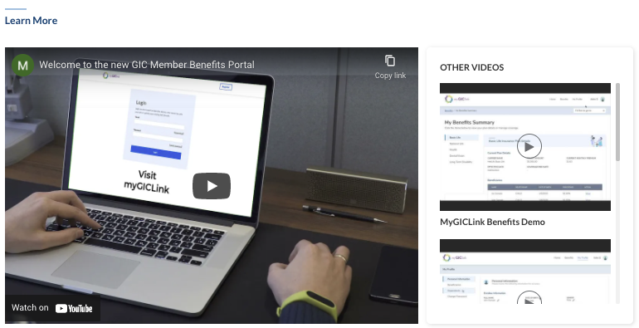

# Benefits

Once members are enrolled, they can review their GIC benefits. Click ‘**Benefits**’ on the top of the homepage and click ‘**My Benefits Summary**’ to navigate the ‘**My Benefits Summary**’ page.

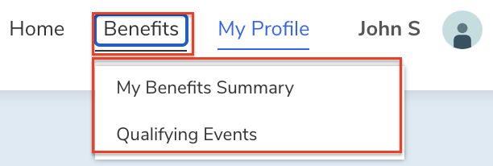

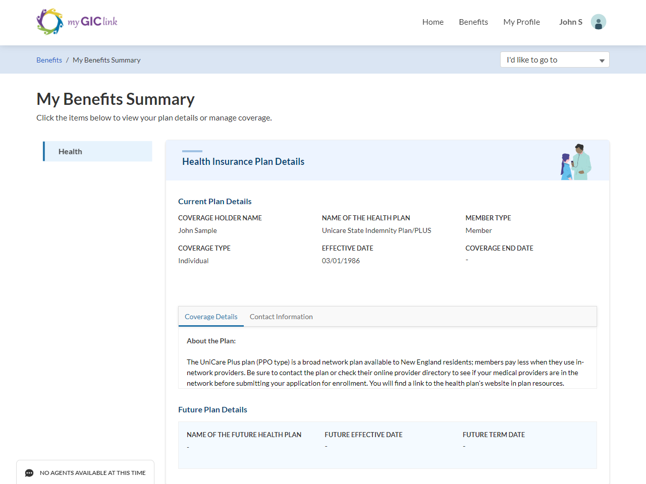

From each plan, click on ‘**Coverage Details**’and ‘**Contact information**’subtabs on the main body of the page to view related information.

# My Profile

Click on ‘**My Profile**’ to view the ‘**Personal Information**’, ‘**Dependents**’, or ‘**Change Password**’ sections.

Click ‘**Personal Information**’ to view enrollee, contact, and employer information.

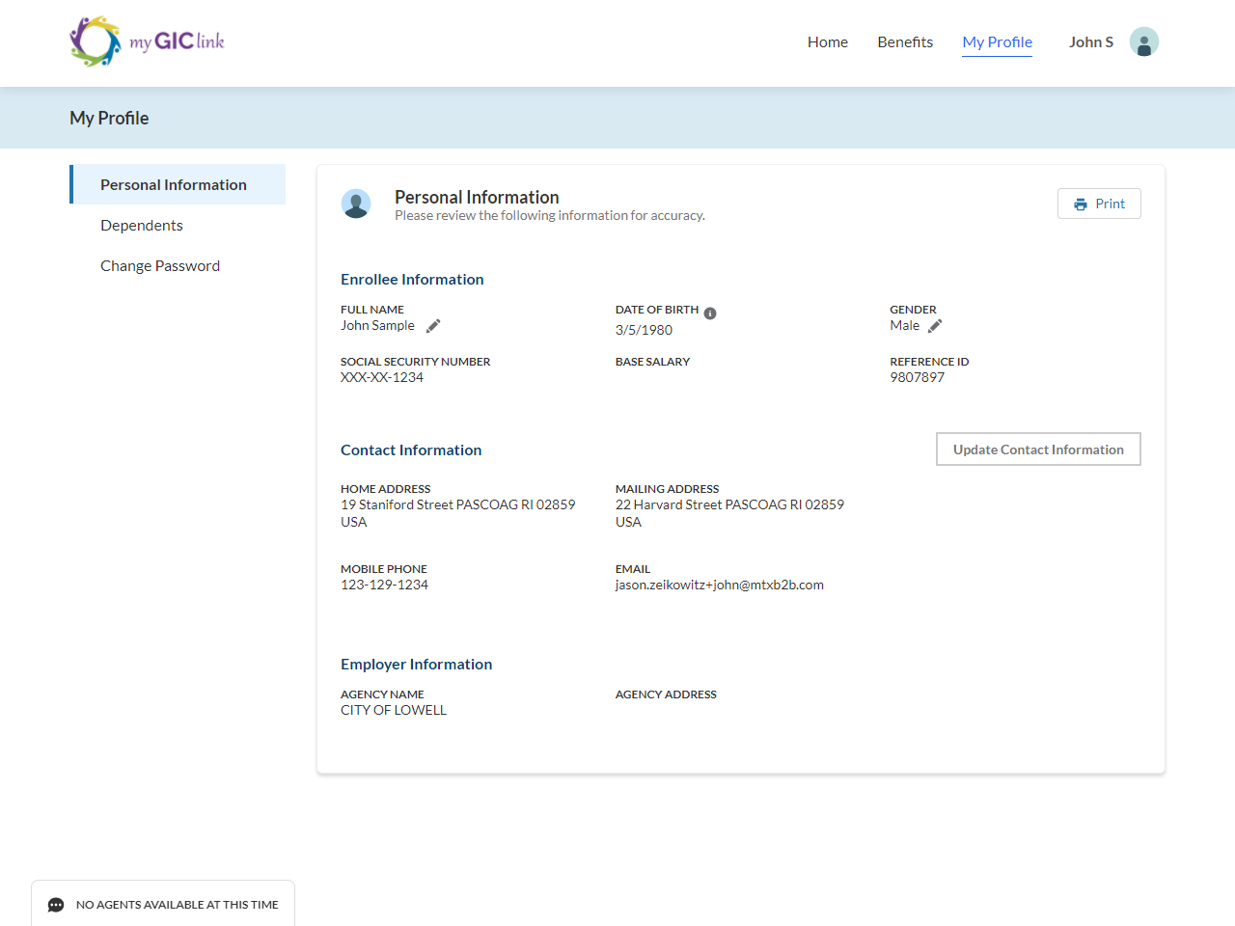

The fields with the pencil icon  can be edited by the member.

To edit the ‘**Full Name**’, click its pencil icon :

1. The ‘**Name Change Request**’ form will open.
2. Edit fields as necessary. All fields with a red asterisk are required.
3. Click ‘**Request Change**’ to send the request for approval by GIC Staff (or)
4. Click ‘**Cancel**’ to cancel the change.

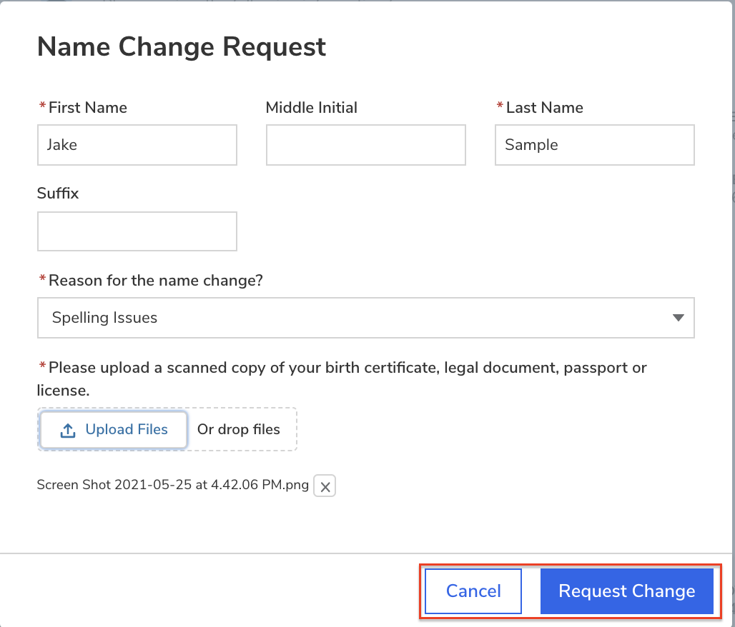

Once a request is submitted, if members click the pencil icon  again, the change request form states, ‘**Your updates are under review**’.

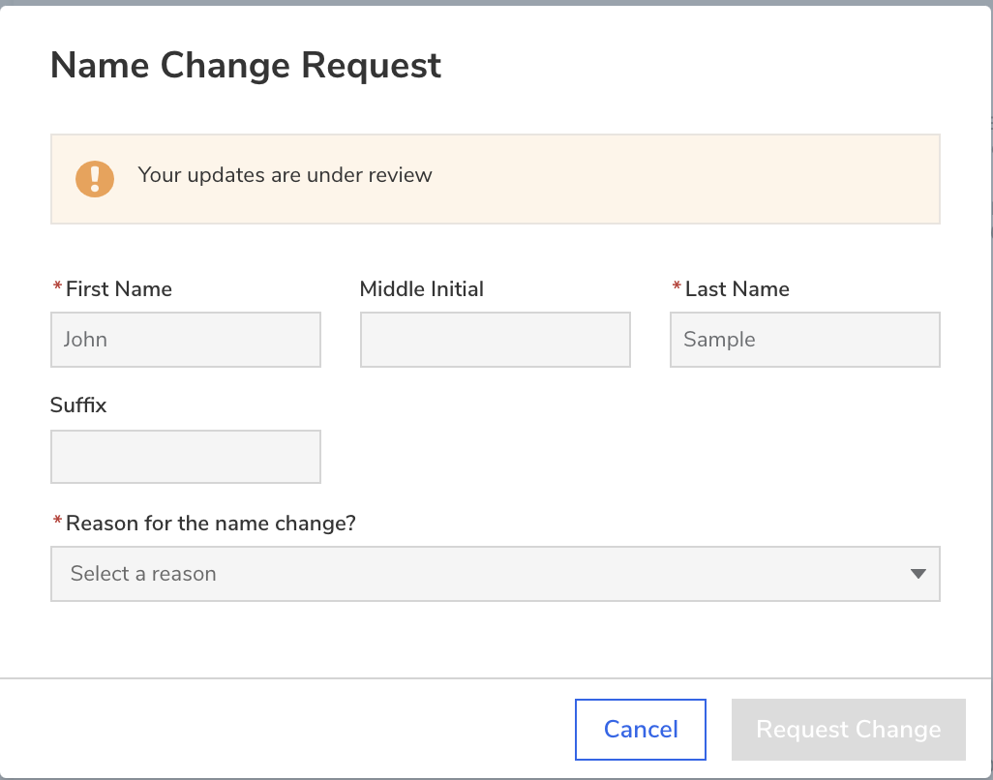

To update ‘**Gender**,’ click its pencil icon :

1. The ‘**Update Gender**’ form will open.
2. Update the ‘**Gender**’ field.
3. Click ‘**Update**’ to save (or)
4. Click ‘**Cancel**’ to cancel.

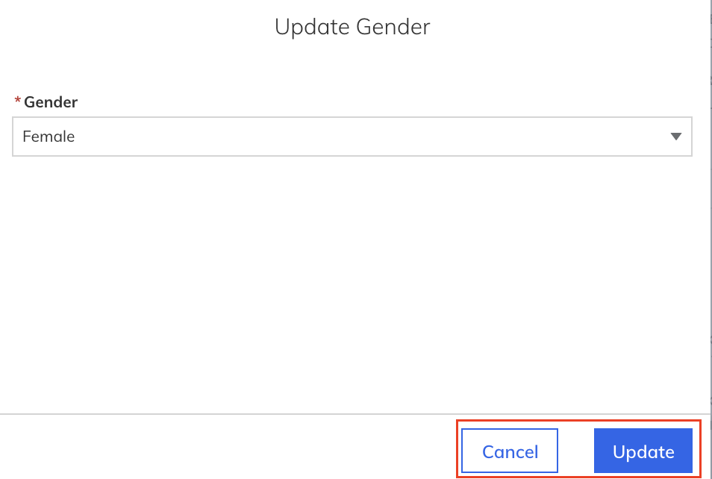

Click ‘**Update Contact Information**’for a member to edit/update their ‘**Contact Information**’ section.



Edit fields as necessary. All fields with a red asterisk are required. Click ‘**Update**’ to save changes, or ‘**Cancel**’ to discard any changes made.

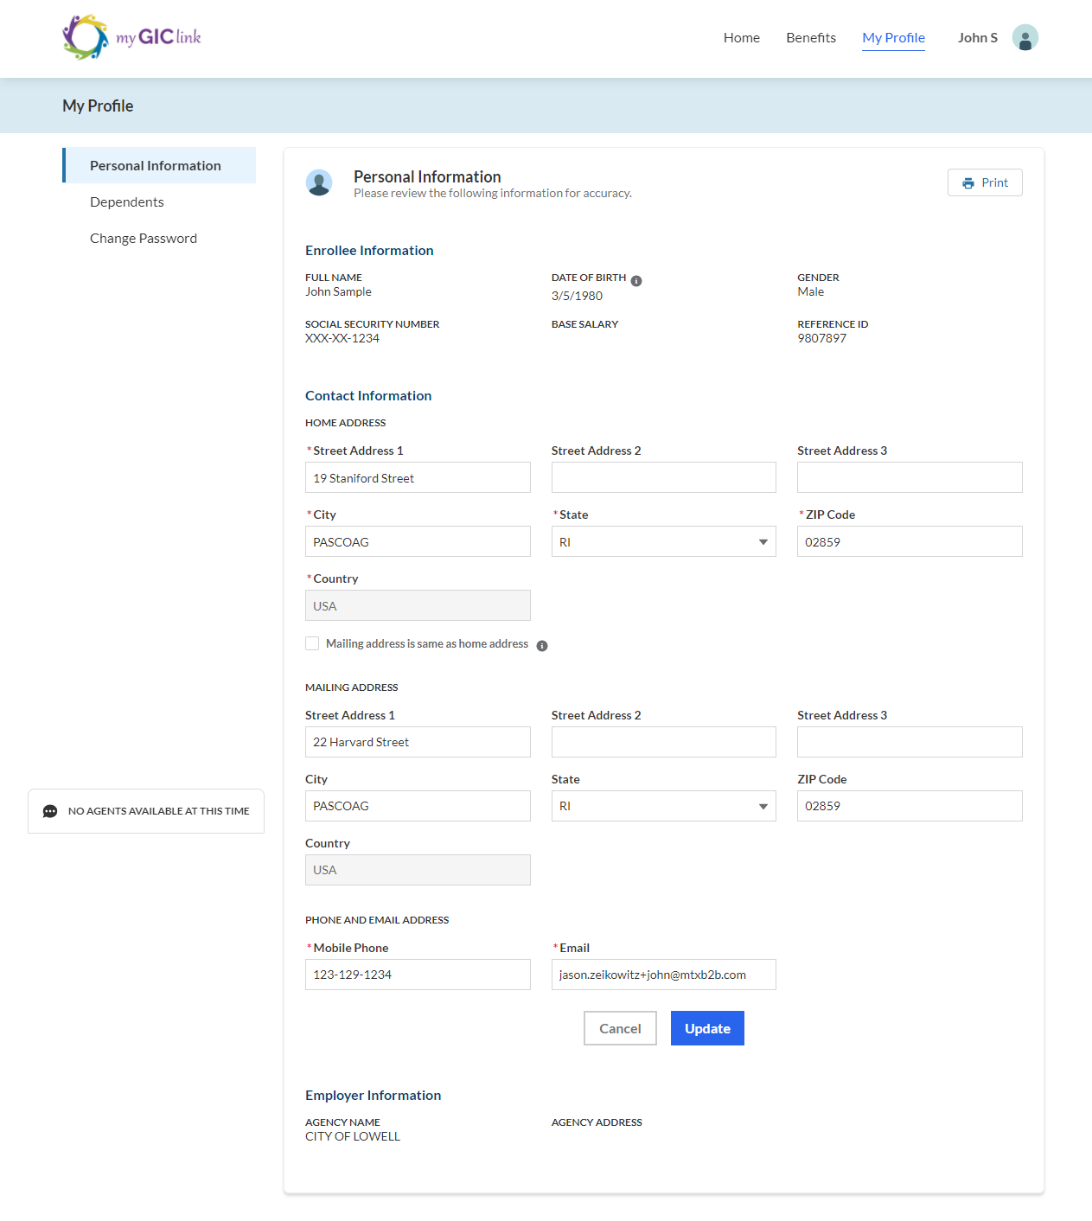

Click on the ‘**Dependents**’ side-tab to view enrolled dependents. For each enrolled dependent, members can click ‘**View**’ to see details, or members can click ‘**Edit**’ to make any changes.

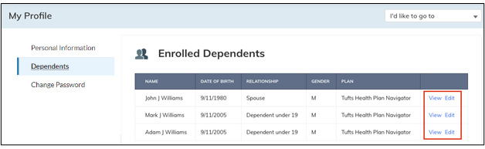

(Continue to the next page)

If members click ‘**Edit**,’ they can update the dependent information and then click ‘**Request Change**’ to submit. After clicking ‘**Request Change**,’ Dependent information goes through the GIC analyst's approval process.

**Please Note**:

* If the member is requesting a change for Gender, they must check the box to attest to terms and conditions and enter their Full Name.
* If a Dependent change request is approved or rejected, members receive an email alert from GIC.

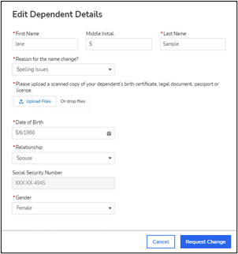

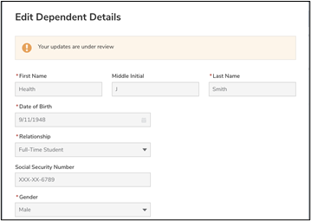

**Please Note:** Members receive an approval/rejection email once their change request has been reviewed by a GIC analyst.

To change a member's password, click the ‘**Change Password**’ side-tab.

On the ‘**Update Password**’ page, the member enters their current password, new password, and a confirmation of their new password. Once complete, the member clicks ‘**Change Password**’ to update their password.

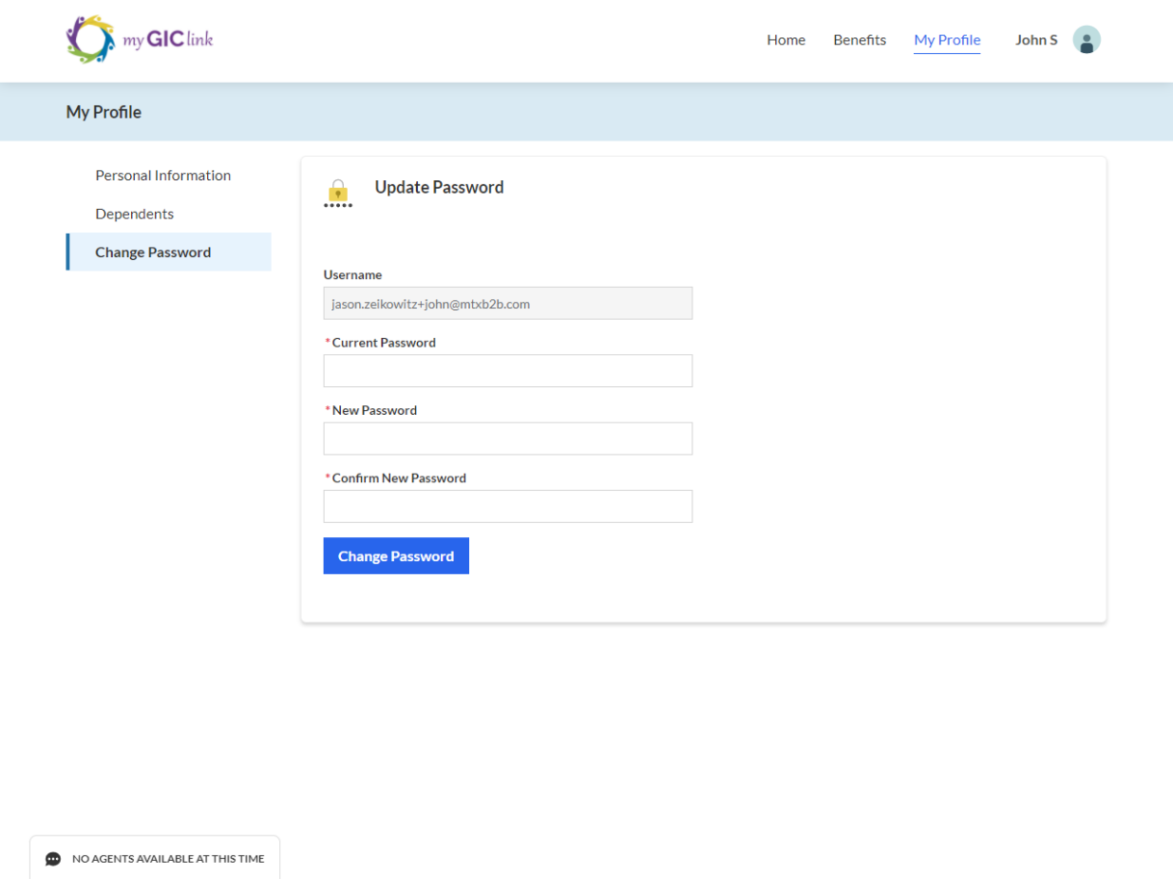

# Benefit Decision

Navigate back to the bottom of the portal homepage and click ‘**GIC Benefit Decision Guide**’ in the ‘**Benefits QuickLinks'** section.

**Please Note:** As stated previously, members can also access this quicklink by using the dropdown menu from the ‘**Benefits**’ or ‘**My Profile**’ page .

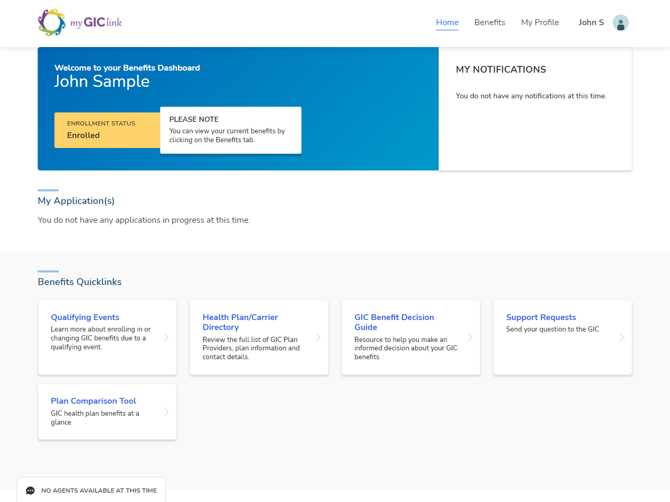

(Continue to the next page)

Members can click any of the panels on this page to navigate to each PDF page.

# Support Cases

On the bottom of the portal homepage, click ‘**Support Requests**’ in the ‘**Benefits QuickLinks'** section.

Here members can ‘**Create a New Support Request**’ and view the status of previously submitted requests under ‘**Logged Support Requests**’.

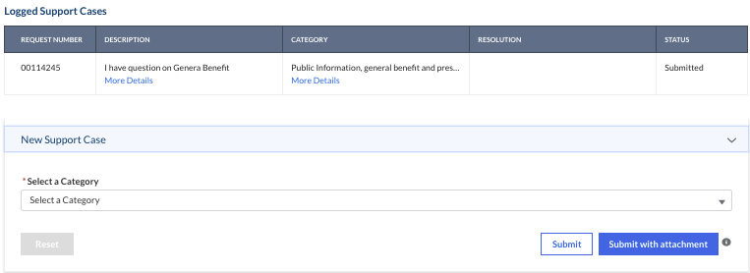

(Continue to the next page)

To ‘**Create a New Support Request**’, select a category from its dropdown menu.

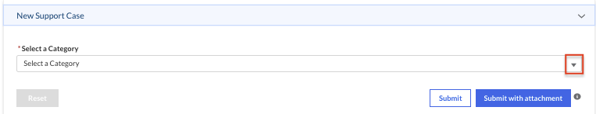

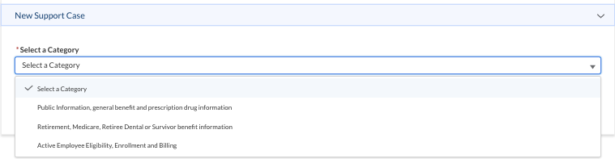

Enter the issue description and click ‘**Submit**’. If members have an attachment related to the issue, they can add it by clicking ‘**Submit with attachment**’.

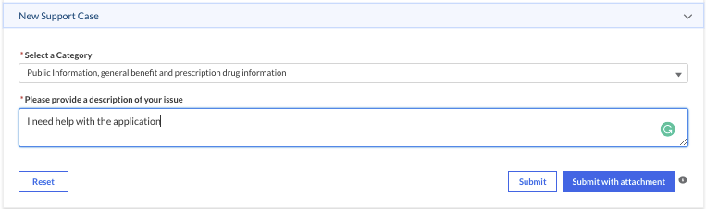

Once the case is submitted, it is tracked under ‘**Logged Support Requests**’ for members to view GIC staff internal comments, resolutions, and status updates.

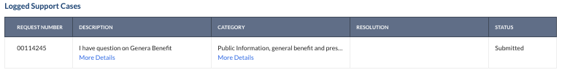

**Please Note:** Attachments should only relate to the issue. Members should never submit any documents specifically related to a ‘**Dependent**’ in this section. Dependent documents should only be uploaded from the application itself or when the dependent information needs to be modified. Help text added for reference.

# Health Plan/ Carrier Directory

On the bottom of the portal homepage, click ‘**Health Plan/Carrier Directory**’ in the ‘**Benefits QuickLinks'** section.



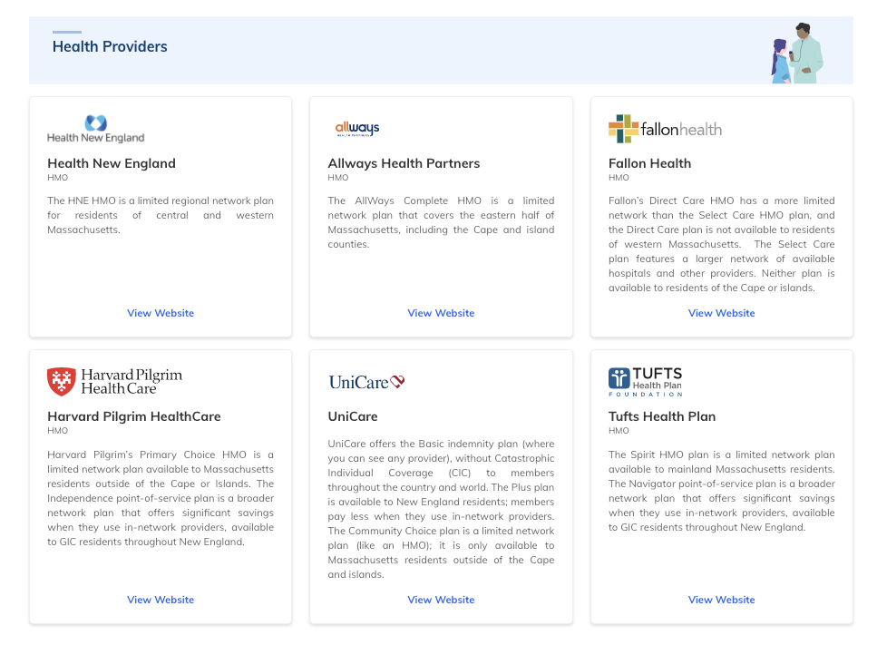

# Plan Comparison Tool

On the bottom of the portal homepage, click ‘**Plan Comparison Tool**’ in the ‘**Benefits QuickLinks'** section.

Select an option from the ‘**GIC Benefit Options**’ dropdown menu.

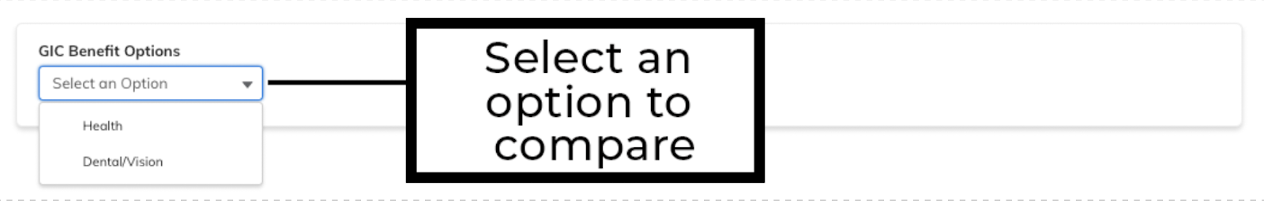

(Continue to the next page)

Members can select up to 3 plans and click ‘**Compare Now**’ to compare plans side by side.

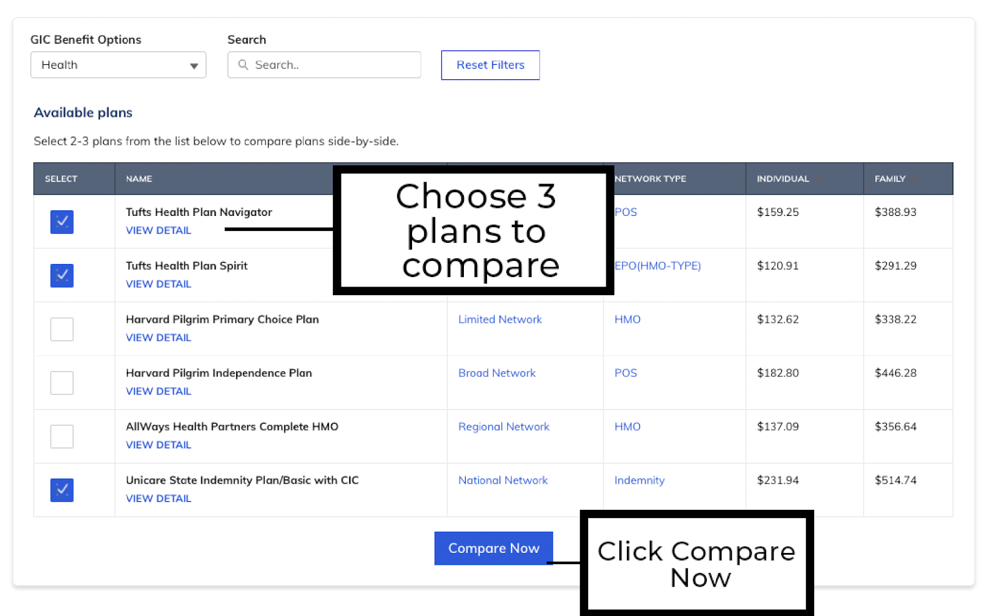

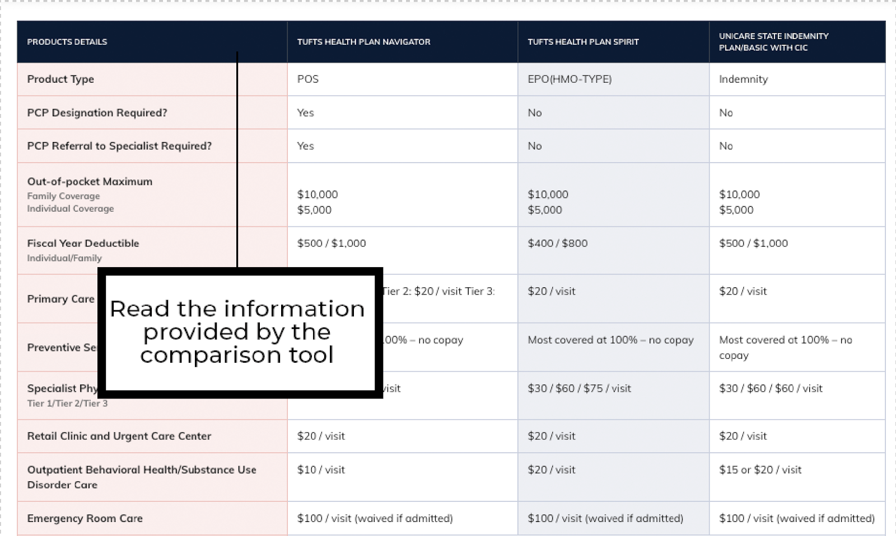

# Live agent

There is a chatbox on the bottom-left corner of the portal homepage, where members can directly speak with a live agent.

Click ‘**CHAT WITH AN AGENT**’ to open the chat console and select a ‘**Category**’ to choose a topic. Click ‘**Start Chatting**’ to initiate a chat with the Live Agent.

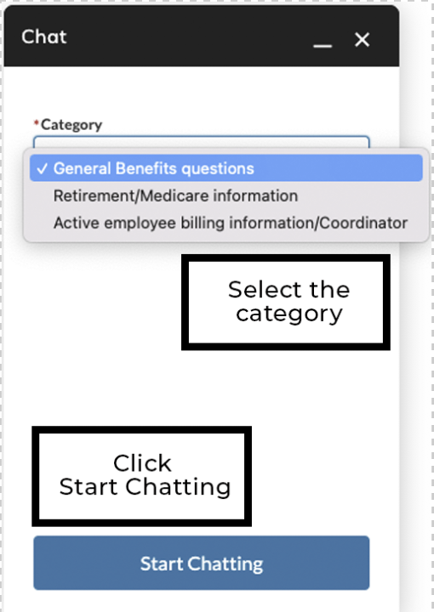

(Continue to the next page)

While waiting to chat, members can ‘**Cancel Chat Request**’.

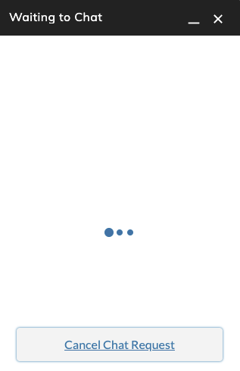

Once connected with the agent, start typing a message in the chat box and click ‘**enter**’ on the keyboard to send a live agent message.

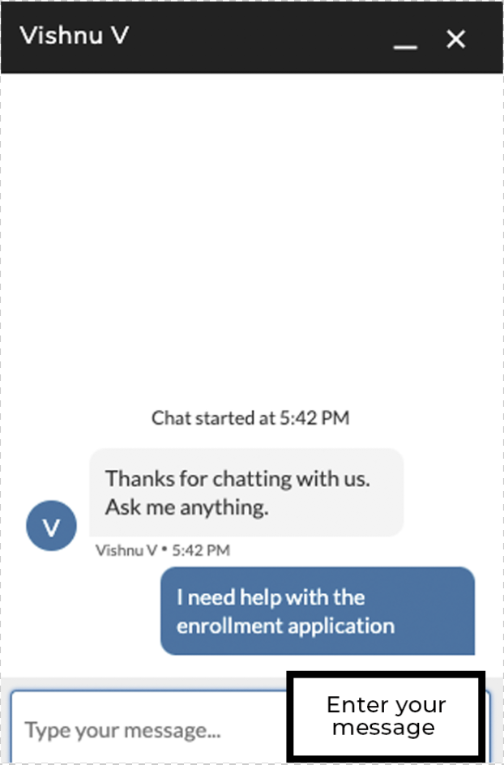

(Continue to the next page)

When live agents are offline, live chat is unavailable on the application portal. On the application portal, it is displayed as ‘**NO AGENTS AVAILABLE AT THIS TIME**.’



**Please Note**: If experts are unavailable, members can create a support request to log any issue or question.

Member Portal User Guide completed.