INCIDENT HIGHLIGHTS
DATE:
November 3, 2017
TIME:
1:53 p.m.
VICTIM:
19-year-old male bicycle food delivery worker
INDUSTRY/NAICS CODE:
Local Delivery / 492210
EMPLOYMENT STATUS:
Independent Contractor
SAFETY & TRAINING:
No safety and health program and no training
SCENE:
Industrial section of a roadway
LOCATION:
Massachusetts
EVENT TYPE:
Struck-by

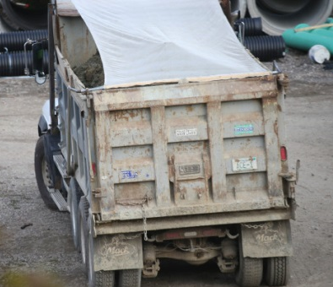

REPORT#: 17MA056 REPORT DATE: March 11, 2020
Gig Economy Bicycle Food Delivery Worker Dies When Struck By a Dump Truck — Massachusetts

SUMMARY
On November 3, 2017, a 19-year-old, independent contractor, bicycle food delivery worker died when struck by a dump truck. The victim, a “gig-economy” worker, was logged onto a food delivery application-based platform via his cell phone at the time of the incident. READ THE FULL REPORT> (p.3)

CONTRIBUTING FACTORS
Key contributing factors identified in this investigation include:
- No side guards on the truck;
- Vehicle blind spots;
- No company provided safety and health protections for the victim, including no personal protective equipment (PPE), because working as an independent contractor; and
- No dedicated bicycle lanes. LEARN MORE> (p.5)

RECOMMENDATIONS
The Massachusetts FACE Program concluded that, to help prevent similar occurrences, employers and other owners of motor vehicles with gross vehicle weight ratings over 10,000 pounds should:
- Consider adding side guards to these vehicles.
Employers, including employers who utilize workers with nontraditional work arrangements should:
- Ensure that all workers who will use bicycles along roadways to perform tasks are wearing the appropriate personal protective equipment (PPE) for the task and should consider providing daytime running lights for the bicycles; and
- Ensure that all workers who will be in proximity to roadways to perform tasks are trained about the concept of vehicle blind spots.
Employers who utilize independent contractors should:
- Comply with the Massachusetts Independent Contractor Law to ensure employees are not misclassified as independent contractors... LEARN MORE> (p.6)
Fatality Assessment and Control Evaluation (FACE) Program

The Massachusetts Department of Public Health, in cooperation with the National Institute for Occupational Safety and Health (NIOSH), conducts investigations on the causes of work-related fatalities. The goal of this program, known as Massachusetts Fatality Assessment and Control Evaluation (Massachusetts FACE) is to prevent future fatal workplace injuries. Massachusetts FACE aims to achieve this goal by identifying and studying the risk factors that contribute to workplace fatalities, by recommending intervention strategies, and by disseminating prevention information to employers and employees.

NIOSH funded state-based FACE Programs currently include: California, Kentucky, Massachusetts, Michigan, New York, Oregon, and Washington.
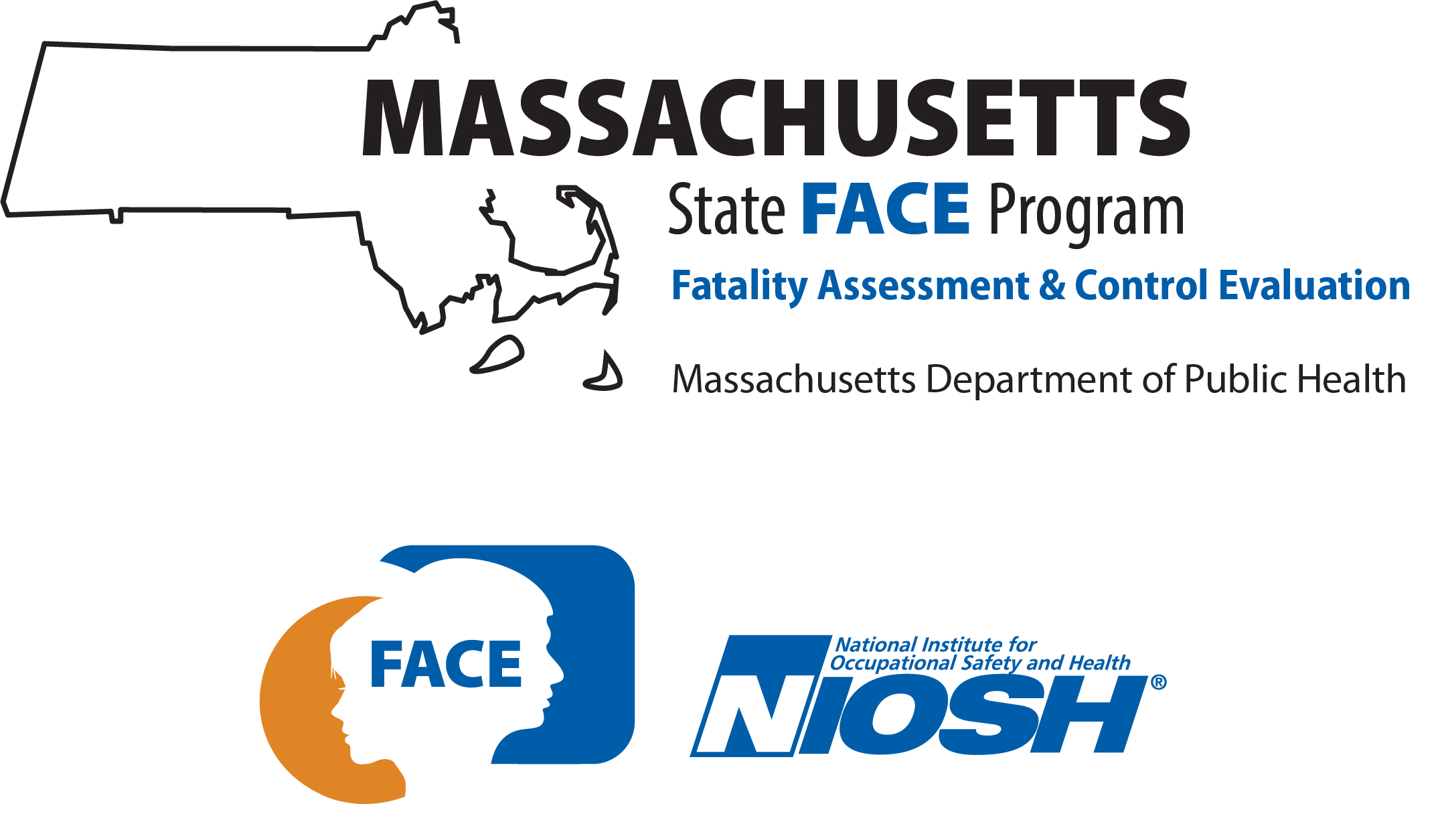

SUMMARY
On November 3, 2017, a 19-year-old “gig economy” bicycle food delivery worker died when he was struck by a dump truck. At the time of the incident, he was logged onto a food delivery, application-based platform via his cell phone, which was in his pocket. He was riding his bicycle along a roadway when he was struck. Once the dump truck operator realized his truck had struck a person, a call was placed for emergency medical services (EMS). EMS arrived quickly and the victim was pronounced at the incident location.

INTRODUCTION
On November 6, 2017, the Massachusetts FACE Program was alerted by the local media about the death of a worker on a bicycle who struck by a truck. On November 29, 2017, a representative from the Massachusetts FACE Program had a telephone conversation with multiple representatives of the company that developed and controls the food delivery application-based platform to discuss the incident. Conversations were also held with the local police department and with community representatives. The incident location was visited and the police report, death certificate, and other information were reviewed.

EMPLOYER INFORMATION
The victim was using a food delivery application-based platform (app) to make money. The “gig economy” company that owns and controls the delivery application-based platform uses logistics services to offer on-demand food delivery to app users from restaurants. The company was formed in 2013 and started providing services in Massachusetts the following year. All of the food delivery workers, including the victim, had nontraditional work arrangements and were treated by the company as independent contractors.
The company paid the food delivery workers for each delivery and not an hourly wage. The payment was $5 per delivery and the food delivery workers kept 100% of the tip provided by the customer. Workers created an account that gave them access to the app. Workers could log onto the app and select from the currently available schedules or select from available schedules in the future. There were no set scheduled hours for the workers. There was no limit on how often someone works. The main tasks for the delivery workers included logging onto the app, reviewing the order provided through the app, and accepting or declining the order. If the order was accepted, the worker then would go to the restaurant, pick up the food order and deliver the order to the customer-provided location, which the customer provides via the app. In addition, there were many conditions that the company deemed as justification for deactivating an account, such as having low customer-based ratings, accepting too few orders for delivery, and creating an unsafe environment, including unsafe driving and biking.
A majority of workers in nontraditional work arrangements, including the victim in this case, are routinely not provided with benefits, such as health insurance, workers’ compensation, paid sick leave or vacation time.¹ These factors can lead to unpredictable income or complete life altering changes if you become injured while working with a nontraditional work arrangement for an employer.¹ The workers’ compensation system in Massachusetts is a private system. Massachusetts employers are required to have workers’ compensation insurance for employees, but only workers classified as employees of the companies have access to this employer provided benefit. This leaves many Massachusetts workers, which included the victim in this incident, without the safety net of workers’ compensation insurance. Workers’ compensation can help ensure economic stability for workers and their families. Workers’ compensation combined with other benefits and protections provided only to employees of companies are a key foundation of financial stability.
The truck operator was employed by a small trucking company based in a neighboring state. The trucking company was hired as sub-contractor for a larger excavation and trucking company. The work for this job included picking up loads of soil at one construction site and transporting the soil to another construction site, which was the incident location. The soil was then off loaded at the incident location.

SAFETY PROGRAMS and TRAINING
OSHA requires employers to provide safe and healthful workplaces that are free from serious recognized hazards. In this case, the gig economy company did not have a safety and health program for the food delivery workers, did not provide these workers with health and safety training, and did not provide them with personal protective equipment (PPE). Because the food delivery workers that the company depended upon were treated as independent contractors and not employees, the company was not required to provide these workers with safety and health training or PPE. The delivery workers were provided with a general orientation that explained how to use the application and the procedures for picking up and delivering food.
Employers should also ensure that the jobs they are providing are accessible, predictable, and well-compensated, which would provide another piece of the much needed social safety net that would help ensure an overall better quality of life. Ideally an employer would make these basic aspects of work available to nontraditional work arrangement workers providing them the same type of basic fundamentals of work that are afforded to their full-time employees.
In reality, however, policies, programs, and systemic discrimination sometimes compromise a person’s access to and the quality of their employment. These factors have tremendous consequences for a person’s health since employment is a social determinant of health. Research shows that when people are employed and have predictable work, they are more likely to have better physical and mental health then people who are unemployed or in a poor-quality job.^{1,5} Being employed in a high-quality job maintains a person’s physical and mental health and improves a person’s financial ability to support their basic needs, a healthy lifestyle, and access to medical care. It also has several psychological benefits such as improving a person’s stress levels, self-worth, self-esteem, and social capital—their connections and networks with others.⁶

WORKER INFORMATION
The victim was a 19-year-old, Black non-Hispanic male who held multiple jobs. These jobs included independent contract work, such as photography, modeling, and bicycle food delivery worker for a gig economy company. He also worked part-time at a restaurant. The bicycle food delivery work was via a food delivery application-based platform. At the time of the incident, he was logged onto the food delivery app and was wearing an insulated food delivery backpack with the logo for the company that owned and maintained the app.
The truck operator was a 38-year-old male who had been driving trucks for over 15 years. He held a valid Class B commercial driver’s license with no restrictions. The truck operator’s shift had started at 7:00 a.m. and had made about 10 trips driving the truck from a different construction site, a couple of miles away. The police determined that the truck operator was not on his cell phone at the time of the incident.

WEATHER
The weather at the time of the incident was approximately 67 degrees Fahrenheit, 73% humidity, 20 mile per hour (mph) average west northwesterly wind speed, and mostly cloudy skies.⁷ There was no precipitation on the day of the incident and during the few days before the incident. The weather on the day of the incident is not believed to have been a factor in this incident.

EQUIPMENT
The victim was riding his personal road bicycle at the time of the incident. He was an experienced rider. It was reported in a local newspaper article that the victim had recently spent a few hundred dollars on maintenance and repairs for his bike for the food delivery work.
The truck involved in the incident was a 10 wheeled tandem axel dump truck manufactured in 1997 (Figure 1). The dump truck body was loaded with soil at the time of the incident and the total weight of the truck was determined to be 78,750 pounds. After the incident, the truck went through a Federal Motor Carrier Safety Alliance (FMCSA) Level 1 Safety Inspection. Multiple violations were identified at the time of the safety inspection and the truck was placed out of service.

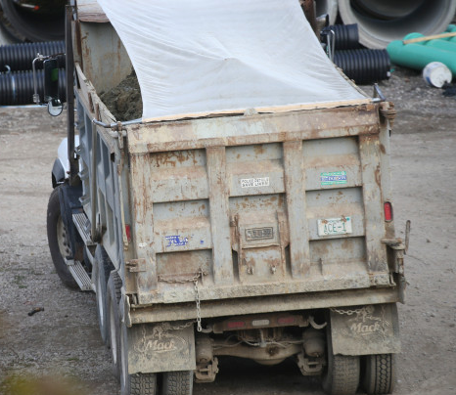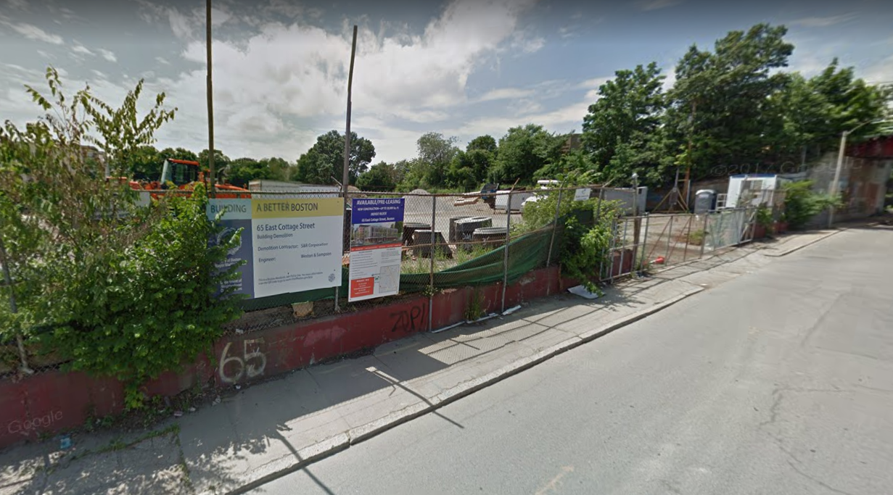
X
Figure 1 – Dump truck involved in the Figure 2 – Street view of the incident location including the fenced
incident construction site with gate. The X indicates location of the crash.

INCIDENT SCENE
The incident occurred in an industrial section of a large city which bordered areas that were more residential (Figure 2). The roadway was comprised of asphalt and vehicles traveled in both the east and west directions, with one travel lane in each direction. The street had sidewalks on both sides of the roadway. There were no painted roadway markings at the time of the incident. The area adjacent to the initial incident location was the entrance and exit for a large construction site. The construction site was enclosed by a chain link fence with a gate at the street location. The ground around the entrance of the construction site was concrete and there was dirt and loose gravel. A few years prior, the building on the site was demolished. At the time of the incident, there was a construction trailer, piles of soil, and other construction materials at the site.

INVESTIGATION
The victim had finished a work shift at a restaurant earlier that day and biked home. He then logged onto a food delivery app and started riding his bike towards downtown where many restaurants are located. It was reported that he had declined a delivery request relatively soon after logging onto the app. The police report states that his cell phone was in his pants pocket and that he was not wearing a helmet. In Massachusetts only bike operators who are 16 years old or younger are required to wear helmets.
The incident occurred at approximately 1:53 p.m. At the time of the incident, the victim was riding his bike on a roadway in an industrial area. The dump truck that struck the victim was traveling forward in an easterly direction. This was the same direction the victim was traveling on his bike. The dump truck operator turned on the truck’s right directional signal to indicate that the truck was going to turn right. At this point, it was determined by the police that the dump truck was traveling approximately 10 mile per hour. As the dump truck started turning right to enter the construction site, the truck and the victim, who was on his bike and located on the right-hand side of the truck, collided. It was reported that the victim might have tried to stop his bike and his bike skidded on the dirt and loose gravel. A motorist behind the dump truck witnessed the collision and stopped his car to notify the truck driver what had happened. The dump truck operator did not realize his truck had struck a person. Multiple calls were placed for emergency medical services (EMS). EMS arrived quickly and the victim was pronounced at the incident location.
X
Figure 3 – Street view of Incident location, including the construction site entrance located on the right.
The arrow indicates the dump truck travel direction. The X indicates the approximate location of the crash.

CAUSE OF DEATH
The medical examiner listed the cause of death as multiple blunt force injuries.

CONTRIBUTING FACTORS
Occupational injuries and fatalities are often the result of one or more contributing factors or key events in a larger sequence of events that ultimately result in the injury or fatality. The Massachusetts FACE Program identified the following contributing factors in this incident:
- No sideguards on the truck;
- Vehicle blind spots;
- No company provided safety and health protections for the victim, including no personal protective equipment (PPE), because working as an independent contractor; and
- No dedicated bicycle lanes.

RECOMMENDATIONS/DISCUSSION
Recommendation #1: Employers and other owners of motor vehicles with gross vehicle weight ratings over 10,000 pounds should consider adding side guards to their vehicles.
Discussion: Large commercial motor vehicles that weigh more than 10,000 pounds, including both tractor-trailers and single-unit trucks, can pose a hazard to smaller vehicles, bicyclists, and pedestrians during a side collision.⁸ One way owners of large vehicles can help ensure pedestrians, bicycle operators, and operators/passengers of smaller vehicles do not end up under the larger vehicle in the event of a side collision, is to install side guards on the large vehicles. Truck side guards are vehicle-based safety devices designed to keep pedestrians, bicyclists, and motorcyclists from being run over by a large truck’s rear wheels in a side-impact collision.⁹ Research has shown the benefits of these side guards.⁹ In Massachusetts, some communities require side guards on large trucks in some capacity. For example, one local municipality has an ordinance that requires large trucks to have side guards before contract work requiring large trucks for that municipality can begin.¹⁰ Another municipality is incorporating side guards on the large trucks and buses that the municipality has ownership over.¹¹ All owners of large vehicles and semi-trailers should consider incorporating side guards.
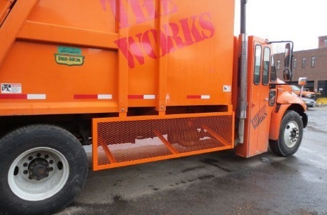
Figure 4 – Refuse truck with a side guard installed
Recommendation #2: Employers should ensure that all workers who will use bicycles along roadways to perform tasks are wearing the appropriate personal protective equipment (PPE) for the task and should consider providing daytime running lights for the bicycles.
Discussion: Employers of all types of workers, both employees of the company and workers with nontraditional work arrangements, including independent contractors, who will be on bikes and in close proximity of moving vehicles should provide and ensure that all of these workers are at a minimum wearing high visibility clothing and head protection. These protections will help make workers on bike more visible and help protect their heads in the event of a crash. In addition, employers should consider providing and ensuring the use of bicycle daytime running lights.
All workers who work on and along roadways, including those on bikes, face many hazards. One of these hazards is routinely being in close proximity to moving motor vehicle traffic.^{12,13,14} In this case the victim was on a bike, and workers on bikes lack protection in a crash, are typically slower than motor vehicles, and can be difficult to see, particularly for operators of large trucks. To help ensure that workers are as visible as possible to vehicle operators, they should wear high-visibility safety apparel. The American National Standard Institute’s (ANSI) standard for High–Visibility Safety Apparel (ANSI/ISEA 107-2015) is published by the International Safety Equipment Association (ISEA). This standard recommends three classes of garments based on the workers’ activities while working in or near moving vehicles.¹⁵ These classes are:
- Class 3 garments provide the highest level of visibility for workers who face serious hazards with high task loads that require attention away from their work where traffic exceeds 50 miles per hour (mph).
- Class 2 garments are intended for use where greater visibility is necessary during inclement weather conditions and when activities occur near roadways where traffic speeds exceed 25 mph.
- Class 1 garments (not for use along highways and streets) are intended for use in activities that permit the wearer's full and undivided attention to approaching traffic. There should be ample separation of the worker from traffic, which should be traveling no faster than 25 mph.
In Massachusetts bike operators who are 16 years old or younger are required to wear helmets. This is part of the Massachusetts General Laws.¹⁶ Studies have shown that wearing a helmet when operating a bicycle is associated with reduced odds of head injury, serious head injury, facial injury and fatal head injury, and that this reduction is greater for serious or fatal head injury.¹⁷ In addition to a helmet protecting your head from blunt force trauma in the event of a crash, wearing a helmet can help other people, especially children and youth, to adopt the healthy behavior of wearing a helmet. Employers should provide and ensure workers riding bikes as part of their job are provided with and are wearing cycling helmets.
Daytime running lights (DRLs) on motor vehicles and motorcycles have proven to be an effective way to reduce the risk of a crash.^{18,19} Studies have also shown that the use of DRLs on bicycles can significantly reduce the occurrence of crashes involving cyclists.²⁰ Employers of all workers who will be riding bicycles on or along roadways as part of their tasks should consider providing them with both front DRLs and rear lights to help ensure the bicycles are as visible as possible when on the road.
Recommendation #3: Employers should ensure that all workers who will be in proximity to roadways to perform tasks are trained about the concept of vehicle blind spots.
Discussion: The truck involved in the incident had a gross vehicle rate weighting of more than 26,000 pounds, therefore to drive this truck the operator was required to have and had a commercial driver’s license. Information about blind spots associated with large vehicles is included in the commercial driver license manual.²¹
Companies that hire workers, both employees of the company and workers with nontraditional work arrangements, including independent contractors, who will be in close proximity to large mobile vehicles or equipment, should ensure through training that all of these workers are knowledgeable on the concept of blind spots associated with vehicles and equipment. Typical blind spot areas on most large vehicles include directly in front, directly behind, and along each side—especially on the right side of the vehicles.
The Federal Motor Carrier Safety Administration (FMCSA) has a web page that focuses on large vehicles’ blind spots and the associated hazards as a result of these blind spots.²² There is also a specific topic page with seven tips for bicyclist and pedestrians about understanding how larger vehicles operate and associated hazards of larger vehicles. These tips are:
- Stay out of blind spots (“No Zones”).
- Prepare for wide turns.
- Respect long stopping distances.
- Make yourself visible.
- Obey traffic laws, signals and signs.
- Stay alert and undistracted.
- Don’t ride or walk impaired.
The FMCSA page for bicyclists and pedestrians also includes some infographics. Two of these infographics help demonstrate the typical multiple blind spots associated with large vehicles and the extent of the space a large vehicle needs when turning.
In the Be Aware of Blind Spots infographic (Infographic 1), it shows that if a worker or even another vehicle was located in any of the red shaded locations then the operator of the vehicle most likely would not be able to see that person. The Give Trucks Extra Space infographic (Infographic 2) shows the wide turns most large vehicles make, especially when turning right, and the increased risk of being struck by the vehicle if a person or another vehicle is on the right-side of a large right-turning vehicle.
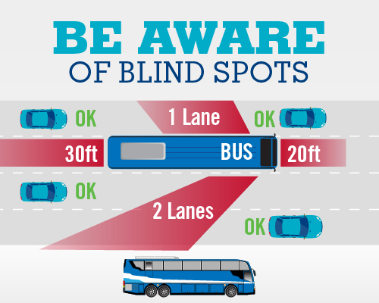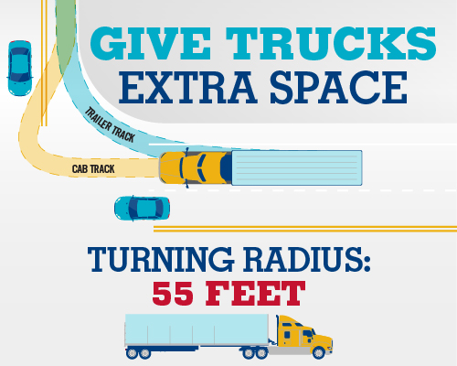
Infographic 1 – Be Aware of Blind Spots Infographic 2 – Give Trucks Extra Space
Recommendation #4: Employers who utilize independent contractors should comply with the Massachusetts Independent Contractor Law to ensure employees are not misclassified as independent contractors.
Discussion: Workers are sometimes misclassified as independent contractors by their employers when legally these workers should be classified as employees of the company. Employees are entitled to a variety of workplace benefits and protections such as the right to minimum wage, overtime, workers’ compensation insurance coverage, earned sick leave, unemployment benefits and other protections. Misclassifying a worker as an independent contractor not only has an overall negative impact on the misclassified worker, it also negatively impacts taxpayers, the Commonwealth of Massachusetts, and fair business competition for law-abiding employers.
Worker misclassification is not only a Massachusetts issue, but a nationwide issue that is becoming more common with the change in the nature of work.⁴ Massachusetts is one of many states with laws that prohibit employers from misclassifying employees as independent contractors.
The goal of this investigation was not to determine if the victim was misclassified as an independent contractor and should have been classified as an employee of the on-demand food delivery app company. Companies should know that the determination as to which workers can be classified as independent contractors is a legal one. An employer who wants to treat someone as an independent contractor rather than an employee has to show that the work is:
- Done without the direction and control of the employer;
- Performed outside the usual course of the employer’s business; and
- Done by someone who has their own, independent business or trade doing that kind of work.
All three of these elements must exist in order for a worker to be classified as an independent contractor. For more information about the Independent Contractor Law please read the Attorney General’s advisory on the Independent Contractor Law (www.mass.gov/files/2017-08/independent-contractor-advisory_1.pdf).²³

Recommendation #5: Municipalities should consider adopting a complete streets approach to ensure the safety of pedestrians and bicyclists.
Discussion: A Complete Street is one that provides safe and accessible options for all travel modes – walking, biking, transit, and motorized vehicles – for people of all ages and abilities. Designing streets with these principles contributes toward the safety, health, economic viability, and quality of life in a community by improving the pedestrian and vehicular environments and providing safer, more accessible, and comfortable means of travel between home, school, work, recreation, and retail destinations. More broadly, embedding Complete Streets principles in policy and practice help promote more livable communities.^{24,25}
The municipality where this incident occurred has made improvements over several years by reducing roadway speed limits to 25 mile per hour on most roadways, increasing the amount of dedicated bike lanes, and adding traffic calming infrastructure in some locations. The roadway where the incident occurred was one of the more main east-west routes in the area, but this roadway was located in an industrial area of the city. The roadway’s location potentially made it less of a priority for the incorporation of Complete Streets type enhancements.
The ideal goal is that the Complete Streets concept would be applied to most roadways in a municipality to help ensure the safety of residents, workers, and visitors. The Massachusetts Department of Transportation (MassDOT) has funds available for municipalities to implement Complete Streets principles to their roadways. Please visit MassDOT web site for more information (https://masscompletestreets.com/).

ADDITIONAL RESOURCES
Oregon OSHA. Fact Sheet – Safety for bicycle couriers. https://osha.oregon.gov/OSHAPubs/factsheets/fs71.pdf

DISCLAIMER
Mention of any company or product does not constitute endorsement by the National Institute for Occupational Safety and Health (NIOSH). In addition, citations to websites external to NIOSH do not constitute NIOSH endorsement of the sponsoring organizations or their programs or products. Furthermore, NIOSH is not responsible for the content of these websites. All web addresses referenced in this document were accessible as of the publication date.

REFERENCES
1. McKee-Ryan, F. M., Song, Z., Wanberg, C. R., & Kinicki, A. (2005). Psychological and Physical Well Being During Unemployment: A Meta-Analytic Study. Journal of Applied Psychology, 90(1), pp. 53-76.

2. Harvard Law School. (2019). Confronting Misclassification and Payroll Fraud: A Survey of State Labor Standard Survey Agencies. https://lwp.law.harvard.edu/files/lwp/files/misclassification.pdf

3. Tran, M., Sokas, R. (2017). The Gig Economy and Contingent Work: An Occupational Health Assessment, Editorial. Journal of Occupational and Environmental Medicine, 59(4), pp. 63-66.

4 The CLS Blue Sky Blog. (2019) Columbia Law School Blog on Corporations and the Capital Markets. Weil Discusses Risks of Classifying Employees as Independent Contractors. http://clsbluesky.law.columbia.edu/2017/10/19/weil-discusses-risks-of-classifying-employees-as-independent-contractors/

5. The National Center on Leadership for the Employment and Economic Advancement of People with Disabilities (LEAD). (2015). Policy Brief. The Impact of Employment on the Health Status and Health Care Costs of Working-age People with Disabilities.
www.leadcenter.org/system/files/resource/downloadable_version/impact_of_employment_health_status_health_care_costs_0.pdf

6. Waddell G, Burton AK. (2006). Is work good for your health and well-being?
https://cardinal-management.co.uk/wp-content/uploads/2016/04/Burton-Waddell-is-work-good-for-you.pdf
7. Weather Underground. Weather History. Massachusetts: TWC Product and Technology LLC.

8. National Transportation Safety Board. (2014). Washington, DC. Safety Recommendations H-14-001 through -007.
www.ntsb.gov/safety/safety-recs/RecLetters/H-14-001-007.pdf

9. U.S. Department of Transportation, Volpe Center. Truck Side Guards Resource Page
www.volpe.dot.gov/sites/volpe.dot.gov/files/docs/Cambridge_Announces_Safer_Truck_Partnership_with_Volpe_FINAL.pdf

10. City of Boston, Inspectional Services
www.cityofboston.gov/isd/pdfs/FinalTruckSideGuardhandoutvF1.pdf

11. City of Cambridge. (2016). Cambridge Safer Truck Initiative: Vehicle-Based Strategies to Protect Pedestrians and Bicyclists. https://rosap.ntl.bts.gov/view/dot/12299

12. Massachusetts Registry of Motor Vehicles. (2019). Rules of the Road. Laws for Bicyclists and Motorist in the Presences of Bicyclists.
www.mass.gov/files/documents/2019/03/19/jud-lib-bicycle-excerpt-rules-of-the-road.pdf

13. CDC. (2017). Motor Vehicle Safety web site, Bicycle Safety.
www.cdc.gov/motorvehiclesafety/bicycle/index.html

14. National Highway Traffic Safety Administration (NHTSA), Bicycle Safety
www.nhtsa.gov/road-safety/bicycle-safety

15. ANSI/ISEA (2015). American National Standard for high-visibility safety apparel. New York, NY: American National Standards Institute, ANSI/ISEA 107 -2015.

16. Massachusetts General Laws, Part I Title XIV Chapter85 Section 11B: Bicycles; operation and equipment; regulations; federal product safety standards, effect; races; violations; penalties https://malegislature.gov/Laws/GeneralLaws/PartI/TitleXIV/Chapter85/Section11B

17. Olivier, J., Creighton, P. (2017). Bicycle injuries and helmet use: a systematic review and meta-analysis. International Journal of Epidemiology. 46(1). https://academic.oup.com/ije/article/46/1/278/2617198

18. Krajicek, M., Schears, R. (2010). Daytime running lights in the USA: what is the impact on vehicle crashes in Minnesota? International Journal of Emergency Medicine. 3(1). www.ncbi.nlm.nih.gov/pmc/articles/PMC2850978/

19. Davoodi, S., Hossayni, S. (2015). Role of Motorcycle Running Lights in Reducing Motorcycle Crashes during Daytime; A Review of the Current Literature. Bulletin of Emergency and Trauma. 3(3). www.ncbi.nlm.nih.gov/pmc/articles/PMC4771245/

20. Madsen, JC, Andersen, T, Lahrmann, HS. (2013). Safety effects of permanent running lights for bicycles: A controlled experiment. Accident Analysis & Prevention. www.ncbi.nlm.nih.gov/pubmed/22884376

21. Federal Motor Carrier Safety Administration. (2005). Commercial Driver License Manual.
www.mass.gov/files/documents/2018/05/04/CDL%20Manual_Combined%20File_0318_0518.pdf

22. Federal Motor Carrier Safety Administration. Tips for Bicyclists and Pedestrians
www.fmcsa.dot.gov/ourroads/tips-bicyclists-and-pedestrians

23. Massachusetts Office of the Attorney General. (2008). An Advisory from the Attorney General’s Fair Labor Division on M.G.L. c. 149, s. 148B. 2008. www.mass.gov/files/2017-08/independent-contractor-advisory_1.pdf

24. Massachusetts Department of Transportation. Complete Streets Funding Program Portal
https://masscompletestreets.com/

25. Smart Growth America. https://smartgrowthamerica.org/

Nontraditional work arrangements include, independent contractors, freelance, temporary agency workers, on-call workers, contract workers and other contingent forms of work where the traditional employer-employee relationship has been altered.^{2,3,4}

