INDOOR AIR QUALITY ASSESSMENT

Gilmore Academy
150 Clinton Street
Brockton, Massachusetts 02302

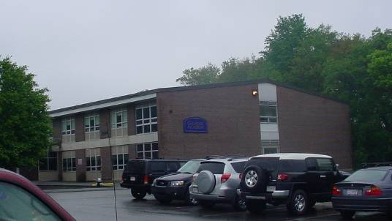

Prepared by:
Massachusetts Department of Public Health
Bureau of Environmental Health
Indoor Air Quality Program
September 2008

Background/Introduction
At the request of the Brockton Health Department (BHD), the Massachusetts Department of Public Health (MDPH), Bureau of Environmental Health (BEH) provided assistance and consultation regarding indoor air quality concerns at Gilmore Academy (GA), 150 Clinton Street, Brockton, Massachusetts. On June 6, 2008, a visit to conduct an assessment was made to GA by Cory Holmes and James Tobin, Inspectors in BEH’s Indoor Air Quality (IAQ) Program.
The GA is a two-story, red brick building built in 1965. The school contains 17 classrooms, a library, computer lab, music room, art room, project room, gymnasium and cafetorium. At the time of the assessment, structural issues concerning cracked roof beams caused a portion of the building to be closed and sealed off. The closed area includes the gymnasium, kitchen and cafetorium. As a result of the closure, students are served lunch in the hallway and eat in their classrooms. It was reported that the roof beams will be replaced over the summer of 2008.

Methods
Air tests for carbon monoxide, carbon dioxide, temperature and relative humidity were conducted with the TSI, Q-Trak, IAQ Monitor, Model 8551. Air tests for airborne particle matter with a diameter less than 2.5 micrometers were taken with the TSI, DUSTTRAK™ Aerosol Monitor Model 8520. BEH staff also performed visual inspection of building materials for water damage and/or microbial growth.

Results
The school houses approximately 365 middle school students in grades 6 to 8 with approximately 35-40 staff members. Tests were taken during normal operations at the school and results appear in Table 1.

Discussion
Ventilation
It can be seen from Table 1 that carbon dioxide levels were above 800 parts per million (ppm) in 25 of 28 areas at the time of the assessment, indicating poor air exchange in the majority of areas surveyed. Elevated levels of carbon dioxide are largely the result of deactivated mechanical ventilation equipment. It is also important to note that at the time of the assessment several classrooms had open windows and/or were empty/sparsely populated, which can greatly reduce carbon dioxide levels. Carbon dioxide levels would be expected to increase with full occupancy and windows closed.
Fresh air is supplied to classrooms by unit ventilator (univent) systems (Picture 1). A univent draws air from the outdoors through a fresh air intake located on the exterior wall of the building (Picture 2) and returns air through an air intake located at the base of the unit (Figure 1). Fresh and return air are mixed, filtered, heated and provided to classrooms through an air diffuser located in the top of the unit. Univents were found deactivated in a number of areas, therefore no means of mechanical ventilation was being provided to these areas at the time of the assessment. Univents were also observed to be obstructed by furniture, books and other stored materials (Picture 3 and 4). The univent in classroom 207 was emitting a “buzzing” noise, which may indicate a mechanical problem. Further, a heavy buildup of dust and debris was observed inside univent cabinets and on the surface of air diffusers in several areas (Picture 5). In order for univents to provide fresh air as designed, air diffusers, intakes and return vents must remain free of obstructions. Importantly, these units must remain “on” and be allowed to operate while rooms are occupied.
Exhaust ventilation in classrooms is provided by wall or ceiling-mounted vents ducted to rooftop motors (Picture 6). Many exhaust vents were deactivated at the time of the assessment. Additional classroom exhaust vents were located in the coat closets; however, these appeared to be sealed. As with univents, in order to function properly, exhaust vents must be activated and allowed to operate while rooms are occupied. Without adequate supply and exhaust ventilation, excess heat and environmental pollutants can build up and lead to indoor air/comfort complaints.
To maximize air exchange, the MDPH recommends that both supply and exhaust ventilation operate continuously during periods of school occupancy. In order to have proper ventilation with a mechanical supply and exhaust system, the systems must be balanced to provide an adequate amount of fresh air to the interior of a room while removing stale air from the room. It is recommended that HVAC systems be re-balanced every five years to ensure adequate air systems function (SMACNA, 1994). The date of the last balancing of these systems was not available at the time of the assessment.
The Massachusetts Building Code requires a minimum ventilation rate of 15 cubic feet per minute (cfm) per occupant of fresh outside air or have openable windows in each room (SBBRS, 1997; BOCA, 1993). The ventilation must be on at all times that the room is occupied. Providing adequate fresh air ventilation with open windows and maintaining the temperature in the comfort range during the cold weather season is impractical. Mechanical ventilation is usually required to provide adequate fresh air ventilation.
Carbon dioxide is not a problem in and of itself. It is used as an indicator of the adequacy of the fresh air ventilation. As carbon dioxide levels rise, it indicates that the ventilating system is malfunctioning or the design occupancy of the room is being exceeded. When this happens, a buildup of common indoor air pollutants can occur, leading to discomfort or health complaints. The Occupational Safety and Health Administration (OSHA) standard for carbon dioxide is 5,000 parts per million parts of air (ppm). Workers may be exposed to this level for 40 hours/week, based on a time-weighted average (OSHA, 1997).
The MDPH uses a guideline of 800 ppm for publicly occupied buildings. A guideline of 600 ppm or less is preferred in schools due to the fact that the majority of occupants are young and considered to be a more sensitive population in the evaluation of environmental health status. Inadequate ventilation and/or elevated temperatures are major causes of complaints such as respiratory, eye, nose and throat irritation, lethargy and headaches. For more information concerning carbon dioxide, consult Appendix A.
Temperature measurements in the school ranged from 69° F to 78° F, which were within the MDPH recommended range in the majority of areas surveyed (Table 1). The MDPH recommends that indoor air temperatures be maintained in a range of 70º F to 78º F in order to provide for the comfort of building occupants. In many cases concerning indoor air quality, fluctuations of temperature in occupied spaces are typically experienced, even in a building with an adequate fresh air supply. Excessive heat was reported in classroom 109, which serves as a computer room with 30 + personal computers. Temperature control is difficult in this room because it has no means of air conditioning to reduce waste heat that is created by personal computers, monitors, printers and other related equipment.
The relative humidity measured in the building ranged from 52 to 66 percent at the time of the assessment, which was within the MDPH recommended comfort range in the majority of areas surveyed (Table 1). The MDPH recommends a comfort range of 40 to 60 percent for indoor air relative humidity. Relative humidity levels in the building would be expected to drop during the winter months due to heating. The sensation of dryness and irritation is common in a low relative humidity environment. Low relative humidity is a very common problem during the heating season in the northeast part of the United States.

Microbial/Moisture Concerns
Several classrooms had water-damaged/missing ceiling tiles which can indicate sources of water penetration from either the roof or the plumbing system (Tables 1). Water-damaged ceiling tiles can provide a source of mold and should be replaced after a water leak is discovered and repaired.
Open seams between sink countertops and walls were observed in several rooms (Picture 7). If not watertight, moisture can penetrate through the seam, causing water damage. Improper drainage or sink overflow can lead to water penetration into the countertop, cabinet interior and areas behind cabinets. Water penetration and chronic exposure of porous and wood-based materials can cause these materials to swell and show signs of water damage.
The US Environmental Protection Agency (US EPA) and the American Conference of Governmental Industrial Hygienists (ACGIH) recommend that porous materials be dried with fans and heating within 24 to 48 hours of becoming wet (US EPA, 2001; ACGIH, 1989). If not dried within this time frame, mold growth may occur. Once mold has colonized porous materials, they are difficult to clean and should be removed/discarded.
Plants were located in a number of classrooms. Plants, soil and drip pans can serve as sources of mold growth and should be properly maintained. Over-watering of plants should be avoided and drip pans should be inspected periodically for mold growth. In addition, flowering plants can be a source of pollen. Therefore, plants should be located away from air stream of ventilation sources (i.e., univents, personal fans) to prevent aerosolization of mold, pollen and particulate matter.
Plants/shrubbery was also observed growing in close proximity to the building and on exterior walls (Picture 2). Plant growth against exterior walls can hold moisture against the building. Plant roots/tendrils can eventually penetrate, leading to cracks and/or fissures in building materials. Over time, this process can undermine the integrity of the building envelope, providing a means of water entry into the building via capillary action through foundation concrete and masonry (Lstiburek & Brennan, 2001).
Pooling water was observed on the roof of the building due to lack of drainage (Pictures 8 and 9). The roof drain is not the lowest point on the roof; therefore, water flows away from the drain. In addition, a buildup of debris and leaves surrounding the drain was observed, preventing drainage. The freezing and thawing of water during winter months can lead to roof leaks and subsequent water penetration into the interior of the building. Pooling water can also become stagnant, which can lead to mold and bacterial growth, and serve as a breeding ground for mosquitoes.

Other IAQ Evaluations
Indoor air quality can be negatively influenced by the presence of respiratory irritants, such as products of combustion. The process of combustion produces a number of pollutants. Common combustion emissions include carbon monoxide, carbon dioxide, water vapor and smoke (fine airborne particle material). Of these materials, exposure to carbon monoxide and particulate matter with a diameter of 2.5 micrometers (μm) or less (PM2.5) can produce immediate, acute health effects upon exposure. To determine whether combustion products were present in the school environment, BEH staff obtained measurements for carbon monoxide and PM2.5.

Carbon Monoxide
Carbon monoxide is a by-product of incomplete combustion of organic matter (e.g., gasoline, wood and tobacco). Exposure to carbon monoxide can produce immediate and acute health affects. Several air quality standards have been established to address carbon monoxide and prevent symptoms from exposure to these substances. The MDPH established a corrective action level concerning carbon monoxide in ice skating rinks that use fossil-fueled ice resurfacing equipment. If an operator of an indoor ice rink measures a carbon monoxide level over 30 ppm, taken 20 minutes after resurfacing within a rink, that operator must take actions to reduce carbon monoxide levels (MDPH, 1997).
The American Society of Heating Refrigeration and Air-Conditioning Engineers (ASHRAE) has adopted the National Ambient Air Quality Standards (NAAQS) as one set of criteria for assessing indoor air quality and monitoring of fresh air introduced by HVAC systems (ASHRAE, 1989). The NAAQS are standards established by the US EPA to protect the public health from six criteria pollutants, including carbon monoxide and particulate matter (US EPA, 2006). As recommended by ASHRAE, pollutant levels of fresh air introduced to a building should not exceed the NAAQS levels (ASHRAE, 1989). The NAAQS were adopted by reference in the Building Officials & Code Administrators (BOCA) National Mechanical Code of 1993 (BOCA, 1993), which is now an HVAC standard included in the Massachusetts State Building Code (SBBRS, 1997). According to the NAAQS, carbon monoxide levels in outdoor air should not exceed 9 ppm in an eight-hour average (US EPA, 2006).
Carbon monoxide should not be present in a typical, indoor environment. If it is present, indoor carbon monoxide levels should be less than or equal to outdoor levels. On the day of assessment, outdoor carbon monoxide concentrations were non-detect (ND) (Table 1). Carbon monoxide levels measured in the school were also ND.
BEH staff observed construction vehicles parked near univent air intakes along the exterior of the building (Picture 10). At the time of the assessment, the vehicles were not operating; however, there is potential for carbon monoxide to become entrained (drawn into) these air intakes when this equipment is operated. The opening of windows allows for unfiltered air to enter the classroom environment carrying with it exhaust emissions as well as airborne dirt, dust and particulates. Thus, opening windows along this area of the building should be done with caution.

Particulate Matter (PM2.5)
The US EPA has established NAAQS limits for exposure to particulate matter. Particulate matter is airborne solids that can be irritating to the eyes, nose and throat. The NAAQS originally established exposure limits to particulate matter with a diameter of 10 μm or less (PM10). According to the NAAQS, PM10 levels should not exceed 150 microgram per cubic meter (μg/m³) in a 24-hour average (US EPA, 2006). These standards were adopted by both ASHRAE and BOCA. Since the issuance of the ASHRAE standard and BOCA Code, US EPA established a more protective standard for fine airborne particles. This more stringent PM2.5 standard requires outdoor air particle levels be maintained below 35 μg/m³ over a 24-hour average (US EPA, 2006). Although both the ASHRAE standard and BOCA Code adopted the PM10 standard for evaluating air quality, MDPH uses the more protective PM2.5 standard for evaluating airborne particulate matter concentrations in the indoor environment.
Outdoor PM2.5 concentrations the day of the assessment were measured at 31 μg/m³. PM2.5 levels measured inside the school ranged from 16 to 34 μg/m³ (Table 1). Both indoor and outdoor PM 2.5 levels were below the NAAQS PM2.5 level of 35 μg/m³. Two classrooms having indoor gym class measured PM2.5 levels greater than the outdoor level (33 and 34 μg/m³). Frequently, indoor air levels of particulates (including PM2.5) can be at higher levels than those measured outdoors. A number of mechanical devices and/or activities that occur in schools can generate particulate during normal operations. Sources of indoor airborne particulates may include but are not limited to particles generated during the operation of fan belts in the HVAC system, cooking in the cafeteria stoves and microwave ovens; use of photocopiers, fax machines and computer printing devices; operation of an ordinary vacuum cleaner and heavy foot traffic indoors.

Volatile Organic Compounds
Indoor air concentrations can be greatly impacted by the use of products containing volatile organic compounds (VOCs). VOCs are carbon-containing substances that have the ability to evaporate at room temperature. Frequently, exposure to low levels of total VOCs (TVOCs) may produce eye, nose, throat and/or respiratory irritation in some sensitive individuals. For example, chemicals evaporating from a paint can stored at room temperature would most likely contain VOCs. In an effort to identify materials that can potentially increase indoor VOC concentrations, BEH staff examined classrooms for products containing these respiratory irritants.
The majority of classrooms contained dry erase boards and related materials. Materials such as dry erase markers and dry erase board cleaners may contain VOCs, such as methyl isobutyl ketone, n-butyl acetate and butyl-cellusolve (Sanford, 1999), which can be irritating to the eyes, nose and throat.
Cleaning products were observed on countertops or below sinks in a number of classrooms. Like dry erase materials, cleaning products contain VOCs and other chemicals. These chemicals can be irritating to the eyes, nose and throat and should be kept out of reach of students. Products should be kept in their original containers, or should be clearly labeled as to their contents, for identification purposes in the event of an emergency. Further, material safety data sheets (MSDS) for all cleaning products must be available at a central location.

Other Conditions
Other conditions that can affect indoor air quality were observed during the assessment. In several classrooms, items were observed on the floor, windowsills, tabletops, counters, bookcases and desks (Pictures 4 and 11). The large number of items stored in classrooms provides a source for dusts to accumulate. These items (e.g., papers, folders, boxes) make it difficult for custodial staff to clean. Items should be relocated and/or be cleaned periodically to avoid excessive dust build up. In addition, these materials can accumulate on flat surfaces (e.g., desktops, shelving and carpets) in occupied areas and subsequently be re-aerosolized causing further irritation.
Lastly, a number of exhaust/return vents, univent air diffusers and personal fans (Pictures 12 and 13) were observed to have accumulated dust. If exhaust vents are not functioning, backdrafting can occur, which can re-aerosolize accumulated dust particles. Re-activated univents and fans can also aerosolize dust accumulated on vents/fan blades.

Conclusions/Recommendations
In view of the findings at the time of the assessment, the following recommendations are made:
- Operate all ventilation systems throughout the building (e.g., gym, locker rooms, cafeteria, classrooms) continuously during periods of school occupancy and independent of thermostat control. To increase airflow in classrooms, set univent controls to “high”.
- Investigate “buzzing” noise in univent for classroom 207 and make repairs/adjustments as needed.
- Use openable windows in conjunction with mechanical ventilation to facilitate air exchange. Care should be taken to ensure windows are properly closed at night and weekends to avoid the freezing of pipes and potential flooding.
- Inspect exhaust motors and belts for proper function. Repair and replace as necessary.
- Consider adopting a balancing schedule of every 5 years for all mechanical ventilation systems, as recommended by ventilation industrial standards (SMACNA, 1994).
- Change filters for air-handling equipment (e.g., univents, AHUs and ACs) as per the manufacturer’s instructions or more frequently if needed. Vacuum interior of units prior to activation to prevent the aerosolization of dirt, dust and particulates. Ensure filters fit flush in their racks with no spaces in between allowing bypass of unfiltered air into the unit.
- Consider installing portable AC unit in computer room 109 to reduce heat and improve comfort.
- For buildings in New England, periods of low relative humidity during the winter are often unavoidable. Therefore, scrupulous cleaning practices should be adopted to minimize common indoor air contaminants whose irritant effects can be enhanced when the relative humidity is low. To control for dusts, a high efficiency particulate arrestance (HEPA) filter equipped vacuum cleaner in conjunction with wet wiping of all surfaces is recommended. Avoid the use of feather dusters. Drinking water during the day can help ease some symptoms associated with a dry environment (throat and sinus irritations).
- Replace water damaged ceiling tiles. Examine the area above and around these areas for mold growth. Disinfect areas of water leaks with an appropriate antimicrobial.
- Seal areas around sinks to prevent water damage to the interior of cabinets and adjacent wallboard. Inspect wallboard for water damage and mold growth, repair/replace as necessary. Disinfect areas with an appropriate antimicrobial, as needed.
- Move plants away from univents in classrooms. Avoid over-watering and examine drip pans periodically for mold growth. Disinfect with an appropriate antimicrobial where necessary.
- Move plants approximately 5-feet away from the exterior of univent air intakes/walls to prevent moisture impingement and the entrainment of pollen, moisture or mold.
- Store cleaning products properly and out of reach of students. Ensure spray bottles are properly labeled. All cleaning products used at the facility should be approved by the school department with MSDS’ available at a central location.
- Relocate or consider reducing the amount of materials stored in classrooms to allow for more thorough cleaning of classrooms. Clean items regularly with a wet cloth or sponge to prevent excessive dust build-up.
- Clean personal fans, univent air diffusers, return vents and exhaust vents periodically of accumulated dust.
- Consider adopting the US EPA (2000) document, “Tools for Schools”, as an instrument for maintaining a good indoor air quality environment in the building. This document is available at: http://www.epa.gov/iaq/schools/index.html.
- Refer to resource manual and other related indoor air quality documents located on the MDPH’s website for further building-wide evaluations and advice on maintaining public buildings. These documents are available at: http://mass.gov/dph/indoor_air.
References

ACGIH. 1989. Guidelines for the Assessment of Bioaerosols in the Indoor Environment. American Conference of Governmental Industrial Hygienists, Cincinnati, OH.

ASHRAE. 1989. Ventilation for Acceptable Indoor Air Quality. American Society of Heating, Refrigeration and Air Conditioning Engineers. ANSI/ASHRAE 62-1989

BOCA. 1993. The BOCA National Mechanical Code/1993. 8th ed. Building Officials and Code Administrators International, Inc., Country Club Hill, IL.

Lstiburek, J. & Brennan, T. 2001. Read This Before You Design, Build or Renovate. Building Science Corporation, Westford, MA. U.S. Department of Housing and Urban Development, Region I, Boston, MA

MDPH. 1997. Requirements to Maintain Air Quality in Indoor Skating Rinks (State Sanitary Code, Chapter XI). 105 CMR 675.000. Massachusetts Department of Public Health, Boston, MA.

OSHA. 1997. Limits for Air Contaminants. Occupational Safety and Health Administration. Code of Federal Regulations. 29 C.F.R 1910.1000 Table Z-1-A.

Sanford. 1999. Material Safety Data Sheet (MSDS No: 198-17). Expo® Dry Erase Markers Bullet, Chisel, and Ultra Fine Tip. Sanford Corporation. Bellwood, IL.

SBBRS. 1997. Mechanical Ventilation. State Board of Building Regulations and Standards. Code of Massachusetts Regulations. 780 CMR 1209.0

SMACNA. 1994. HVAC Systems Commissioning Manual. 1st ed. Sheet Metal and Air Conditioning Contractors’ National Association, Inc., Chantilly, VA.

US EPA. 2001. “Mold Remediation in Schools and Commercial Buildings”. Office of Air and Radiation, Indoor Environments Division, Washington, DC. EPA 402-K-01-001. March 2001. Available at: http://www.epa.gov/iaq/molds/mold_remediation.html

US EPA. 2006. National Ambient Air Quality Standards (NAAQS). US Environmental Protection Agency, Office of Air Quality Planning and Standards, Washington, DC. http://www.epa.gov/air/criteria.html.

Picture 1

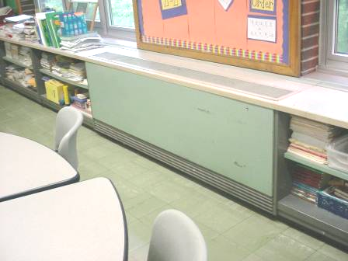

Classroom Univent

Picture 2

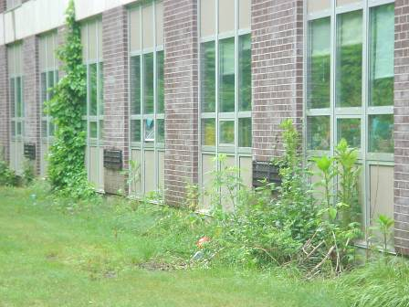

Univent Fresh Air Intakes, Note Plant Growth on Exterior Walls

Picture 3

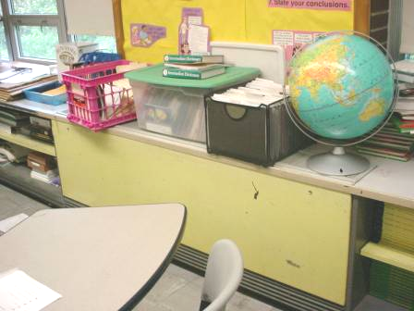

Univent Air Diffusers Blocked by Stored Materials

Picture 4

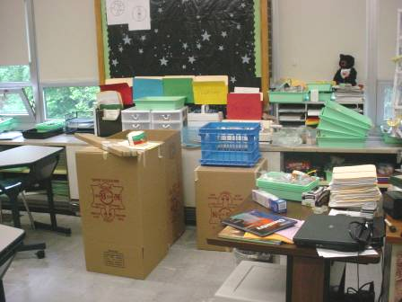

Univent Blocked by Stored Materials

Picture 5

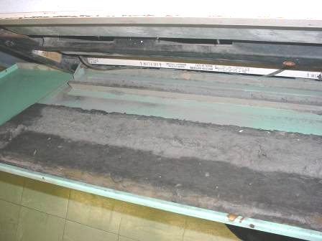

Buildup of Dirt, Dust and Debris inside Univent Cabinet

Picture 6

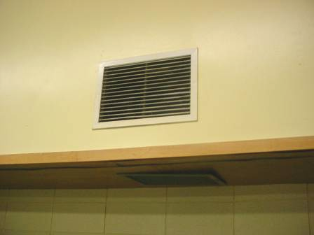

Wall Mounted Exhaust Vent

Picture 7

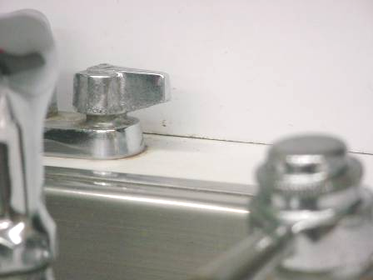

Open Seam between Sink Countertop and Backsplash

Picture 8

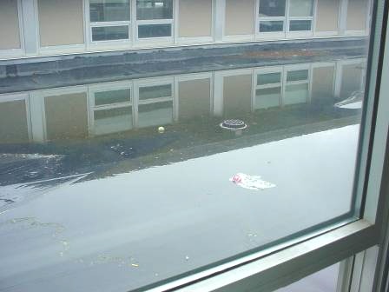

Pooling Water on Roof, Note Roof Drain

Picture 9

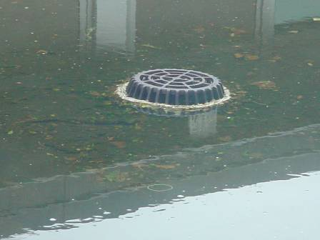

Roof Drain Clogged by Debris and Leaves

Picture 10

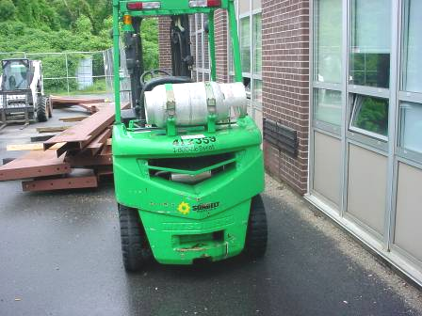

Construction Vehicles Parked Near Univent Fresh Air Intake

Picture 11



Accumulation of Classroom Items

Picture 12

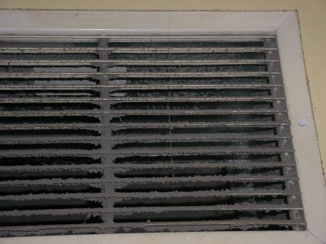

Dust/Debris Accumulation on Exhaust Vent

Picture 13

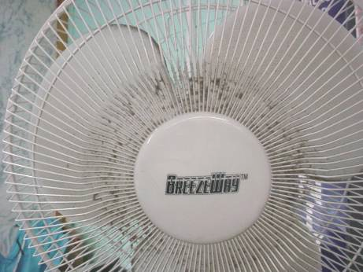

Dust/Debris Accumulation on Personal Fan Cage and Blades
Location/ Room | Occupants  in Room | Temp  (°F) | Relative  Humidity  (%) | Carbon  Dioxide  (ppm) | Carbon Monoxide  (ppm) | PM2.5  (µg/m³) | Windows  Openable | Ventilation |  | Remarks
 |  |  |  |  |  |  |  | Supply | Exhaust | Remarks
background |  | 62 | 95-100 | 385 | ND | 31 |  |  |  | cool, rain light to moderate, winds
100 | 0 | 75 | 58 | 1068 | ND | 25 | N | Y  passive door vent | off  dusty
101 | 11 | 74 | 58 | 1268 | ND | 19 | Y | Y  weak | Y  dusty | Space between sink counter and wall; DO
102 | 7 | 75 | 61 | 1403 | ND | 18 | Y | Y  weak | Y | Space between sink counter and wall
103 | 0 | 74 | 61 | 1259 | ND | 22 | Y | Y  weak | off | 3 WD CT along windows; spray cleaners; space between sink counter and wall
104 | 26 | 73 | 66 | 1266 | ND | 24 | Y | Y | off | 5 WD CT, 2 MT along windows, leaks in winter; space between sink counter and wall
105 | 19 | 73 | 60 | 1160 | ND | 24 | Y  open | Y  blocked | Y
106 | 10 | 73 | 59 | 983 | ND | 24 | Y  open | Y  weak | Y | PF
107 | 18 | 75 | 54 | 943 | ND | 27 | Y  open | Y  weak | Y | Space between sink counter and wall
108 | 0 | 73 | 61 | 1223 | ND | 25 | Y | Y  weak | Y  dusty | PF-dusty; 7 WD CT along windows; dust on window sills
109 | 19 | 77 | 58 | 1286 | ND | 19 | Y  open | Y  weak | Y | 30+ computers; heat issues; no AC
201 | 3 | 71 | 65 | 753 | ND | 27 | Y | Y  weak; dirt, dust, debris | Y | Space between sink counter and wall; PF-dusty
202 | 21 | 69 | 60 | 836 | ND | 31 | Y  open | Y  blocked | Y  dusty | Hole in CT; space between sink counter and wall; accumulated items; dust on flat surfaces
203 | 0 | 71 | 56 | 899 | ND | 28 | Y  open | off  blocked | Y | DO
204 | 19 | 71 | 58 | 544 | ND | 30 | Y  open | Y  weak  blocked | Y | Space between sink counter wall; DO
205 | 22 | 71 | 57 | 1153 | ND | 28 | Y  open | Y  weak | Y | Space between sink counter and wall; DO
206 | 1 | 74 | 55 | 782 | ND | 25 | Y  open | Y | Y | Occupants (17) gone 10 minutes; PF-dusty; space between sink counter and wall
207 | 25 | 75 | 57 | 1088 | ND | 20 | Y  open | Y  weak | Y | Univent-“buzzing” noise; space between sink counter and wall
210 | 22 | 76 | 57 | 1264 | ND | 32 | Y  open | off | off | Space between sink counter and wall; DO
211 | 30 | 76 | 55 | 1452 | ND | 34 | Y  open | off | off | Space between sink counter and wall; two classrooms opened up for indoor gym
212 | 20 | 78 | 57 | 1569 | ND | 33 | Y  open | off | off | Space between sink counter and wall; DO
213 | 0 | 76 | 52 | 1097 | ND | 22 | Y  open | Y  blocked | Y
214 | 24 | 75 | 61 | 1132 | ND | 16 | Y  open | off | Y | DEM; Fan in window; Plants
215 | 18 | 75 | 58 | 1795 | ND | 21 | Y  open | Y  weak | off | Space between sink counter and wall; hole in CT; cleaners on counter
Book Room | 0 | 76 | 58 | 1177 | ND | 23 | N | Y  passive door vent | off | Network server
Guidance Office | 1 | 74 | 61 | 1344 | ND | 21 | N | Y  passive door vent | off  dusty | PF
Inst. Resource Specialist | 0 | 74 | 57 | 1114 | ND | 28 | N | N | off  dusty | No supply, undercut door or passive door vent
Library | 20 | 69 | 57 | 939 | ND | 27 | N | Y  blocked | off
Teacher’s lounge | 4 | 76 | 57 | 1278 | ND | 32 | Y | N | Y  no draw | DO
Exterior/  Perimeter |  |  |  |  |  |  |  |  |  | Standing/pooling water on roof  Plant growth on exterior walls  Construction vehicles near air intakes

