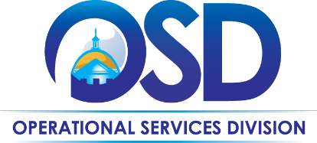
The Commonwealth of Massachusetts Operational Services Division Office of Vehicle Management

Glass Overview

Glass Damage or Replacement: Effective 7/1/2022, auto glass repair and replacement will be managed by Fleet Response through Statewide Contract VEH113. The VEH103 contract for Glass/Windshields will be allowed to expire on 6/30/2022.

This is a guidance document for OVM managed vehicles only. Agencies enrolled with OVM should experience a seamless transition of services from one contract to the other.

Agencies should follow the option below which best describes their situation. Please direct process questions to OVM via osdovmmaintenance@mass.gov.

- Glass Only – Driver must call the Fleet Response toll-free number, listen to the menu options, and select Glass. The call is routed to Safelite who takes the claim and coordinates the repair with the driver at a Safelite location. Safelite bills Fleet Response directly. Fleet Response bills the Agency through the regular monthly invoice process. No purchase order or billing information is needed from the Agency.

Fleet Response
1-800-338-0619

  - NOTE: The Driver may not go directly to a Safelite location for service; they first must call Fleet Response who will order the required materials and schedule time to perform the work. Work performed outside of the above-described process may result in improper billing or out-of-network fees.

- Glass w/Body Damage – Driver must call the Fleet Response toll-free number, within 24 hours of the incident, listen to the menu options, and select Accidents. Fleet Response takes all the information for a First Notice of Loss. A body shop will be assigned for the incident estimate and associated photos. The glass damage is handled by the body shop as part of the overall repair. The repair is billed to Fleet Response and Agencies are billed through the regular Fleet Response monthly invoice process. No purchase order or billing information is needed from the Agency.

Below are links to the VEH113 Master Blanket Purchase Order (MBPO) details and the Contract User Guide (CUG) within COMMBUYS:

Contract ID# | Description | MBPO Links | CUG Link
VEH113 | Fleet Management Services | Fleet Response MBPO | VEH113 Contract User Guide

Individual Agencies/Departments may have additional processes to follow. Check with your Agency Fleet Manager.

Last Updated 06-2022

