INDOOR AIR QUALITY ASSESSMENT

Gloucester District Court
97 Main Street
Gloucester, MA

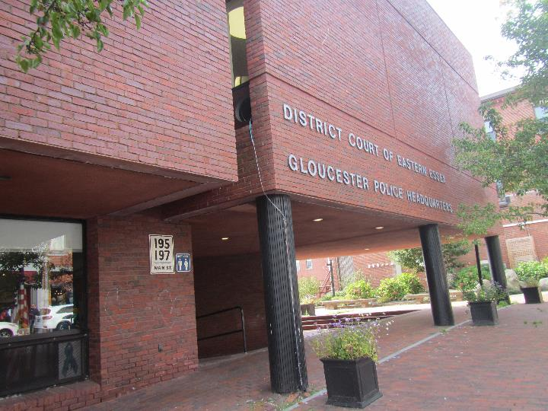

Prepared by:
Massachusetts Department of Public Health
Bureau of Environmental Health
Indoor Air Quality Program
October 2022

BACKGROUND
Building: | Gloucester District Court (GDC)
Address: | 97 Main St, Gloucester
Assessment Requested By: | Referral from Department of Labor Standards (DLS)
Reason for Request: | General indoor air quality (IAQ) concerns and water damage concerns
Date of Assessment: | September 30, 2022
Massachusetts Department of Public Health/Bureau of Environmental Health (MDPH/BEH) Staff Conducting Assessment: | Michael Feeney, Director, and Ruth  Alfasso, Environmental Inspector,  IAQ Program
Building Description: | The GDC occupies the second floor of a three-story brick building built in 1973. The City of Gloucester owns the building, and the Gloucester Police Department (GPD) occupies other areas of the building. The GDC and GPD share the lockup area for detainees. The building has a complex shape, and several levels of flat roofs.
Windows: | Some windows are openable

INTRODUCTION
Due to reports of mold to the MA DLS, the DPH IAQ Program conducted an assessment of the GDC. According to city and court officials, the GDC is schedule to be renovated, which should include repairs to the building envelope as well as the HVAC systems. It is important to note that many conditions shown in this assessment will likely be addressed as part of this planned renovation.

METHODS
Please refer to the IAQ Manual for methods, sampling procedures, and interpretation of results (MDPH, 2015).

RESULTS AND DISCUSSION
The following is a summary of indoor air testing results (Table 1).
- Carbon dioxide levels were below 800 parts per million (ppm) in all areas assessed. Note that some areas were lightly occupied or unoccupied at the time of the assessment; carbon dioxide levels would be expected to be higher with higher occupancy.
- Temperature was within the recommended range of 70°F to 78°F in areas assessed.
- Relative humidity was within the recommended range of 40% to 60% in all areas assessed.
- Carbon monoxide levels were non-detectable (ND) in all areas assessed.
- Fine particulate matter (PM2.5) concentrations measured were below the National Ambient Air Quality Standard (NAAQS) level of 35 μg/m³ in all areas assessed

Ventilation
A heating, ventilating, and air conditioning (HVAC) system has several functions. First it provides heating and, if equipped, cooling. Second, it is a source of fresh air. Finally, an HVAC system will dilute and remove normally occurring indoor environmental pollutants by not only introducing fresh air, but by filtering the airstream, and ejecting stale air to the outdoors via exhaust ventilation. Even if an HVAC system is operating as designed, point sources of respiratory irritation may exist and cause symptoms in sensitive individuals. The following analysis examines and identifies components of the HVAC system and likely sources of respiratory irritant/allergen exposure due to water damage, aerosolized dust, and/or chemicals found in the indoor environment.
The GDC has an air handling unit (AHU) located in the basement (Picture 1). This unit takes air through a vent outside (Picture 2), filters and heats/cools it, and delivers it to supply vents in the building. It is believed that this unit supplies some of the areas assessed on the 2nd floor. There is also another AHU in the courtroom area that supplies fresh air for those portions of the building, and additional AHU equipment in ceilings, but these could not be accessed during the visit.
Each AHU should be equipped with appropriate filters that match the function, design, and capacity of the ventilation system equipment. Filters should be changed on a regular schedule, at least twice a year and more often if needed. Filters used should be the best quality/highest Minimum Efficiency Rating Value (MERV) rated filters that can be used with current equipment. During filter changes, AHU cabinets should be cleaned as well.
During the assessment, it was noted that many rooms had a single vent that could not be identified as to whether it was a supply or return vent (Picture 3). It is recommended that all occupied areas have a source of both supply air and exhaust/return air. Some mechanical ventilation systems operate by supplying fresh air to the interior of offices and having return vents in hallways or open areas (e.g., Picture 4), with air circulation occurring when doors are open, or via undercuts at the bottom of doors. This may be how the ventilation system in this building is designed. At least one door had a transfer air vent (Picture 5), which is an old method of allowing air movement between areas that is no longer allowed in new buildings due to fire codes.
Additional cooling is supplied by window-mounted air conditioners (WAC) (Picture 6). These units can supply some fresh air when in use. WAC are equipped with filters that should be cleaned periodically. Several portable air conditioners (PAC) were also present in the space (Picture 7). These units appear to be configured to eject waste heat into the ceiling plenum that may not be designed to provide exhaust/return ventilation. In this condition, water vapor and heat accumulate in the ceiling plenum, which in turn likely re-enters the occupied space through light fixtures and space in the suspended ceiling.
Waste heat and water vapor by the PAC units can be vented from the building if a ceiling plenum is purposely designed as a return system integrated in the HVAC system. If a plenum return system exists, it needs to have a sufficient draw rate of return air to remove the extra air, heat, and potentially moisture generated by PACs from the building. If no return system exists in the ceiling plenum, pressurization may allow waste heat/moisture as well as dust and debris above ceiling tiles to infiltrate into occupied space through spaces in the suspended ceiling.
Additional fresh air is available in some areas through openable windows. Windows should be used for fresh air only during temperate weather and kept closed during hot and humid or wet weather to prevent introducing water and water vapor into the building. Windows should not be opened when air conditioning is operating in the room, as this may lead to condensation on chilled surfaces. Windows should be tightly closed when not in use to prevent the infiltration of outside air and pests.
Restrooms appear to be equipped with exhaust vents which should be vented directly outside to remove moisture and odors from restroom operations. It could not be determined if these were operating.
To maximize air exchange, the MDPH recommends that both supply and exhaust ventilation operate continuously during periods of occupancy. To have proper ventilation with a mechanical supply and exhaust system, the systems must be balanced to provide an adequate amount of fresh air to the interior of a room while removing stale air from the room. It is recommended that HVAC systems be re-balanced every five years to ensure adequate air systems function (SMACNA, 2013). The date of the last balancing of these systems was not available at the time of the assessment.

Microbial/Moisture Concerns
Water-damaged ceiling tiles and ceiling plaster were observed in various areas around the building (Pictures 8 through 10, Table 1). Water-damaged ceiling tiles and plaster indicate leaks from plumbing or the building envelope. The roof of this building is relatively new (~6 years) and some of the water-damaged tiles may have occurred prior to the roof being fixed. Leaks should be repaired when they are found, and water-damaged materials such as ceiling tiles or plaster repaired or replaced. Water-damaged ceiling tiles can become a source of mold or odors if moistened chronically or repeatedly. While some occupants expressed concerns regarding water-damaged ceiling tiles and mold, no dark staining indicating mold or moldy odors were noted during the assessment. Note that some of the ceiling tiles in this building may be of a type that contain asbestos.
Some of the window air conditioners were installed with wood or other non-waterproof material around it (Picture 11). Window air conditioners should be sealed with an appropriate waterproof material to prevent water intrusion and water damage.
Water coolers and small refrigerators were located on carpet (Picture 12) which can be moistened by spills. Plants were noted in a few offices (Picture 13). Plants can be a source of pollen, mold, and odors, particularly if not well maintained. Plants should be kept in good condition, not overwatered, and placed on waterproof drip pans that are periodically cleaned.
In general, it is recommended that porous material be dried with fans and heating within 24 to 48 hours of becoming wet (US EPA, 2008, ACGIH, 1989). If porous materials are not dried within this time frame, mold growth may occur. Water-damaged porous materials cannot be adequately cleaned to remove mold growth.
The exterior of the building was examined for conditions that may impact the building envelope or IAQ. Plants, including climbing vines, were located on or close to the exterior of the building in a few areas including near the fresh air intakes for the AHU (Picture 2). Plants can hold moisture against the building, can be a source of pollen and odors through open windows, and can provide harborage for pests. Plants should be trimmed at least five feet away from the building.
Seagulls and seagull waste, including feces, feathers, corpses, and food waste, were observed both on the roof (Picture 12), and near the fresh air intake. These materials can be a source of odors and potentially harmful microorganisms and should be removed and the area cleaned regularly. Debris and plant growth was also noted on the roof including near roof drains (Picture 12). These can impede drainage and should be cleaned periodically.

Other Concerns
Exposure to low levels of total volatile organic compounds (TVOCs) may produce eye, nose, throat, and/or respiratory irritation in some sensitive individuals. BEH/IAQ staff noted hand sanitizers and cleaners in the office space (Table 1). All of these products have the potential to be irritants to the eyes, nose, throat, and respiratory system of sensitive individuals.
Some areas in GDC have carpeting, some of which is older and in poor condition (Picture 14). Carpeting should be vacuumed regularly with a high efficiency particulate arrestance (HEPA) filter equipped vacuum cleaner to avoid particulates from causing further irritation or serving as a reservoir for microbial colonization. Also, carpeting and rugs should be deep cleaned at least once per year according to IICRC recommendations (IICRC 2012). Aging carpet can produce fibers that can be irritating to the respiratory system and may be difficult to clean effectively.
Some supply and return vents were dusty (Table 1). These should be cleaned periodically.
Food and food preparation equipment was found in a few places in the building (Table 1). Cooking equipment, such as toasters, refrigerators, and microwaves should be kept clean to prevent odors, microbial growth, smoke, and pests. Food should be stored in pest-proof containers and any food debris should be cleaned promptly.

CONCLUSIONS/RECOMMENDATIONS
Note that this building is scheduled for major renovations beginning in the next year. The project is planned to include both building envelope repairs and HVAC system upgrades. The following are divided into short-term recommendations that should be considered as soon as possible, and long-term recommendations that may be a part of the renovations.
Of note, are issues that were discovered relating to potential regulated material (asbestos). Ensure all applicable State and Federal asbestos regulations and guidance are followed with regard to potential asbestos-containing materials.
Based on the observations made during this assessment, the IAQ program makes the following recommendations:

Short-term recommendations

Ventilation Recommendations
- Use openable windows for fresh air during temperate weather. Keep windows closed during heavy rain and during hot, humid weather when the air conditioning is operating. Ensure windows have intact screens to exclude pests, and that windows are tightly closed at the end of the day.
- Change filters in AHU equipment regularly in accordance with manufacturer’s instructions. Use high-quality filters with a Minimum Efficiency Rating Value (MERV) rating of at least 8 or higher if the HVAC equipment can operate with more restrictive filters.
- Assess the function of restroom exhaust fans, and repair as needed. Ensure restroom exhaust fans operate at all times to remove odors and moisture when the building is occupied.
- Clean supply and return vents of dust periodically.
- Maintain window air conditioners and portable air conditioners regularly including cleaning filters.
- Ensure that when portable air conditioners are operating, the plenum return has sufficient draw of air to maintain the plenum at a neutral or negative pressure to remove waste heat and moisture and prevent back drafting.

Water Damage Recommendations
- Replace water-damaged ceiling tiles and repair water-damaged ceiling plaster wherever possible once the source of the leak is identified and repaired.
- Replace water-damaged wood around air conditioners with water-resistant materials.
- Consider using waterproof mats in areas where refrigerators and water dispensers are used.
- Ensure plants in offices are well maintained, and not overwatered. Place plants on waterproof drip pans that are cleaned regularly.
- Trim plants including ivy away from the exterior of the building a minimum of five feet.
- Remove bird wastes, bird corpses, and other debris from the roof and from near air intakes regularly.
- Clean the area around roof drains periodically and assess roof drain function following wet weather.

Other Recommendations
- Keep food storage and preparation equipment clean. Only store food in sealed pest-proof containers.
- Clean all carpeting in accordance with IICRC recommendations (IICRC, 2012). This includes daily vacuuming with a HEPA-equipped vacuum cleaner, and annual or semi-annual deep cleaning.
- Refer to resource manual and other related IAQ documents located on the MDPH’s website for further building-wide evaluations and advice on maintaining public buildings. These documents are available at: http://mass.gov/dph/iaq.

Long Term Recommendations
- Replace carpeting in the building that may be stained, worn or otherwise beyond its service life. Consider replacing with non-porous, wear-resistant flooring.
- Consult with an HVAC engineering contractor regarding airflow in the building to ensure every occupied area has fresh air supply and return ventilation.
- Consider moving the fresh air intake located in the alley shown in Picture 2 to a location that is easier to keep clean.
- Repair building envelope issues that may be responsible for ongoing leaks.
- If renovations result in performing construction in or adjacent to occupied areas, use the guidelines “Construction and renovation generated pollutants in occupied buildings” to minimize IAQ issues.

REFERENCES
ACGIH. 1989. Guidelines for the Assessment of Bioaerosols in the Indoor Environment. American Conference of Governmental Industrial Hygienists, Cincinnati, OH.
IICRC. 2012. Institute of Inspection, Cleaning and Restoration Certification. Carpet Cleaning: FAQ.
MDPH. 2015. Massachusetts Department of Public Health. Indoor Air Quality Manual: Chapters I-III. Available at: https://www.mass.gov/lists/indoor-air-quality-manual-and-appendices.
SMACNA. 2013. HVAC Systems Commissioning Manual. 2nd ed. Sheet Metal and Air Conditioning Contractors’ National Association, Inc., Chantilly, VA.

US EPA. 2008. “Mold Remediation in Schools and Commercial Buildings”. Office of Air and Radiation, Indoor Environments Division, Washington, DC. EPA 402-K-01-001. September 2008. Available at: http://www.epa.gov/mold/mold-remediation-schools-and-commercial-buildings-guide.

Picture 1
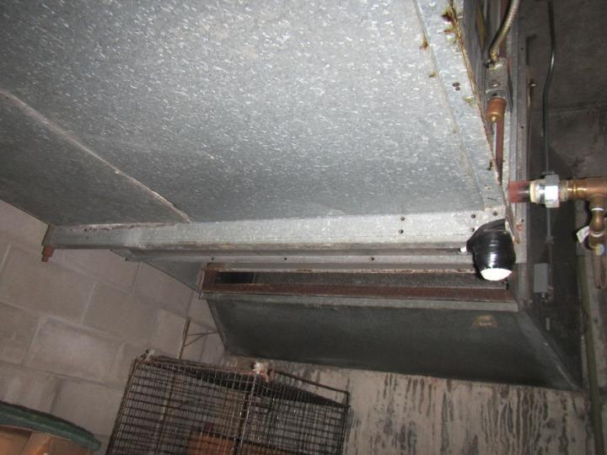
Air Handling Unit (AHU) in the basement
Picture 2
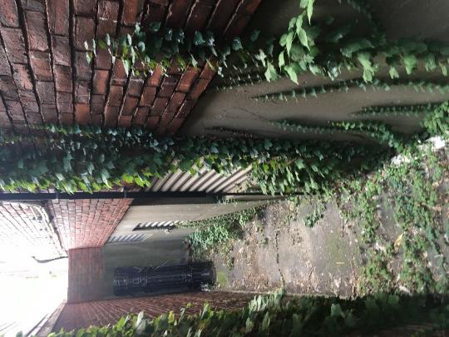
Fresh air intake for AHU (arrow) and other vents for combustion make-up air; note ivy and debris
Picture 3
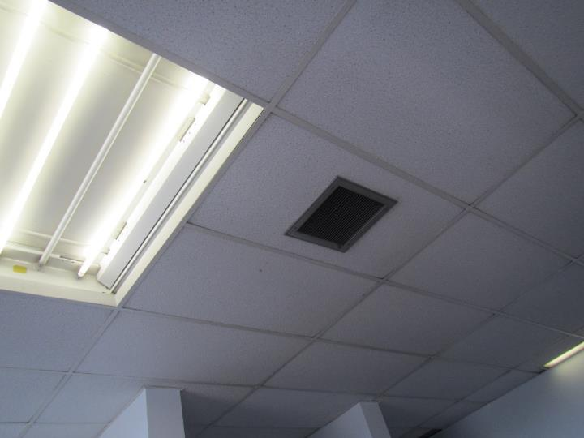
Ceiling-mounted vent, not known if supply or return
Picture 4
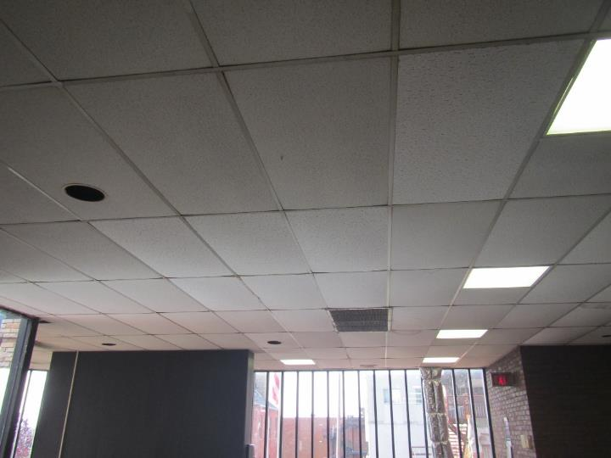
Arrow shows location of likely return vent in central area of second floor
Picture 5
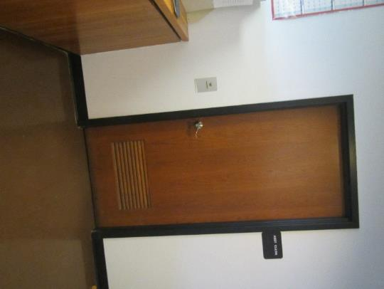
Transfer air vent in a door (arrow)
Picture 6
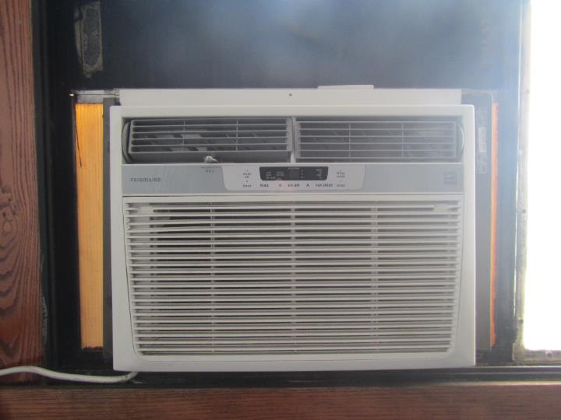
Window-mounted air conditioner
Picture 7
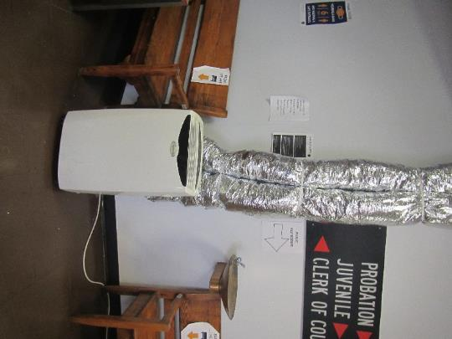
Portable air conditioner
Picture 8
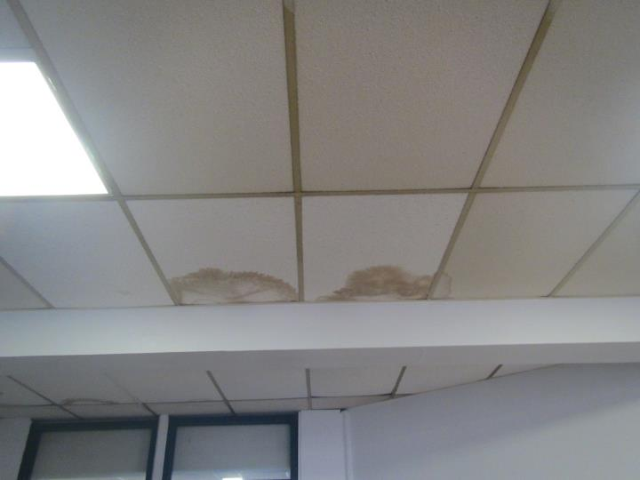
Water-damaged ceiling tiles
Picture 9
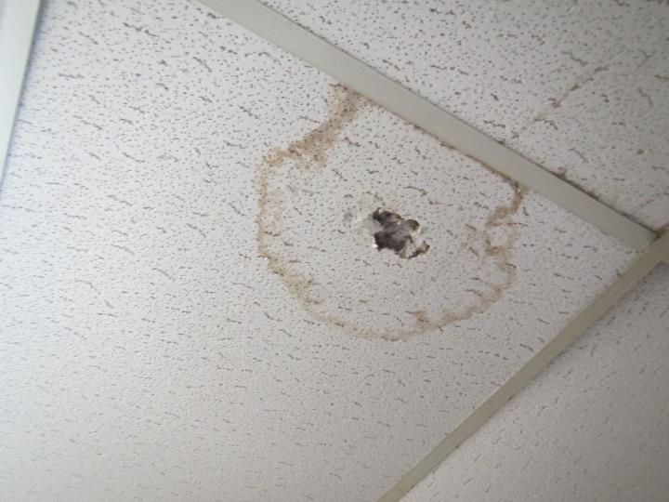
Water-damaged ceiling tile that occupant was able to poke a hole into
Picture 10
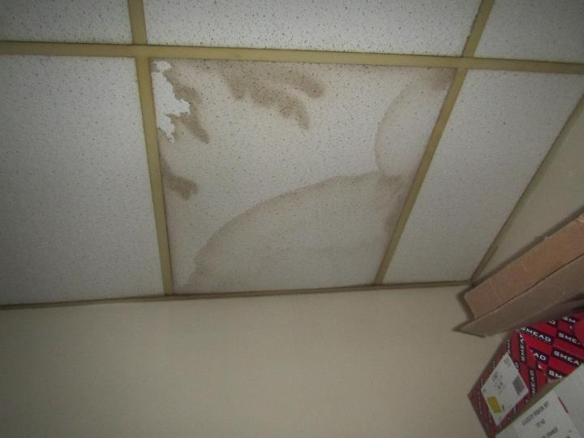
Water-damaged ceiling tile in a storeroom
Picture 11
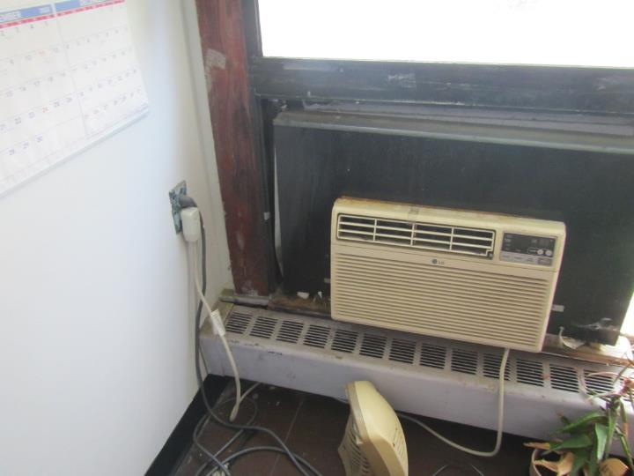
Water-damaged wood underneath window air conditioner
Picture 12
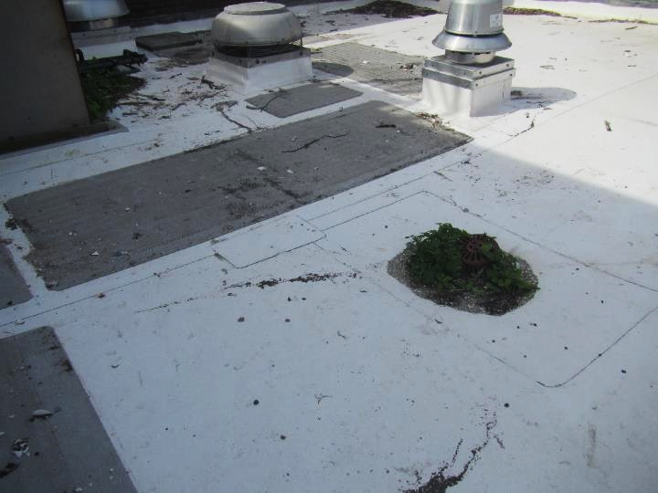
Debris, including shells, bones, and bird waste on the roof; also note plants growing around drain
Picture 13
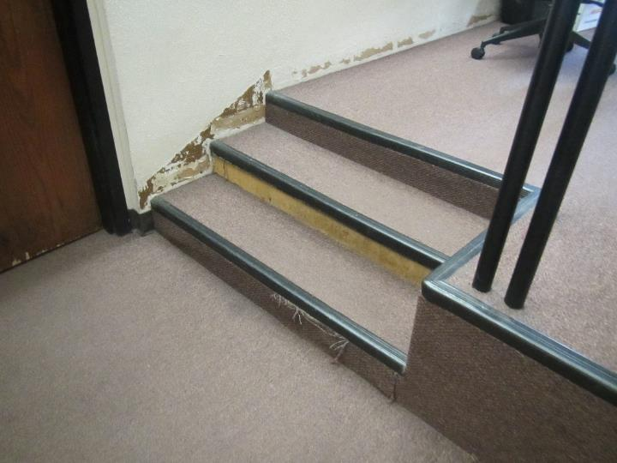
Carpeting in poor condition in Session 1 Courtroom
Location | Carbon  Dioxide  (ppm) | Carbon Monoxide  (ppm) | Temp  (°F) | Relative  Humidity  (%) | PM2.5  (µg/m³) | Occupants  in Room | Windows  Openable | Ventilation |  | Remarks
 |  |  |  |  |  |  |  | Supply | Exhaust
Background | 349 | ND | 63 | 51 | 1
Juvenile meeting room | 546 | ND | 71 | 46 | 1 | 4 | Y | Y |  | Loose and ajar CT, bowed CT, HS, stand fan, carpeted, WAC
Mills’ office | 560 | ND | 74 | 44 | ND | 0 | Y |  | Y | WAC, WD CT, heater, microwave
Probation | 575 | ND | 71 | 41 | 1 | 3 | Y | N | N | WAC, 1 WD CT, bowed CT
Probation | 613 | ND | 73 | 44 | ND | 1 | N |  |  | NC, flooring in poor condition, AT, WAC with wood around it
Probation (Collins’ office) | 563 | ND | 75 | 42 | ND | 0 | N |  |  | WAC, flies under light cover, ajar tiles, WD CT, heater, plant
Probation Chief | 389 | ND | 73 | 41 | ND | 0 | Y open | N | Y | WAC, 3 WD CT, bowed CT
Probation hallway |  |  |  |  |  |  |  |  |  | Many WD CT, NC, HS
Probation Officer | 507 | ND | 73 | 42 | ND | 1 | Y |  |  | WAC, fridge, NC
Probation Private | 480 | ND | 74 | 43 | 1 | 0 | Y | N | Y | 3 WD CT, 2 WAC, bowed CT
Vault | 510 | ND | 74 | 42 | 1 | 0 | N | N | N | Bowed CT
Victim Witness | 563 | ND | 75 | 44 | 1 | 0 | N | Y | N | Bowed CT
Victim Witness | 589 | ND | 73 | 45 | ND | 0 | N |  | Y | HS, NC, 1 WD CT, cloth furniture
Waiting area | 526 | ND | 74 | 43 | 1 | 0 | Y open |  | Y | NC, 2 portable AC, many WD CT
Women’s restroom |  |  |  |  |  |  | N | N | Y, dusty | Many WD CT
Clerk of Courts Area
Clerk of Courts | 537 | ND | 74 | 45 | 1 | 0 | N | Y | Y | 3 WD CT, PC
Clerk of Courts main area | 636 | ND | 72 | 46 | ND | 3 | N |  | Y | 2 WAC, NC, plant, a few WD CT
Clerk of Courts Management | 618 | ND | 72 | 46 | ND | 0 | Y |  |  | WAC, carpet, attached restroom
Clerk of Courts next to vault room | 574 | ND | 73 | 47 | 1 | 0 | N | Y | N | 2 WD CT
Clerk of Courts vault | 578 | ND | 73 | 46 | 1 | 0 | N | N | N
Court security | 641 | ND | 73 | 45 | ND | 1 | N |  |  | WD CT, NC, fridge, low ceiling
Courtroom/Session 1 | 750 | ND | 73 | 48 | 1 | 5 | N | Y | Y | Carpet – old and worn, HS, WD plaster
Entry/reception | 615 | ND | 74 | 44 | ND | 0 | N |  |  | WD CT, NC
Judge’s Office | 670 | ND | 73 | 46 | ND | 0 | Y |  |  | WAC, carpet, fridge on carpet, food, PF
Judge’s Restroom |  |  |  |  |  |  | N |  | Y | NC

