CGMM/GMS Basic Training Manual

Section 1 Main Menu

Section 2 Add new people to the Organization, Grant, and Bank Accounts & Roles/Permissions

Section 3 Activities, Projects, Contractors, and Administrative Expenses

Section 4 Basic transactions in the Bank Account

Section 5 Amendments

Section 6 Extensions

Section 7 Claims

Section 8 Single Audit Review

Section 9 Quarterly Reporting

Section 10 Close-Out Process

This abbreviated Training Manual covers the core elements of the CGMM/GMS system.

Section 1 – Main Menu:

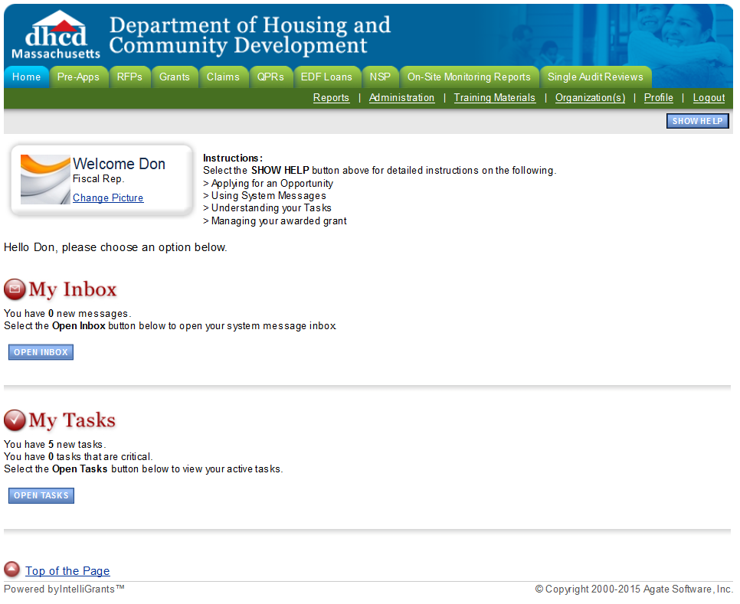
______________________________________________________________________

If you are a new user, go to https://gms.ocd.state.ma.us and click on New User. Fill out the profile, create your password, and click Save.

Section 2 – Adding New People to the Organization / Grant / bank Accounts & Roles/Permissions:

- The AO can add people to the Organization:
Go to the Grants Tab and search for the grant. Go to the tab and
put the person’s name in the text box. Hit the search button. When the person’s name comes up on the screen, place a check in the box, choose the appropriate Role from the drop down option, and put in an Active Date; click the Save button. The person should now be listed as a member of your organization. You must also assign any new members to the grant object. In the Grant, click on Add/Edit People. Put the person’s name in the text box and hit the search button. When the person’s name comes up on the screen, place a check in the box, choose the appropriate Role from the drop down option, and put in an Active Date; click the Save button. The person should now be listed in the Grant. You must deactivate members when they leave your organization by putting in an end date.

- The AO can add people to the Bank Accounts:
If there is a new AO, DHCD will add the AO as a Representative. The AO is then responsible for adding any additional representatives to the bank account. Go to box and click on VIEW. Choose the appropriate account. Go to the Representatives tab and put the person’s name in the text box. Hit the search button. When the person’s name comes up on the screen, place a check in the box, and put in an Active Date; click the Save button. The person should now have access to this account. You must deactivate members when they leave your organization by putting in an end date.

- Roles & Permissions:

Authorized Official will be able to:
􀂃 Highest level security role for an organization
􀂃 Add new and existing users to their current organization(s)
􀂃 Edit their own user account information
􀂃 Initiate available pre-applications, applications and application submission by the organization
􀂃 Enter, update and delete information on applications
􀂃 Download and attach files to the application
􀂃 Cancel an entire application before submission
􀂃 Submit applications, for the various applications available to MADHCD
􀂃 Check on the status of each application

Administrator will be able to:
􀂃 Add new and existing users to their current organization(s)
􀂃 Edit their own user account information
􀂃 Enter, update and delete information on applications
􀂃 Download and attach files to the applications
􀂃 Check on the status of each application

Writer will be able to:
􀂃 Edit their own user account information
􀂃 Enter, update and delete information on applications
􀂃 Download and attach files to the applications
􀂃 Check on the status of applications where permission is granted

Viewer will be able to: 􀂃 Access to view application and grant-related information

Section 3 – Activities, Projects, Contractors, and Administrative Expenses:
You will find the Activity Link in the grant, under the “View, Edit & Complete Forms” link on the Grant Menu. Click on the Activity Link. The drop down option, on the upper right side of the screen, will show you all of the activities in the grant. The bottom left side of the screen shows you the related pages. You must complete the Applicant screen for activities 4B, 4C, and 4D. You can create more than one Applicant by clicking on the Add button at the top of the page.
For all activities except 4A, 5A, 6A, 8A, and 9, you must create a project/projects. First, click on the Project Link for all activities except 4A, 5A, 6A, 8A, and 9. Follow the instructions on the top of the screen. For activities 4B, 4C and 4D, please select an applicant (remember you must first complete the Applicant screen for 4B-D). For all other activities, please fill in the project name. You can create more than one Project by clicking on the Add button at the top of the page. Remember to save your information. You need to enter a Budget for each Project you create.
Once you have created a project(s), you must create the Contractor screen. You can create more than one Contractor by clicking on the Add button at the top of the page. Remember to save your information. You need to enter a Budget for each Contractor you create.

You must complete the Unit of Measure page for every activity except: 4A, 5A, 6A, 8A, and 9. Complete the Beneficiary Summary or Beneficiary Detail information at the bottom of the Project screen as required for each Activity. The instructions on the top of the screen show which screen to complete for which activity. For the Beneficiary Summary, complete this grid only if the National Objective for this project is "Low/Moderate Income" and the current activity is one of the following: 5E, 5F, 5M, 6B, 6C, 6D, 6E, 6F, 6G, 6H, 6I, 6J, 6K, and 7. For the Beneficiary Detail, complete this form only if the National Objective for this project is "Low/Moderate Income" and this project is part of one of the following: 1, 2, 3, 5B, 5D, 5N, and 8B.

Complete the Administrative Account page for 4A, 5A, 6A, 8A, and 9. You can create more than one Admin Expense by clicking on the Add button at the top of the page. Remember to save your information. You need to enter a Budget for each Admin Expense you create. Refer to the cost category budgets in the Program Delivery and General Administrative pages of your Grant Application.

After you have set up your Projects, Contractors, and Administrative Expenses according to your approved application, you can begin to pay bills and submit claims.

Section 4 – Basic Transactions in the Bank Account:

The grantee must pay any contractor and/or administrative expenses out of the Direct Depository account if you are only using CDBG funds OR for Cash Management (if you have Program Income) by choosing: Pay a Contractor Expense from the Direct Depository Account or Pay an Admin Expense from the Direct Depository Account. These options are in the Transactions Tab in the Direct Depository Account. Choose the appropriate option from the dropdown menu labeled Transaction Description.

The grantee must deposit any CDBG drawdowns/claims in your Direct Depository account by choosing: Record a Drawdown for a Grant into Direct Depository Account. If you use your Program Income account for Cash Management, you must transfer money from the Program Income Account into the Direct Depository by choosing: Transfer money from Program Income Account to Direct Depository Account. You must use your program income first and then you can complete a drawdown and replenish the Program Income account by choosing: Transfer money from Direct Depository Account to Program Income Account.

Direct Depository Rules:
- Interest earned over $100 in a calendar year must be returned to HUD
- No more than $10,000 may be held in the account for more than one warrant cycle

Common Recording Mistakes:
- Selecting the wrong grant/fiscal year
- Not selecting a vendor from the dropdown menu
- Not reviewing the bank account after the transaction to make sure it was recorded correctly by GMS

If you are using only Program Income to pay for projects in specific activities (via a budget amendment or grant application), you can pay the contractor and/or administrative expense out of the Program Income Account by choosing: Pay a Contractor Expense from the Program Income Account or Pay an Admin Expense from the Program Income Account. These options are in the Transactions Tab in the Program Income Account. Choose the appropriate option from the dropdown menu labeled Transaction Description.

PI Facts –

- PI is money received by a municipality as a result of CDBG programming (e.g., sale of property improved with CDBG $, sale of CDBG funded equipment, etc.)
- If less than $35,000 is returned to a program in a calendar year, this money is NOT PI (with the exception of revolving loan funds) – it is considered “miscellaneous income” (MI) and is used at the discretion of the grantee. MI must be moved out of the direct depository and is not reported to DHCD
- Proceeds from the sale or improvement of CDBG funded property, if received more than 5 years after an expired grant, is NOT PI
- 2% of a calendar year’s NEW PI is due to DHCD at the beginning of each following year

Common “Error Message” – if you get a BIG – BOLD ERROR MESSAGE, click the back button and try to submit it again. Try 2 or 3 times, and it should work. Make sure to check GMS to make sure the transaction happened ONLY ONCE!!

Section 5 – Amendments:
In order to complete an amendment or an extension, you must be in the grant object.
Access the grant on the main menu using the Grants tab. Click on the grant object. The Information Box on the top of the page will show you: the Organization, Your Role, Current Status, and Period. You can only work in a grant when it is in Grant Awarded status; once you put a grant in amendment or in extension you lose functionality within the grant until it is approved. To start an Amendment, click on the blue View Status Changes button on the front page of the grant and change the status to Grant in Amendment. See the instructions below. Go into View, Edit and Complete Forms:
- Click on Amendment Request link. Read the instructions, complete the first screen, and hit the save button.
- After you hit the save button, five additional Amendment links will appear at the bottom of the screen.
- Complete the Budget Amendment Form, if necessary.
- Generate the Amendment Form. The CEO or Selectman must first sign the form and then you can upload the document.
- You may attach any additional documents to the Amendment Attachment link (consult with a Program Representative when attaching additional documentation).
- Return to the Grant Menu and change status to Grant Amendment Submitted (remember to hit the Change Status button).
Amendments are required when –
- You add an activity
- You move money between construction and non-construction
- You add (or take out) PI
- You move Admin or Program Delivery (PD) funds
- When more than 10% of the total budget is moved between lines and the original grant is more than $100,000
- Make sure these caps are still maintained when moving money – 15% General Admin (GA) ; 27% GA & PD; 20% Social Services

Section 6 – Extensions:

Access the grant on the main menu (using Grants tab). Click on the grant object. The Information Box on the top of the page will show you: the Organization, Your Role, Current Status, and Period. You can only work in a grant when it is in Grant Awarded status; once you put a grant in amendment or in extension you lose functionality within the grant until it is approved. To start an Extension, click on the blue View Status Changes button on the front page of the grant and change the status to Grant Extension Request in Process. Go into View, Edit and Complete Forms:

- Click on Extension Request Page.
- Enter the extension date; the extension date is the date you want to extend to. It must be a quarter ending date. Provide detailed information justifying the extension. Hit the save button.
- After you hit the save button, three additional Extension links will appear at the bottom of the screen.
- Generate the Extension Form. The CEO or Selectman must first sign the form and then you can upload the document.
- You may attach any additional documents to the Extension Attachment link. Return to the Grant Menu and change status to Grant Extension Submitted (remember to hit the Change Status button).
- Submit 30 days prior to grant expiration date.
- In GMS, program extensions are processed by your Program Rep. CONTRACT extensions, however, are processed by your Fiscal Rep. When in doubt, call one of us and we will direct you to the right staff person to answer any questions!
Program vs. Contract End Dates –
- CDBG program implementation dates are typically 18 months. This is SEPARATE from the CONTRACT end date.
- CDBG contracts are 3 state fiscal years in length. FY 18 contracts begin on 7/1/18 and end on 6/30/21. If a grantee wants to add another year to the grant or reduce the grant to 24 months (so you can access your final $1,000) they must contact their Fiscal Rep to do a contract amendment at least 2 months before the grant terminates.

Section 7 – Claims:

The grantee submits all requests for payment through the CGMM system in the form of a claim. The Program Representative and Fiscal Representative review each claim for accuracy and approve the claim for final payment. You can track the progress of your claim through the system, by clicking on the Status History (under Management Tools) link in the claim.

- Select a Grant.
- Click on Related Items and Initiate a Claim.
- The status will change to Claim in Process and you will be on front page of the claim
- Click on View, Edit and Complete forms
- Complete the menu items on the Claim tree in succession beginning with Claim Request Information.
- Click on the Claim Detail screen. You will see all of the activities in the drop down box on the upper right side of the screen.
- Enter the amount of your request in the Current Request field on the Claim Detail screen.
- When all Claim Detail screens have been completed, go to the Claim Summary page; the page must be saved in order to perform the calculations.
- Download the Payment Request Voucher; sign, scan, and upload the voucher.
- Return to Change the Status on the front page of the Claim menu and change the status to Claim Submitted.
See Section 10 - Close Out Process - on how to do a Negative Draw
IMPORTANT FACTS ABOUT DRAWDOWNS –

- Drawdowns are processed at the end of the week. Submit your drawdown on or before Wednesday if you want it in that week’s “batch”
- Make sure the “Payment Request Document” is uploaded in LANDSCAPE mode, and nothing is handwritten on the document, with the exception of the “Vendor Certification” signature and “Vendor Code” number (please double check this number for accuracy)
- After being processed by your Fiscal Rep, it typically takes 5-10 days for the drawdown to be deposited in the Town’s Treasury
- $5,000 is the minimum drawdown request – unless it is the final payment
- No line can be processed if under $1. Any claim received with less than $1 in a line will be returned for correction
- Occasionally, the last $1,000 of your grant cannot be accessed until the new fiscal year (July 1, xxxx). When this happens, your options are: 1) wait until July 1 to be paid or 2) do a contract amendment to move the end date of your grant into the current fiscal year, if time permits

Section 8 - Single Audit Review:

Section 8– Audits:
Grantees must submit their Single Audit Review (if required) within the CGMS system within nine (9) months after the end of previous fiscal year (i.e., June 30th). You will find the Create New Single Audit Review in the My Documents section on the Main Menu. Click on the Create New Single Audit Review link, Click on I Agree, and the Single Audit Review object will be created; the new status will be Single Audit Review in Progress. Click on either Single Audit Review or Extension Request on the right hand side of the screen in the Forms section.

If you are requesting an extension, fill in the appropriate date and upload a letter signed by the CEO or Treasurer. Return to the Single Audit Review screen and change the status to Single Audit Extension Submitted. Once the extension is approved by the Audit Coordinator (i.e., Fiscal Rep), it will return to your Active Desktop and will be in the Single Audit Review in Progress status. This status will allow you to submit the Audit by the approved extension date.

The Grantee must either submit an audit review or request an extension. When you are ready to submit the Audit, click on the Single Audit Review link. Check the appropriate box and upload the Audit. Return to the Single Audit Review screen and change the status to Single Audit Review Submitted.

The link for “Create New Single Audit Review” is only available for a few weeks
prior to when an audit is due (March 31).

Cities and towns must upload their Audit in the Federal Clearinghouse (https://harvester.census.gov/facweb/). Please make sure that is done prior to submitting your Audit in GMS.

Section 9– Quarterly Reporting:

Quarterly reports are due on the 15th of the month following the end of each quarter. Quarterly reports are accessed under Related Items on the Forms page of the grant in the same place you find a claim. Quarterly reports are available on the first day of the quarter and will remain available until the due date. After that, you will need to contact your program rep in order to have the report reestablished. It is recommended that you create the report early in the quarter.

- Click on Related Items and Initiate a/an QPR xx Quarter
- The status will change to Report in Progress and you will be on front page of the QPR
- Click on View Edit and Complete Forms
- Click on the Narrative link and enter information as directed. You can also attach a report her if you desire.
- Click on Activity and enter activity information. The quarterly progress report should discuss activity that took place during the quarter.
- The quarterly report object is for transferring a narrative report. Quarterly reporting also includes updating statistics on accomplishments which is done through the grant.
- When you have completed the narrative and statistical information is up-to-date, return to the front page of the QPR and click on View Status Options. Change the status to Report Submitted.

Section 10 - Close Out Process:

The close out process begins when the grantee submits their final quarterly report. Check the Project Closure Report to ensure all required program statistics are updated as ‘actual’ prior to submitting the final quarterly report. When this report is approved, the Fiscal Manager will push the grant to Grant Closure Initiated. At that point, the grantee will have access to their Grant Certification of Completion form. You must review this form for accuracy. In addition, make sure you check your Financial Activity Report to ensure your transactions are up-to-date and complete. Close the Projects and then run the Check Errors Report. Finally, review your Grant Certification of Completion form and pay close attention to:

Line 1 This number should accurately represent total program costs (CDBG dollars and Program Income).

Line 2 This number should accurately represent any Program Income that was used in this grant.

Line 6 This should be your correct grant award

The other lines in the form represent calculations based on the numbers above.

When you are ready to submit the form for the Fiscal Representative’s review, you may change the Status to Grant in Closure. The Fiscal Representative may send this back to you for modifications or if you need to submit a negative claim or complete additional transactions in the grant. The Fiscal Representative will push the grant to either Grant Awarded or Grant Close Out Mods Required. In either instance, after you make the requested changes, you will resubmit the grant by changing the status to Grant in Closure II or Grant Close Out Mods Submitted respectively.

If you have drawn more CDBG money than you have spent, you must repay this money to DHCD. Follow these steps:

- Submit a Negative Claim (your fiscal rep will provide instructions)
- Adjust the Direct Depository by choosing Record a Negative Drawdown for a Grant into the Direct Depository
- Send DHCD a check.

